Table S1 The attribution of peak in FT-IR absorption spectra of PP.
Wave number/cm-1 | Attribution of peak
3401.82 | Stretching vibrations of O-H
2937.06 | Asymmetric stretching vibration of CH₂
1614.13 | Asymmetric stretching vibration of C=O
1423.21 | Shear vibration of CH₂
1101.16 | Bending vibrations of C-H
1016.30 | Pyranoside

Table S2 The monosaccharide composition of PP.
Number | Retention time (min) | Monosaccharides | Composition (%)
1 | 17.371 | Mannose | 3.28
2 | 21.612 | Aminoglucose | 0.31
3 | 22.623 | Ribose | 0.30
4 | 24.298 | Rhamnose | 7.31
5 | 26.131 | Glucuronic acid | 0.83
6 | 28.971 | Galacturonic acid | 71.85
7 | 36.292 | Galactosamine | 2.08
8 | 41.297 | Glucose | 6.76
9 | 44.065 | Galactose | 0.35
10 | 45.637 | Xylose | 6.28
11 | 53.618 | Arabinose | 0.21
12 | 56.286 | Fucose | 0.43
Analysis by HPLC, chromatogram of standard monosaccharide, 1-Mannose, 2-Aminoglucose, 3-Ribose, 4-Rhamnose, 5-Glucuronic acid, 6-Galacturonic acid,7-Galactosamine, 8-Glucose, 9-Galactose, 10-Xylose, 11-Arabinose, 12-Fucose, chromatogram of monosaccharide composition.

Table S3 The results of ɑ-diversity analysis.
 | Control | Model | SASP | PP_100
Feature | 248.83 ± 23.3 | 244.33 ± 23.38 | 250.33 ± 7.94 | 217.67 ± 39.8
ACE | 283.79 ± 19.36 | 279.83 ± 18.10 | 282.42 ± 10.53 | 252.28 ± 33.4
Chao1 | 284.96 ± 24.07 | 278.9 ± 12.80 | 283.30 ± 8.98 | 254.38 ± 37.77
Simpson | 0.92 ± 0.06 | 0.95 ± 0.01 | 0.96 ± 0.01 | 0.94 ± 0.04
Shannon | 5.20 ± 0.82 | 5.55 ± 0.27 | 5.69 ± 0.22 | 5.35 ± 0.56
PD_whole_tree | 17.3 ± 1.04 | 17.06 ± 0.98 | 17.52 ± 0.39 | 15.76 ± 1.90

Table S4 DAI scoring system.
DAI score | Weight loss (%) | Stool consistency | Occult/gross bleeding
0 | None | Normal | Normal
1 | 1-5 | Loose stools | Hemoccult positive
2 | 5-10 | Loose stools | Hemoccult positive
3 | 10-20 | Loose stools | Hemoccult positive
4 | >20 | Diarrhea | Gross bleeding

Table S5 Histological scoring system.
Score | Extent of Inflammation | Infiltration neutrophils+lympho-histiocytes | Extent of crypt damage | Crypt abscesses | Sub-mucosal oedema | Loss of goblet cells | Reactive epithelial  hyperplasia
0 | None | None | None | None | None | None | None
1 | Mucosa | Focal | Basal one third | Focal | Focal | Focal | Focal
2 | Mucosa+submucosa | Multifocal | Basal two third | Multifocal | Multifocal | Multifocal | Multifocal
3 | Mucosa+submucosa+muscle layer | Diffuse | Entire crypt damage | - | Diffuse | Diffuse | Diffuse
4 | Transmural | - | Crypt damage + ulceration | - | - | - | -

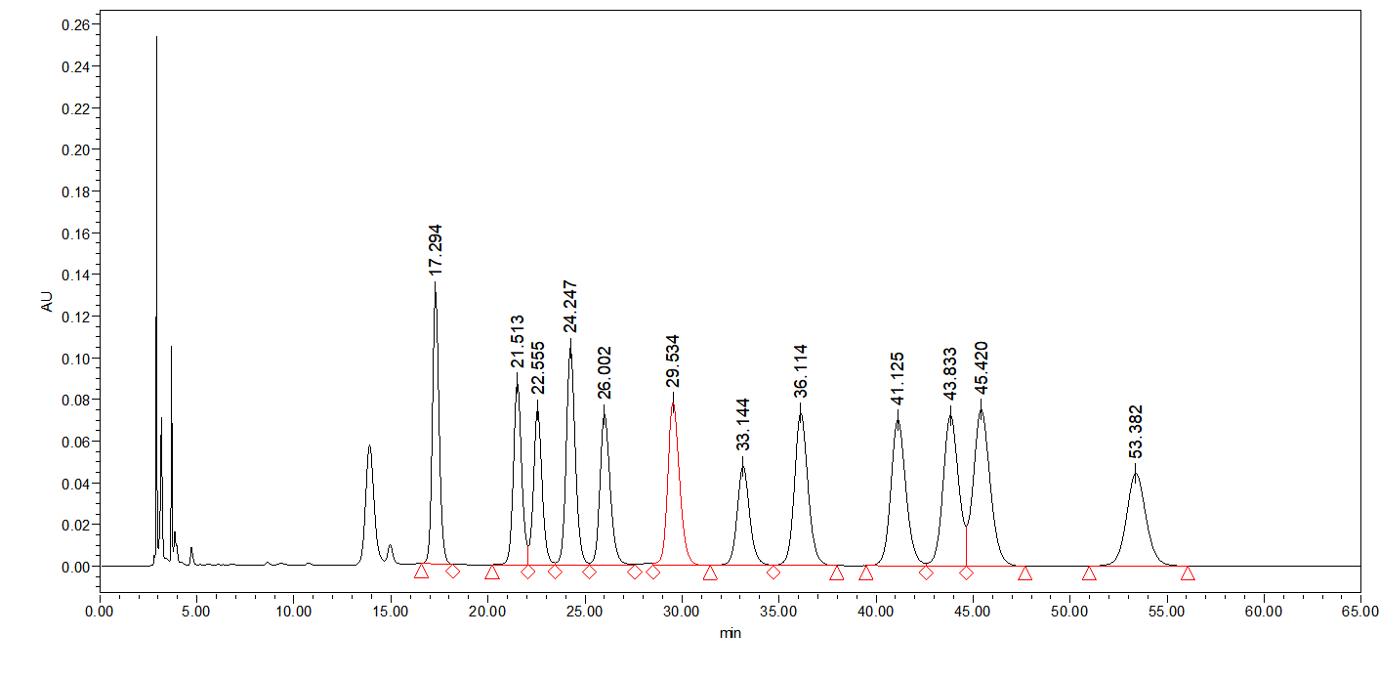
Fig. S1 Chromatographic elution peak of monosaccharide standard.

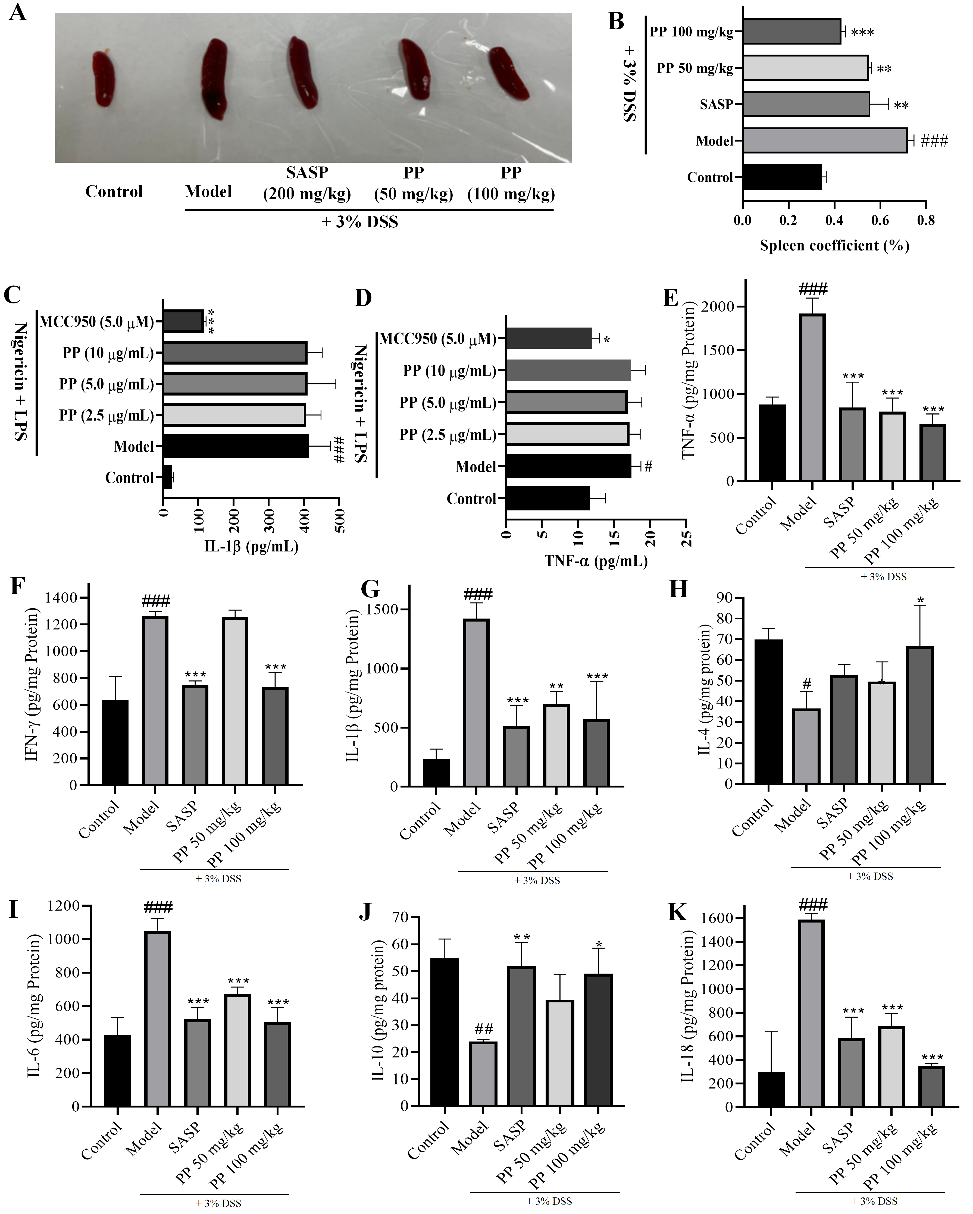
Fig. S2 Effects of PPs on spleen coefficient in DSS-induced mice. (A) The representative pictures of mouse spleen. (B) Statistical result of spleen coefficient. PPs (2.5, 5.0 and 10 μg/mL) exhibit no effect on IL-1β (C) and TNF-ɑ (D) levels in the supernatant of LPS and Nigericin induced THP-1 cells. n=6. #P < 0.05 vs control, ###P < 0.001 vs control; *P < 0.05 vs Model, **P < 0.01 vs Model, ***P < 0.001 vs model.
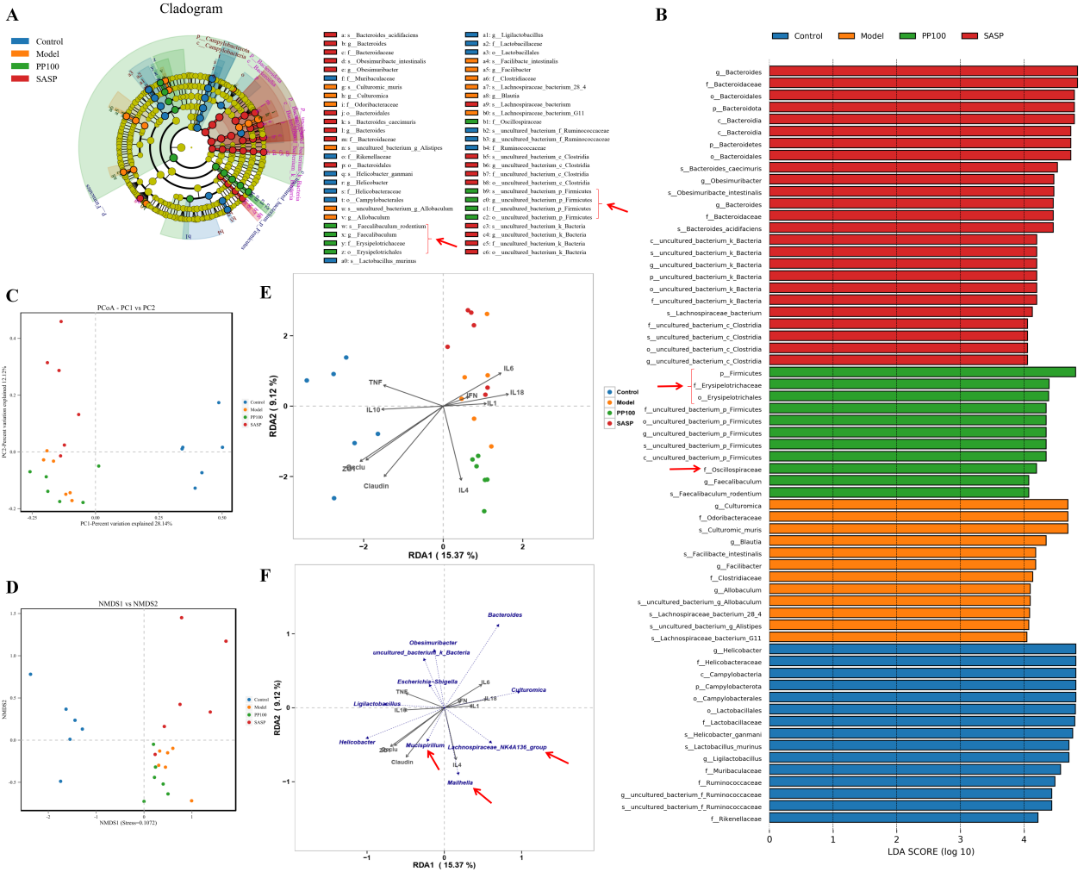
Fig. S3 LEfSe analysis after PPs treatment. (A) The distribution histogram of control, model, SASP and PP_50 groups in gut microbiota; (B) Cladogram. The size of each node represents the relative abundance of the species. (p, phylum; c, class; o, order; f, family; g, genus; s, species); (C) Principal coordinate analysis; (D) Non-metric multidimensional scaling analysis; (E) Correlation between tight junction proteins and inflammatory cytokines on different groups; (F) Correlation between gut microbiota, inflammatory cytokines and tight junction proteins.
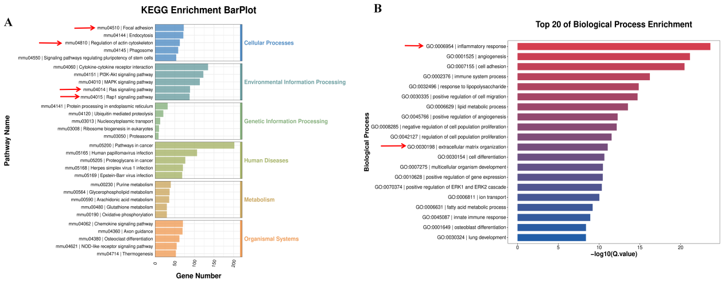
Fig. S4 The results of transcriptional analysis after PPs treatment. (A) Biological process enrichment analysis; (B) KEGG enrichment analysis.

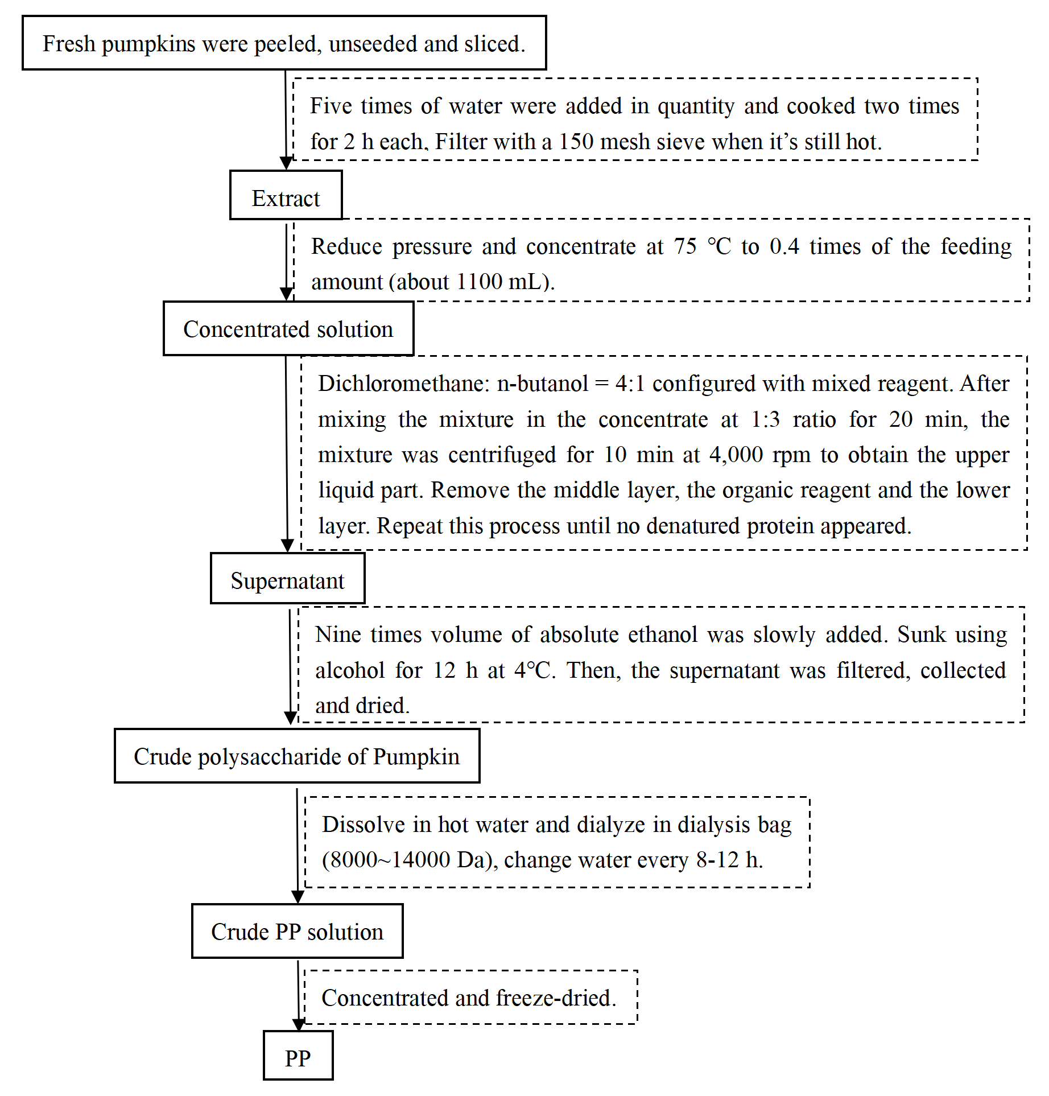
Fig. S5 The diagram of extraction process of PP.

