Impact of corticosteroids exposure for preterm labor in neonates eventually born at term
C. Best¹,J-M. Hascoet², E. Jeanbert³, O. Morel⁴, C. Baumann^{3,} ,E. Renard¹
SUPPLEMENTARYINFORMATIONS :Audipog curves
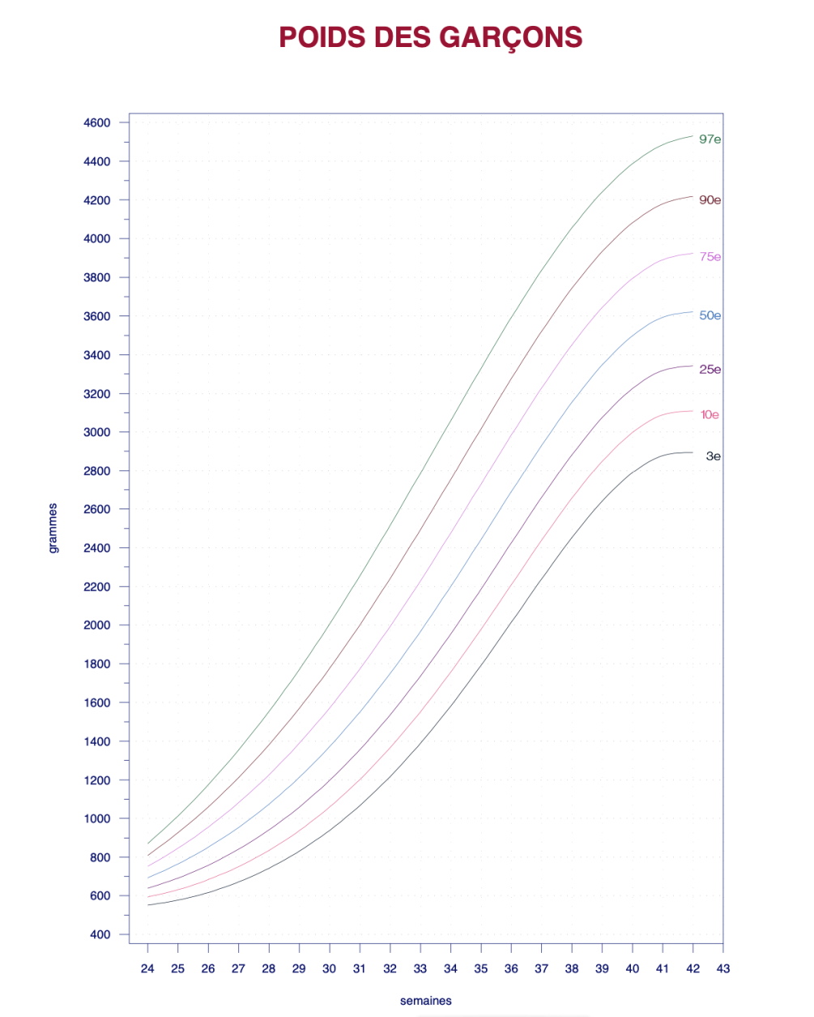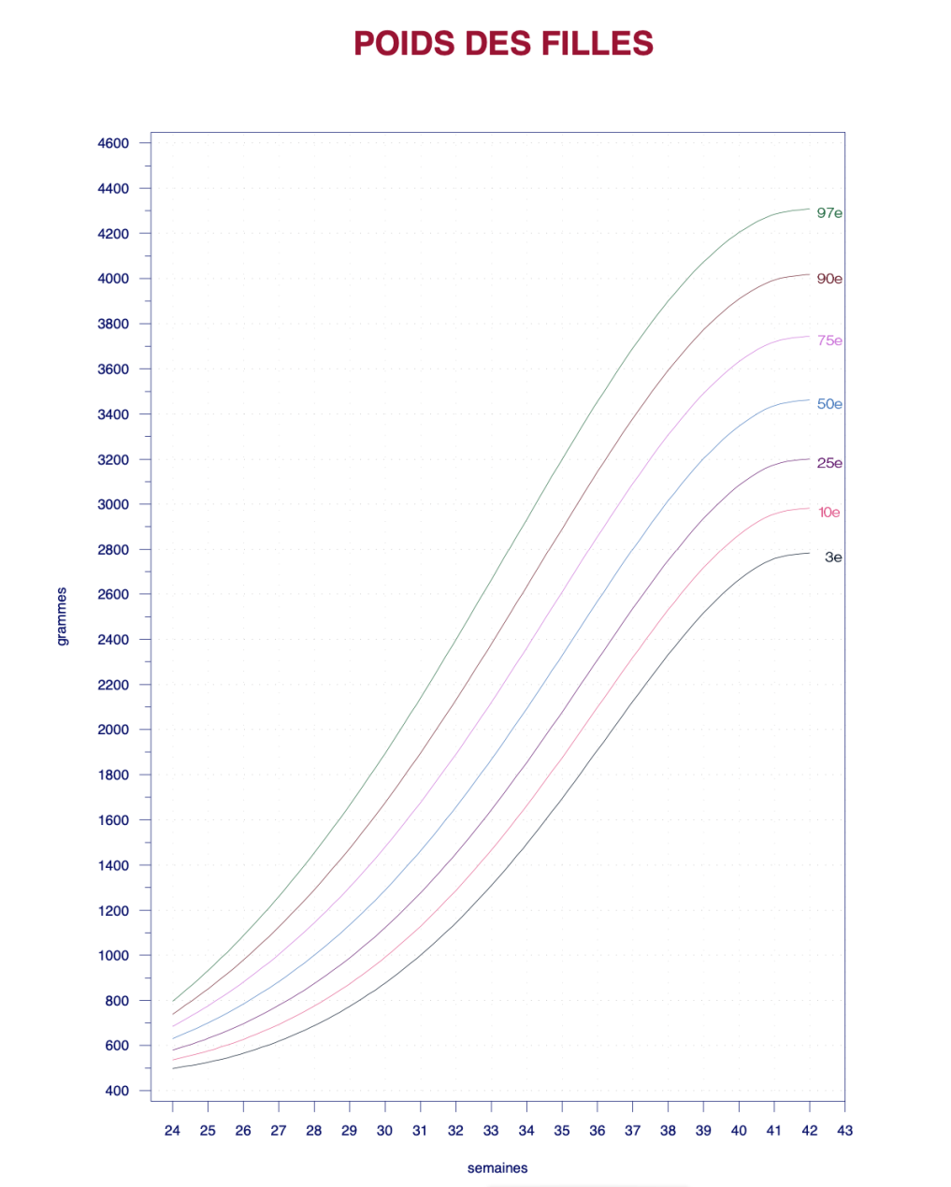
FEMALEWEIGHT
Weeks
MALEWEIGHT
Weeks
Grams
Grams

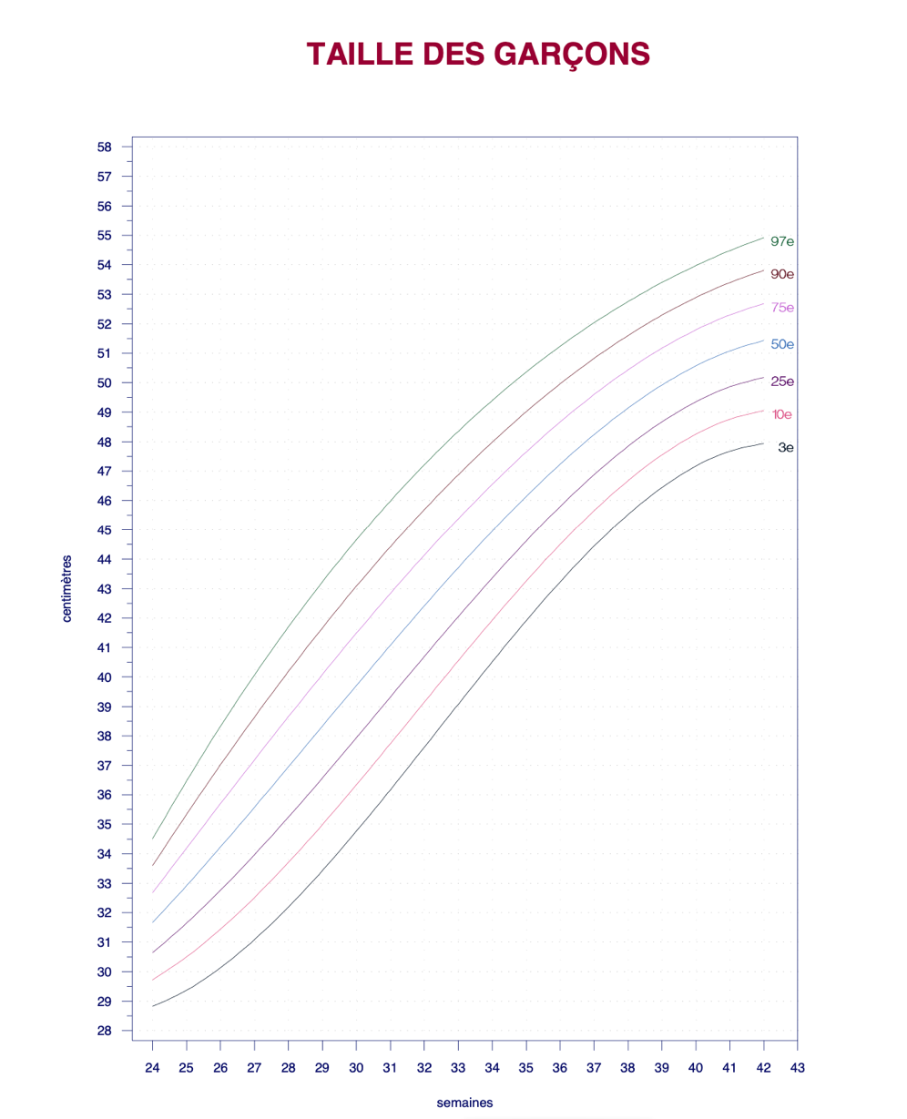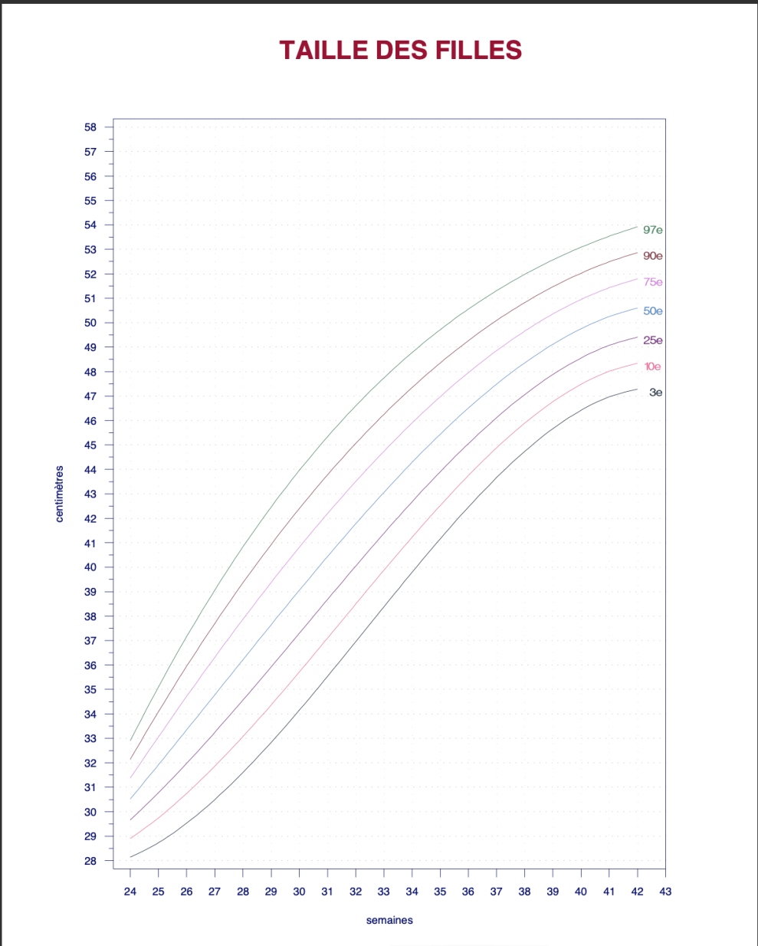
FEMALELENGTH
centimeters
MALE LENGTH
centimeters
Weeks
Weeks

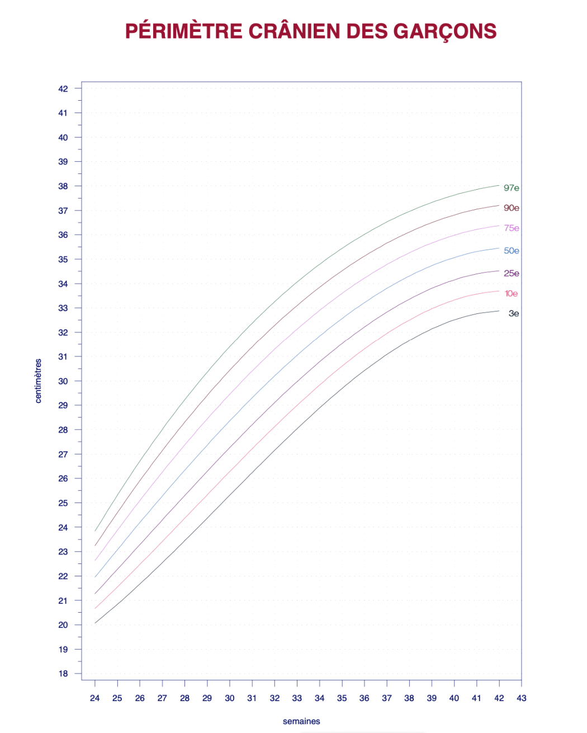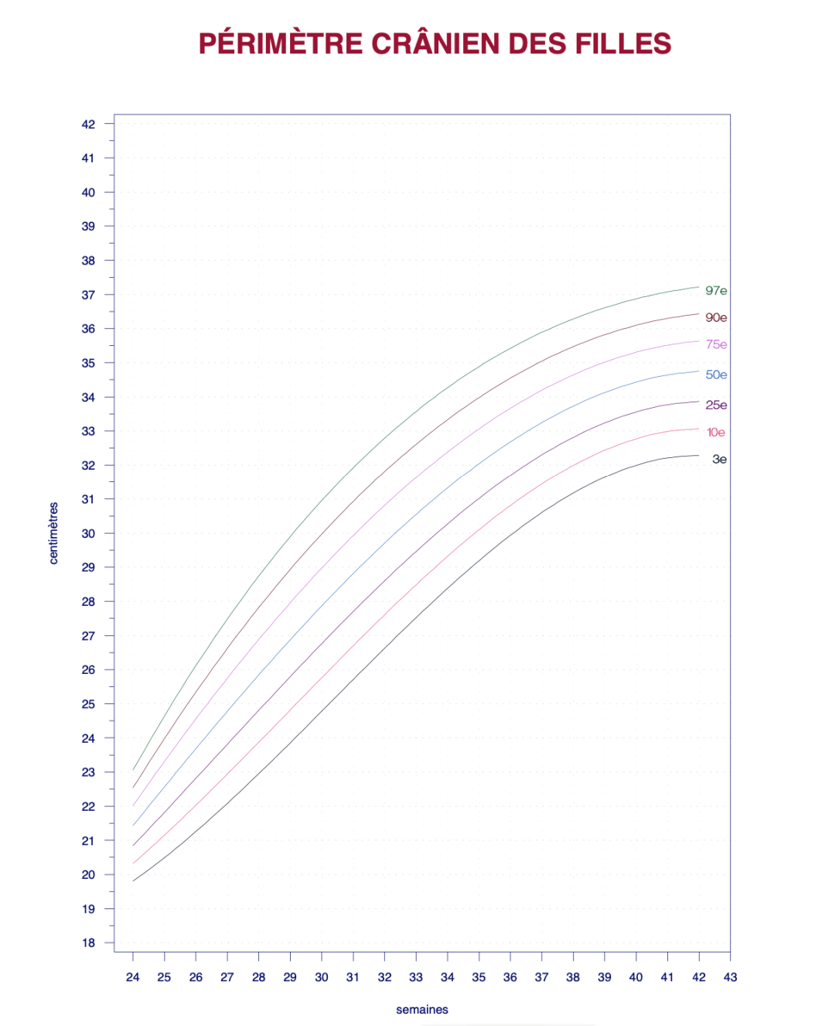
FEMALEHEADCIRCUMFERENCE
Weeks
centimeters
MALE HEAD CIRCUMFERENCE
Weeks
centimeters

