Supplementary Materials

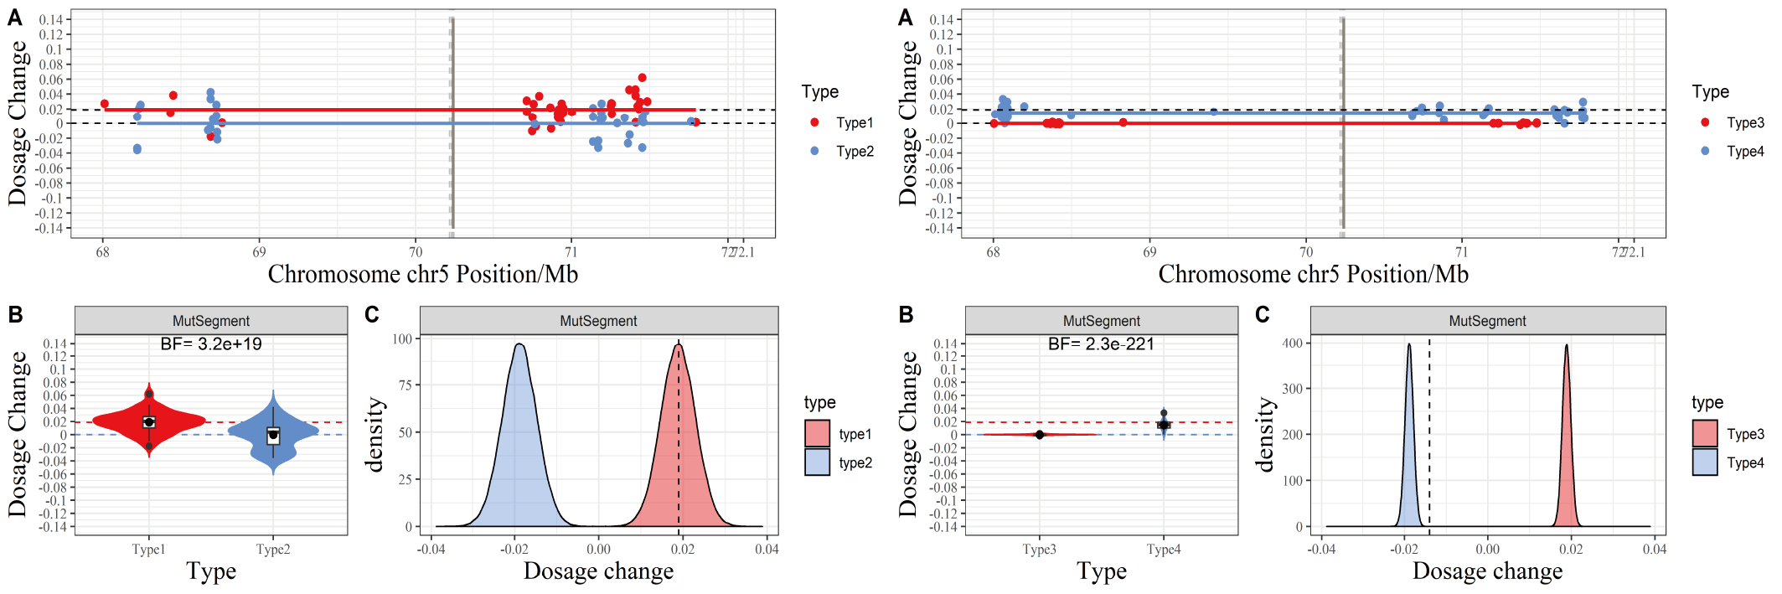

Figure S1. The typical NIPD result of scatter plot and violin plot.
(A) Scatter plot of each allele's dosage change (DC) for P10. The X-axis is the genomic coordinate, and the Y-axis represents DC. Red dots denote the DC of the Type 1 allele (over-represented if the fetus inherited maternal Hap1, which carries the pathogenic variant), while blue dots are the DC of the Type 2 allele (over-represented if the fetus inherited maternal Hap 2, which carries wild-type SMA gene). The red and blue dashed lines indicate the expected value of DC for Type1 and Type2 alleles under the assumption that the fetus inherits maternal pathogenic and wild-type haplotype. The red and blue horizontal line is the center of DC returned by the CBS algorithm, and the gray vertical dashed line marks the position of SMA exons. (B) Violin plot of DC. The shape around each box demonstrates the distribution of DC. The red and blue dashed lines indicate the expected value of DC for Type1 and Type2 alleles under the assumption that the fetus inherits maternal pathogenic and wild-type haplotype. The Bayes factor is labeled on the top region, BF≥10 indicates a positive test result, favoring the assumption that the fetus inherits the maternal pathogenic variant, while BF≤0.1 reveals a negative test result, where the fetus inherits the wild-type haplotype.

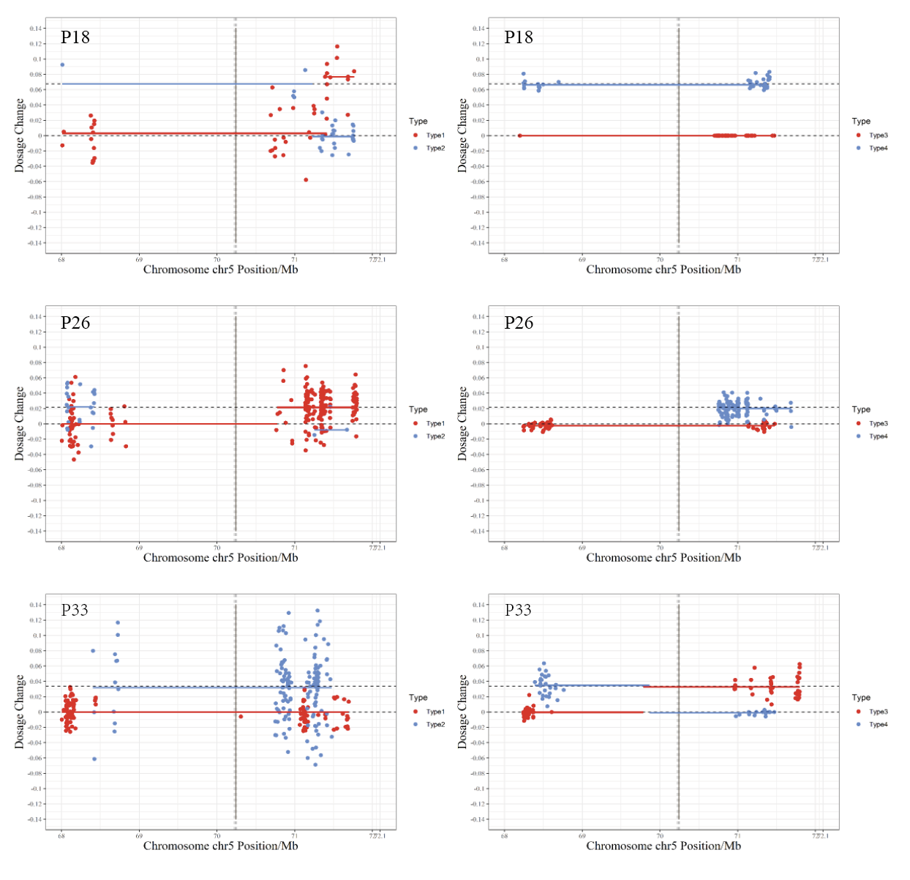

Figure S2. The recombination RHDO results of P18, P26, and P33. Scatter plot of each allele's dosage change (DC) for each family. The red and blue horizontal line is the center of DC returned by the CBS algorithm. When a recombination event presents, both lines will cross over at the switch site. A gray vertical dashed line marks the position of SMN exons. The maternal or paternal inheritance is no call if the recombination region crosses the gray vertical dashed (P26, P33). The results won't be disturbed when the recombination occurs far away from the SMN exon (P18).

Table S1 The targeted sequencing datasets of the 36 SMA families.
Family  members | Relationship | Sample type | Variants | Genotype | Total reads | Average depth | On- target rate  (Capture ratio) | Coverage (≥30X)
P1 | Offspring | gDNA | NM_000344.3:EX7_8del | hom | 4031835 | 456 | 62.63% | 94.8%
P1 | Mother | gDNA | NM_000344.3:EX7_8del | het | 4368937 | 490 | 63% | 94.52%
P1 | Father | gDNA | NM_000344.3:EX7_8del | het | 4279541 | 486 | 63.72% | 97.13%
P1 | Mother | cfDNA | - | - | 5301774 | 631 | 69.67% | 90.67%
P2 | Offspring | gDNA | NM_000344.3:EX7_8del | hom | 3043076 | 352 | 60.28% | 96.45%
P2 | Mother | gDNA | NM_000344.3:EX7_8del | het | 2988299 | 349 | 60.61% | 93.17%
P2 | Father | gDNA | NM_000344.3:EX7_8del | het | 2042222 | 257 | 58.78% | 93%
P2 | Mother | cfDNA | - | - | 5450560 | 572 | 60.51% | 76.29%
P3 | Offspring | gDNA | NM_000344.3:EX7_8del | hom | 2632870 | 298 | 55.84% | 94.11%
P3 | Mother | gDNA | NM_000344.3:EX7_8del | het | 3595058 | 419 | 63.49% | 93.39%
P3 | Father | gDNA | NM_000344.3:EX7_8del | het | 10491346 | 841 | 48.51% | 86.24%
P3 | Mother | cfDNA | - | - | 1844488 | 249 | 62.29% | 95.5%
P4 | Offspring | gDNA | NM_000344.3:EX7_8del | hom | 1039273 | 175 | 63.07% | 85.58%
P4 | Mother | gDNA | NM_000344.3:EX7_8del | het | 6528030 | 578 | 51.09% | 95.01%
P4 | Father | gDNA | NM_000344.3:EX7_8del | het | 1551757 | 225 | 63.76% | 95.36%
P4 | Mother | cfDNA | - | - | 6315136 | 556 | 50.55% | 87.35%
P5 | Offspring | gDNA | NM_000344.3:EX7_8del | hom | 4498455 | 513 | 64.55% | 94.58%
P5 | Mother | gDNA | NM_000344.3:EX7_8del | het | 3207894 | 418 | 70.86% | 95.06%
P5 | Father | gDNA | NM_000344.3:EX7_8del | het | 7533478 | 805 | 64.41% | 98.04%
P5 | Mother | cfDNA | - | - | 5584671 | 518 | 52.61% | 67.33%
P6 | Offspring | gDNA | NM_000344.3:EX7_8del | hom | 7915407 | 608 | 44.7% | 95.04%
P6 | Mother | gDNA | NM_000344.3:EX7_8del | het | 7195868 | 555 | 44.24% | 93.16%
P6 | Father | gDNA | NM_000344.3:EX7_8del | het | 6696767 | 531 | 45.22% | 97.76%
P6 | Mother | cfDNA | - | - | 9790119 | 875 | 54.29% | 94.67%
P7 | Offspring | gDNA | NM_000344.3:EX7_8del | hom | 9319040 | 730 | 46.72% | 95.25%
P7 | Mother | gDNA | NM_000344.3:EX7_8del | het | 11207736 | 867 | 47% | 94.93%
P7 | Father | gDNA | NM_000344.3:EX7_8del | het | 8412874 | 672 | 47.13% | 97.17%
P7 | Mother | cfDNA | - | - | 4809043 | 541 | 64.33% | 91.87%
P8 | Offspring | gDNA | NM_000344.3:EX7_8del | hom | 4560061 | 469 | 57.23% | 97.51%
P8 | Mother | gDNA | NM_000344.3:EX7_8del | het | 4782341 | 489 | 57.4% | 95.44%
P8 | Father | gDNA | NM_000344.3:EX7_8del | het | 4150293 | 436 | 57.69% | 97.59%
P8 | Mother | cfDNA | - | - | 5100481 | 474 | 51.89% | 89.41%
P9 | Offspring | gDNA | NM_000344.3:EX7_8del | hom | 3008695 | 357 | 61.92% | 94.23%
P9 | Mother | gDNA | NM_000344.3:EX7_8del | het | 2538356 | 314 | 62.13% | 94%
P9 | Father | gDNA | NM_000344.3:EX7_8del | het | 2930028 | 359 | 64.12% | 97.4%
P9 | Mother | cfDNA | - | - | 4429754 | 422 | 51.93% | 88.12%
P10 | Offspring | gDNA | NM_000344.3:EX7_8del | hom | 3008695 | 357 | 61.92% | 94.23%
P10 | Mother | gDNA | NM_000344.3:EX7_8del | het | 4835602 | 539 | 63.61% | 94.96%
P10 | Father | gDNA | NM_000344.3:EX7_8del | het | 2930028 | 359 | 64.12% | 97.4%
P10 | Mother | cfDNA | - | - | 4481199 | 514 | 65% | 77.18%
P11 | Offspring | gDNA | NM_000344.3:EX7_8del | hom | 5525598 | 444 | 44.31% | 90.89%
P11 | Mother | gDNA | NM_000344.3:EX7_8del | het | 5289434 | 432 | 44.68% | 88.76%
P11 | Father | gDNA | NM_000344.3:EX7_8del | het | 5377095 | 426 | 43.3% | 85.09%
P11 | Mother | cfDNA | - | - | 3604551 | 446 | 68.16% | 94.68%
P12 | Offspring | gDNA | NM_000344.3:EX7_8del | hom | 5357965 | 545 | 58.25% | 94.55%
P12 | Mother | gDNA | NM_000344.3:EX7_8del | het | 2406772 | 278 | 55.66% | 88.45%
P12 | Father | gDNA | NM_000344.3:EX7_8del | het | 4474975 | 480 | 60.09% | 97.38%
P12 | Mother | cfDNA | - | - | 4052609 | 434 | 58.67% | 89.71%
P13 | Offspring | gDNA | NM_000344.3:EX7_8del | hom | 7617378 | 769 | 60.5% | 98.16%
P13 | Mother | gDNA | NM_000344.3:EX7_8del | het | 10157159 | 883 | 52.87% | 95.62%
P13 | Father | gDNA | NM_000344.3:EX7_8del | het | 8138627 | 814 | 60.33% | 98.77%
P13 | Mother | cfDNA | - | - | 6221974 | 612 | 57.33% | 87.29%
P14 | Offspring | gDNA | NM_000344.3:EX7_8del | hom | 7094694 | 650 | 53.85% | 96.52%
P14 | Mother | gDNA | NM_000344.3:EX7_8del | het | 5998231 | 566 | 54.3% | 95.26%
P14 | Father | gDNA | NM_000344.3:EX7_8del | het | 7108207 | 661 | 54.7% | 97.89%
P14 | Mother | cfDNA | - | - | 13211730 | 995 | 46.29% | 94.41%
P15 | Offspring | gDNA | NM_000344.3:EX7_8del | hom | 3508625 | 397 | 60.84% | 94.32%
P15 | Mother | gDNA | NM_000344.3:EX7_8del | het | 3886092 | 388 | 53.27% | 93.64%
P15 | Father | gDNA | NM_000344.3:EX7_8del | het | 4179257 | 473 | 63.1% | 97.8%
P15 | Mother | cfDNA | - | - | 5762818 | 559 | 55.79% | 92.48%
P16 | Offspring | gDNA | NM_000344.3:EX7_8del | hom | 3753552 | 466 | 69.02% | 95.42%
P16 | Mother | gDNA | NM_000344.3:EX7_8del | het | 3882930 | 479 | 68.99% | 95.66%
P16 | Father | gDNA | NM_000344.3:EX7_8del | het | 3604550 | 451 | 69.1% | 98.03%
P16 | Mother | cfDNA | - | - | 3496974 | 429 | 66.99% | 93.57%
P17 | Offspring | gDNA | NM_000344.3:EX7_8del | hom | 3519619 | 344 | 50.53% | 93.19%
P17 | Mother | gDNA | NM_000344.3:EX7_8del | het | 3818053 | 368 | 50.79% | 94.05%
P17 | Father | gDNA | NM_000344.3:EX7_8del | het | 4816916 | 451 | 51.7% | 96.88%
P17 | Mother | cfDNA | - | - | 7399424 | 583 | 45.55% | 76.78%
P18 | Offspring | gDNA | NM_000344.3:EX7_8del | hom | 3191339 | 389 | 65.18% | 97.43%
P18 | Mother | gDNA | NM_000344.3:EX7_8del | het | 3731176 | 439 | 64.71% | 95.41%
P18 | Father | gDNA | NM_000344.3:EX7_8del | het | 3081215 | 380 | 65.5% | 97.88%
P18 | Mother | cfDNA | - | - | 4089423 | 435 | 58.42% | 87.51%
P19 | Offspring | gDNA | NM_000344.3:EX7_8del | hom | 3238988 | 373 | 60.96% | 97.68%
P19 | Mother | gDNA | NM_000344.3:EX7_8del | het | 4011037 | 394 | 52.69% | 94.08%
P19 | Father | gDNA | NM_000344.3:EX7_8del | het | 2649231 | 316 | 60.24% | 97.85%
P19 | Mother | cfDNA | - | - | 2481257 | 274 | 52.82% | 63.02%
P20 | Offspring | gDNA | NM_000344.3:EX7_8del | hom | 2406428 | 308 | 63.85% | 94.95%
P20 | Mother | gDNA | NM_000344.3:EX7_8del | het | 2589563 | 325 | 63.77% | 95.09%
P20 | Father | gDNA | NM_000344.3:EX7_8del | het | 3519311 | 416 | 64.22% | 97.95%
P20 | Mother | cfDNA | - | - | 8775695 | 948 | 66.1% | 93.79%
P21 | Offspring | gDNA | NM_000344.3:EX7_8del | hom | 2998326 | 372 | 67.82% | 97.82%
P21 | Mother | gDNA | NM_000344.3:EX7_8del | het | 2991412 | 369 | 67.51% | 95.13%
P21 | Father | gDNA | NM_000344.3:EX7_8del | het | 3431499 | 428 | 67.43% | 98.21%
P21 | Mother | cfDNA | - | - | 3307259 | 408 | 66.95% | 92.04%
P22 | Offspring | gDNA | NM_000344.3:EX7_8del | hom | 2296404 | 273 | 66.91% | 66.85%
P22 | Mother | gDNA | NM_000344.3:EX7_8del | het | 1817138 | 208 | 66.61% | 66.83%
P22 | Father | gDNA | NM_000344.3:EX7_8del | het | 2766368 | 336 | 66.95% | 69.3%
P22 | Mother | cfDNA | - | - | 2865894 | 328 | 63.27% | 76.93%
P23 | Offspring | gDNA | NM_000344.3:EX7_8del | hom | 6016374 | 565 | 49.93% | 66.93%
P23 | Mother | gDNA | NM_000344.3:EX7_8del | het | 4516664 | 421 | 50.51% | 66.19%
P23 | Father | gDNA | NM_000344.3:EX7_8del | het | 5155465 | 484 | 50.36% | 69.21%
P23 | Mother | cfDNA | - | - | 5321583 | 612 | 60.82% | 64.11%
P24 | Offspring | gDNA | NM_000344.3:EX7_8del | hom | 3812558 | 303 | 50.86% | 92.52%
P24 | Mother | gDNA | NM_000344.3:EX7_8del | het | 3849544 | 304 | 50.46% | 92.51%
P24 | Father | gDNA | NM_000344.3:EX7_8del | het | 4751622 | 401 | 51.65% | 97.13%
P24 | Mother | cfDNA | - | - | 4305412 | 406 | 57.58% | 81.68%
P25 | Offspring | gDNA | NM_000344.3:EX7_8del | hom | 3631365 | 411 | 69.13% | 94.31%
P25 | Mother | gDNA | NM_000344.3:EX7_8del | het | 4047409 | 467 | 69.29% | 95.42%
P25 | Father | gDNA | NM_000344.3:EX7_8del | het | 3828041 | 439 | 69.43% | 97.9%
P25 | Mother | cfDNA | - | - | 6089670 | 597 | 57.34% | 94.33%
P26 | Offspring | gDNA | NM_000344.3:EX7_8del | hom | 5184336 | 437 | 51% | 66.15%
P26 | Mother | gDNA | NM_000344.3:EX7_8del | het | 4216546 | 350 | 51.86% | 66.47%
P26 | Father | gDNA | NM_000344.3:EX7_8del | het | 4863004 | 419 | 52.46% | 68.71%
P26 | Mother | cfDNA | - | - | 4321663 | 531 | 72.66% | 65.23%
P27 | Offspring | gDNA | NM_000344.3:EX7_8del | hom | 4838152 | 374 | 47.82% | 67.45%
P27 | Mother | gDNA | NM_000344.3:EX7_8del | het | 4904544 | 378 | 47.62% | 65%
P27 | Father | gDNA | NM_000344.3:EX7_8del | het | 4571200 | 351 | 47.92% | 67.59%
P27 | Mother | cfDNA | - | - | 4732513 | 504 | 63.38% | 65.56%
P28 | Offspring | gDNA | NM_000344.3:EX7_8del | hom | 4045801 | 483 | 71.44% | 67.55%
P28 | Mother | gDNA | NM_000344.3:EX7_8del | het | 4356362 | 529 | 71.82% | 67.79%
P28 | Father | gDNA | NM_000344.3:EX7_8del | het | 3633159 | 435 | 72.47% | 69.87%
P28 | Mother | cfDNA | - | - | 4489059 | 564 | 73.92% | 68.13%
P29 | Offspring | gDNA | NM_000344.3:EX7_8del | hom | 4904628 | 464 | 66.92% | 69.84%
P29 | Mother | gDNA | NM_000344.3:EX7_8del | het | 2888940 | 290 | 63.19% | 67.62%
P29 | Father | gDNA | NM_000344.3:EX7_8del | het | 5102448 | 483 | 67.48% | 70.38%
P29 | Mother | cfDNA | - | - | 4701713 | 452 | 67.69% | 62.82%
P30 | Offspring | gDNA | NM_000344.3:EX7_8del | hom | 4731968 | 410 | 59.86% | 66.95%
P30 | Mother | gDNA | NM_000344.3:EX7_8del | het | 4590907 | 403 | 60.38% | 67.04%
P30 | Father | gDNA | NM_000344.3:EX7_8del | het | 4724055 | 417 | 61.18% | 69.49%
P30 | Mother | cfDNA | - | - | 1683120 | 194 | 61.01% | 65.9%
P31 | Offspring | gDNA | NM_000344.3:EX7_8del | hom | 2045607 | 226 | 63.12% | 67.34%
P31 | Mother | gDNA | NM_000344.3:EX7_8del | het | 2475969 | 258 | 62.91% | 67.34%
P31 | Father | gDNA | NM_000344.3:EX7_8del | het | 1962303 | 220 | 63.1% | 69.6%
P31 | Mother | cfDNA | - | - | 1654546 | 194 | 61.75% | 65.28%
P32 | Offspring | gDNA | NM_000344.3:EX7_8del | hom | 1461905 | 175 | 59.27% | 66.13%
P32 | Mother | gDNA | NM_000344.3:EX7_8del | het | 1772752 | 197 | 59.21% | 66.26%
P32 | Father | gDNA | NM_000344.3:EX7_8del | het | 1455482 | 175 | 59.51% | 68.79%
P32 | Mother | cfDNA | - | - | 1788460 | 199 | 59.68% | 63.13%
P33 | Offspring | gDNA | NM_000344.3:EX7_8del | hom | 1072455 | 146 | 57.78% | 66.74%
P33 | Mother | gDNA | NM_000344.3:EX7_8del | het | 1225283 | 158 | 59% | 66%
P33 | Father | gDNA | NM_000344.3:EX7_8del | het | 1313533 | 165 | 59.41% | 68.36%
P33 | Mother | cfDNA | - | - | 1616378 | 181 | 56.66% | 63.38%
P34 | Offspring | gDNA | NM_000344.3:EX7_8del | hom | 2443400 | 252 | 61.66% | 66.29%
P34 | Mother | gDNA | NM_000344.3:EX7_8del | het | 3060124 | 298 | 61.99% | 66.47%
P34 | Father | gDNA | NM_000344.3:EX7_8del | het | 2410317 | 249 | 61.65% | 68.74%
P34 | Mother | cfDNA | - | - | 2887424 | 279 | 60.08% | 73.9%
P35 | Offspring | gDNA | NM_000344.3:EX7_8del | hom | 803485 | 121 | 51.87% | 79.39%
P35 | Mother | gDNA | NM_000344.3:EX7_8del | het | 3087133 | 256 | 49.91% | 65.65%
P35 | Father | gDNA | NM_000344.3:EX7_8del | het | 3016363 | 252 | 50.01% | 68.4%
P35 | Mother | cfDNA | - | - | 3006413 | 287 | 59.99% | 75.11%
P36 | Offspring | gDNA | NM_000344.3:EX7_8del | hom | 2570634 | 261 | 61.78% | 68.68%
P36 | Mother | gDNA | NM_000344.3:EX7_8del | het | 3569150 | 333 | 61.39% | 66.6%
P36 | Father | gDNA | NM_000344.3:EX7_8del | het | 3123114 | 300 | 61.25% | 69.2%
P36 | Mother | cfDNA | - | - | 3730022 | 348 | 62.03% | 79.03%
*homozygote: hom heterozygote: het

Table S2 The NIPD results and invasive validations in the 36 SMA families
Family | Gestational weeks | Fetal fraction | Type1; Type2; Type3; Type4 | BF1;  BF2 | Recombination | Redraw blood | NIPD results | Validation samples | MLPA validation
P1 | 11 | 13.12% | 198;92;20;45 | 3.6e+80;6.7e+134 | No | No | affected | chorion villus | affected
P2 | 11+5 | 5.12% | 83;341;107;17 | 2.1e-09;6.7e-87 | No | No | unaffected | chorion villus | unaffected
P3 | 7+4;9 | 4.59% | 79;42;111;86 | 27;3.7e+130 | No | Yes | affected | apoblema | affected
P4 | 8+3 | 4.02% | 46;47;46;92 | 1.3e+05;2e-296 | No | No | maternal carrier | amniotic fluid | maternal carrier
P5 | 9 | 3.36% | 18;43;60;93 | 1.4e-05;9.6e-183 | No | No | unaffected | amniotic fluid | unaffected
P6 | 13 | 2.79% | 58;134;89;52 | 15；7.4e-172 | No | No | maternal carrier | amniotic fluid | maternal carrier
P7 | 8+4 | 4.29% | 114;95;58;131 | 3.2e+15；1e-300 | No | No | maternal carrier | amniotic fluid | maternal carrier
P8 | 8+5 | 4.86% | 57;81;81;94 | 6.3e+22；1e+276 | No | No | affected | apoblema | affected
P9 | 8+4 | 4.29% | 63;43;39;64 | 11000；4.4e+67 | No | No | affected | apoblema | affected
P10 | 7+3 | 3.77% | 58;20;39;57 | 530；4.4e-268 | No | No | maternal carrier | amniotic fluid | maternal carrier
P11 | 12 | 4.99% | 91;93;30;61 | 8.5e+14；1.4e-241 | No | No | maternal carrier | amniotic fluid | maternal carrier
P12 | 12+5 | 3.54% | 105;13;21;154 | 4.5e+06；8.0e-88 | No | No | maternal carrier | amniotic fluid | maternal carrier
P13 | 9+3;12+1 | <1%；13.5% | 69;70;68;83 | 3.3e-64；6e+298 | No | Yes | paternal carrier | amniotic fluid | paternal carrier
P14 | 7+6 | 10.04% | 39;152;80;45 | 3.4e-88；9.0e+298 | No | No | paternal carrier | amniotic fluid | paternal carrier
P15 | 8+4 | 6.90% | 128;75;102;128 | 8.4e-8；3e-300 | No | No | unaffected | amniotic fluid | unaffected
P16 | 7+4 | 2.43% | 147;112;96;37 | 2.0e-11,；4.0e+253 | No | No | paternal carrier | amniotic fluid | paternal carrier
P17 | 8+1 | 5.71% | 113;46;53;22 | 2.6e+10；1.0e+93 | No | No | affected | apoblema | affected
P18 | 8+0 | 13.52% | 36;23;126;33 | 4.4e-34,；8.8e-273 | Yes | No | unaffected | amniotic fluid | unaffected
P19 | 9+0; 10+5 | 3%;9.92% | 45;37;51;101 | 3.1e+20;1.6e+252 | No | Yes | affected | apoblema | affected
P20 | 8+1 | 1.94% | 37;97;139;58 | 0.024;1.4e-46 | No | No | unaffected | amniotic fluid | unaffected
P21 | 10+0 | 7.83% | 96;119;80;143 | 3.0-52；7.0-298 | No | No | unaffected | amniotic fluid | unaffected
P22 | 8 | 7.61% | 91;130;67;50 | 1.6e+38;2e+299 | No | No | affected | apoblema | affected
P23 | 11 | 2.78% | 83;73;79;70 | 1.8e-12；1e-191 | No | No | unaffected | amniotic fluid | unaffected
P24 | 7+5 | 6.25% | 70;18;99;31 | 8.1e-15；9e-203 | No | No | unaffected | amniotic fluid | unaffected
P25 | 8+2 | 4.90% | 200;90;56;40 | 3.2e+39；3.8e-106 | No | No | maternal carrier | amniotic fluid | maternal carrier
P26 | 8+6 | 4.32% | 216;28;72;122 | No call（downstream recombintion）；13.e-300 | Yes | No | no call | amniotic fluid | unaffected
P27 | 9+0 | 9.25% | 173;27;30;127 | 9.8e-55；3.8e+209 | No | No | paternal carrier | amniotic fluid | paternal carrier
P28 | 8+0 | 5.78% | 96;70;50;123 | 9.3e-55；1.0e-300 | No | No | unaffected | amniotic fluid | unaffected
P29 | 10+6 | 4.36% | 99;145;47;69 | 2.8e-09；7.4e-290 | No | No | unaffected | amniotic fluid | unaffected
P30 | 8+6 | 7.96% | 74;73;13;70 | 2.3e+22;1.4e+55 | No | No | affected | apoblema | affected
P31 | 10+5 | 6.39% | 93;54;172;64 | 4.6e-18;1.0e-300 | No | No | unaffected | amniotic fluid | unaffected
P32 | 8+3 | 9.56% | 147;51;71;23 | 2.4e-29;4.5e-233 | No | No | unaffected | amniotic fluid | unaffected
P33 | 10+0 | 6.75% | 119;142;53;20 | 2.5e-39;no call（recombination） | Yes | No | no call | chorion villus | unaffected
P34 | 12+0；14+4 | 2.47%;5.89% | 55;17;35;87 | ①no call②7e+192;4.8e-10 | No | Yes | paternal carrier | chorion villus | paternal carrier
P35 | 8+0 | 2.16% | 42;67;6;25 | 6.2e-4;4.1e+63 | No | No | paternal carrier | amniotic fluid | paternal carrier
P36 | 8+6 | 1.9% | 37;67;91;96 | 2.6e+4;2.5e-182 | No | No | maternal carrier | apoblema | maternal carrier

