Supporting information for

Preparation of block copolymer-stabilised microspheres of common polymers and their use as microplastics proxies in degradation studies
Jeppe Madsen, Arianna Rech, Nanna B. Hartmann, Anders E. Daugaard
Figure S 1: Size exclusion chromatography of starting polymers: PETG, PCL, PC, PLA, MPEG and of dissolved particles 2
Figure S 2: Assigned ¹H NMR of MPEG-PETG particles dissolved in deuterated chloroform 3
Figure S 3: Assigned ¹H NMR of MPEG-PCL particles dissolved in deuterated chloroform 4
Figure S 4: Assigned ¹H NMR of MPEG-PC particles dissolved in deuterated chloroform 5
Figure S 5: Assigned ¹H NMR of MPEG-PLA particles dissolved in deuterated chloroform 6
Figure S 6: Assigned ¹H NMR of MPEG-PET particles dissolved in a 6:1 v/v mixture of deuterated chloroform and trifluoroacetic acid 7
Figure S 7: Assigned ¹H NMR of MPEG-PE particles dissolved in deuterated 1,1,2,2-tetrachloroethane at 120 ºC 8
Figure S 8: Assigned ¹H NMR of PET particles dissolved in a 6:1 v/v mixture of deuterated chloroform and trifluoroacetic acid 9
Figure S 9: Particle size distributions by volume acquired using a NanocuvetteTM S cuvette 9

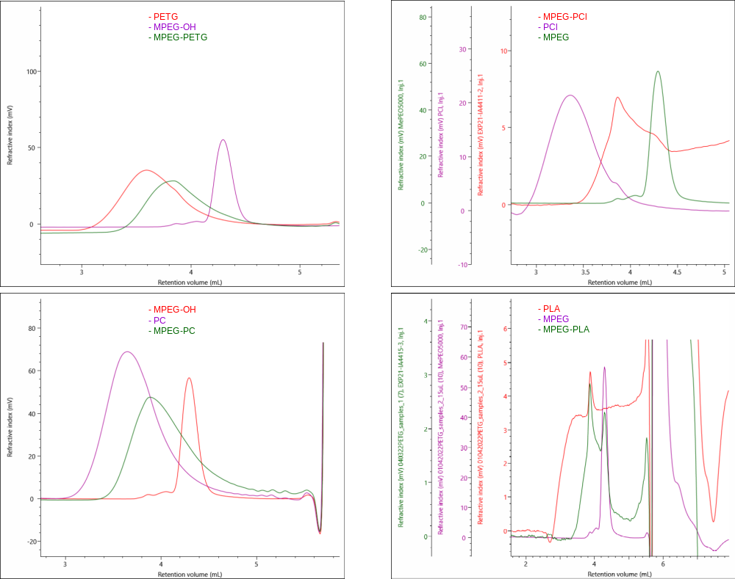
Figure S 1: Size exclusion chromatography of starting polymers: PETG, PCL, PC, PLA, MPEG and of dissolved particles
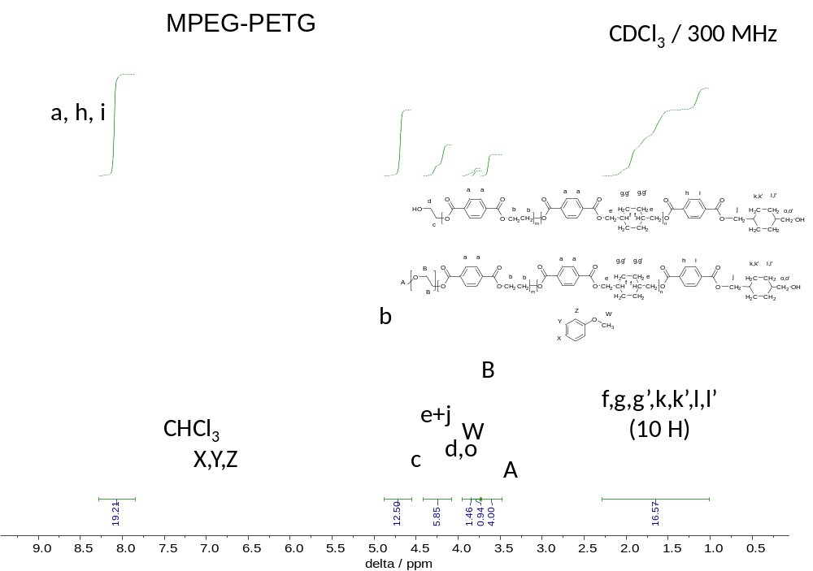
Figure S 2: Assigned ¹H NMR of MPEG-PETG particles dissolved in deuterated chloroform
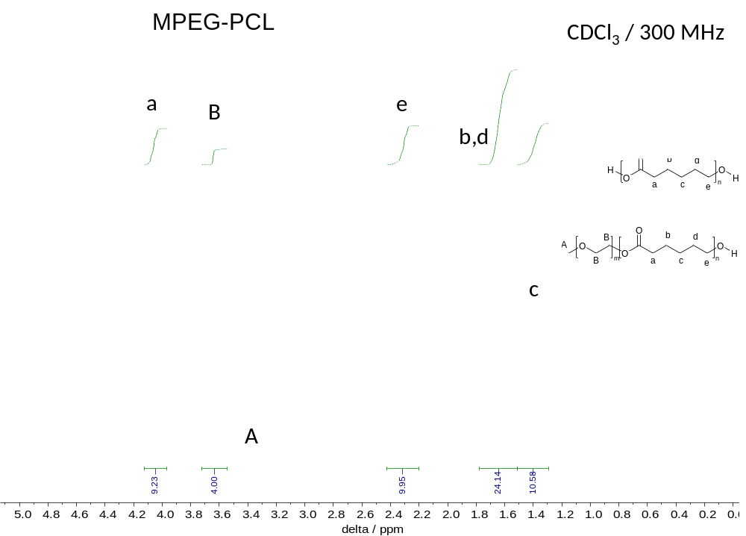
Figure S 3: Assigned ¹H NMR of MPEG-PCL particles dissolved in deuterated chloroform
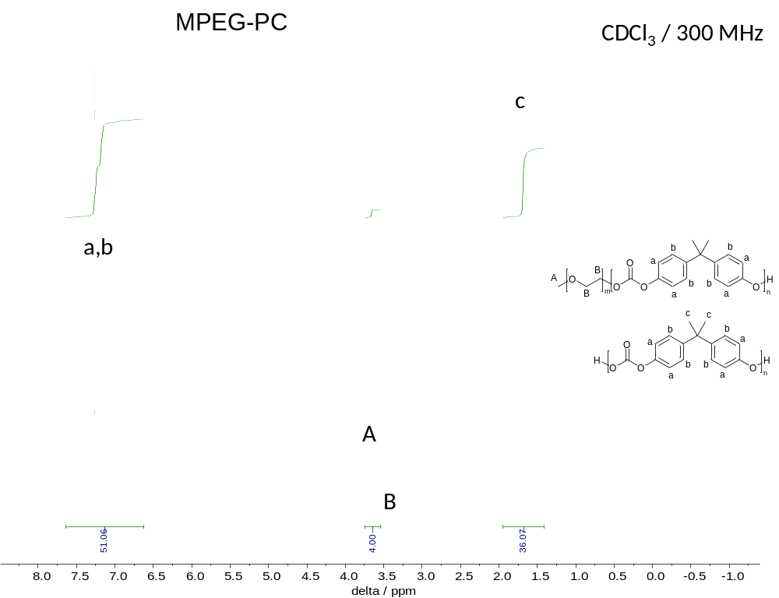
Figure S 4: Assigned ¹H NMR of MPEG-PC particles dissolved in deuterated chloroform
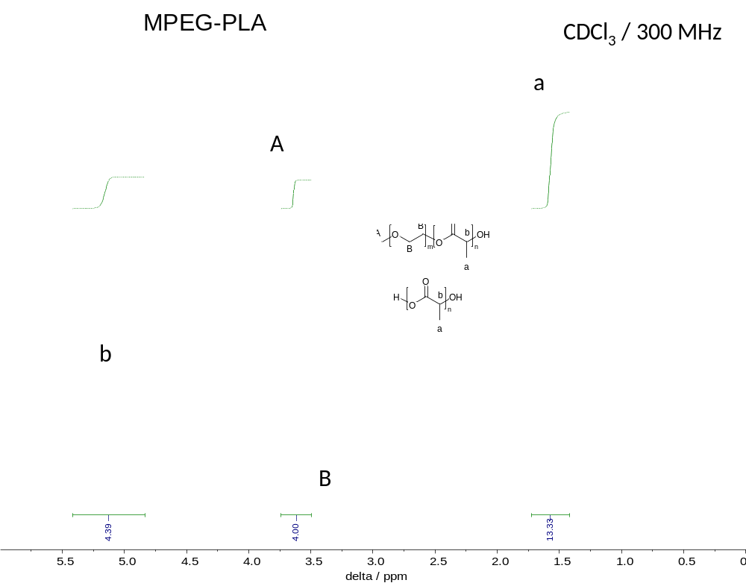
Figure S 5: Assigned ¹H NMR of MPEG-PLA particles dissolved in deuterated chloroform
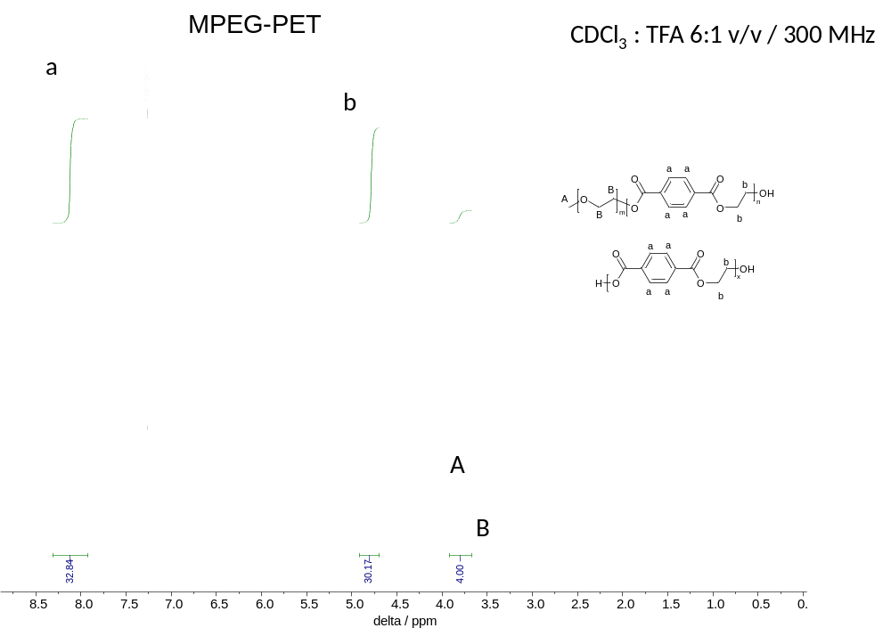
Figure S 6: Assigned ¹H NMR of MPEG-PET particles dissolved in a 6:1 v/v mixture of deuterated chloroform and trifluoroacetic acid
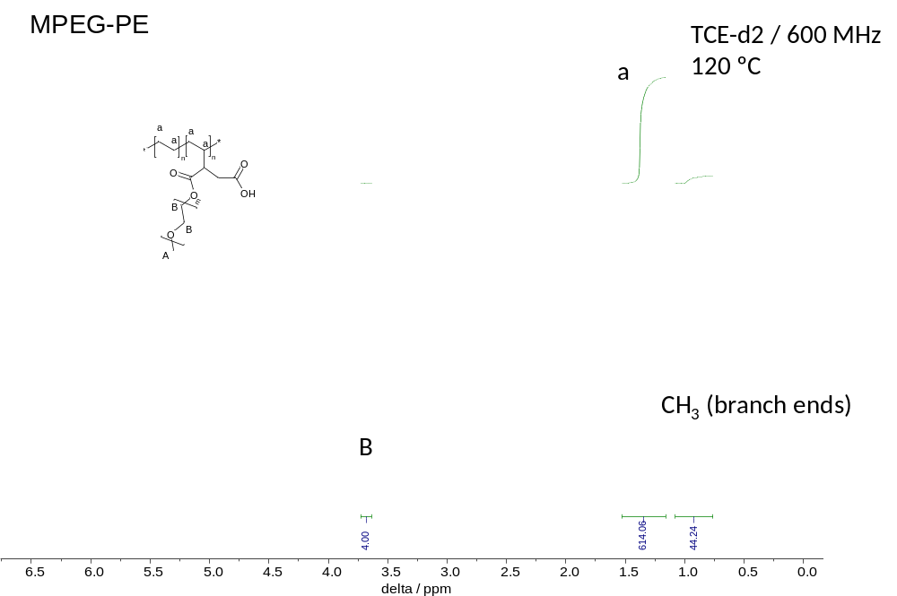
Figure S 7: Assigned ¹H NMR of MPEG-PE particles dissolved in deuterated 1,1,2,2-tetrachloroethane at 120 ºC
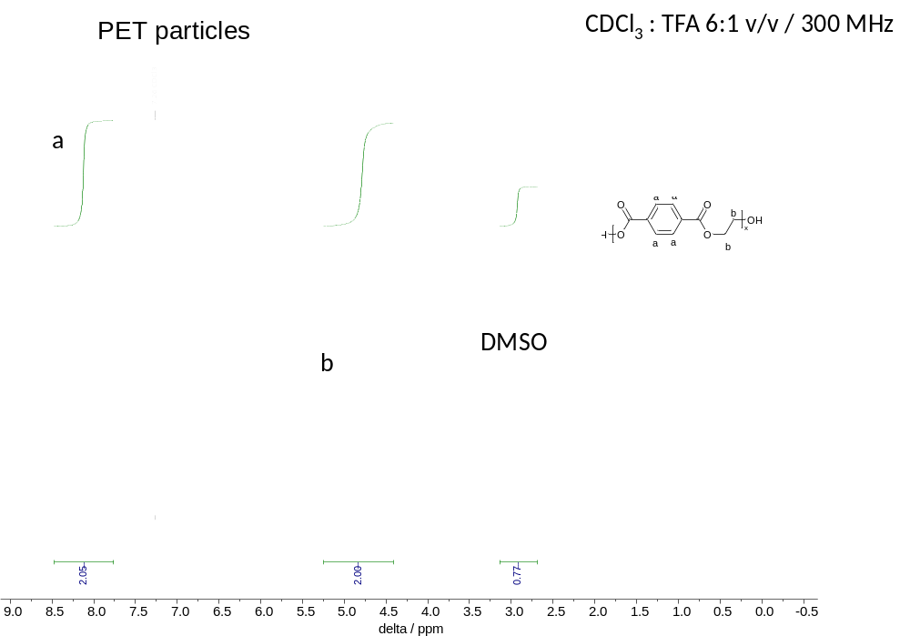
Figure S 8: Assigned ¹H NMR of PET particles dissolved in a 6:1 v/v mixture of deuterated chloroform and trifluoroacetic acid
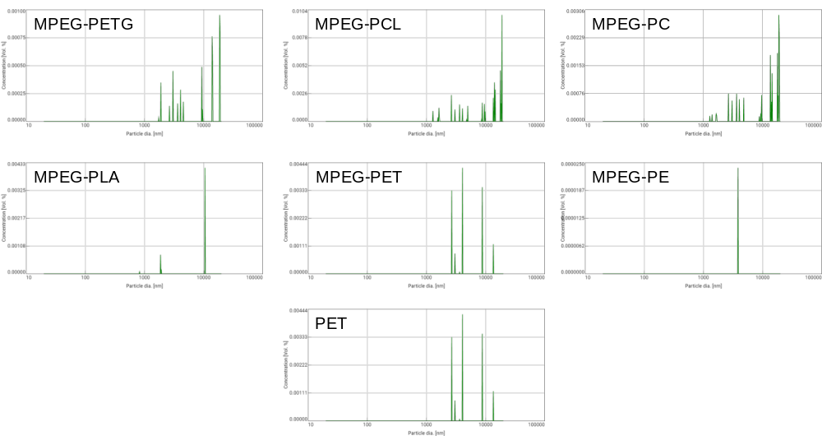
Figure S 9: Particle size distributions by volume acquired using a NanocuvetteTM S cuvette

