Supplemental Method
Middle Cerebral Artery Occlusion and Reperfusion (MCAO/R) Surgery
MCAO was induced according to previously established methodology ^{1, 2}. Briefly, rats were in a air/oxygen mixture (70/30) mixture and maintained with 1.5% isoflurane through a facemask during the surgery period. Rectal temperatures were maintained at 37 ± 0.5 °C with a heating pad. The transient MCAO was induced by inserting a silicone-coated monofilament nylon surgical suture (2636-A5, Beijing Xi Nong Technology Co Ltd., China) into the internal carotid until a slight resistance was felt. The success of occlusion was characterized as the cerebral blood flow (CBF) was less than 10% of baseline, which was monitored using a laser Doppler flowmetey. 90 min after MCAO introduction, animals were reanesthetized followed by the removal of the filament to restoring blood flow. The animals were kept in recovery cages with free access to food and water and were killed after 24 or 72 h. Animals in the sham group underwent the same procedure without suture insertion. All of the animals were euthanized with an isoflurane overdose.

Intracerebral Ventricular Injections
Intracerebral ventricular Injections was performed as reported previously ³. Briefly, rats were anesthetized with 1.5% isoflurane and placed in a stereotaxic apparatus. A small burr hole was drilled in the skull with the coordinates of 0.5 mm posteriorly and 1.6 mm laterally relative to the bregma. A total volume of 10 μl rGAS6 or PBS at a rate of 0.5 μL/min was delivered into the contralateral ventricle using a 10 μl microliter syringe which was fixed onto the microinjection pump and inserted 4.8 mm below the bregma (Hamilton, Reno, NV, USA). Then the needle was slowly removed 15 min after injection to avert leakage. The burr hole was filled with bone wax and the incision was gently sutured. Sham-operated rats underwent the same surgical procedures without injection. All the injection was performed at the start of reperfusion.

Behavioral Tests
Neurobehavioral functions were assessed by the modified Garcia neurological score as previously described ⁴. Briefly, six items were included in modified Garcia score: spontaneous activity; reaction to touch on both sides of trunk; spontaneous movement of all limbs; movement of forelimbs; response to vibrissae touch; and climbing. The tests can be graded from either 0–3 or 1–3 and the total score ranged from 3 (most severe deficit) to 18 (maximum).

Infarct Measurement
Rats were anesthetized and sacrificed. The brain tissue was immediately removed and placed on a tissue slicer and frozen in -80℃, and the cerebellum were removed and discarded. The remaining brain was cut into 2-mm coronal slices beginning from the rostral end. To visualize the region of infarction, sections were immersed in 1.5% 2,3,5-triphenyltetrazolium chloride stained for 20 min at 37°C. After staining, the sections were transferred to 4% paraformaldehyde (PFA) overnight. The infarct area in each section was calculated using the Image J software. To eliminate the disturbance of cerebral edema, infarct size was calculated as infarction volume /contralateral volume ⁵.

Spectrophotometric Assay of Hemoglobin
We used hemoglobin content in the hemorrhagic brains to quantify hematoma volume ⁶. Briefly, rats were anesthetized and perfused through the heart to completely remove intravascular blood. The brain was rapidly removed and separated into the ipsilateral and contralateral hemispheres. Each part was minced and homogenized in 300 μl PBS. To generate a standard curve, whole blood was obtained by cardiac puncture of anaesthetized intact rats. Incremental volumes of homologous blood (0, 1, 2, 4, 8, and 16 μL) were then added to 300 μl lysate from a normal brain sample. After centrifugation at 13,000 g for 30 min at 4°C, Drabkin reagent (80 μl; Sigma) was added to 20 μl of supernatant aliquots and incubated for 15 min at room temperature. The optical density was measured at 540nm with a spectrophotometer (Spectronix 3000, Milton-Roy, Rochester, NY) and compared with the standard curve to obtain the hemorrhage volume (μL).

Brain Water Content
Briefly, rats were anesthetized and decapitated under deep anesthesia. The brains were immediately removed without transcardiac perfusion, and the surface water on the cerebral tissues was blotted with filter paper. The brains were then dissected into three parts: the cerebellum and left and right hemispheres and weighed on an electronic balance to obtain the wet weight and then dried at 100°C for 24 h to obtain the dry weight. Brain water content was calculated as: brain water content (%) = (wet weight − dry weight)/wet weight × 100% ⁷.

BBB Permeability
We studied Evans Blue (EB) extravasation to the brain tissue as reported with minor modifcations ⁸. Briefly, 2ml/kg of EB dye (4%) (Solarbio, Japan) was injected via the tail vein. After 2 h, the anesthetized rats were transcardially perfused with PBS to remove the intravascular EB dye. The brain tissue was removed and the ipsilateral and contralateral hemispheres were separated. Each tissue was then weighed and incubated in a solution of 50% trichloroacetic acid (2mL/g of tissue), homogenized, and centrifuged 12,000×g for 20 min at 4 °C. The supernatant was measured at 610 nm for absorbance using a spectrophotometer. The concentration of EB was calculated as μg/g of brain tissue using a linear standard curve generated with known concentrations of the dye.

Hematoxylin and Eosin (H&E) Staining
Rats were anesthetized and perfused intracardially with 4% PFA. Brains were removed and fixed in 4% PFA for 24 h and then embedded in paraffin for sectioning into 4-μm-thick sections. The sections were placed onto glass slides and stained with hematoxylin and eosin. The slides were assessed in a blinded manner under a light microscopy.

Protein Extraction and Western Blot
Cells or brain tissues were harvested and lysed in cold RIPA lysis buffer containing protease inhibitors and phosphatase inhibitors for 20 min on ice. After centrifugation at 12,000g for 20 min at 4°C, the protein concentration was measured using the Bicinchoninic acid (BCA) assay (Thermo Fisher Scientific, USA). Equal amounts of total protein were separated by 4–12% SDS-PAGE and transferred onto 0.45-μm PVDF membranes (Millipore, CA, USA). After the membranes were blocked with 5% fat-free dry milk in TBST for 1 h, they were incubated with anti-GAS6 (1:1,000), anti-p-Axl (1:1,000), anti-Axl (1:1,000), anti-SOCS1 (1:1,000), anti-SOCS3 (1:1,000), anti-claudin-5 (1:1,000), anti-occludin (1:2,000), anti-ZO-1(1:1,500) and anti-β-actin (1:2,000) at 4°C overnight. Membranes were washed with TBST for three times and incubated with the HRP-conjugated secondary antibodies for 1h. Protein bands were visualized by ECL reagents (Amersham Pharmacia Biotech) and detected with a FUSION SOLO 6S Chemiluminescence imaging system (VILBER Bio Imaging SAS, France). The intensity of the protein signal was quantified with ImageJ software and normalized to β-actin level in all samples ⁹.

RT-qPCR
Total RNA was separated from BV-2 cells and the ipsilateral cortex of rats using TRIzol reagent according to the manufacturer. Then RNA was reverse transcribed into cDNA. Afterward, RT-qPCR reactions were run in a volume of 20 μl in an ABI QuantStudio 3 Real-Time PCR System (Thermo Fisher Scientific, USA). The PCR reaction was performed as follows: (1) 10 min at 95 °C, (2) 10 s at 95 °C and 30 s at 60 °C for 40 cycles and (3) melt curve analysis. The threshold cycle (CT) readings were collected, and the relative gene expression was calculated with the 2−ΔΔCT method and was normalized to GAPDH level in all samples ¹⁰. The expression levels of the mRNA were expressed as fold changes versus the first group. The qPCR primer sequences were represented in Supplementary Table 1.

Immunofluorescence Staining
Immunofluorescence analysis was performed as previously described ¹¹. Briefly, rats were anesthetized and transcardially perfused with PBS. A 4-mm-thick brain section was sectioned and fixed in 4% PFA for 1 h and dehydrated in 10%, 20%, 30% sucrose for 3 days. Then it was embedded in OCT and frozen in -80℃. Frozen brain tissue sections (10 um thick) were permeabilized and blocked in 0.3% Triton X-100 and 10% goat serum for 1 h. Then the brain slides were incubated at 4°C overnight with the following primary antibodies made in 10% goat serum: anti-NeuN (1:100), anti-Iba-1 (1:100), anti-GFAP (1:300), anti-Axl (1:200), anti-claudin-5 (1:200), anti-CD31 (1:100), anti-CD16 (1:100) or anti-CD206 (1:100). Then, the sections were washed with PBS for four times and incubated with the corresponding secondary antibodies in 1% BSA for 1 h in the dark. After that, the sections were washed with PBS for four times and covered with DAPI (1:5000, Sigma) for 10 min at room temperature. Images were taken on a laser scanning confocal microscope (Olympus, Tokyo, Japan) and analyzed using ImageJ software. At least 3 different areas per section and 3 different sections per rat were measured.

Enzyme-linked immunosorbent assay (ELISA)
To measure cytokine concentrations in the brain of rats, rats were anesthetized and transcardially perfused with PBS, and the ipsilateral brain tissues were obtained. The levels of inflammatory cytokines (interleukin (IL)-1β, IL-6, IL-10 and tumor necrotic factor (TNF)-α) were detected using commercially available kits according to the manufacturer’s protocol. To quantify the secreted levels of inflammatory cytokines in cells, cell supernatants were harvested and centrifuged at 12,000 rpm for 15 min at 4°C. The supernatants were used for cytokine quantification with ELISA kits according to the manufacturer's instructions.

Cell Culture and Experimental OGD/R
Mouse BV-2 microglia cells and brain Bend.3 endothelial cells purchased from FuHeng Cell Center (ShangHai, China) were cultured in DMEM supplemented with 1% penicillin/streptomycin, 10% fetal bovine serum (FBS) at 37°C with 5% CO₂. The OGD/R model was established as reported previously ¹². The medium of cells was replaced with D-glucose-free DMEM, and incubated at 37 °C in a hypoxic chamber filled with 5% CO₂/95% N₂ for 6 h, then cells were treated with their original culture condition for an additional 12 h. The supernatant were changed 2 h after reoxygenation.

Cell Viability Assay
Cell viability was measured by CCK8 assays. Cells were plated in 96-well plates. 12 h after reoxygenation, the conditioned medium were refreshed, and 10 µl CCK-8 (Solarbio, Japan) was added to the culture medium, and the viability of the cells was measured 2 h later at 450 nm using a spectrophotometer according to the manufacturer’s instructions.

SiRNA Preparation and Transfection
According to the manufacturer’s instructions, BV-2 cells were plated into 6-well plates and grown to 40% confluency before transfection with siRNA. Cells were transfected with siRNA against Axl, SOCS1, and SOCS3 or nc siRNA using hiperfect transfection reagent (Qiagen, Germany) at 12 h before OGD, and the silencing efficiency was confirmed by western blot and RT-qPCR 12 h after reoxygenation. The sequences used for Axl knockdown were sense 5’- CUUAUGGAUAUAGGGCUAATT-3’ and antisense 5’-UUAGCCCUAUAUCCAUAAGTT-3’; the sequences used for SOCS1 knockdown was sense 5’-GUGACUACCUGAGUUCCUUTT -3’ and antisense 5’-AAGGAACUCAGGUAGUCACTT-3’; the sequences used for SOCS3 knockdown was sense 5’- GCUUCGACUGUGUACUCAATT -3’ and antisense 5’-UUGAGUACACAGUCGAAGCTT -3’.

Determination of BV2 Cell Phenotype by Flow Cytometry
CD16 and iNOS are main characteristic makers of M1 phenotype of microglia, while CD206 and Arg-1 are characteristic makers of M2 phenotype of microglia. To determine the cell quantity of different phenotypes, resuspended BV2 cells in FACS buffer were firstly incubated with anti-murine CD16/CD32 FC-Receptor for 15 min in 4°C. Then, cells were stained for surface markers, iNOS, Arg-1 and CD86 in FACS buffer for 30 min in 4°C in the dark. Next, cells were fixed and permeabilized using the cytofix/cytoperm fixation/permeabilization kit for 30 min in 4°C in the dark. After washed and resuspended, cells were incubated with CD206 antibody in FACS buffer for 30 min in 4° in the dark to perform intracellular staining. BD Compbeads (BD Biosciences) were used to optimize fluorescence compensation settings to enable multicolor flow cytometric analyses. The cells were washed and resuspended in FACS buffer and the positive rates of microglia were detected by flow cytometer (Becton, Dickinson and Company, New Jersey, U.S). Each experiment was performed in triplicate to assess consistency of results. In all experiments gates were set based on fluorescence-minus-one (FMO) controls.

FACS Analysis of Apoptotic Cell Death
Annexin V +/propidium iodide (PI) staining was performed to detect apoptotic cell death as previously described (Kang, Tiziani, Park, Kaul, & Paternostro, 2014). Cells were harvested, washed with PBS, and re-suspended in 100 μL 2% BSA. Cells were then stained with annexin VAPC and PI for 15 min at room temperature in the dark and immediately analyzed by FACS analysis. The annexin V+ /PI− cells were considered as early apoptotic cells whereas the annexin V+ /PI+ cells were considered as late apoptotic cells.

Supplemental Table 1 Experimental design

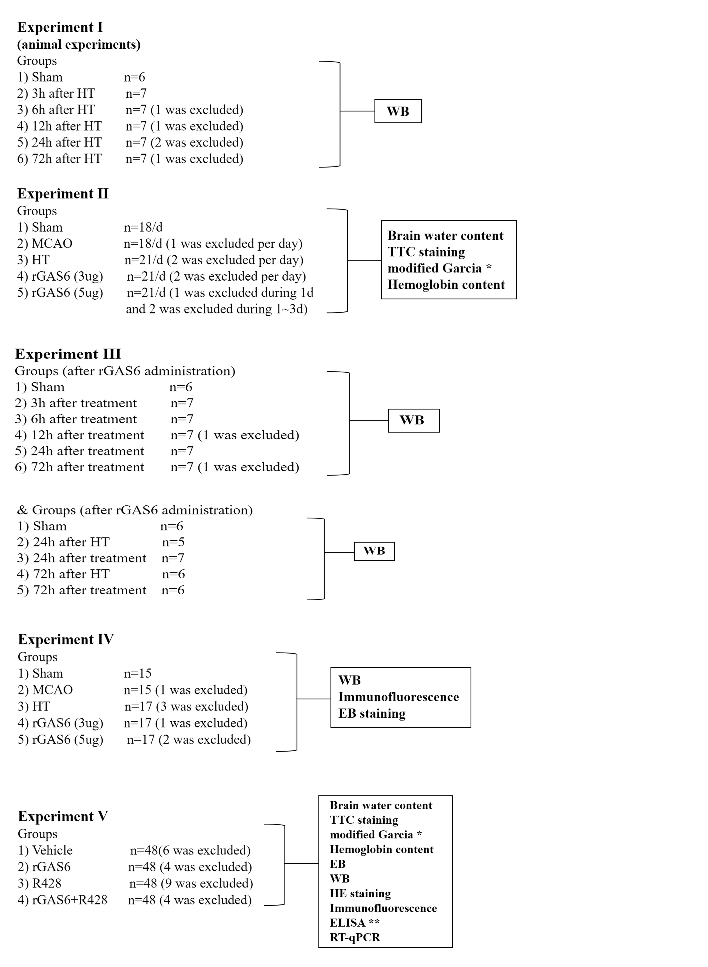
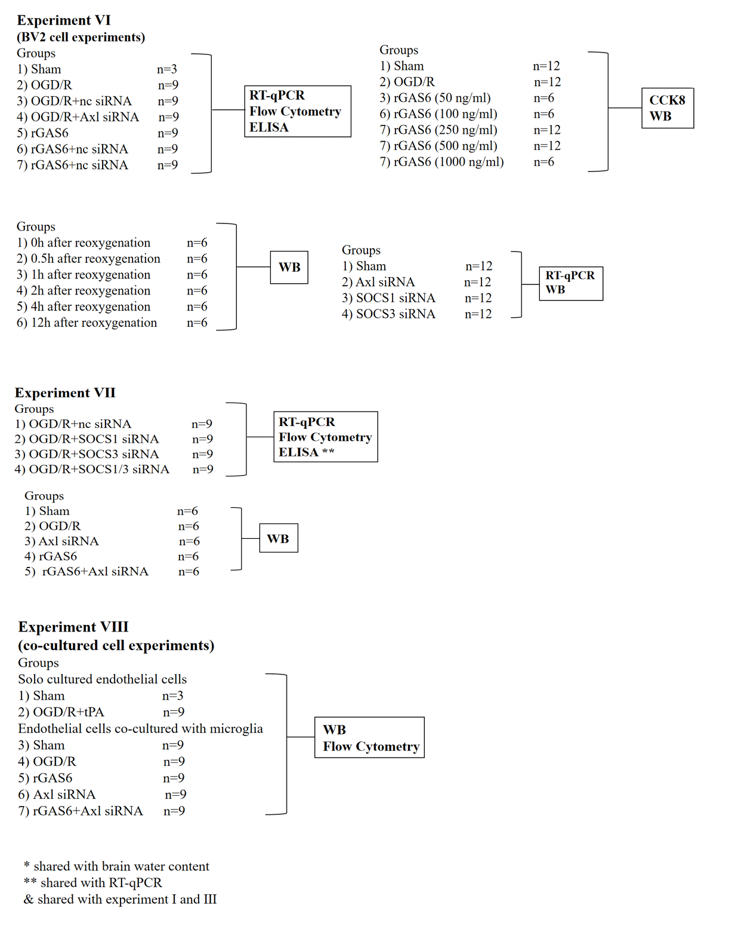

Supplemental Table 2 The qPCR primer sequences
Animal
Gene | Forward primer sequence  (5′–3′) | Reverse primer sequence  (5′–3′)
iNOS | TCCTCAGGCTTGGGTCTTGT | ATCCTGTGTTGTTGGGCTGG
CD206 | TCAACTCTTGGACTCACGGC | CATGATCTGCGACTCCGACA
Arg1 | CCAGTATTCACCCCGGCTAC | GTCCTGAAAGTAGCCCTGTCT
GAPDH | AGTGCCAGCCTCGTCTCATA | GGTAACCAGGCGTCCGATAC
CD16 | AACGGCACTGCTACTTACGG | CGAGATGAGGCTTTTGTTATGG
CD32 | GTTGCCGGTATTGACGATTG | GAGCTTCAGGATGCTTGAGA
Ym-1 | CCAGTATTCACCCCGGCTAC | GTCCTGAAAGTAGCCCTGTCT

Cell
Gene | Forward primer sequence  (5′–3′) | Reverse primer sequence  (5′–3′)
Axl | ATG CCA GTC AAG TGG ATT GCT | CAC ACA TCG CTC TTG CTG GT
SOCS1 | TGGTTGTAGCAGCTTGTGTC | CCCCTGGTTTGTGCAAAGATAC
SOCS-3 | AAGGCCGGAGATTTCGCTTC | GGAAACTTGCTGTGGGTGAC
TGFβ1 | CTCCCGTGGCTTCTAGTGC | GCCTTAGTTTGGACAGGATCTG
CD16 | TTTGGACACCCAGATGTTTCAG | GTCTTCCTTGAGCACCTGGATC
CD32 | AATCCTGCCGTTCCTACTGATC | GTGTCACCGTGTCTTCCTTGAG
CD206 | CCGTCTGTGCATTTCCATTC | TGCCAGTCAGTGGATCTTTGT
Arg-1 | TCACCTGAGCTTTGATGTCG | TTCCCAAGAGTTGGGTTCAC
iNOS | GCAGAATGTGACCATCATGG | ACAACCTTGGTGTTGAAGGC
GAPDH | GCCAAGGCTGTGGGCAAGGT | TCTCCAGGCGGCACGCAGA

1. Clark WM, Lessov NS, Dixon MP, Eckenstein F. Monofilament intraluminal middle cerebral artery occlusion in the mouse. Neurological research. 1997;19:641-648
2. Soejima Y, Ostrowski RP, Manaenko A, Fujii M, Tang J, Zhang JH. Hyperbaric oxygen preconditioning attenuates hyperglycemia enhanced hemorrhagic transformation after transient mcao in rats. Medical gas research. 2012;2:9
3. Zheng J, Sun Z, Liang F, Xu W, Lu J, Shi L, et al. Adiporon attenuates neuroinflammation after intracerebral hemorrhage through adipor1-ampk pathway. Neuroscience. 2019;412:116-130
4. Garcia JH, Wagner S, Liu KF, Hu XJ. Neurological deficit and extent of neuronal necrosis attributable to middle cerebral artery occlusion in rats. Statistical validation. Stroke. 1995;26:627-634; discussion 635
5. Swanson RA, Sharp FR. Infarct measurement methodology. Journal of cerebral blood flow and metabolism : official journal of the International Society of Cerebral Blood Flow and Metabolism. 1994;14:697-698
6. Choudhri TF, Hoh BL, Solomon RA, Connolly ES, Jr., Pinsky DJ. Use of a spectrophotometric hemoglobin assay to objectively quantify intracerebral hemorrhage in mice. Stroke. 1997;28:2296-2302
7. Krafft PR, Caner B, Klebe D, Rolland WB, Tang J, Zhang JH. Pha-543613 preserves blood-brain barrier integrity after intracerebral hemorrhage in mice. Stroke. 2013;44:1743-1747
8. Belayev L, Ginsberg MD, Alonso OF, Singer JT, Zhao W, Busto R. Bilateral ischemic tolerance of rat hippocampus induced by prior unilateral transient focal ischemia: Relationship to c-fos mrna expression. Neuroreport. 1996;8:55-59
9. Zhang Y, Chen Y, Wu J, Manaenko A, Yang P, Tang J, et al. Activation of dopamine d2 receptor suppresses neuroinflammation through αb-crystalline by inhibition of nf-κb nuclear translocation in experimental ich mice model. Stroke. 2015;46:2637-2646
10. Livak KJ, Schmittgen TD. Analysis of relative gene expression data using real-time quantitative pcr and the 2(-delta delta c(t)) method. Methods. 2001;25:402-408
11. Huang L, Sherchan P, Wang Y, Reis C, Applegate RL, 2nd, Tang J, et al. Phosphoinositide 3-kinase gamma contributes to neuroinflammation in a rat model of surgical brain injury. J Neurosci. 2015;35:10390-10401
12. Lu E, Wang Q, Li S, Chen C, Wu W, Xu YXZ, et al. Profilin 1 knockdown prevents ischemic brain damage by promoting m2 microglial polarization associated with the rhoa/rock pathway. J Neurosci Res. 2020;98:1198-1212

