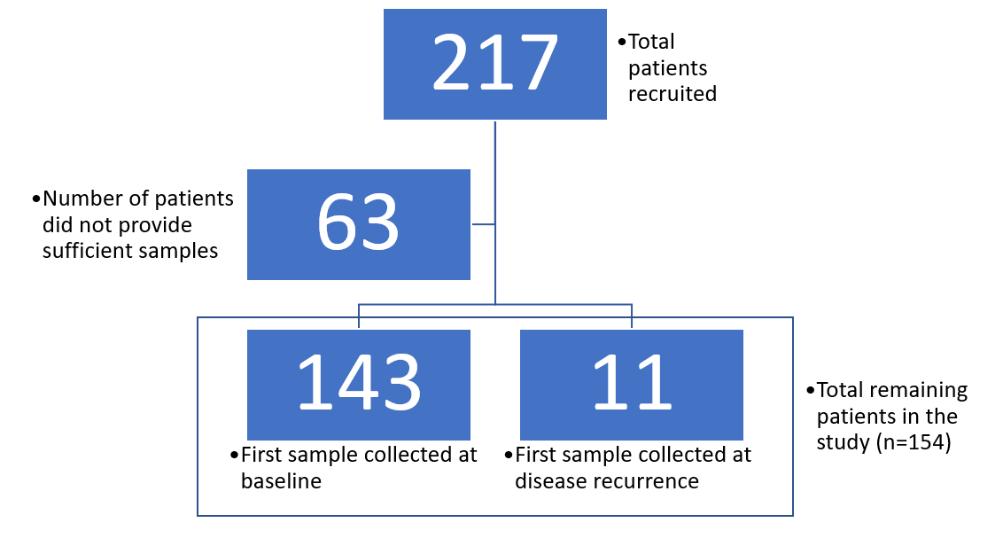
Supplementary Figure 1: Work flow of patient recruitment

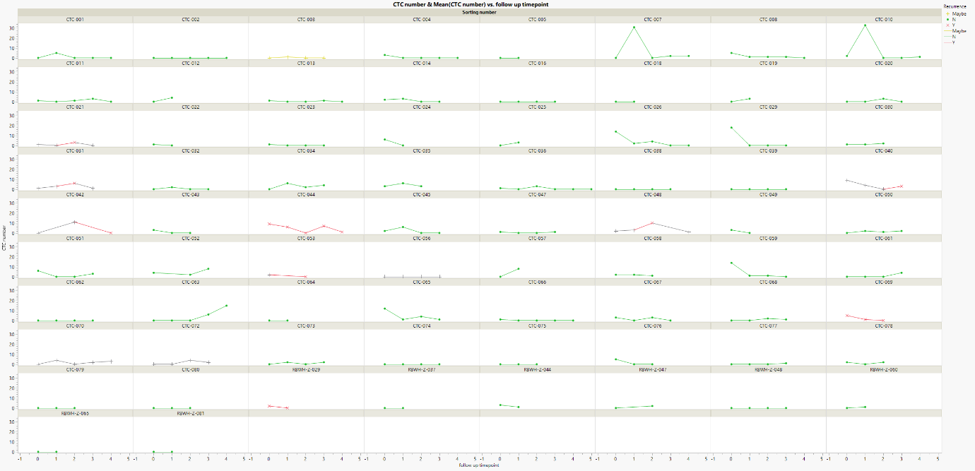
Supplementary Figure 2: Summary of trends of CTC changes in patients reported in this study.

