Supplemental Figure:
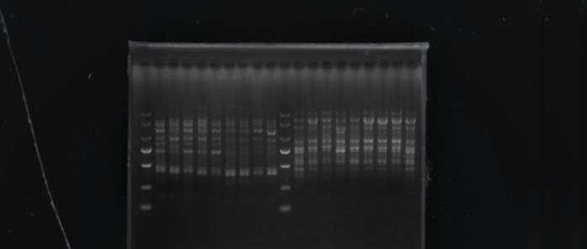
Figure S1 Amplification results of graph primers ISSR 810 and 813

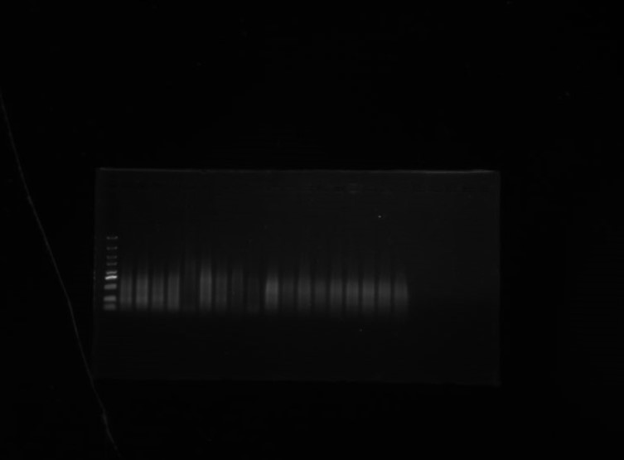
Figure S2 Preamplification fragments of genomic DNA EcoR I/Hpa II and EcoR I/Msp in susceptible and nonsusceptible cherry plants
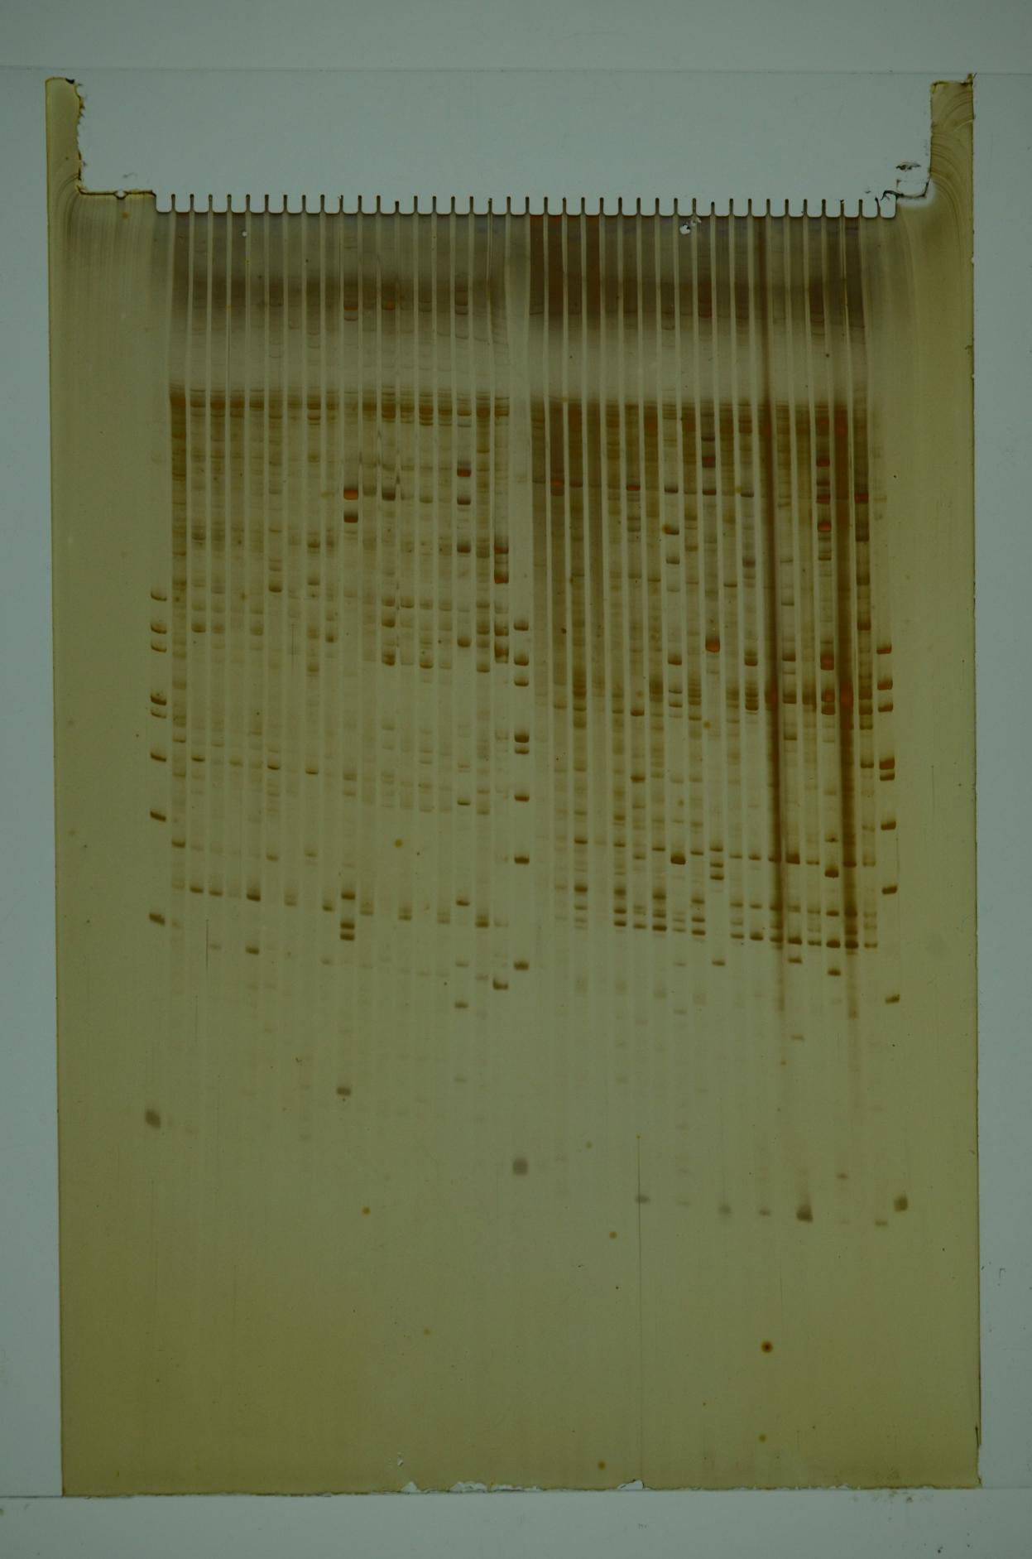
Figure S3 Amplification fragments of genomic DNA EcoR I/Hpa II（E32/H60;E32/H83）and EcoR I/Msp from susceptible and non-susceptible cherry plants by MSAP

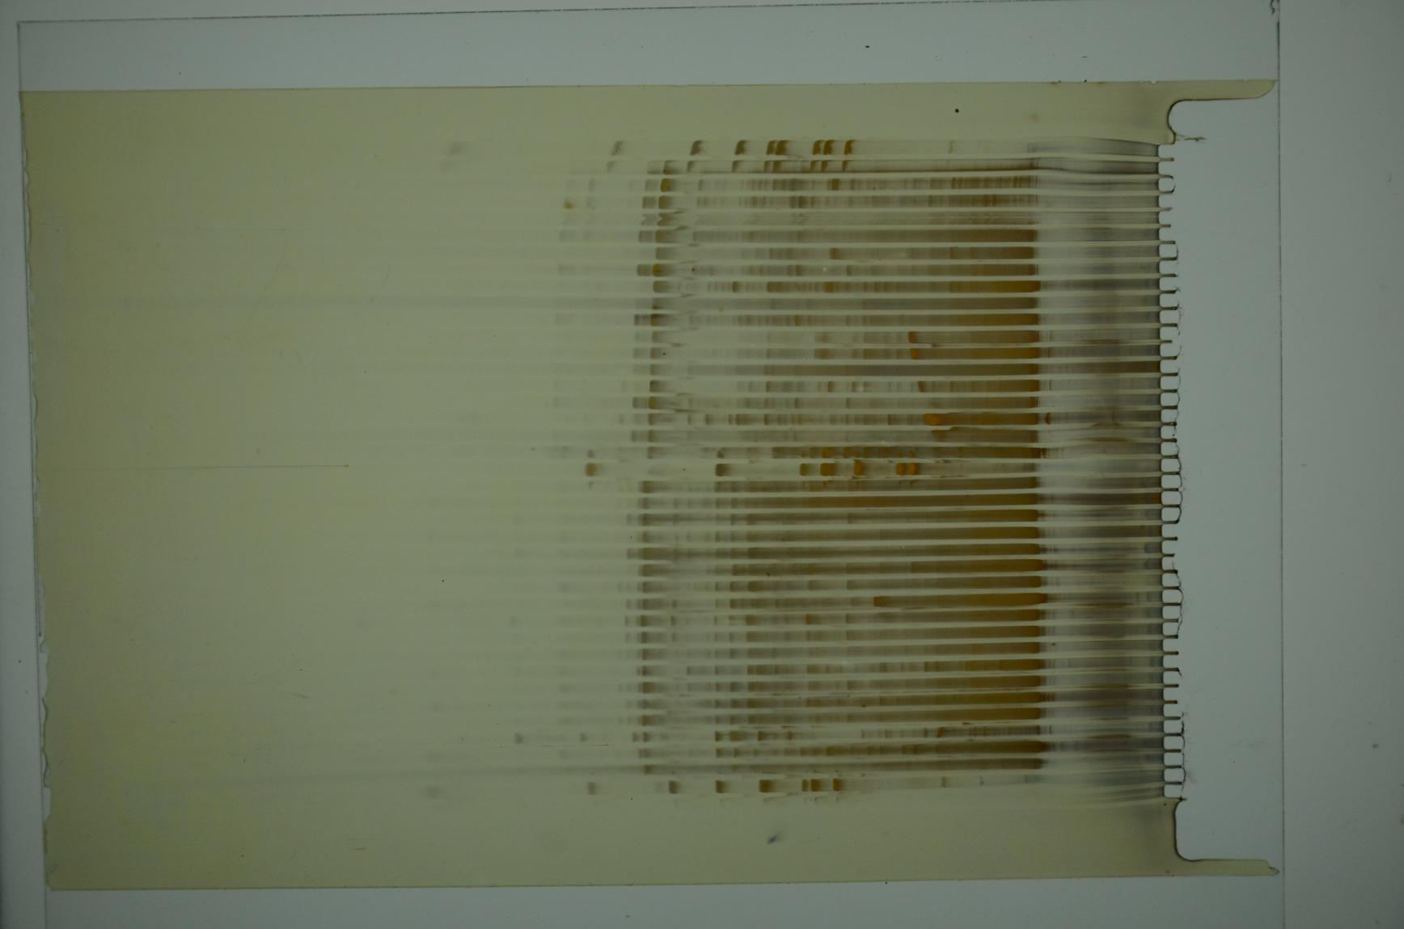
Figure S4 Amplification fragments of genomic DNA EcoR I/Hpa II（E35/H60;E35/H83）and EcoR I/Msp from susceptible and non-susceptible cherry plants by MSAP

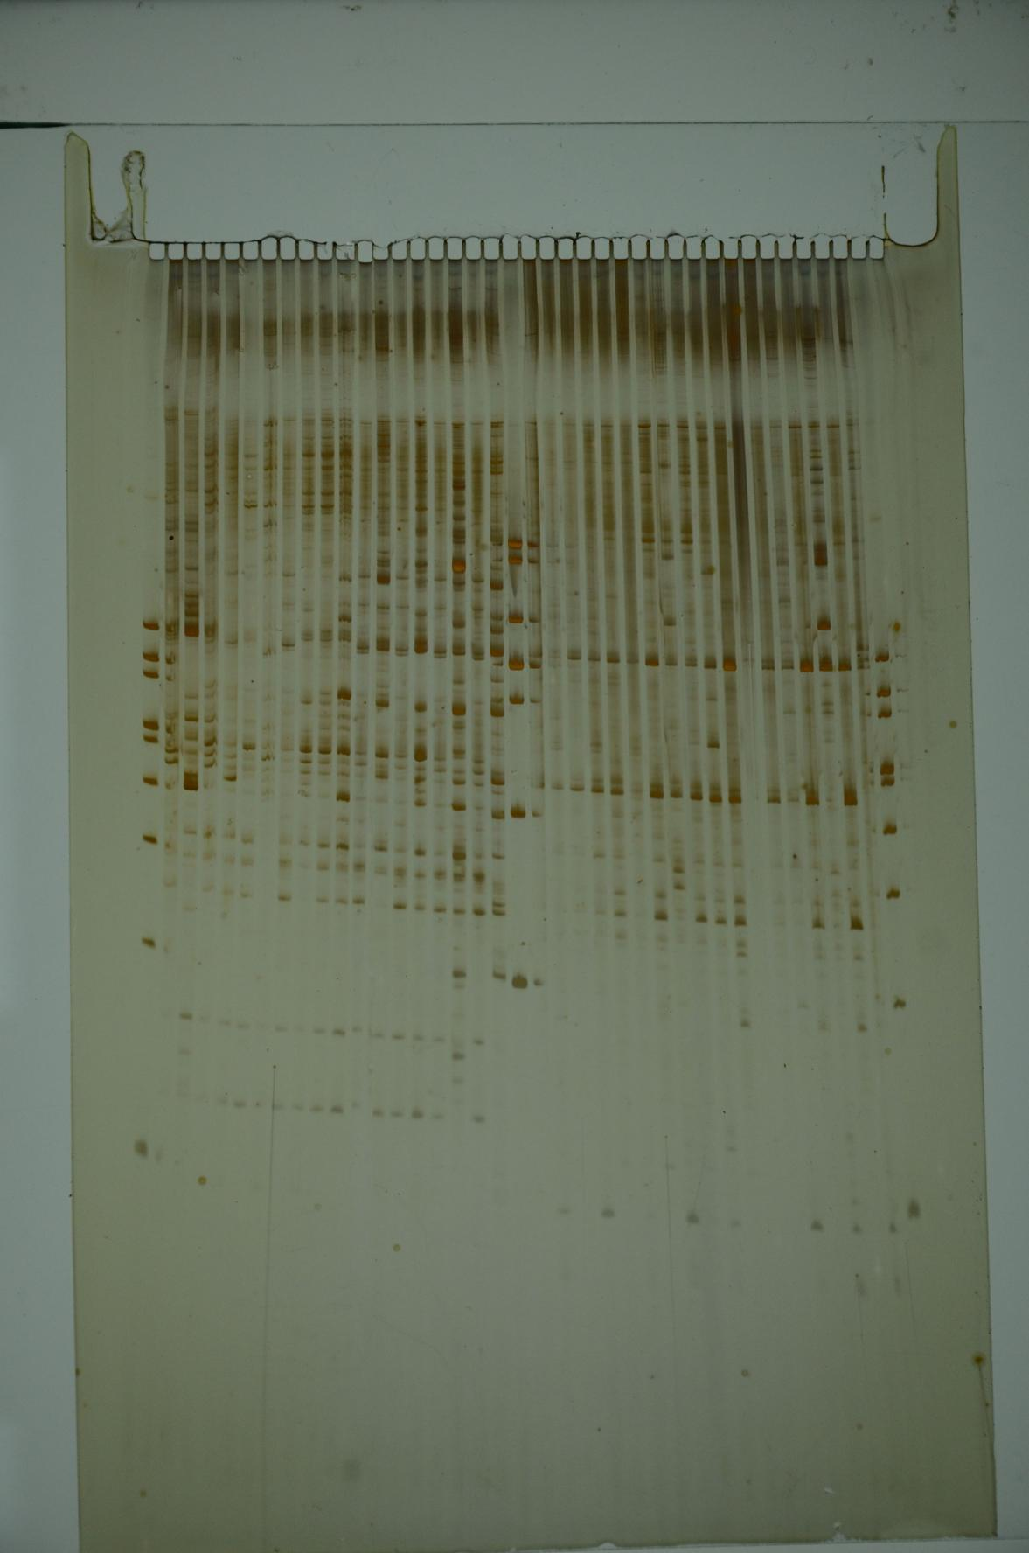
Figure S5 Amplification fragments of genomic DNA EcoR I/Hpa II（E39/H23;E39/H45）and EcoR I/Msp from susceptible and non-susceptible cherry plants by MSAP

