Supplementary Information
Construction of oxygen vacancies on Cu-COF as electron collector for high efficient photocatalytic hydrogen evolution

Contents
1. Supplementary Methods
2. Supplementary Figures
3. Supplementary Tables

1. Supplementary Methods
Materials and characterizations
All of the reagents and solvents were commercially available and used without further purification besides 1,3,5-triformylphloroglucinol (Tp) which was prepared from phloroglucinol. The composition and structure of the materials were investigated by X-ray powder diffraction (XRD) patterns (Smartlab SE), Fourier transform infrared (FT-IR) spectra, transmission electron microscopy (TEM) experiment (JEM-2100 electron microscope), high-angle annular dark-field scanning transmission electron microscopy (HAADF-STEM) (Thermofisher Spectra 300 300Ti) and X-ray photoelectron spectroscopy spectrum (XPS) analyses experiment. The N₂ adsorption–desorption isotherms were determined by BSD instrument 3H-2000PS2 analyzer at 77 K. Before the measurement, the catalysts were degassed at 120 °C for 10 h. Optical properties were studied by diffuse reflectance UV-vis spectroscopy (UV-2600), photoluminescence spectrum (PL) and time-resolved PL (FIS 1000-stm with an excitation wavelength of 420 nm). The Mott-Schottky plot, electrochemical impedance spectra (EIS) and photocurrent-time (I-T) profiles were recorded on the CHI660E electrochemical workstation with a standard three-electrode system with the photocatalyst-coated ITO as the working electrode, Pt plate as the counter electrode and an Ag/AgCl electrode as a reference electrode. A 0.2 M Na₂SO₄ solution was used as the electrolyte. The as-synthesized samples (2 mg) were added into 0.5 mL ethanol and 20 μL Nafion mixed solution, and the working electrodes were prepared by dropping the suspension onto an ITO surface and drying at room temperature.
AQE measurement
The AQE was measured using the monochromatic light (420, 450, 480, 520 and 575 nm, Perfectlight). The number of incident photons reaching the solution was measured using a laser power meter (Model 843-R, Power Meter). The temperature of reaction was kept at 40℃ by cool flowing water. The AQE was calculated using the following equation:
$$AQE=\frac{2MN_{A}hc}{AItλ}×100\%$$
where M is the amount of hydrogen molecules, N_{A} is the Avogadro’s constant, h is the Planck constant, c is the light velocity, I is the intensity of the light, A is the irradiation area, t is the reaction time, and λ is the wavelength of light.
Electrochemical measurements
Photoelectrochemical properties are measured by photoelectrochemical test system (PEC2000, Beijing Perfectlight Technology Co., Ltd.). The working electrode was prepared by loading samples on the ITO glass (5 cm², 10 mg catalysis in 0.5 mL ethanol and 20 μL naphthol). The reference electrode was Ag/AgCl, KCl (3 M). The Pt sheet was used as the counter electrode. EIS was investigated at 0.25 V in 0.5 M Na₂SO₄ electrolyte.
OVs formation calculation method
The first principle calculations are performed by Vienna Ab initio Simulation Package (VASP)¹ with the projector augmented wave (PAW) method². The exchange-functional is treated using the Perdew-Burke-Ernzerhof (PBE)¹ functional, in combination with the DFT-D correction³. The calculations were performed in a spin-polarized manner. The cut-off energy of the plane-wave basis is set at 450 eV. For the optimization of both geometry and lattice size, the Brillouin zone integration is performed with 2*2*10 Monkhorts-Pack⁴ kpoint sampling for TpPa-1, and 1*1*1 for O atom. The self-consistent calculations apply a convergence energy threshold of 10⁻⁵ eV. The equilibrium geometries and lattice constances are optimized with maximum stress on each atom within 0.02 eV/Å.
$$E_{f}^{vac}=\left[E_{rel}^{vac}+E_{c}\right]−E_{rel}$$
$E_{f}^{vac}$: The energy of a vacancy
$E_{c}$: The energy of an individual atom
$E_{rel}$: Protocell energy without oxygen vacancy
Hydrogen evolution free energy calculation
VASP was employed to perform all of the DFT calculations based on the generalized gradient approximation (GGA) and Perdew−Burke−Ernzerhof (PBE) functions. The projector augmented wave (PAW) model was utilized to describe the ionic cores. Taking the valence electrons into account, a plane-wave cutoff was set to be 450 eV. Additionally, the convergence energy threshold for the self-consistent calculations was set to be 10⁻⁵ eV, and the geometry optimization was carried out as the total energy convergent was less than 0.02 eV Å⁻¹. The Monkhorst mesh of 1 × 1 × 1 k-point was chosen to sample the Brillouin zone.

2. Supplementary Figures

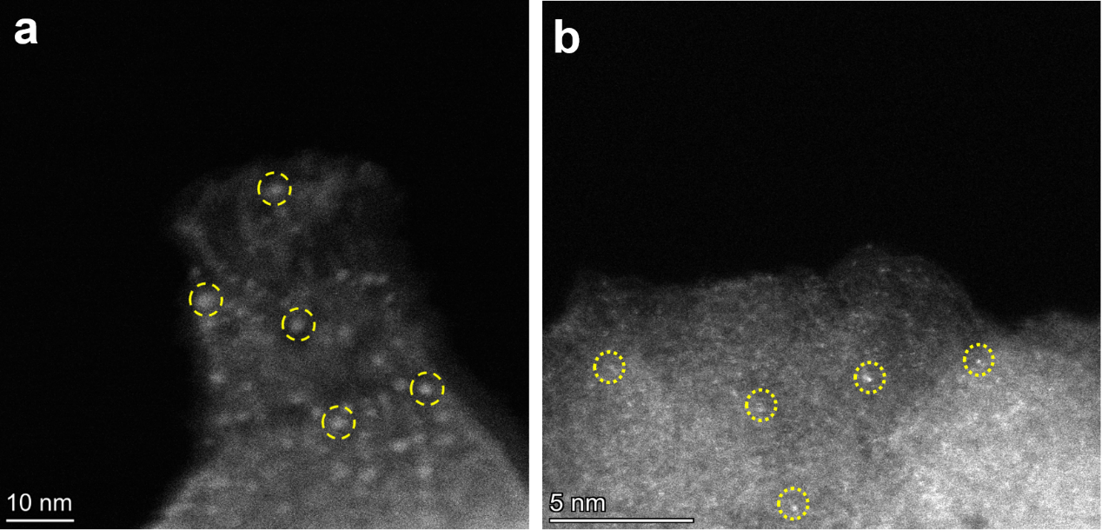
Fig. S1 HAADF-STEM images of a 20%Cu-OV-TpPa, b 10%Cu-OV-TpPa

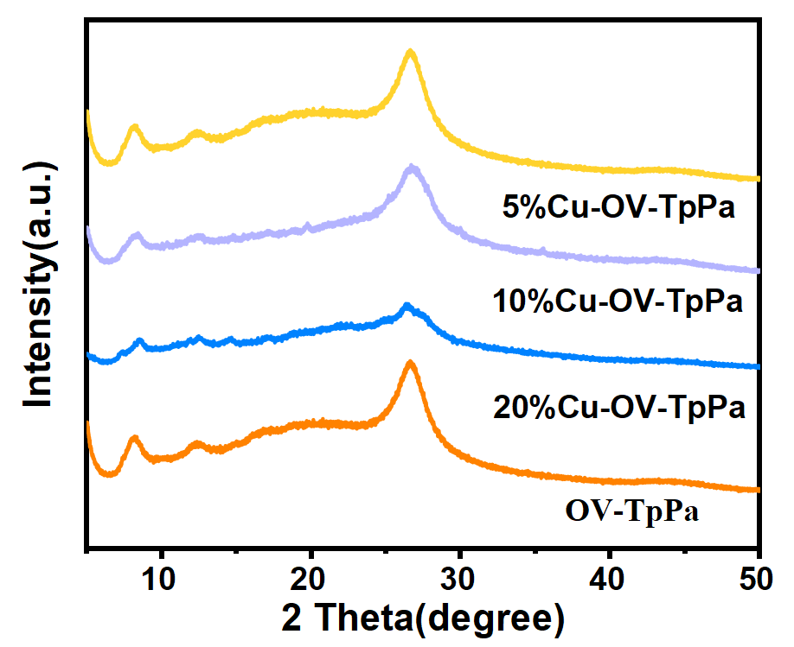
Fig. S2 The PXRD patterns of the samples with different Cu loads

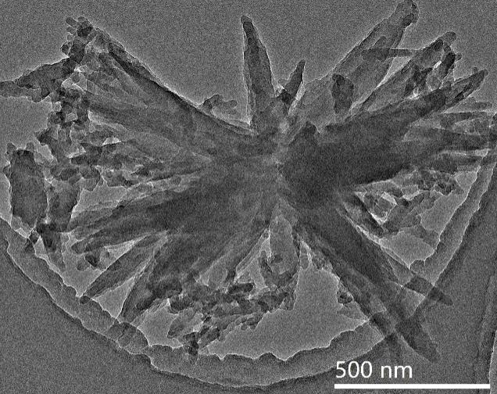
Fig. S3 TEM images of OV-TpPa

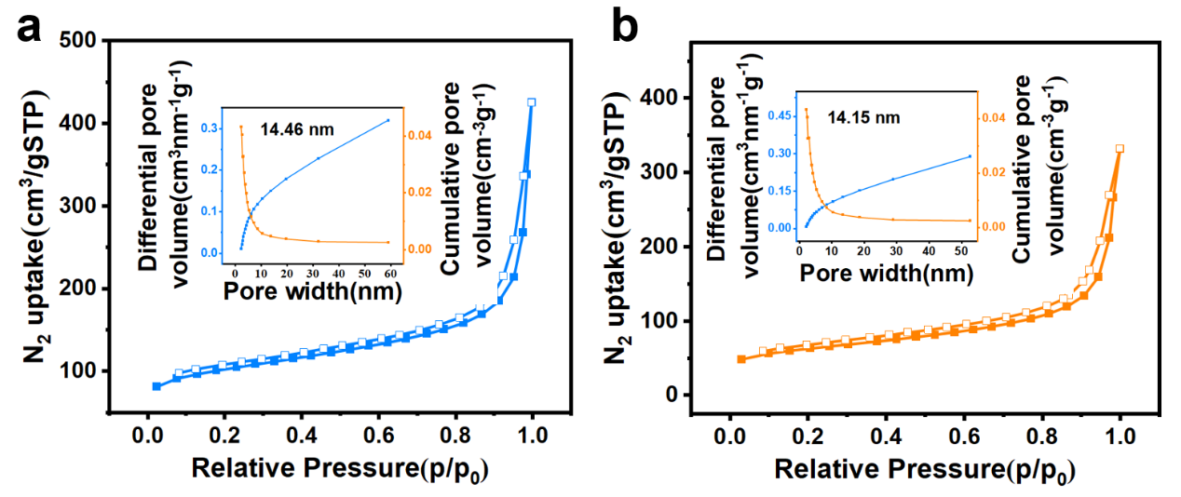
Fig. S4 N₂ sorption isotherms of a 10%Cu-OV-TpPa and b OV-TpPa measured at 77 K (inset: pore size distributions).

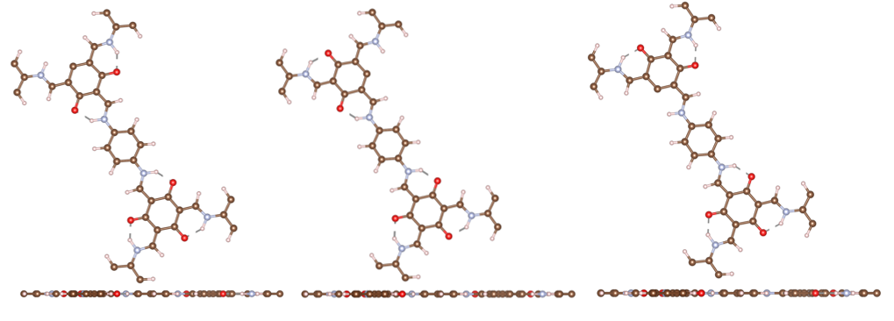
Fig. S5 The structure of three kinds of OVs

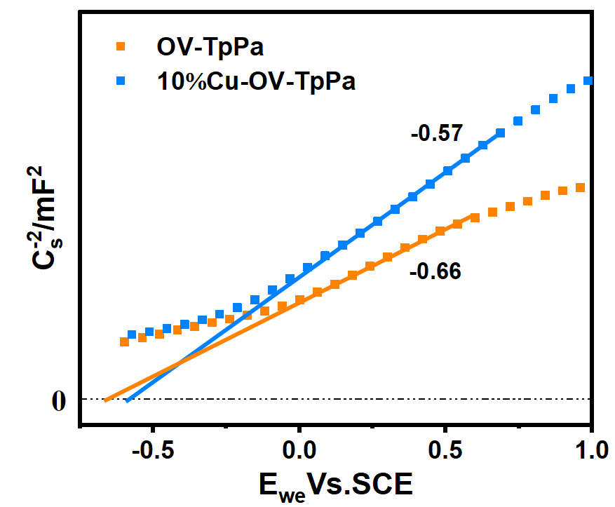
Fig. S6 Mott-Schottky plots for OV-TpPa and 10%Cu-OV-TpPa

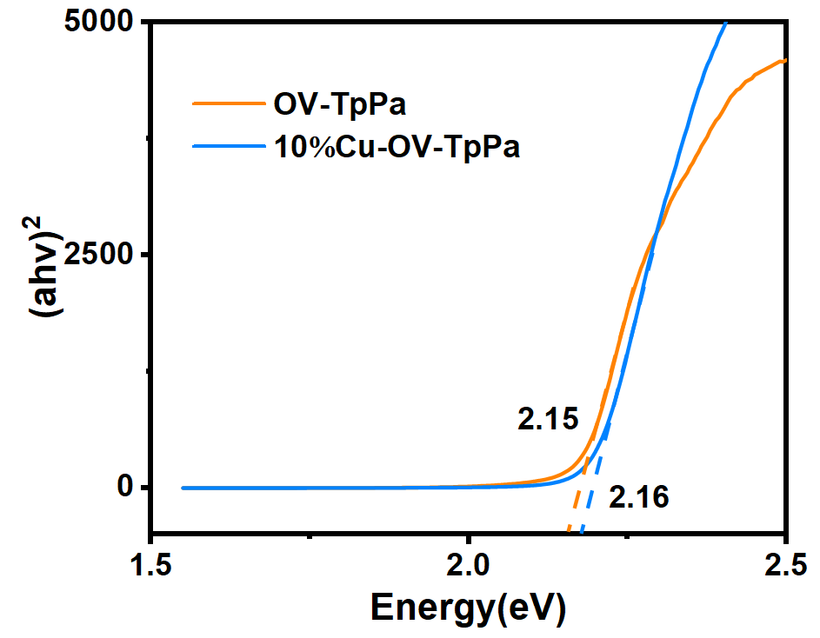
Fig. S7 The band-gap energies of OV-TpPa and 10%Cu-OV-TpPa

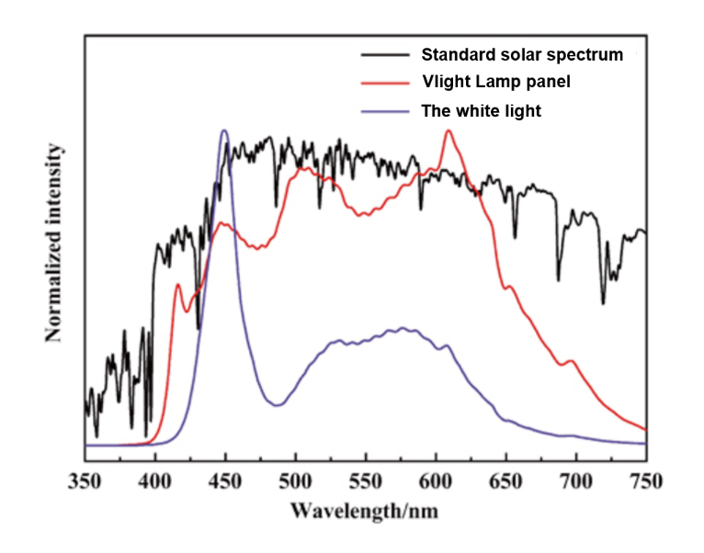
Fig. S8 The experimental spectra (red line)

catalyst | Co-catalyst | SED | Solvent | Illumination | Activity,  μmol g⁻¹ h⁻¹ | Ref
Cu-TpPa-1 | - | AA | water | >400 nm | 2722 | This work
TP-BDDA | Pt | TEOA | water | ＞395 nm | 324 | [5]⁵
N₂-COF | Co-1 b | TEOA | CAN/H₂O | AM 1.5 | 782 | [6]⁶
N₁-COF | Co-1 | TEOA | CAN/H₂O | AM 1.5 | 100 | [6]⁶
PTP-COF | Pt | TEOA | PBS Buffer | AM 1.5 | 83.83 | [7]⁷
COF-42 | Co-1 | TEOA | CAN/H₂O | AM 1.5 | 233 | [6]⁶
3. Supplementary Tables

Table. S1 Comparison of hydrogen production by several COFs based photocatalysts

References
1. Perdew, J. P., Burke, K. & Ernzerhof, M. Generalized gradient approximation made simple. Phys. Rev. Lett. 77, 3865–3868 (1996).
2. Joubert, D. From ultrasoft pseudopotentials to the projector augmented-wave method. Phys. Rev. B - Condens. Matter Mater. Phys. 59, 1758–1775 (1999).
3. Grimme, S., Antony, J., Ehrlich, S. & Krieg, H. A consistent and accurate ab initio parametrization of density functional dispersion correction (DFT-D) for the 94 elements H-Pu. J. Chem. Phys. 132, (2010).
4. Hu, K. et al. Special points for Brillonin-zone integrations*. Phys. Rev. B 13, 5188–5192 (1976).
5. Pachfule, P. et al. Diacetylene Functionalized Covalent Organic Framework (COF) for Photocatalytic Hydrogen Generation. J. Am. Chem. Soc. 140, 1423–1427 (2018).
6. Banerjee, T. et al. Single-Site Photocatalytic H₂ Evolution from Covalent Organic Frameworks with Molecular Cobaloxime Co-Catalysts. J. Am. Chem. Soc. 139, 16228–16234 (2017).
7. Haase, F., Banerjee, T., Savasci, G., Ochsenfeld, C. & Lotsch, B. V. Structure-property-activity relationships in a pyridine containing azine-linked covalent organic framework for photocatalytic hydrogen evolution. Faraday Discuss. 201, 247–264 (2017).

