Extended Data
Extended Data Table 1 | Compound potencies and properties.
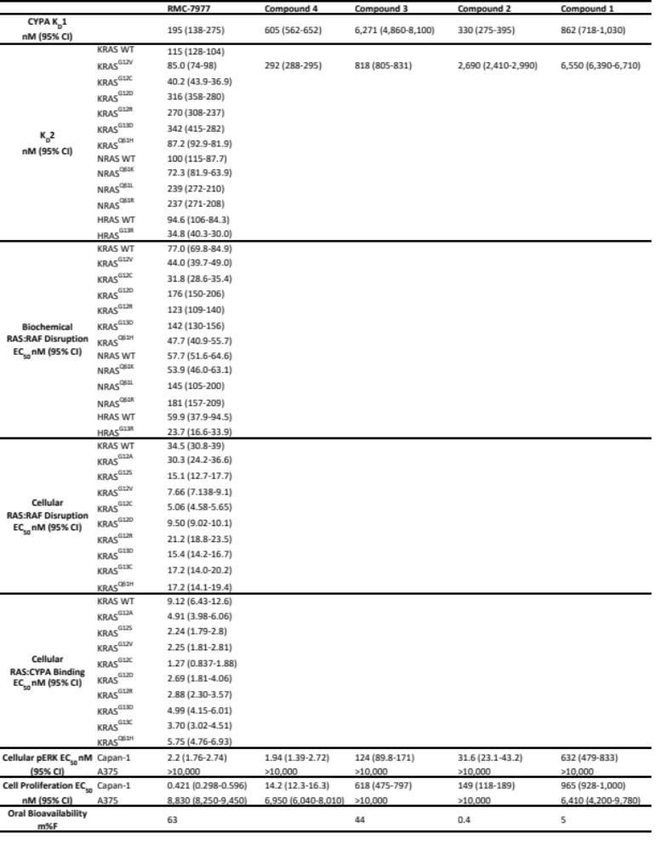Potencies for compounds 1-4 and RMC-7977 in biophysical (K_{D}1 and K_{D}2 measured by SPR), biochemical (KRAS:BRAF RBD disruption measured by time-resolved fluorescence binding assay), cellular, and in vivo assays (RAS:CRAF RBD Disruption and RAS:CYPA Binding measured by nano-BRET, pERK measured by MSD, proliferation measured by CTG, Oral bioavailability measured by LC-MS/MS analysis, 0-24 hour AUC, of total blood exposure from a single oral dose compared to intravenous exposure).
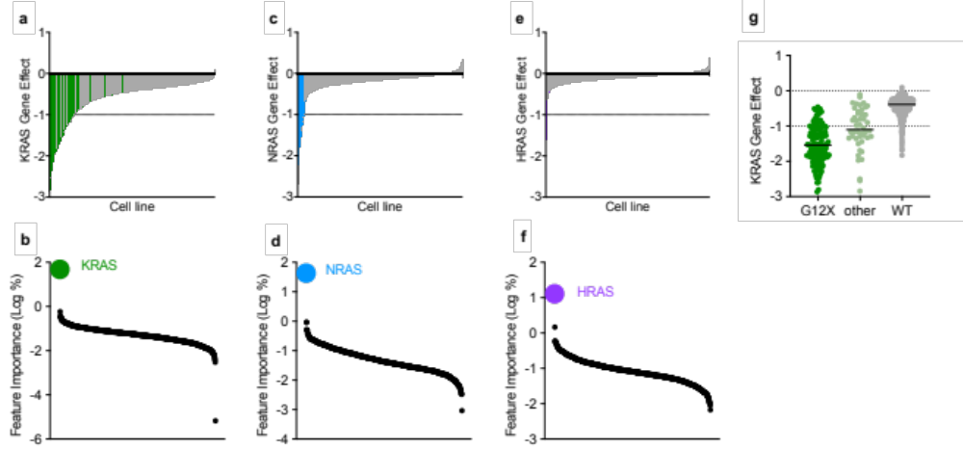

Extended Data Fig. 1: Relationship between RAS gene effect and RAS mutation.
a,c,e, Barplots ordered by KRAS (a), NRAS (c), or HRAS (e) CHRONOS score (gene effect, Depmap.org). Each bar represents a cell line. KRAS, NRAS or HRAS mutated cells colored green, blue or purple respectively. b,d,f, Gene mutation features from trained Random Forest regression model mapping gene mutation status to gene effect. Data points represent mutated genes, ordered by importance for the gene effect in each plot. Y-axis indicates the genetic feature importance for KRAS (b), NRAS (d), or HRAS (f) gene effect (see Methods). g, KRAS gene effect plotted as a function KRAS genotype. Each point represents a cell line.
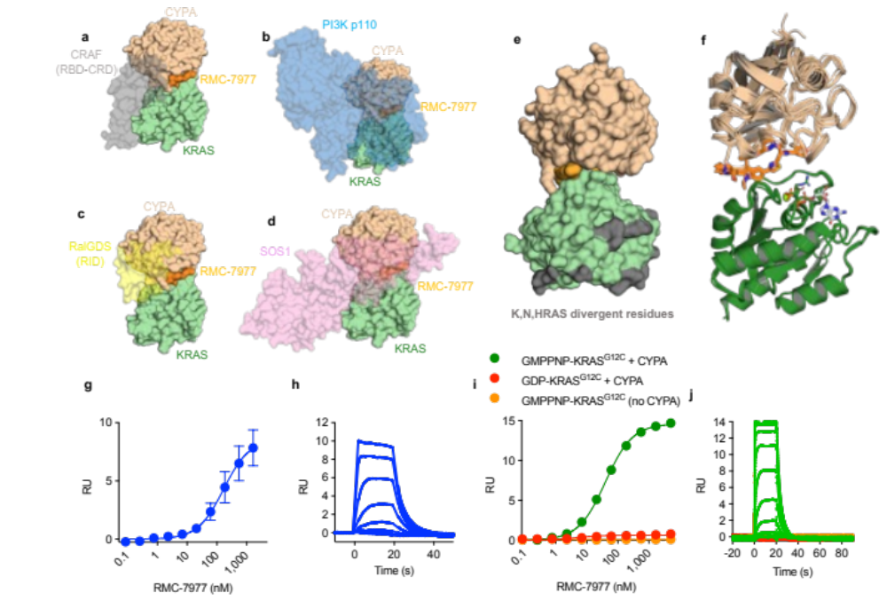
Extended Data Fig. 2: RMC-7977 biophysical and structural characterization.
a,b,c,d, Superimposition of the CYPA:RMC-7977:KRAS wild-type (WT) tri-complex structure with KRAS:CRAF RBD-CRD complex (a, PDB: 6XI7), HRAS:PIK3 CD (b, PDB: 1HE8), KRAS:SOS1 REM-CDC25 (c, PDB: 1XD2), or HRAS:RALGDS (d, PDB: 1LFD). Note the steric clashes caused by CYPA occupying the Switch I and II motif of KRAS. e, RAS interacts with CYPA and RMC-7977 through the conserved effector lobe. Isoform divergent residues are distal from the site of interaction, allowing pan isoform inhibition. f, Alignment of wild-type HRAS, wild-type NRAS, and KRAS^{G12X} (A, C, D, R, S, V) mutant tri-complexes shows functionally identical binding modes to the CYPA:RMC-7977 binary complex. 12th position mutant sidechains shown as sticks. g,h Steady state (g) and kinetic sensorgram (h) of RMC-7977 and CYPA binding measured by surface plasmon resonance (SPR) response units (RU). i,j Steady state (i) and kinetic sensorgram (j) of RMC-7977 binding to KRAS^{G12C} measured by SPR. Measurements taken in the presence or absence of CYPA, and GMPPNP or GDP nucleotides. No binding was measured in the absence of GMPPNP or CYPA. Error bars represent standard deviation of 3 replicates.
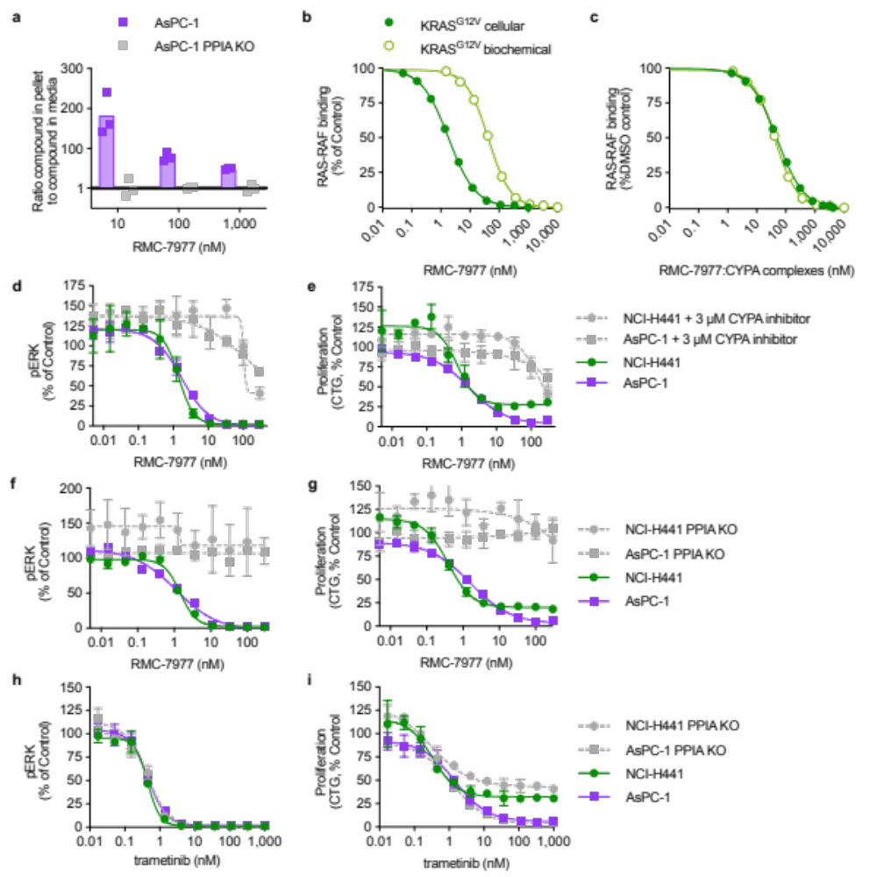
Extended Data Fig. 3: Cellular concentration of CYPA determines the cellular concentration of binary complex.
a, Ratio of RMC-7977 concentration in cells to concentration in media following exposure of parental or PPIA KO AsPC-1 cells to indicated concentrations of RMC-7977 for 1 hour as determined by LC/MS bioanalysis. b, RMC-7977 concentration response for biochemical and cellular nano-BRET KRAS^{G12V}-RAF disruption. c, same data as b, with calculated concentration of active binary complexes. Correction is based on equation 1:
$$\left[binary complex\right]=\frac{{\left[CYPA\right]}_{cell}*{\left[RMC-7977\right]}_{unbound}}{K_{D}1+{\left[RMC-7977\right]}_{unbound}}$$
This calculation assumes the extracellular volume is much greater than the intracellular volume and that the concentration of unbound RMC-7977 ([RMC-7977]_{unbound}) equilibrates between intracellular and extracellular space. A value of 5 µM was used for the cellular CYPA concentration ([CYPA]_{cell}). No adjustment was applied to the biochemical data because under experimental conditions >99% of RMC-7977 is bound to CYPA. d,e,f,g,h,i, pERK levels (MSD) (d,f,h) and cell proliferation (CTG) (e,g,i) in AsPC-1 and NCI-H441 cells treated with RMC-7977 or trametinib for 4 hours. Each data point is the mean of technical duplicates and normalized to vehicle control. Error bars represent s.d. Representative data of replicate experiments are shown (AsPC-1, n=3, NCI-H441, n=2). RMC-7977 co-treatment with a CYPA inhibitor¹⁴ (d,e) or PPIA KO (f,g) rescued pERK and proliferation in RMC-7977 treated cells, but did not affect response to trametinib (h,i).
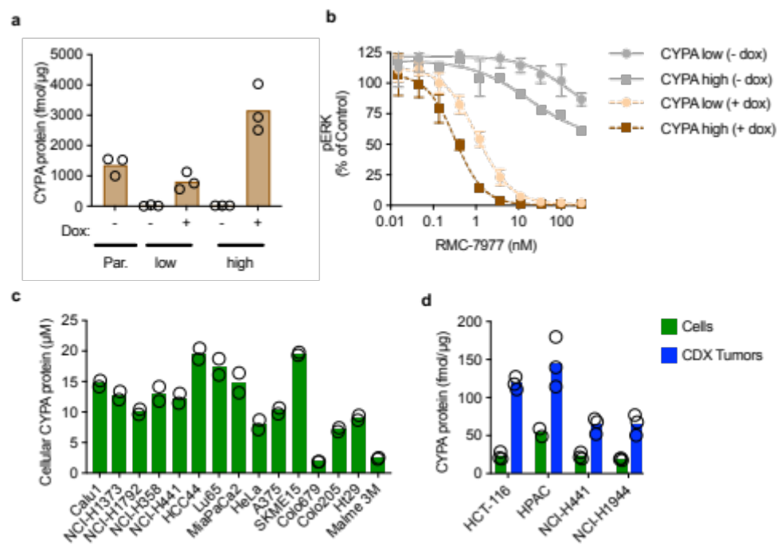

Extended Data Fig. 4: CYPA is required for cellular activity.
a, Cellular CYPA protein levels determined by parallel reaction monitoring (PRM) mass spectrometry in NCI-H358 cells harboring doxycycline-inducible expression of low or high CYPA in the absence or presence of doxycycline (0.1 µg/ml) for 120 hours. b, pERK levels (MSD) of CYPA high and CYPA low cells treated with RMC-7977 in the absence or presence of doxycycline (0.1 µg/ml) for 120 hours. Each data point is the mean of technical duplicates and normalized to vehicle control. Error bars represent s.d. Representative data of replicate experiments are shown. c, Cellular CYPA protein concentration in a panel of cell lines determined by PRM. Data 2 stable isotope labeled peptide standards (SIS) was averaged for each replicate. Intracellular µM concentration estimated assuming cell volume of 2 pl. Data points represent biological duplicates d, CYPA protein expression in cells (blue bars) and corresponding xenograft tumors (green bars) determined by PRM. 5 SIS peptides were used and data averaged for each biological replicate. Data points represent biological duplicates for HPAC cells and triplicates for all others.
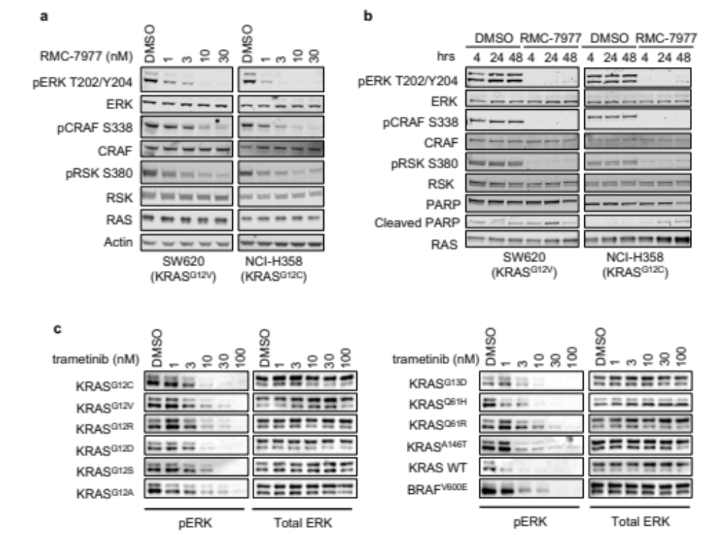

Extended Data Fig. 5: Inhibition of RAS signal transduction pathways.
a, Western blots of KRAS mutated cell lines treated with RMC-7977 for 4 hours before harvesting whole cell lysates and blotting for the indicated RAS pathway target proteins. b, Western blots of KRAS mutated cell lines treated with RMC-7977 (100 nM) or DMSO control for indicated time points. c, Western blots of isogenic RAS-less MEF cell lines harboring an exogenous, wild-type (WT) or mutant KRAS, or BRAF^{V600E} transgene, treated with indicated concentrations of trametinib or DMSO control for 24 hours.
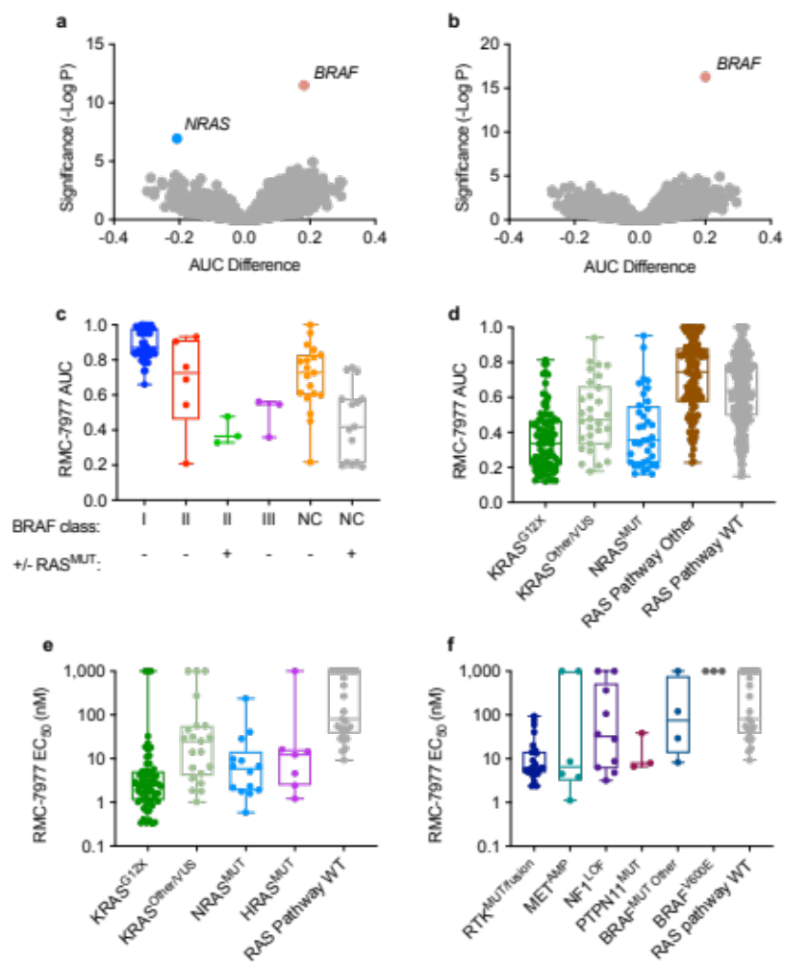
Extended Data Fig. 6: RMC-7977 sensitivity by genotype.
a,b. PRISM data. AUC difference between cell lines with and without a given gene mutation (x-axis) and the significance of the difference (y-axis). Each point represents a mutated gene. Negative AUC implies increased sensitivity. NRAS correlation shown in (a) was only evident when KRAS mutants were removed, likely due to the disproportionately larger number of KRAS mutant cell lines. The dataset in (b) excluded both KRAS and NRAS mutants. A small sampling of HRAS mutants was insufficient to determine a statistically significant correlation with HRAS dependence. c, PRISM data. BRAF Class I mutations are strongly activating monomers; Class II mutations are moderately activating dimers; Class III are kinase impaired; NC are BRAF mutated but have not been classified as I, II, or III; KRAS, NRAS, or HRAS co-mutation status indicated as with +/- for each group. Each point represents a cell line. d, PRISM data. KRAS mutations at codon 12 (KRAS^{G12X}) or NRAS mutations (NRAS^{MUT}) had lower AUCs compared to: (i) cell lines with KRAS mutations at a different codon (KRAS^{Other/VUS}); (ii) cell lines with a mutated gene within the RAS pathway (RAS Pathway other defined in Methods) and; (iii) cell lines that were otherwise wildtype. Each point represents a cell line. e,f RMC-7977 EC₅₀ as a function of RAS genotype (e) or RAS pathway activating mutation (f). Each point represents a cell line. Median EC₅₀: KRAS^{G12X} mutated (2.40 nM), KRAS^{Other/VUS} (25.1 nM), NRAS mutated (5.89 nM), HRAS mutated (12.3 nM), RTK^{MUT/fusion} (6.14 nM), MET^{AMP} (6.61 nM), NF1^{LOF} (32.5 nM), PTPN11^{MUT} (7.95 nM), BRAF^{MUT Other} (75.4 nM), BRAF^{V600E} (>1 µM), RAS pathway wild-type (WT) (71.5 nM). See Extended Data Table 2 for individual EC₅₀ values.

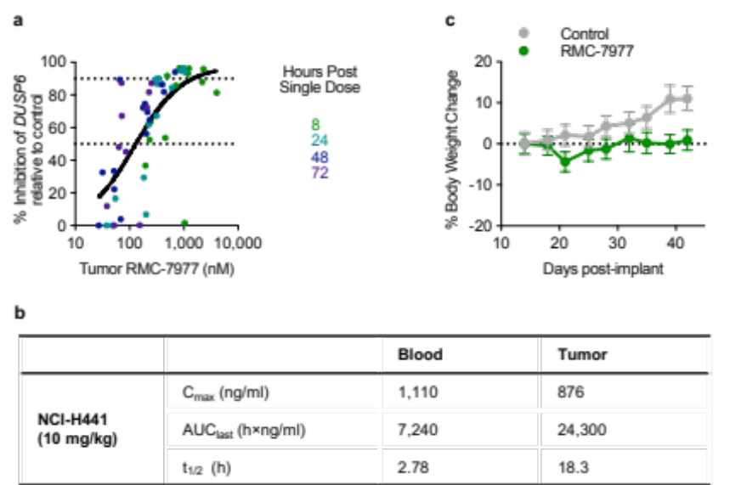

Extended Data Fig. 7: PK parameters and PKPD Relationship for RMC-7977 in NCI-H441 tumor bearing BALB/c nude mice.
a, pharmacokinetic (PK) relationship to pharmacodynamic (PD) marker (DUSP6) levels. RMC-7977 tumor concentrations and percentage of DUSP6 inhibition in tumor following single oral administration in NCI-H441 tumor bearing BALB/c nude mice. A 3-parameter sigmoidal concentration response model was fit to the data (GraphPad Prism) to derive an EC₅₀ of 130 nM and an EC₉₀ of 1450 nM, with a maximal level of inhibition near 100% relative to control in the NCI-H441 human NSCLC CDX model. b, Table of blood and tumor PK parameters of RMC-7977 following single oral administration of RMC-7977 in NCI-H441 tumor bearing BALB/c nude mice. Whole blood and tumor concentrations of RMC-7977 were determined using liquid chromatography-tandem mass spectrometry (LC-MS/MS) methods performed at Wuxi AppTech (Suzhou, China). PK parameters were calculated by non-compartmental analysis (Phoenix WinNonlin). c, % Body weight change of NCI-H441 tumor bearing BALB/c nude mice following repeated oral administration of either vehicle control or RMC-7977 at 10 mg/kg. Percentage change in body weight for each animal on a given day was determined as ((body weight on test article administration end date / body weight on test article administration start date) –1) × 100).

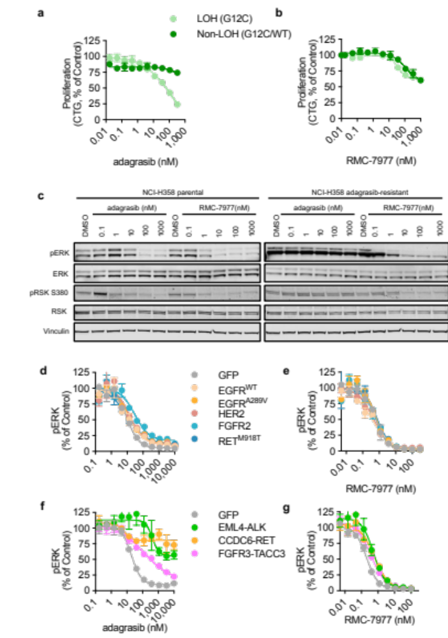

Extended Data Fig. 8: RAS^{MULTI} inhibition overcomes G12C inhibitor resistance mechanisms.
a,b, Loss-of-heterozygosity (LOH) KRAS^{G12C} and heterozygous KRAS^{G12C/WT} MEF cells were treated with RMC-7977 or adagrasib for 120 hours. Graphs are representative of two independent replicate experiments in which each data point is the mean of technical triplicates and normalized to vehicle control, error bars represent s.d. c, Western blots of parental NCI-H358 (KRAS^{G12C} NSCLC) and an adagrasib resistant clone of NCI-H358 cells with a secondary NRAS^{Q61K} mutation. Cells were treated with adagrasib or RMC-7977 at the indicated concentrations for 4 hours. Whole lysates were collected and probed for the indicated protein markers (pERK, ERK, pRSK, RSK and vinculin). d, pERK levels (MSD) in NCI-H358 (KRAS^{G12C}) cells expressing exogenous RTK DNA constructs indicated by color (GFP control, EGFR^{WT} EGFR^{A289V}, HER2, FGFR2, or RET^{M918T}, treated with adagrasib (c) or RMC-7977 (d) for 24 hours. e,f pERK levels (MSD) in MiaPaCa2 (KRAS^{G12C}) cells expressing exogenous RTK fusion DNA constructs indicated by color (GFP control, EML4-ALK, CDC6-RET, FGFR3-TACC3), treated with adagrasib (e), or RMC-7977 (f) for 24 hours.

