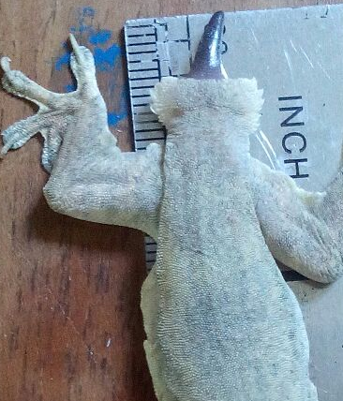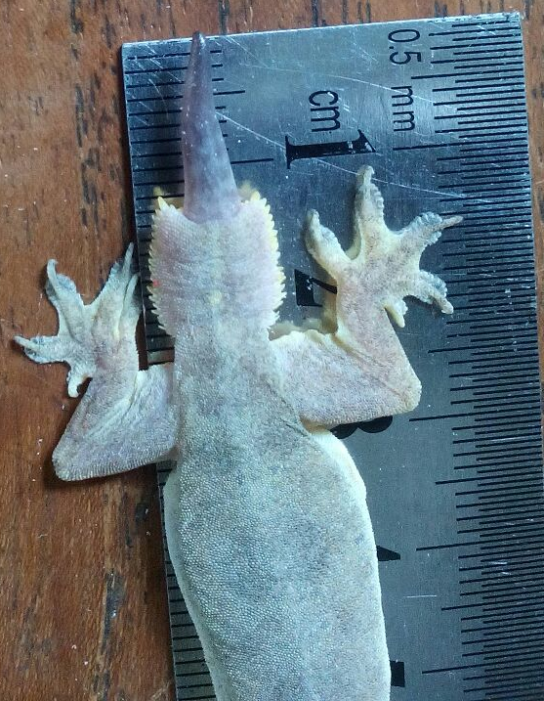
B
A

Additional Figure. 1 The Growth of house gecko (Hemidactylus platyurus) tail (A) on day 3;
(B) on day 13 after autotomy.

