Multiple genetic control of anti-COVID-19 vaccine response by HLA locus
Supplementary Figures
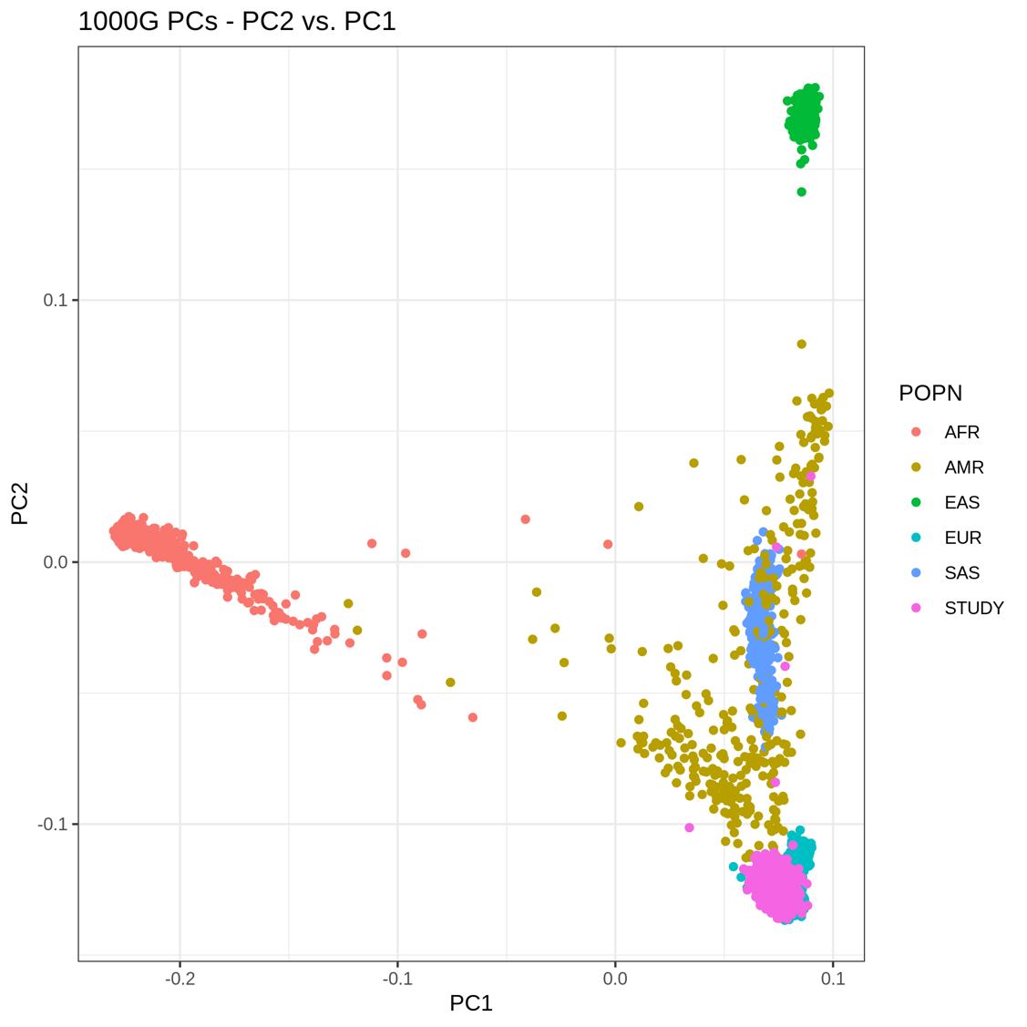
Supplementary Figure 1. PC projection of our samples into the same PC space of 1,563 subjects, from different ancestries, belonging to the 1000 Genomes Project. Pink dots represent our samples (STUDY), whereas the other colours indicate different populations (AFR, Africans, AMR, Americans, EAS, East-Asians, EUR, Europeans, SAS, South-Asians). The four pink dots not clustering with the majority of our samples (and with Europeans) were those excluded from the GWAS, since they were not of European origin.

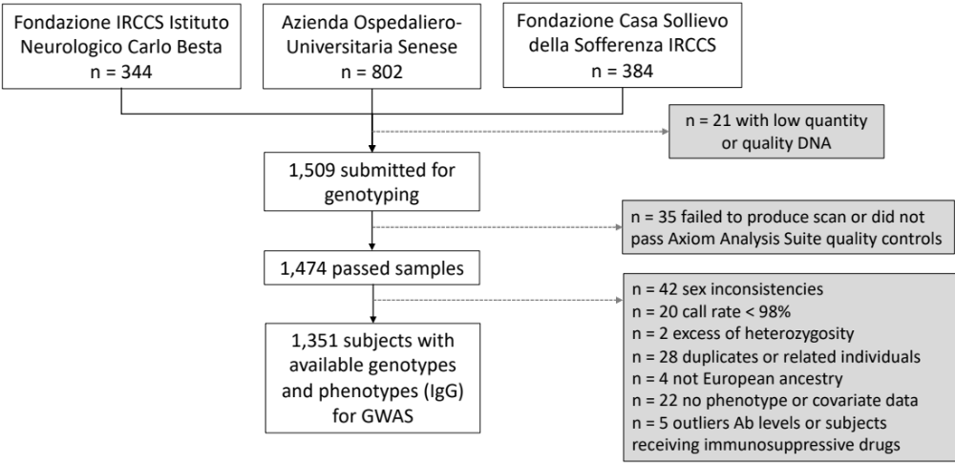
Supplementary Figure 2. Flow diagram of selected subjects for the GWAS. The final 1,351 series consisted of n=306 subjects from Milan, n=689 from Siena, and n=356 from San Giovanni Rotondo.
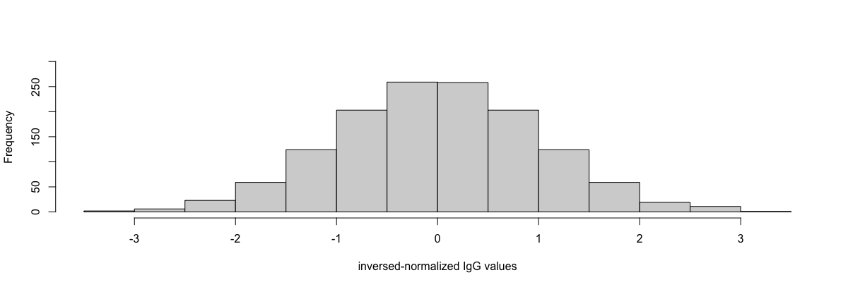
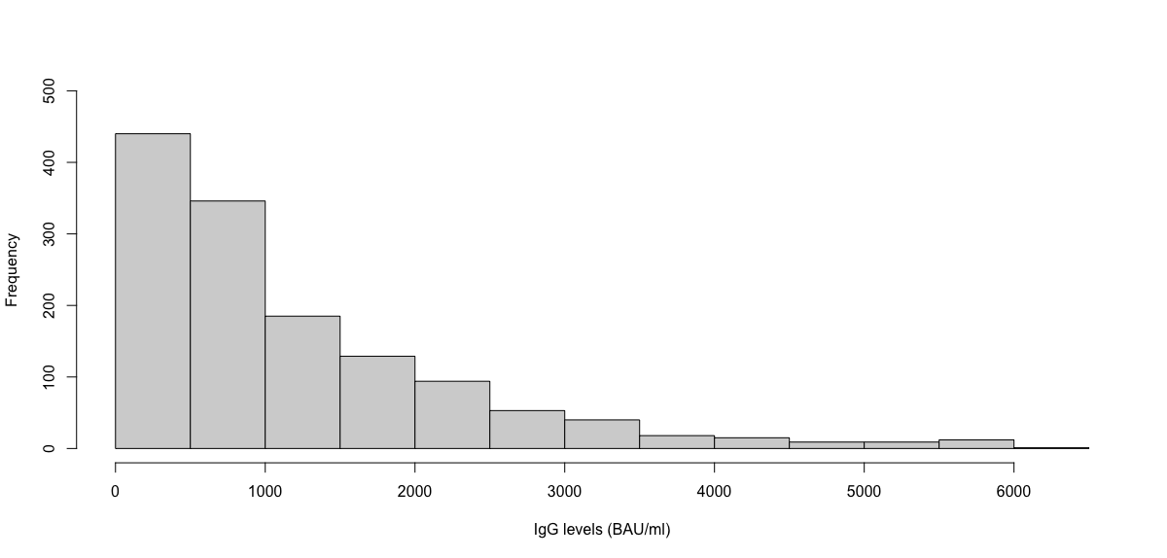
A.
B.
P < 0.001
P > 0.05
Supplementary Figure 3. Histograms representing the distribution of IgG levels in our series before (A) and after (B) inverse-normalization. P-values of Shapiro-Wilk test for normality are shown.

