Improving ginger’s bioactive composition by combining innovative drying and extraction technologies

Raul Remor Dalsasso ª, Germán Ayala Valencia ^{b}, Alcilene Rodrigues Monteiro ^{c}*

^{abc} Department of Chemical and Food Engineering, Federal University of Santa Catarina, Trindade, Florianópolis, SC, CEP 88040-900, Brazil.
ª ORCID: 0000-0003-0881-8440
^{b} ORCID: 0000-0001-9824-4510
^{c} ORCID: 0000-0002-5319-9741
*Corresponding author:
Prof. Alcilene Rodrigues Monteiro (A.R. Monteiro). Address: Department of Chemical and Food Engineering, Federal University of Santa Catarina, Trindade, Florianópolis, SC, CEP 88040-900, Brazil; e-mail address: alcilene.fritz@ufsc.br; Tel: +55 48 3721 2512.

Material and methods

Reagents and chemicals
Analytical grade chemicals: Follin-Ciocalteu, 2,20-azinobis (3-ethylbenzothiazoline-6-sulfonic acid) diammonium salt (ABTS) and 2,2-diphenyl-1-picrylhydrazyl (DPPH) reagents were bought from Sigma-Aldrich Co. (St. Louis, MO, USA). 98.8% Methanol was purchased from Neon Comercial Reagentes Analíticos Ltd. (Suzano, Brazil).

Ginger rhizomes
Ginger (Zingiber officinale Roscoe) was bought from a local producer (Grão-Pará, SC, Brazil). Freshly harvested (March 2021) and cleaned rhizomes were selected and packed in polypropylene bags of 2 kg and stored in a freezer at -20 ºC until use, for a maximum of 24 weeks. Rhizomes to be dried were cut in slices of 4 mm and irregular diameter perpendicularly to the fibers. The rhizomes to be extracted without drying (fresh) were grounded in a domestic processor (800 W power, Multipro, Philco, Brasil) at maximum power for 1 min.

Drying
Convective oven drying (OD) at 60 (F60), 80 (F80), or 120 ºC (F120) was performed in an oven (TE 394/2, TECNAL, Ourinhos, Brazil). Vacuum microwave drying (VMD) was performed in an adapted domestic microwave (MS4297DIR (A), LG Electronics do Brasil Ltd., Cajamar, São Paulo) (power of 1200 W and frequency of 2.45 GHz) with power control and vacuum cell with a rotation speed control [1]. The drying power was set as 840 W (power density 5.25 w/g) until 30% moisture and then reduced to 480 W, until mass stabilization, as a method adapted from Izli and Polat [2]. Total VMD time was 20 min, determined in preliminary tests. After drying, ginger was grounded in a processor (800 W power, Multipro, Philco, Brasil) at maximum power for 1 min to form the ginger powder to be further analyzed for color, moisture content, and water activity.

Extraction
The conventional solvent reflux extraction (Sox) was performed with 5 g of powder or milled fresh ginger in 150 mL of 99.8% ethanol in a Soxhlet apparatus at 80 ºC for 6 h. For ultrasound-assisted extractions (UAE), 5 g of ginger powder and 150 mL of 99.8% ethanol were subjected to an ultrasonic disruptor (QR 550W, Ultronique, São Paulo, Brasil) with a frequency of 20 kHz and adjusted for the power of 330 W for 3 h. The solution was maintained in a glass-coated cell connected to a thermostatic bath, which controlled the extraction temperature as needed by the experiment (80 ºC, or 20 ºC with ice). The extraction of fresh ginger was also evaluated in microwave-assisted extraction (MAE) in a digestor Monowave 200 (850 W power, Anton Paar, Germany). 1 g of milled fresh ginger was extracted for 15 min at 150 ºC with 20 mL of 99.8% ethanol.After all the extractions, the solids were removed by filtration and the solvent by rotary evaporation at 50 ºC.

drying kinectics
For OD (60, 80, and 120 ºC), 100 g of sliced ginger was dried over the load cell of a mass measuring system inside the oven. Measurements were taken each 30 s. The measurement system consisted of an aluminum plate connected to a single-point load cell (Alfa Instruments, Model GL1, São Paulo, Brazil) with a capacity of 2 kg and accuracy of 0.1 g, sustained by a metallic support into the dryer and connected to a computer by an electronic interface (Alfa Instruments, Model 3102, São Paulo, Brazil). A moisture analyzer (Smart System5, CEM, Glendale, CA, EUA) measured the final moisture content (H^{eq}), used for calculations of moisture content (X, d.b.) through the drying.
In VMD, 160 g of sliced ginger was distributed in four capped plastic pots with perforated lids to allow vapor outlet. Each pot was kept inside one of the four sections of the equipment’s vacuum chamber. A rotation of 2-3 rpm was set. At the beginning of VMD, the microwave generator was turned on, and the vacuum pump (system pressure set to 100 mbar) (DVP, Vacuum Technology, Model – LC.305, San Pietro in Casale, BO, Italy) was kept on through the whole process. Each 2.5 min the process was stopped, and the mass of samples in the plastic pots was quickly measured (Knwaagen, Model - KNCD60/1, Cotia - SP, Brazil). Then, the process was reestablished until the end of drying [3].
The experiments were performed in duplicates. Drying kinetics curves were expressed as moisture ratio (X*) as a function of drying time, as shown in Equation 1 [4]:
$$X^{*}={(X-X^{eq})}/{(X^{i}-X^{eq})}$$ | (1)
where X (g/g) is the moisture content at a determined time of extraction (t), $X^{eq}$ (g/g) is the moisture content at equilibrium, and $X^{i}$ (g/g) is the initial moisture content. The initial and final moisture content and water activity of ginger were determined by a moisture analyzer (Smart System5, CEM Corp, NC, EUA) and a digital hygrometer with internal temperature control (Aqualab, Decagon Devices, EUA), respectively.
Maximum drying rate ($V_{d}^{max}$) was obtained as the angular coefficient of the linear regression of moisture ratio (X*) as a function of t during the constant drying period. $V_{d}^{max}$ represents the water removed (kg/kg of dry sample) versus extraction time [5]. The drying time until 10% moisture content (T_{d}) (w.b.) was used for comparisons.

Effects of drying and extraction over the extract
Effects of emergent drying (VMD at 100 mbar of pressure and 840 W of initial microwave power) and extraction (UAE at 20 or 80 ºC) processes over the extract were evaluated in comparison to conventional (OD at 80 or 120 ºC and Sox extraction). A conventional coupled process consisting of OD at 60 ºC followed by Sox extraction was evaluated as a control. Figure S1 shows a flowchart of the experiments. The acronyms used to name the samples are composed of a drying method prefix and an extraction suffix: fresh undried samples used the prefix Fre; oven drying at 60, 80, and 120 ºC were called F60, F80, and F120, respectively; vacuum microwave dried samples used the prefix Mic; UAE at 20 and 80 ºC were represented by Ult20 and Ult80 suffixes, respectively; Soxhlet extraction used the suffix Sox.
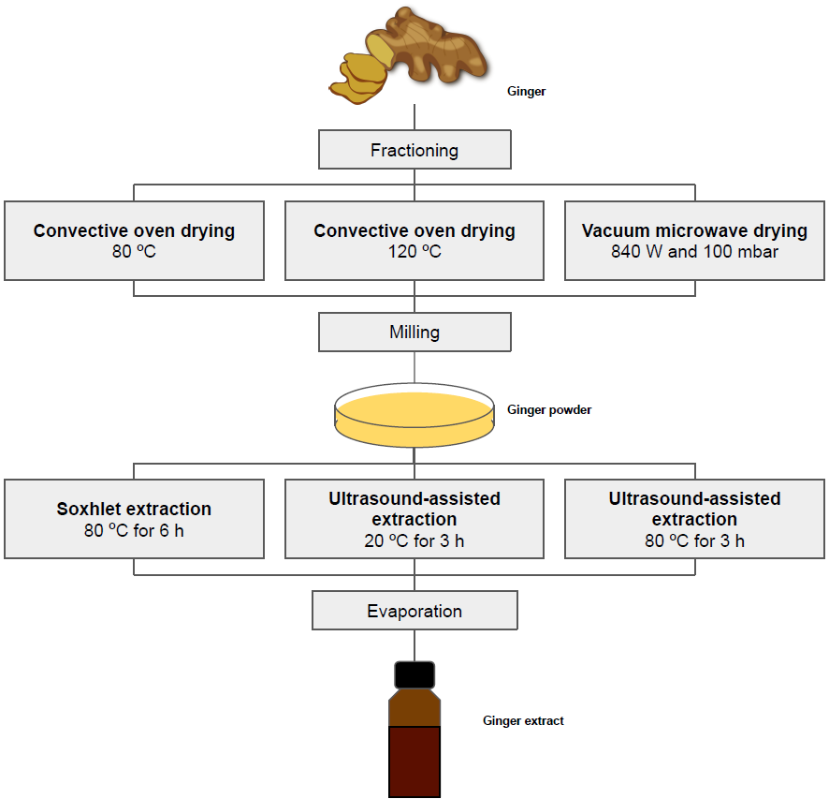
Figure S1. Steps and conditions used for producing ginger powders and extracts.

Ginger powder characterization

Ginger powder color
The ginger powder color was evaluated by digital image analysis [6]. Images of the samples were taken by a photographic camera (AF-S DX NIKKOR 18-55 mm f/3,5-5,6G VR, Nikon Inc., NY, USA). The color of the images was standardized with Adobe Photoshop software by adjusting the white background color parameters to match the parameters determined by a colorimeter (Ultra Scan Vis 1043, Hunter Lab, Reston, USA). Images were digitally analyzed by the software Image J (National Institute Health, Bethesda, MD, EUA). The measurements were in the CIE-Lab scale, which comprises the coordinates: lightness (L*), green-red color intensity (a*), and blue-yellow color intensity (b*). The relative saturation, or chroma (C*), and the hue angle (h_{o}) were calculated as described by Mahayothee et al. [5].

Particle size
The particle size of ginger powder was determined by a sieve shaker (Art-Lab, BERTEL, Brazil) with mesh sizes 18, 20, 25, 30, 35, 40, 80 mesh.

Characterization of ginger extracts

Global extraction yield (Yg)
The global extraction yields (Yg) of ginger extracts were determined gravimetrically using an analytical balance (AY 220, Shimadzu Corp. Kyoto, Japan) and expressed as a percentage of obtained mass extract over dried ginger mass.

Antioxidant activity
The antioxidant activity assays were performed as described by Rufino et al. [7, 8], with adaptations. DPPH (1,1-Diphenyl-2-picrylhydrazyl) and ABTS (2,2-azino-bis, 3-ethylbenzothiazoline-6-sulphonic acid) scavenging spectrophotometric methods were used.
A DPPH stock solution (0.06 mM) in ethanol was prepared. 3.9 mL of DPPH stock solution was mixed with 0.1 mL of samples and kept in the dark for 30 min. Absorbance in 515 nm was measured. A blank of ethanol was also submitted to the procedure and analyzed with the samples. Absorbances were compared with a calibration curve of Trolox. Results were reported as mmol.Trolox/mL of extract.
For ABTS assays, 5 mL of a previously prepared solution with 7 mM ABTS in distilled water was mixed with 0.88 µl of potassium persulfate 120 mM and kept in the dark for 16 h at 4 ºC. This solution was diluted until it reached the absorbance of 0.7 ± 0.01 at 734 to form the work reagent solution. 30 µl samples were added to 3 mL of ABTS reagent solution and incubated in the dark for 6 min. After incubation, the absorbance in 734 nm was measured and compared to a standard curve of Trolox. A blank of ethanol was used and submitted to the same procedure as the samples. Results were reported as mmol.Trolox/mL of extract.

Total phenolic content (TPC)
Total phenolic compounds content was determined by the Folin-Ciocalteau method [9], with modifications. 250 µL of ginger extract sample, 2 mL of distilled water, and 2 mL of Folin-Ciocalteau reagent (0.25 N) were mixed. After 5 min, 3 mL of sodium carbonate (7.5%) and 3.25 mL of water were added to the solution. After 2 h in the dark, the absorbance was measured at 750 nm (Quimis, Q898U2M5, Brazil) and compared with a standard curve of gallic acid. 99.8% ethanol was used as a blank. TPC were expressed as mg of gallic acid equivalent (GAE) per mL of extract.

Components profile
Ginger extract composition was determined by gas chromatography coupled with mass spectrometry, as described by Adams [10]. The chromatographer (Agilent 7890A, Denmark) was equipped with a selective mass detector (Agilent 5975C, Denmark) and a fused silica capillary column HP-5MS (Agilent, Denmark) (30 m x 250 µm x 0,25 µm composed by 5% phenyl and 95% methylpolsiloxone) connected to a quadrupole detector operating in EI (electron impact ionization) mode at 70 eV and mass detection range of 41-415 m/z. Helium at a flow rate of 1.0 mL/min was used as carrying gas. The temperatures of the injector (split ratio 1:20) and interface were 220 and 240 ºC, respectively. The solvent delay was 3.0 min. The injection volume was 0.2 µL performed by an automatic sampler (GC Sampler 80, Agilent, Denmark) equipped with a 10 µL syringe. The oven temperature was programmed for a temperature ramp from 60 to 246 ºC (3 ºC/min), with a total time of 62 min. The compounds were identified by the comparison of the specters with data from the National Institute of Technology databank [11]. The linear retention indexes (LRI) were calculated by retention times of n-alkanes, which were injected at the same chromatographic conditions [10, 12].

Statistical analysis
The statistical significances were evaluated by one-way variance analysis followed by Tukey test with a significance level of 95% with the software Statistica 13.0 (Statsoft Inc., OK, USA). The experimental results were expressed as average ± standard deviation.
REFERENCES
1. Gomide AI, Monteiro RL, Laurindo JB (2022) Impact of the power density on the physical properties, starch structure, and acceptability of oil-free potato chips dehydrated by microwave vacuum drying. Lwt 155:112917. https://doi.org/10.1016/j.lwt.2021.112917
2. Izli N, Polat A (2019) Effect of convective and microwave methods on drying characteristics, color, rehydration and microstructure properties of ginger. 2061:652–659
3. Carvalho GR, Monteiro RL, Laurindo JB, Augusto PED (2021) Microwave and microwave-vacuum drying as alternatives to convective drying in barley malt processing. Innovative Food Science and Emerging Technologies 73:. https://doi.org/10.1016/j.ifset.2021.102770
4. da Silva WP, e Silva CMDPS, Gama FJA, Gomes JP (2014) Mathematical models to describe thin-layer drying and to determine drying rate of whole bananas. Journal of the Saudi Society of Agricultural Sciences 13:67–74. https://doi.org/10.1016/j.jssas.2013.01.003
5. Mahayothee B, Thamsala T, Khuwijitjaru P, Janjai S (2020) Effect of drying temperature and drying method on drying rate and bioactive compounds in cassumunar ginger (Zingiber montanum). J Appl Res Med Aromat Plants 18:100262. https://doi.org/10.1016/j.jarmap.2020.100262
6. Cárdenas-Pérez S, Chanona-Pérez J, Méndez-Méndez J V., et al (2017) Evaluation of the ripening stages of apple (Golden Delicious) by means of computer vision system. Biosyst Eng 159:46–58. https://doi.org/10.1016/j.biosystemseng.2017.04.009
7. Rufino M do S, Alves RE, Brito ES de, et al (2007) Metodologia científica: determinação da atividade antioxidante total em frutas pela captura do radical livre ABTS. Comunicado técnico 128 0–3
8. Rufino M do S, Alves RE, Brito ES de, et al (2007) Metodologia científica: determinação da atividade antioxidante total em frutas pela captura do radical livre DPPH. Comunicado técnico 127 0–3
9. Singleton VL, Orthofer R, Lamuela-Raventós RML (1974) Analysis of total phenols and other oxidation substrates and antioxidants by means of Folin-Ciocalteu reagent. Polyphenols and flavonoids 299:152–178. https://doi.org/10.1016/j.scienta.2016.11.004
10. Adams RP (2007) Identification of essential oil components by gas chromatography / mass spectroscopy, 4th ed. Allured public., Carol Stream, IL
11. NIST (2022) NIST Livro de Química na Web, SRD 69. https://webbook.nist.gov/chemistry/cas-ser/. Accessed 9 Jan 2022
12. Bizzo HR, Barboza EG, Santos MCS, Gama PE (2020) Um conjunto de planilhas teóricas para a identificação e quantificação de constituintes de óleos essenciais. Quim Nova 43:98–105. https://doi.org/10.21577/0100-4042.20170458

