Supplementary Information
A Multifunctional Drug Delivery System Based on Peptide-Stabilized Emulsions
Daniel Boas^{1,2}, Alexander van Teijlingen³, Zohar Shpilt¹, Deborah E. Shalev^{4,5✉}, Edit Y. Tshuva^{1✉}, Tell Tuttle^{3✉}, Meital Reches^{1,2✉}
¹Institute of Chemistry, The Hebrew University of Jerusalem, Jerusalem, 9190401, Israel
²The Center for Nanoscience and Nanotechnology, The Hebrew University of Jerusalem, Jerusalem, 9190401, Israel
³WestCHEM, Department of Pure and Applied Chemistry, University of Strathclyde, Glasgow G1 1XL, UK
⁴Department of Pharmaceutical Engineering, Azrieli College of Engineering Jerusalem
⁵Wolfson Centre for Applied Structural Biology, the Hebrew University of Jerusalem
✉e-mail: debbie.shalev@mail.huji.ac.il; edit.tshuva@mail.huji.ac.il; tell.tuttle@strath.ac.uk; meital.reches@mail.huji.ac.il

Contents
Contents
Supplementary movie legends 2
Supplementary figures 3
Supplementary table 14
References 15

Supplementary movie legends
Supplementary movie 1. pH-dependent disassembly of the emulsion. An emulsion stabilized by a peptide-Cu²⁺ complex using chloroform is disassembled by addition of 10 µL HCl (1 M) and reassembled by addition of 15 µL NaOH (1 M) (speed x3).
Supplementary movie 2. Emulsion behavior at extracellular pH values. Emulsion stabilized with a peptide-Zn²⁺ complex using paraffin oil, after addition to a buffer at pH=7.5 Scale bar, 20 µm.
Supplementary movie 3. Emulsion behavior at extracellular pH values. Emulsion stabilized with a peptide-Zn²⁺ complex using paraffin oil, after addition to a buffer at pH=6.2. Scale bar, 20 µm.

Supplementary figures
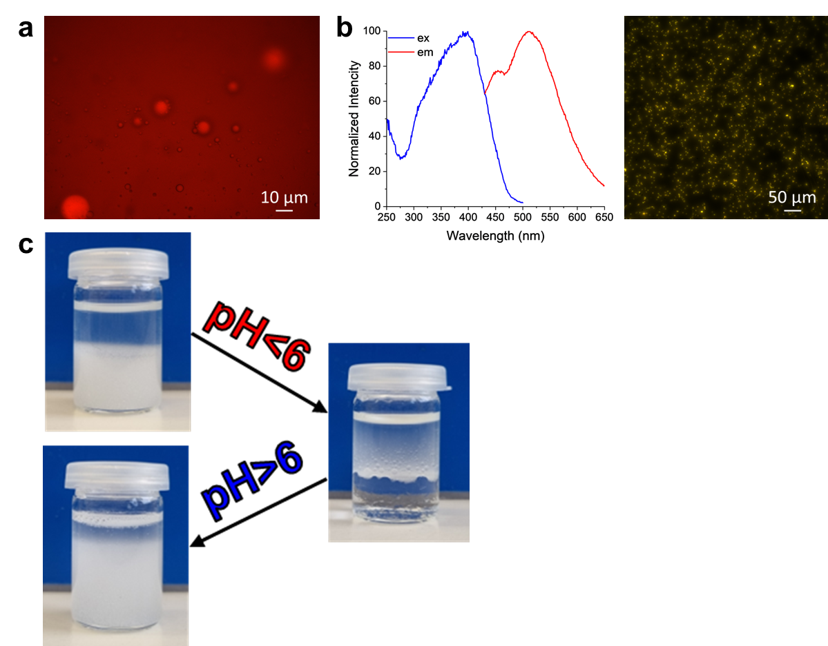
Supplementary Fig. 1: Emulsion characterization. a, A w/o emulsion formed using 90% (v/v) castor oil labeled with nile red. b, Excitation and emission spectra for the peptide (left) and a fluorescence microscopy image of the peptide fibrous structures. c, Images depicting the reversible assembly and disassembly of the emulsion through pH changes.
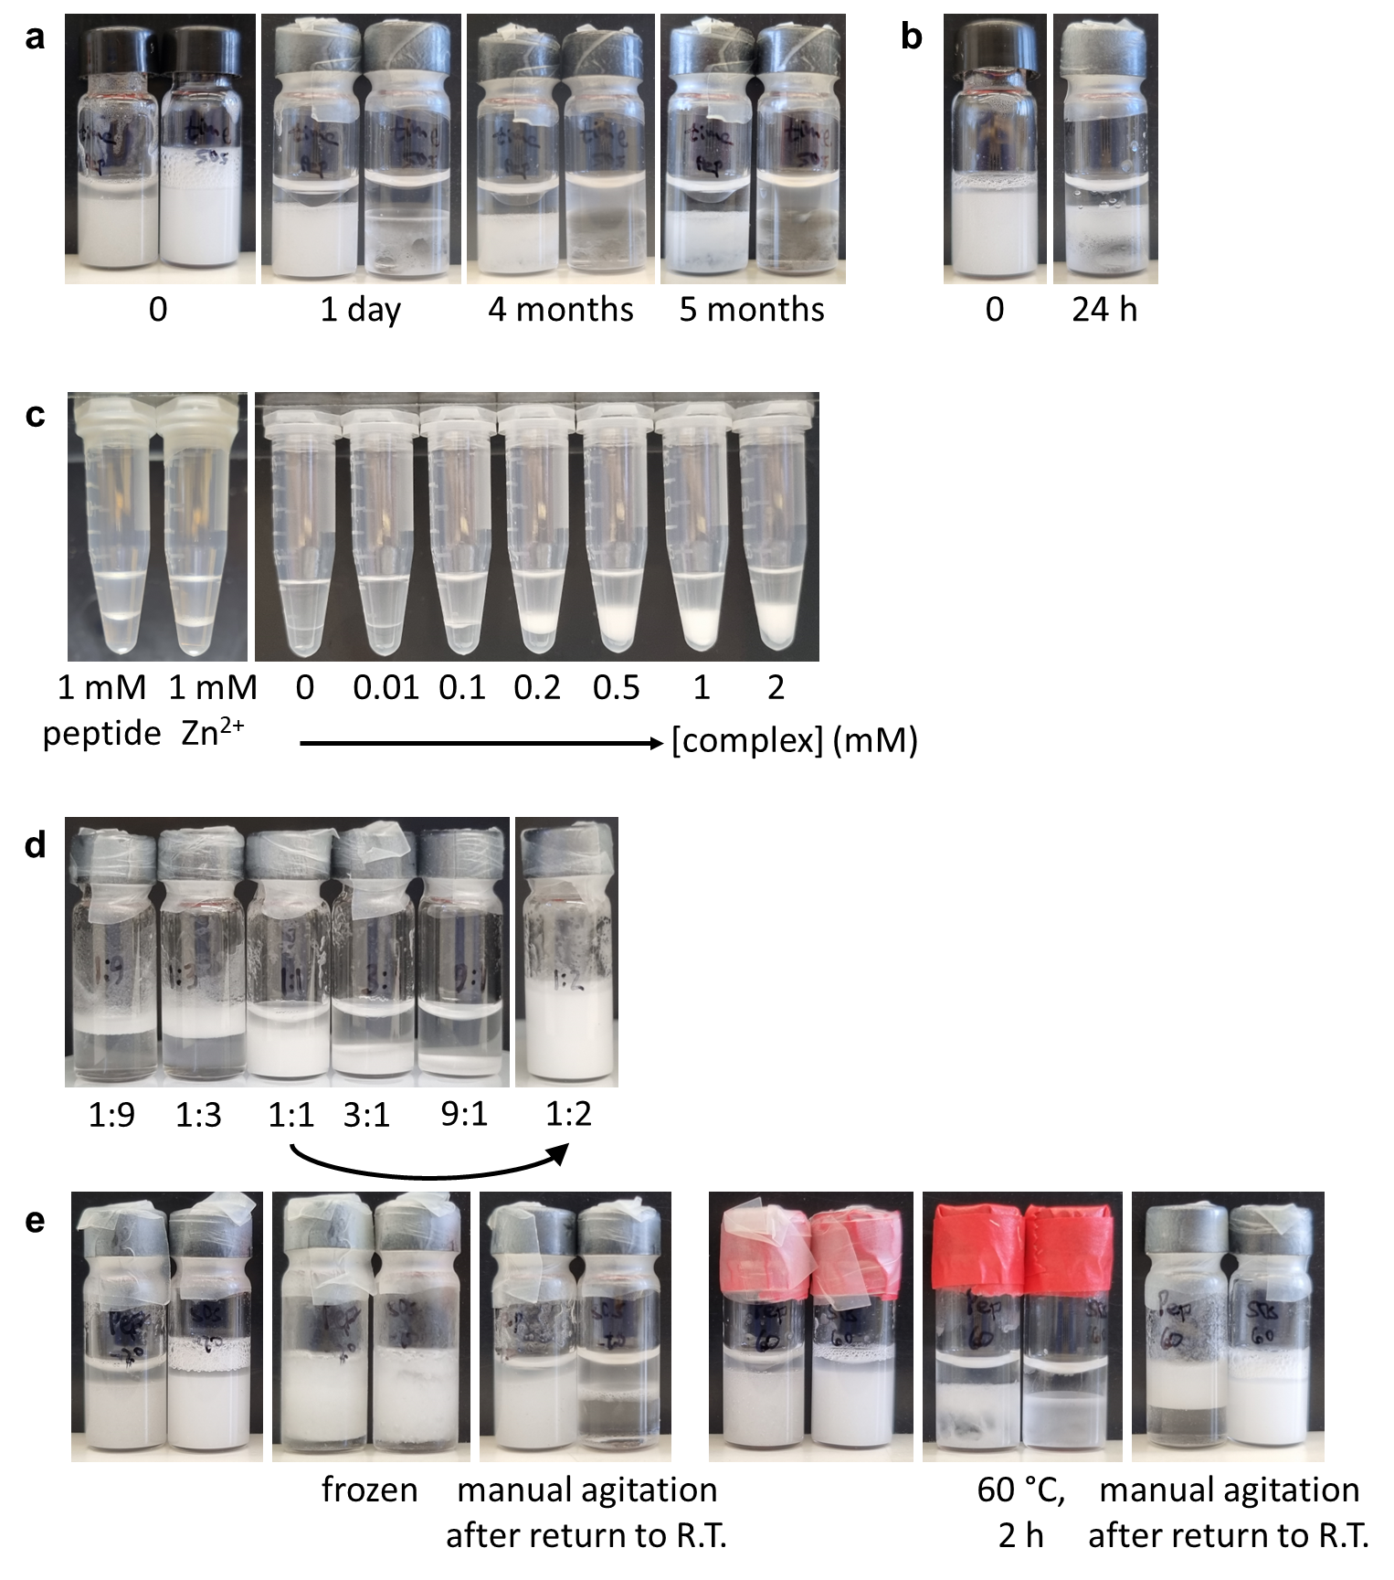
Supplementary Fig. 2: Emulsion stability. a, Stability of chloroform in water emulsions. The left vial in each image is the peptide-Zn²⁺-stabilized emulsion and the right vial is the SDS-stabilized emulsion. b, A peptide-Zn²⁺-stabilized chloroform in water emulsion after addition of 1 eq. EDTA. c, Chloroform-water mixtures with 1 mM peptide, 1 mM Zn²⁺, or increasing concentrations of the peptide-Zn²⁺ complex. d, Peptide-Zn²⁺-stabilized chloroform in water emulsions with different oil-water ratios. e. Thermal stability of chloroform in water emulsions. The left vial in each image is the peptide-Zn²⁺-stabilized emulsion and the right vial is the SDS-stabilized emulsion.

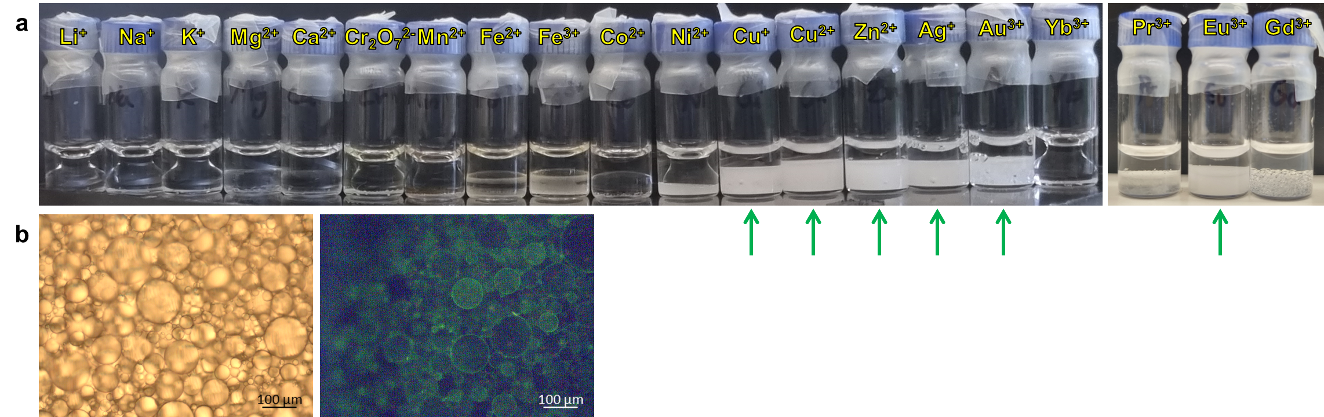
Supplementary Fig. 3: Emulsions with different metal ions. a, Chloroform in water mixtures with the peptide (1 mM) and different metal ions (1 mM). Green arrows point to samples with metal ions that formed stable emulsions with the peptide b, Light and fluorescent microscopy images of the peptide-Eu³⁺-stabilized emulsion.

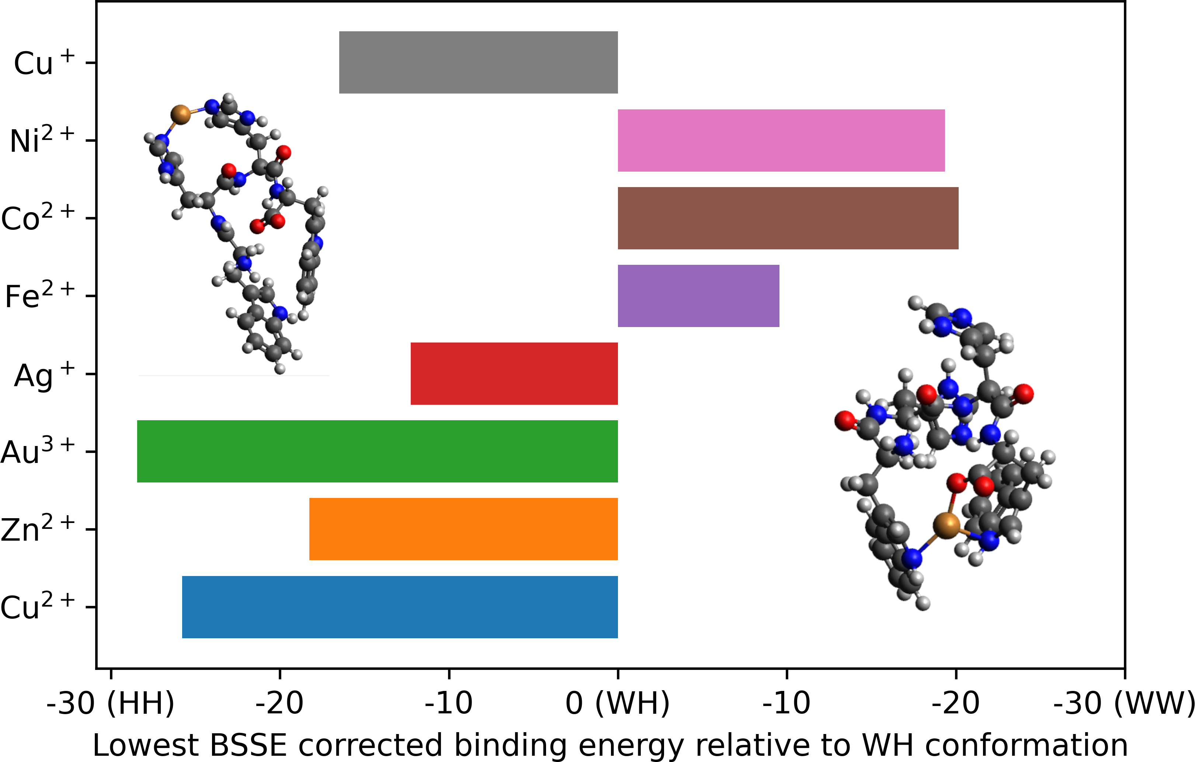
Supplementary Fig. 4: Affinity of different metal ions. The basis set superposition error (BSSE) corrected binding energy calculated for the different metal ions to bind the histidines (HH), tryptophan-histidine (WH), or the tryptophans (WW), the latter of which included C-terminus involvement. The lowest energy refers to the most strongly bound conformation, none of which are the WH conformation. Inset are the HH and WW conformations of Cu²⁺.
To compare the magnitude of metal ion binding in the metal ion complexes we used DFT to optimize each structure using the ωB97X functional¹ and def2-TZVP basis set² with the auxiliary RIJCOSX basis and the CPCM water model³. All calculations were performed using the ORCA 5 program⁴. We used the built-in D4 algorithm⁵ to evaluate dispersion interactions. The electrostatic interaction energy was calculated according to Equation 1. We minimized the BSSE by calculating a counterpoise-corrected interaction energy.
Equation 1: Formula for calculating electronic interaction energy between two species that form a complex and performing a counterpoise correction.
$$E_{interaction}=E_{complex}-\left(E_{ligand}+E_{metal}\right)$$
$$BSSE=E_{ligand optimitzed}+E_{ligand and ghost atoms}+E_{metal ghost atoms}-2E_{ligand}-E_{metal}$$
$$E_{counterpoise-corrected interaction energy}=E_{interaction}-BSSE$$

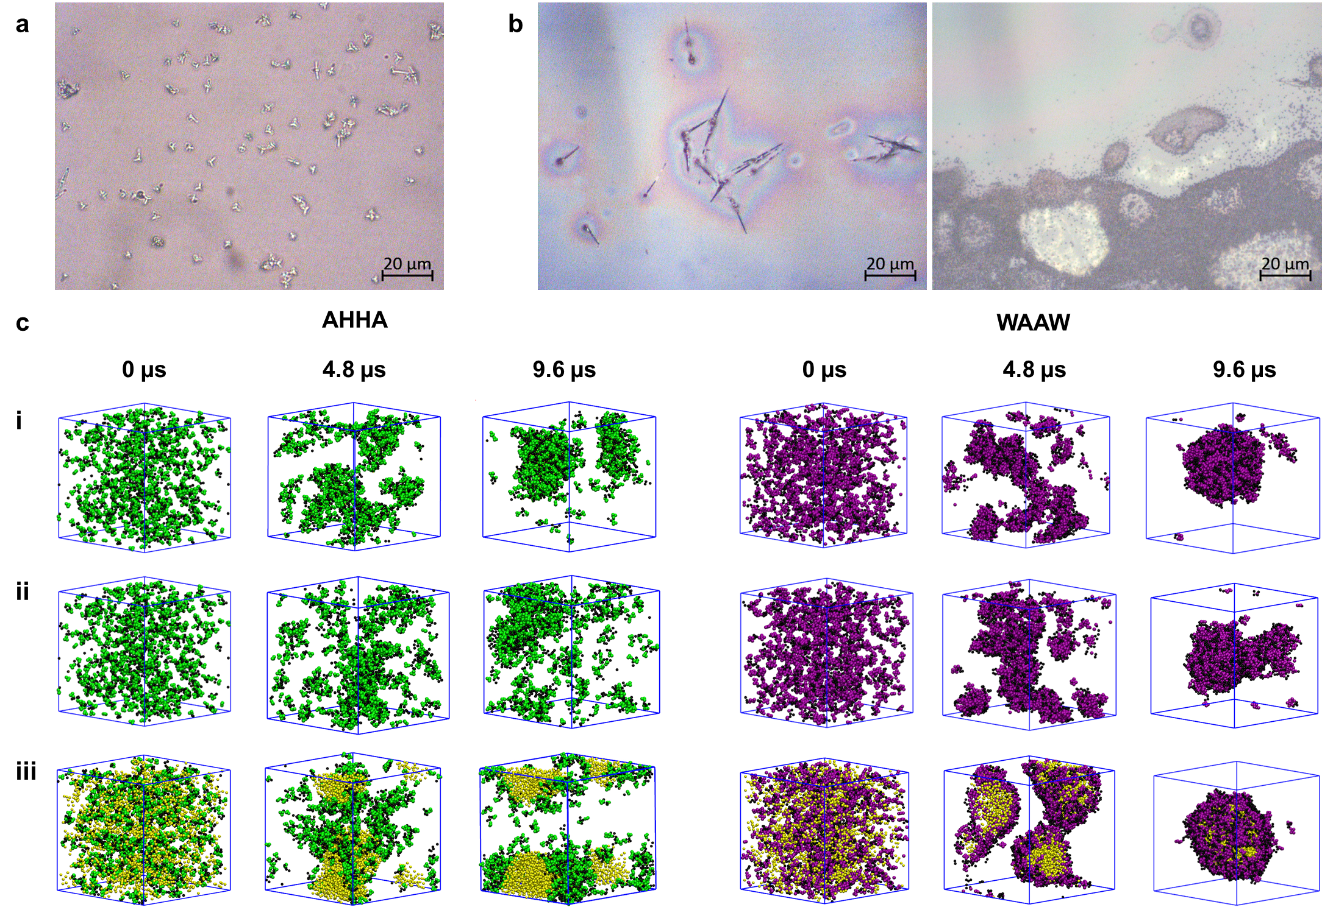
Supplementary Fig. 5: Peptide structures and molecular dynamics simulations for the control peptides. a, The peptide (10 mM) forms fibrous structures after 24 h in water. b, When the peptide (5 mM) is mixed with Cu²⁺ ions (5 mM), it forms spherical aggregates alongside the fibrous structures. c, CGMD simulations at three time periods of AHHA and WAAW in water (i), in water with divalent ions (ii), and in water with divalent ions and octane (yellow spheres) (iii). The black spheres represent the backbone while the purple and green represent the tryptophan and histidine residues, respectively.

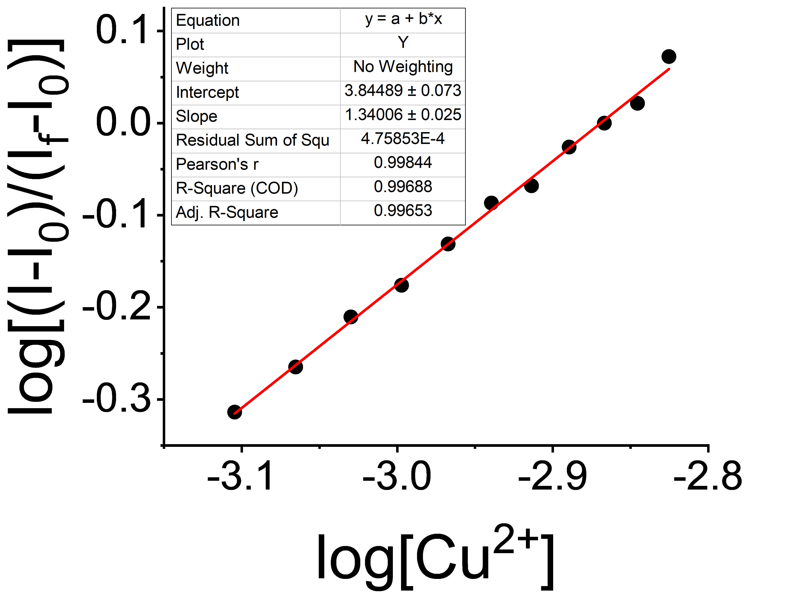
Supplementary Fig. 6: Benesi-Hildebrand plot. The stability constant derived from this plot was 6918.3±0.2 M⁻¹, similar to the known value for imidazole⁶.

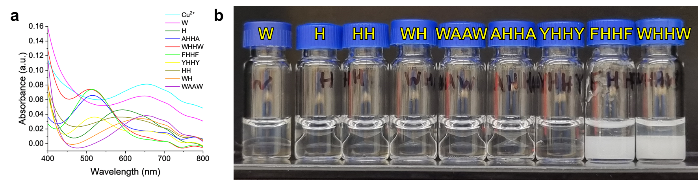
Supplementary Fig. 7: Control peptides. a, UV-vis spectra for mixtures of the peptide derivatives with Cu²⁺ ions. b, Chloroform-water mixtures with 1 mM of the peptide derivatives and 1 mM Cu²⁺ ions.
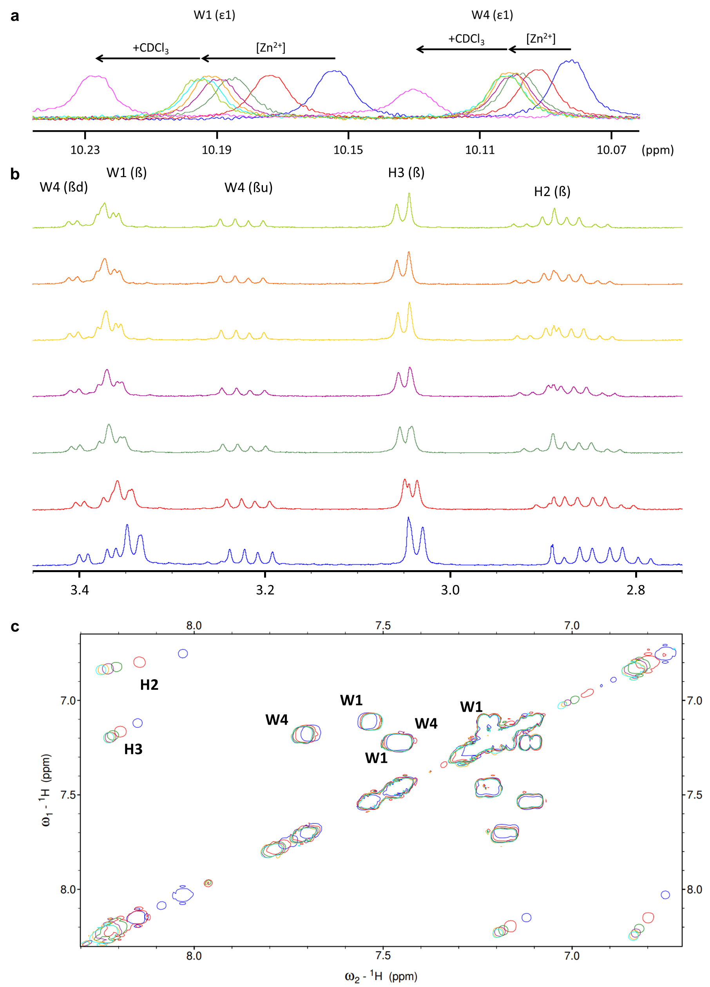
Supplementary Fig. 8: NMR analysis. a, ε1 peaks of the tryptophan side chains during the titration with Zn²⁺ ions and with CDCl₃. b, The aliphatic region of the peptide during titration with Zn²⁺ ions and with CDCl₃. c, The aromatic region of the peptide during titration with Zn²⁺ ions and with CDCl₃ by 2D COSY NMR.

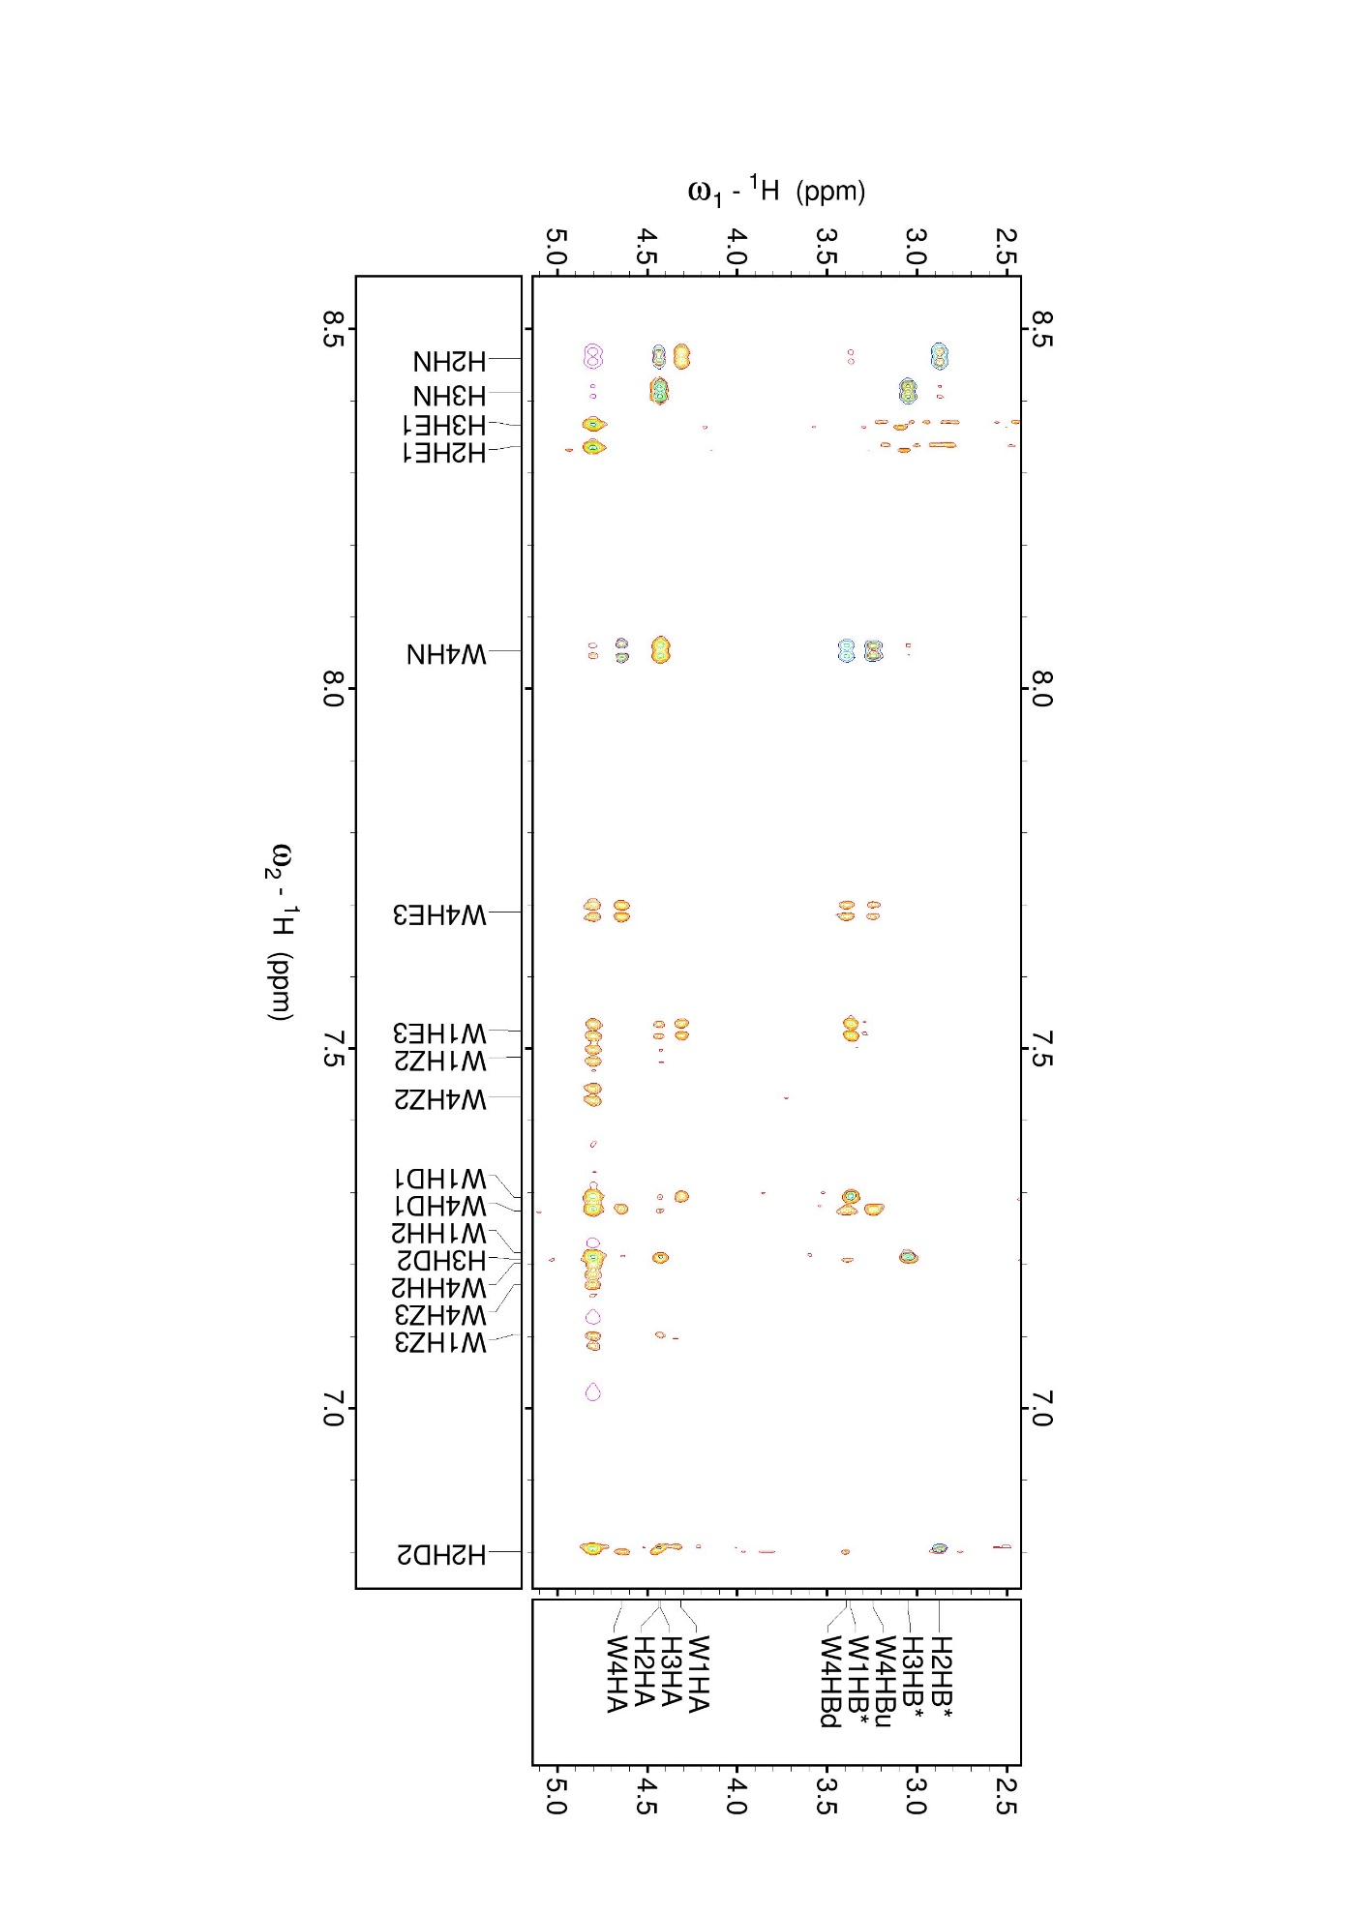
Supplementary Fig. 9: Emulsion NMR analysis. ¹H-¹H-NMR Fingerprint region of the peptide with ROESY (reds), TOCSY (blues), and COSY peaks (black).

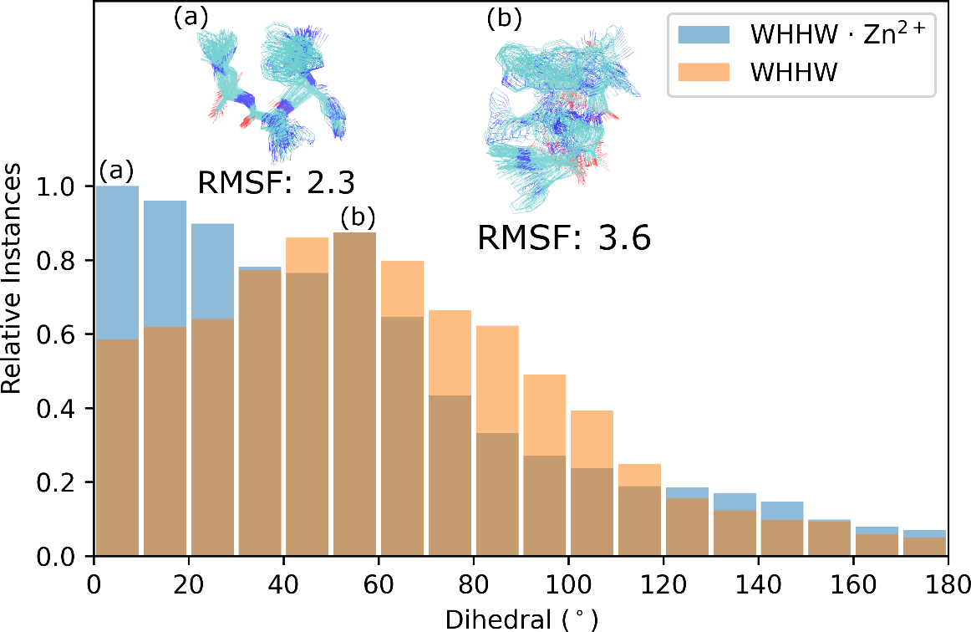
Supplementary Fig. 10: Peptide dihedral angle. Equilibration simulations (100 ns) of a single all-atom WHHW structure in aqueous solution with and without Zn²⁺ ions. The relative frequency of His-His dihedral occurrences is displayed in bins of 10°. The most populated bin is 0-10° when Zn²⁺ ions are present and 50-60° without ions. Inset are the root mean squared deviation minimized and time-averaged structures within bins (a) and (b).
To compare the effect of divalent cations on the His-His dihedral and stabilization of the peptide structure we used the AMBER94 forcefield⁷ with a timestep of 2 fs and constrained bond lengths for all hydrogen atoms to simulate a WHHW monomer in solution with and without Zn²⁺ ions.

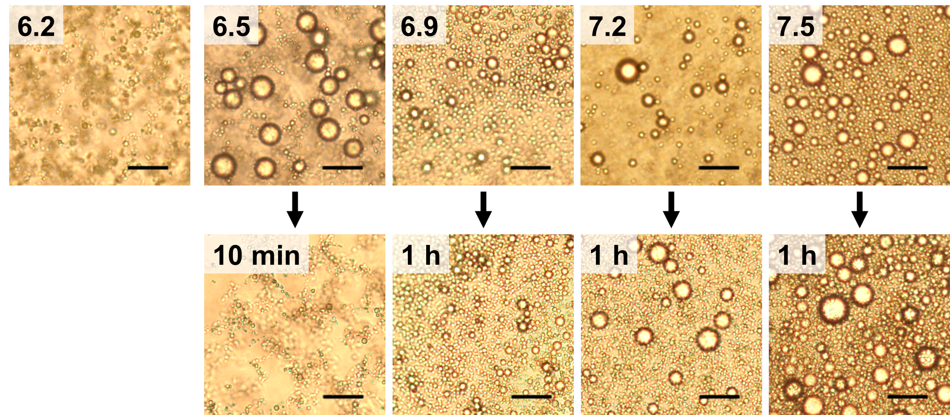
Supplementary Fig. 11: Emulsion pH-dependent stability. Representative light microscopy images of emulsions stabilized with a peptide-Zn²⁺ complex using paraffin oil, after addition to buffers with varying pH values. Scale bar, 50 µm.

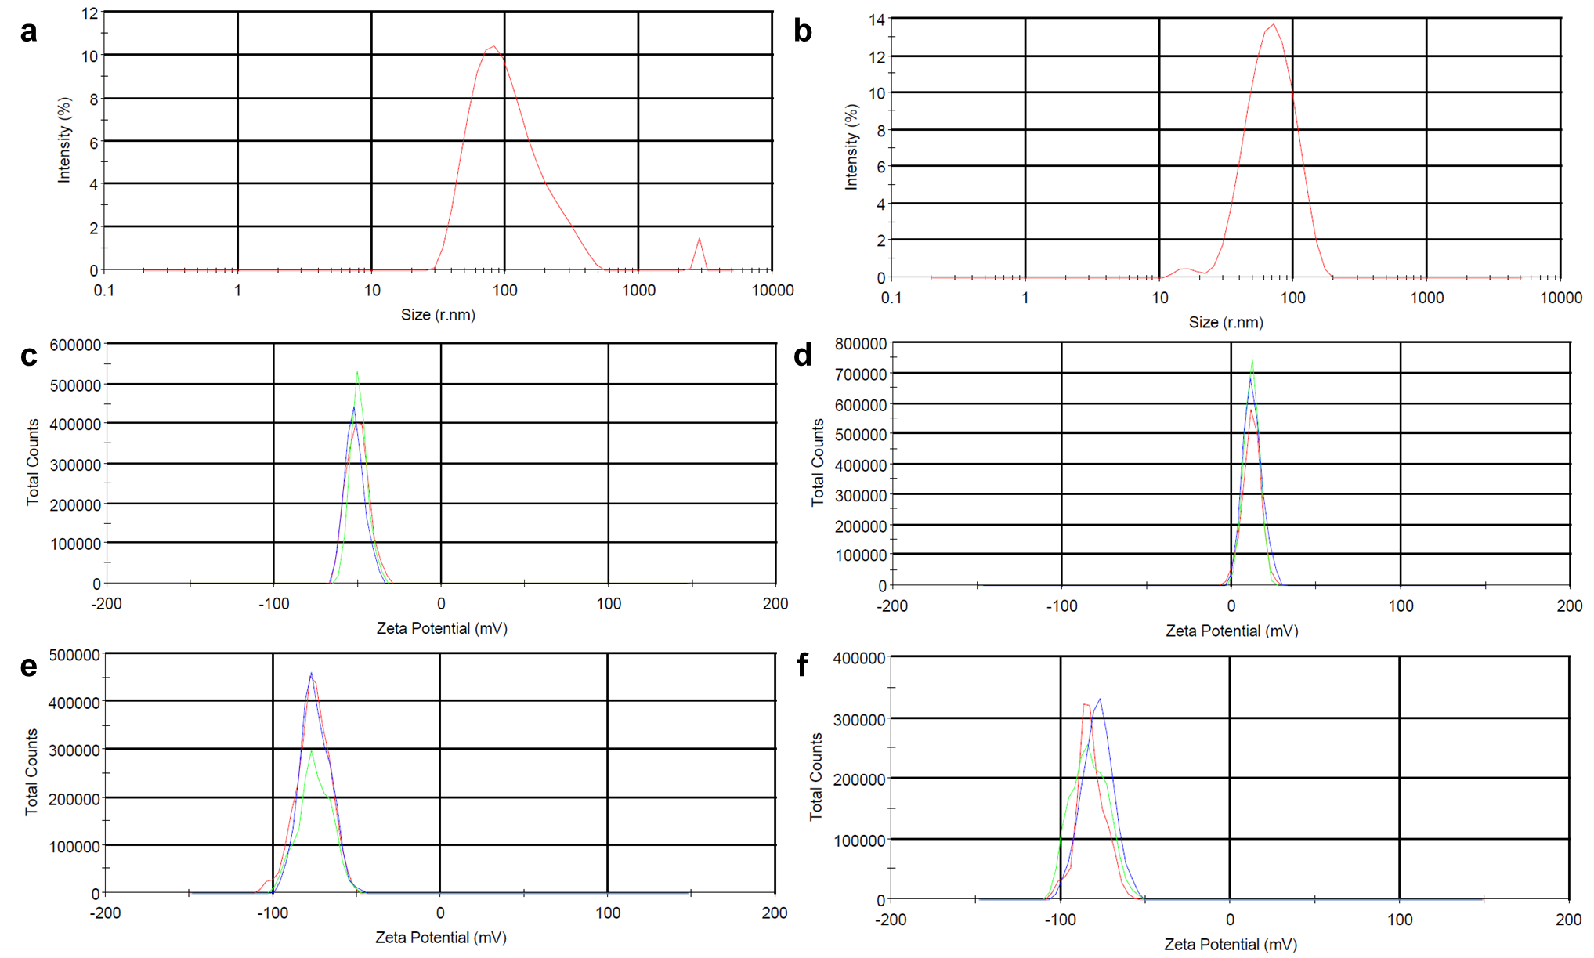
Supplementary Fig. 12: ζ potential measurements. a, DLS size distribution for the peptide-Zn²⁺-stabilized emulsion. b, DLS size distribution for the peptide-Zn²⁺-stabilized emulsion after filtration with a 0.45 µm filter. c, ζ-potential distribution for a peptide-Zn²⁺-stabilized emulsion. d, ζ-potential distribution for the same emulsion with ~0.2 eq. of H₆-Rh. e, ζ-potential distribution for a peptide-Cu²⁺-stabilized emulsion. f, ζ-potential distribution for the same emulsion with 0.2 µg/mL of the HRP probe.

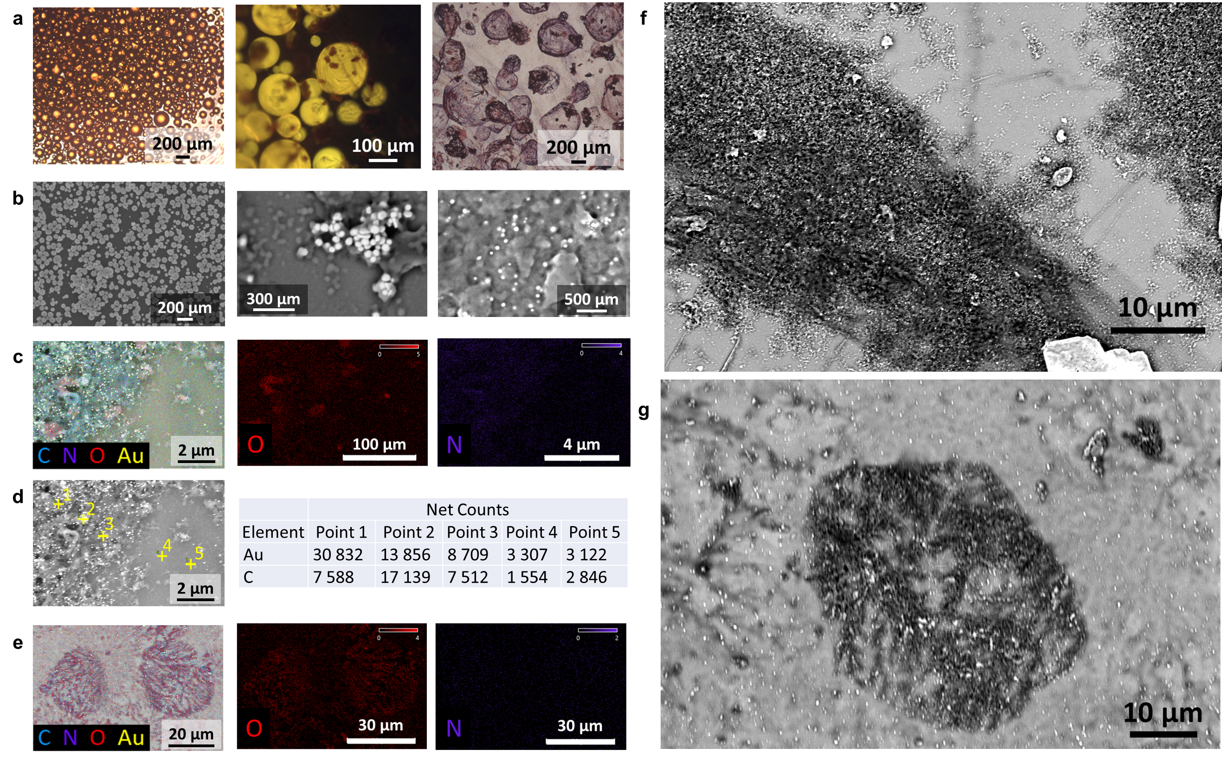
Supplementary Fig. 13: AuNPs coating. a, Drying process of an emulsion prepared with a peptide-Cu²⁺ complex and benzene labeled with nile red as the non-aqueous phase. b, SEM images of the H₆-F₂-Y*-AuNPs. c, EDS mapping of the dry peptide-stabilized emulsion with H₆-F₂-Y*-AuNPs. d, EDS point scan data of the dry peptide-stabilized emulsion with H₆-F₂-Y*-AuNPs. e, EDS mapping of the dry SDS-stabilized emulsion with H₆-F₂-Y*-AuNPs. f, SEM image of the dry peptide-stabilized emulsion with H₆-F₂-Y*-AuNPs. g, SEM image of the dry SDS-stabilized emulsion with H₆-F₂-Y*-AuNPs.

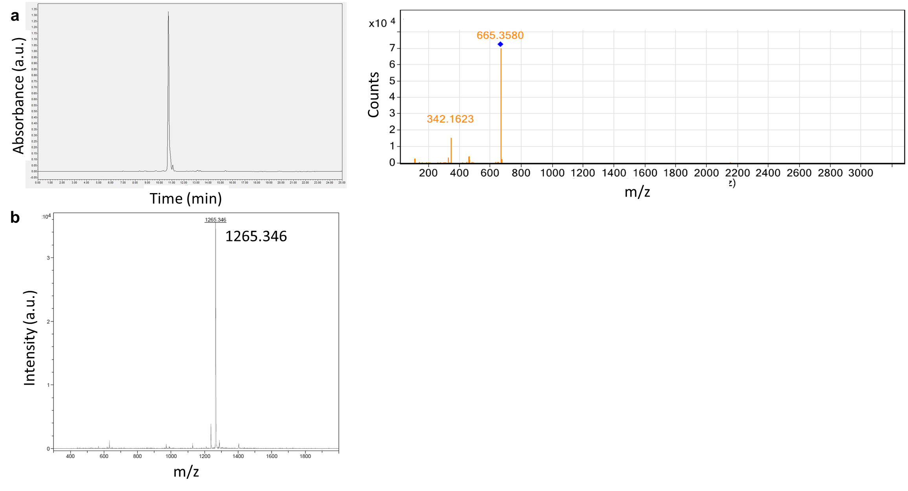
Supplementary Fig. 14: Peptide identity and purity. a, Analytical HPLC chromatogram (280 nm) and MS analysis for WHHW. b, MALDI TOF/TOF analysis for the H₆-Rh peptide.

Supplementary table
Residue | Proton | Apo | Zn²⁺ | CDCl₃ | Δδ_{a}  (Zn²⁺-Apo) | Δδ_{b}  (CDCl₃-Zn²⁺)
 |  | ppm | ppm | ppm | Hz | Hz
W1 | δ₁ | 7.25 | 7.29 | 7.29 | 18.22 | 0.05
 | ε₁ | 10.15 | 10.19 | 10.23 | 20.0 | 17.1
 | ε₃ | 7.47 | 7.47 | 7.49 | -0.4 | 11.4
 | ζ₂ | 7.54 | 7.53 | 7.52 | -5.1 | -2.1
 | ζ₃ | 7.20 | 7.20 | 7.22 | -0.4 | 7.7
 | η₂ | 7.10 | 7.11 | 7.10 | 2.5 | -7.3
H2 | HN | n.d. | n.d. | 8.488 | n.d. | n.d.
 | H_{ß} | 2.83 | 2.88 | 2.872 | 25.7 | -3.6
 | δ₂ | 6.75 | 6.84 | 6.78 | 43.8 | -29.0
 | ε₁ | 8.03 | 8.24 | 8.41 | 109.136 | 85.363
H3 | HN | n.d. | n.d. | 8.445 | n.d. | n.d.
 | H_{ß} | 3.03 | 3.05 | 3.05 | 8.5 | 0.5
 | δ₂ | 7.19 | 7.19 | 7.21 | 37.8 | 6.1
 | ε₁ | 8.15 | 8.23 | 8.35 | 39.6 | 60.6
W4 | HN | 7.75 | 7.79 | 8.15 | 23.4 | 180.7
 | δ₁ | 7.25 | 7.27 | 7.276 | 7.8 | 3.3
 | ε₁ | 10.08 | 10.10 | 10.13 | 9.4 | 14.6
 | ε₃ | 7.43 | 7.45 | 7.43 | 10.1 | -14.2
 | ζ₂ | 7.69 | 7.71 | 7.68 | 12.9 | -17.7
 | ζ₃ | 7.22 | 7.22 | 7.23 | 1.1 | 5.5
 | η₂ | 7.17 | 7.18 | 7.16 | 4.8 | -6.5
Supplementary Table 1: NMR analysis. ¹H chemical shift values for the free peptide, peptide with Zn²⁺ ions (1 eq.), and peptide with Zn²⁺ ions and with 15% (v/v) CDCl₃.

References
1 Chai, J.-D. & Head-Gordon, M. Systematic optimization of long-range corrected hybrid density functionals. J. Chem. Phys. 128, 084106 (2008).
2 Weigend, F. & Ahlrichs, R. Balanced basis sets of split valence, triple zeta valence and quadruple zeta valence quality for H to Rn: Design and assessment of accuracy. Phys. Chem. Chem. Phys. 7, 3297-3305 (2005).
3 Barone, V. & Cossi, M. Quantum calculation of molecular energies and energy gradients in solution by a conductor solvent model. J. Phys. Chem. A 102, 1995-2001 (1998).
4 Neese, F., Wennmohs, F., Becker, U. & Riplinger, C. The ORCA quantum chemistry program package. J. Chem. Phys. 152, 224108 (2020).
5 Caldeweyher, E., Bannwarth, C. & Grimme, S. Extension of the D3 dispersion coefficient model. J. Chem. Phys. 147, 034112 (2017).
6 Chakravorty, A. & Cotton, F. STABILITY CONSTANTS AND STRUCTURES OF SOME METAL COMPLEXES WITH IMIDAZOLE DERIVATIVES. J. Phys. Chem. 67, 2878-2879 (1963).
7 Cornell, W. D. et al. A second generation force field for the simulation of proteins, nucleic acids, and organic molecules. J. Am. Chem. Soc. 117, 5179-5197 (1995).

