Supplementary material for the article: The Red Queen hypothesis from a structural perspective.

Supplementary Figure 1: Proportion (percentage) and year of detection of main Brazilian dengue lineages. In Brazil, the evolution of dengue serotypes has been a significant public health challenge. Dengue is a viral disease transmitted mainly by the Aedes aegypti mosquito and is caused by four distinct serotypes: DENV-1, DENV-2, DENV-3 and DENV-4. Over the years, there has been an alternation of predominant serotypes, which has a direct impact on the severity of outbreaks and on the immune response of the population. Since the 1980s, Brazil has had dengue epidemics caused mainly by serotypes DENV-1, DENV-2 and DENV-3. DENV-4, on the other hand, was first detected in the country in 2010 and since then there has been concern about its spread. The alternation of dengue serotypes is worrying because infection with a specific serotype confers long-term immunity against the same serotype, but only partial and temporary immunity against the other serotypes. This means that the population may be more susceptible to infections by serotypes other than those to which it has already been exposed, increasing the risk of more severe cases, such as dengue hemorrhagic fever and dengue shock syndrome.

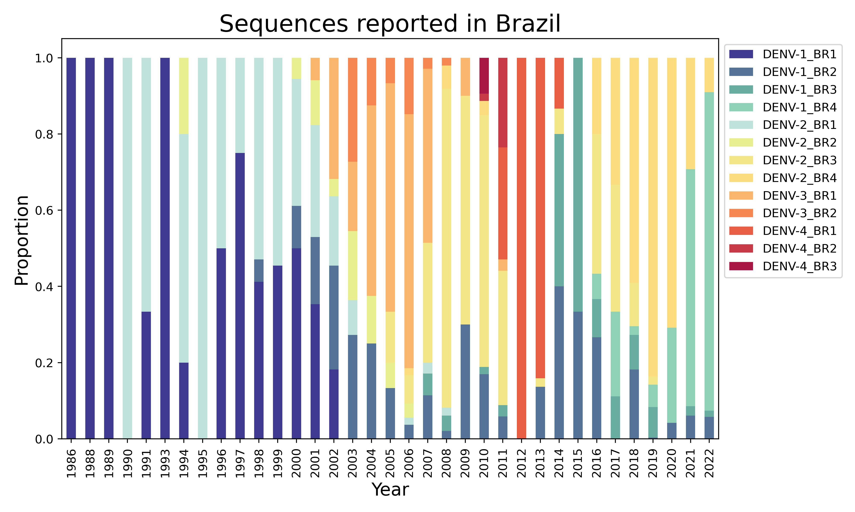

Supplementary Figure 2: Tanglegram between a phylogeny of Whole Genome and Envelope region of Dengue virus. The tanglegram methodology is a visual approach used in phylogenetic analysis to compare and relate independent phylogenetic trees across different data sets. The tanglegram represents the phylogenetic trees as interconnected linear diagrams, where the corresponding nodes between the trees are connected by lines. This representation allows the visualization of correspondence and discordance relationships between tree topologies, revealing coevolution patterns or shared speciation events. The tanglegram is useful for comparing similarity and agreement between phylogenetic trees constructed with different data sets, such as different genes or species. This methodology provides a more comprehensive view of the evolutionary relationships between organisms and helps in understanding the underlying evolutionary processes.

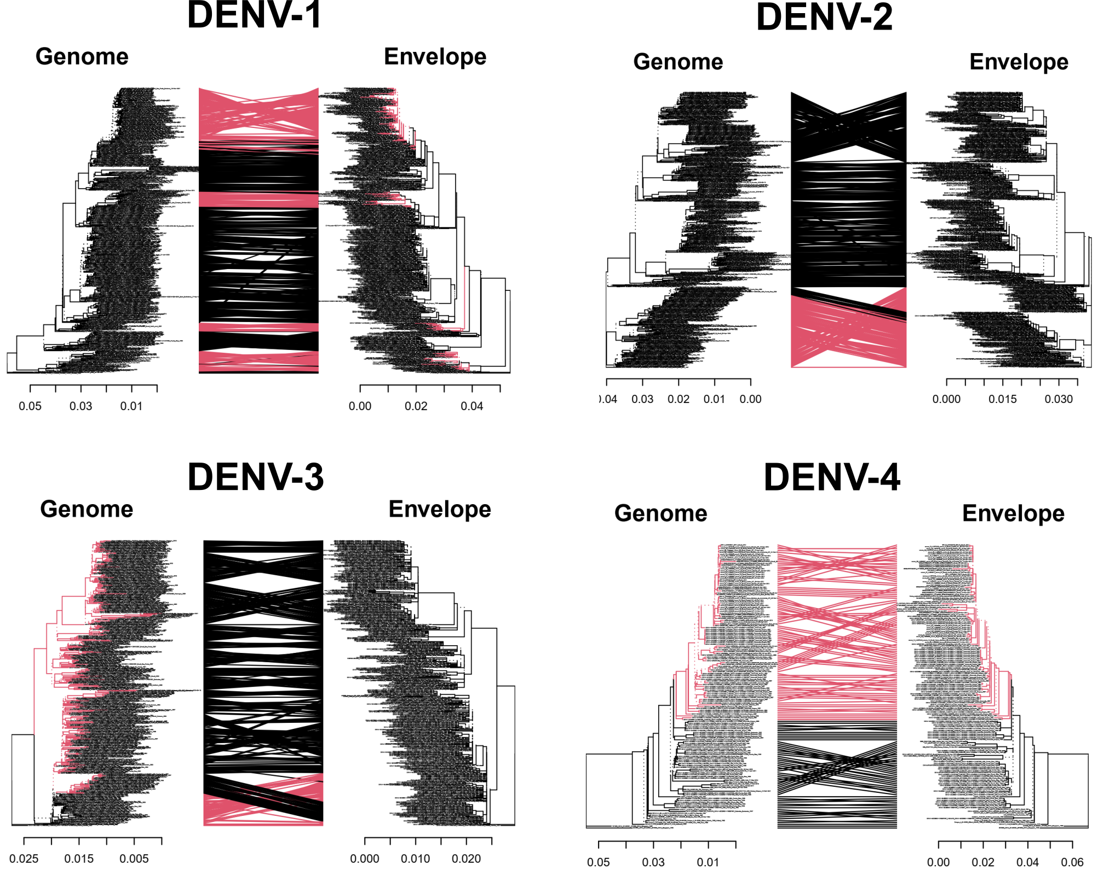

Supplementary Figure 3: Proportion (percentage) and year of detection of each Brazilian dengue lineages. Dengue is an endemic disease in Brazil, with the country presenting a high proportion of cases over the years. The incidence of the disease varies seasonally, with peaks during the warmest and wettest months, which are favorable for the reproduction of the vector mosquito, Aedes aegypti. Brazil has recorded millions of dengue cases annually, with significant geographic variations. States such as São Paulo, Minas Gerais, Bahia and Paraná often report the highest number of cases. The proportion of dengue cases in Brazil demonstrates the continued importance of epidemiological surveillance, the adoption of vector control measures and public awareness to combat this disease and minimize its impact on the population's health. The figure below summarizes these findings based on the most prevalent genotype over time.
s
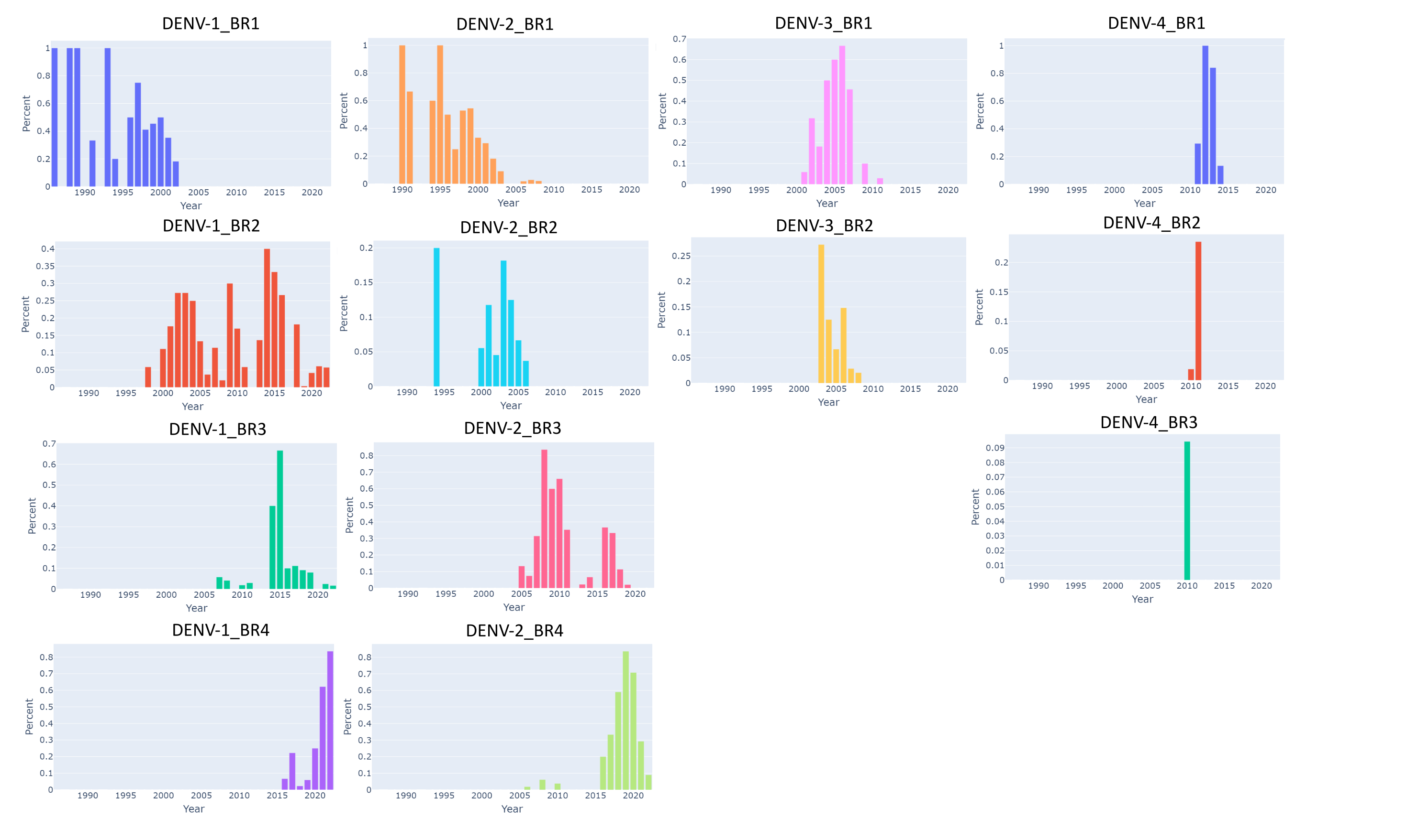
Supplementary table 1: DOPE scores per residue

See attached file

Supplementary figure 4 : DOPE scores (Discrete Optimized Protein Energy) are a measure used to evaluate the structural quality of proteins. These scores provide an estimate of potential energy and stability of protein structures, based on physicochemical parameters. The more negative the DOPE score, the better the quality of the structure, indicating a more stable conformation and probably closer to the real three-dimensional structure of the protein. This score is widely used in protein modeling to select and optimize the best structures, helping to understand their functioning and molecular interactions. Here all sequences modeled were plotted together as per-residue scores.

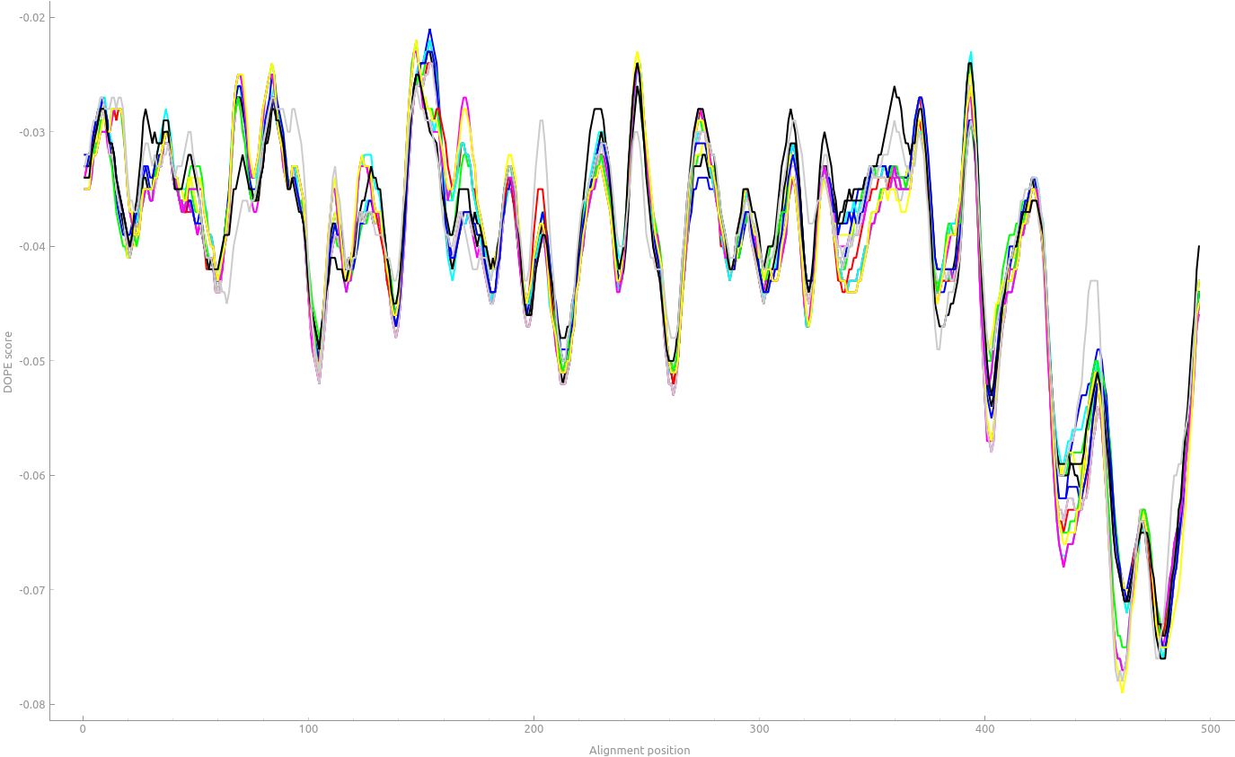
Supplementary table 2: Structural divergence calculated in PyMol

See attached file

Supplementary figure 5: Structural divergence in proteins refers to differences in three-dimensional structures between evolutionarily related proteins. During the process of evolution, proteins can undergo mutations and modifications that lead to changes in their amino acid sequence. These alterations can result in structural variations, where proteins acquire different three-dimensional conformations. Structural divergence can occur at different levels, from small local changes to large structural rearrangements. These structural differences can affect protein function and interactions, resulting in different biological properties.

Root mean squared deviations (RMSD) of the alpha carbons measured after energy minimization in vacuum of the structures are presented in supplementary table 3.
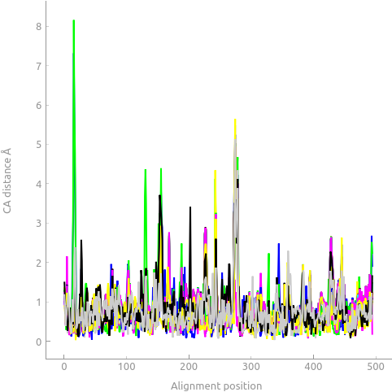

Supplementary table 3: Root-Mean-Square Deviations (RMSD) of the alpha carbons measured after energy minimization in vacuum of the modeled structures . RMSD is a metric widely used in protein analysis to assess the structural similarity between two or more protein structures. RMSD measures the difference between the positions of atoms in the compared structures and provides a quantitative measure of conformational variability. The lower the RMSD value, the greater the structural overlap between the proteins under analysis. This metric is especially useful in comparing experimental or modeled protein structures, allowing assessment of the accuracy of a predictive model against the known reference structure. The RMSD is an essential tool for understanding the structure-function relationship of proteins and plays a key role in the field of structural bioinformatics.

See attached file

Supplementary figure 6A: DENV1_BR2_1997-2002 MM/GBSA results. The GBSA method (Generalized Born with a Simple Switching Function) is a molecular mechanics approach used to calculate solvation energies in biological systems. This technique allows estimating the interactions between a molecule and its solvent environment, which play a crucial role in molecular stability and dynamics. GBSA uses a simplified solvation function, based on the Born model, to efficiently calculate solvation energies. This approach is particularly useful in studies of large biological systems, where the detailed calculation of all solvent molecules is computationally infeasible. The GBSA method provides valuable information on the thermodynamic and conformational properties of proteins, allowing the understanding of the effects of the solvent environment on biological processes and aiding in drug development and protein design.

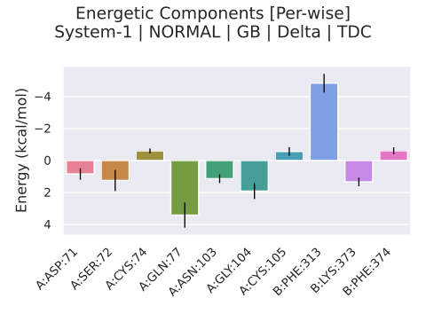
Supplementary figure 6B: DENV1_BR2_1997-2002 MM/GBSA heatmap of interactions: Ligand (DENV1_BR2_1997-2002 envelope: A), Receptor (DC-SIGN: B).

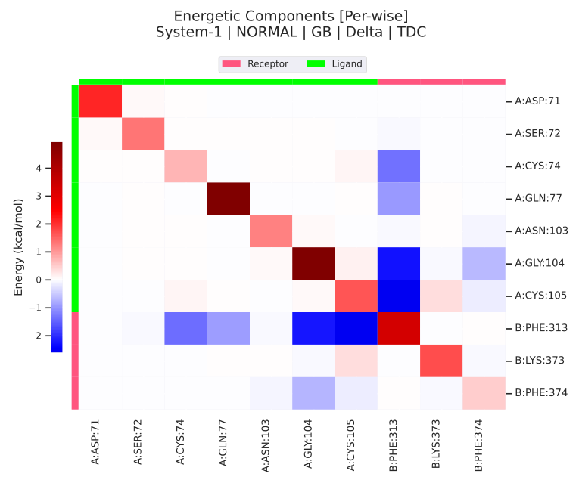
Supplementary figure 7A: DENV2_BR1_1990-2000 MM/GBSA results.

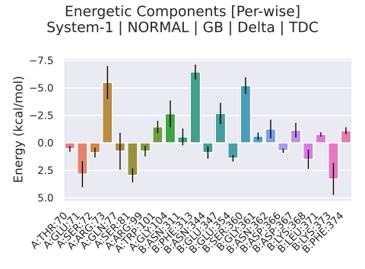
Supplementary figure 7B: DENV2_BR1_1990-2000 MM/GBSA heatmap of interactions: Ligand ( DENV2_BR1_1990-2000 envelope: A), Receptor (DC-SIGN: B).

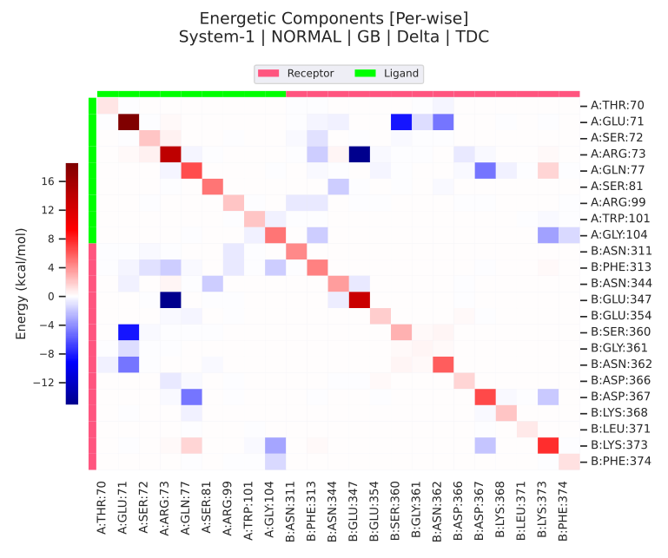
Supplementary figure 8A: DENV2_BR2_2000-2006 MM/GBSA results.

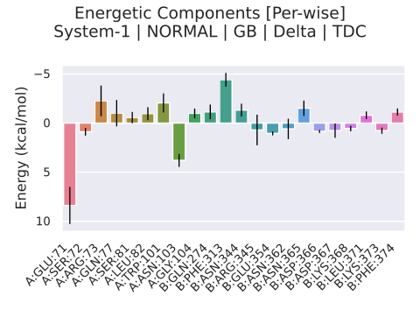
Supplementary figure 8B: DENV2_BR2_2000-2006 MM/GBSA heatmap of interactions: Ligand ( DENV2_BR2_2000-2006 envelope: A), Receptor (DC-SIGN: B).

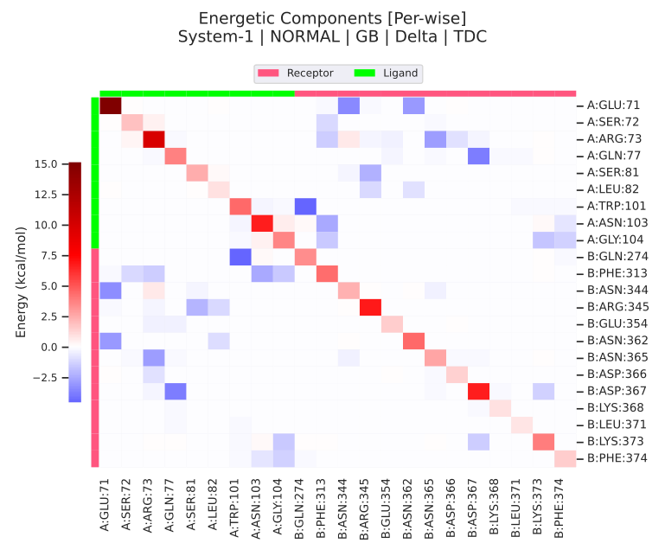

Supplementary figure 9A: DENV2_BR3_2008-2012 MM/GBSA results.

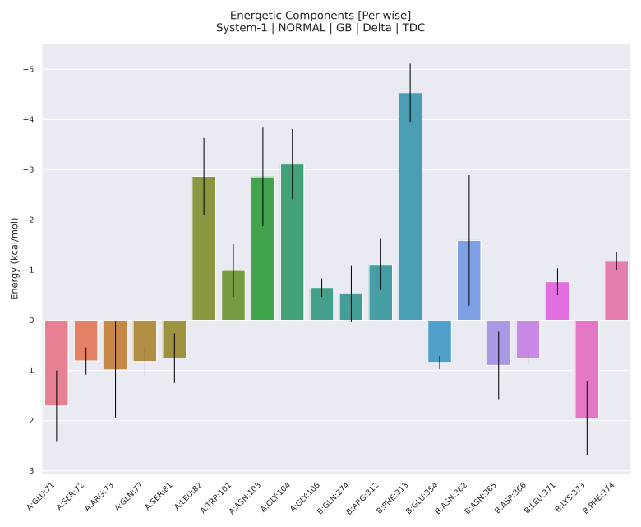

Supplementary figure 9B: DENV2_BR3_2008-2012 MM/GBSA heatmap of interactions: Ligand (DENV2_BR3_2008-2012 envelope: A), Receptor (DC-SIGN: B).

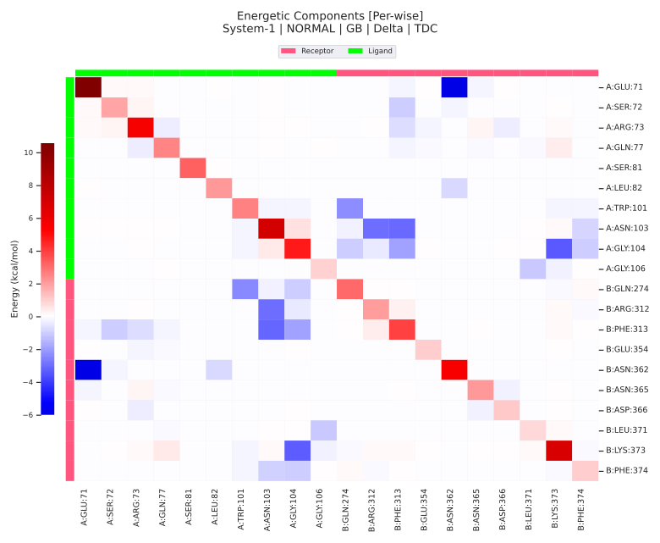
Supplementary figure 10A: DENV3 MM/GBSA results.

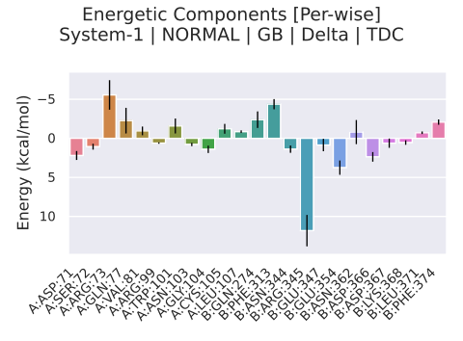
Supplementary figure 10B: DENV3 MM/GBSA heatmap of interactions: Ligand (DENV3 envelope: A), Receptor (DC-SIGN: B).

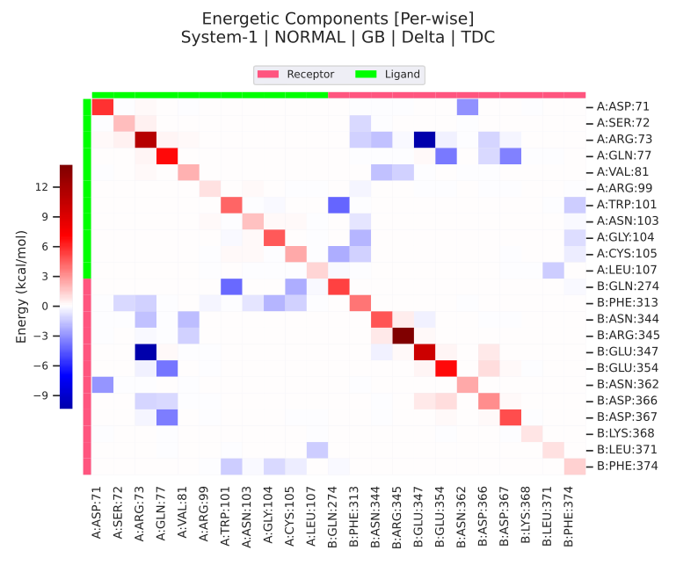

Supplementary figure 11A: DENV1-BR4_2007-2010 MM/GBSA results.

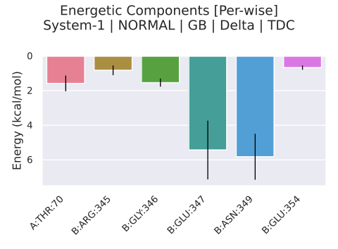
Supplementary figure 11B: DENV1-BR4_2007-2010 MM/GBSA heatmap of interactions: Ligand ( DENV1-BR4_2007-2010 envelope: A), Receptor (DC-SIGN: B).

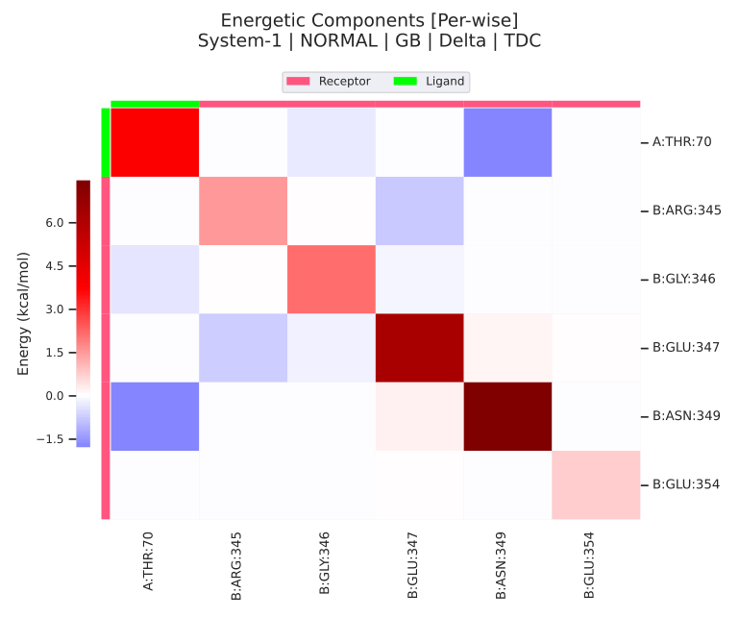
Supplementary figure 12A: DENV1_BR1_2010-2015 MM/GBSA results.

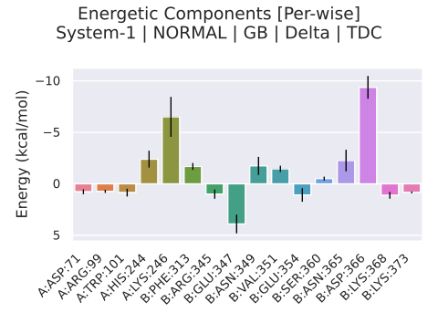
Supplementary figure 12B: DENV1_BR1_2010-2015 MM/GBSA heatmap of interactions: Ligand ( DENV1-BR4_2007-2010 envelope: A), Receptor (DC-SIGN: B).

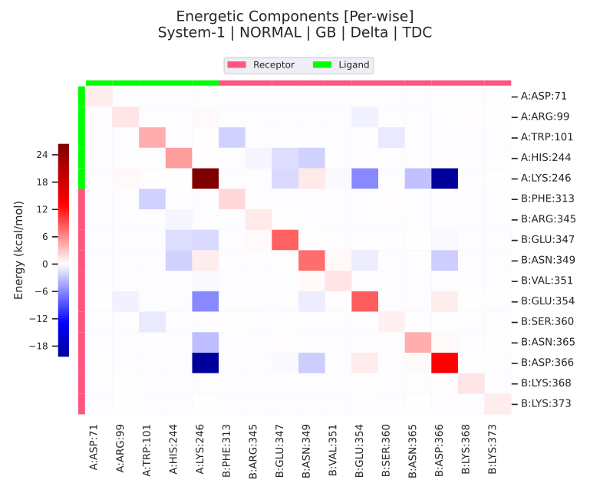
Supplementary figure 14A: DENV4 MM/GBSA results.

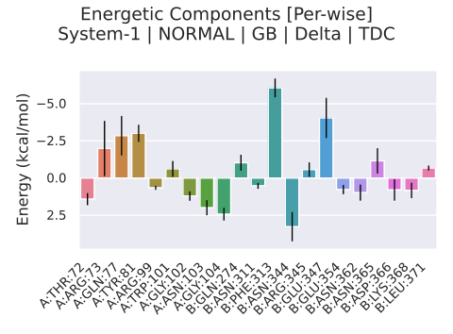
Supplementary figure 14B: DENV4 MM/GBSA heatmap of interactions: Ligand ( DENV4 envelope: A), Receptor (DC-SIGN: B).

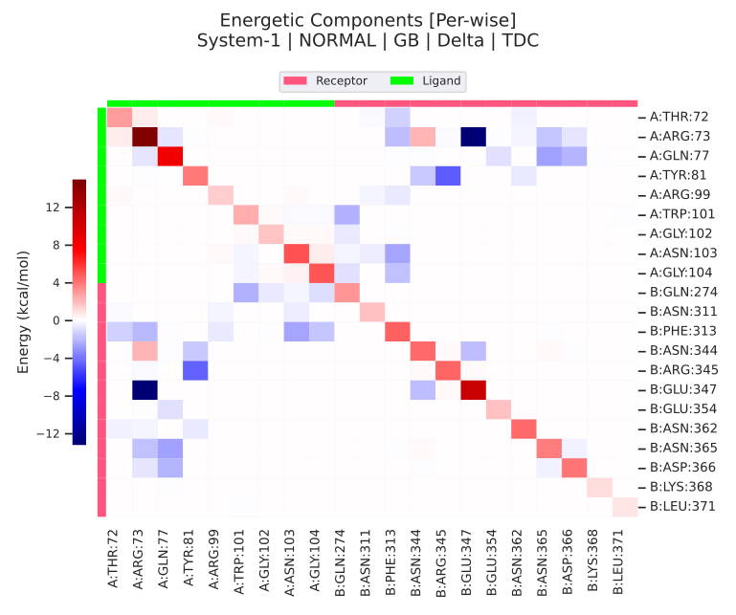
Supplementary figure 15A: DENV1_BR4-2014-2019 MM/GBSA results.

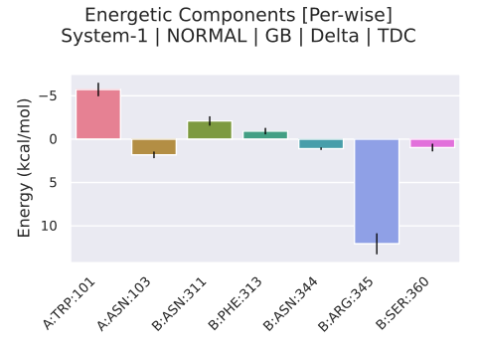
Supplementary figure 15B: DENV1_BR4-2014-2019 MM/GBSA heatmap of interactions: Ligand ( DENV1_BR4-2014-2019 envelope: A), Receptor (DC-SIGN: B).

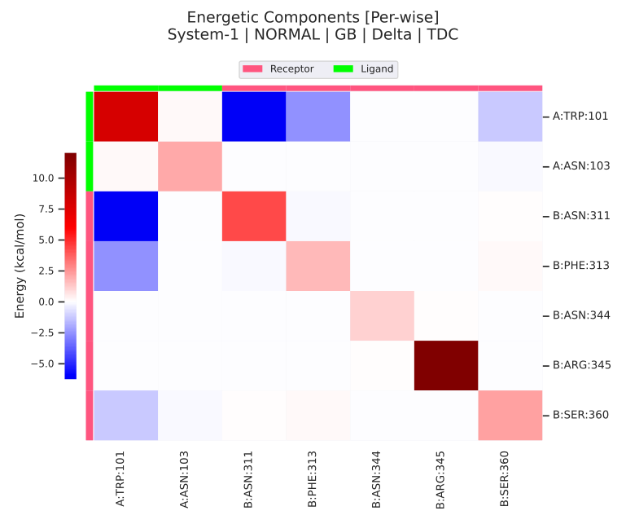
Supplementary figure 16A: DENV1_BR5_2014-2019 MM/GBSA results.

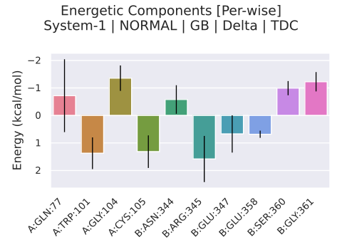
Supplementary figure 16B: DENV1_BR5_2014-2019 MM/GBSA heatmap of interactions: Ligand ( DENV1_BR5_2014-2019 envelope: A), Receptor (DC-SIGN: B).

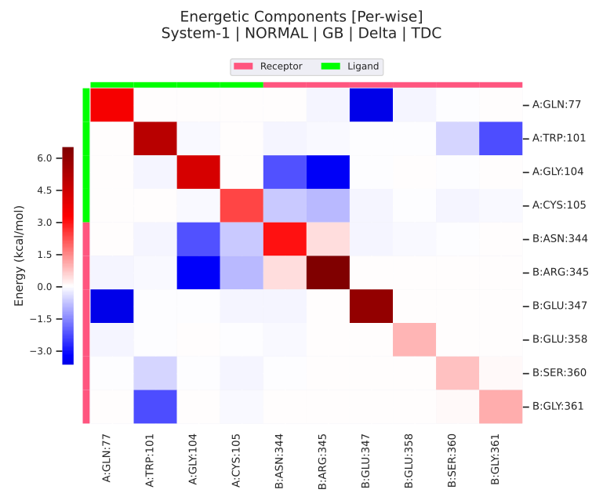
Supplementary figure 17A: DENV2_BR3_2016-2018 MM/GBSA results.

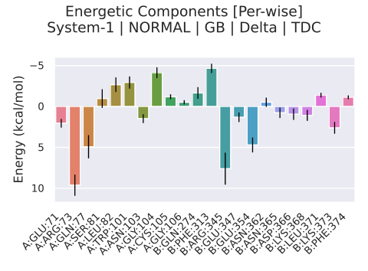
Supplementary figure 17B: DENV2_BR3_2016-2018 MM/GBSA heatmap of interactions: Ligand ( DENV2_BR3_2016-2018 envelope: A), Receptor (DC-SIGN: B).

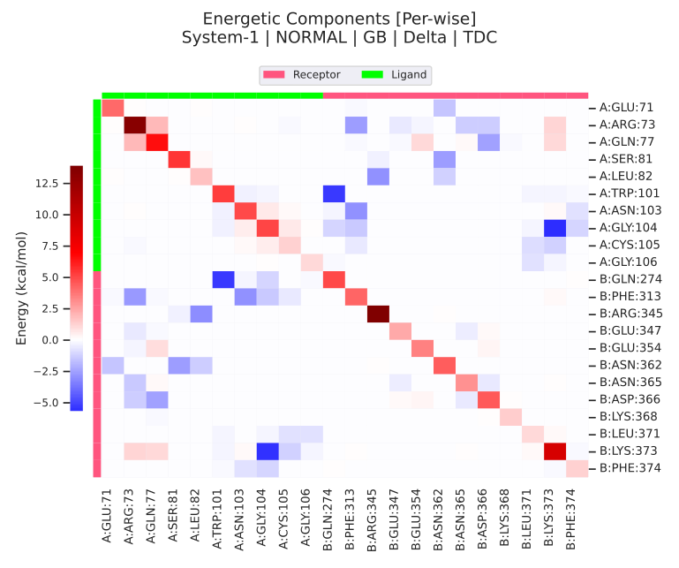
Supplementary figure 18A: DENV2_BR4_2019-2022 MM/GBSA results.

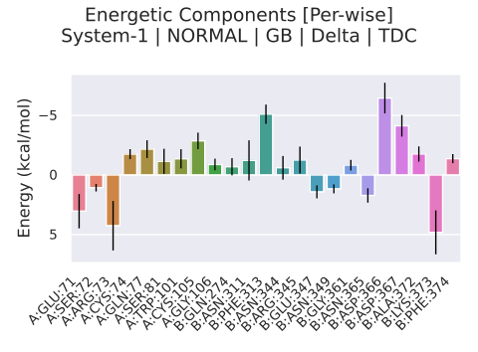
Supplementary figure 18B: DENV2_BR4_2019-2022 MM/GBSA heatmap of interactions: Ligand ( DENV2_BR4_2019-2022 envelope: A), Receptor (DC-SIGN: B).

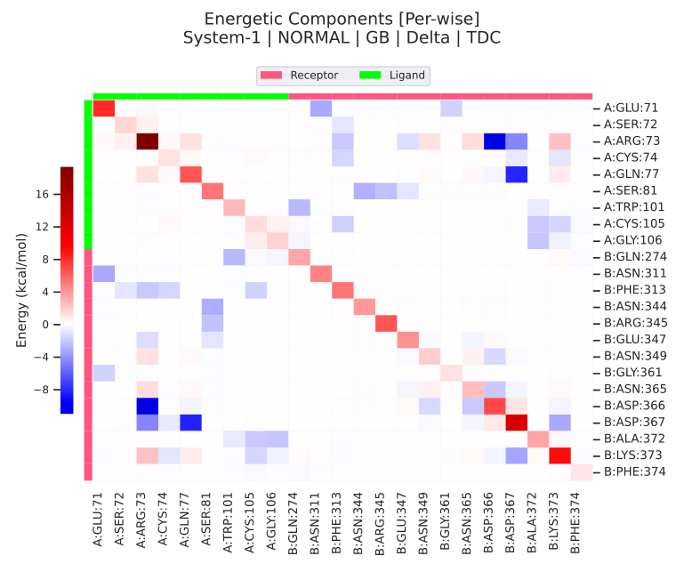
Supplementary figure 19A: DENV1_BR4_2019 MM/GBSA results.

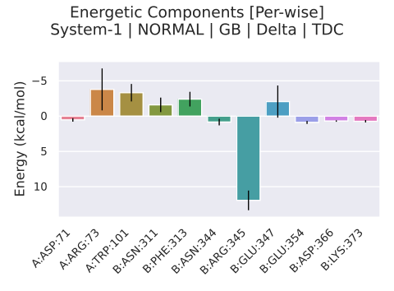
Supplementary figure 19B: DENV1_BR4_2019 MM/GBSA heatmap of interactions: Ligand ( DENV1_BR4_2019 envelope: A), Receptor (DC-SIGN: B).

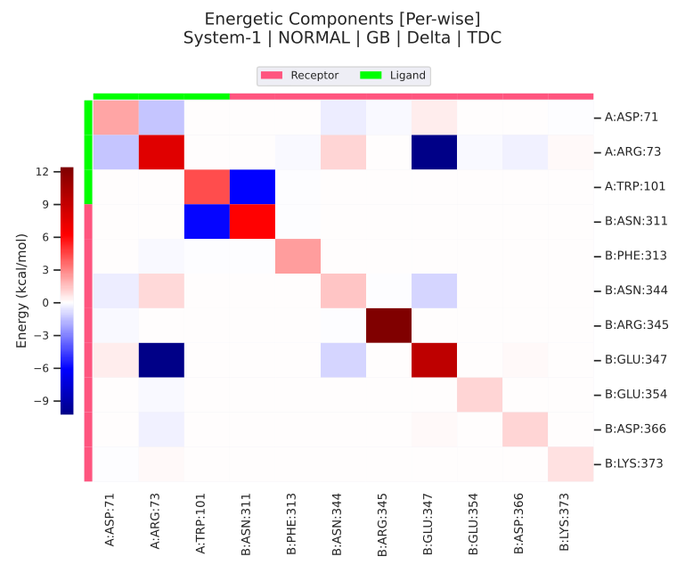
Supplementary figure 20A: DENV1_BR1_2022 MM/GBSA results.

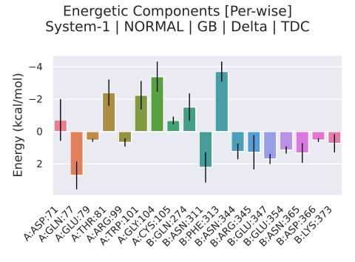
Supplementary figure 20B: DENV1_BR1_2022 MM/GBSA heatmap of interactions: Ligand ( DENV1_BR1_2022 envelope: A), Receptor (DC-SIGN: B).

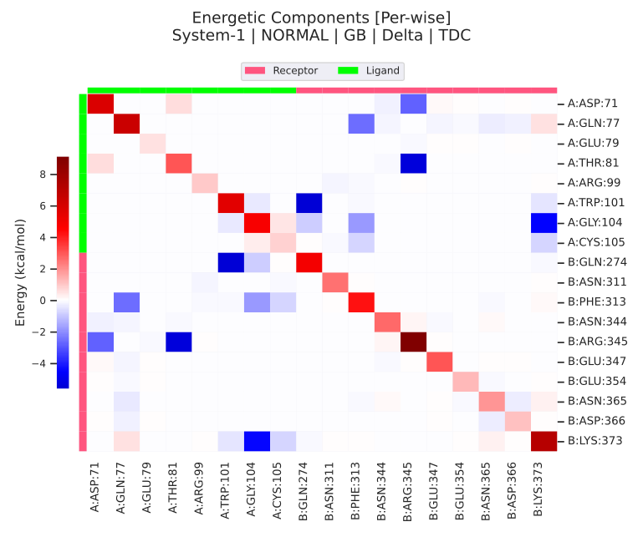
Supplementary figure 21A: DENV1_BR3_2022 MM/GBSA results.

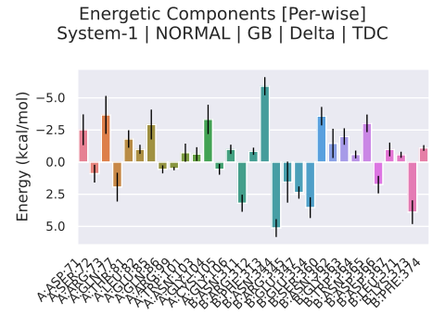
Supplementary figure 21B: DENV1_BR3_2022 MM/GBSA heatmap of interactions: Ligand ( DENV1_BR3_2022 envelope: A), Receptor (DC-SIGN: B).

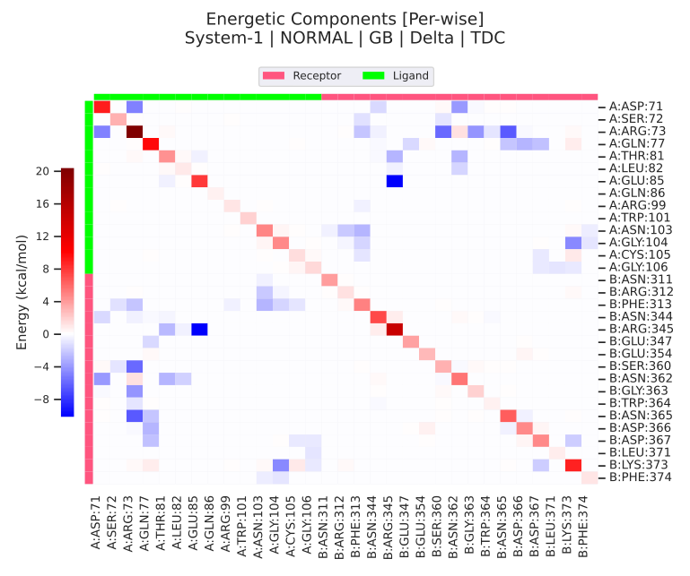
Supplementary figure 22A: DENV2_2022 MM/GBSA results.

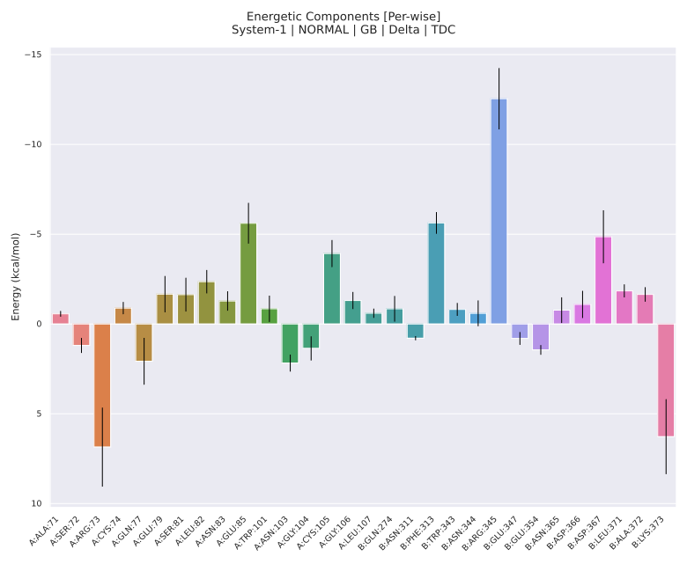
Supplementary figure 22B: DENV2_2022 MM/GBSA heatmap of interactions: Ligand ( DENV2_2022 envelope: A), Receptor (DC-SIGN: B).

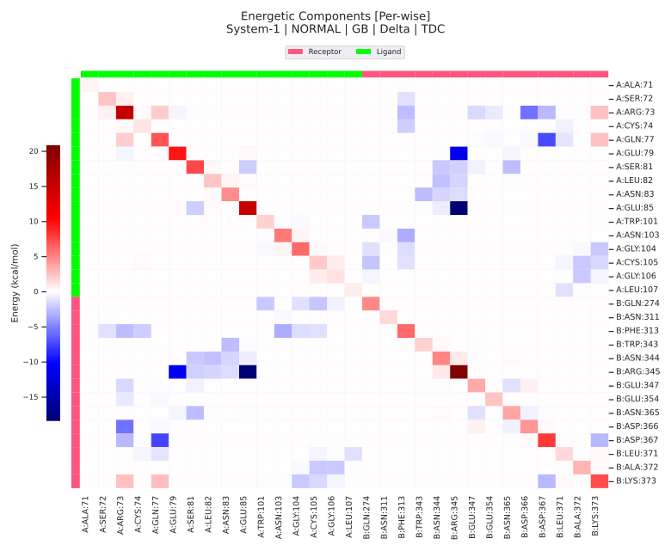
Supplementary figure 23: DENV1_BR2_1997-2002 – Electrostatic surface of the modeled proteins predicted by the Adaptive Poisson-Boltzmann Solver (APBS) website. APBS is a widely used program to calculate the electrostatic surfaces of molecules and biomolecular complexes. This approach is based on the solution of the Poisson-Boltzmann equation, which describes the distribution of electrical charges and the effects of the solvent around biomolecules. APBS allows predicting the electrostatic surfaces of molecules, which are represented as electrostatic potential maps. These maps provide valuable information about electrostatic interactions, such as the location of binding sites, regions of positive or negative charge, and interactions between molecules. The electrostatic surfaces predicted by APBS help in the understanding of the structure and function of biomolecules, as well as in the design of experiments and in the rational design of drugs and proteins based on electrostatic interactions.

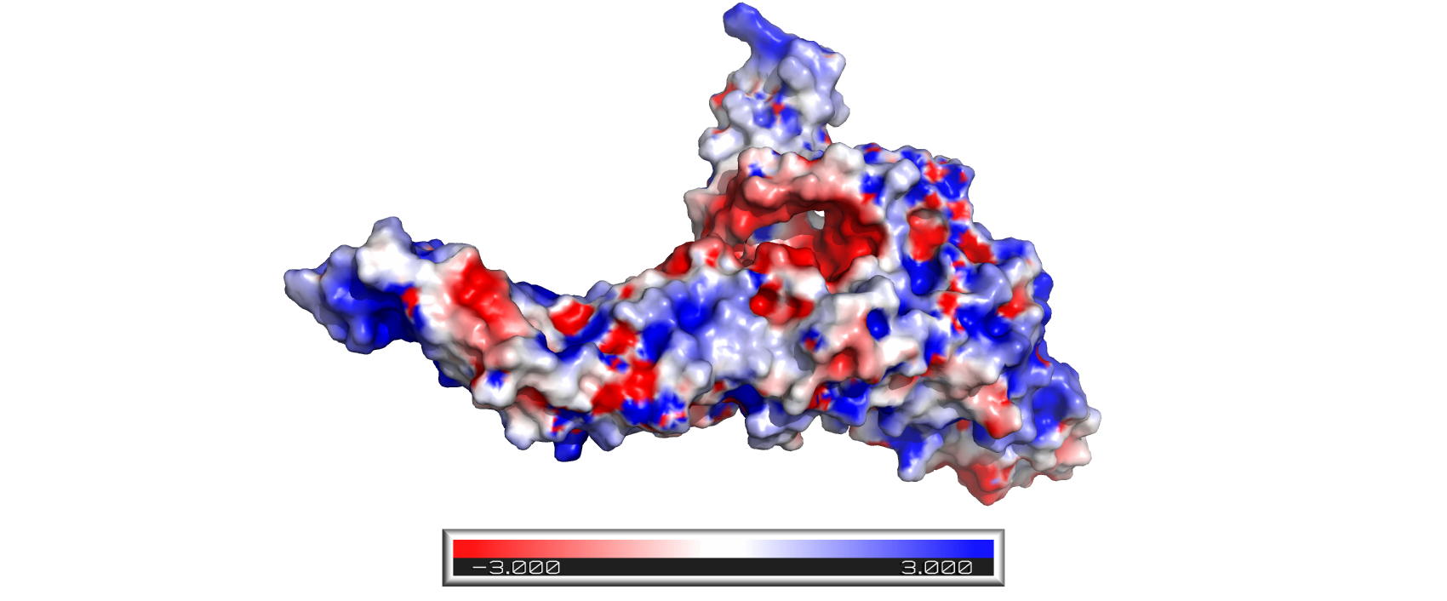
Supplementary figure 24: DENV2_BR1_1990-2000.

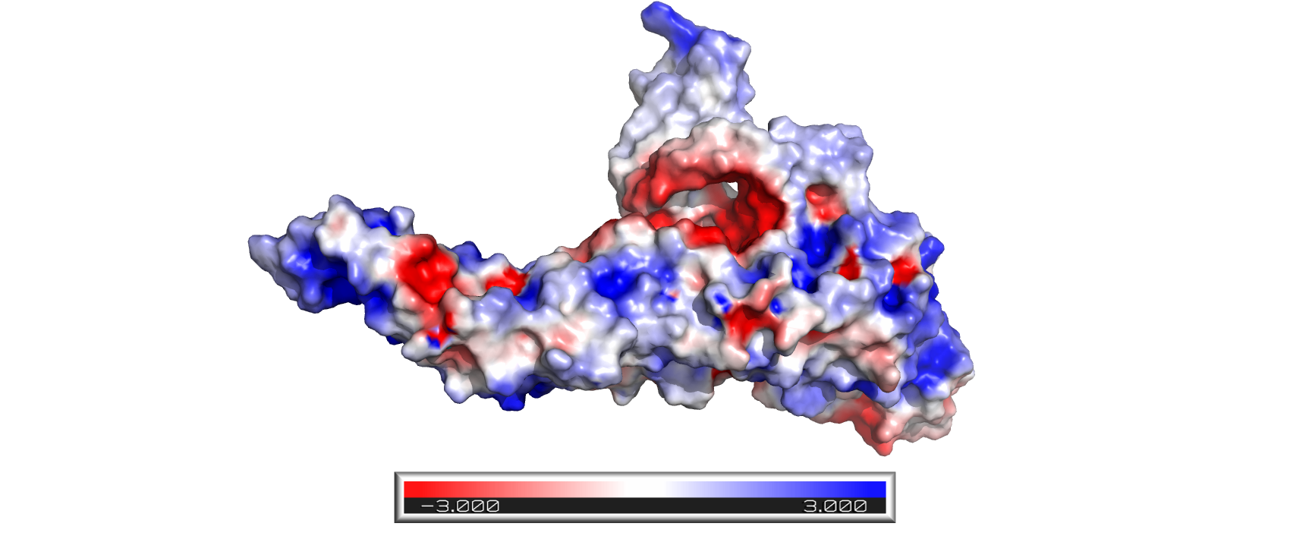
Supplementary figure 25: DENV2_BR2_2000-2006.
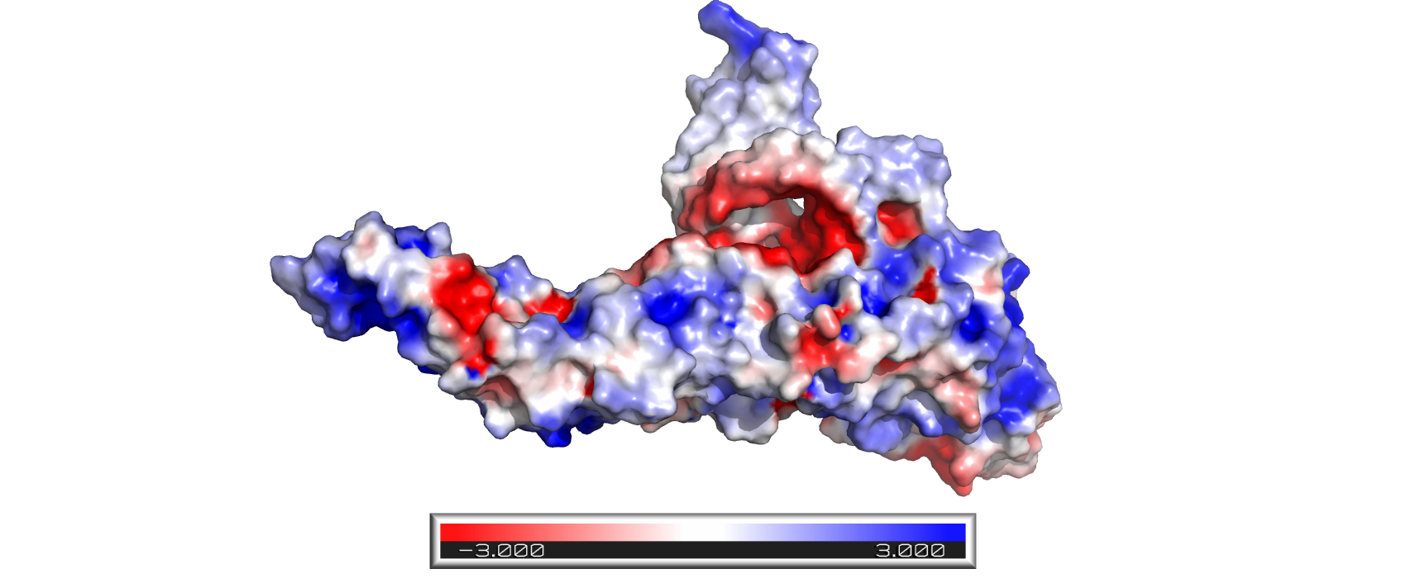

Supplementary figure 26: DENV2_BR3_2008-2012.

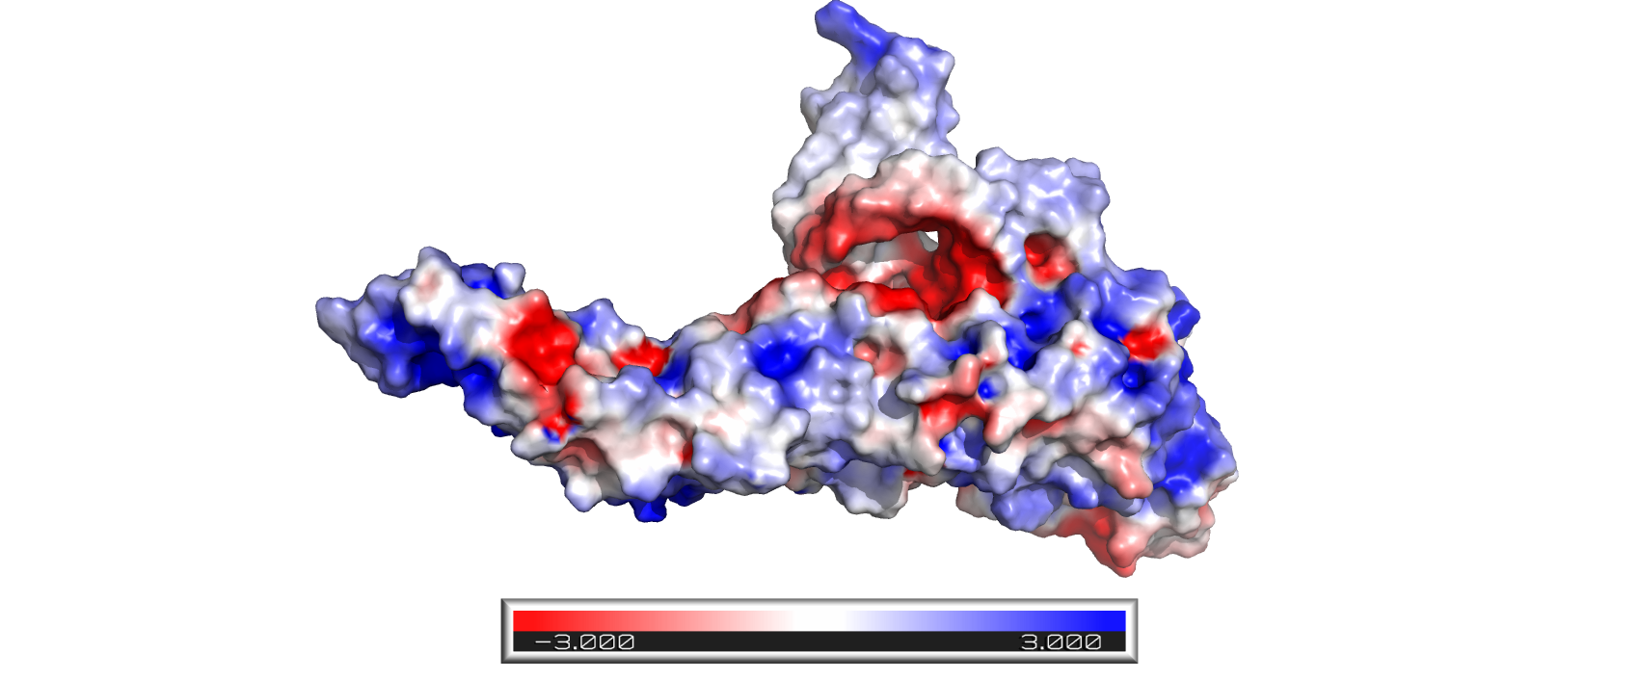
Supplementary figure 27: DENV3.

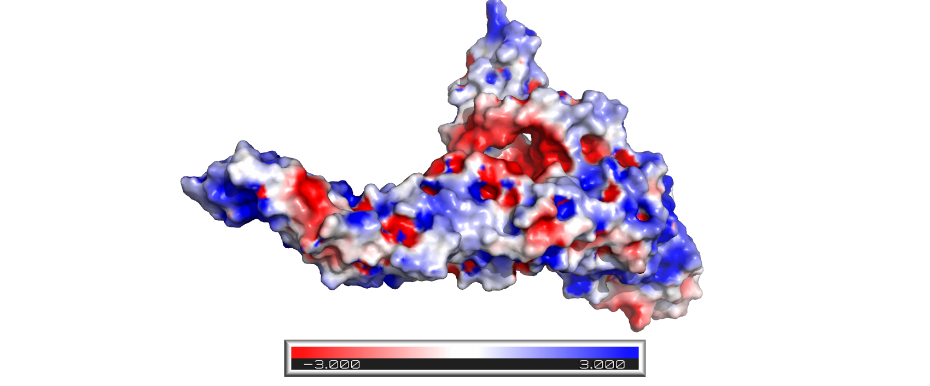
Supplementary figure 28: DENV1_BR4_2007-2010.
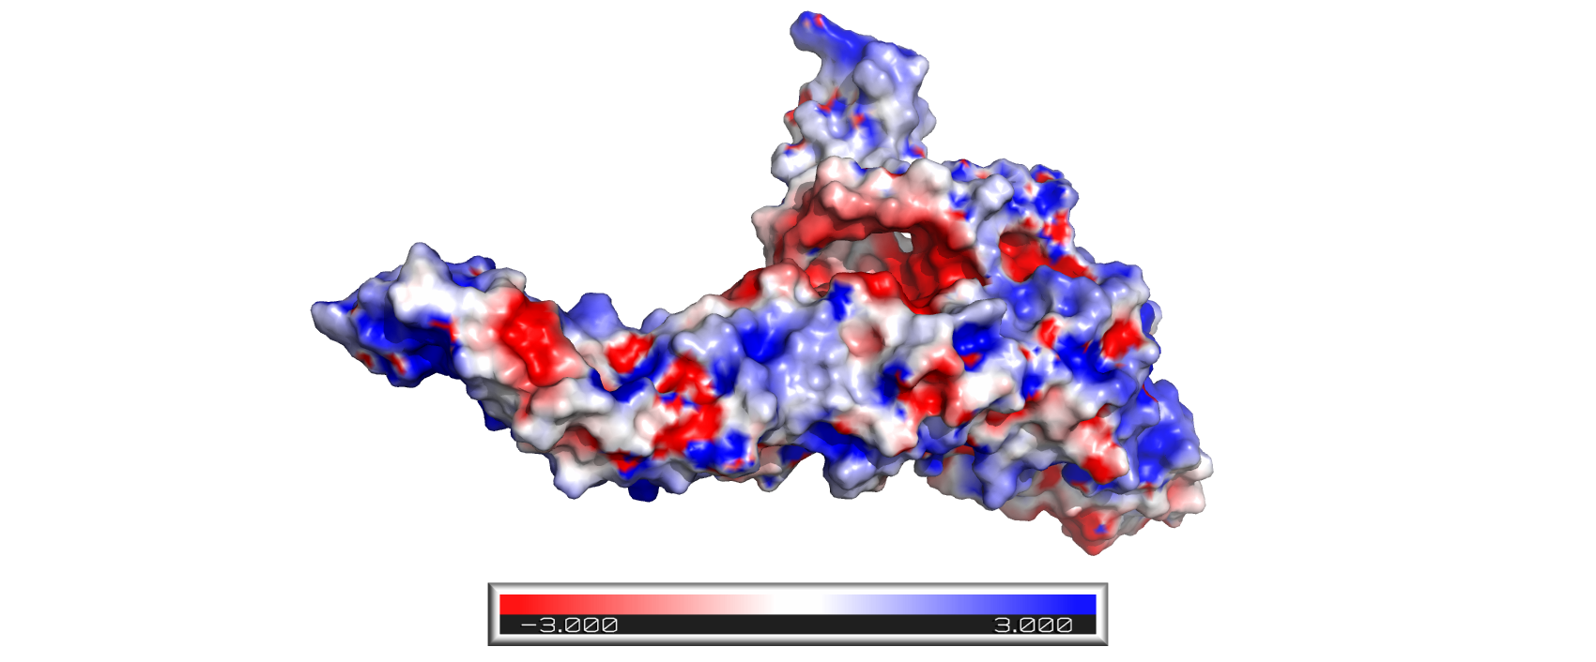
Supplementary figure 29: DENV1_BR1_2010-2015.

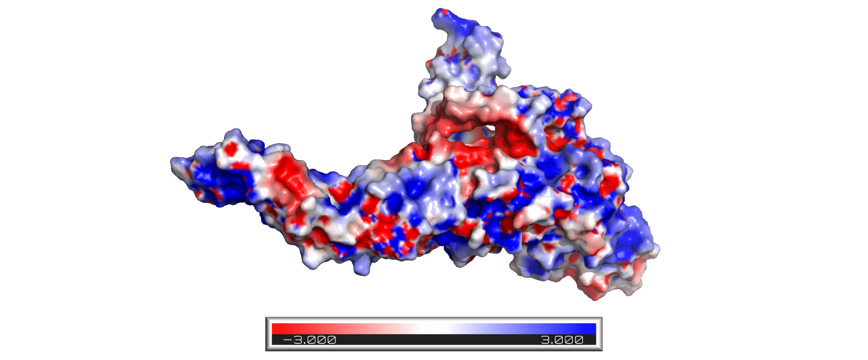
Supplementary figure 30: DENV4.

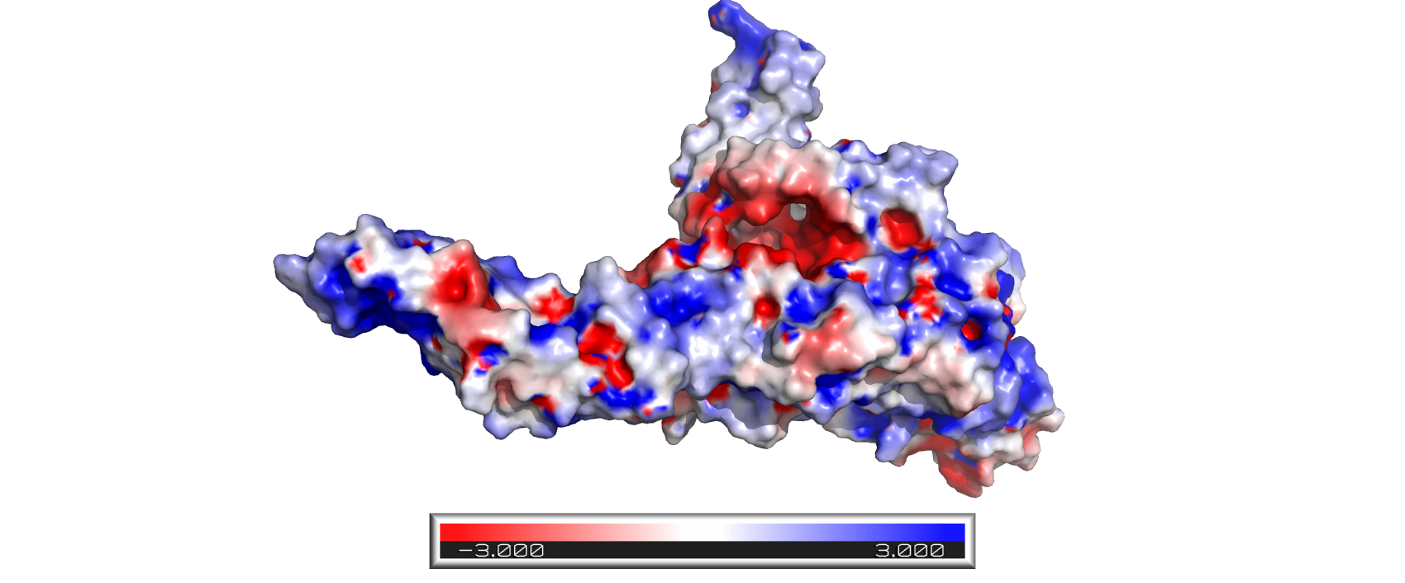
Supplementary figure 31: DENV1_BR4_2014-2019.

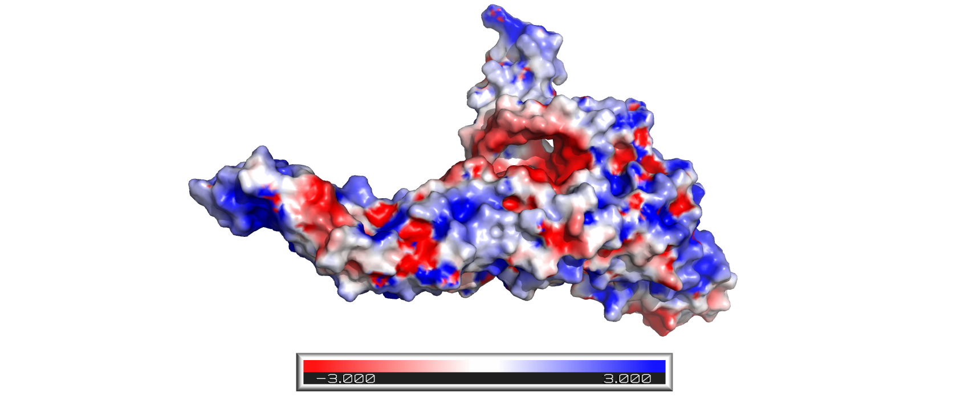
Supplementary figure 32: DENV1_BR5_2014-2019.

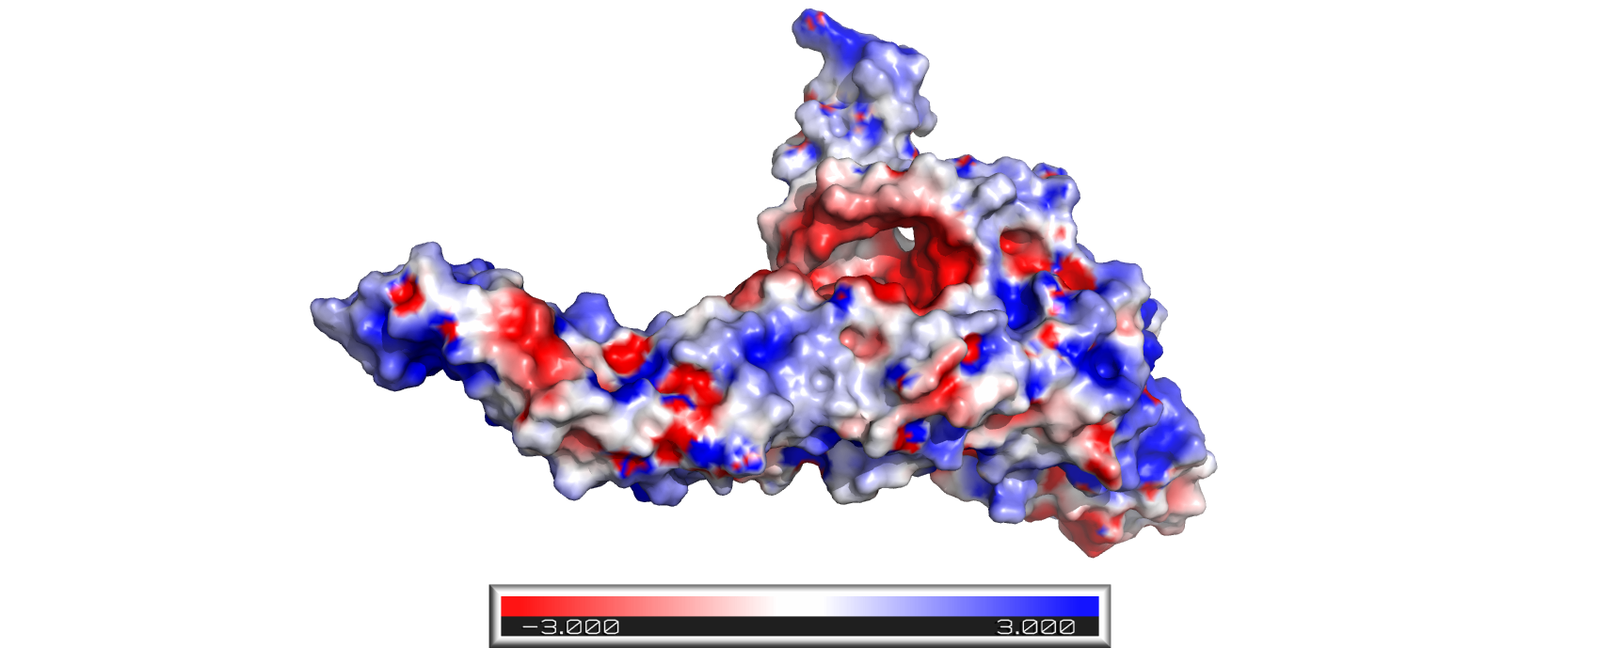
Supplementary figure 33: DENV2_BR3_2016-2018

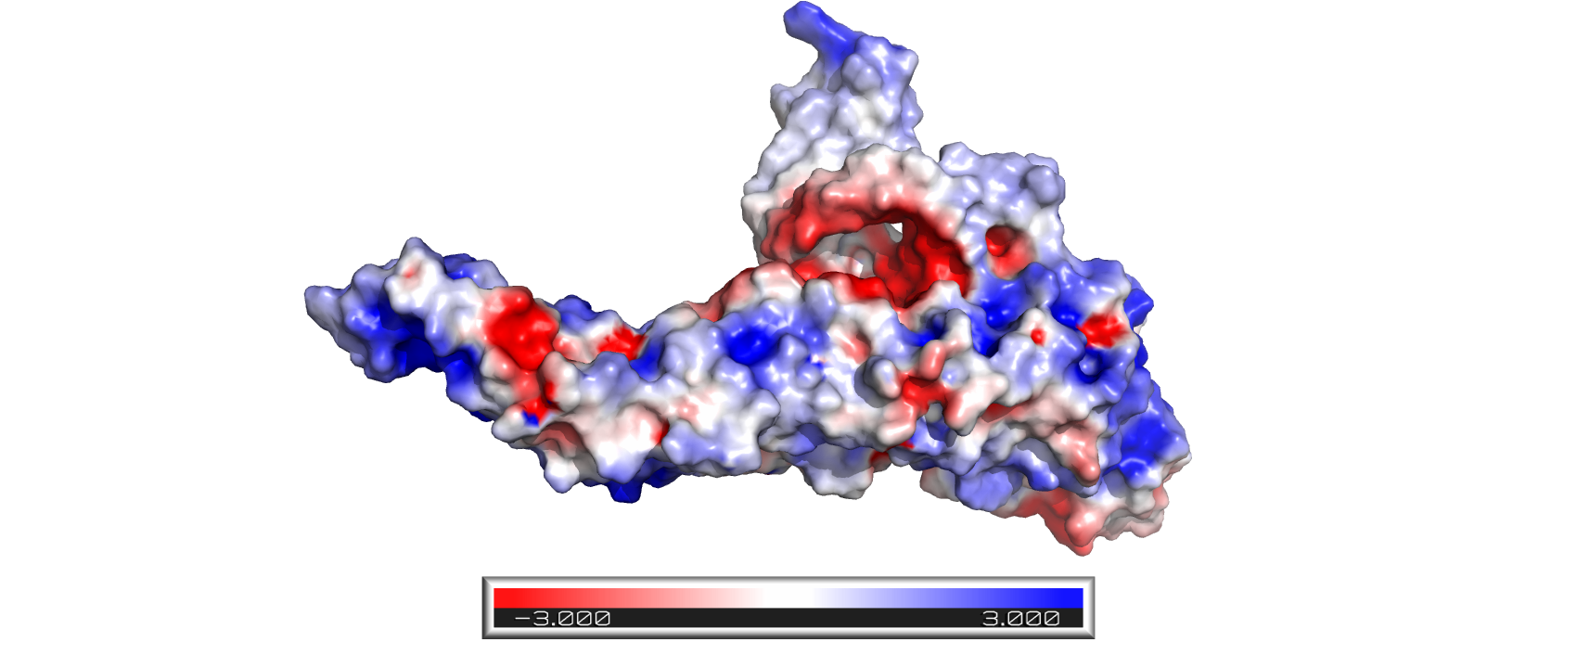
Supplementary figure 34: DENV2_BR4_2019-2022.

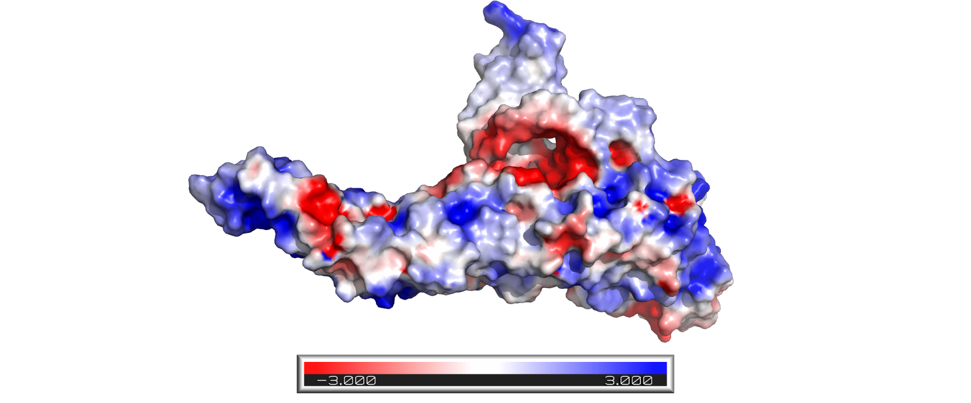
Supplementary figure 35: DENV1_BR4_2019.

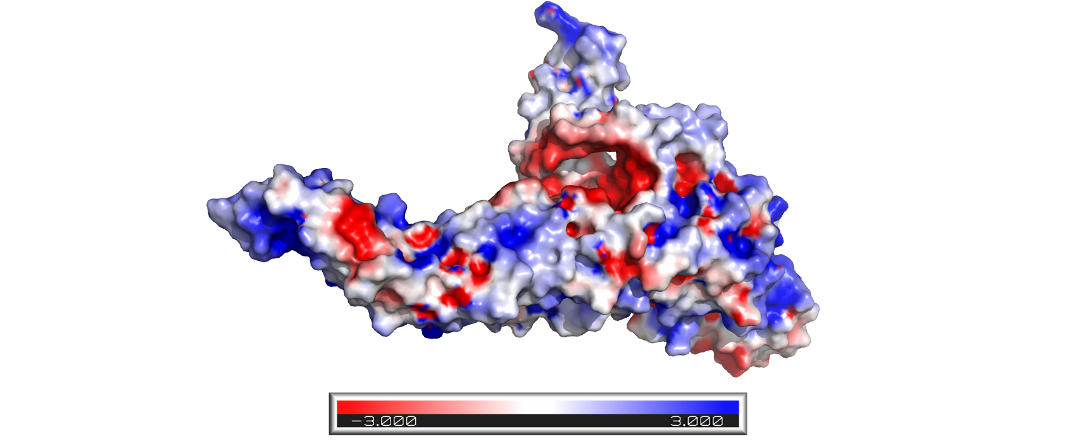
Supplementary figure 36: DENV1_BR1_2022.

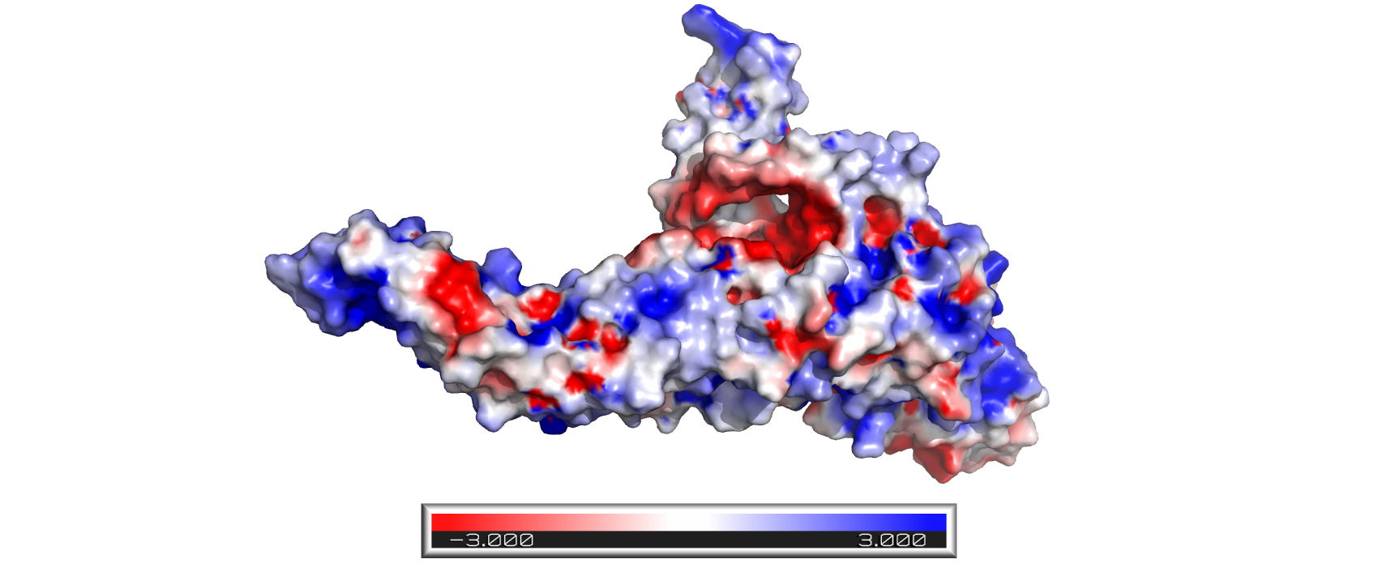
Supplementary figure 37: DENV1_BR3_2022.

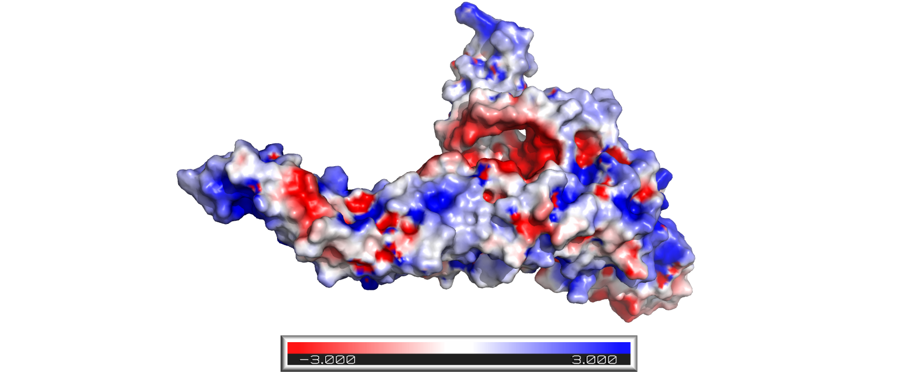
Supplementary figure 38: DENV2_2022.

