The systemic challenge of phasing out fossil finance

Supplementary Information

J. Rickman¹, M. Falkenberg², S. Kothari¹, F. Larosa³, M. Grubb¹, N. Ameli¹

¹Institute for Sustainable Resources, University College London, UK
² Department of Mathematics, City University of London, London, UK
³ KTH Royal Institute of Technology, Sweden

Supplementary materials containing supplementary figures, tables and methods.

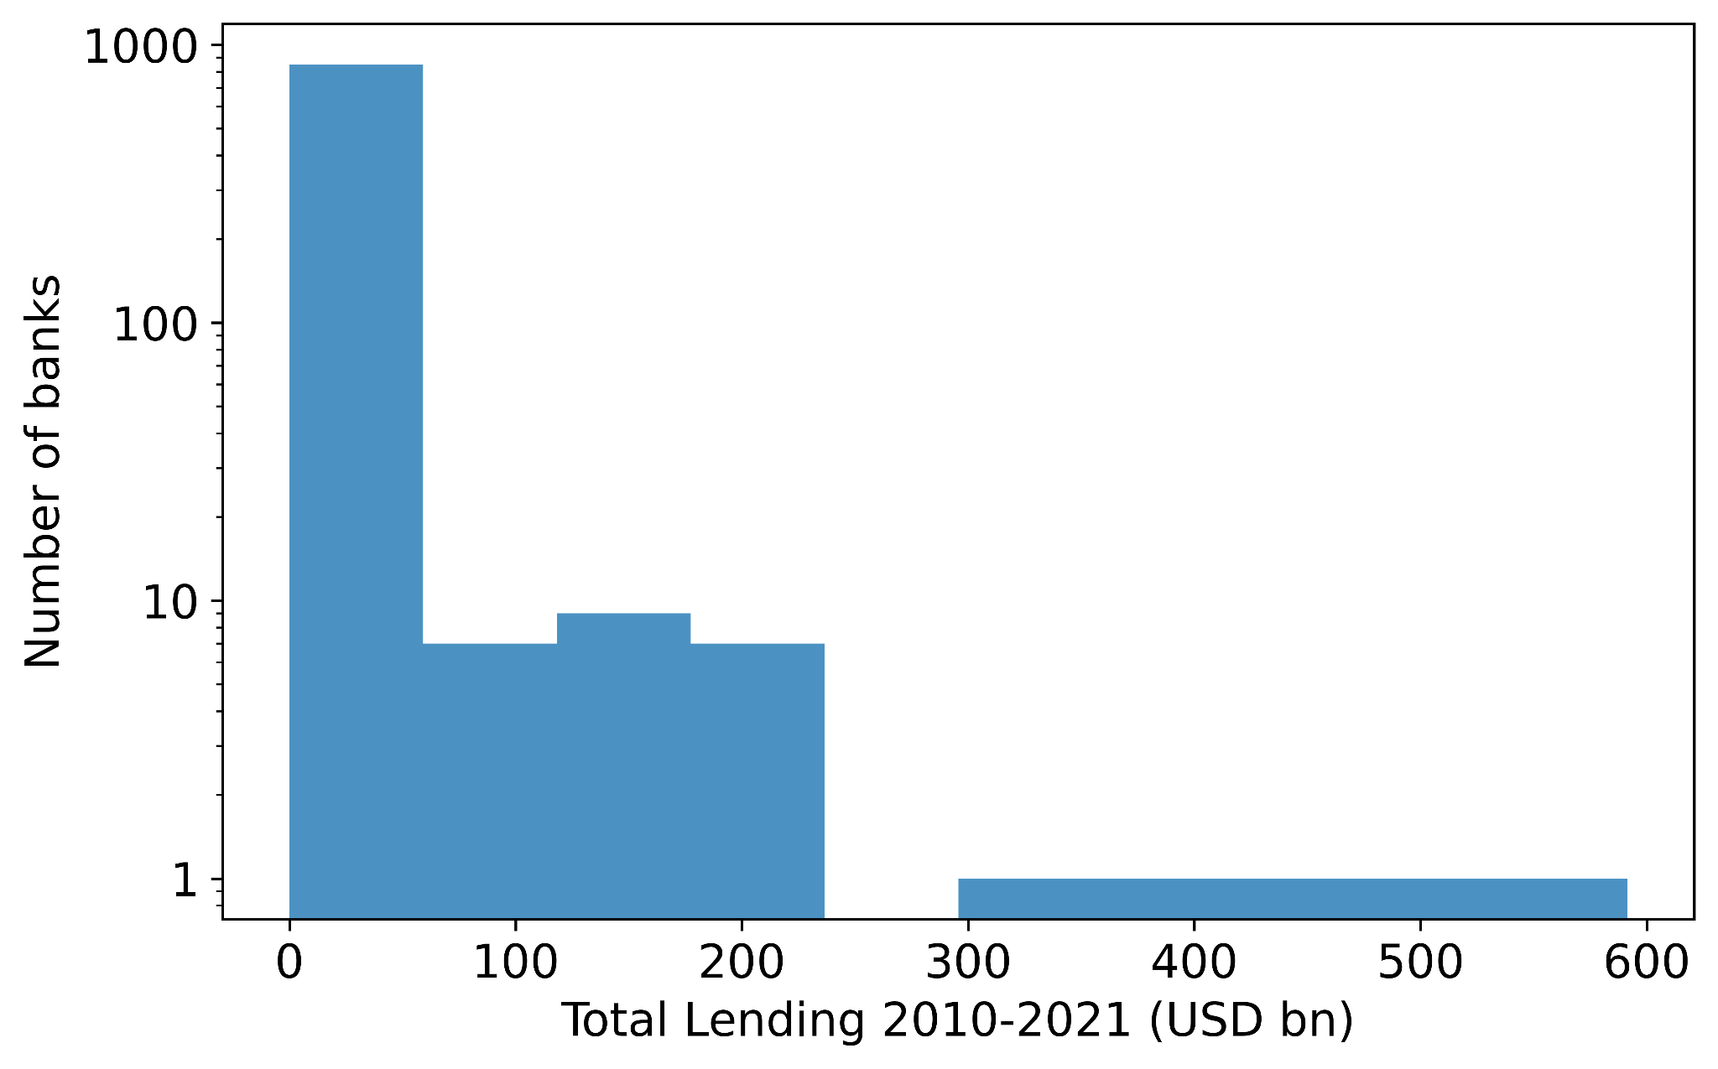
Figure S1. Lending activity across the banking sector. Histogram shows the total lending of 709 banks between 2010 and 2021.

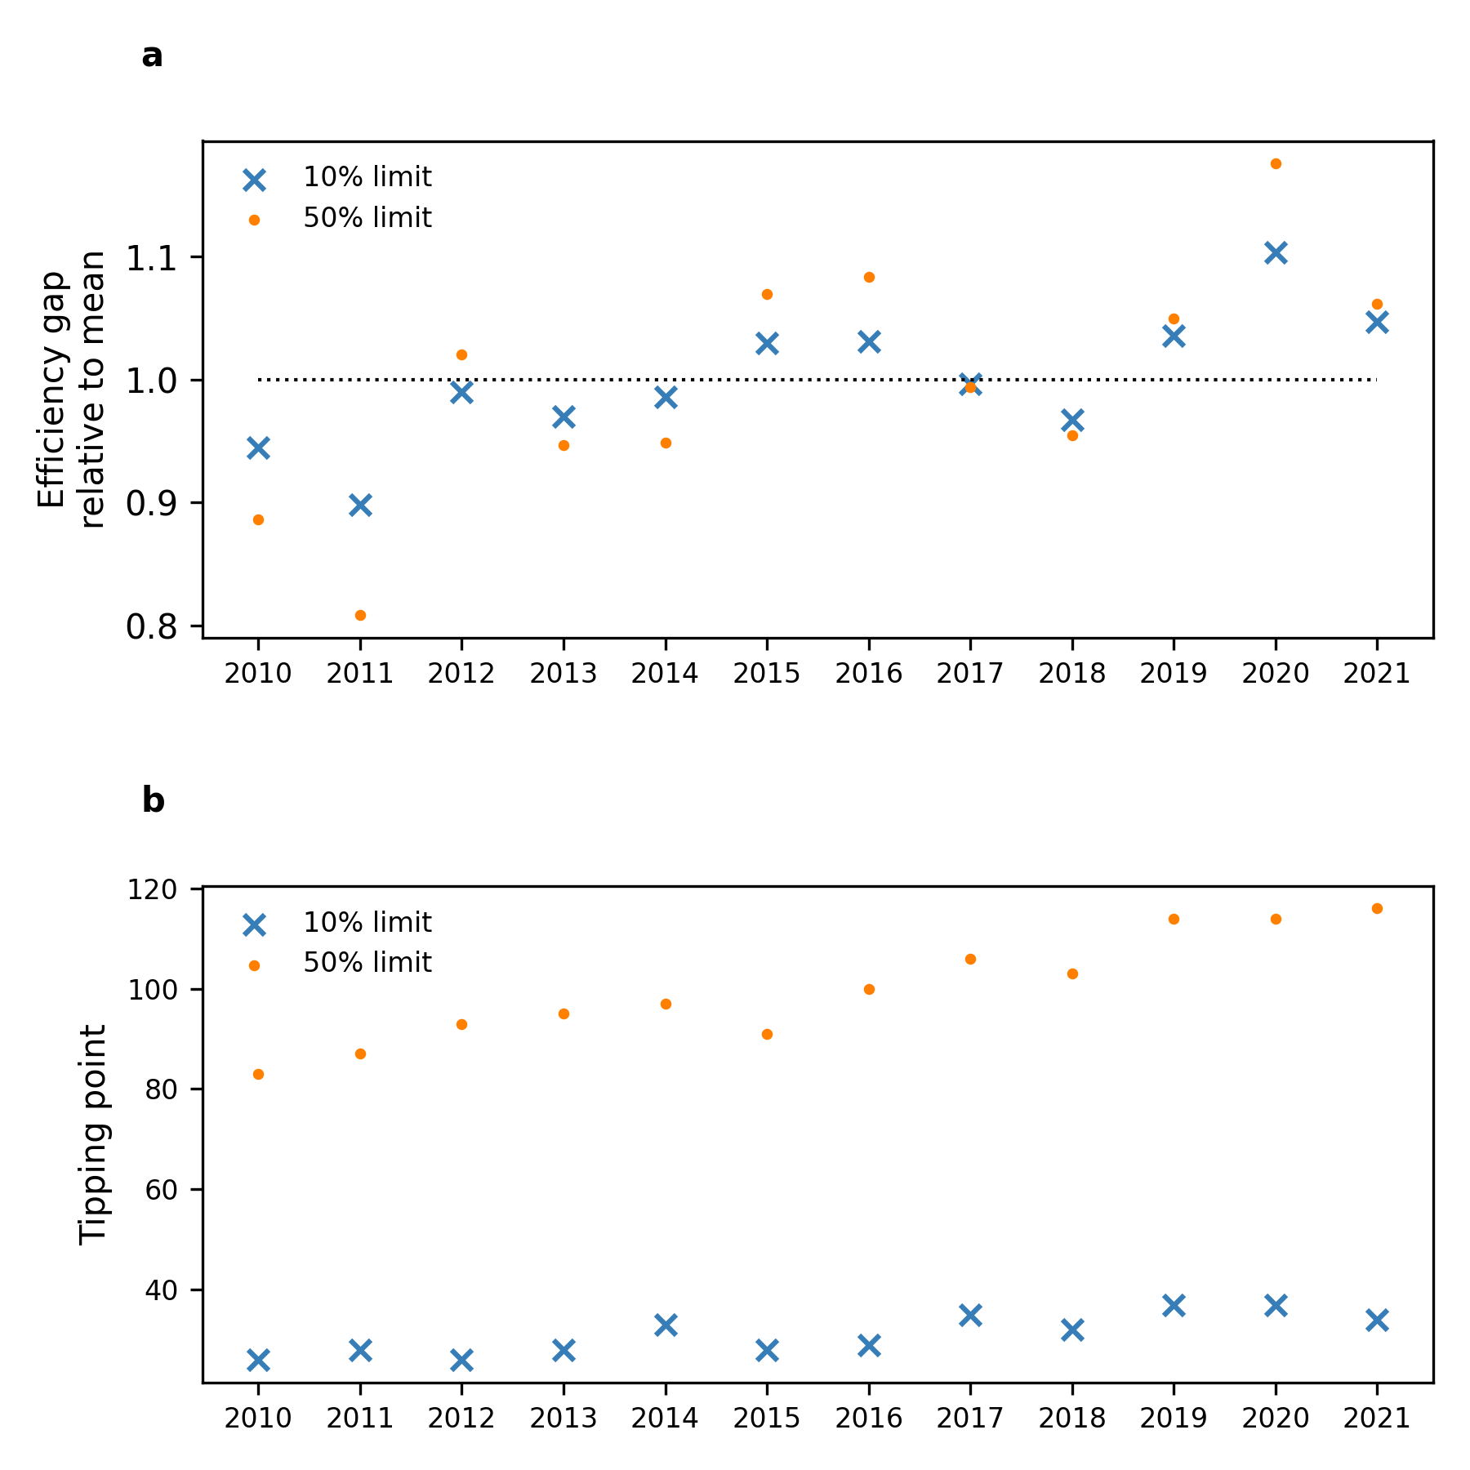

Figure S2. Efficiency gap and tipping point each year. (a) The size of the efficiency gap as a multiple of the average efficiency gap in the period 2010-2021. The efficiency gap is relatively stable for a fixed capital limit over time, fluctuating between +/-20% in the observed time period. Larger capital limits result in larger fluctuations in the efficiency gap. (b) The number of banks that must be removed to reach the tipping point for each year in the period 2010-2021 for two different capital limits. Note that the tipping point is larger for the 2021 syndicated network than for any previous year, despite not having the largest efficiency gap. This is a consequence of growing deal syndication between 2010-2021.

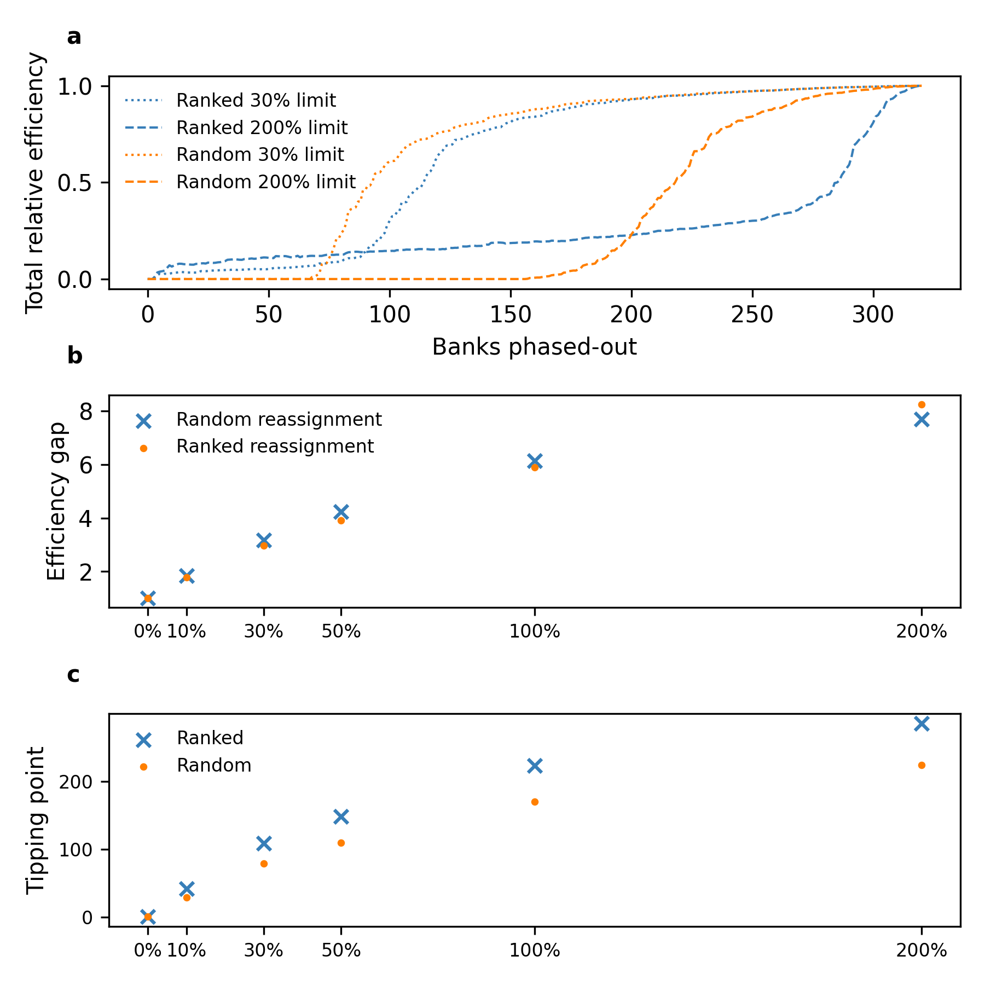
Figure S3. Phase-out model variant comparing random and ranked substitution. In the random model substituted capital is replaced by a random bank, in the ranked model capital is replaced by banks ranked according to the number of existing relationships with the existing syndicate. (a) The relative efficiency of the phase-out process for two different capital limits. (b) The efficiency gap for the ranked and random models with different capital limits. (c) The tipping point for the ranked and random models with different capital limits.

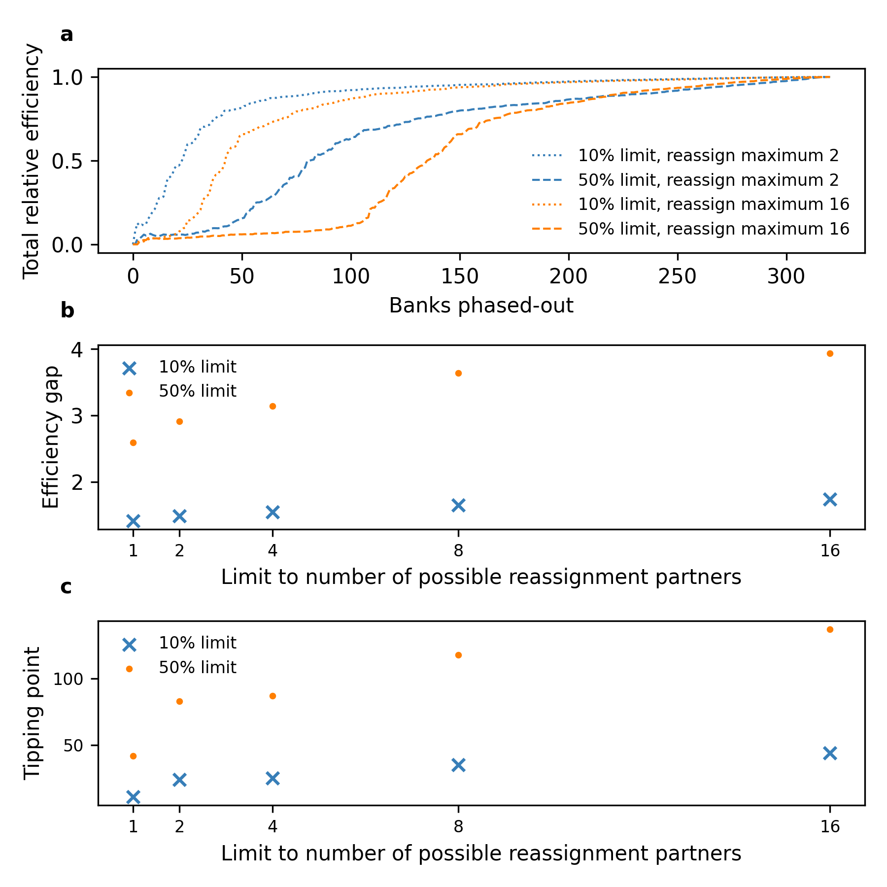
Figure S4. Phase-out model variant with restrictions on the maximum number of banks that can substitute capital into an at risk deal. (a) The total relative efficiency with two different capital limits (10% and 50%) and two values of the bank substitute partner limit (2 and 16 for illustrative purposes), which restricts the number of candidate banks from whom substitute capital can be acquired. (b) The efficiency gap as a function of the capital limit and the bank partner reassignment limit. (c) The tipping point as a function of the capital limit and the bank partner reassignment limit.

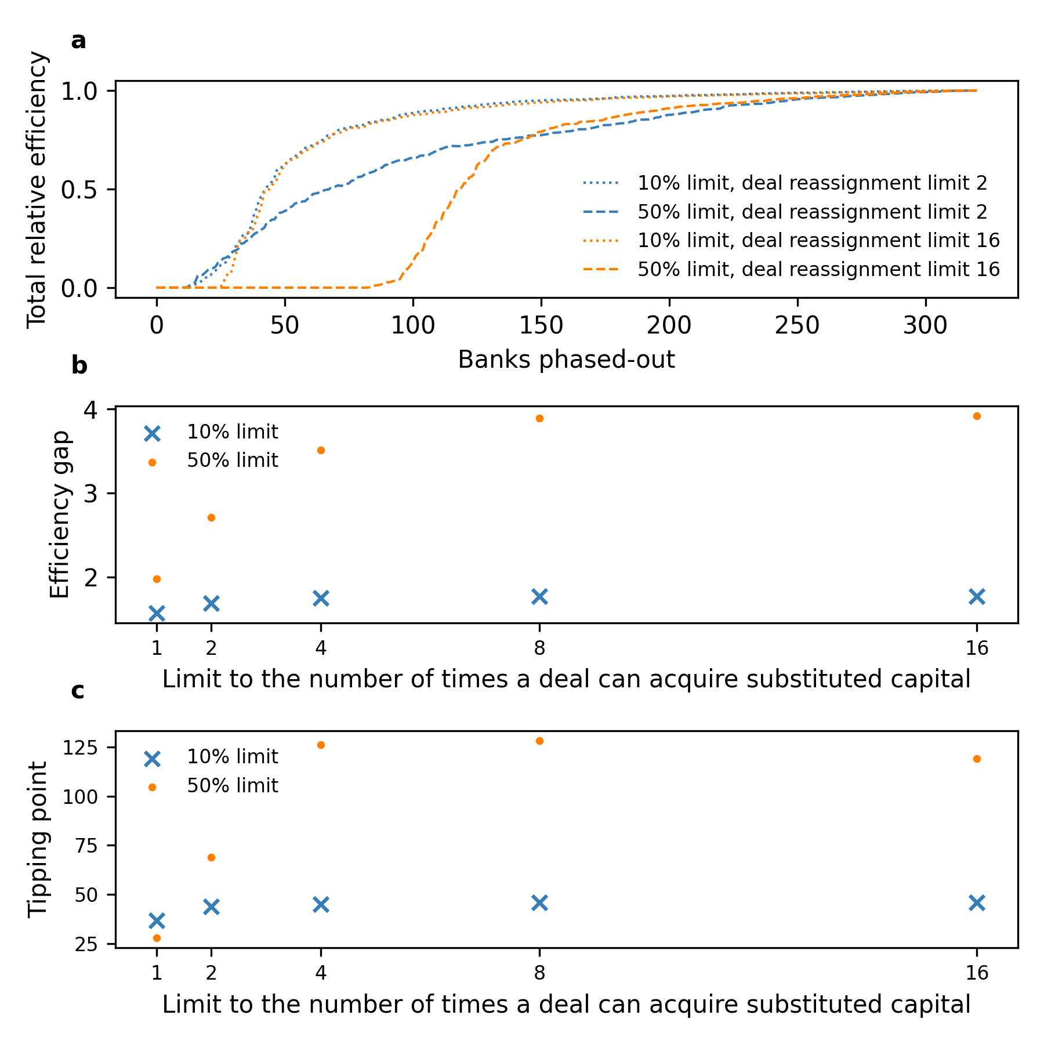
Figure S5. Phase-out model variant restricting the number of times a single deal can acquire substituted capital before automatically failing. (a) The total relative efficiency with two different capital limits (10% and 50%) and two values for the capital substitution limit (2 and 16 for illustrative purposes), which restricts the number of times a single deal can acquire substituted capital after a partner bank phases-out from the fossil fuel sector, before the deal automatically fails. (b) The efficiency gap as a function of the capital limit and the deal substitution limit. (c) The tipping point as a function of the capital limit and the deal substitution limit.

Centrality Measure | Pre-Paris (2010-2016) | Post-Paris (2017-2021)
Degree | 0.98 | 0.99
Eigenvector | 0.98 | 0.98
Closeness | 0.34 | 0.35
Betweenness | 0.63 | 0.61
Table S1. Correlation between banks’ centrality and syndication activity. Pearson’s correlation coefficient between banks’ syndication activity and network centrality measures in a pre-Paris Agreement (2010-2016) and post-Paris Agreement (2017-2021) period. The weighted versions of eigenvector and betweenness centrality are computed.

Supplementary Methods

Data coverage
Comparing the Bloomberg data with a joint report by Rainforest Action Network, BankTrack, Indigenous Environmental Network, Oil Change International, Reclaim Finance, Sierra Club and urgewald¹ affirms that it is representative of the finance provided global banking sector. The joint report cites that 742 billion USD of bank finance (debt and equity) was provided to the fossil fuel sector in 2021. A conservative minimum estimate for the equity share of total finance is 10%², which indicates 667 billion USD was provided as bonds and loans. This figure compares well with the Bloomberg data, which reports 592 billion USD of bonds and loans in 2021.
Phase-out model results for the years 2010-2021
Figure S2 shows results for the phase-out model computed with data from 2010 to 2021. For each year, we compute the efficiency gap and tipping point using two different values of the capital limit percentage. In Fig. S2a we plot the efficiency gap for both capital limits (10% and 50% for illustrative purposes) relative to the mean efficiency gap across all 12 years. We find that the efficiency gap only varies by small amounts over time for fixed capital limit percentages. In years with greater fossil fuel lending and syndication, the efficiency gap is generally larger than in years where lending is lower. These effects are larger for higher capital limit percentages. However, overall fluctuations in the capital limit are small, with the efficiency gap always within 20% of the mean value across the time period.
In terms of the tipping point, we see that our result that the tipping point is delayed for larger capital limits is robust across all 12 years studied. We note that although the efficiency gap has fluctuated over time, reaching a peak in 2020, the tipping point has steadily grown over time. This is indicative of the growing level of syndication of the fossil fuel lending network in the period 2010-21.
Variants of the phase-out model
We now study three variants of the basic phase-out model. First, we study how changes to the procedure for finding new syndicate partners for substitution affect fossil fuel phase-out (Fig. S3). In the ‘random’ phase-out model substituted capital is replaced by a random bank, in the ‘ranked’ phase-out model capital is replaced by banks ranked according to the number of existing relationships with the existing syndicate. Then, we consider limits to the number of banks who can act as candidates for substitution for any given at-risk deal (Fig. S4). Finally, we test a model variant that accounts for the increased perceived risk of a deal that acquires substitute capital multiple times, by limiting the number of times a deal can substitute capital before automatically failing (Fig. S5).
- Ranked vs. random substitution
In the base model, candidate syndicate partners for substitution are chosen at random from all banks who are not phased-out from the sector and who are not yet part of the syndicate. We refer to this as the ‘random’ case. We now compare this to a model where syndicate partners are chosen preferentially in order of the total number of syndicates in which the existing syndicate banks co-invest with the candidate bank. We refer to this as the ‘ranked’ case. Results are shown in Fig. S3 using two different values for the capital limit, 30% and 200% for illustrative purposes.
In Fig. S3a, we see two key differences between the random and ranked cases: (1) In the ranked case, there is non-zero phase-out efficiency before the tipping point is reached (efficiency > 0.5), with the efficiency slowly growing throughout the phase-out process. However, (2) this increase in early phase-out efficiency appears to delay the onset of the tipping point. Overall, we see in Fig S2b&c that there is very little difference in the efficiency gap and tipping point that arises between the two cases for fixed capital limits.
The lack of a sharp transition from zero to non-zero phase-out efficiency in the ranked case is the result of deals for which the syndicate members have co-investment relationships with only a small number of banks. Hence, if these candidate banks for substitution phase-out or reach their capital limits, no other banks can substitute capital. This effect is representative of deals which are regionally isolated and only involve a small number of local / regional banks who do not have relationships with the broader fossil fuel lending network. However, these effects do not have a significant impact on the overall efficiency of phase-out.
- Limiting the number of candidate banks for substitution
In the base model, a deal at risk will attempt to acquire substitute capital from any of the banks which are not yet phased-out of the sector. Here, we adapt the model to limit the number of possible banks who can act as a candidate for substitution. If a deal at risk fails to acquire substitute capital from those limited candidate banks, the deal fails. Results with two capital limits (10% and 50% for illustrative purposes) are shown in Fig. S4.
Figure S4a shows that imposing limits to the number of substituting partners reduces the number of banks which must phase-out of the sector to reach the tipping point. In particular, if the limit on the candidate banks is highly restrictive, this can substantially improve phase-out efficiency. However, the key feature of the model – a sharp transition from low to high phase-out efficiency – persists in this variant. The efficiency gap and tipping point both decrease with tighter limits on the number of substitute banks (Fig. S4b & c). However, phase-out efficiency remains low, even with tight limits on the number of substitute banks, unless strict capital limits are also in place.
- Limiting the number of capital substitutions
In the base model, there is no limit to the number of times a single deal can substitute capital when a syndicate partner phases-out from the fossil fuel sector. In this model variant we incorporate a feature of reflecting the perceived ‘risk’ of a deal whereby a deal can only substitute capital a certain number of times before automatically failing. Results are shown in Fig. S5 for two fixed values of the capital limit and variable limits to the number of times a single deal can substitute capital.
Fig. S5a shows that limiting the number of times a deal can acquire substitute capital significantly increases phase-out efficiency so that fewer banks are required to reach the tipping point. Note however, that Fig. S5b shows that limits to the number of times a deal can acquire substitute capital are only effective if the limit is very small (1 or 2 substitutions), and that this effect is secondary to restrictions on capital limits.

References
1. Rainforest Action Network, et al., Banking on Climate Chaos 2023. 2023.
2. Fight, A., Syndicated lending. 2004: Elsevier.

