Supplementary Material
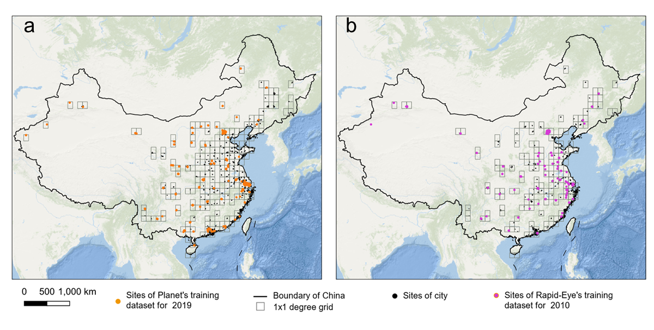
Supplementary Fig. 1. Sites of training-label parcels for the deep-learning model. a, Training parcels for PlanetScope imagery in 2019; b, Training parcels for RapidEye imagery in 2010. The Ocean Basemap is provided by Esri.
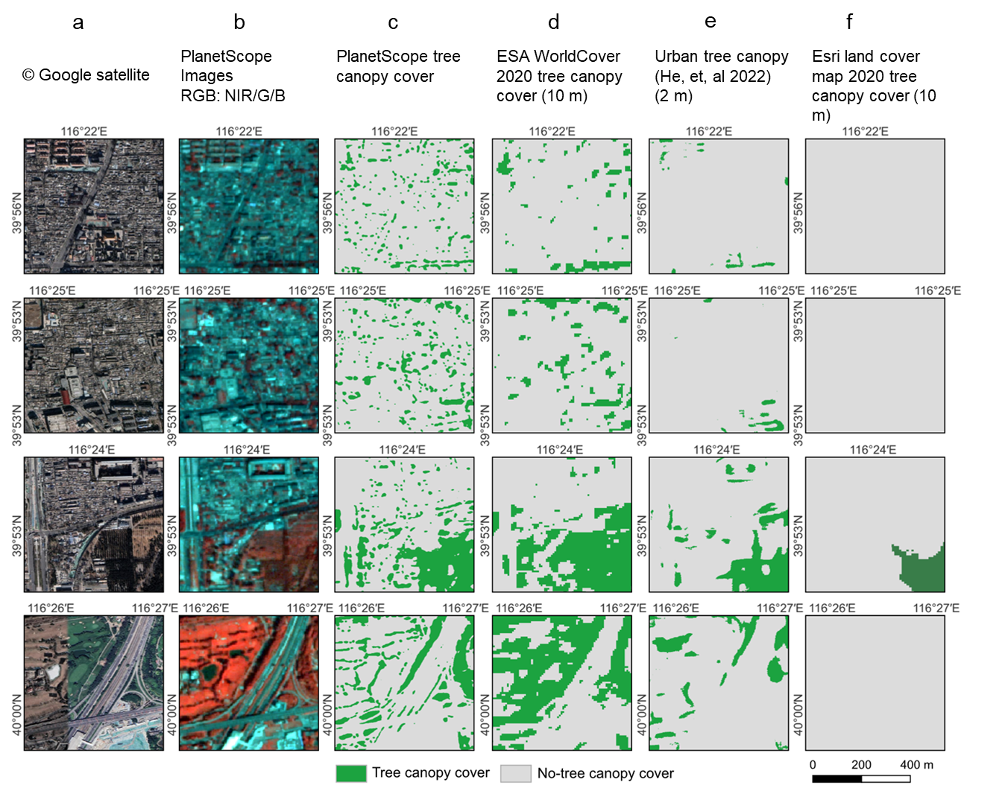

Supplementary Fig. 2. Comparison of PlanetScope tree canopy mapping with other products. a, Google Earth satellite images. b, PlanetScope Image 2019 (RGB: NIR/G/B). c, PlanetScope tree canopy mapping 2019. d, Tree canopy from ESA 2020 Land cover map¹. e, 2 m fine-scale urban tree canopy map from He et, al 2022². f, Tree canopy based on Esri land cover map 2020³.
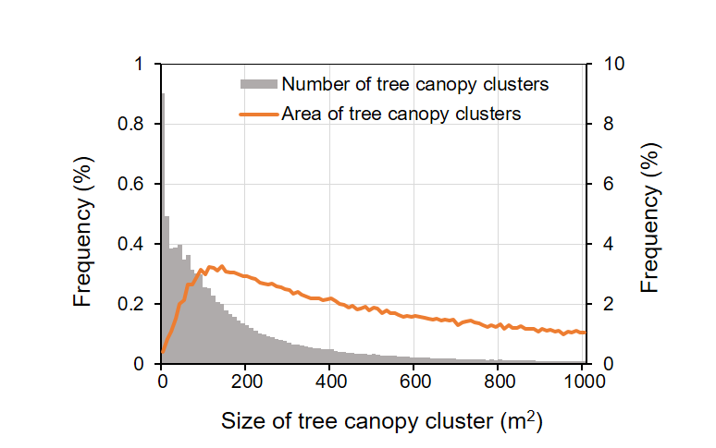

Supplementary Fig. 3. Histogram of the size of tree canopy clusters in urban areas.
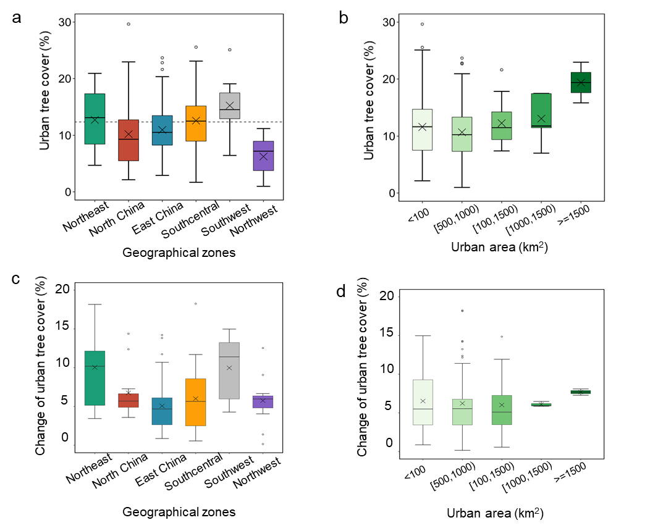

Supplementary Fig. 4. Urban tree cover 2019 and change from 2010 to 2019 at city level. a, Urban tree cover in 2019 grouped by city area, and (b) by geographical zones. c, Urban tree cover change from 2010 to 2019 at city level grouped by city size, and (d) by geographical zones.
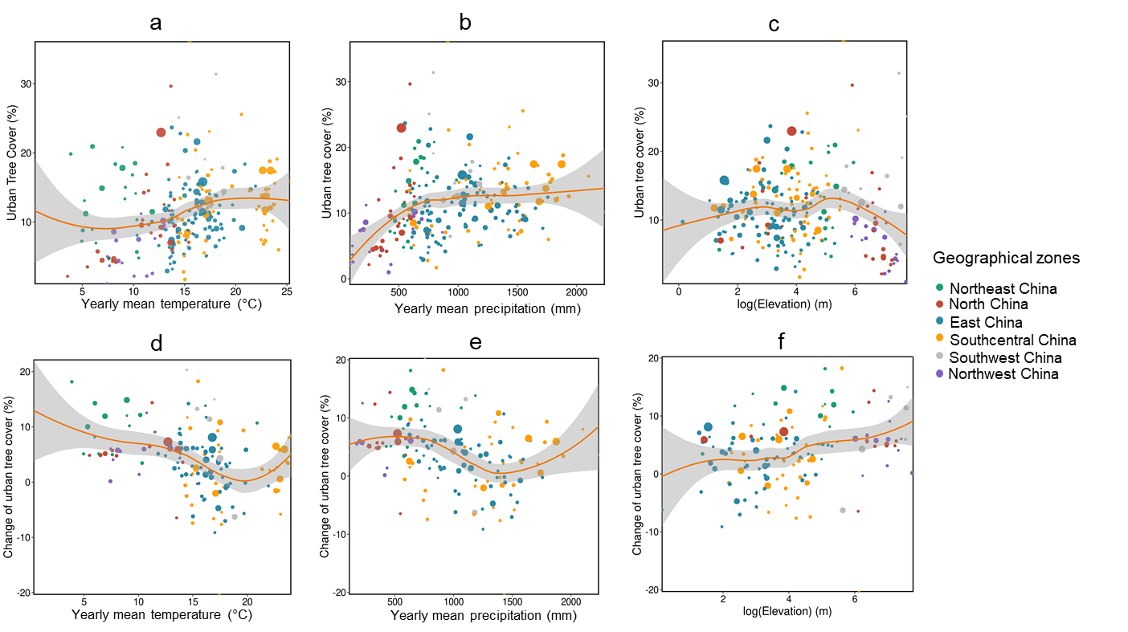

Supplementary Fig. 5. Urban tree cover for 2019 as well as change in urban tree cover from 2010 to 2019 in relation to climate/elevation variables. Mean annual temperature in 2015 (a), mean precipitation in 2015 (b) and elevation (c) at city level (n = 242). Change in urban tree cover during 2010-2019 in relation to mean annual temperature in 2015 (d) and mean precipitation in 2015 (e) and elevation (f) at city level (n =145). The fitted orange lines and confidence areas were fitted by a loess function in R.

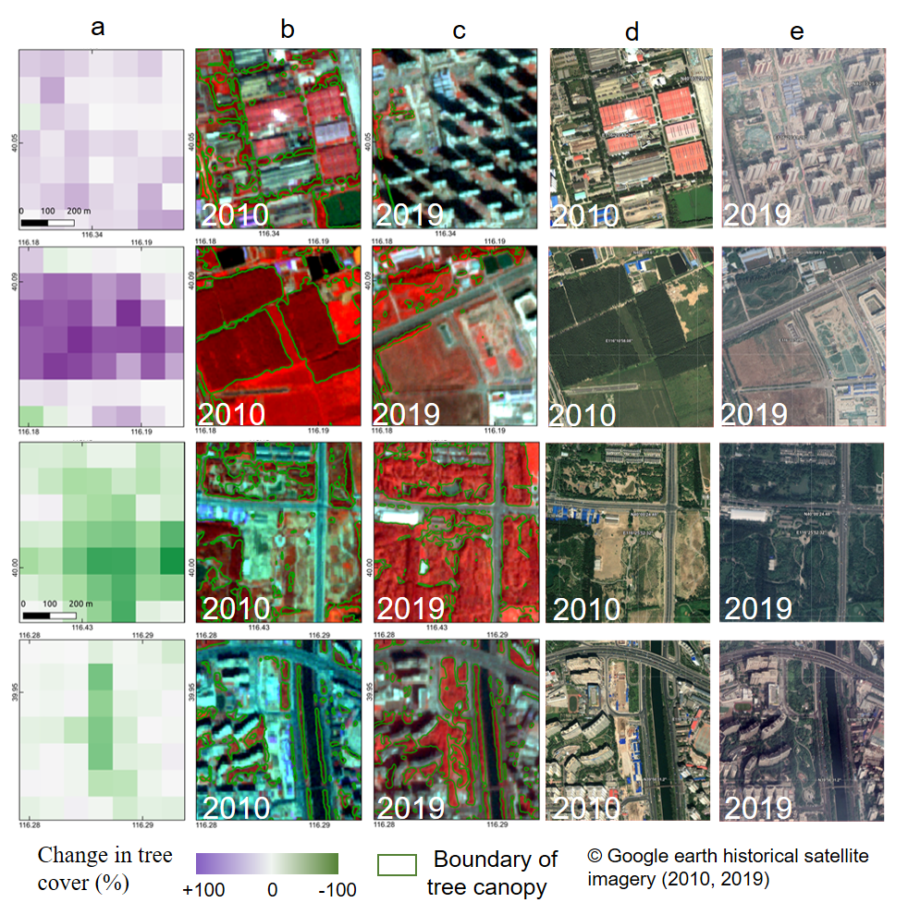

Supplementary Fig. 6. Examples showing an increase in tree canopy cover from 2010 to 2019. a, Change in tree cover in 1 ha grids (2010 - 2019). b, Prediction of tree canopy cover based on RapidEye imagery for 2010. c, Prediction of tree canopy cover based on PlanetScope imagery for 2019. d, Google Earth historical imagery in 2010. e, Google Earth historical imagery in 2019.
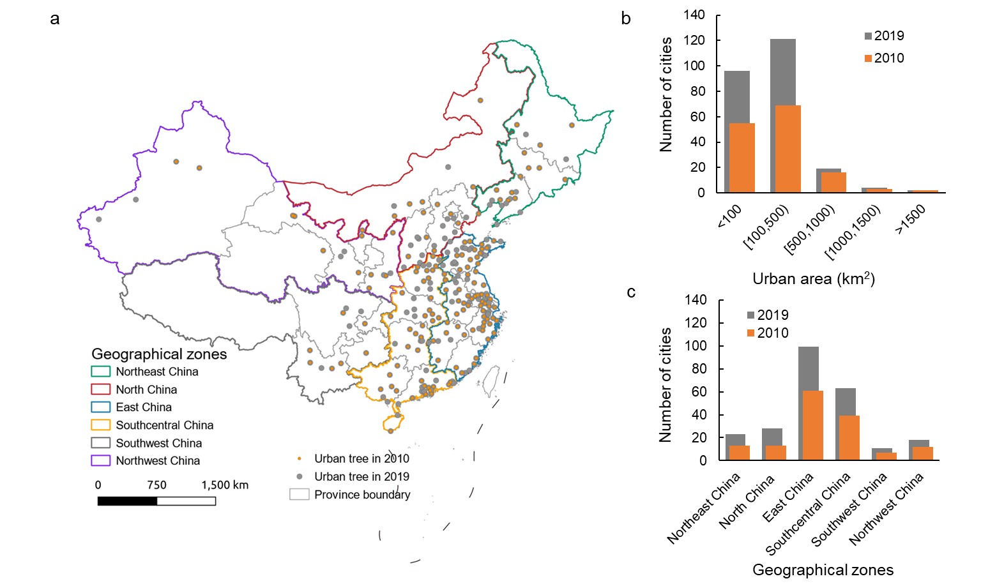
Supplementary Fig. 7. Cities studied in 2010 and 2019. a, Spatial distribution of cities studied in 2010 and 2019. b, Size of cities analyzed. c, Number of cities in the different geographical zones.
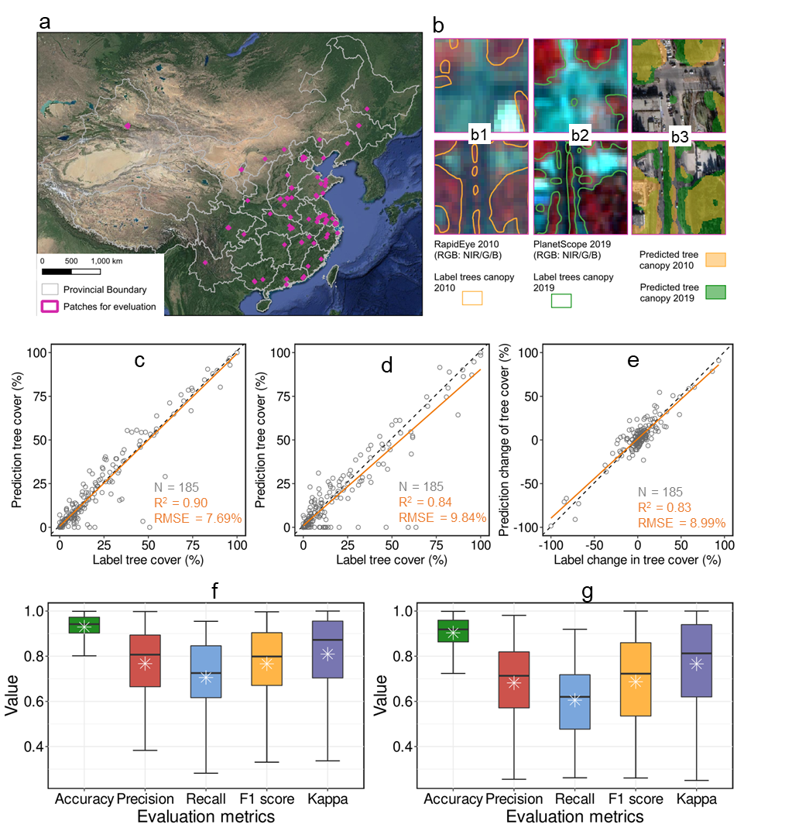

Supplementary Fig. 8. Comparison between manually labeled areas from the test dataset and the corresponding predictions for 185 patches (the size of each patch is 1 ha). a, Location of patches for evaluation. b, examples of patches with labelled tree canopy cover for 2010 (b1) and 2019 (b2) and prediction (b3). c, Comparison between predictions and manual labelling for PlanetScope 2019 tree canopy cover. d, Comparison between predictions and manual labelling for RapidEye 2010 tree canopy cover. e, Comparison of tree canopy cover changes from 2010 to 2019 between model predictions and manual labelling. f, Statistical evaluation metrics for the PlanetScope 2019 tree canopy cover mapping. g, Statistical evaluation metrics for the RapidEye 2010 tree canopy cover mapping.

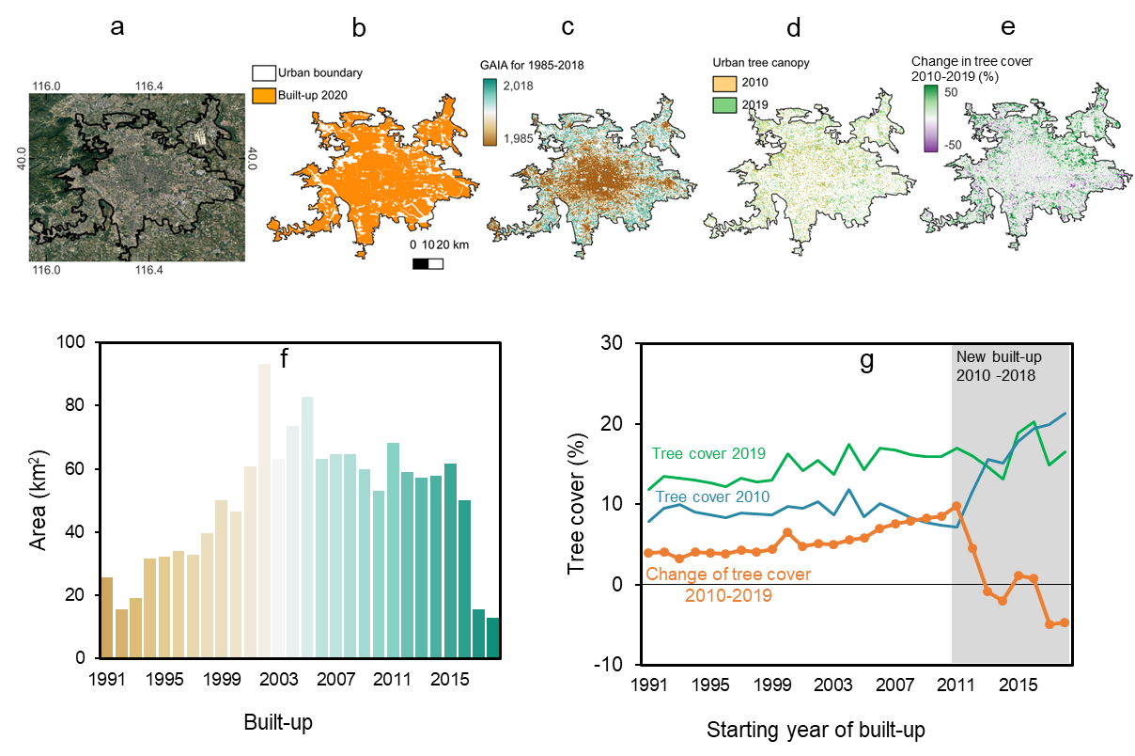
Supplementary Fig. 9. Change in tree cover and urbanization in Beijing. a, Google satellite image. b, Built-up areas in 2020 and the urban boundary from the GlobalLand30 2020 map. c, Expansion of built-up areas from GAIA 1991-2018⁴. d, Tree canopy cover in 2010 and 2019. e, Change of tree cover between 2010 and 2019 in 1-ha grids. f, Area of new built-up from 1991-2018. g, Mean tree cover for areas of different built-up time-steps during 1991-2018.
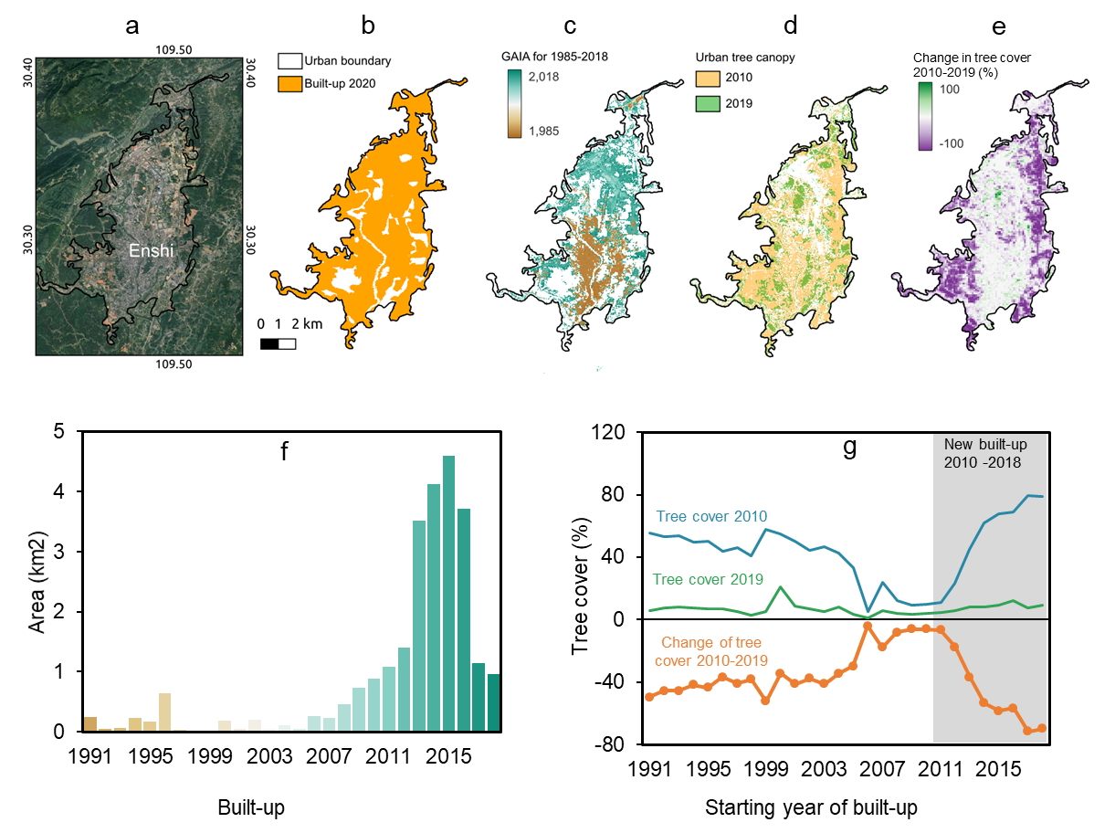
Supplementary Fig. 10. Change in tree cover and urbanization in Enshi. a, Google satellite image. b, Built-up areas in 2020 and the urban boundary from the GlobalLand30 2020 map. c, Expansion of built-up areas from GAIA 1991-2018⁴. d, Tree canopy cover in 2010 and 2019. e, Change in tree cover between 2010 and 2019 in 1-ha grids. f, Area of new built-up from 1991-2018. g, Mean tree cover for areas of different built-up time-steps during 1991-2018.

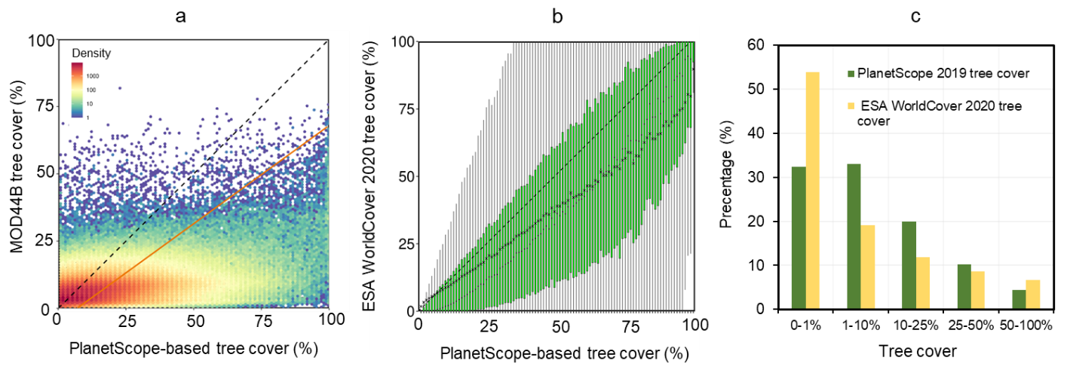

Supplementary Fig. 11. Comparison of tree cover predictions from PlanetScope estimations and other tree cover products. a, Density plot for the PlanetScope-based 2019 tree cover and MOD44B 2019 tree cover. b, Density plot for the PlanetScope-based 2019 tree cover and ESA WorldCover 2020 tree cover. c, histogram of Planet 2019 tree cover and ESA WorldCover 2020 tree cover.

Supplementary Table 1. Datasets used in the study.
Dataset | Resolution | Bands | Count of cities | Areas (km²)
PlanetScope Imagery 2019 | ~3 m | Blue, Green, Red, NIR | 242 | 51882
RapidEye Imagery 2010 | ~5 m | Blue,Green,Red,Red Edge,NIR | 145 | 36068
GAIA 2000 - 2018 | 30 m | Impervious surface | 242 | 51882
MODIS vegetation index (MOD13Q1 C6, MYD13Q1 C6) | 250 m | NDVI | 242 | 51882

Supplementary Table 2. Mean tree cover by land cover class. Land cover classes are derived from the ESA WorldCover 2020 map¹.
Land cover type (ESA WorldCover 2020) | Total area (km²) | PlanetScope tree cover (%)
Tree cover | 65291.74 | 48.26
Shrubland | 806.22 | 23.02
Grassland | 11301.15 | 14.24
Cropland | 74083.89 | 17.59
Built-up | 401606.23 | 6.79
Bare/sparse vegetation | 85634.48 | 6.41
Permanent water bodies | 9461.42 | 5.27
Herbaceous wetland | 161.62 | 12.46

Supplementary Table 3. Information of samples fed into the U-Net model and the core model settings for the analysis.

PlanetScope 2019 |  | RapidEye 2010 |  | Training settings
Inputs | Count | Inputs | Count | Hyperparameters | Setting
Box with positive and negative samples | 418 | Box with positive and negative samples | 423 | Sampling Strategy | Sequential patches with 1/4 overlap
Box with only negative samples | 78 | Box with only negative samples | 58 | Patch Size | 256
Box | 496 | Box | 481 | Batch Size | 8
Positive Samples (km²) | 34.74 | Positive Samples (km²) | 12.89 | Training Steps | 100
Negative Samples (km²) | 174.55 | Negative Samples (km²) | 67.88 | Number of Epochs | 500
Distributed cities | 69 | Distributed cities | 57 | Ratio in Tversky Loss | 0.6, 0.4
Bands | 4 (Blue, Green, Red, NIR) | Bands | 5 (Blue, Green, Red, Red Edge, NIR) | Resampled-scale | 3

Reference
1. Zanaga, D. et al. ESA WorldCover 10 m 2020 v100. (2021) doi:10.5281/zenodo.5571936.
2. He, D., Shi, Q., Liu, X., Zhong, Y. & Zhang, L. Generating 2m fine-scale urban tree cover product over 34 metropolises in China based on deep context-aware sub-pixel mapping network. Int. J. Appl. Earth Obs. Geoinformation 106, 102667 (2022).
3. Karra, K. et al. Global land use/land cover with Sentinel 2 and deep learning. in 4704–4707 (IEEE, 2021).
4. Gong, P. et al. Annual maps of global artificial impervious area (GAIA) between 1985 and 2018. Remote Sens. Environ. 236, 111510 (2020).

