ADDITIONAL FILE 2: DATA OVERVIEW OF THE BLASTOMERE SAMPLES FROM ARRESTED CLEAVAGE-STAGE EMBRYOS

Table 1. Characteristics of the blastomere samples.

Sample | Time of collection (day post ICSI) | Concentration after WGA (ng/µL) | Coverage of analyzed SNP genotypes (%) | Sex
Mare01_ Embryo01_Cell1 | 11 | 432 | 45.14* | ♀
Mare01_ Embryo01_Cell2 | 11 | 348 | 39.49* | ♀
Mare01_ Embryo01_Cell3 | 11 | 364 | 45.54* | ♀
Mare01_ Embryo01_Cell4 | 11 | Lost during collection |  | ♀
Mare01_ Embryo01_Cell5 | 11 | 372 | 35.80* | ♀
Mare01_ Embryo02_Cell1 | 11 | 378 | 43.62* | ♀
Mare01_ Embryo02_Cell2 | 11 | 412 | 46.92* | ♀
Mare01_ Embryo02_Cell3 | 11 | Lost during collection |  | ♀
Mare01_ Embryo02_Cell4 | 11 | 316 | 61.29 | ♀
Mare01_ Embryo02_Cell5 | 11 | 174 | 50.97 | ♀
Mare01_ Embryo02_Cell6 | 11 | 222 | 60.75 | ♀
Mare01_ Embryo02_Cell7 | 11 | 392 | 42.20* | ♀
Mare01_ Embryo02_Cell8 | 11 | 406 | 49.39* | ♀
Mare02_ Embryo01_Cell1 | 11 | 390 | 50.30* | ♀
Mare02_ Embryo01_Cell2 | 11 | 374 | 47.50* | ♀
Mare02_ Embryo01_Cell3 | 11 | 364 | 48.69* | ♀
Mare02_ Embryo02_Cell1 | 11 | 338 | 45.73* | ♂
Mare02_ Embryo02_Cell2 | 11 | 282 | 44.60* | ♂
Mare02_ Embryo02_Cell3 | 11 | 416 | 44.48* | ♂
Mare02_ Embryo02_Cell4 | 11 | 388 | 47.56* | ♂
Mare02_ Embryo03_Cell1 | 11 | 426 | 47.31* | ♀
Mare02_ Embryo03_Cell2 | 11 | 308 | 45.53* | ♀
Mare02_ Embryo03_Cell3 | 11 | 364 | 47.57* | ♀
Mare02_ Embryo03_Cell4 | 11 | 90.4 | 62.20 | ♀
Mare02_ Embryo03_Cell5 | 11 | 280 | 61.91 | ♀
Mare02_ Embryo03_Cell6 | 11 | 76.2 | 54.72 | ♀
Mare04_ Embryo01_Cell1 | 12 | 226 | 58.97 | ♀
Mare04_ Embryo01_Cell2 | 12 | 260 | 41.32* | ♀
Average coverage (%) |  |  | 48.83
Average coverage successful (*) samples (%) |  |  | 45.19
*Samples successfully analyzed by haplarithmisis. ICSI: intracytoplasmic sperm injection; SNP: single nucleotide polymorphism; WGA: whole genome amplification.

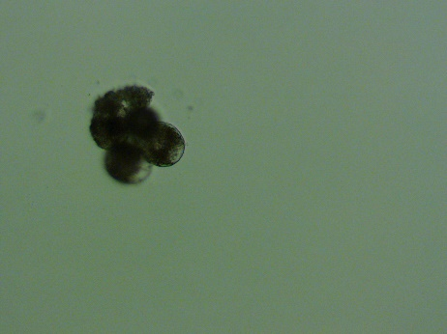
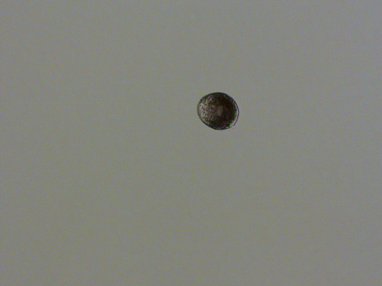
Figure 1. Pictures of the arrested cleavage-stage embryos and the blastomere samples and haplarithm plots of the blastomere samples.
Mare01_ Embryo01_Cell1
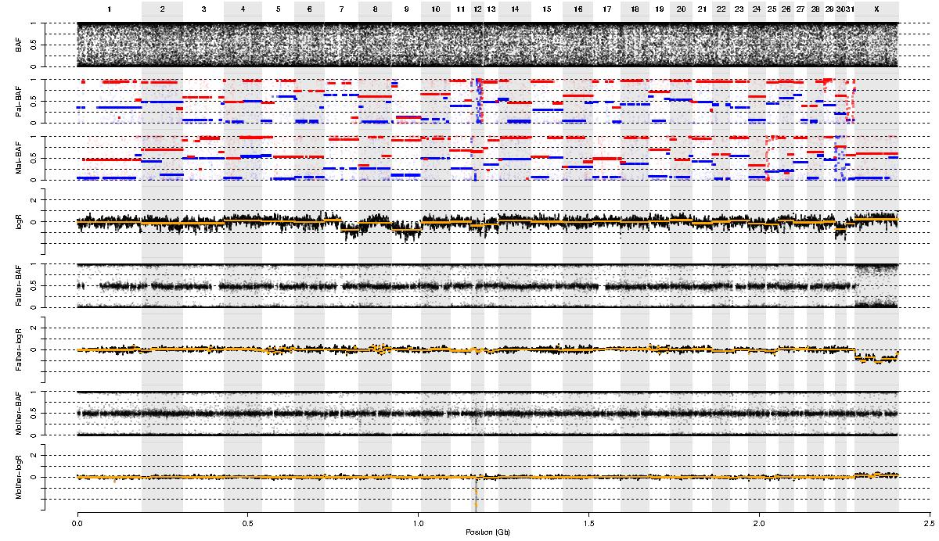
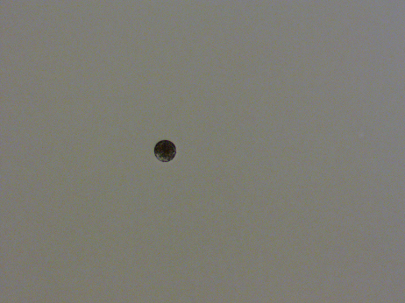
Mare01_ Embryo01_Cell2

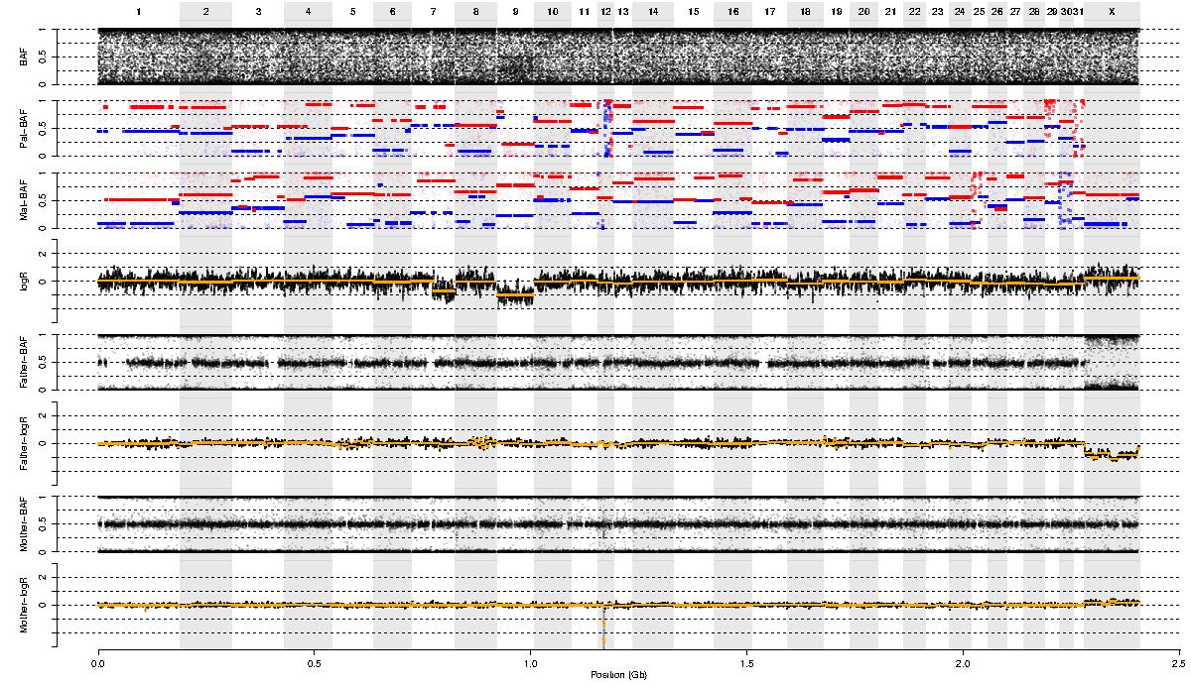
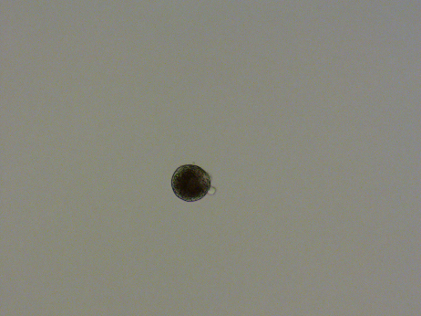
Mare01_ Embryo01_Cell3

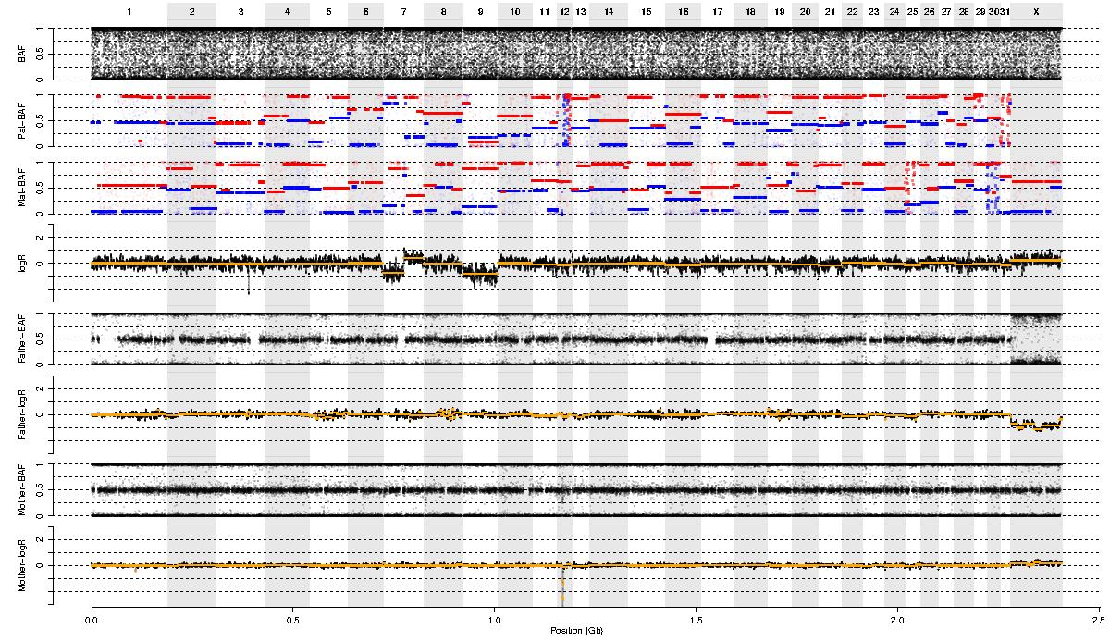
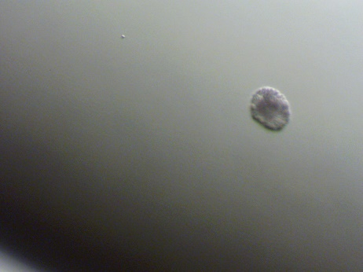
Mare01_ Embryo01_Cell4
Lost during collection.

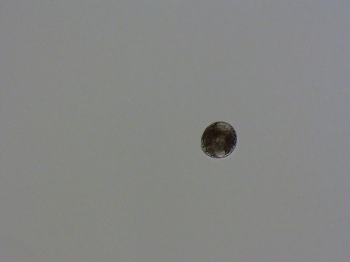
Mare01_ Embryo01_Cell5

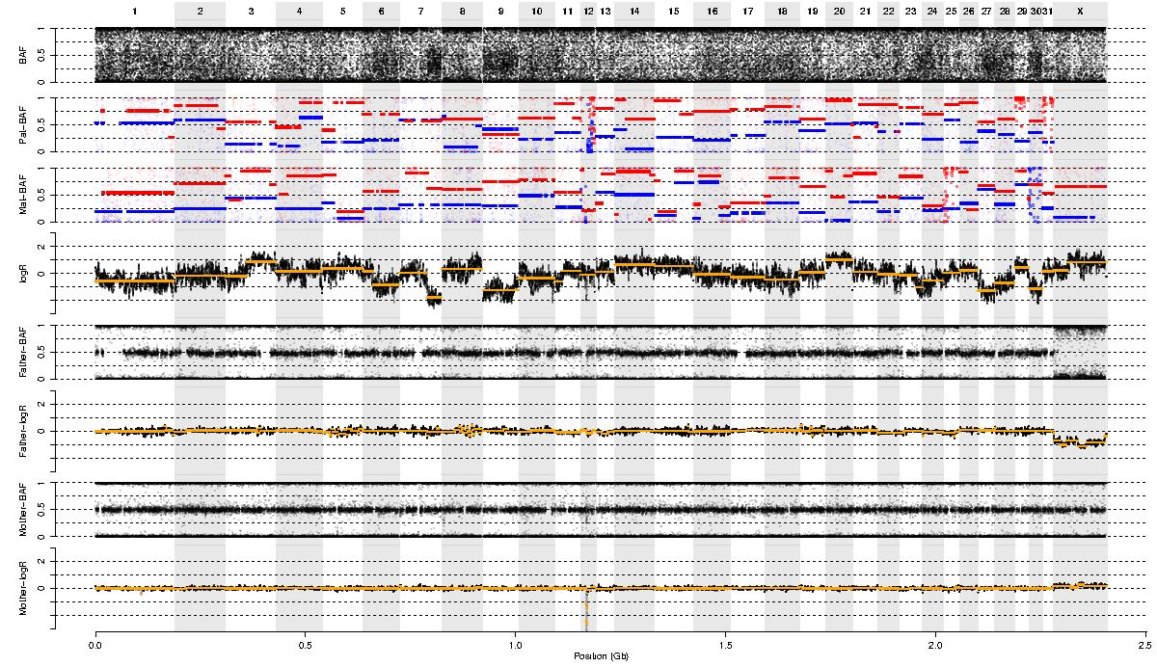
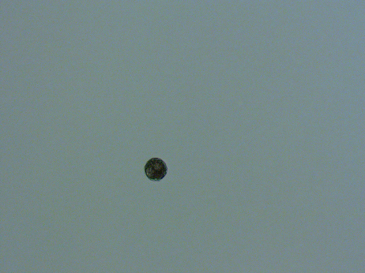
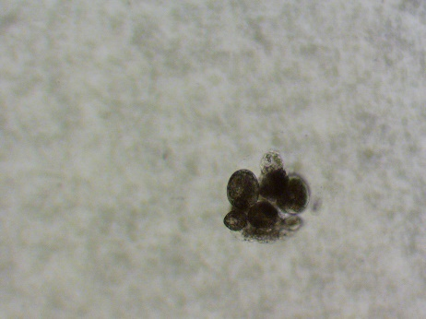
Mare01_ Embryo02_Cell1

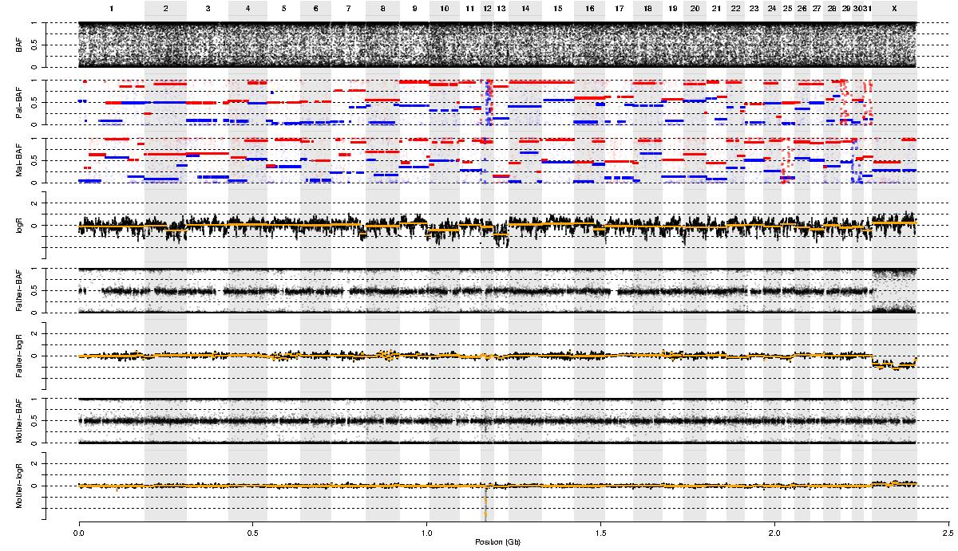

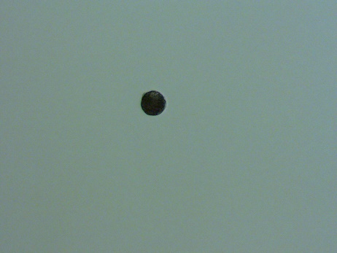
Mare01_ Embryo02_Cell2

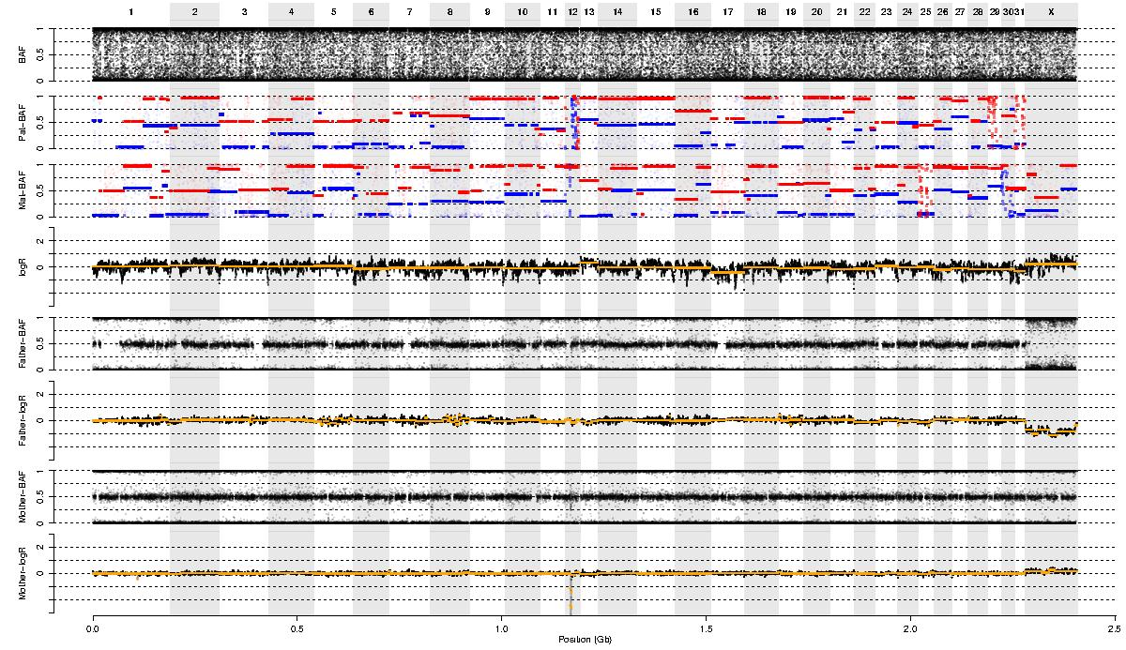

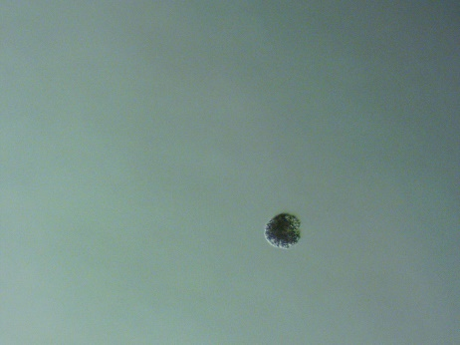
Mare01_ Embryo02_Cell3
Lost during collection.

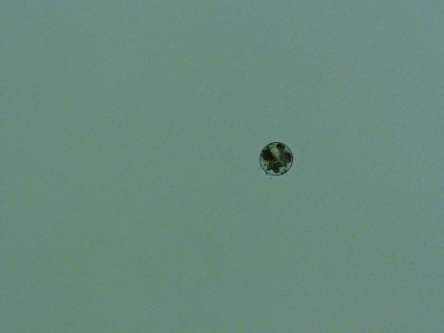
Mare01_ Embryo02_Cell4

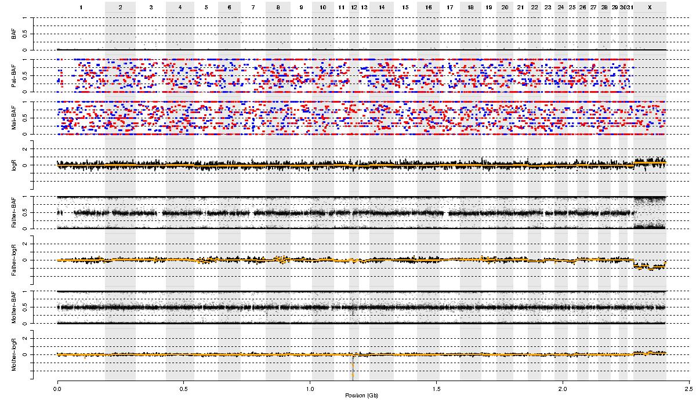


Mare01_ Embryo02_Cell5

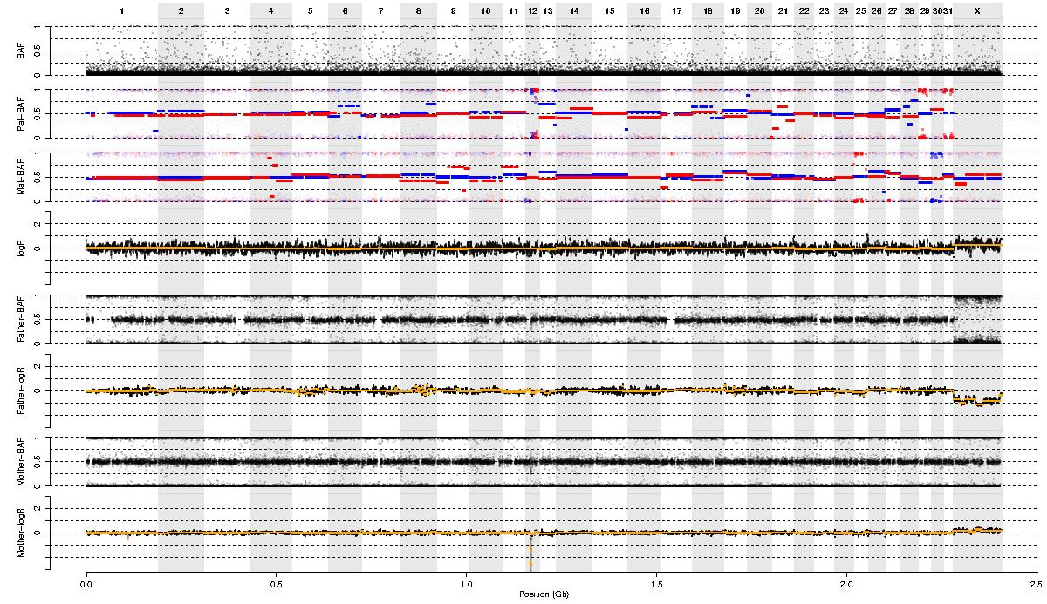
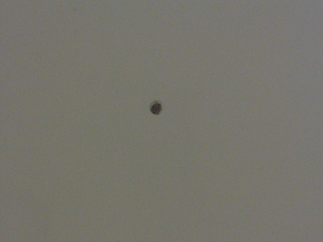
Mare01_ Embryo02_Cell6

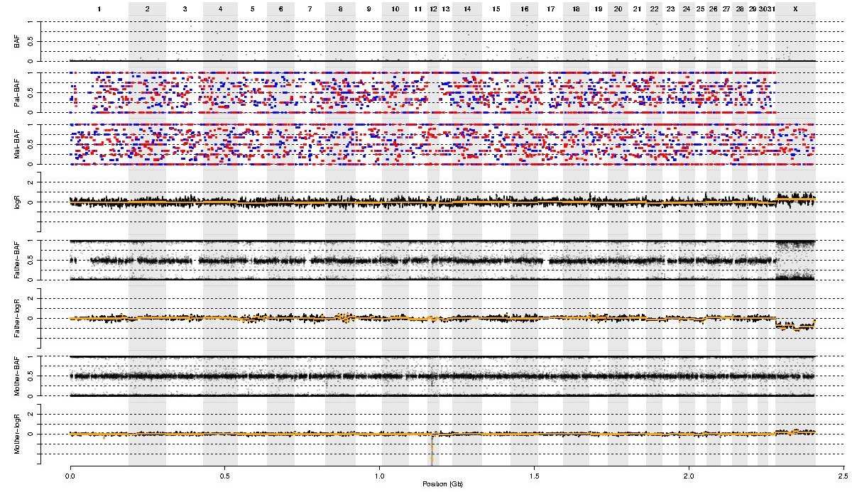
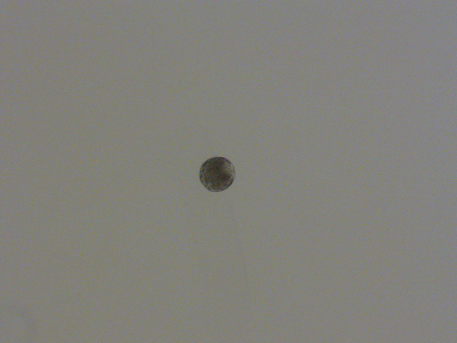
Mare01_ Embryo02_Cell7

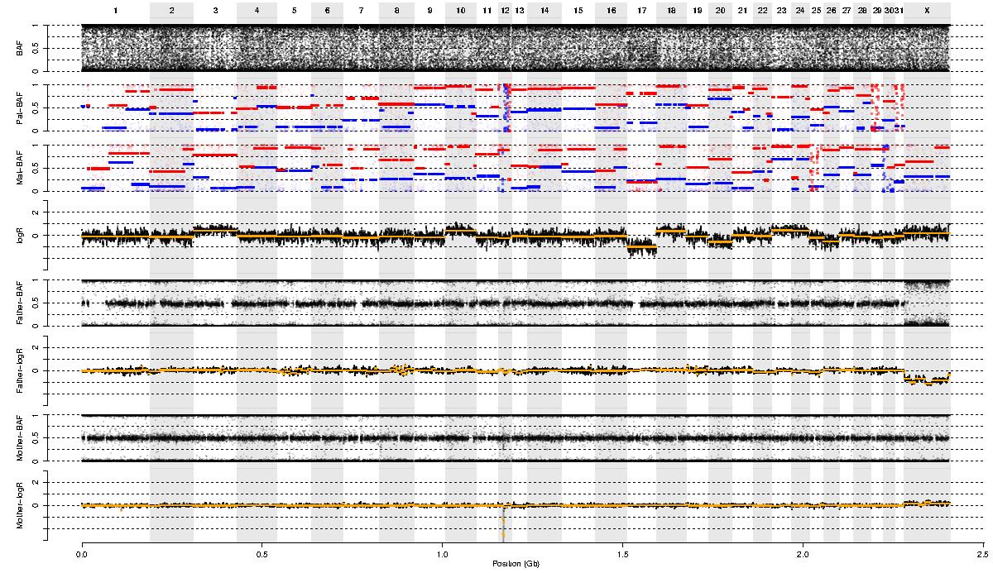
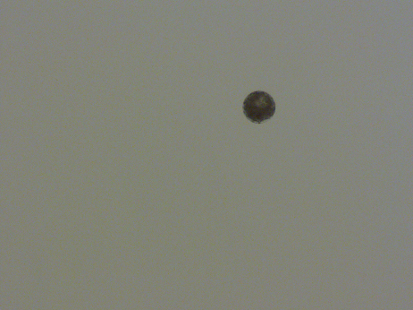
Mare01_ Embryo02_Cell8

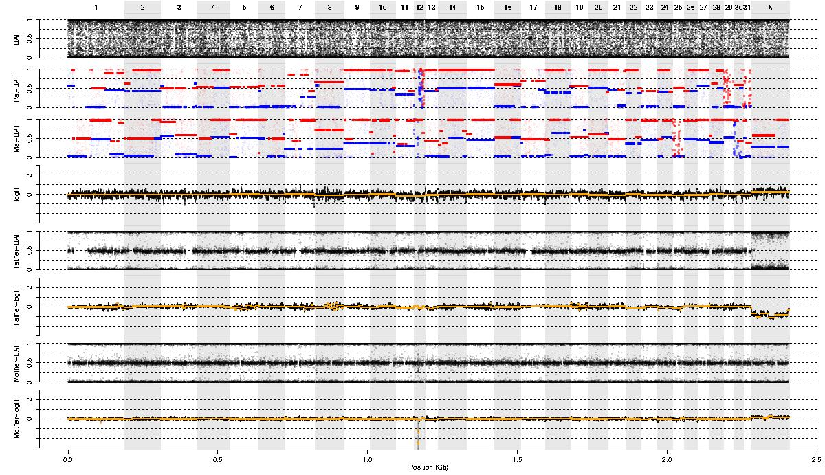
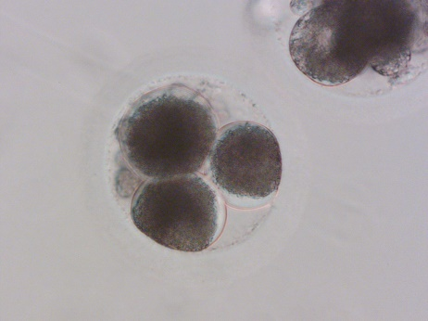
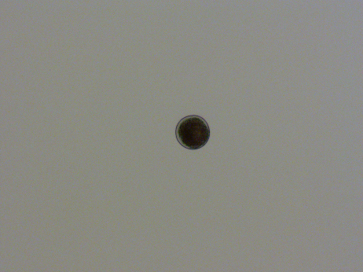
Mare02_ Embryo01_Cell1

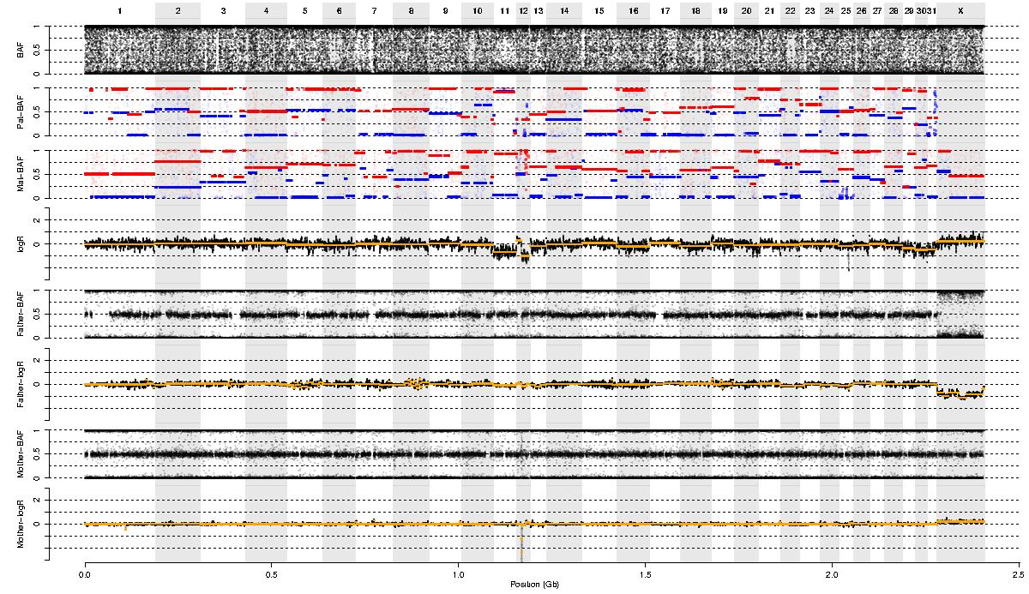

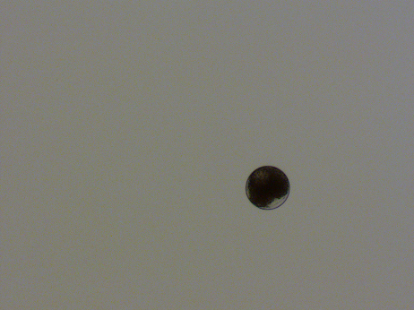
Mare02_ Embryo01_Cell2

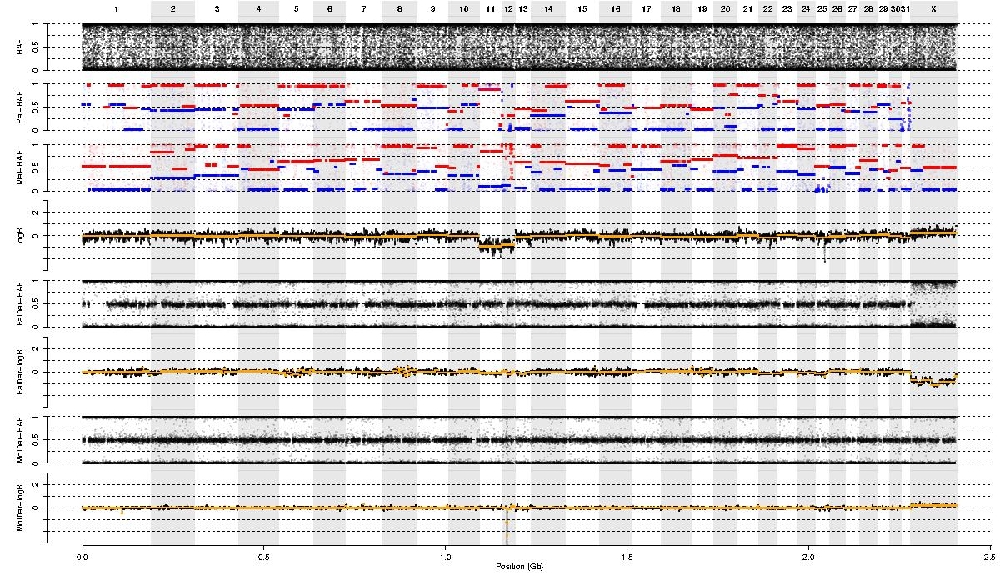
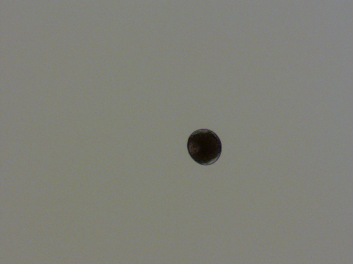
Mare02_ Embryo01_Cell3

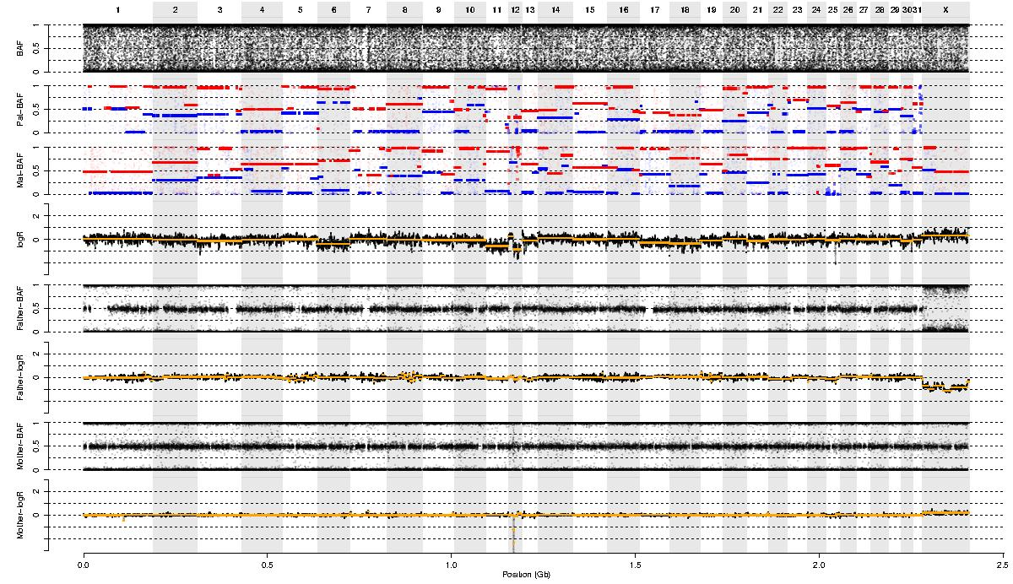
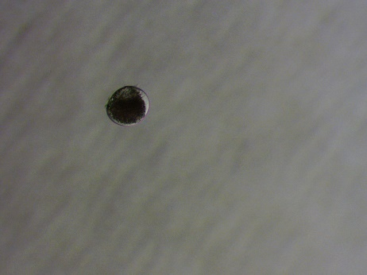
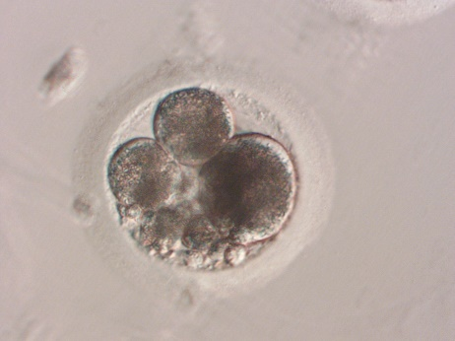
Mare02_ Embryo02_Cell1

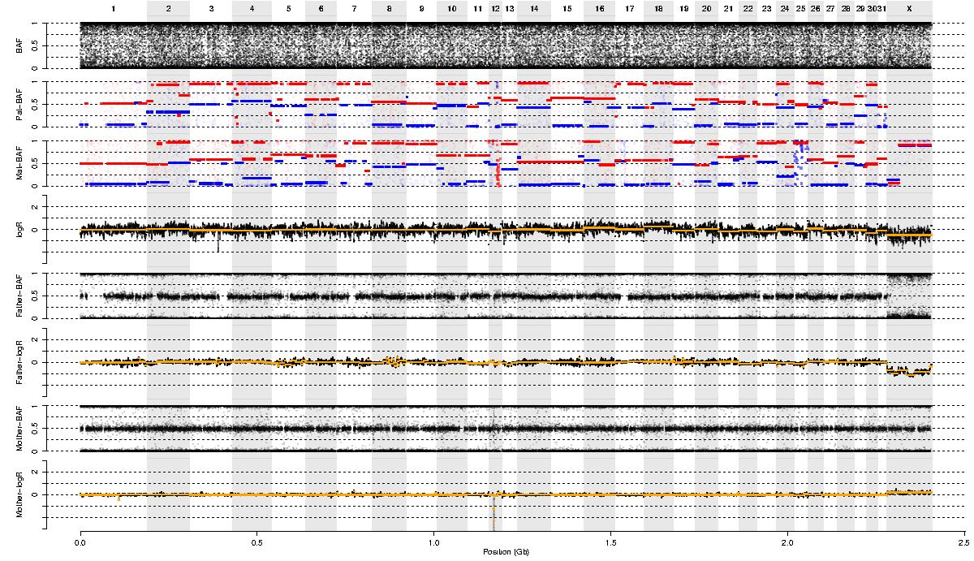
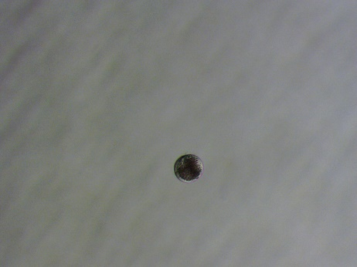
Mare02_ Embryo02_Cell2

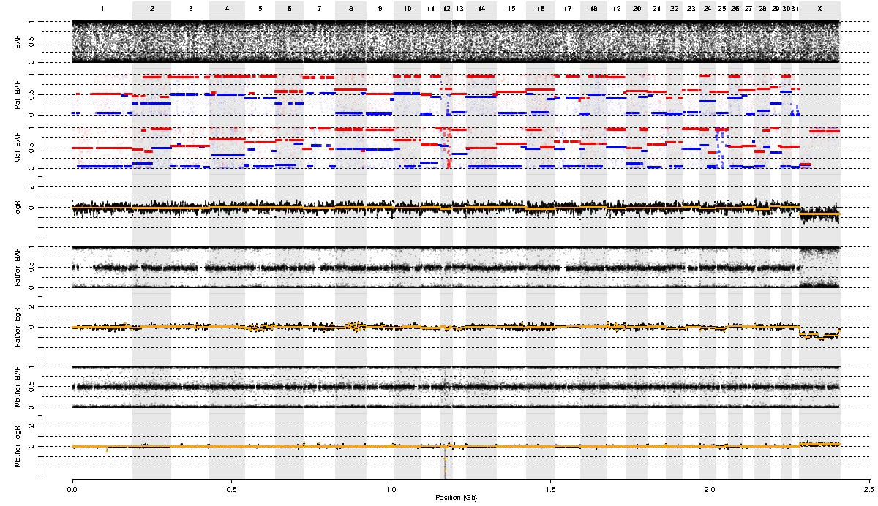
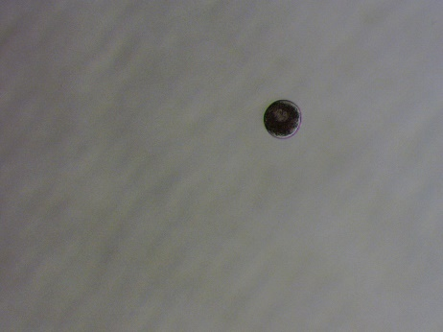
Mare02_ Embryo02_Cell3

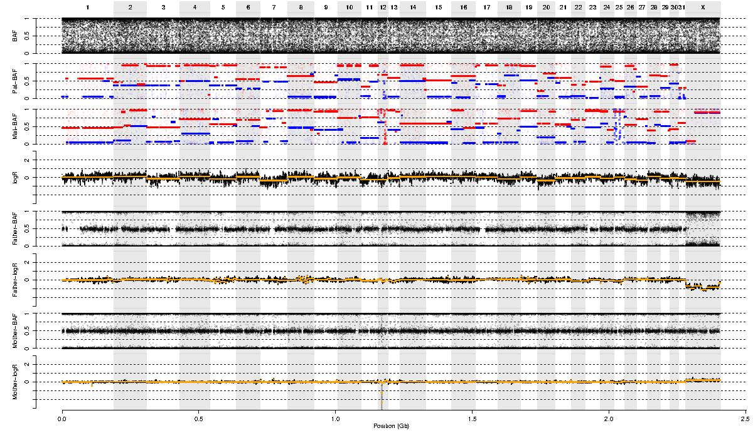
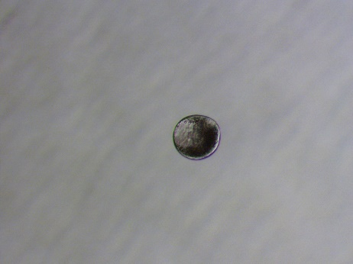
Mare02_ Embryo02_Cell4

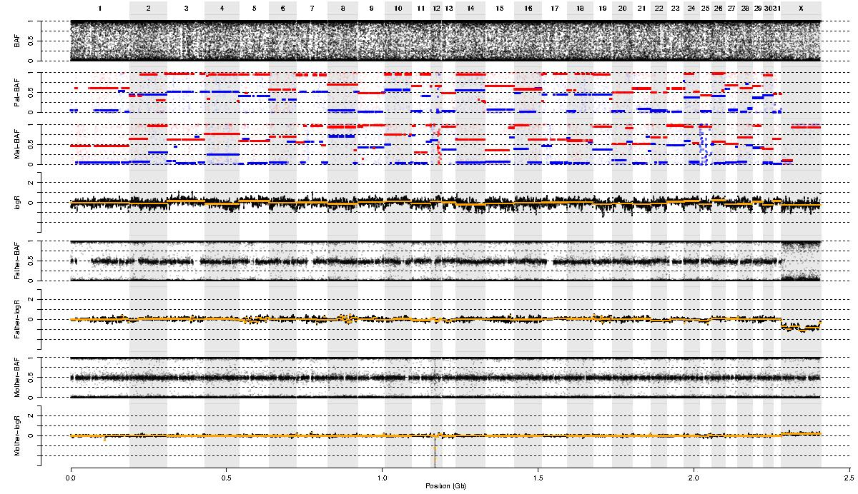
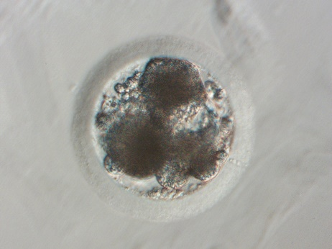
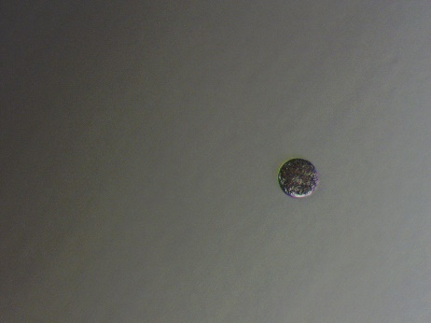
Mare02_ Embryo03_Cell1

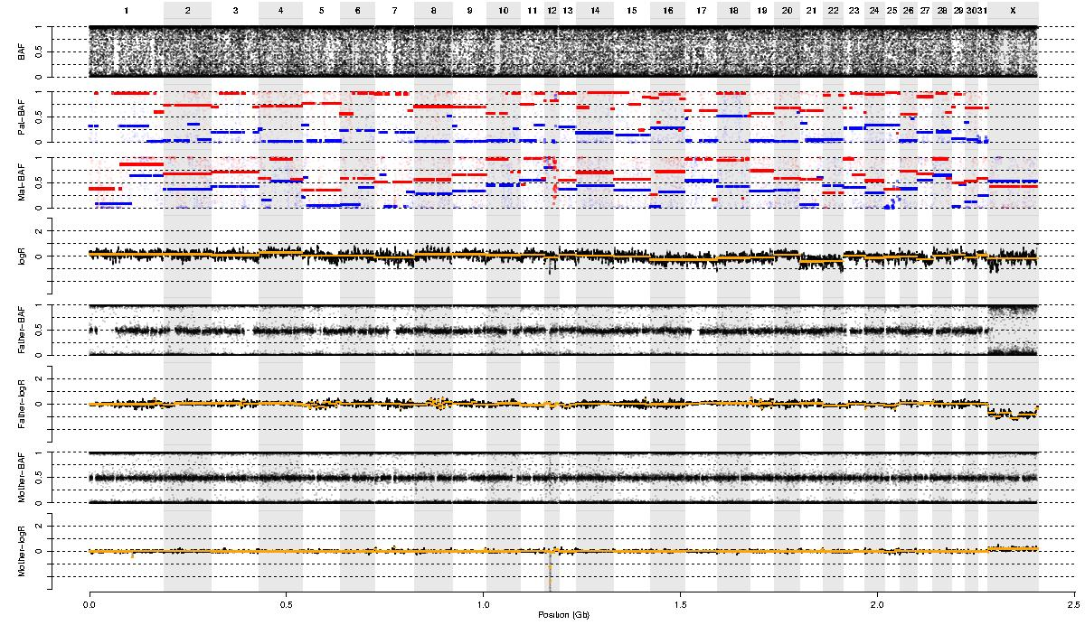
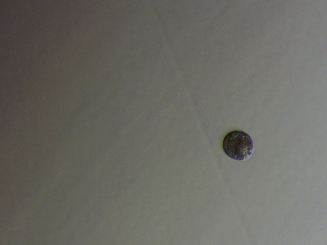
Mare02_ Embryo03_Cell2

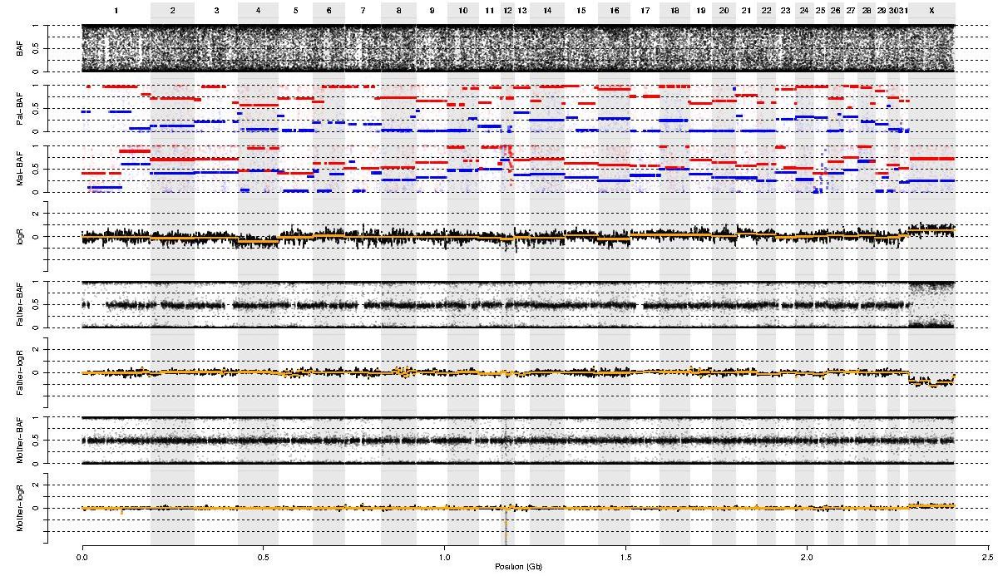
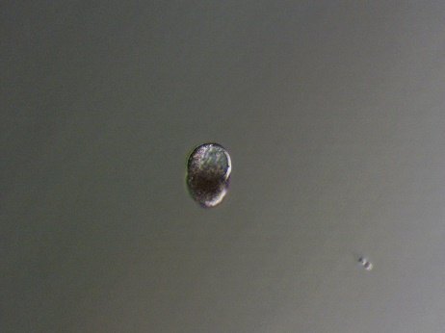
Mare02_ Embryo03_Cell3

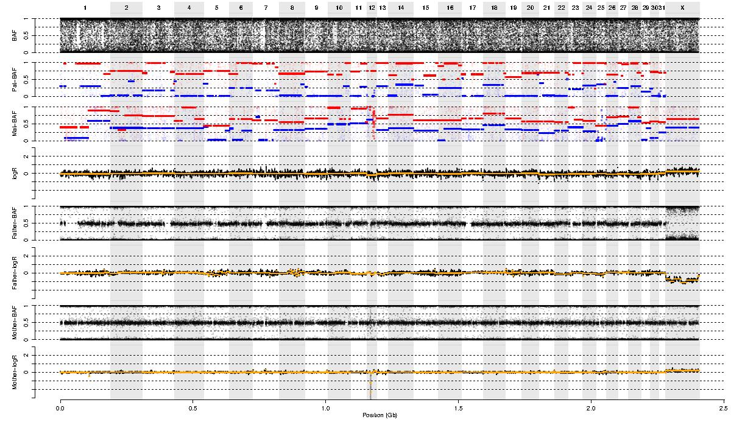
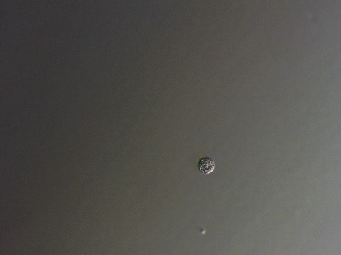
Mare02_ Embryo03_Cell4

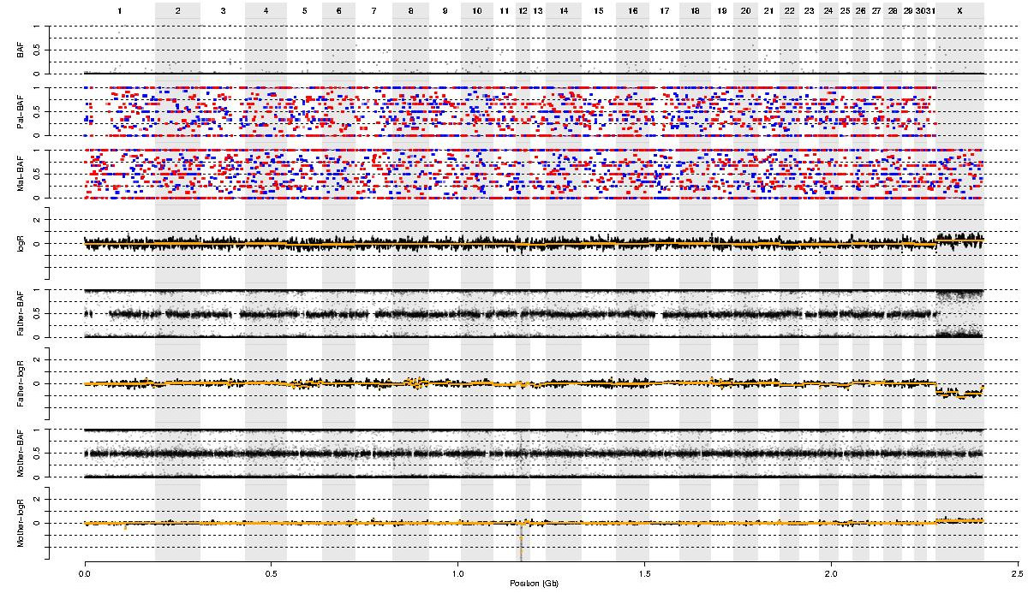
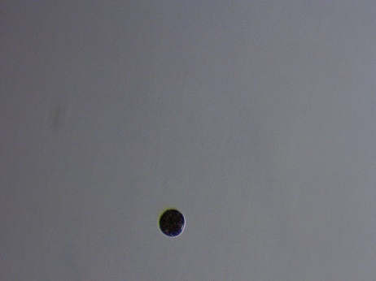
Mare02_ Embryo03_Cell5

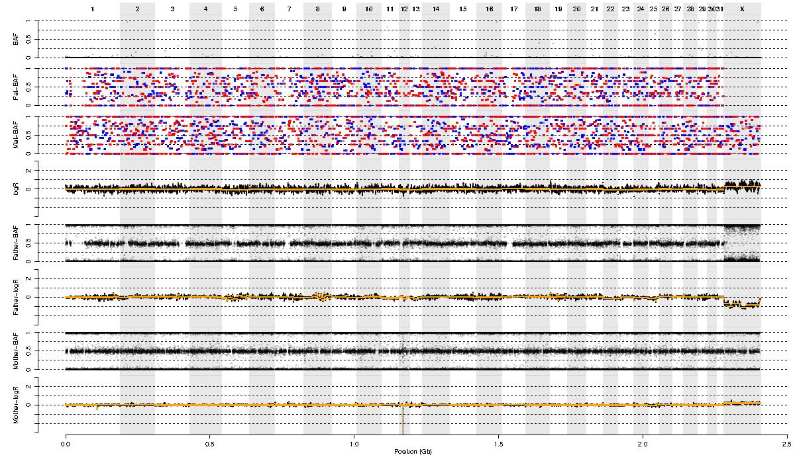

Mare02_ Embryo03_Cell6

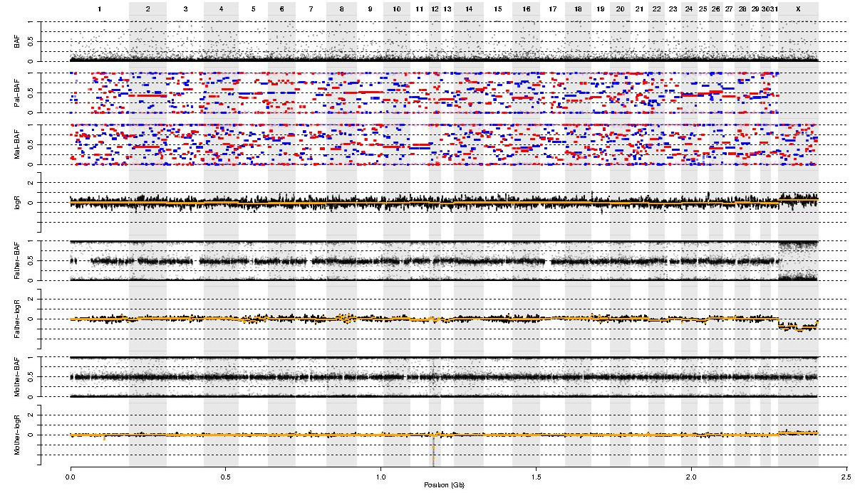
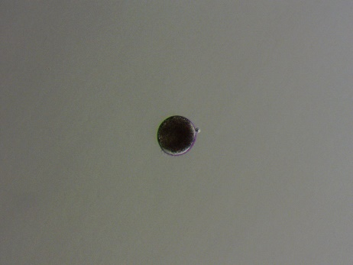
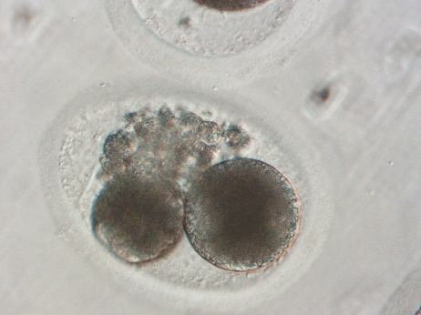
Mare04_ Embryo01_Cell1

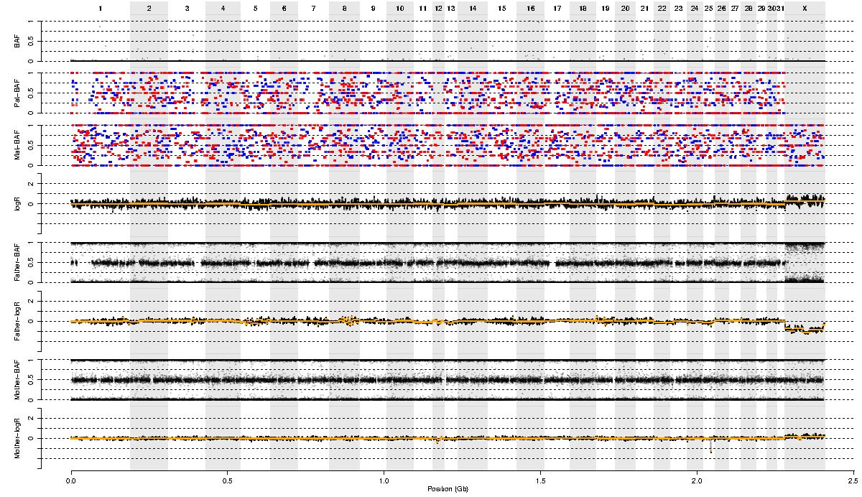

Mare04_ Embryo01_Cell2

