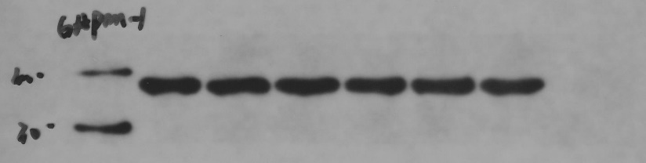GAPDH 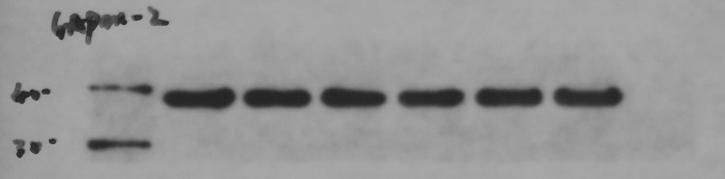GAPDH
miR-133 inhibitor
miR-133 mimic
inhibitor-NC
mimic-NC
miR-23b inhibitor
miR-23b mimic
marker
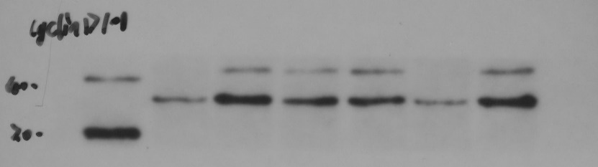Cyclin D1 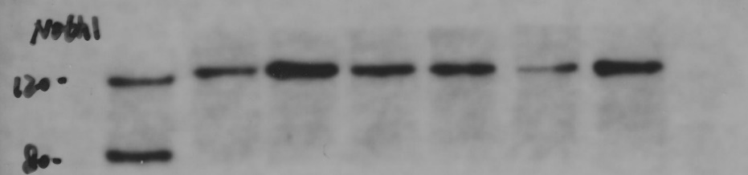NOTCH1
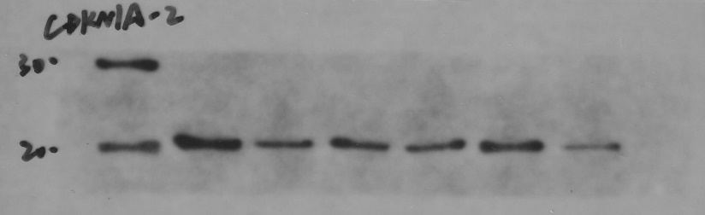CDKN1A 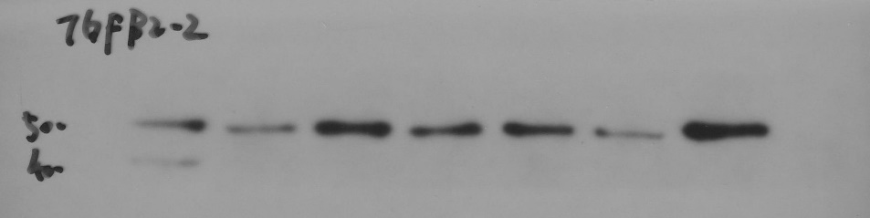TGFβ2
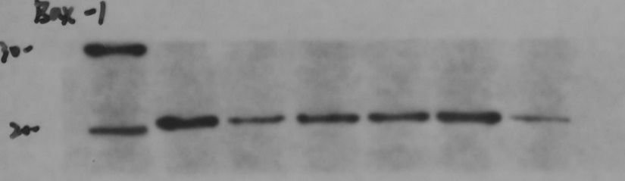BAX
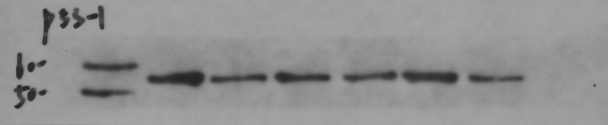P53
Fig S5. Original image of Western blotting. The order of loading is marker, miR-23b mimic, miR-23b inhibitor, mimic-NC, inhibitor-NC, miR-133 mimic, miR-133 inhibitor. The red box represents the part of the manuscript where the images are displayed.

