Supplementary figures and tables
Manuscript: Developing Clinical Prediction Models for Nominal Polytomous Outcomes: a simulation study comparing available approaches
Table of Contents
1. Supplementary figures and tables for large sample size analysis 1
2. Supplementary tables for small sample size analysis 32
2.1. Tables S5 – S8: Tables for small development sample size analysis under different sets of generated coefficients, K = 3. 32
2.2. Tables S9 – S20: Tables for small development sample size analysis under different sets of generated coefficients, K = 5. 40
3. Supplementary figures from clinical example 64
4. References 65

Supplementary figures and tables for large sample size analysis
In Figures S1.1 to S1.8 we present the equivalent figures to those in the main manuscript, but with K = 5 outcome categories. Figures from simulation runs with different randomly generated coefficients led to the same conclusions as those from the presented figures. We have therefore chosen not to overload the supplementary material or manuscript with these figures. They are however available at the GitHub page for this study.¹
In Figures S1.1 – S1.8 (K = 5) we see similar patterns to when K = 3. OvA-N has poor calibration across all scenarios. OvO-PC and MLR have very similar levels of calibration across all scenarios. MLR and c-ratio are both perfectly calibrated when the model is correctly specified, and have varying levels of mis-calibration when the model is mis-specified. Importantly, the mis-calibration of c-ratio is much more extreme than that of MLR.
In Figures S1.9 – S1.16 we present the equivalent figures to those in the main manuscript, but using the per-outcome binary logistic recalibration framework with loess smoothers. This approach is not an ideal way to calibrate a model predicting a polytomous outcome as it only considers each outcome in isolation. However, these plots do provide some protection over using a recalibration framework based on multinomial logistic regression, which it could be argued may favour the MLR analysis method.
In Figures S1.9 – S1.16 the flexible calibration plots have the same shape as the average of the points from Figures 1 to 8 in the main manuscript. This indicates that the calibration plots produced from the nominal recalibration framework of van Hoorde et al REF XXXX, do not favour the MLR analysis method in a way which makes comparison of the methods unfair.

Figures S1 – S6: Flexible calibration plots for scenarios B.1, C.1 and D.1, K = 3 (large sample size analysis)
Figure S1: Large sample analysis: Flexible calibration plot for scenario B.1, K = 3, multinomial DGM.
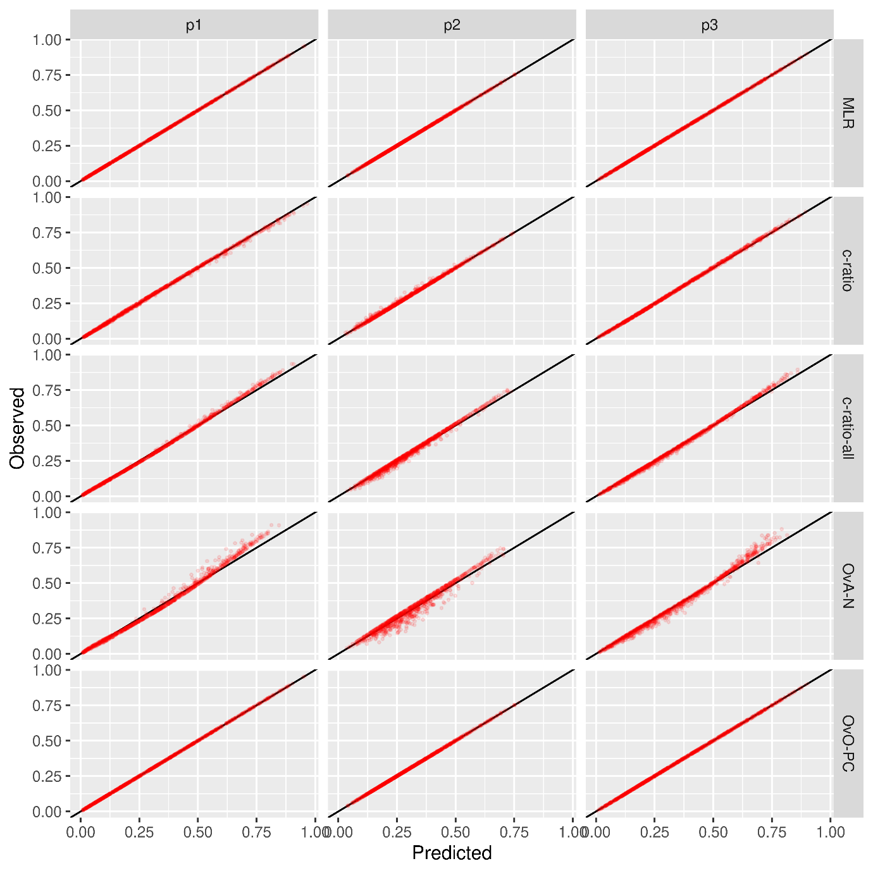
Figure S2: Large sample analysis: Flexible calibration plot for scenario B.1, K = 3, c-ratio DGM.
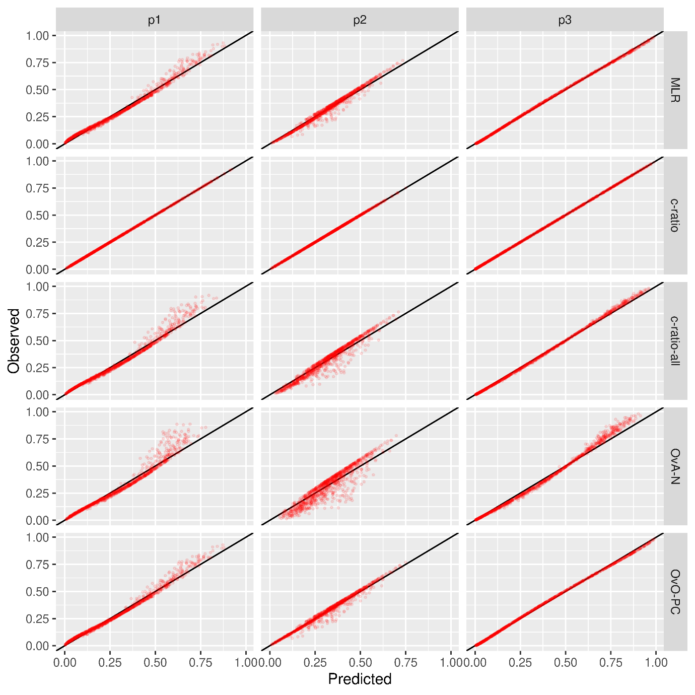

Figure S3: Large sample analysis: Flexible calibration plot for scenario C.1, K = 3, multinomial DGM.
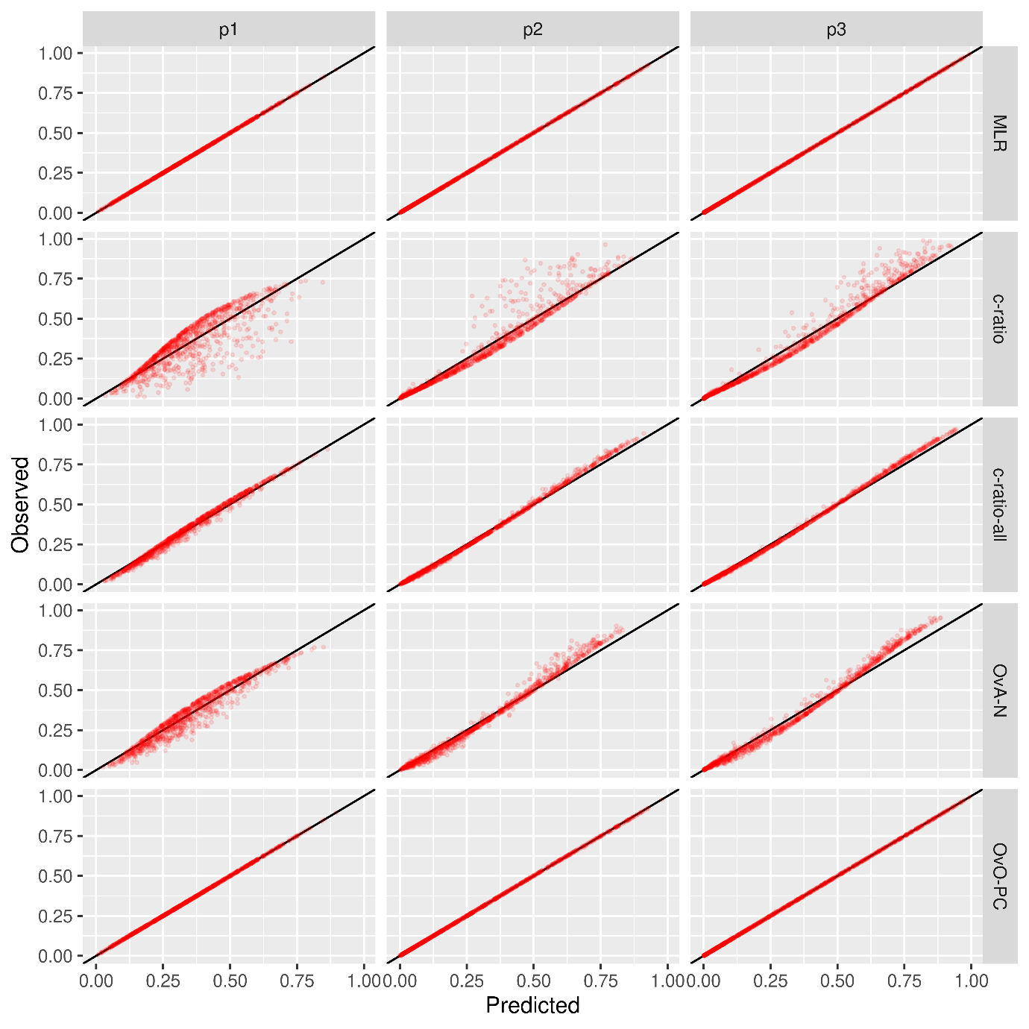

Figure S4: Large sample analysis: Flexible calibration plot for scenario C.1, K = 3, c-ratio DGM.
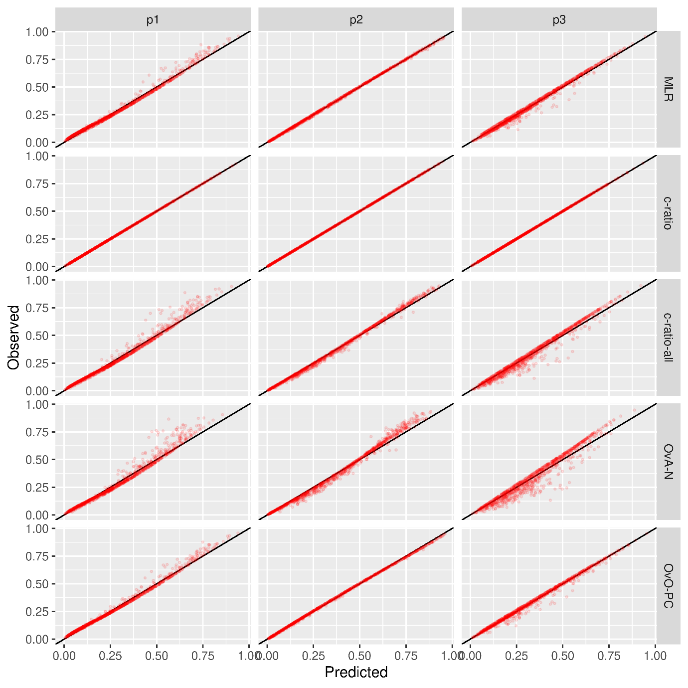

Figure S5: Large sample analysis: Flexible calibration plot for scenario D.1, K = 3, multinomial DGM.
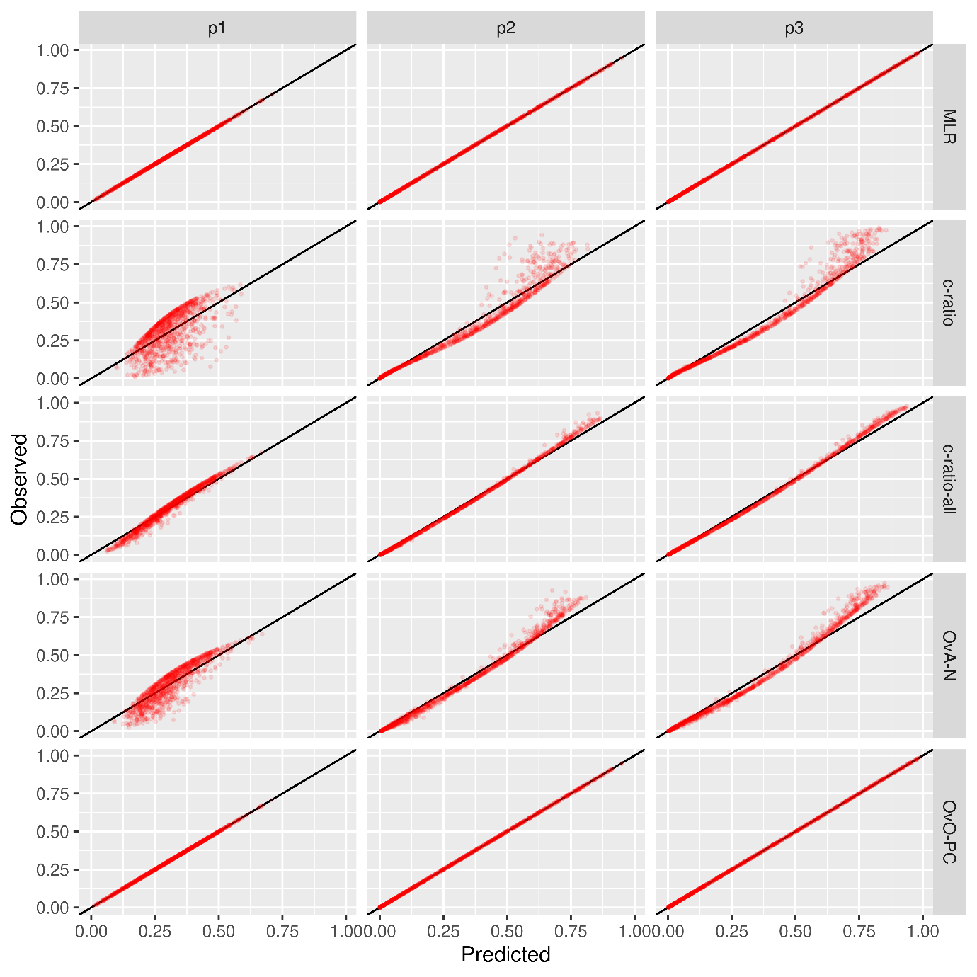

Figure S6: Large sample analysis: Flexible calibration plot for scenario D.1, K = 3, c-ratio DGM.
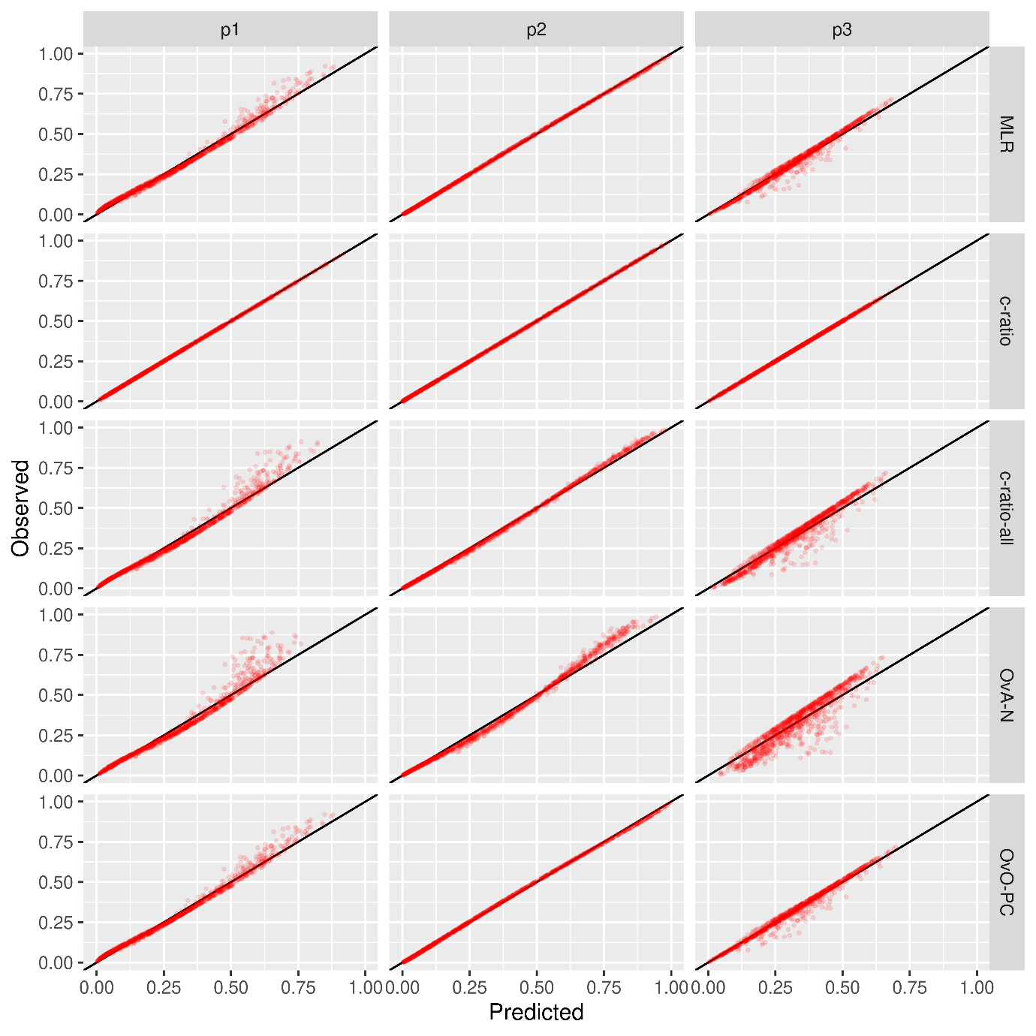

Figures S7 – S14: Flexible calibration plots for scenarios B.1, C.1 and D.1, K = 5 (large sample size analysis)
Figures S7: Flexible calibration plot for scenario A.1, K = 5, DGM multinomial.
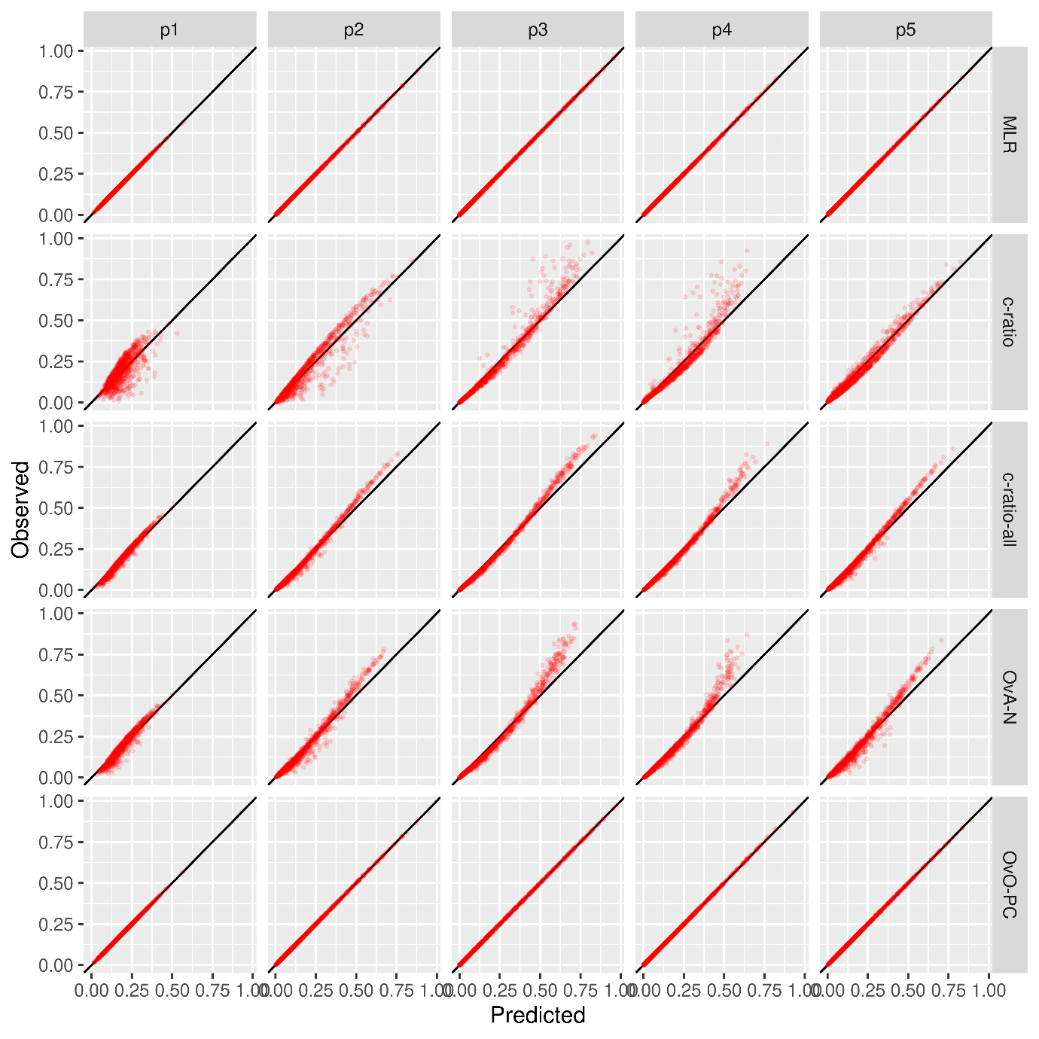
Figure S8: Flexible calibration plot for scenario A.1, K = 5, DGM c-ratio.
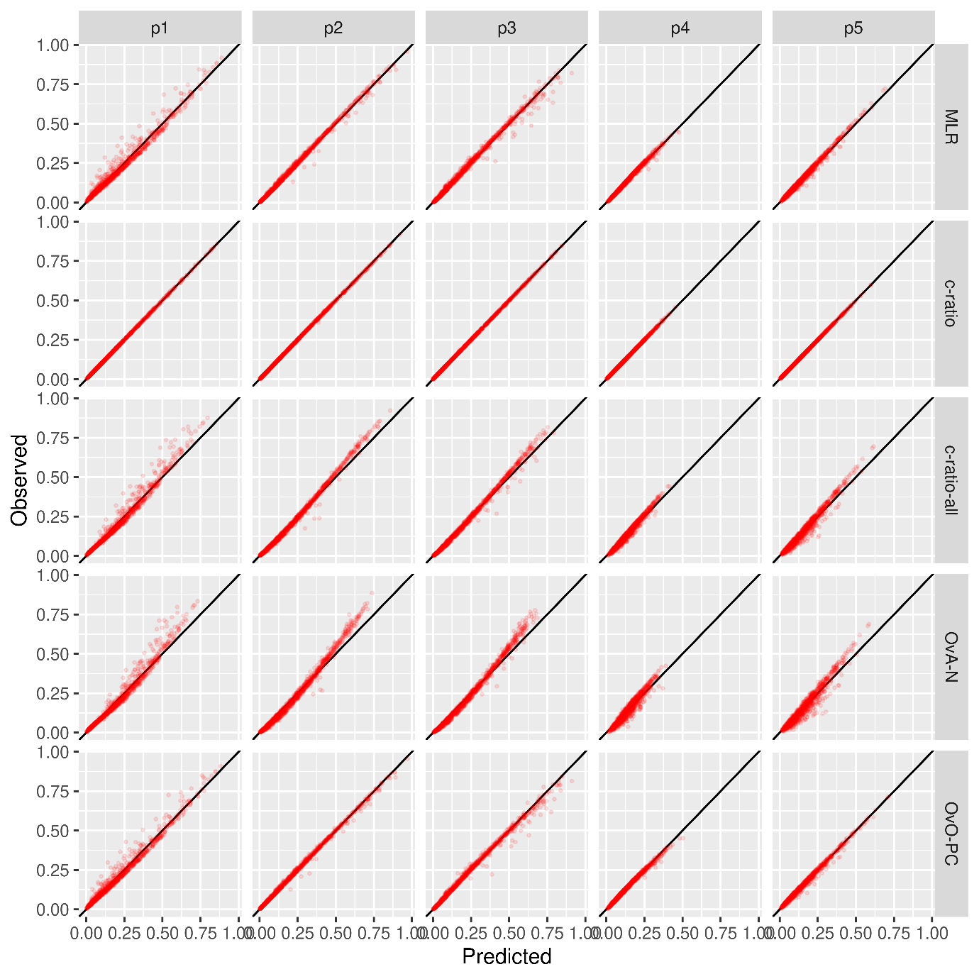

Figure S9: Flexible calibration plot for scenario B.1, K = 5, DGM multinomial.
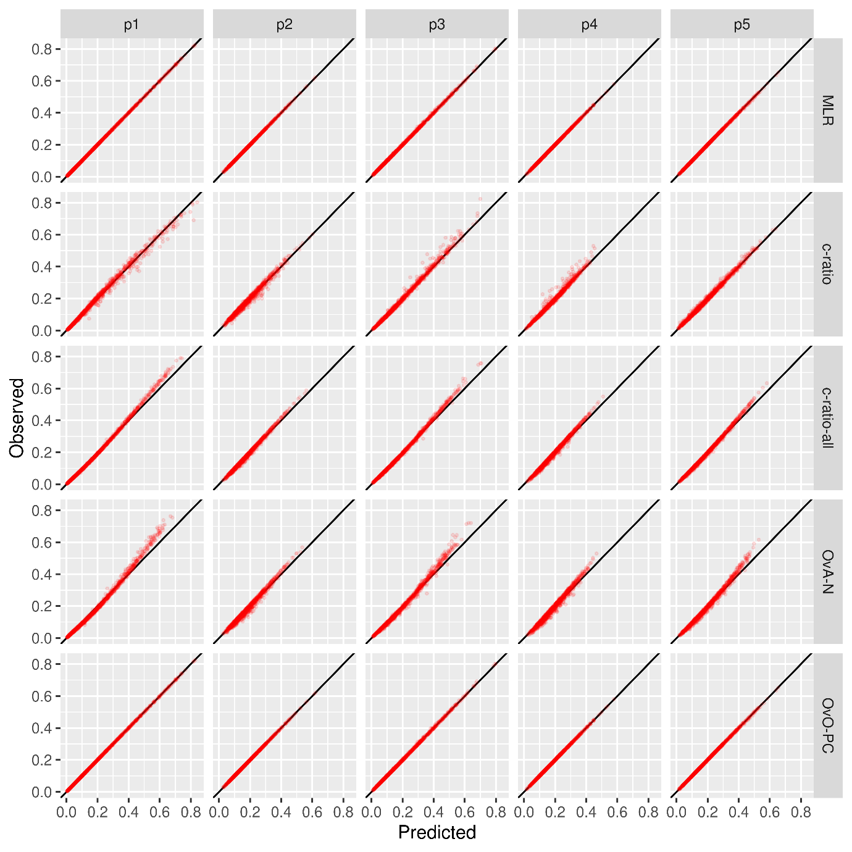

Figure S10: Flexible calibration plot for scenario B.1, K = 5, DGM c-ratio.
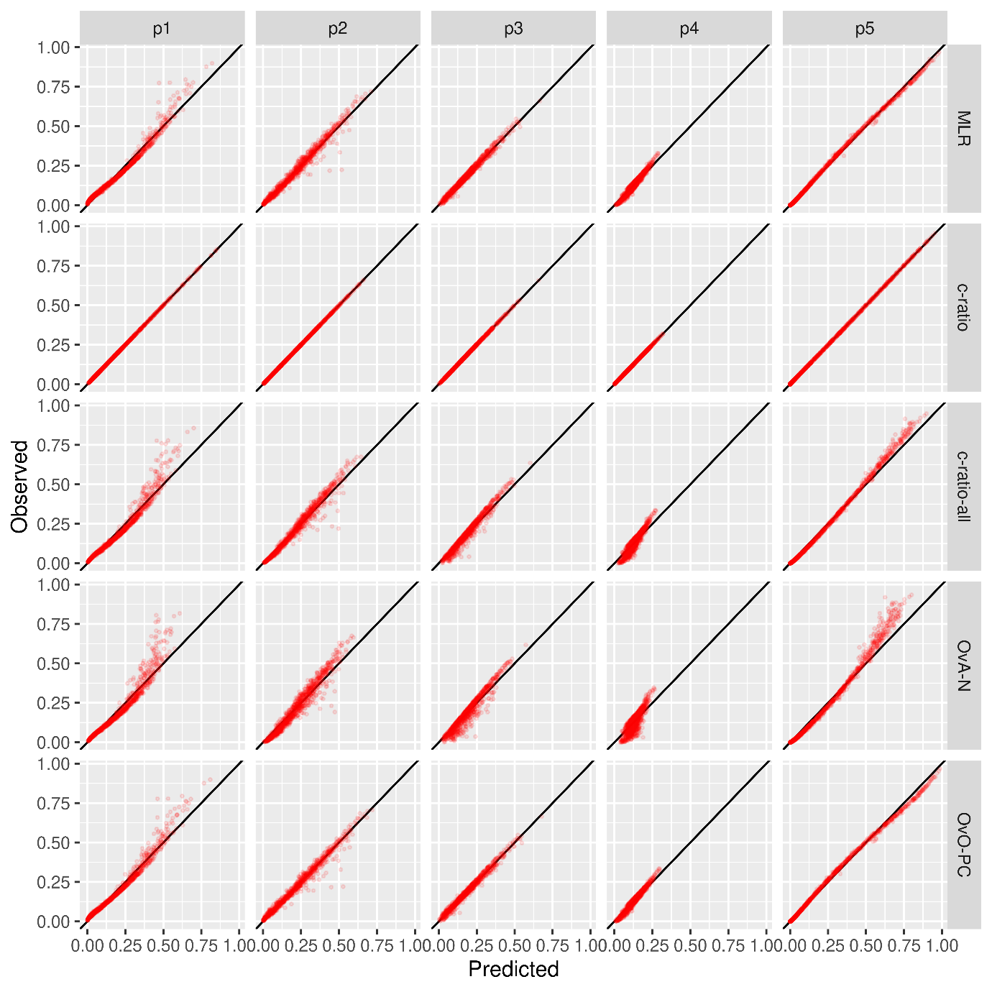

Figure S11: Flexible calibration plot for scenario C.1, K = 5, DGM multinomial.
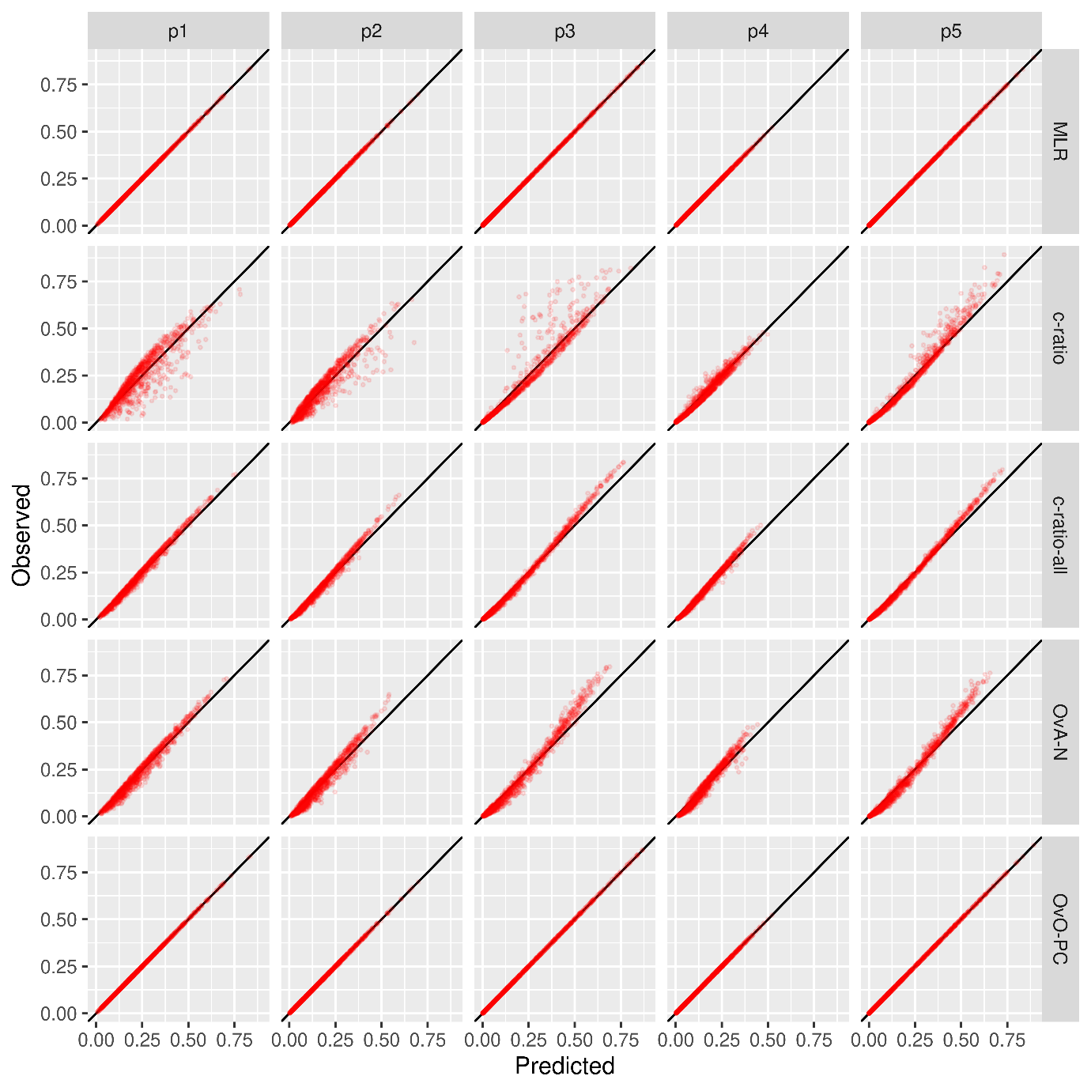

Figure S12: Flexible calibration plot for scenario C.1, K = 5, DGM c-ratio.
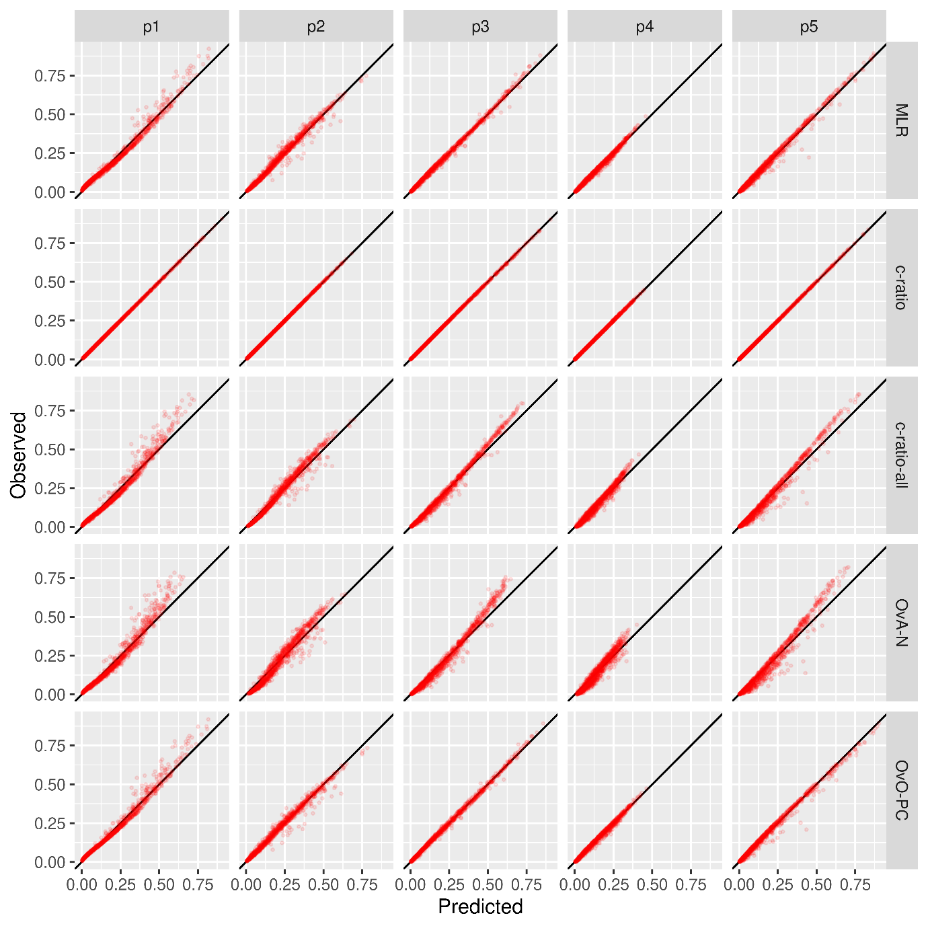

Figure S13: Flexible calibration plot for scenario D.1, K = 5, DGM multinomial.
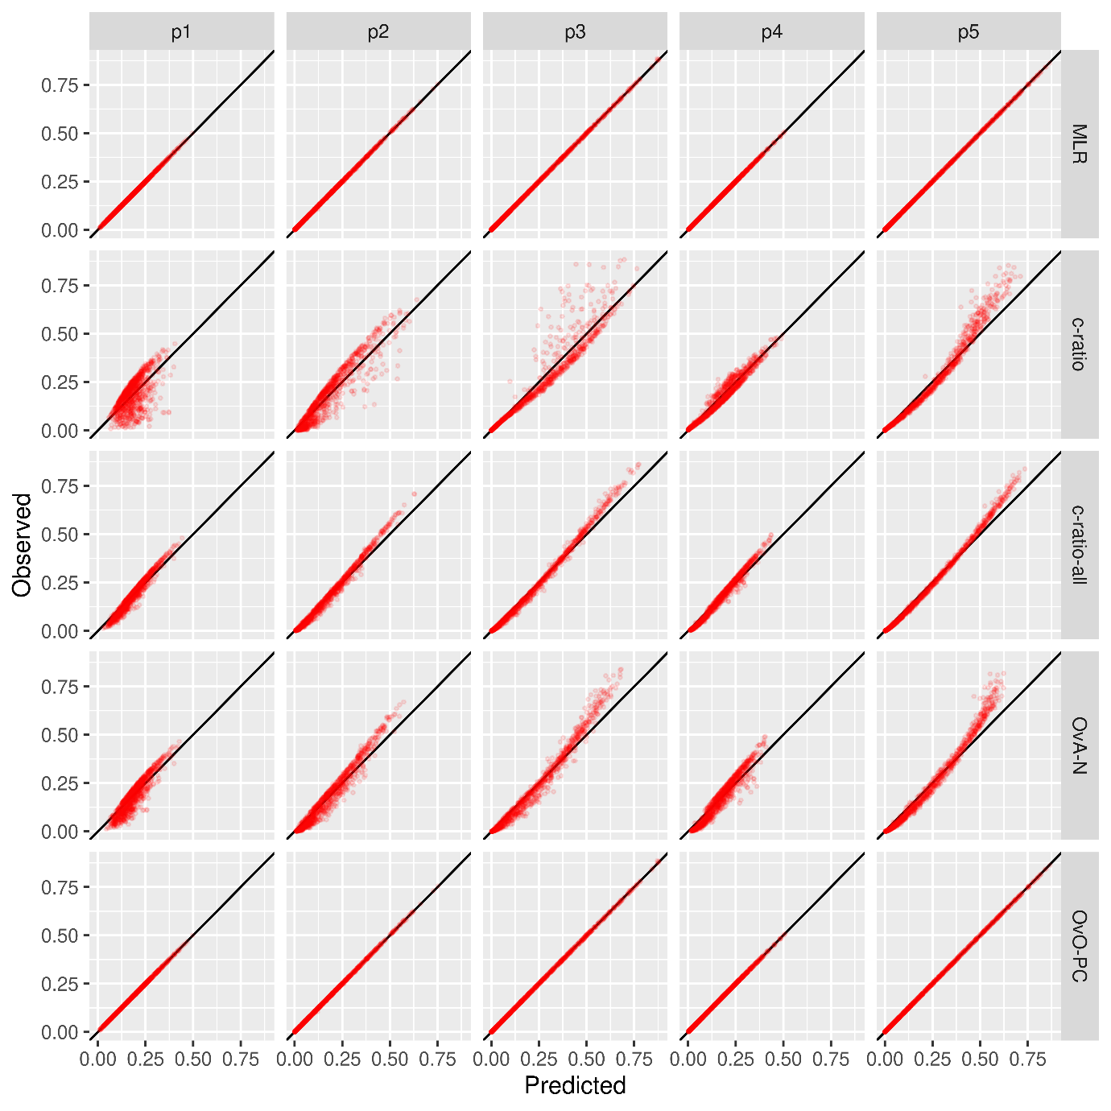

Figure S14: Flexible calibration plot for scenario D.1, K = 5, DGM c-ratio.
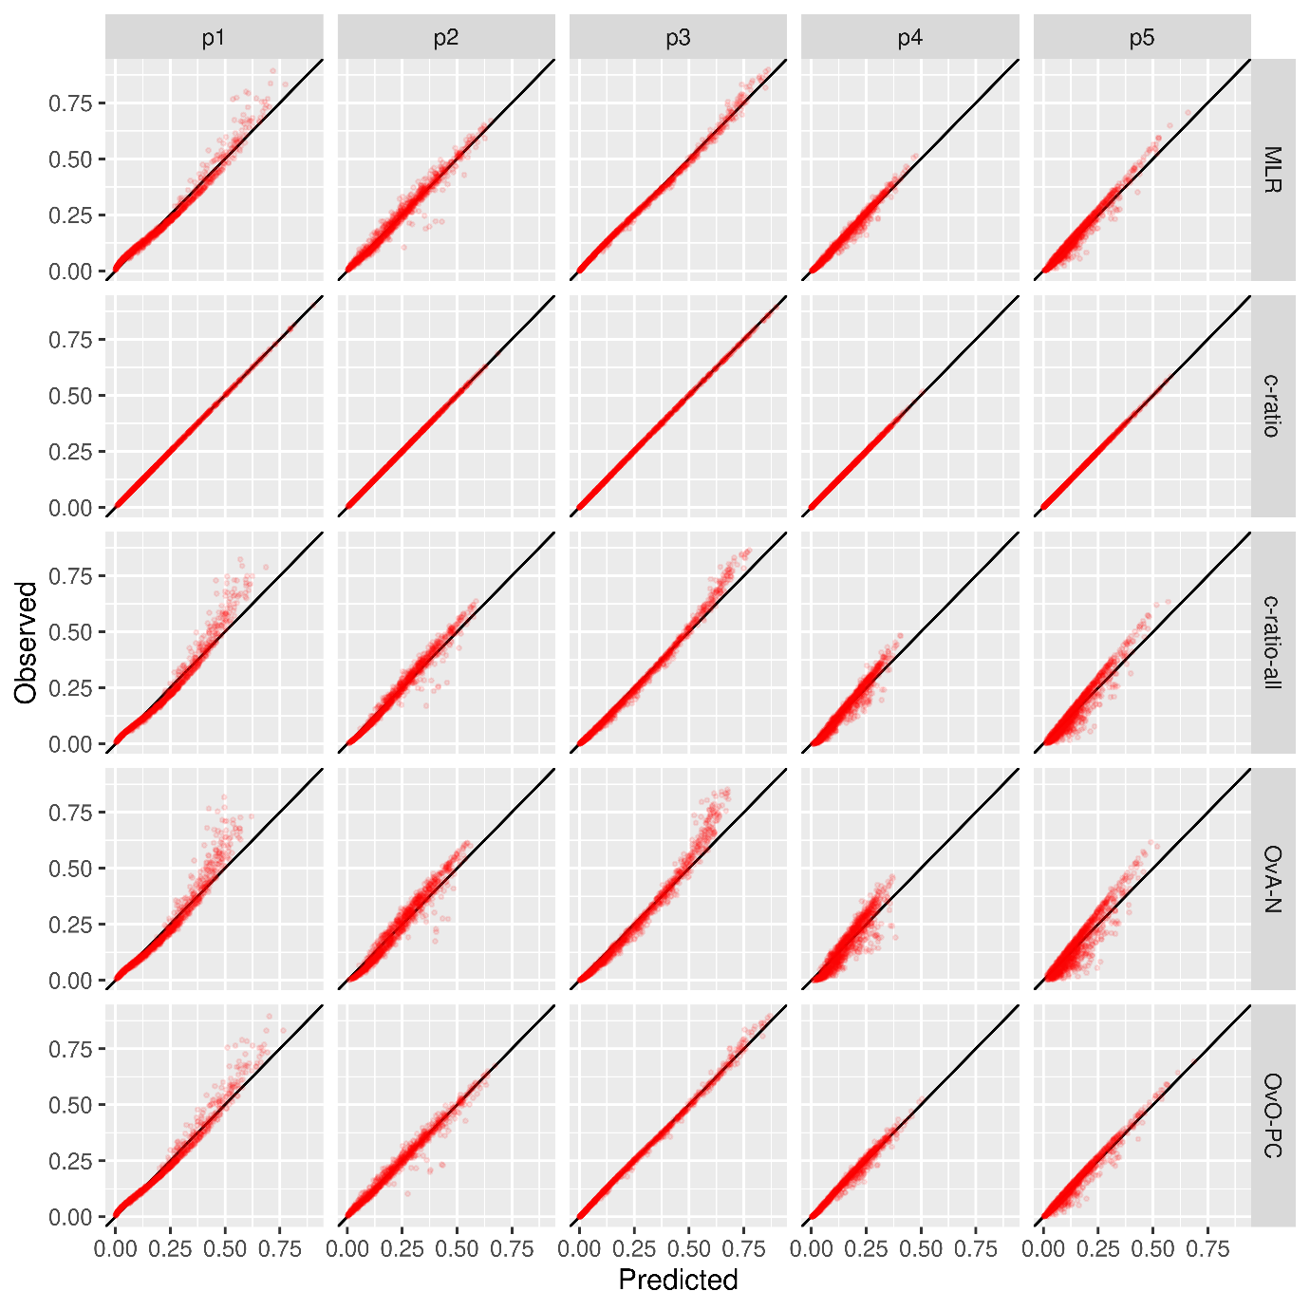

Figures S15 – S22: Flexible calibration plots per outcome, under a binary logistic recalibration framework, for scenarios A.1, B.1, C.1 and D.1, K = 3 (large sample size analysis)
Figure S15: Per-outcome binary calibration plot for scenario A.1, K = 3, multinomial DGM.
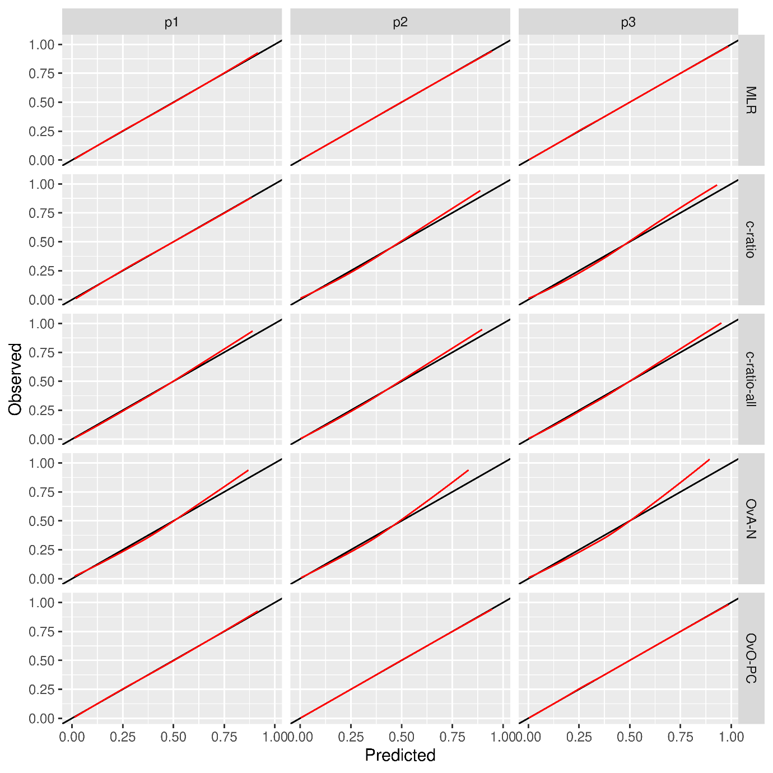

Figure S16: Per-outcome binary calibration plot for scenario A.1, K = 3, c-ratio DGM.
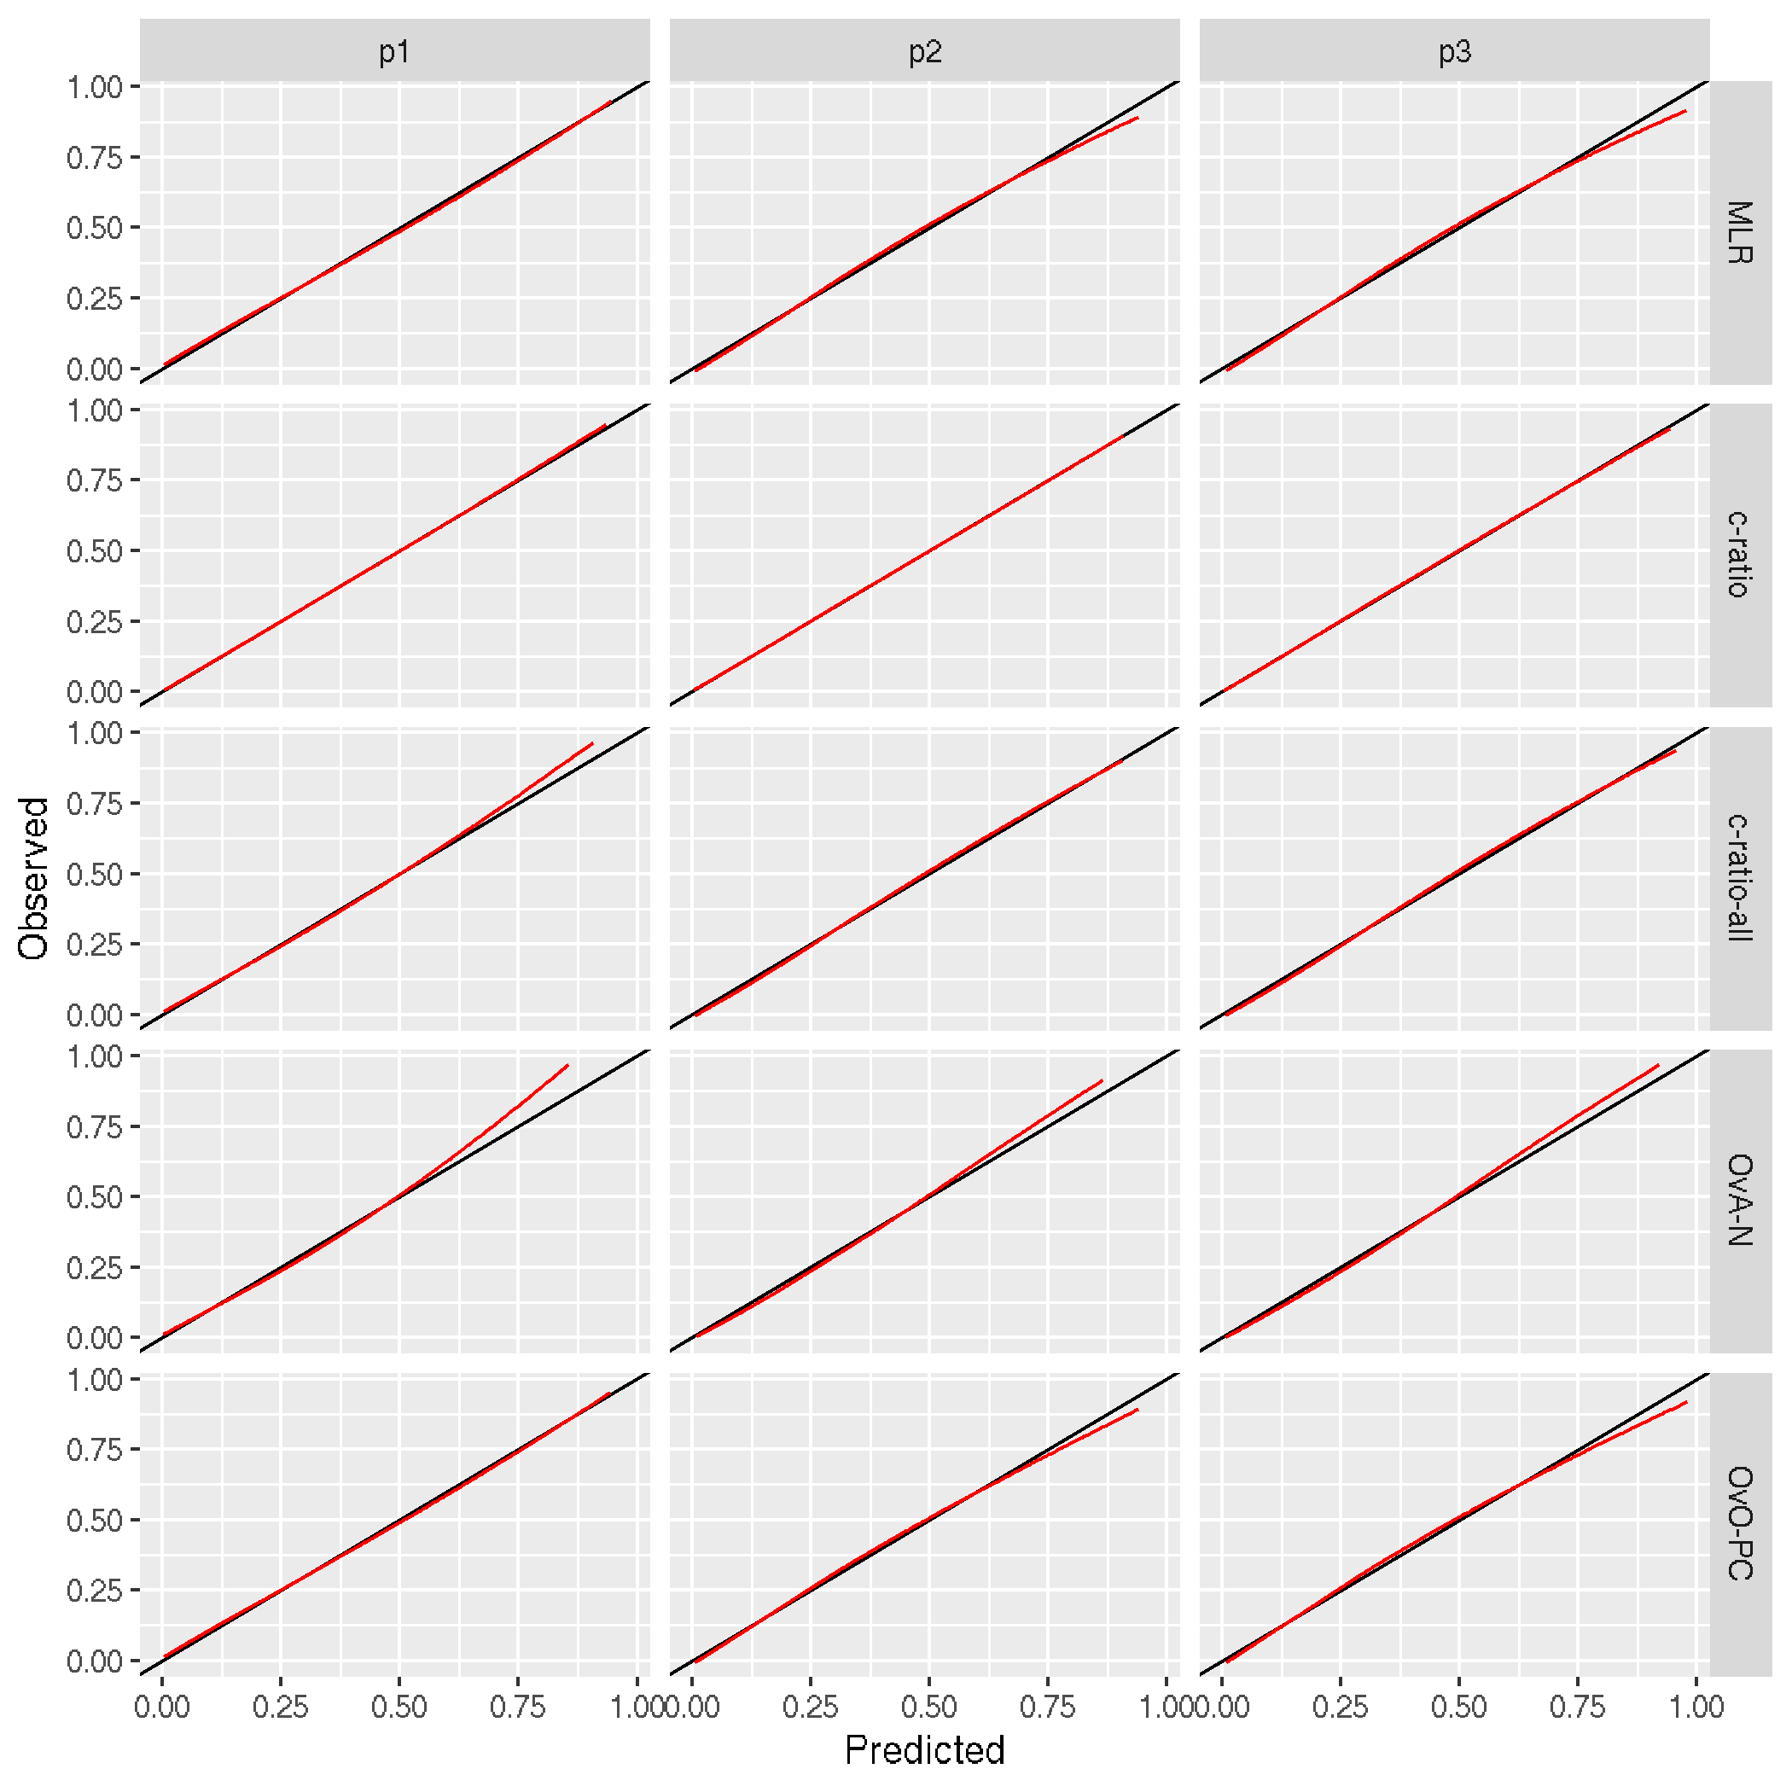

Figure S17: Per-outcome binary calibration plot for scenario B.1, K = 3, multinomial DGM.
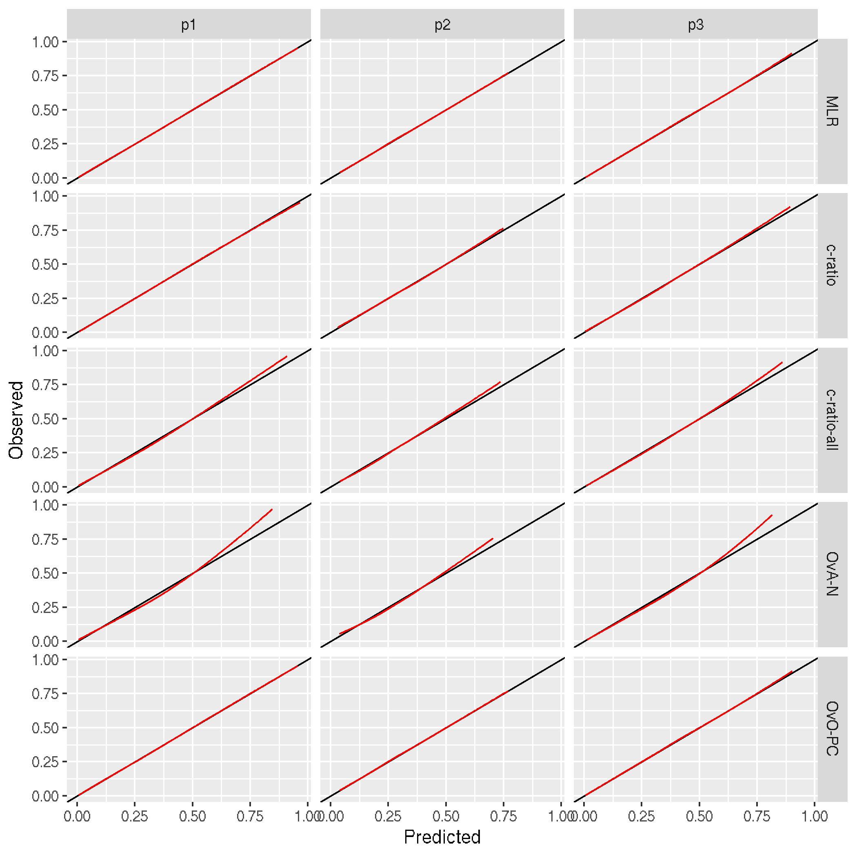

Figure S18: Per-outcome binary calibration plot for scenario B.1, K = 3, c-ratio DGM.
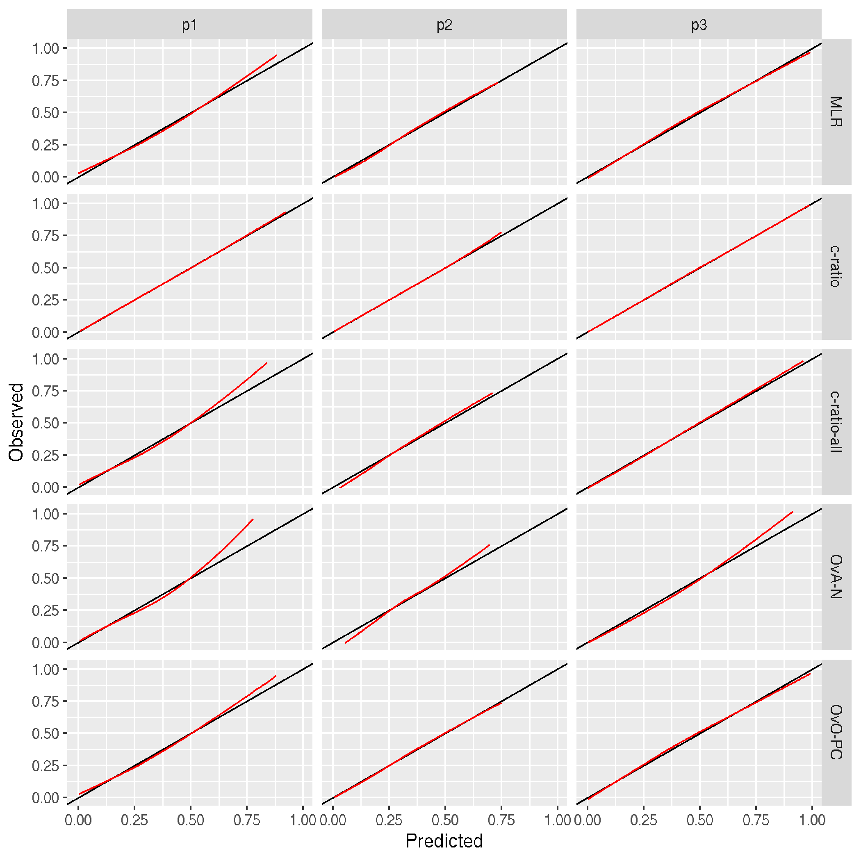

Figure S19: Per-outcome binary calibration plot for scenario C.1, K = 3, multinomial DGM.
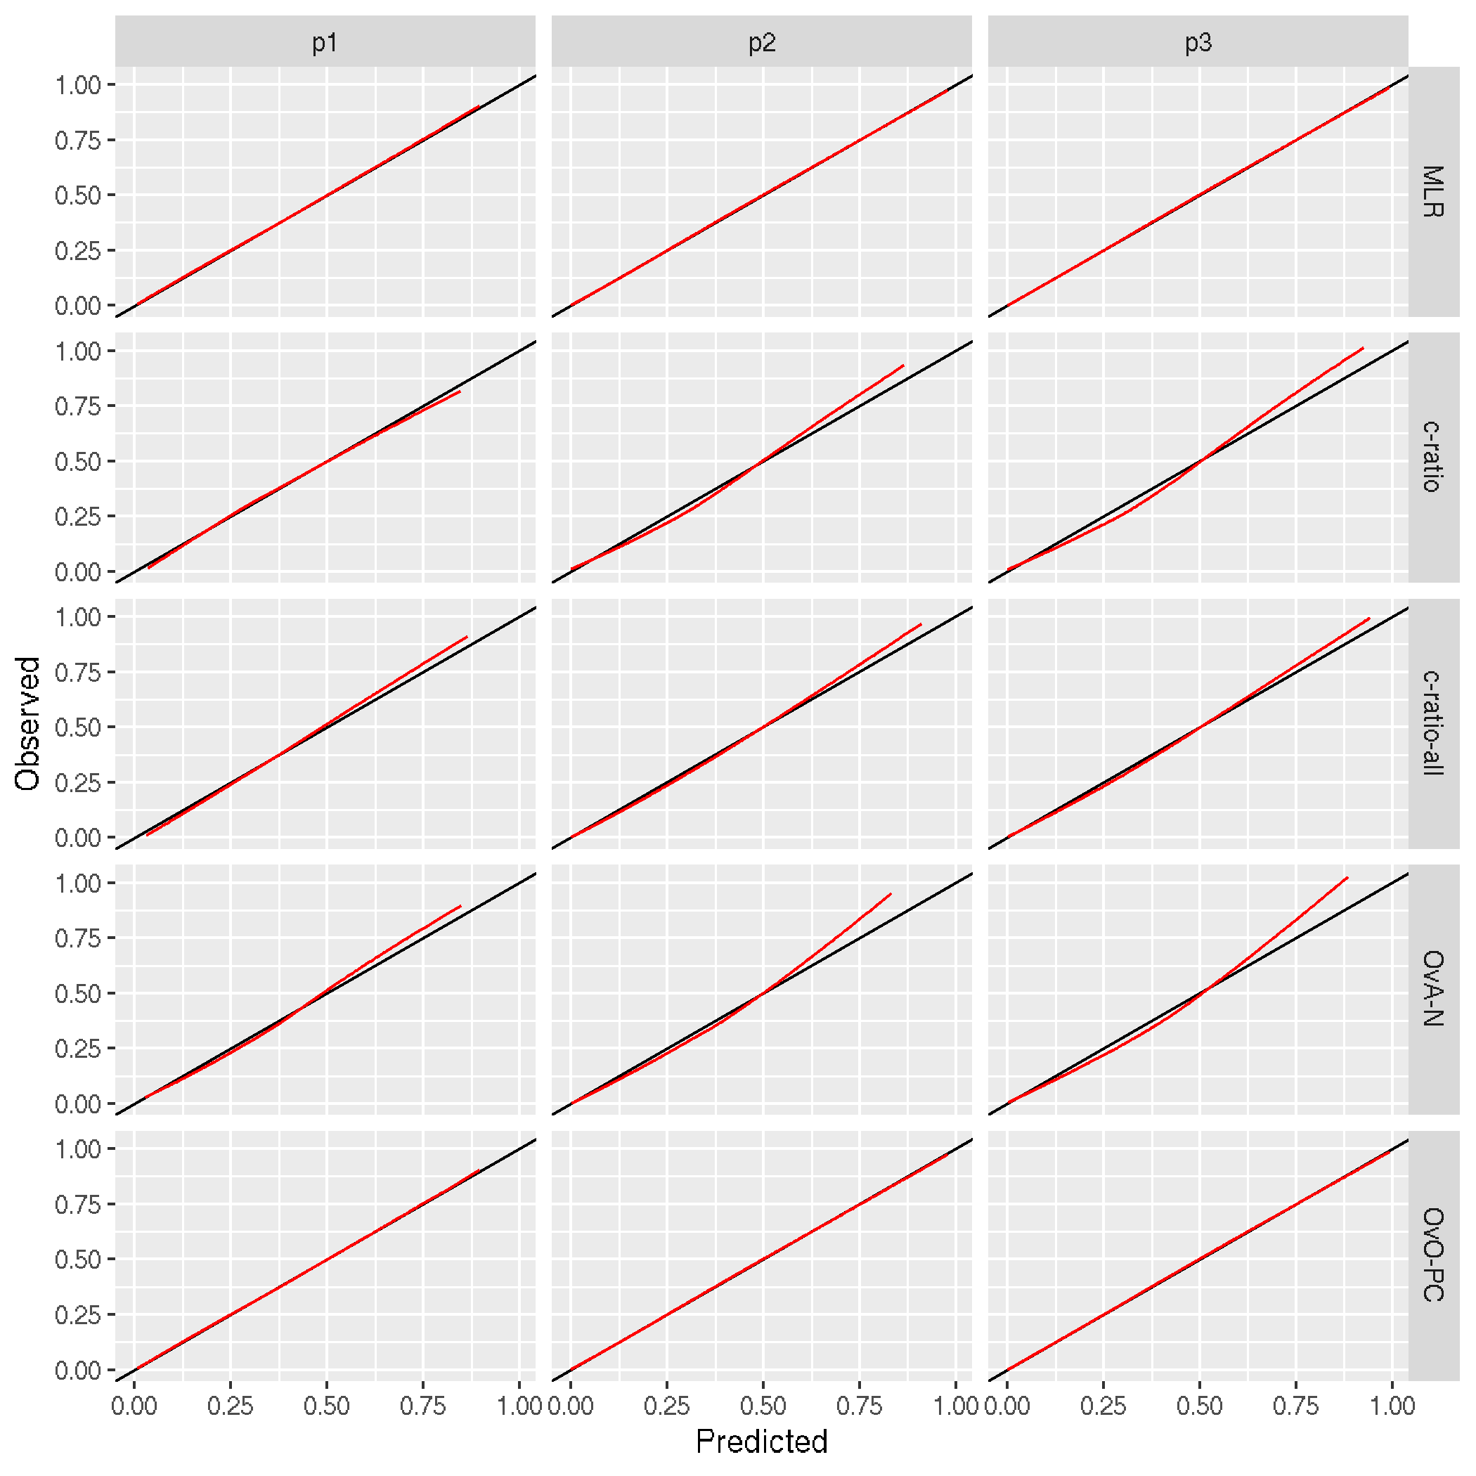

Figure S20: Per-outcome binary calibration plot for scenario C.1, K = 3, c-ratio DGM.
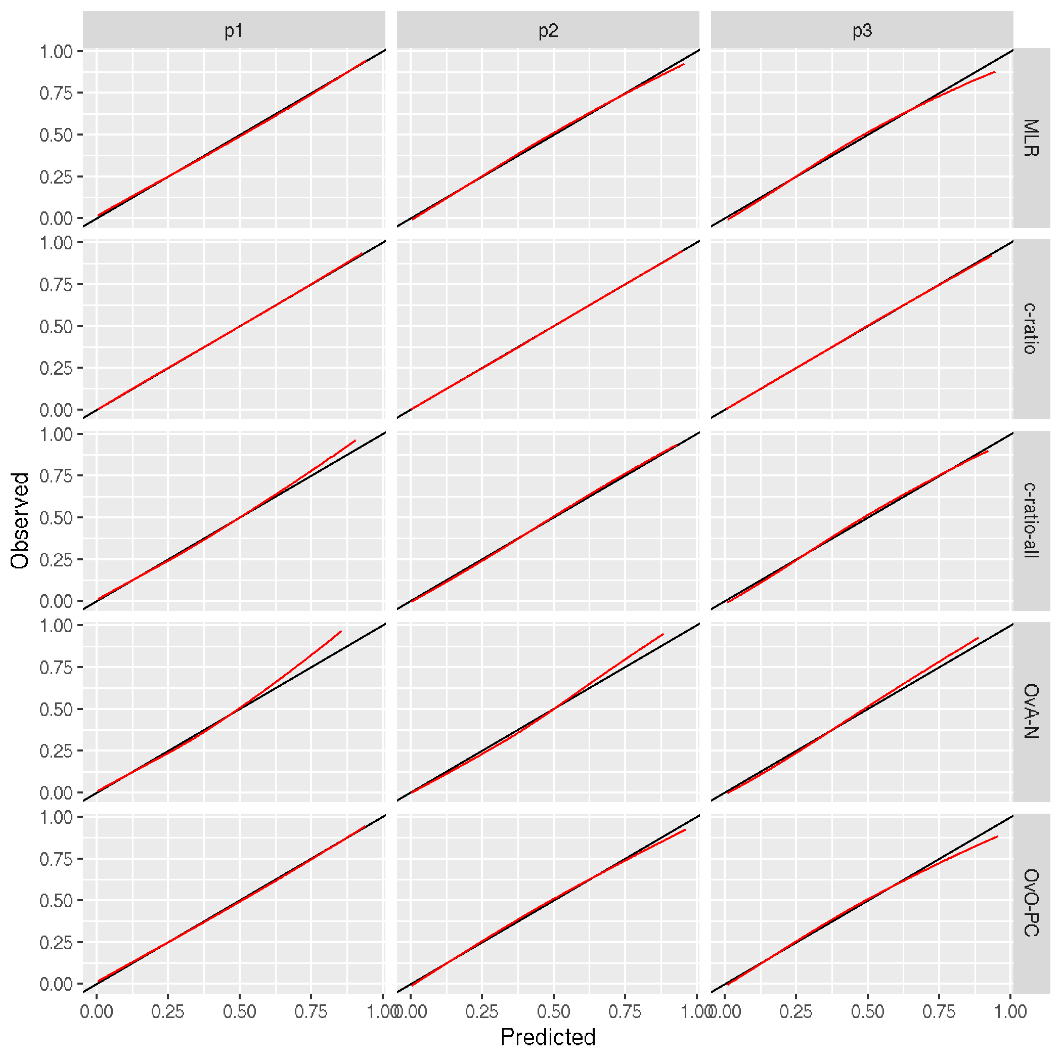

Figure S21: Per-outcome binary calibration plot for scenario D.1, K = 3, multinomial DGM.
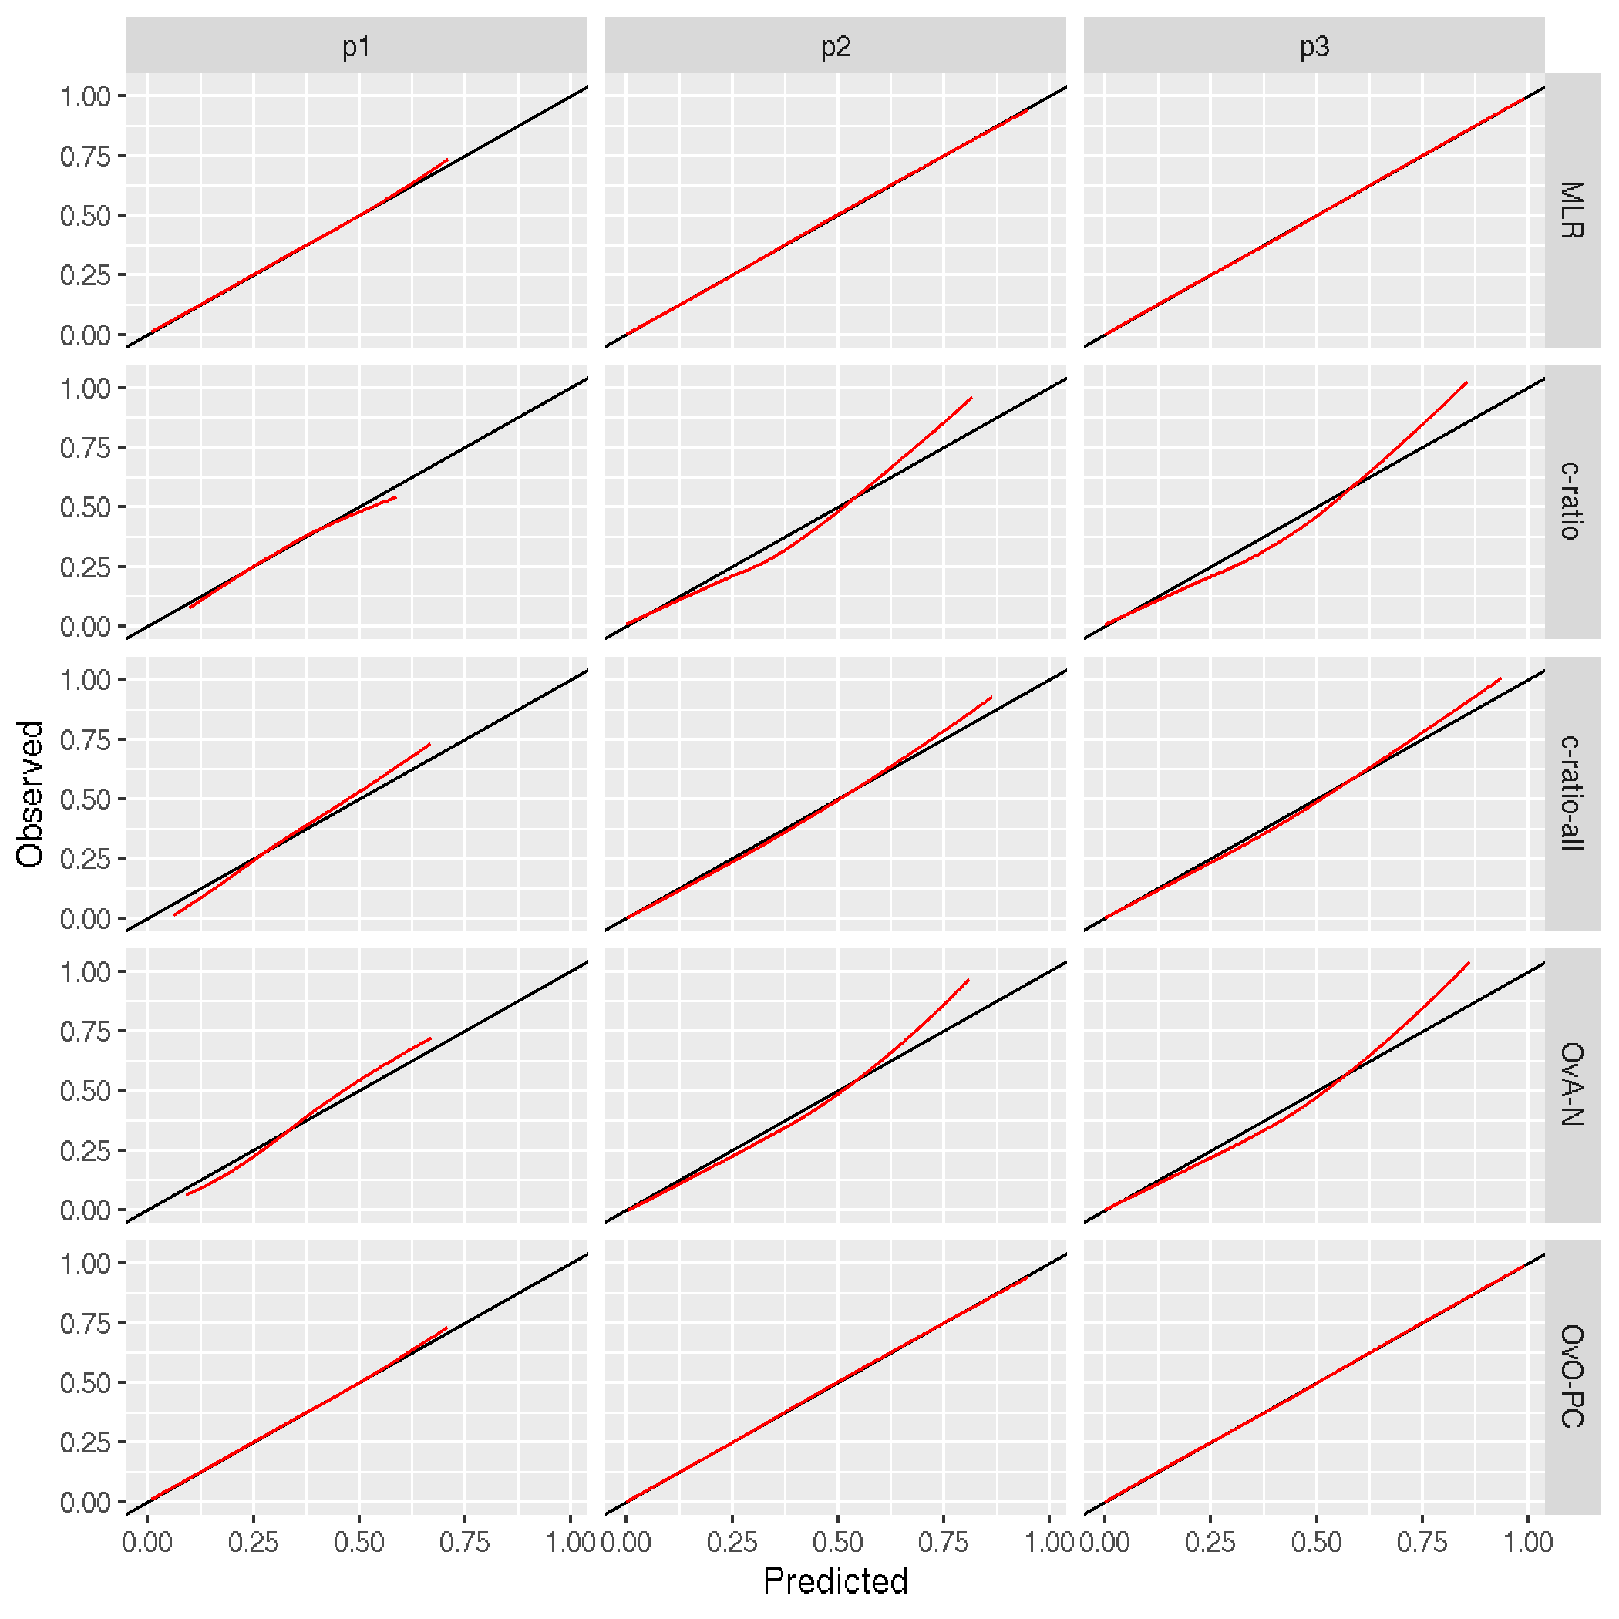

Figure S22: Per-outcome binary calibration plot for scenario D.1, K = 3, c-ratio DGM.
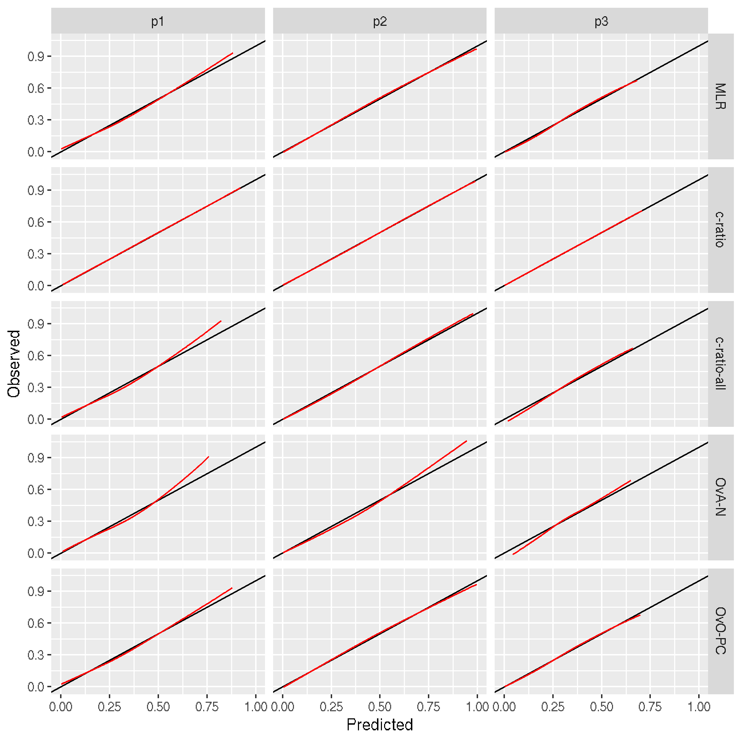

Tables S1 – S4: Tables for large sample size analysis under different sets of generated coefficients
Table S1: Large sample analysis: ECI, AUC-per-outcome and PDI of each method, K = 3, second set of generated coefficients.
Scenario | Method | O:E(Y=1) | O:E(Y=2) | O:E(Y=3) | wc-po(Y=1) | wc-po(Y=2) | wc-po(Y=3) | ECI | C₁ | C₂ | C₃ | PDI
MLR data generating mechanism
A.2 | MLR | 1.00 | 1.00 | 1.00 | 0.00/1.00 | 0.00/1.00 | 0.00/1.00 | 0.00 | 0.72 | 0.83 | 0.83 | 0.67
A.2 | c-ratio | 1.00 | 1.00 | 1.00 | 0.00/1.00 | 0.00/1.11 | 0.00/1.11 | 0.10 | 0.69 | 0.82 | 0.82 | 0.65
A.2 | c-ratio-all | 1.00 | 1.00 | 1.00 | 0.00/1.11 | 0.00/1.08 | 0.00/1.08 | 0.01 | 0.72 | 0.83 | 0.83 | 0.67
A.2 | OvA-N | 0.99 | 1.01 | 1.01 | -0.02/1.11 | 0.01/1.15 | 0.01/1.15 | 0.03 | 0.71 | 0.83 | 0.83 | 0.67
A.2 | OvO-PC | 1.00 | 1.00 | 1.00 | 0.00/1.00 | 0.00/1.00 | 0.00/1.00 | 0.00 | 0.72 | 0.83 | 0.83 | 0.67
c-ratio data generating mechanism
A.2 | MLR | 1.00 | 1.00 | 1.00 | 0.00/0.97 | 0.00/1.00 | 0.00/1.03 | 0.00 | 0.79 | 0.79 | 0.74 | 0.65
A.2 | c-ratio | 1.00 | 1.00 | 1.00 | 0.00/1.00 | 0.00/1.00 | 0.00/1.00 | 0.00 | 0.79 | 0.79 | 0.74 | 0.65
A.2 | c-ratio-all | 1.00 | 1.00 | 1.00 | 0.00/1.04 | 0.00/1.06 | 0.00/1.08 | 0.01 | 0.79 | 0.79 | 0.74 | 0.65
A.2 | OvA-N | 1.01 | 1.00 | 0.99 | 0.01/1.08 | 0.00/1.11 | -0.01/1.10 | 0.03 | 0.79 | 0.79 | 0.74 | 0.65
A.2 | OvO-PC | 1.00 | 1.00 | 1.00 | 0.00/0.97 | 0.00/0.99 | 0.00/1.00 | 0.00 | 0.79 | 0.79 | 0.74 | 0.65
MLR data generating mechanism
B.2 | MLR | 1.00 | 1.00 | 1.00 | 0.00/1.00 | 0.00/1.00 | 0.00/1.00 | 0.00 | 0.79 | 0.74 | 0.76 | 0.64
B.2 | c-ratio | 1.00 | 1.00 | 1.00 | 0.00/1.00 | 0.00/1.02 | 0.00/1.03 | 0.00 | 0.79 | 0.74 | 0.76 | 0.63
B.2 | c-ratio-all | 1.00 | 1.00 | 1.00 | 0.00/1.06 | 0.00/1.05 | 0.00/1.05 | 0.00 | 0.79 | 0.74 | 0.76 | 0.64
B.2 | OvA-N | 1.00 | 1.00 | 1.00 | 0.01/1.10 | -0.01/1.08 | 0.00/1.08 | 0.01 | 0.79 | 0.74 | 0.76 | 0.64
B.2 | OvO-PC | 1.00 | 1.00 | 1.00 | 0.00/1.00 | 0.00/1.00 | 0.00/1.00 | 0.00 | 0.79 | 0.74 | 0.76 | 0.64
c-ratio data generating mechanism
B.2 | MLR | 1.00 | 1.00 | 1.00 | 0.00/0.96 | 0.00/1.06 | 0.00/1.00 | 0.00 | 0.79 | 0.71 | 0.82 | 0.64
B.2 | c-ratio | 1.00 | 1.00 | 1.00 | 0.00/1.00 | 0.00/1.00 | 0.00/1.00 | 0.00 | 0.79 | 0.72 | 0.82 | 0.64
B.2 | c-ratio-all | 1.00 | 1.00 | 1.00 | 0.00/1.04 | 0.00/1.12 | 0.00/1.06 | 0.02 | 0.79 | 0.71 | 0.82 | 0.64
B.2 | OvA-N | 1.00 | 0.99 | 1.00 | 0.01/1.09 | -0.01/1.14 | 0.01/1.14 | 0.05 | 0.79 | 0.70 | 0.82 | 0.64
B.2 | OvO-PC | 1.00 | 1.00 | 1.00 | 0.00/0.98 | 0.00/1.02 | 0.00/0.99 | 0.00 | 0.79 | 0.71 | 0.82 | 0.64
MLR data generating mechanism
C.2 | MLR | 1.00 | 1.00 | 1.00 | 0.00/1.00 | 0.00/1.00 | 0.00/1.00 | 0.00 | 0.74 | 0.82 | 0.83 | 0.68
C.2 | c-ratio | 1.00 | 1.00 | 1.00 | 0.00/1.00 | 0.00/1.09 | 0.00/1.11 | 0.08 | 0.71 | 0.82 | 0.83 | 0.66
C.2 | c-ratio-all | 1.00 | 1.00 | 1.00 | 0.00/1.10 | 0.00/1.08 | 0.00/1.08 | 0.00 | 0.74 | 0.82 | 0.83 | 0.68
C.2 | OvA-N | 0.99 | 1.01 | 1.01 | -0.02/1.10 | 0.01/1.14 | 0.02/1.15 | 0.02 | 0.73 | 0.82 | 0.83 | 0.68
C.2 | OvO-PC | 1.00 | 1.00 | 1.00 | 0.00/1.00 | 0.00/1.00 | 0.00/1.00 | 0.00 | 0.74 | 0.82 | 0.83 | 0.68
c-ratio data generating mechanism
C.2 | MLR | 1.00 | 1.00 | 1.00 | 0.00/0.96 | 0.00/1.01 | 0.00/1.02 | 0.00 | 0.79 | 0.79 | 0.77 | 0.66
C.2 | c-ratio | 1.00 | 1.00 | 1.00 | 0.00/1.00 | 0.00/1.00 | 0.00/1.00 | 0.00 | 0.80 | 0.79 | 0.77 | 0.67
C.2 | c-ratio-all | 1.00 | 1.00 | 1.00 | 0.00/1.03 | 0.00/1.06 | 0.00/1.07 | 0.01 | 0.79 | 0.79 | 0.76 | 0.66
C.2 | OvA-N | 1.00 | 1.00 | 1.00 | 0.01/1.08 | 0.00/1.12 | -0.01/1.11 | 0.03 | 0.79 | 0.79 | 0.76 | 0.66
C.2 | OvO-PC | 1.00 | 1.00 | 1.00 | 0.00/0.96 | 0.00/0.99 | 0.00/0.99 | 0.00 | 0.79 | 0.79 | 0.77 | 0.66
MLR data generating mechanism
D.2 | MLR | 1.00 | 1.00 | 1.00 | 0.00/1.00 | 0.00/1.00 | 0.00/1.00 | 0.00 | 0.70 | 0.84 | 0.85 | 0.67
D.2 | c-ratio | 1.00 | 1.00 | 1.00 | 0.00/1.00 | 0.00/1.13 | 0.00/1.15 | 0.13 | 0.64 | 0.84 | 0.84 | 0.64
D.2 | c-ratio-all | 1.00 | 1.00 | 1.00 | 0.00/1.18 | 0.00/1.09 | 0.00/1.09 | 0.01 | 0.69 | 0.84 | 0.85 | 0.67
D.2 | OvA-N | 0.98 | 1.01 | 1.01 | -0.03/1.19 | 0.01/1.17 | 0.02/1.18 | 0.05 | 0.68 | 0.84 | 0.85 | 0.67
D.2 | OvO-PC | 1.00 | 1.00 | 1.00 | 0.00/1.00 | 0.00/1.00 | 0.00/1.00 | 0.00 | 0.70 | 0.84 | 0.85 | 0.67
c-ratio data generating mechanism
D.2 | MLR | 1.00 | 1.00 | 1.00 | 0.00/0.96 | 0.00/1.00 | 0.00/1.06 | 0.00 | 0.79 | 0.82 | 0.71 | 0.64
D.2 | c-ratio | 1.00 | 1.00 | 1.00 | 0.00/1.00 | 0.00/1.00 | 0.00/1.00 | 0.00 | 0.79 | 0.82 | 0.72 | 0.64
D.2 | c-ratio-all | 1.00 | 1.00 | 1.00 | 0.00/1.04 | 0.00/1.06 | 0.00/1.12 | 0.02 | 0.79 | 0.82 | 0.71 | 0.64
D.2 | OvA-N | 1.00 | 1.01 | 0.99 | 0.01/1.09 | 0.01/1.14 | -0.02/1.15 | 0.05 | 0.79 | 0.82 | 0.70 | 0.64
D.2 | OvO-PC | 1.00 | 1.00 | 1.00 | 0.00/0.98 | 0.00/0.99 | 0.00/1.02 | 0.00 | 0.79 | 0.82 | 0.71 | 0.64
*O:E = observed vs expected ratio; wc-po = weak calibration per outcome; C_{k} = C-statistic for outcome category k; ECI = estimated calibration index; PDI = polytomous discrimination index

Table S1.2: Large sample analysis: ECI, AUC-per-outcome and PDI of each method, K = 3, third set of generated coefficients.
Scenario | Method | O:E(Y=1) | O:E(Y=2) | O:E(Y=3) | wc-po(Y=1) | wc-po(Y=2) | wc-po(Y=3) | ECI | C₁ | C₂ | C₃ | PDI
MLR data generating mechanism
A.3 | MLR | 1.00 | 1.00 | 1.00 | 0.00/1.00 | 0.00/1.00 | 0.00/1.00 | 0.00 | 0.65 | 0.78 | 0.77 | 0.60
A.3 | c-ratio | 1.00 | 1.00 | 1.00 | 0.00/1.00 | 0.00/1.10 | 0.00/1.09 | 0.08 | 0.62 | 0.78 | 0.77 | 0.59
A.3 | c-ratio-all | 1.00 | 1.00 | 1.00 | 0.00/1.11 | 0.00/1.06 | 0.00/1.05 | 0.01 | 0.65 | 0.78 | 0.77 | 0.60
A.3 | OvA-N | 0.99 | 1.00 | 1.00 | -0.01/1.11 | 0.01/1.11 | 0.01/1.11 | 0.02 | 0.64 | 0.78 | 0.77 | 0.60
A.3 | OvO-PC | 1.00 | 1.00 | 1.00 | 0.00/1.01 | 0.00/1.00 | 0.00/1.00 | 0.00 | 0.65 | 0.78 | 0.77 | 0.60
c-ratio data generating mechanism
A.3 | MLR | 1.00 | 1.00 | 1.00 | 0.00/0.98 | 0.00/1.00 | 0.00/1.02 | 0.00 | 0.74 | 0.74 | 0.67 | 0.58
A.3 | c-ratio | 1.00 | 1.00 | 1.00 | 0.00/1.00 | 0.00/1.00 | 0.00/1.00 | 0.00 | 0.75 | 0.74 | 0.67 | 0.58
A.3 | c-ratio-all | 1.00 | 1.00 | 1.00 | 0.00/1.03 | 0.00/1.04 | 0.00/1.06 | 0.01 | 0.74 | 0.74 | 0.67 | 0.58
A.3 | OvA-N | 1.00 | 1.00 | 1.00 | 0.01/1.07 | 0.00/1.08 | -0.01/1.07 | 0.02 | 0.75 | 0.74 | 0.66 | 0.57
A.3 | OvO-PC | 1.00 | 1.00 | 1.00 | 0.00/0.99 | 0.00/0.99 | 0.00/1.00 | 0.00 | 0.74 | 0.74 | 0.67 | 0.58
MLR data generating mechanism
B.3 | MLR | 1.00 | 1.00 | 1.00 | 0.00/1.00 | 0.00/1.00 | 0.00/1.00 | 0.00 | 0.75 | 0.71 | 0.70 | 0.58
B.3 | c-ratio | 1.00 | 1.00 | 1.00 | 0.00/1.00 | 0.00/1.02 | 0.00/1.01 | 0.00 | 0.75 | 0.71 | 0.70 | 0.58
B.3 | c-ratio-all | 1.00 | 1.00 | 1.00 | 0.00/1.04 | 0.00/1.04 | 0.00/1.04 | 0.00 | 0.75 | 0.71 | 0.70 | 0.58
B.3 | OvA-N | 1.00 | 1.00 | 1.00 | 0.00/1.07 | 0.00/1.06 | 0.00/1.06 | 0.01 | 0.75 | 0.71 | 0.70 | 0.58
B.3 | OvO-PC | 1.00 | 1.00 | 1.00 | 0.00/1.00 | 0.00/1.00 | 0.00/1.00 | 0.00 | 0.75 | 0.71 | 0.70 | 0.58
c-ratio data generating mechanism
B.3 | MLR | 1.00 | 1.00 | 1.00 | 0.00/0.98 | 0.00/1.05 | 0.00/1.00 | 0.00 | 0.76 | 0.67 | 0.78 | 0.60
B.3 | c-ratio | 1.00 | 1.00 | 1.00 | 0.00/1.00 | 0.00/1.00 | 0.00/1.00 | 0.00 | 0.76 | 0.67 | 0.78 | 0.60
B.3 | c-ratio-all | 1.00 | 1.00 | 1.00 | 0.00/1.03 | 0.00/1.10 | 0.00/1.05 | 0.01 | 0.76 | 0.67 | 0.78 | 0.59
B.3 | OvA-N | 1.00 | 0.99 | 1.00 | 0.01/1.08 | -0.01/1.12 | 0.00/1.11 | 0.04 | 0.76 | 0.66 | 0.78 | 0.59
B.3 | OvO-PC | 1.00 | 1.00 | 1.00 | 0.00/0.99 | 0.00/1.02 | 0.00/0.99 | 0.00 | 0.76 | 0.67 | 0.78 | 0.60
MLR data generating mechanism
C.3 | MLR | 1.00 | 1.00 | 1.00 | 0.00/1.00 | 0.00/1.00 | 0.00/1.00 | 0.00 | 0.67 | 0.80 | 0.80 | 0.63
C.3 | c-ratio | 1.00 | 1.00 | 1.00 | 0.00/1.00 | 0.00/1.11 | 0.00/1.10 | 0.09 | 0.64 | 0.80 | 0.80 | 0.61
C.3 | c-ratio-all | 1.00 | 1.00 | 1.00 | 0.00/1.11 | 0.00/1.07 | 0.00/1.07 | 0.00 | 0.67 | 0.80 | 0.80 | 0.63
C.3 | OvA-N | 0.99 | 1.01 | 1.01 | -0.02/1.12 | 0.01/1.13 | 0.01/1.13 | 0.03 | 0.66 | 0.80 | 0.80 | 0.63
C.3 | OvO-PC | 1.00 | 1.00 | 1.00 | 0.00/1.00 | 0.00/1.00 | 0.00/1.00 | 0.00 | 0.67 | 0.80 | 0.80 | 0.63
c-ratio data generating mechanism
C.3 | MLR | 1.00 | 1.00 | 1.00 | 0.00/0.98 | 0.00/1.00 | 0.00/1.03 | 0.00 | 0.76 | 0.77 | 0.69 | 0.60
C.3 | c-ratio | 1.00 | 1.00 | 1.00 | 0.00/1.00 | 0.00/1.00 | 0.00/1.01 | 0.00 | 0.76 | 0.77 | 0.69 | 0.61
C.3 | c-ratio-all | 1.00 | 1.00 | 1.00 | 0.00/1.03 | 0.00/1.05 | 0.00/1.07 | 0.01 | 0.76 | 0.77 | 0.69 | 0.60
C.3 | OvA-N | 1.00 | 1.00 | 0.99 | 0.01/1.07 | 0.00/1.10 | -0.01/1.09 | 0.03 | 0.76 | 0.77 | 0.69 | 0.60
C.3 | OvO-PC | 1.00 | 1.00 | 1.00 | 0.00/0.99 | 0.00/0.99 | 0.00/1.01 | 0.00 | 0.76 | 0.77 | 0.69 | 0.60
MLR data generating mechanism
D.3 | MLR | 1.00 | 1.00 | 1.00 | 0.00/1.00 | 0.00/1.00 | 0.00/1.00 | 0.00 | 0.66 | 0.81 | 0.81 | 0.63
D.3 | c-ratio | 1.00 | 1.00 | 1.00 | 0.00/1.00 | 0.00/1.12 | 0.00/1.11 | 0.11 | 0.61 | 0.81 | 0.80 | 0.61
D.3 | c-ratio-all | 1.00 | 1.00 | 1.00 | 0.00/1.16 | 0.00/1.07 | 0.00/1.07 | 0.01 | 0.65 | 0.81 | 0.81 | 0.62
D.3 | OvA-N | 0.99 | 1.01 | 1.01 | -0.02/1.19 | 0.01/1.14 | 0.01/1.14 | 0.04 | 0.64 | 0.81 | 0.81 | 0.62
D.3 | OvO-PC | 1.00 | 1.00 | 1.00 | 0.00/1.00 | 0.00/1.00 | 0.00/1.00 | 0.00 | 0.66 | 0.81 | 0.81 | 0.63
c-ratio data generating mechanism
D.3 | MLR | 1.00 | 1.00 | 1.00 | 0.00/0.98 | 0.00/1.00 | 0.00/1.04 | 0.00 | 0.76 | 0.78 | 0.67 | 0.59
D.3 | c-ratio | 1.00 | 1.00 | 1.00 | 0.00/1.00 | 0.00/1.00 | 0.00/0.99 | 0.00 | 0.77 | 0.78 | 0.67 | 0.59
D.3 | c-ratio-all | 1.00 | 1.00 | 1.00 | 0.00/1.03 | 0.00/1.05 | 0.00/1.09 | 0.01 | 0.76 | 0.78 | 0.67 | 0.59
D.3 | OvA-N | 1.00 | 1.00 | 0.99 | 0.01/1.08 | 0.00/1.11 | -0.01/1.11 | 0.04 | 0.76 | 0.78 | 0.66 | 0.59
D.3 | OvO-PC | 1.00 | 1.00 | 1.00 | 0.00/0.99 | 0.00/0.99 | 0.00/1.01 | 0.00 | 0.76 | 0.78 | 0.67 | 0.59
*O:E = observed vs expected ratio; wc-po = weak calibration per outcome; C_{k} = C-statistic for outcome category k; ECI = estimated calibration index; PDI = polytomous discrimination index

Table S1.3: Large sample analysis: ECI, AUC-per-outcome and PDI of each method, K = 5, second set of generated coefficients.
Scenario | Method | O:E  (Y=1) | O:E  (Y=2) | O:E  (Y=3) | O:E  (Y=4) | O:E  (Y=5) | wc-po(Y=1) | wc-po(Y=2) | wc-po(Y=3) | wc-po(Y=4) | wc-po(Y=5) | ECI | C₁ | C₂ | C₃ | C₄ | C₅ | PDI
MLR data generating mechanism
A.2 | MLR | 1.00 | 1.00 | 1.00 | 1.00 | 1.00 | 0.00/1.00 | 0.00/1.00 | 0.00/1.00 | 0.00/1.00 | 0.00/1.00 | 0.00 | 0.67 | 0.84 | 0.82 | 0.74 | 0.86 | 0.52
A.2 | c-ratio | 1.00 | 1.01 | 1.01 | 0.95 | 1.01 | 0.00/1.00 | 0.02/1.08 | 0.02/1.11 | -0.07/0.91 | 0.02/1.21 | 0.07 | 0.63 | 0.83 | 0.81 | 0.73 | 0.86 | 0.50
A.2 | c-ratio-all | 0.99 | 1.01 | 1.00 | 0.99 | 1.01 | -0.02/1.18 | 0.01/1.14 | 0.00/1.13 | -0.01/1.13 | 0.02/1.16 | 0.02 | 0.67 | 0.84 | 0.81 | 0.74 | 0.86 | 0.52
A.2 | OvA-N | 0.97 | 1.01 | 1.00 | 0.98 | 1.02 | -0.04/1.18 | 0.02/1.19 | 0.01/1.18 | -0.02/1.15 | 0.04/1.21 | 0.04 | 0.66 | 0.84 | 0.81 | 0.74 | 0.86 | 0.52
A.2 | OvO-PC | 1.00 | 1.00 | 1.00 | 1.00 | 1.00 | 0.00/1.00 | 0.00/1.00 | 0.00/1.00 | 0.00/1.00 | 0.00/1.00 | 0.00 | 0.67 | 0.84 | 0.82 | 0.74 | 0.86 | 0.52
c-ratio data generating mechanism
A.2 | MLR | 1.00 | 1.00 | 1.00 | 1.00 | 1.00 | 0.00/0.95 | 0.00/0.98 | 0.00/1.01 | 0.00/1.02 | 0.00/1.06 | 0.00 | 0.80 | 0.80 | 0.67 | 0.81 | 0.73 | 0.48
A.2 | c-ratio | 1.00 | 1.00 | 1.00 | 1.00 | 1.00 | 0.00/1.00 | 0.00/1.00 | 0.00/1.00 | 0.00/1.00 | 0.00/1.00 | 0.00 | 0.80 | 0.80 | 0.67 | 0.81 | 0.74 | 0.49
A.2 | c-ratio-all | 1.00 | 1.00 | 0.99 | 1.00 | 1.00 | 0.00/1.07 | 0.00/1.09 | -0.01/1.11 | 0.01/1.11 | -0.01/1.13 | 0.02 | 0.80 | 0.80 | 0.67 | 0.81 | 0.73 | 0.48
A.2 | OvA-N | 1.01 | 1.01 | 0.98 | 1.01 | 0.99 | 0.01/1.10 | 0.01/1.14 | -0.02/1.12 | 0.01/1.17 | -0.02/1.15 | 0.04 | 0.80 | 0.80 | 0.66 | 0.80 | 0.72 | 0.48
A.2 | OvO-PC | 1.00 | 1.00 | 1.00 | 0.99 | 1.00 | 0.00/0.96 | 0.00/0.97 | 0.00/0.97 | -0.01/0.96 | 0.00/1.01 | 0.01 | 0.80 | 0.80 | 0.67 | 0.81 | 0.73 | 0.48
MLR data generating mechanism
B.2 | MLR | 1.00 | 1.00 | 1.00 | 1.00 | 1.00 | 0.00/1.00 | 0.00/1.00 | 0.00/1.00 | 0.00/1.00 | 0.00/1.00 | 0.00 | 0.77 | 0.73 | 0.72 | 0.62 | 0.75 | 0.43
B.2 | c-ratio | 1.00 | 1.00 | 1.00 | 0.99 | 1.00 | 0.00/1.00 | 0.00/1.03 | 0.00/1.04 | -0.01/0.93 | 0.00/1.08 | 0.01 | 0.77 | 0.73 | 0.72 | 0.62 | 0.75 | 0.43
B.2 | c-ratio-all | 1.00 | 1.00 | 1.00 | 1.00 | 1.00 | 0.01/1.08 | 0.00/1.07 | 0.00/1.07 | -0.01/1.09 | 0.00/1.07 | 0.01 | 0.77 | 0.73 | 0.72 | 0.62 | 0.75 | 0.43
B.2 | OvA-N | 1.01 | 1.00 | 1.00 | 0.99 | 1.00 | 0.01/1.11 | 0.00/1.08 | 0.00/1.09 | -0.01/1.11 | 0.00/1.09 | 0.01 | 0.77 | 0.73 | 0.72 | 0.62 | 0.75 | 0.43
B.2 | OvO-PC | 1.00 | 1.00 | 1.00 | 1.00 | 1.00 | 0.00/1.00 | 0.00/1.01 | 0.00/1.00 | 0.00/1.00 | 0.00/1.00 | 0.00 | 0.77 | 0.73 | 0.72 | 0.62 | 0.75 | 0.43
c-ratio data generating mechanism
B.2 | MLR | 1.00 | 1.00 | 1.00 | 1.00 | 1.00 | 0.00/0.94 | 0.00/1.01 | 0.00/1.06 | 0.00/1.07 | 0.00/1.00 | 0.01 | 0.80 | 0.74 | 0.62 | 0.73 | 0.84 | 0.45
B.2 | c-ratio | 1.00 | 1.00 | 1.00 | 1.00 | 1.00 | 0.00/1.00 | 0.00/1.00 | 0.00/1.00 | 0.00/1.00 | 0.00/1.00 | 0.00 | 0.80 | 0.74 | 0.63 | 0.73 | 0.84 | 0.46
B.2 | c-ratio-all | 1.00 | 1.00 | 0.99 | 1.00 | 1.01 | 0.00/1.08 | 0.00/1.11 | -0.01/1.41 | -0.01/1.18 | 0.02/1.14 | 0.04 | 0.80 | 0.74 | 0.62 | 0.72 | 0.84 | 0.45
B.2 | OvA-N | 1.01 | 0.99 | 0.98 | 0.99 | 1.02 | 0.02/1.13 | -0.01/1.18 | -0.03/1.57 | -0.02/1.19 | 0.04/1.24 | 0.08 | 0.80 | 0.74 | 0.61 | 0.71 | 0.84 | 0.45
B.2 | OvO-PC | 1.00 | 1.00 | 1.00 | 1.00 | 1.00 | 0.00/0.98 | 0.00/0.97 | 0.00/1.03 | 0.00/1.06 | -0.01/0.97 | 0.01 | 0.80 | 0.74 | 0.62 | 0.73 | 0.84 | 0.46
MLR data generating mechanism
C.2 | MLR | 1.00 | 1.00 | 1.00 | 1.00 | 1.00 | 0.00/1.01 | 0.00/1.00 | 0.00/1.00 | 0.00/1.00 | 0.00/1.00 | 0.00 | 0.70 | 0.79 | 0.81 | 0.75 | 0.82 | 0.50
C.2 | c-ratio | 1.00 | 1.01 | 1.00 | 0.97 | 1.01 | 0.00/1.00 | 0.02/1.07 | 0.00/1.07 | -0.04/1.01 | 0.02/1.16 | 0.08 | 0.67 | 0.78 | 0.80 | 0.74 | 0.82 | 0.48
C.2 | c-ratio-all | 0.99 | 1.00 | 1.00 | 1.00 | 1.01 | -0.01/1.14 | 0.00/1.14 | 0.01/1.14 | -0.01/1.13 | 0.01/1.14 | 0.02 | 0.70 | 0.79 | 0.81 | 0.74 | 0.82 | 0.50
C.2 | OvA-N | 0.98 | 1.00 | 1.01 | 0.99 | 1.02 | -0.03/1.14 | 0.00/1.17 | 0.01/1.19 | -0.01/1.15 | 0.03/1.21 | 0.04 | 0.69 | 0.79 | 0.81 | 0.74 | 0.82 | 0.49
C.2 | OvO-PC | 1.00 | 1.00 | 1.00 | 1.00 | 1.00 | 0.00/1.00 | 0.00/1.01 | 0.00/1.00 | 0.00/1.00 | 0.00/1.00 | 0.00 | 0.70 | 0.79 | 0.81 | 0.75 | 0.82 | 0.50
c-ratio data generating mechanism
C.2 | MLR | 1.00 | 1.00 | 1.00 | 1.00 | 1.00 | 0.00/0.95 | 0.00/1.00 | 0.00/0.99 | 0.00/1.05 | 0.00/1.04 | 0.01 | 0.80 | 0.74 | 0.78 | 0.75 | 0.77 | 0.48
C.2 | c-ratio | 1.00 | 1.00 | 1.00 | 1.00 | 1.00 | 0.00/1.00 | 0.00/1.00 | 0.00/1.00 | 0.00/1.00 | 0.00/1.00 | 0.00 | 0.80 | 0.75 | 0.78 | 0.76 | 0.77 | 0.49
C.2 | c-ratio-all | 1.00 | 1.00 | 1.00 | 1.00 | 1.00 | 0.01/1.08 | 0.00/1.10 | 0.00/1.11 | 0.00/1.16 | 0.00/1.13 | 0.03 | 0.80 | 0.74 | 0.78 | 0.75 | 0.76 | 0.48
C.2 | OvA-N | 1.01 | 0.99 | 1.00 | 1.00 | 0.99 | 0.02/1.12 | -0.01/1.15 | 0.00/1.16 | 0.00/1.22 | -0.01/1.15 | 0.06 | 0.80 | 0.74 | 0.78 | 0.75 | 0.76 | 0.48
C.2 | OvO-PC | 1.00 | 1.00 | 1.00 | 1.00 | 1.00 | 0.01/0.98 | 0.00/0.96 | 0.00/0.99 | 0.00/1.01 | -0.01/0.99 | 0.01 | 0.80 | 0.74 | 0.78 | 0.75 | 0.77 | 0.48
MLR data generating mechanism
D.2 | MLR | 1.00 | 1.00 | 1.00 | 1.00 | 1.00 | 0.00/1.01 | 0.00/1.00 | 0.00/1.00 | 0.00/1.00 | 0.00/1.00 | 0.00 | 0.65 | 0.80 | 0.82 | 0.79 | 0.82 | 0.50
D.2 | c-ratio | 1.00 | 1.01 | 1.00 | 0.99 | 1.00 | 0.00/1.00 | 0.02/1.07 | -0.01/1.06 | -0.01/1.11 | 0.00/1.12 | 0.11 | 0.58 | 0.79 | 0.81 | 0.79 | 0.82 | 0.47
D.2 | c-ratio-all | 0.99 | 1.00 | 1.01 | 1.00 | 1.00 | -0.02/1.38 | 0.00/1.15 | 0.01/1.16 | 0.00/1.16 | 0.01/1.15 | 0.03 | 0.64 | 0.80 | 0.82 | 0.79 | 0.82 | 0.50
D.2 | OvA-N | 0.97 | 1.00 | 1.01 | 1.00 | 1.01 | -0.04/1.52 | 0.00/1.20 | 0.02/1.23 | 0.00/1.22 | 0.02/1.21 | 0.07 | 0.63 | 0.79 | 0.82 | 0.78 | 0.82 | 0.49
D.2 | OvO-PC | 1.00 | 1.00 | 1.00 | 1.00 | 1.00 | 0.00/1.01 | 0.00/1.00 | 0.00/1.00 | 0.00/1.01 | 0.00/1.00 | 0.00 | 0.65 | 0.80 | 0.82 | 0.79 | 0.82 | 0.50
c-ratio data generating mechanism
D.2 | MLR | 1.00 | 1.00 | 1.00 | 1.00 | 1.00 | 0.00/0.94 | 0.00/1.01 | 0.00/0.99 | 0.00/1.08 | 0.00/1.15 | 0.01 | 0.79 | 0.74 | 0.82 | 0.71 | 0.69 | 0.45
D.2 | c-ratio | 1.00 | 1.00 | 1.00 | 1.00 | 1.00 | 0.00/1.00 | 0.00/1.00 | 0.00/1.00 | 0.00/0.99 | 0.00/1.00 | 0.00 | 0.80 | 0.75 | 0.82 | 0.71 | 0.70 | 0.46
D.2 | c-ratio-all | 1.00 | 1.00 | 1.00 | 1.00 | 0.99 | 0.00/1.07 | 0.00/1.11 | 0.01/1.12 | 0.00/1.20 | -0.01/1.25 | 0.03 | 0.79 | 0.74 | 0.82 | 0.71 | 0.69 | 0.45
D.2 | OvA-N | 1.01 | 0.99 | 1.01 | 0.99 | 0.98 | 0.02/1.12 | -0.01/1.18 | 0.02/1.22 | -0.01/1.27 | -0.02/1.27 | 0.09 | 0.79 | 0.74 | 0.82 | 0.70 | 0.67 | 0.45
D.2 | OvO-PC | 1.00 | 1.00 | 1.00 | 1.00 | 1.00 | 0.00/0.97 | 0.00/0.97 | 0.00/0.99 | 0.00/1.01 | 0.00/1.08 | 0.01 | 0.79 | 0.74 | 0.82 | 0.71 | 0.69 | 0.45
*wc.po = weak calibration per outcome; ECI = estimated calibration index; PDI = polytomous discrimination index

Table S1.4: Large sample analysis: ECI, AUC-per-outcome and PDI of each method, K = 5, third set of generated coefficients.
Scenario | Method | O:E  (Y=1) | O:E  (Y=2) | O:E  (Y=3) | O:E  (Y=4) | O:E  (Y=5) | wc-po(Y=1) | wc-po(Y=2) | wc-po(Y=3) | wc-po(Y=4) | wc-po(Y=5) | ECI | C₁ | C₂ | C₃ | C₄ | C₅ | PDI
MLR data generating mechanism
A.3 | MLR | 1.00 | 1.00 | 1.00 | 1.00 | 1.00 | 0.00/1.00 | 0.00/1.00 | 0.00/1.00 | 0.00/1.00 | 0.00/1.00 | 0.00 | 0.62 | 0.80 | 0.73 | 0.71 | 0.82 | 0.46
A.3 | c-ratio | 1.00 | 1.01 | 1.00 | 0.98 | 1.01 | 0.00/1.00 | 0.02/1.09 | 0.00/1.06 | -0.03/0.93 | 0.01/1.17 | 0.07 | 0.58 | 0.80 | 0.73 | 0.70 | 0.82 | 0.44
A.3 | c-ratio-all | 0.99 | 1.01 | 1.00 | 0.99 | 1.01 | -0.01/1.25 | 0.01/1.12 | 0.00/1.09 | -0.01/1.09 | 0.01/1.12 | 0.02 | 0.62 | 0.80 | 0.73 | 0.71 | 0.82 | 0.45
A.3 | OvA-N | 0.98 | 1.02 | 0.99 | 0.99 | 1.02 | -0.02/1.35 | 0.02/1.19 | -0.01/1.11 | -0.02/1.10 | 0.03/1.19 | 0.05 | 0.61 | 0.80 | 0.73 | 0.71 | 0.82 | 0.45
A.3 | OvO-PC | 1.00 | 1.00 | 1.00 | 1.00 | 1.00 | 0.00/1.00 | 0.00/1.00 | 0.00/1.00 | 0.00/1.00 | 0.00/1.00 | 0.00 | 0.62 | 0.80 | 0.73 | 0.71 | 0.82 | 0.46
c-ratio data generating mechanism
A.3 | MLR | 1.00 | 1.00 | 1.00 | 1.00 | 1.00 | 0.00/0.97 | 0.00/0.97 | 0.00/0.96 | 0.00/1.03 | 0.00/1.09 | 0.02 | 0.75 | 0.74 | 0.65 | 0.75 | 0.69 | 0.42
A.3 | c-ratio | 1.00 | 1.00 | 1.00 | 1.00 | 1.00 | 0.00/1.00 | 0.00/1.00 | 0.00/1.00 | 0.00/1.00 | 0.00/1.00 | 0.00 | 0.75 | 0.74 | 0.65 | 0.75 | 0.70 | 0.42
A.3 | c-ratio-all | 1.00 | 1.00 | 1.00 | 1.00 | 1.00 | 0.00/1.07 | 0.00/1.06 | -0.01/1.04 | 0.00/1.10 | 0.00/1.14 | 0.03 | 0.75 | 0.74 | 0.65 | 0.75 | 0.69 | 0.41
A.3 | OvA-N | 1.01 | 1.00 | 0.99 | 1.00 | 1.00 | 0.01/1.11 | 0.00/1.09 | -0.01/1.06 | 0.00/1.15 | 0.00/1.21 | 0.05 | 0.75 | 0.74 | 0.65 | 0.74 | 0.69 | 0.41
A.3 | OvO-PC | 1.00 | 1.00 | 1.00 | 1.00 | 1.00 | 0.01/1.00 | 0.00/0.98 | 0.00/0.95 | -0.01/0.98 | 0.00/1.02 | 0.02 | 0.75 | 0.74 | 0.65 | 0.75 | 0.69 | 0.42
MLR data generating mechanism
B.3 | MLR | 1.00 | 1.00 | 1.00 | 1.00 | 1.00 | 0.00/1.00 | 0.00/1.00 | 0.00/1.00 | 0.00/1.00 | 0.00/1.00 | 0.00 | 0.77 | 0.69 | 0.62 | 0.66 | 0.72 | 0.39
B.3 | c-ratio | 1.00 | 1.00 | 1.00 | 1.00 | 1.00 | 0.00/1.00 | 0.00/1.02 | 0.00/1.02 | 0.00/0.99 | 0.00/1.04 | 0.01 | 0.77 | 0.69 | 0.62 | 0.65 | 0.72 | 0.39
B.3 | c-ratio-all | 1.00 | 1.00 | 1.00 | 1.00 | 1.00 | 0.01/1.08 | 0.00/1.06 | 0.00/1.07 | 0.00/1.07 | 0.00/1.06 | 0.01 | 0.77 | 0.69 | 0.62 | 0.66 | 0.72 | 0.39
B.3 | OvA-N | 1.01 | 1.00 | 0.99 | 1.00 | 1.00 | 0.02/1.11 | 0.00/1.08 | -0.01/1.09 | 0.00/1.10 | 0.00/1.09 | 0.02 | 0.77 | 0.69 | 0.62 | 0.65 | 0.72 | 0.39
B.3 | OvO-PC | 1.00 | 1.00 | 1.00 | 1.00 | 1.00 | 0.00/1.00 | 0.00/1.00 | 0.00/1.00 | 0.00/1.00 | 0.00/1.00 | 0.00 | 0.77 | 0.69 | 0.62 | 0.66 | 0.72 | 0.39
c-ratio data generating mechanism
B.3 | MLR | 1.00 | 1.00 | 1.00 | 1.00 | 1.00 | 0.00/0.94 | 0.00/0.95 | 0.00/1.18 | 0.00/1.13 | 0.00/1.00 | 0.01 | 0.77 | 0.70 | 0.63 | 0.70 | 0.85 | 0.43
B.3 | c-ratio | 1.00 | 1.00 | 1.00 | 1.00 | 1.00 | 0.00/1.00 | 0.00/1.00 | 0.00/1.00 | 0.00/1.00 | 0.00/1.00 | 0.00 | 0.77 | 0.70 | 0.63 | 0.71 | 0.85 | 0.43
B.3 | c-ratio-all | 1.00 | 0.99 | 0.99 | 1.00 | 1.01 | 0.00/1.06 | -0.01/1.07 | -0.01/1.46 | 0.00/1.24 | 0.02/1.13 | 0.04 | 0.77 | 0.70 | 0.63 | 0.70 | 0.85 | 0.43
B.3 | OvA-N | 1.01 | 0.99 | 0.98 | 0.99 | 1.03 | 0.01/1.11 | -0.02/1.13 | -0.02/1.70 | -0.02/1.24 | 0.05/1.24 | 0.09 | 0.77 | 0.70 | 0.62 | 0.69 | 0.85 | 0.42
B.3 | OvO-PC | 1.00 | 1.00 | 1.00 | 1.00 | 1.00 | 0.00/0.97 | 0.00/0.93 | 0.00/1.06 | 0.01/1.11 | -0.01/0.96 | 0.01 | 0.77 | 0.70 | 0.63 | 0.70 | 0.85 | 0.43
MLR data generating mechanism
C.3 | MLR | 1.00 | 1.00 | 1.00 | 1.00 | 1.00 | 0.00/0.99 | 0.00/1.00 | 0.00/1.00 | 0.00/1.00 | 0.00/1.00 | 0.00 | 0.67 | 0.77 | 0.78 | 0.79 | 0.79 | 0.47
C.3 | c-ratio | 1.00 | 1.01 | 0.99 | 1.00 | 1.00 | 0.00/1.00 | 0.02/1.08 | -0.01/1.02 | 0.00/1.11 | 0.00/1.11 | 0.10 | 0.63 | 0.77 | 0.77 | 0.79 | 0.79 | 0.46
C.3 | c-ratio-all | 0.99 | 1.00 | 1.00 | 1.00 | 1.00 | -0.01/1.17 | 0.00/1.14 | 0.00/1.14 | 0.01/1.15 | 0.00/1.14 | 0.02 | 0.67 | 0.77 | 0.78 | 0.79 | 0.79 | 0.47
C.3 | OvA-N | 0.98 | 1.00 | 1.01 | 1.01 | 1.01 | -0.03/1.20 | 0.00/1.20 | 0.01/1.22 | 0.01/1.23 | 0.01/1.21 | 0.06 | 0.66 | 0.77 | 0.78 | 0.79 | 0.78 | 0.47
C.3 | OvO-PC | 1.00 | 1.00 | 1.00 | 1.00 | 1.00 | 0.00/0.99 | 0.00/1.00 | 0.00/1.00 | 0.00/1.00 | 0.00/1.00 | 0.00 | 0.67 | 0.77 | 0.78 | 0.79 | 0.79 | 0.47
c-ratio data generating mechanism
C.3 | MLR | 1.00 | 1.00 | 1.00 | 1.00 | 1.00 | 0.00/0.94 | 0.00/0.95 | 0.00/1.00 | 0.00/1.14 | 0.00/1.07 | 0.01 | 0.77 | 0.70 | 0.82 | 0.68 | 0.75 | 0.45
C.3 | c-ratio | 1.00 | 1.00 | 1.00 | 1.00 | 1.00 | 0.00/1.00 | 0.00/1.00 | 0.00/1.00 | 0.00/1.01 | 0.00/1.00 | 0.00 | 0.77 | 0.70 | 0.82 | 0.69 | 0.75 | 0.45
C.3 | c-ratio-all | 1.00 | 1.00 | 1.00 | 1.00 | 1.00 | 0.00/1.05 | 0.00/1.06 | 0.01/1.11 | 0.00/1.26 | 0.00/1.13 | 0.03 | 0.77 | 0.70 | 0.82 | 0.68 | 0.74 | 0.44
C.3 | OvA-N | 1.01 | 0.99 | 1.02 | 0.99 | 0.99 | 0.01/1.09 | -0.01/1.12 | 0.03/1.19 | -0.01/1.28 | -0.01/1.17 | 0.06 | 0.77 | 0.70 | 0.82 | 0.67 | 0.74 | 0.44
C.3 | OvO-PC | 1.00 | 1.00 | 1.00 | 1.00 | 1.00 | 0.01/0.97 | 0.00/0.94 | 0.00/0.99 | 0.00/1.09 | -0.01/1.00 | 0.01 | 0.77 | 0.70 | 0.82 | 0.68 | 0.75 | 0.45
MLR data generating mechanism
D.3 | MLR | 1.00 | 1.00 | 1.00 | 1.00 | 1.00 | 0.00/0.99 | 0.00/1.00 | 0.00/1.00 | 0.00/1.00 | 0.00/1.00 | 0.00 | 0.63 | 0.79 | 0.79 | 0.80 | 0.80 | 0.47
D.3 | c-ratio | 1.00 | 1.01 | 0.99 | 1.00 | 1.00 | 0.00/1.00 | 0.02/1.10 | -0.02/1.00 | 0.00/1.11 | 0.00/1.14 | 0.11 | 0.56 | 0.78 | 0.78 | 0.80 | 0.80 | 0.45
D.3 | c-ratio-all | 0.99 | 1.00 | 1.00 | 1.00 | 1.00 | -0.02/1.45 | 0.00/1.15 | 0.00/1.15 | 0.01/1.16 | 0.01/1.16 | 0.03 | 0.63 | 0.79 | 0.79 | 0.80 | 0.80 | 0.47
D.3 | OvA-N | 0.97 | 1.00 | 1.01 | 1.01 | 1.01 | -0.04/1.72 | 0.00/1.23 | 0.01/1.25 | 0.01/1.25 | 0.01/1.24 | 0.08 | 0.62 | 0.78 | 0.79 | 0.80 | 0.80 | 0.47
D.3 | OvO-PC | 1.00 | 1.00 | 1.00 | 1.00 | 1.00 | 0.00/1.00 | 0.00/1.00 | 0.00/1.00 | 0.00/1.00 | 0.00/1.00 | 0.00 | 0.63 | 0.79 | 0.79 | 0.80 | 0.80 | 0.47
c-ratio data generating mechanism
D.3 | MLR | 1.00 | 1.00 | 1.00 | 1.00 | 1.00 | 0.00/0.94 | 0.00/0.94 | 0.00/1.00 | 0.00/1.15 | 0.00/1.22 | 0.01 | 0.77 | 0.70 | 0.83 | 0.69 | 0.68 | 0.42
D.3 | c-ratio | 1.00 | 1.00 | 1.00 | 1.00 | 1.00 | 0.00/1.00 | 0.00/1.00 | 0.00/1.00 | 0.00/0.99 | 0.00/1.00 | 0.00 | 0.77 | 0.70 | 0.83 | 0.69 | 0.69 | 0.43
D.3 | c-ratio-all | 1.00 | 1.00 | 1.01 | 1.00 | 1.00 | 0.00/1.05 | -0.01/1.06 | 0.01/1.12 | 0.00/1.28 | -0.01/1.30 | 0.03 | 0.77 | 0.70 | 0.83 | 0.68 | 0.68 | 0.42
D.3 | OvA-N | 1.01 | 0.99 | 1.02 | 0.99 | 0.99 | 0.01/1.11 | -0.02/1.13 | 0.03/1.22 | -0.02/1.32 | -0.02/1.39 | 0.09 | 0.77 | 0.70 | 0.83 | 0.67 | 0.68 | 0.41
D.3 | OvO-PC | 1.00 | 1.00 | 1.00 | 1.00 | 1.00 | 0.00/0.97 | 0.00/0.94 | 0.00/0.99 | 0.00/1.08 | 0.00/1.08 | 0.02 | 0.77 | 0.70 | 0.83 | 0.69 | 0.68 | 0.42
*wc.po = weak calibration per outcome; ECI = estimated calibration index; PDI = polytomous discrimination index

Supplementary tables for small sample size analysis

Tables S5 – S8: Tables for small development sample size analysis under different sets of generated coefficients, K = 3.

Table S5: Small sample analysis: Mean value of performance metrics over 1000 simulations, sample size = 250, K = 3, second set of generated coefficients.
Scenario | Method | OvE (Y=1) | OvE (Y=2) | OvE (Y=3) | wc-po (Y=1) | wc-po (Y=2) | wc-po (Y=3) | wc-ms (LP1) | wc-ms (LP2) | wc-ms (LP3) | ECI | C₁ | C₂ | C₃ | PDI
MLR data generating mechanism
A.1 | MLR | 1.01 | 1.00 | 1.01 | 0.00/0.85 | 0.00/0.91 | 0.01/0.91 | -0.01/0.90 | 0.00/0.91 | NA/NA | 0.04 | 0.71 | 0.82 | 0.82 | 0.66
A.1 | c-ratio | 1.01 | 1.00 | 1.01 | 0.00/0.86 | 0.00/0.98 | -0.01/0.98 | 0.00/0.86 | 0.01/0.90 | NA/NA | 0.13 | 0.68 | 0.81 | 0.81 | 0.64
A.1 | c-ratio-all | 1.01 | 1.00 | 1.01 | 0.00/0.95 | 0.00/0.99 | -0.01/0.99 | NA/NA | NA/NA | NA/NA | 0.05 | 0.70 | 0.82 | 0.82 | 0.66
A.1 | OvA-N | 0.99 | 1.01 | 1.02 | -0.02/0.96 | 0.01/1.06 | 0.02/1.06 | 0.00/0.86 | 0.00/0.92 | 0.00/0.92 | 0.06 | 0.70 | 0.82 | 0.82 | 0.66
A.1 | OvO-PC | 1.01 | 1.00 | 1.01 | 0.01/0.84 | -0.01/0.90 | 0.01/0.90 | 0.00/0.88 | 0.00/0.89 | -0.01/0.90 | 0.05 | 0.71 | 0.82 | 0.82 | 0.66
c-ratio data generating mechanism
A.1 | MLR | 1.01 | 1.00 | 1.01 | 0.01/0.87 | 0.00/0.91 | 0.00/0.89 | 0.00/0.91 | 0.00/0.89 | NA/NA | 0.05 | 0.78 | 0.78 | 0.73 | 0.64
A.1 | c-ratio | 1.01 | 1.00 | 1.01 | 0.00/0.92 | 0.00/0.91 | 0.00/0.87 | 0.00/0.92 | 0.00/0.89 | NA/NA | 0.05 | 0.79 | 0.78 | 0.73 | 0.64
A.1 | c-ratio-all | 1.01 | 1.00 | 1.01 | -0.01/0.94 | 0.00/0.97 | 0.00/0.94 | NA/NA | NA/NA | NA/NA | 0.05 | 0.78 | 0.78 | 0.73 | 0.64
A.1 | OvA-N | 1.01 | 1.01 | 1.00 | 0.02/0.99 | 0.00/1.02 | -0.01/0.98 | 0.00/0.92 | 0.00/0.92 | 0.00/0.88 | 0.07 | 0.79 | 0.78 | 0.72 | 0.64
A.1 | OvO-PC | 1.01 | 1.00 | 1.01 | 0.01/0.87 | 0.00/0.89 | 0.00/0.86 | 0.00/0.90 | 0.00/0.88 | 0.00/0.89 | 0.05 | 0.78 | 0.78 | 0.73 | 0.64
MLR data generating mechanism
B.1 | MLR | 1.00 | 1.01 | 1.01 | -0.01/0.91 | 0.01/0.88 | 0.01/0.90 | 0.01/0.89 | 0.01/0.90 | NA/NA | 0.05 | 0.78 | 0.73 | 0.75 | 0.62
B.1 | c-ratio | 1.00 | 1.01 | 1.01 | 0.01/0.92 | -0.01/0.89 | -0.01/0.91 | 0.01/0.92 | 0.00/0.87 | NA/NA | 0.06 | 0.78 | 0.73 | 0.75 | 0.62
B.1 | c-ratio-all | 1.00 | 1.01 | 1.01 | 0.00/0.96 | 0.00/0.93 | -0.01/0.95 | NA/NA | NA/NA | NA/NA | 0.05 | 0.78 | 0.73 | 0.75 | 0.62
B.1 | OvA-N | 1.01 | 1.01 | 1.01 | 0.00/1.01 | 0.00/0.96 | 0.01/0.98 | -0.01/0.92 | 0.00/0.89 | 0.01/0.91 | 0.06 | 0.78 | 0.73 | 0.75 | 0.62
B.1 | OvO-PC | 1.00 | 1.01 | 1.01 | -0.01/0.90 | 0.01/0.87 | 0.01/0.89 | -0.01/0.89 | -0.01/0.90 | 0.00/0.87 | 0.06 | 0.78 | 0.73 | 0.75 | 0.62
c-ratio data generating mechanism
B.1 | MLR | 1.01 | 1.01 | 1.00 | 0.01/0.87 | 0.00/0.87 | 0.00/0.92 | 0.00/0.85 | 0.00/0.90 | NA/NA | 0.05 | 0.78 | 0.70 | 0.81 | 0.63
B.1 | c-ratio | 1.01 | 1.01 | 1.01 | 0.00/0.92 | 0.00/0.82 | 0.00/0.92 | 0.00/0.92 | 0.00/0.89 | NA/NA | 0.05 | 0.79 | 0.70 | 0.81 | 0.63
B.1 | c-ratio-all | 1.01 | 1.01 | 1.01 | -0.01/0.94 | 0.00/0.93 | 0.00/0.98 | NA/NA | NA/NA | NA/NA | 0.06 | 0.78 | 0.69 | 0.81 | 0.63
B.1 | OvA-N | 1.01 | 1.00 | 1.01 | 0.01/0.99 | -0.02/0.95 | 0.01/1.06 | 0.00/0.92 | 0.00/0.83 | 0.00/0.93 | 0.09 | 0.78 | 0.69 | 0.81 | 0.62
B.1 | OvO-PC | 1.01 | 1.01 | 1.00 | 0.01/0.88 | 0.00/0.83 | 0.00/0.90 | 0.00/0.84 | 0.00/0.91 | 0.00/0.89 | 0.06 | 0.78 | 0.70 | 0.81 | 0.63
MLR data generating mechanism
C.1 | MLR | 1.01 | 1.01 | 1.00 | 0.00/0.87 | 0.01/0.91 | 0.00/0.92 | 0.00/0.91 | 0.00/0.92 | NA/NA | 0.04 | 0.73 | 0.81 | 0.83 | 0.67
C.1 | c-ratio | 1.01 | 1.01 | 1.01 | 0.00/0.89 | 0.00/0.97 | 0.00/0.99 | 0.00/0.89 | -0.01/0.90 | NA/NA | 0.13 | 0.70 | 0.81 | 0.82 | 0.65
C.1 | c-ratio-all | 1.01 | 1.01 | 1.01 | 0.00/0.96 | -0.01/0.99 | 0.00/1.00 | NA/NA | NA/NA | NA/NA | 0.04 | 0.73 | 0.81 | 0.82 | 0.67
C.1 | OvA-N | 0.99 | 1.01 | 1.01 | -0.02/0.98 | 0.02/1.05 | 0.02/1.06 | 0.00/0.89 | 0.00/0.92 | 0.00/0.93 | 0.06 | 0.72 | 0.81 | 0.82 | 0.67
C.1 | OvO-PC | 1.01 | 1.01 | 1.00 | 0.01/0.86 | 0.00/0.90 | 0.00/0.91 | 0.00/0.89 | 0.00/0.90 | 0.01/0.90 | 0.04 | 0.73 | 0.81 | 0.82 | 0.67
c-ratio data generating mechanism
C.1 | MLR | 1.01 | 1.00 | 1.01 | 0.01/0.86 | -0.01/0.92 | 0.01/0.90 | -0.01/0.91 | 0.00/0.89 | NA/NA | 0.05 | 0.78 | 0.78 | 0.75 | 0.65
C.1 | c-ratio | 1.01 | 1.00 | 1.01 | -0.01/0.91 | 0.01/0.91 | -0.01/0.88 | -0.01/0.91 | 0.01/0.90 | NA/NA | 0.04 | 0.79 | 0.79 | 0.76 | 0.65
C.1 | c-ratio-all | 1.01 | 1.00 | 1.01 | -0.01/0.93 | 0.01/0.97 | -0.01/0.96 | NA/NA | NA/NA | NA/NA | 0.06 | 0.78 | 0.78 | 0.75 | 0.65
C.1 | OvA-N | 1.02 | 1.00 | 1.00 | 0.02/0.98 | -0.01/1.03 | 0.00/1.00 | 0.01/0.91 | -0.01/0.92 | 0.01/0.90 | 0.06 | 0.78 | 0.78 | 0.75 | 0.65
C.1 | OvO-PC | 1.01 | 1.00 | 1.01 | 0.01/0.86 | -0.01/0.89 | 0.01/0.87 | 0.02/0.90 | 0.00/0.88 | -0.01/0.90 | 0.05 | 0.78 | 0.78 | 0.75 | 0.65
MLR data generating mechanism
D.1 | MLR | 1.01 | 1.01 | 1.00 | 0.00/0.80 | 0.00/0.92 | 0.00/0.92 | 0.00/0.90 | 0.00/0.91 | NA/NA | 0.04 | 0.68 | 0.83 | 0.84 | 0.66
D.1 | c-ratio | 1.00 | 1.01 | 1.01 | 0.00/0.78 | -0.01/1.00 | -0.01/1.02 | 0.00/0.78 | 0.00/0.90 | NA/NA | 0.19 | 0.62 | 0.82 | 0.84 | 0.63
D.1 | c-ratio-all | 1.00 | 1.01 | 1.01 | 0.00/0.95 | -0.01/1.00 | -0.01/1.00 | NA/NA | NA/NA | NA/NA | 0.05 | 0.67 | 0.83 | 0.84 | 0.66
D.1 | OvA-N | 0.99 | 1.02 | 1.02 | -0.03/0.97 | 0.02/1.08 | 0.03/1.09 | 0.00/0.78 | 0.00/0.93 | 0.00/0.93 | 0.09 | 0.66 | 0.83 | 0.84 | 0.65
D.1 | OvO-PC | 1.01 | 1.01 | 1.00 | 0.00/0.79 | 0.00/0.91 | 0.00/0.91 | 0.00/0.88 | 0.00/0.89 | 0.00/0.90 | 0.04 | 0.68 | 0.83 | 0.84 | 0.66
c-ratio data generating mechanism
D.1 | MLR | 1.01 | 1.01 | 1.01 | 0.00/0.87 | 0.00/0.92 | 0.00/0.88 | 0.00/0.90 | 0.00/0.86 | NA/NA | 0.06 | 0.78 | 0.81 | 0.70 | 0.63
D.1 | c-ratio | 1.01 | 1.01 | 1.01 | 0.00/0.91 | 0.00/0.92 | 0.00/0.84 | 0.00/0.91 | 0.00/0.90 | NA/NA | 0.05 | 0.79 | 0.81 | 0.70 | 0.63
D.1 | c-ratio-all | 1.01 | 1.01 | 1.01 | -0.01/0.93 | 0.00/0.98 | 0.00/0.95 | NA/NA | NA/NA | NA/NA | 0.06 | 0.78 | 0.81 | 0.69 | 0.63
D.1 | OvA-N | 1.01 | 1.01 | 1.00 | 0.01/0.98 | 0.02/1.06 | -0.02/0.98 | 0.00/0.91 | 0.00/0.93 | 0.00/0.85 | 0.09 | 0.78 | 0.81 | 0.69 | 0.62
D.1 | OvO-PC | 1.01 | 1.01 | 1.01 | 0.01/0.87 | 0.00/0.90 | 0.00/0.84 | 0.01/0.90 | 0.00/0.84 | 0.00/0.90 | 0.06 | 0.78 | 0.81 | 0.70 | 0.63
*O:E = observed vs expected ratio; wc-po = weak calibration per outcome (calibration intercept/calibration slope); wc-ms = model specific weak calibration (intercept/slope from specific framework); ECI = estimated calibration index; C_{k} = C-statistic for outcome category k; PDI = polytomous discrimination index

Table S6: Small sample analysis: Mean value of performance metrics over 400 simulations, sample size = 250, K = 3, third set of generated coefficients.
Scenario | Method | OvE (Y=1) | OvE (Y=2) | OvE (Y=3) | wc-po (Y=1) | wc-po (Y=2) | wc-po (Y=3) | wc-ms (LP1) | wc-ms (LP2) | wc-ms (LP3) | ECI | C₁ | C₂ | C₃ | PDI
MLR data generating mechanism
A.1 | MLR | 1.00 | 1.00 | 1.00 | 0.00/0.92 | 0.00/0.96 | 0.00/0.96 | 0.00/0.95 | 0.00/0.95 | NA/NA | 0.02 | 0.71 | 0.82 | 0.82 | 0.67
A.1 | c-ratio | 1.00 | 1.00 | 1.00 | 0.00/0.92 | 0.00/1.05 | 0.00/1.05 | 0.00/0.92 | 0.00/0.95 | NA/NA | 0.12 | 0.68 | 0.82 | 0.82 | 0.65
A.1 | c-ratio-all | 1.00 | 1.00 | 1.00 | 0.00/1.02 | 0.00/1.03 | 0.00/1.04 | NA/NA | NA/NA | NA/NA | 0.02 | 0.71 | 0.82 | 0.82 | 0.67
A.1 | OvA-N | 0.99 | 1.01 | 1.01 | -0.02/1.02 | 0.01/1.10 | 0.02/1.10 | 0.00/0.92 | 0.00/0.96 | 0.00/0.96 | 0.04 | 0.70 | 0.82 | 0.82 | 0.66
A.1 | OvO-PC | 1.00 | 1.00 | 1.00 | 0.00/0.91 | 0.00/0.95 | 0.00/0.96 | 0.00/0.94 | 0.00/0.94 | 0.00/0.95 | 0.02 | 0.71 | 0.82 | 0.82 | 0.67
c-ratio data generating mechanism
A.1 | MLR | 1.00 | 1.00 | 1.00 | 0.00/0.92 | 0.00/0.95 | 0.00/0.96 | 0.00/0.95 | 0.00/0.94 | NA/NA | 0.03 | 0.79 | 0.79 | 0.74 | 0.64
A.1 | c-ratio | 1.00 | 1.00 | 1.00 | 0.00/0.96 | 0.00/0.95 | 0.00/0.93 | 0.00/0.96 | 0.00/0.94 | NA/NA | 0.02 | 0.79 | 0.79 | 0.74 | 0.65
A.1 | c-ratio-all | 1.00 | 1.00 | 1.00 | 0.00/0.99 | 0.00/1.00 | 0.00/1.01 | NA/NA | NA/NA | NA/NA | 0.03 | 0.79 | 0.79 | 0.73 | 0.64
A.1 | OvA-N | 1.01 | 1.00 | 1.00 | 0.01/1.04 | 0.00/1.06 | -0.01/1.04 | 0.00/0.96 | 0.00/0.95 | 0.00/0.94 | 0.05 | 0.79 | 0.79 | 0.73 | 0.64
A.1 | OvO-PC | 1.00 | 1.00 | 1.00 | 0.00/0.92 | 0.00/0.93 | 0.00/0.92 | 0.00/0.94 | 0.00/0.94 | 0.00/0.94 | 0.03 | 0.79 | 0.79 | 0.74 | 0.64
MLR data generating mechanism
B.1 | MLR | 1.00 | 1.01 | 1.00 | 0.00/0.95 | 0.00/0.94 | 0.00/0.95 | 0.00/0.94 | 0.00/0.95 | NA/NA | 0.03 | 0.78 | 0.74 | 0.76 | 0.63
B.1 | c-ratio | 1.00 | 1.01 | 1.00 | 0.00/0.95 | 0.00/0.95 | 0.00/0.97 | 0.00/0.95 | 0.00/0.93 | NA/NA | 0.03 | 0.78 | 0.74 | 0.75 | 0.63
B.1 | c-ratio-all | 1.00 | 1.00 | 1.00 | 0.00/1.00 | 0.00/0.99 | 0.00/1.00 | NA/NA | NA/NA | NA/NA | 0.03 | 0.78 | 0.74 | 0.75 | 0.63
B.1 | OvA-N | 1.01 | 1.00 | 1.00 | 0.01/1.05 | 0.00/1.02 | 0.00/1.03 | 0.00/0.95 | 0.00/0.94 | 0.00/0.95 | 0.04 | 0.78 | 0.73 | 0.75 | 0.63
B.1 | OvO-PC | 1.00 | 1.01 | 1.00 | 0.00/0.95 | 0.00/0.93 | 0.00/0.94 | 0.00/0.94 | 0.00/0.95 | 0.00/0.93 | 0.03 | 0.78 | 0.74 | 0.75 | 0.63
c-ratio data generating mechanism
B.1 | MLR | 1.00 | 1.01 | 1.00 | 0.00/0.91 | 0.01/0.97 | 0.00/0.96 | 0.00/0.92 | 0.00/0.95 | NA/NA | 0.03 | 0.79 | 0.70 | 0.82 | 0.64
B.1 | c-ratio | 1.00 | 1.01 | 1.00 | 0.00/0.95 | -0.01/0.91 | 0.00/0.96 | 0.00/0.95 | 0.00/0.95 | NA/NA | 0.02 | 0.79 | 0.71 | 0.82 | 0.64
B.1 | c-ratio-all | 1.00 | 1.01 | 1.00 | 0.00/0.98 | 0.00/1.03 | 0.00/1.02 | NA/NA | NA/NA | NA/NA | 0.04 | 0.79 | 0.70 | 0.82 | 0.63
B.1 | OvA-N | 1.01 | 1.00 | 1.01 | 0.01/1.03 | -0.01/1.06 | 0.01/1.10 | 0.00/0.95 | 0.00/0.92 | 0.00/0.96 | 0.06 | 0.79 | 0.69 | 0.82 | 0.63
B.1 | OvO-PC | 1.00 | 1.01 | 1.00 | 0.00/0.92 | 0.01/0.92 | 0.00/0.94 | 0.00/0.92 | 0.01/0.95 | 0.00/0.95 | 0.03 | 0.79 | 0.70 | 0.82 | 0.64
MLR data generating mechanism
C.1 | MLR | 1.01 | 1.00 | 1.00 | 0.01/0.93 | 0.00/0.95 | 0.00/0.96 | 0.00/0.95 | -0.01/0.96 | NA/NA | 0.02 | 0.73 | 0.82 | 0.83 | 0.68
C.1 | c-ratio | 1.01 | 1.00 | 1.00 | 0.00/0.94 | 0.00/1.03 | 0.00/1.05 | 0.00/0.94 | -0.01/0.95 | NA/NA | 0.10 | 0.71 | 0.81 | 0.82 | 0.66
C.1 | c-ratio-all | 1.00 | 1.00 | 1.00 | 0.00/1.02 | 0.00/1.03 | 0.00/1.04 | NA/NA | NA/NA | NA/NA | 0.02 | 0.73 | 0.82 | 0.83 | 0.68
C.1 | OvA-N | 0.99 | 1.01 | 1.01 | -0.02/1.04 | 0.01/1.09 | 0.01/1.11 | 0.00/0.94 | 0.00/0.96 | -0.01/0.96 | 0.04 | 0.72 | 0.82 | 0.83 | 0.67
C.1 | OvO-PC | 1.01 | 1.00 | 1.00 | 0.01/0.92 | 0.00/0.95 | -0.01/0.95 | 0.00/0.94 | 0.01/0.95 | 0.01/0.95 | 0.02 | 0.73 | 0.82 | 0.83 | 0.68
c-ratio data generating mechanism
C.1 | MLR | 1.01 | 1.00 | 1.00 | 0.01/0.91 | 0.00/0.96 | 0.00/0.96 | -0.01/0.95 | 0.00/0.95 | NA/NA | 0.02 | 0.79 | 0.79 | 0.76 | 0.65
C.1 | c-ratio | 1.00 | 1.00 | 1.00 | 0.00/0.96 | 0.00/0.95 | 0.00/0.94 | 0.00/0.96 | 0.00/0.95 | NA/NA | 0.02 | 0.79 | 0.79 | 0.76 | 0.66
C.1 | c-ratio-all | 1.01 | 1.00 | 1.00 | -0.01/0.98 | 0.00/1.02 | 0.00/1.02 | NA/NA | NA/NA | NA/NA | 0.03 | 0.79 | 0.79 | 0.76 | 0.65
C.1 | OvA-N | 1.01 | 1.00 | 1.00 | 0.01/1.03 | 0.00/1.07 | -0.01/1.06 | 0.00/0.96 | 0.00/0.96 | 0.00/0.95 | 0.05 | 0.79 | 0.79 | 0.76 | 0.65
C.1 | OvO-PC | 1.01 | 1.00 | 1.00 | 0.01/0.91 | -0.01/0.93 | 0.00/0.93 | 0.01/0.95 | 0.00/0.94 | 0.00/0.95 | 0.02 | 0.79 | 0.79 | 0.76 | 0.65
MLR data generating mechanism
D.1 | MLR | 1.00 | 1.00 | 1.01 | -0.01/0.89 | 0.00/0.96 | 0.01/0.96 | 0.01/0.95 | 0.01/0.96 | NA/NA | 0.02 | 0.69 | 0.84 | 0.85 | 0.67
D.1 | c-ratio | 1.00 | 1.00 | 1.01 | 0.01/0.88 | 0.00/1.07 | -0.01/1.09 | 0.01/0.88 | 0.01/0.96 | NA/NA | 0.15 | 0.63 | 0.83 | 0.84 | 0.64
D.1 | c-ratio-all | 1.00 | 1.00 | 1.01 | 0.01/1.05 | 0.00/1.05 | -0.01/1.05 | NA/NA | NA/NA | NA/NA | 0.03 | 0.68 | 0.84 | 0.85 | 0.66
D.1 | OvA-N | 0.98 | 1.01 | 1.02 | -0.04/1.07 | 0.02/1.13 | 0.03/1.14 | -0.01/0.88 | 0.00/0.97 | 0.01/0.97 | 0.07 | 0.67 | 0.84 | 0.85 | 0.66
D.1 | OvO-PC | 1.00 | 1.00 | 1.01 | -0.01/0.89 | 0.00/0.96 | 0.01/0.96 | -0.01/0.94 | -0.01/0.94 | -0.01/0.96 | 0.02 | 0.69 | 0.84 | 0.85 | 0.67
c-ratio data generating mechanism
D.1 | MLR | 1.00 | 1.00 | 1.01 | 0.00/0.92 | 0.00/0.96 | 0.01/0.96 | 0.00/0.95 | 0.00/0.92 | NA/NA | 0.03 | 0.79 | 0.82 | 0.70 | 0.63
D.1 | c-ratio | 1.00 | 1.00 | 1.01 | 0.00/0.96 | 0.00/0.96 | -0.01/0.91 | 0.00/0.96 | 0.01/0.95 | NA/NA | 0.02 | 0.79 | 0.82 | 0.71 | 0.64
D.1 | c-ratio-all | 1.00 | 1.00 | 1.01 | 0.00/0.99 | 0.00/1.02 | -0.01/1.02 | NA/NA | NA/NA | NA/NA | 0.04 | 0.79 | 0.82 | 0.70 | 0.63
D.1 | OvA-N | 1.01 | 1.01 | 1.00 | 0.01/1.04 | 0.01/1.10 | -0.01/1.04 | 0.00/0.96 | 0.00/0.97 | 0.01/0.91 | 0.07 | 0.79 | 0.82 | 0.69 | 0.63
D.1 | OvO-PC | 1.00 | 1.00 | 1.01 | 0.00/0.92 | 0.00/0.95 | 0.01/0.92 | 0.00/0.95 | -0.01/0.92 | -0.01/0.95 | 0.03 | 0.79 | 0.82 | 0.70 | 0.64
*O:E = observed vs expected ratio; wc-po = weak calibration per outcome (calibration intercept/calibration slope); wc-ms = model specific weak calibration (intercept/slope from specific framework); ECI = estimated calibration index; C_{k} = C-statistic for outcome category k; PDI = polytomous discrimination index

Table S7: Small sample analysis: Mean value of performance metrics over 400 simulations, sample size = 500, K = 3, second set of generated coefficients.
Scenario | Method | OvE (Y=1) | OvE (Y=2) | OvE (Y=3) | wc-po (Y=1) | wc-po (Y=2) | wc-po (Y=3) | wc-ms (LP1) | wc-ms (LP2) | wc-ms (LP3) | ECI | C₁ | C₂ | C₃ | PDI
MLR data generating mechanism
A.1 | MLR | 1.00 | 1.01 | 1.01 | 0.00/0.75 | 0.01/0.91 | 0.01/0.90 | 0.01/0.89 | 0.00/0.88 | NA/NA | 0.07 | 0.63 | 0.77 | 0.76 | 0.58
A.1 | c-ratio | 1.00 | 1.01 | 1.01 | 0.00/0.75 | -0.01/0.96 | -0.01/0.95 | 0.00/0.75 | 0.00/0.89 | NA/NA | 0.16 | 0.61 | 0.77 | 0.76 | 0.57
A.1 | c-ratio-all | 1.00 | 1.01 | 1.01 | 0.00/0.83 | -0.01/0.96 | -0.01/0.95 | NA/NA | NA/NA | NA/NA | 0.08 | 0.63 | 0.77 | 0.76 | 0.58
A.1 | OvA-N | 1.00 | 1.02 | 1.01 | -0.02/0.85 | 0.02/1.01 | 0.01/1.00 | 0.00/0.75 | 0.01/0.91 | 0.00/0.91 | 0.09 | 0.62 | 0.77 | 0.76 | 0.58
A.1 | OvO-PC | 1.00 | 1.01 | 1.01 | 0.00/0.74 | 0.01/0.90 | 0.00/0.89 | -0.01/0.86 | 0.00/0.85 | 0.00/0.89 | 0.07 | 0.63 | 0.77 | 0.76 | 0.58
c-ratio data generating mechanism
A.1 | MLR | 1.01 | 1.00 | 1.01 | 0.01/0.87 | -0.01/0.90 | 0.00/0.81 | -0.01/0.88 | 0.00/0.83 | NA/NA | 0.08 | 0.73 | 0.73 | 0.65 | 0.56
A.1 | c-ratio | 1.01 | 1.00 | 1.01 | -0.01/0.89 | 0.00/0.90 | 0.00/0.79 | -0.01/0.89 | 0.01/0.87 | NA/NA | 0.08 | 0.73 | 0.73 | 0.65 | 0.56
A.1 | c-ratio-all | 1.01 | 1.00 | 1.01 | -0.01/0.91 | 0.01/0.93 | 0.00/0.85 | NA/NA | NA/NA | NA/NA | 0.08 | 0.73 | 0.73 | 0.65 | 0.56
A.1 | OvA-N | 1.02 | 1.00 | 1.00 | 0.02/0.95 | 0.00/0.98 | 0.00/0.87 | 0.01/0.89 | -0.01/0.91 | 0.00/0.81 | 0.09 | 0.73 | 0.73 | 0.65 | 0.56
A.1 | OvO-PC | 1.01 | 1.00 | 1.01 | 0.01/0.86 | -0.01/0.89 | 0.00/0.79 | 0.01/0.89 | 0.01/0.82 | -0.01/0.87 | 0.08 | 0.73 | 0.73 | 0.65 | 0.56
MLR data generating mechanism
B.1 | MLR | 1.01 | 1.00 | 1.01 | 0.00/0.90 | 0.00/0.86 | 0.01/0.85 | 0.00/0.88 | 0.01/0.87 | NA/NA | 0.08 | 0.74 | 0.70 | 0.69 | 0.57
B.1 | c-ratio | 1.01 | 1.00 | 1.01 | 0.00/0.90 | 0.00/0.87 | -0.01/0.86 | 0.00/0.90 | 0.01/0.84 | NA/NA | 0.08 | 0.74 | 0.70 | 0.69 | 0.57
B.1 | c-ratio-all | 1.01 | 1.00 | 1.01 | 0.00/0.93 | 0.00/0.90 | -0.01/0.89 | NA/NA | NA/NA | NA/NA | 0.08 | 0.74 | 0.70 | 0.69 | 0.57
B.1 | OvA-N | 1.01 | 1.00 | 1.01 | 0.01/0.97 | 0.00/0.93 | 0.01/0.92 | 0.00/0.90 | 0.00/0.88 | 0.01/0.87 | 0.08 | 0.74 | 0.70 | 0.69 | 0.57
B.1 | OvO-PC | 1.01 | 1.00 | 1.01 | 0.00/0.89 | 0.00/0.85 | 0.01/0.84 | 0.00/0.88 | -0.01/0.88 | -0.01/0.84 | 0.08 | 0.74 | 0.70 | 0.69 | 0.57
c-ratio data generating mechanism
B.1 | MLR | 1.01 | 1.01 | 1.00 | 0.00/0.88 | 0.01/0.82 | 0.00/0.91 | 0.01/0.83 | 0.00/0.89 | NA/NA | 0.07 | 0.75 | 0.65 | 0.77 | 0.58
B.1 | c-ratio | 1.01 | 1.01 | 1.00 | 0.00/0.91 | -0.01/0.79 | 0.00/0.91 | 0.00/0.91 | -0.01/0.88 | NA/NA | 0.07 | 0.76 | 0.65 | 0.77 | 0.58
B.1 | c-ratio-all | 1.01 | 1.01 | 1.00 | 0.00/0.93 | -0.01/0.87 | 0.01/0.96 | NA/NA | NA/NA | NA/NA | 0.07 | 0.75 | 0.65 | 0.77 | 0.58
B.1 | OvA-N | 1.01 | 1.01 | 1.01 | 0.01/0.98 | 0.00/0.89 | 0.00/1.01 | 0.00/0.91 | 0.01/0.79 | -0.01/0.92 | 0.09 | 0.75 | 0.64 | 0.77 | 0.58
B.1 | OvO-PC | 1.01 | 1.01 | 1.00 | 0.00/0.88 | 0.01/0.79 | -0.01/0.90 | -0.01/0.83 | 0.00/0.90 | 0.01/0.88 | 0.07 | 0.75 | 0.65 | 0.77 | 0.58
MLR data generating mechanism
C.1 | MLR | 1.01 | 1.01 | 1.01 | 0.00/0.79 | 0.00/0.91 | 0.00/0.91 | 0.00/0.90 | 0.00/0.90 | NA/NA | 0.06 | 0.66 | 0.80 | 0.79 | 0.61
C.1 | c-ratio | 1.01 | 1.01 | 1.01 | 0.00/0.79 | 0.00/0.97 | -0.01/0.97 | 0.00/0.79 | 0.00/0.90 | NA/NA | 0.18 | 0.62 | 0.79 | 0.78 | 0.60
C.1 | c-ratio-all | 1.01 | 1.01 | 1.01 | 0.00/0.88 | 0.00/0.97 | -0.01/0.97 | NA/NA | NA/NA | NA/NA | 0.06 | 0.65 | 0.79 | 0.79 | 0.61
C.1 | OvA-N | 0.99 | 1.01 | 1.01 | -0.02/0.91 | 0.02/1.04 | 0.02/1.04 | 0.00/0.79 | 0.00/0.92 | 0.00/0.92 | 0.08 | 0.65 | 0.79 | 0.79 | 0.61
C.1 | OvO-PC | 1.01 | 1.01 | 1.01 | 0.00/0.78 | 0.00/0.90 | 0.00/0.90 | 0.00/0.87 | 0.00/0.87 | 0.00/0.90 | 0.06 | 0.65 | 0.79 | 0.79 | 0.61
c-ratio data generating mechanism
C.1 | MLR | 1.01 | 1.00 | 1.01 | 0.00/0.87 | 0.00/0.91 | 0.01/0.84 | 0.00/0.89 | 0.00/0.85 | NA/NA | 0.07 | 0.75 | 0.76 | 0.67 | 0.59
C.1 | c-ratio | 1.01 | 1.00 | 1.01 | 0.00/0.90 | 0.00/0.91 | -0.01/0.82 | 0.00/0.90 | 0.01/0.88 | NA/NA | 0.06 | 0.76 | 0.76 | 0.68 | 0.59
C.1 | c-ratio-all | 1.01 | 1.00 | 1.01 | -0.01/0.92 | 0.00/0.95 | -0.01/0.89 | NA/NA | NA/NA | NA/NA | 0.07 | 0.75 | 0.76 | 0.67 | 0.59
C.1 | OvA-N | 1.01 | 1.01 | 1.00 | 0.01/0.96 | 0.00/1.00 | 0.00/0.91 | 0.00/0.90 | 0.00/0.92 | 0.00/0.84 | 0.08 | 0.75 | 0.76 | 0.67 | 0.59
C.1 | OvO-PC | 1.01 | 1.00 | 1.01 | 0.00/0.87 | 0.00/0.89 | 0.01/0.82 | 0.01/0.89 | 0.00/0.84 | -0.01/0.88 | 0.07 | 0.75 | 0.76 | 0.67 | 0.59
MLR data generating mechanism
D.1 | MLR | 1.01 | 1.00 | 1.01 | 0.00/0.74 | 0.00/0.92 | 0.01/0.92 | 0.00/0.90 | 0.00/0.89 | NA/NA | 0.06 | 0.64 | 0.80 | 0.80 | 0.61
D.1 | c-ratio | 1.01 | 1.01 | 1.01 | 0.00/0.69 | 0.00/0.99 | -0.01/0.98 | 0.00/0.69 | 0.00/0.91 | NA/NA | 0.17 | 0.59 | 0.80 | 0.79 | 0.59
D.1 | c-ratio-all | 1.01 | 1.01 | 1.01 | 0.00/0.84 | 0.00/0.98 | -0.01/0.98 | NA/NA | NA/NA | NA/NA | 0.07 | 0.63 | 0.80 | 0.80 | 0.61
D.1 | OvA-N | 0.99 | 1.01 | 1.01 | -0.02/0.86 | 0.02/1.05 | 0.02/1.05 | 0.00/0.69 | 0.00/0.92 | 0.01/0.92 | 0.10 | 0.62 | 0.80 | 0.80 | 0.60
D.1 | OvO-PC | 1.01 | 1.00 | 1.01 | 0.00/0.73 | 0.00/0.91 | 0.01/0.91 | 0.00/0.87 | 0.00/0.86 | 0.00/0.91 | 0.06 | 0.64 | 0.80 | 0.80 | 0.61
c-ratio data generating mechanism
D.1 | MLR | 1.01 | 1.01 | 1.00 | 0.00/0.87 | 0.01/0.91 | 0.00/0.81 | 0.00/0.88 | 0.00/0.82 | NA/NA | 0.07 | 0.75 | 0.77 | 0.65 | 0.58
D.1 | c-ratio | 1.01 | 1.01 | 1.00 | 0.00/0.90 | -0.01/0.91 | 0.00/0.77 | 0.00/0.90 | -0.01/0.87 | NA/NA | 0.07 | 0.76 | 0.77 | 0.65 | 0.58
D.1 | c-ratio-all | 1.01 | 1.01 | 1.00 | 0.00/0.92 | -0.01/0.95 | 0.00/0.86 | NA/NA | NA/NA | NA/NA | 0.07 | 0.75 | 0.77 | 0.65 | 0.58
D.1 | OvA-N | 1.01 | 1.01 | 1.00 | 0.01/0.97 | 0.02/1.01 | -0.02/0.88 | 0.00/0.90 | 0.01/0.91 | -0.01/0.78 | 0.09 | 0.75 | 0.77 | 0.64 | 0.58
D.1 | OvO-PC | 1.01 | 1.01 | 1.00 | 0.00/0.87 | 0.01/0.89 | 0.00/0.78 | 0.00/0.89 | 0.00/0.81 | 0.01/0.87 | 0.07 | 0.75 | 0.77 | 0.65 | 0.58
*O:E = observed vs expected ratio; wc-po = weak calibration per outcome (calibration intercept/calibration slope); wc-ms = model specific weak calibration (intercept/slope from specific framework); ECI = estimated calibration index; C_{k} = C-statistic for outcome category k; PDI = polytomous discrimination index

Table S8: Small sample analysis: Mean value of performance metrics over 400 simulations, sample size = 500, K = 3, third set of generated coefficients.
Scenario | Method | OvE (Y=1) | OvE (Y=2) | OvE (Y=3) | wc-po (Y=1) | wc-po (Y=2) | wc-po (Y=3) | wc-ms (LP1) | wc-ms (LP2) | wc-ms (LP3) | ECI | C₁ | C₂ | C₃ | PDI
MLR data generating mechanism
A.1 | MLR | 1.00 | 1.00 | 1.00 | 0.00/0.86 | 0.00/0.95 | 0.00/0.95 | 0.00/0.94 | 0.00/0.94 | NA/NA | 0.03 | 0.64 | 0.78 | 0.77 | 0.59
A.1 | c-ratio | 1.00 | 1.00 | 1.00 | 0.00/0.86 | 0.00/1.03 | 0.00/1.01 | 0.00/0.86 | 0.00/0.95 | NA/NA | 0.14 | 0.62 | 0.77 | 0.76 | 0.58
A.1 | c-ratio-all | 1.00 | 1.00 | 1.00 | 0.00/0.95 | 0.00/1.00 | 0.00/1.00 | NA/NA | NA/NA | NA/NA | 0.04 | 0.64 | 0.78 | 0.77 | 0.59
A.1 | OvA-N | 1.00 | 1.01 | 1.01 | -0.01/0.96 | 0.01/1.06 | 0.01/1.06 | 0.00/0.86 | 0.00/0.95 | 0.00/0.95 | 0.06 | 0.63 | 0.78 | 0.77 | 0.59
A.1 | OvO-PC | 1.00 | 1.00 | 1.00 | 0.00/0.85 | 0.00/0.95 | 0.00/0.94 | 0.00/0.93 | 0.00/0.92 | 0.00/0.95 | 0.04 | 0.64 | 0.78 | 0.77 | 0.59
c-ratio data generating mechanism
A.1 | MLR | 1.01 | 1.00 | 1.00 | 0.01/0.93 | 0.00/0.94 | 0.00/0.90 | -0.01/0.94 | -0.01/0.91 | NA/NA | 0.04 | 0.74 | 0.74 | 0.66 | 0.57
A.1 | c-ratio | 1.01 | 1.00 | 1.00 | -0.01/0.95 | 0.00/0.94 | 0.00/0.88 | -0.01/0.95 | 0.00/0.92 | NA/NA | 0.04 | 0.74 | 0.74 | 0.66 | 0.57
A.1 | c-ratio-all | 1.01 | 1.00 | 1.00 | -0.01/0.97 | 0.00/0.98 | 0.00/0.93 | NA/NA | NA/NA | NA/NA | 0.05 | 0.74 | 0.74 | 0.66 | 0.57
A.1 | OvA-N | 1.01 | 1.00 | 1.00 | 0.01/1.01 | 0.00/1.02 | -0.01/0.95 | 0.01/0.95 | 0.00/0.95 | 0.00/0.88 | 0.06 | 0.74 | 0.74 | 0.65 | 0.57
A.1 | OvO-PC | 1.01 | 1.00 | 1.00 | 0.01/0.93 | 0.00/0.93 | 0.00/0.88 | 0.01/0.95 | 0.01/0.91 | 0.00/0.92 | 0.04 | 0.74 | 0.74 | 0.66 | 0.57
MLR data generating mechanism
B.1 | MLR | 1.00 | 1.00 | 1.00 | 0.00/0.95 | 0.00/0.93 | 0.00/0.93 | 0.00/0.94 | 0.00/0.94 | NA/NA | 0.04 | 0.74 | 0.71 | 0.70 | 0.57
B.1 | c-ratio | 1.00 | 1.00 | 1.00 | 0.00/0.95 | 0.00/0.94 | 0.00/0.94 | 0.00/0.95 | 0.00/0.92 | NA/NA | 0.04 | 0.74 | 0.71 | 0.70 | 0.57
B.1 | c-ratio-all | 1.00 | 1.00 | 1.00 | 0.00/0.99 | 0.00/0.96 | 0.00/0.96 | NA/NA | NA/NA | NA/NA | 0.04 | 0.74 | 0.71 | 0.70 | 0.57
B.1 | OvA-N | 1.01 | 1.00 | 1.00 | 0.01/1.02 | 0.00/0.99 | 0.00/0.99 | 0.00/0.95 | 0.00/0.93 | 0.00/0.94 | 0.04 | 0.74 | 0.71 | 0.70 | 0.57
B.1 | OvO-PC | 1.00 | 1.00 | 1.00 | 0.00/0.94 | 0.00/0.92 | 0.00/0.92 | 0.00/0.94 | 0.00/0.94 | 0.00/0.92 | 0.04 | 0.74 | 0.71 | 0.70 | 0.57
c-ratio data generating mechanism
B.1 | MLR | 1.00 | 1.01 | 1.00 | 0.00/0.92 | 0.01/0.91 | 0.00/0.95 | 0.00/0.90 | 0.00/0.94 | NA/NA | 0.04 | 0.76 | 0.66 | 0.77 | 0.59
B.1 | c-ratio | 1.00 | 1.01 | 1.00 | 0.00/0.95 | -0.01/0.88 | 0.00/0.95 | 0.00/0.95 | -0.01/0.93 | NA/NA | 0.03 | 0.76 | 0.66 | 0.77 | 0.59
B.1 | c-ratio-all | 1.00 | 1.01 | 1.00 | 0.00/0.98 | -0.01/0.97 | 0.00/1.00 | NA/NA | NA/NA | NA/NA | 0.04 | 0.76 | 0.66 | 0.77 | 0.59
B.1 | OvA-N | 1.01 | 1.00 | 1.00 | 0.01/1.02 | 0.00/0.99 | 0.00/1.05 | 0.00/0.95 | 0.01/0.88 | 0.00/0.96 | 0.06 | 0.76 | 0.65 | 0.77 | 0.58
B.1 | OvO-PC | 1.00 | 1.01 | 1.00 | 0.00/0.93 | 0.01/0.88 | 0.00/0.94 | -0.01/0.90 | 0.00/0.95 | 0.01/0.93 | 0.04 | 0.76 | 0.66 | 0.77 | 0.59
MLR data generating mechanism
C.1 | MLR | 1.00 | 1.00 | 1.00 | 0.00/0.89 | 0.00/0.95 | 0.00/0.96 | 0.00/0.95 | 0.00/0.95 | NA/NA | 0.03 | 0.66 | 0.80 | 0.80 | 0.62
C.1 | c-ratio | 1.00 | 1.01 | 1.00 | 0.00/0.89 | 0.00/1.04 | 0.00/1.04 | 0.00/0.89 | -0.01/0.95 | NA/NA | 0.12 | 0.63 | 0.80 | 0.79 | 0.60
C.1 | c-ratio-all | 1.00 | 1.01 | 1.00 | 0.00/0.99 | 0.00/1.02 | 0.00/1.02 | NA/NA | NA/NA | NA/NA | 0.03 | 0.66 | 0.80 | 0.80 | 0.62
C.1 | OvA-N | 0.99 | 1.01 | 1.01 | -0.02/1.01 | 0.02/1.08 | 0.01/1.08 | 0.00/0.89 | 0.00/0.96 | 0.00/0.96 | 0.05 | 0.65 | 0.80 | 0.79 | 0.62
C.1 | OvO-PC | 1.00 | 1.00 | 1.00 | 0.00/0.88 | 0.00/0.95 | 0.00/0.95 | 0.00/0.93 | 0.00/0.93 | 0.01/0.95 | 0.04 | 0.66 | 0.80 | 0.80 | 0.62
c-ratio data generating mechanism
C.1 | MLR | 1.00 | 1.00 | 1.00 | 0.00/0.92 | 0.00/0.95 | 0.00/0.93 | 0.00/0.94 | 0.00/0.92 | NA/NA | 0.03 | 0.76 | 0.76 | 0.68 | 0.60
C.1 | c-ratio | 1.00 | 1.00 | 1.00 | 0.00/0.94 | 0.00/0.95 | 0.00/0.91 | 0.00/0.94 | 0.00/0.94 | NA/NA | 0.03 | 0.76 | 0.76 | 0.68 | 0.60
C.1 | c-ratio-all | 1.01 | 1.00 | 1.00 | 0.00/0.97 | 0.00/0.99 | 0.00/0.98 | NA/NA | NA/NA | NA/NA | 0.04 | 0.76 | 0.76 | 0.68 | 0.60
C.1 | OvA-N | 1.01 | 1.00 | 1.00 | 0.01/1.02 | 0.00/1.04 | -0.01/1.00 | 0.00/0.94 | 0.00/0.95 | 0.00/0.91 | 0.05 | 0.76 | 0.76 | 0.68 | 0.59
C.1 | OvO-PC | 1.01 | 1.00 | 1.00 | 0.00/0.92 | 0.00/0.94 | 0.00/0.90 | 0.00/0.94 | 0.00/0.92 | 0.00/0.94 | 0.03 | 0.76 | 0.76 | 0.68 | 0.60
MLR data generating mechanism
D.1 | MLR | 1.01 | 1.00 | 1.00 | 0.00/0.86 | 0.00/0.95 | 0.00/0.95 | 0.00/0.95 | 0.00/0.94 | NA/NA | 0.03 | 0.65 | 0.81 | 0.80 | 0.62
D.1 | c-ratio | 1.01 | 1.00 | 1.00 | 0.00/0.84 | 0.00/1.05 | 0.00/1.04 | 0.00/0.84 | 0.00/0.95 | NA/NA | 0.14 | 0.60 | 0.80 | 0.80 | 0.60
D.1 | c-ratio-all | 1.00 | 1.00 | 1.00 | 0.00/0.99 | 0.00/1.02 | 0.00/1.02 | NA/NA | NA/NA | NA/NA | 0.03 | 0.64 | 0.81 | 0.80 | 0.62
D.1 | OvA-N | 0.99 | 1.01 | 1.01 | -0.01/1.02 | 0.01/1.09 | 0.01/1.09 | 0.00/0.84 | 0.00/0.96 | 0.00/0.95 | 0.06 | 0.63 | 0.81 | 0.80 | 0.61
D.1 | OvO-PC | 1.01 | 1.00 | 1.00 | 0.01/0.85 | 0.00/0.95 | 0.00/0.95 | 0.00/0.93 | 0.00/0.92 | 0.00/0.95 | 0.03 | 0.65 | 0.81 | 0.80 | 0.62
c-ratio data generating mechanism
D.1 | MLR | 1.00 | 1.00 | 1.00 | 0.00/0.93 | 0.00/0.95 | 0.00/0.92 | 0.00/0.94 | 0.00/0.91 | NA/NA | 0.04 | 0.76 | 0.77 | 0.66 | 0.59
D.1 | c-ratio | 1.00 | 1.00 | 1.00 | 0.00/0.95 | 0.00/0.96 | 0.00/0.89 | 0.00/0.95 | 0.00/0.94 | NA/NA | 0.03 | 0.76 | 0.77 | 0.66 | 0.59
D.1 | c-ratio-all | 1.00 | 1.00 | 1.00 | 0.00/0.98 | 0.00/1.00 | 0.00/0.98 | NA/NA | NA/NA | NA/NA | 0.04 | 0.76 | 0.77 | 0.66 | 0.59
D.1 | OvA-N | 1.01 | 1.01 | 1.00 | 0.01/1.02 | 0.01/1.06 | -0.01/1.00 | 0.00/0.95 | 0.00/0.96 | 0.00/0.89 | 0.06 | 0.76 | 0.77 | 0.65 | 0.58
D.1 | OvO-PC | 1.00 | 1.00 | 1.00 | 0.00/0.93 | 0.00/0.94 | 0.00/0.89 | 0.00/0.94 | 0.00/0.90 | 0.00/0.94 | 0.04 | 0.76 | 0.77 | 0.66 | 0.59
*O:E = observed vs expected ratio; wc-po = weak calibration per outcome (calibration intercept/calibration slope); wc-ms = model specific weak calibration (intercept/slope from specific framework); ECI = estimated calibration index; C_{k} = C-statistic for outcome category k; PDI = polytomous discrimination index

Tables S9 – S20: Tables for small development sample size analysis under different sets of generated coefficients, K = 5.
For K = 5 the results had to be split up into two tables, the model specific weak calibration metrics, and all the other performance metrics were separated. This is because for the OvO-PC method there are 10 linear predictors, and hence 10 intercepts/slopes. The most important output from the small sample analysis is overfitting, which is assessed primarily through the model specific weak calibration.
Table S9: Small development sample analysis: Mean value of model specific weak calibration over 1000 simulations, K = 5, sample size = 250, first set of generated coefficients
Scenario | Method | wc-ms(1) | wc-ms(2) | wc-ms(3) | wc-ms(4) | wc-ms(5) | wc-ms(6) | wc-ms(7) | wc-ms(8) | wc-ms(9) | wc-ms(10)
MLR data generating mechanism
A.1 | MLR | 0.00/0.87 | -0.01/0.89 | 0.00/0.85 | -0.01/0.86 | NA/NA | NA/NA | NA/NA | NA/NA | NA/NA | NA/NA
A.1 | c-ratio | -0.01/0.67 | 0.00/0.89 | 0.01/0.90 | -0.01/0.81 | NA/NA | NA/NA | NA/NA | NA/NA | NA/NA | NA/NA
A.1 | c-ratio-all | NA/NA | NA/NA | NA/NA | NA/NA | NA/NA | NA/NA | NA/NA | NA/NA | NA/NA | NA/NA
A.1 | OvA-N | 0.01/0.67 | 0.00/0.90 | 0.00/0.92 | 0.01/0.90 | 0.00/0.88 | NA/NA | NA/NA | NA/NA | NA/NA | NA/NA
A.1 | OvO-PC | 0.00/0.79 | 0.01/0.83 | 0.00/0.77 | 0.01/0.79 | 0.00/0.84 | -0.01/0.83 | 0.00/0.83 | -0.02/0.85 | -0.01/0.85 | 0.01/0.81
c-ratio data generating mechanism
A.1 | MLR | 0.00/0.85 | 0.00/0.86 | -0.01/0.83 | 0.01/0.82 | NA/NA | NA/NA | NA/NA | NA/NA | NA/NA | NA/NA
A.1 | c-ratio | 0.00/0.88 | -0.01/0.90 | -0.01/0.84 | 0.01/0.74 | NA/NA | NA/NA | NA/NA | NA/NA | NA/NA | NA/NA
A.1 | c-ratio-all | NA/NA | NA/NA | NA/NA | NA/NA | NA/NA | NA/NA | NA/NA | NA/NA | NA/NA | NA/NA
A.1 | OvA-N | 0.00/0.88 | 0.01/0.90 | 0.01/0.91 | 0.00/0.72 | 0.01/0.82 | NA/NA | NA/NA | NA/NA | NA/NA | NA/NA
A.1 | OvO-PC | 0.00/0.83 | 0.01/0.84 | 0.02/0.79 | 0.00/0.78 | 0.00/0.87 | 0.01/0.78 | 0.00/0.82 | 0.01/0.76 | -0.01/0.81 | -0.01/0.74
MLR data generating mechanism
B.1 | MLR | 0.01/0.79 | 0.01/0.83 | 0.00/0.77 | 0.01/0.82 | NA/NA | NA/NA | NA/NA | NA/NA | NA/NA | NA/NA
B.1 | c-ratio | 0.00/0.90 | 0.00/0.76 | -0.01/0.84 | 0.01/0.64 | NA/NA | NA/NA | NA/NA | NA/NA | NA/NA | NA/NA
B.1 | c-ratio-all | NA/NA | NA/NA | NA/NA | NA/NA | NA/NA | NA/NA | NA/NA | NA/NA | NA/NA | NA/NA
B.1 | OvA-N | 0.00/0.90 | 0.00/0.76 | 0.01/0.87 | 0.00/0.77 | 0.01/0.83 | NA/NA | NA/NA | NA/NA | NA/NA | NA/NA
B.1 | OvO-PC | -0.01/0.81 | -0.01/0.85 | -0.01/0.79 | -0.01/0.83 | -0.01/0.74 | 0.00/0.70 | 0.00/0.76 | 0.01/0.81 | 0.00/0.77 | -0.01/0.64
c-ratio data generating mechanism
B.1 | MLR | -0.02/0.70 | -0.01/0.80 | 0.00/0.78 | -0.01/0.86 | NA/NA | NA/NA | NA/NA | NA/NA | NA/NA | NA/NA
B.1 | c-ratio | -0.02/0.89 | 0.00/0.89 | 0.00/0.83 | 0.00/0.79 | NA/NA | NA/NA | NA/NA | NA/NA | NA/NA | NA/NA
B.1 | c-ratio-all | NA/NA | NA/NA | NA/NA | NA/NA | NA/NA | NA/NA | NA/NA | NA/NA | NA/NA | NA/NA
B.1 | OvA-N | 0.02/0.89 | -0.01/0.85 | 0.00/0.79 | 0.01/0.40 | 0.01/0.92 | NA/NA | NA/NA | NA/NA | NA/NA | NA/NA
B.1 | OvO-PC | 0.02/0.67 | 0.02/0.80 | 0.01/0.77 | 0.00/0.86 | 0.00/0.81 | -0.01/0.74 | -0.01/0.86 | -0.01/0.42 | 0.00/0.85 | 0.00/0.79
MLR data generating mechanism
C.1 | MLR | 0.01/0.83 | 0.01/0.86 | 0.01/0.81 | 0.01/0.86 | NA/NA | NA/NA | NA/NA | NA/NA | NA/NA | NA/NA
C.1 | c-ratio | 0.00/0.85 | 0.00/0.84 | 0.00/0.88 | 0.00/0.63 | NA/NA | NA/NA | NA/NA | NA/NA | NA/NA | NA/NA
C.1 | c-ratio-all | NA/NA | NA/NA | NA/NA | NA/NA | NA/NA | NA/NA | NA/NA | NA/NA | NA/NA | NA/NA
C.1 | OvA-N | 0.00/0.85 | 0.00/0.84 | 0.01/0.90 | 0.01/0.80 | 0.01/0.91 | NA/NA | NA/NA | NA/NA | NA/NA | NA/NA
C.1 | OvO-PC | 0.00/0.79 | -0.01/0.83 | -0.01/0.78 | 0.00/0.84 | 0.00/0.74 | 0.00/0.80 | 0.01/0.83 | 0.00/0.82 | 0.00/0.84 | 0.00/0.63
c-ratio data generating mechanism
C.1 | MLR | 0.00/0.73 | -0.01/0.87 | 0.01/0.85 | 0.00/0.87 | NA/NA | NA/NA | NA/NA | NA/NA | NA/NA | NA/NA
C.1 | c-ratio | 0.00/0.90 | 0.00/0.90 | 0.01/0.86 | 0.00/0.79 | NA/NA | NA/NA | NA/NA | NA/NA | NA/NA | NA/NA
C.1 | c-ratio-all | NA/NA | NA/NA | NA/NA | NA/NA | NA/NA | NA/NA | NA/NA | NA/NA | NA/NA | NA/NA
C.1 | OvA-N | 0.00/0.90 | 0.00/0.85 | 0.00/0.90 | 0.01/0.80 | 0.01/0.90 | NA/NA | NA/NA | NA/NA | NA/NA | NA/NA
C.1 | OvO-PC | 0.00/0.69 | 0.00/0.86 | 0.00/0.82 | 0.00/0.84 | 0.01/0.86 | 0.00/0.81 | 0.00/0.84 | -0.01/0.58 | -0.01/0.85 | 0.00/0.79
MLR data generating mechanism
D.1 | MLR | 0.00/0.84 | 0.01/0.87 | 0.01/0.81 | 0.02/0.84 | NA/NA | NA/NA | NA/NA | NA/NA | NA/NA | NA/NA
D.1 | c-ratio | 0.01/0.60 | 0.01/0.86 | 0.00/0.88 | 0.00/0.60 | NA/NA | NA/NA | NA/NA | NA/NA | NA/NA | NA/NA
D.1 | c-ratio-all | NA/NA | NA/NA | NA/NA | NA/NA | NA/NA | NA/NA | NA/NA | NA/NA | NA/NA | NA/NA
D.1 | OvA-N | -0.01/0.60 | 0.00/0.87 | 0.01/0.91 | 0.01/0.82 | 0.02/0.90 | NA/NA | NA/NA | NA/NA | NA/NA | NA/NA
D.1 | OvO-PC | 0.00/0.77 | -0.01/0.82 | -0.01/0.76 | -0.02/0.83 | -0.01/0.75 | -0.01/0.82 | -0.04/0.83 | 0.01/0.84 | -0.01/0.83 | 0.00/0.60
c-ratio data generating mechanism
D.1 | MLR | 0.00/0.71 | 0.00/0.86 | 0.00/0.84 | 0.00/0.78 | NA/NA | NA/NA | NA/NA | NA/NA | NA/NA | NA/NA
D.1 | c-ratio | 0.00/0.89 | -0.01/0.90 | 0.00/0.84 | 0.01/0.76 | NA/NA | NA/NA | NA/NA | NA/NA | NA/NA | NA/NA
D.1 | c-ratio-all | NA/NA | NA/NA | NA/NA | NA/NA | NA/NA | NA/NA | NA/NA | NA/NA | NA/NA | NA/NA
D.1 | OvA-N | 0.00/0.89 | 0.00/0.86 | 0.00/0.92 | 0.00/0.78 | 0.01/0.78 | NA/NA | NA/NA | NA/NA | NA/NA | NA/NA
D.1 | OvO-PC | 0.00/0.67 | 0.01/0.86 | 0.00/0.83 | 0.00/0.77 | 0.00/0.87 | 0.00/0.83 | 0.00/0.76 | 0.00/0.63 | -0.01/0.83 | -0.01/0.76
*wc-ms(k) = model specific weak calibration (intercept/slope from specific framework) of the kth sub-model. Each method has a different number of sub-models resulting in NA’s in various columns. It was not possible to assess model specific weak calibration of c-ratio-all.

Table S10: Small development sample analysis: Mean value of performance metrics (excluding wc-ms) over 1000 simulations, K = 5, sample size = 250, first set of generated coefficients
Scenario | Method | O:E  (Y=1) | O:E  (Y=2) | O:E  (Y=3) | O:E  (Y=4) | O:E  (Y=5) | wc-po(Y=1) | wc-po(Y=2) | wc-po(Y=3) | wc-po(Y=4) | wc-po(Y=5) | ECI | C₁ | C₂ | C₃ | C₄ | C₅ | PDI
MLR data generating mechanism
A.1 | MLR | 1.02 | 1.01 | 1.01 | 1.02 | 1.01 | 0.01/0.69 | 0.01/0.87 | 0.00/0.90 | 0.01/0.87 | 0.00/0.86 | NA | 0.64 | 0.78 | 0.83 | 0.78 | 0.78 | 0.49
A.1 | c-ratio | 1.01 | 1.02 | 1.02 | 1.02 | 0.98 | 0.01/0.67 | 0.02/0.94 | 0.03/1.01 | 0.02/0.90 | -0.04/0.84 | NA | 0.61 | 0.77 | 0.82 | 0.77 | 0.77 | 0.47
A.1 | c-ratio-all | 1.00 | 1.01 | 1.02 | 1.02 | 1.01 | -0.01/0.81 | 0.01/1.00 | 0.02/1.05 | 0.02/1.00 | 0.00/0.99 | NA | 0.64 | 0.78 | 0.83 | 0.78 | 0.78 | 0.49
A.1 | OvA-N | 0.99 | 1.01 | 1.03 | 1.03 | 1.01 | -0.03/0.85 | 0.00/1.04 | 0.04/1.12 | 0.03/1.07 | 0.00/1.03 | NA | 0.64 | 0.78 | 0.83 | 0.78 | 0.77 | 0.49
A.1 | OvO-PC | 1.02 | 1.01 | 1.00 | 1.02 | 1.01 | 0.02/0.65 | 0.00/0.84 | 0.00/0.87 | 0.01/0.84 | 0.00/0.83 | NA | 0.64 | 0.78 | 0.83 | 0.78 | 0.77 | 0.49
c-ratio data generating mechanism
A.1 | MLR | 1.01 | 1.01 | 1.01 | 1.01 | 1.02 | 0.01/0.78 | 0.01/0.88 | 0.01/0.89 | 0.00/0.76 | 0.01/0.84 | NA | 0.75 | 0.79 | 0.78 | 0.66 | 0.71 | 0.45
A.1 | c-ratio | 1.01 | 1.01 | 1.01 | 1.01 | 1.02 | 0.00/0.88 | 0.01/0.90 | 0.01/0.89 | 0.00/0.67 | 0.01/0.77 | NA | 0.76 | 0.79 | 0.78 | 0.67 | 0.72 | 0.45
A.1 | c-ratio-all | 1.01 | 1.01 | 1.02 | 1.01 | 1.02 | 0.01/0.89 | 0.01/0.98 | 0.01/0.98 | -0.01/0.84 | 0.01/0.92 | NA | 0.75 | 0.79 | 0.78 | 0.66 | 0.71 | 0.45
A.1 | OvA-N | 1.01 | 1.02 | 1.02 | 1.00 | 1.01 | 0.01/0.93 | 0.02/1.04 | 0.02/1.06 | -0.02/0.88 | 0.00/0.95 | NA | 0.75 | 0.79 | 0.78 | 0.65 | 0.71 | 0.44
A.1 | OvO-PC | 1.01 | 1.01 | 1.01 | 1.01 | 1.02 | 0.01/0.76 | 0.01/0.84 | 0.01/0.84 | 0.00/0.70 | 0.01/0.78 | NA | 0.75 | 0.78 | 0.78 | 0.67 | 0.71 | 0.45
MLR data generating mechanism
B.1 | MLR | 1.01 | 1.02 | 1.02 | 1.01 | 1.02 | 0.00/0.88 | 0.01/0.73 | 0.02/0.85 | 0.00/0.74 | 0.01/0.80 | NA | 0.77 | 0.65 | 0.73 | 0.65 | 0.69 | 0.40
B.1 | c-ratio | 1.01 | 1.02 | 1.02 | 1.02 | 1.01 | 0.00/0.90 | 0.01/0.76 | 0.02/0.88 | 0.00/0.70 | 0.00/0.76 | NA | 0.77 | 0.65 | 0.73 | 0.65 | 0.68 | 0.40
B.1 | c-ratio-all | 1.01 | 1.01 | 1.02 | 1.01 | 1.02 | 0.01/0.96 | 0.00/0.79 | 0.02/0.91 | 0.00/0.81 | 0.01/0.86 | NA | 0.77 | 0.65 | 0.73 | 0.65 | 0.69 | 0.40
B.1 | OvA-N | 1.02 | 1.01 | 1.02 | 1.01 | 1.02 | 0.02/1.01 | -0.01/0.82 | 0.02/0.96 | -0.01/0.84 | 0.01/0.90 | NA | 0.77 | 0.65 | 0.73 | 0.65 | 0.69 | 0.40
B.1 | OvO-PC | 1.01 | 1.02 | 1.02 | 1.01 | 1.02 | 0.00/0.86 | 0.01/0.70 | 0.01/0.82 | 0.00/0.70 | 0.01/0.76 | NA | 0.77 | 0.65 | 0.73 | 0.65 | 0.68 | 0.40
c-ratio data generating mechanism
B.1 | MLR | 1.02 | 1.01 | 1.01 | 1.03 | 1.01 | 0.02/0.79 | -0.01/0.82 | 0.00/0.78 | 0.01/0.70 | 0.01/0.91 | NA | 0.76 | 0.73 | 0.68 | 0.63 | 0.85 | 0.42
B.1 | c-ratio | 1.02 | 1.01 | 1.01 | 1.03 | 1.01 | 0.02/0.89 | 0.00/0.83 | 0.00/0.77 | 0.01/0.59 | 0.01/0.90 | NA | 0.76 | 0.73 | 0.68 | 0.64 | 0.85 | 0.43
B.1 | c-ratio-all | 1.02 | 1.00 | 1.01 | 1.01 | 1.03 | 0.02/0.92 | -0.01/0.93 | -0.01/0.90 | 0.00/0.77 | 0.04/1.05 | NA | 0.76 | 0.73 | 0.68 | 0.62 | 0.85 | 0.42
B.1 | OvA-N | 1.03 | 1.00 | 0.99 | 1.00 | 1.04 | 0.03/0.98 | -0.02/1.01 | -0.03/0.93 | -0.02/0.74 | 0.07/1.16 | NA | 0.76 | 0.72 | 0.67 | 0.60 | 0.85 | 0.42
B.1 | OvO-PC | 1.02 | 1.00 | 1.02 | 1.03 | 1.01 | 0.02/0.80 | -0.01/0.76 | 0.01/0.73 | 0.02/0.65 | 0.00/0.86 | NA | 0.76 | 0.73 | 0.68 | 0.63 | 0.85 | 0.42
MLR data generating mechanism
C.1 | MLR | 1.01 | 1.02 | 1.01 | 1.02 | 1.01 | 0.00/0.82 | 0.01/0.81 | 0.01/0.88 | 0.01/0.76 | 0.01/0.89 | NA | 0.72 | 0.73 | 0.81 | 0.69 | 0.80 | 0.45
C.1 | c-ratio | 1.01 | 1.03 | 1.01 | 0.99 | 1.03 | 0.00/0.85 | 0.02/0.88 | 0.01/0.89 | -0.02/0.71 | 0.04/0.97 | NA | 0.69 | 0.72 | 0.79 | 0.68 | 0.80 | 0.43
C.1 | c-ratio-all | 1.00 | 1.01 | 1.02 | 1.02 | 1.02 | -0.01/0.94 | 0.00/0.93 | 0.02/1.01 | 0.01/0.89 | 0.02/1.02 | NA | 0.71 | 0.73 | 0.81 | 0.69 | 0.80 | 0.45
C.1 | OvA-N | 0.99 | 1.01 | 1.03 | 1.01 | 1.03 | -0.03/0.97 | 0.00/0.98 | 0.04/1.08 | 0.00/0.96 | 0.04/1.10 | NA | 0.71 | 0.72 | 0.80 | 0.69 | 0.80 | 0.45
C.1 | OvO-PC | 1.01 | 1.02 | 1.01 | 1.02 | 1.01 | 0.01/0.79 | 0.01/0.78 | 0.01/0.85 | 0.01/0.72 | 0.01/0.86 | NA | 0.71 | 0.73 | 0.81 | 0.69 | 0.80 | 0.45
c-ratio data generating mechanism
C.1 | MLR | 1.01 | 1.01 | 1.01 | 1.02 | 1.02 | 0.01/0.80 | 0.01/0.82 | 0.00/0.88 | 0.01/0.83 | 0.01/0.91 | NA | 0.76 | 0.72 | 0.77 | 0.70 | 0.79 | 0.45
C.1 | c-ratio | 1.01 | 1.01 | 1.01 | 1.03 | 1.02 | 0.00/0.90 | 0.01/0.84 | 0.00/0.89 | 0.01/0.73 | 0.01/0.86 | NA | 0.76 | 0.73 | 0.77 | 0.71 | 0.80 | 0.46
C.1 | c-ratio-all | 1.01 | 1.01 | 1.01 | 1.02 | 1.02 | 0.01/0.93 | 0.00/0.93 | 0.00/0.99 | 0.01/0.93 | 0.02/1.01 | NA | 0.76 | 0.72 | 0.77 | 0.70 | 0.79 | 0.45
C.1 | OvA-N | 1.02 | 1.01 | 1.01 | 1.02 | 1.02 | 0.02/0.98 | 0.00/1.00 | 0.00/1.06 | 0.01/0.98 | 0.02/1.06 | NA | 0.76 | 0.72 | 0.77 | 0.69 | 0.79 | 0.45
C.1 | OvO-PC | 1.02 | 1.01 | 1.01 | 1.02 | 1.01 | 0.01/0.81 | 0.01/0.77 | 0.00/0.86 | 0.01/0.77 | 0.00/0.84 | NA | 0.75 | 0.72 | 0.77 | 0.70 | 0.79 | 0.45
MLR data generating mechanism
D.1 | MLR | 1.01 | 1.01 | 1.01 | 1.02 | 1.02 | 0.00/0.70 | 0.00/0.84 | 0.01/0.89 | 0.01/0.78 | 0.02/0.88 | NA | 0.65 | 0.75 | 0.82 | 0.71 | 0.82 | 0.44
D.1 | c-ratio | 1.01 | 1.02 | 1.01 | 0.99 | 1.04 | -0.01/0.60 | 0.02/0.93 | 0.00/0.88 | -0.03/0.73 | 0.06/1.01 | NA | 0.58 | 0.74 | 0.80 | 0.70 | 0.81 | 0.42
D.1 | c-ratio-all | 0.99 | 1.01 | 1.02 | 1.02 | 1.03 | -0.02/0.86 | 0.00/0.99 | 0.02/1.04 | 0.01/0.95 | 0.03/1.03 | NA | 0.64 | 0.75 | 0.82 | 0.71 | 0.82 | 0.44
D.1 | OvA-N | 0.97 | 1.01 | 1.03 | 1.01 | 1.04 | -0.05/0.89 | 0.00/1.06 | 0.04/1.13 | 0.00/1.02 | 0.05/1.15 | NA | 0.63 | 0.75 | 0.82 | 0.70 | 0.81 | 0.44
D.1 | OvO-PC | 1.01 | 1.01 | 1.01 | 1.02 | 1.02 | 0.00/0.66 | 0.00/0.80 | 0.00/0.86 | 0.01/0.75 | 0.02/0.85 | NA | 0.65 | 0.75 | 0.82 | 0.71 | 0.82 | 0.44
c-ratio data generating mechanism
D.1 | MLR | 1.01 | 1.01 | 1.01 | 1.02 | 1.02 | 0.01/0.79 | 0.01/0.82 | 0.00/0.89 | 0.01/0.84 | 0.01/0.88 | NA | 0.76 | 0.73 | 0.80 | 0.70 | 0.71 | 0.43
D.1 | c-ratio | 1.01 | 1.02 | 1.01 | 1.02 | 1.02 | 0.00/0.89 | 0.01/0.84 | 0.00/0.90 | 0.01/0.73 | 0.01/0.76 | NA | 0.76 | 0.73 | 0.80 | 0.71 | 0.72 | 0.44
D.1 | c-ratio-all | 1.02 | 1.01 | 1.01 | 1.02 | 1.01 | 0.01/0.92 | 0.00/0.94 | 0.01/1.02 | 0.01/0.95 | 0.00/0.96 | NA | 0.76 | 0.73 | 0.80 | 0.70 | 0.70 | 0.43
D.1 | OvA-N | 1.02 | 1.01 | 1.02 | 1.01 | 1.00 | 0.02/0.98 | 0.00/1.02 | 0.03/1.10 | 0.00/1.00 | -0.01/0.98 | NA | 0.76 | 0.72 | 0.80 | 0.69 | 0.69 | 0.42
D.1 | OvO-PC | 1.02 | 1.01 | 1.01 | 1.02 | 1.02 | 0.01/0.81 | 0.00/0.77 | 0.00/0.88 | 0.01/0.78 | 0.01/0.80 | NA | 0.76 | 0.73 | 0.80 | 0.71 | 0.71 | 0.43
*O:E = observed vs expected ratio; wc-po = weak calibration per outcome (calibration intercept/calibration slope); ECI = estimated calibration index; C_{k} = C-statistic for outcome category k; PDI = polytomous discrimination index

Table S11: Small development sample analysis: Mean value of model specific weak calibration over 1000 simulations, K = 5, sample size = 500, first set of generated coefficients
Scenario | Method | wc-ms(1) | wc-ms(2) | wc-ms(3) | wc-ms(4) | wc-ms(5) | wc-ms(6) | wc-ms(7) | wc-ms(8) | wc-ms(9) | wc-ms(10)
MLR data generating mechanism
A.1 | MLR | 0.00/0.94 | 0.00/0.94 | 0.00/0.93 | 0.00/0.93 | NA/NA | NA/NA | NA/NA | NA/NA | NA/NA | NA/NA
A.1 | c-ratio | 0.00/0.83 | 0.00/0.94 | -0.01/0.95 | 0.00/0.90 | NA/NA | NA/NA | NA/NA | NA/NA | NA/NA | NA/NA
A.1 | c-ratio-all | NA/NA | NA/NA | NA/NA | NA/NA | NA/NA | NA/NA | NA/NA | NA/NA | NA/NA | NA/NA
A.1 | OvA-N | 0.00/0.83 | 0.00/0.95 | 0.00/0.96 | 0.00/0.95 | 0.00/0.94 | NA/NA | NA/NA | NA/NA | NA/NA | NA/NA
A.1 | OvO-PC | 0.00/0.90 | 0.00/0.91 | 0.00/0.89 | 0.00/0.89 | 0.00/0.92 | 0.00/0.92 | 0.00/0.91 | 0.01/0.93 | 0.00/0.92 | 0.00/0.90
c-ratio data generating mechanism
A.1 | MLR | 0.00/0.93 | -0.01/0.93 | 0.00/0.92 | -0.01/0.91 | NA/NA | NA/NA | NA/NA | NA/NA | NA/NA | NA/NA
A.1 | c-ratio | -0.01/0.95 | 0.00/0.94 | 0.00/0.91 | 0.00/0.86 | NA/NA | NA/NA | NA/NA | NA/NA | NA/NA | NA/NA
A.1 | c-ratio-all | NA/NA | NA/NA | NA/NA | NA/NA | NA/NA | NA/NA | NA/NA | NA/NA | NA/NA | NA/NA
A.1 | OvA-N | 0.01/0.95 | 0.00/0.95 | 0.00/0.95 | 0.01/0.86 | 0.00/0.90 | NA/NA | NA/NA | NA/NA | NA/NA | NA/NA
A.1 | OvO-PC | 0.00/0.93 | 0.01/0.93 | 0.00/0.90 | 0.01/0.89 | 0.01/0.93 | 0.00/0.88 | 0.00/0.90 | -0.01/0.87 | -0.01/0.90 | 0.00/0.86
MLR data generating mechanism
B.1 | MLR | 0.00/0.90 | 0.00/0.92 | 0.00/0.89 | -0.01/0.91 | NA/NA | NA/NA | NA/NA | NA/NA | NA/NA | NA/NA
B.1 | c-ratio | 0.00/0.95 | 0.00/0.88 | -0.01/0.92 | -0.01/0.82 | NA/NA | NA/NA | NA/NA | NA/NA | NA/NA | NA/NA
B.1 | c-ratio-all | NA/NA | NA/NA | NA/NA | NA/NA | NA/NA | NA/NA | NA/NA | NA/NA | NA/NA | NA/NA
B.1 | OvA-N | 0.00/0.95 | 0.00/0.88 | 0.01/0.94 | 0.01/0.89 | 0.00/0.91 | NA/NA | NA/NA | NA/NA | NA/NA | NA/NA
B.1 | OvO-PC | 0.01/0.90 | 0.00/0.92 | 0.00/0.89 | 0.01/0.91 | 0.00/0.88 | -0.01/0.85 | 0.00/0.88 | 0.00/0.91 | 0.01/0.87 | 0.01/0.82
c-ratio data generating mechanism
B.1 | MLR | 0.00/0.84 | 0.00/0.89 | 0.00/0.88 | 0.00/0.92 | NA/NA | NA/NA | NA/NA | NA/NA | NA/NA | NA/NA
B.1 | c-ratio | 0.00/0.95 | -0.01/0.95 | 0.00/0.90 | 0.00/0.89 | NA/NA | NA/NA | NA/NA | NA/NA | NA/NA | NA/NA
B.1 | c-ratio-all | NA/NA | NA/NA | NA/NA | NA/NA | NA/NA | NA/NA | NA/NA | NA/NA | NA/NA | NA/NA
B.1 | OvA-N | 0.00/0.95 | 0.00/0.93 | 0.00/0.88 | 0.00/0.61 | 0.00/0.95 | NA/NA | NA/NA | NA/NA | NA/NA | NA/NA
B.1 | OvO-PC | 0.00/0.82 | 0.00/0.90 | 0.00/0.89 | -0.01/0.93 | 0.00/0.90 | 0.01/0.87 | 0.00/0.92 | 0.00/0.63 | 0.00/0.91 | 0.00/0.89
MLR data generating mechanism
C.1 | MLR | 0.00/0.92 | 0.01/0.94 | 0.00/0.90 | 0.01/0.93 | NA/NA | NA/NA | NA/NA | NA/NA | NA/NA | NA/NA
C.1 | c-ratio | 0.00/0.92 | 0.00/0.92 | -0.01/0.95 | 0.01/0.80 | NA/NA | NA/NA | NA/NA | NA/NA | NA/NA | NA/NA
C.1 | c-ratio-all | NA/NA | NA/NA | NA/NA | NA/NA | NA/NA | NA/NA | NA/NA | NA/NA | NA/NA | NA/NA
C.1 | OvA-N | 0.00/0.92 | 0.00/0.92 | 0.01/0.96 | 0.00/0.90 | 0.01/0.96 | NA/NA | NA/NA | NA/NA | NA/NA | NA/NA
C.1 | OvO-PC | 0.00/0.89 | 0.00/0.93 | 0.00/0.88 | 0.00/0.92 | -0.01/0.88 | 0.00/0.90 | 0.00/0.91 | 0.00/0.92 | 0.01/0.93 | -0.01/0.80
c-ratio data generating mechanism
C.1 | MLR | 0.00/0.85 | 0.00/0.93 | 0.00/0.92 | 0.00/0.93 | NA/NA | NA/NA | NA/NA | NA/NA | NA/NA | NA/NA
C.1 | c-ratio | 0.00/0.94 | 0.00/0.95 | 0.00/0.92 | 0.00/0.89 | NA/NA | NA/NA | NA/NA | NA/NA | NA/NA | NA/NA
C.1 | c-ratio-all | NA/NA | NA/NA | NA/NA | NA/NA | NA/NA | NA/NA | NA/NA | NA/NA | NA/NA | NA/NA
C.1 | OvA-N | 0.00/0.94 | 0.00/0.93 | 0.00/0.95 | 0.00/0.89 | 0.00/0.94 | NA/NA | NA/NA | NA/NA | NA/NA | NA/NA
C.1 | OvO-PC | 0.00/0.82 | 0.00/0.92 | 0.00/0.90 | 0.01/0.92 | 0.00/0.93 | 0.00/0.90 | 0.00/0.91 | 0.00/0.76 | 0.00/0.91 | 0.00/0.89
MLR data generating mechanism
D.1 | MLR | 0.00/0.91 | 0.00/0.93 | 0.00/0.89 | 0.00/0.92 | NA/NA | NA/NA | NA/NA | NA/NA | NA/NA | NA/NA
D.1 | c-ratio | 0.00/0.78 | -0.01/0.93 | 0.00/0.94 | 0.00/0.79 | NA/NA | NA/NA | NA/NA | NA/NA | NA/NA | NA/NA
D.1 | c-ratio-all | NA/NA | NA/NA | NA/NA | NA/NA | NA/NA | NA/NA | NA/NA | NA/NA | NA/NA | NA/NA
D.1 | OvA-N | 0.00/0.78 | 0.01/0.93 | 0.00/0.95 | 0.00/0.90 | 0.00/0.95 | NA/NA | NA/NA | NA/NA | NA/NA | NA/NA
D.1 | OvO-PC | 0.00/0.87 | 0.00/0.92 | 0.00/0.86 | 0.00/0.90 | 0.01/0.87 | 0.00/0.91 | 0.00/0.91 | -0.01/0.91 | -0.01/0.92 | 0.00/0.79
c-ratio data generating mechanism
D.1 | MLR | 0.00/0.85 | -0.01/0.92 | 0.00/0.91 | -0.01/0.88 | NA/NA | NA/NA | NA/NA | NA/NA | NA/NA | NA/NA
D.1 | c-ratio | -0.01/0.94 | -0.01/0.95 | 0.00/0.91 | -0.01/0.87 | NA/NA | NA/NA | NA/NA | NA/NA | NA/NA | NA/NA
D.1 | c-ratio-all | NA/NA | NA/NA | NA/NA | NA/NA | NA/NA | NA/NA | NA/NA | NA/NA | NA/NA | NA/NA
D.1 | OvA-N | 0.01/0.94 | 0.01/0.93 | -0.01/0.95 | 0.01/0.89 | 0.00/0.89 | NA/NA | NA/NA | NA/NA | NA/NA | NA/NA
D.1 | OvO-PC | 0.00/0.83 | 0.02/0.92 | 0.01/0.89 | 0.01/0.86 | 0.00/0.93 | 0.00/0.91 | 0.01/0.87 | -0.01/0.79 | 0.00/0.91 | 0.01/0.87
*wc-ms(k) = model specific weak calibration (intercept/slope from specific framework) of the kth sub-model. Each method has a different number of sub-models resulting in NA’s in various columns. It was not possible to assess model specific weak calibration of c-ratio-all.

Table S12: Small development sample analysis: Mean value of performance metrics (excluding wc-ms) over 1000 simulations, K = 5, sample size = 500, first set of generated coefficients
Scenario | Method | O:E  (Y=1) | O:E  (Y=2) | O:E  (Y=3) | O:E  (Y=4) | O:E  (Y=5) | wc-po(Y=1) | wc-po(Y=2) | wc-po(Y=3) | wc-po(Y=4) | wc-po(Y=5) | ECI | C₁ | C₂ | C₃ | C₄ | C₅ | PDI
MLR data generating mechanism
A.1 | MLR | 1.01 | 1.01 | 1.01 | 1.01 | 1.00 | 0.01/0.83 | 0.00/0.94 | 0.01/0.95 | 0.00/0.94 | 0.00/0.93 | NA | 0.66 | 0.79 | 0.84 | 0.79 | 0.78 | 0.50
A.1 | c-ratio | 1.01 | 1.02 | 1.02 | 1.01 | 0.98 | 0.00/0.83 | 0.02/1.00 | 0.03/1.08 | 0.01/1.01 | -0.04/0.94 | NA | 0.62 | 0.78 | 0.83 | 0.78 | 0.78 | 0.48
A.1 | c-ratio-all | 1.00 | 1.01 | 1.02 | 1.01 | 1.00 | -0.01/0.98 | 0.00/1.06 | 0.02/1.10 | 0.01/1.08 | 0.00/1.06 | NA | 0.65 | 0.79 | 0.84 | 0.79 | 0.78 | 0.50
A.1 | OvA-N | 0.98 | 1.01 | 1.03 | 1.02 | 1.00 | -0.03/1.01 | 0.00/1.10 | 0.04/1.17 | 0.02/1.15 | 0.00/1.10 | NA | 0.65 | 0.79 | 0.84 | 0.79 | 0.78 | 0.50
A.1 | OvO-PC | 1.01 | 1.01 | 1.01 | 1.01 | 1.00 | 0.01/0.81 | 0.00/0.92 | 0.00/0.93 | 0.00/0.92 | 0.00/0.91 | NA | 0.65 | 0.79 | 0.84 | 0.79 | 0.78 | 0.50
c-ratio data generating mechanism
A.1 | MLR | 1.01 | 1.01 | 1.00 | 1.01 | 1.01 | 0.01/0.85 | 0.00/0.93 | 0.00/0.94 | 0.01/0.92 | 0.00/0.94 | NA | 0.75 | 0.79 | 0.79 | 0.68 | 0.72 | 0.46
A.1 | c-ratio | 1.01 | 1.00 | 1.00 | 1.01 | 1.01 | 0.01/0.95 | 0.00/0.94 | 0.00/0.94 | 0.01/0.82 | 0.00/0.87 | NA | 0.77 | 0.79 | 0.79 | 0.68 | 0.73 | 0.46
A.1 | c-ratio-all | 1.01 | 1.01 | 1.00 | 1.01 | 1.00 | 0.01/0.97 | 0.01/1.03 | 0.00/1.04 | 0.00/1.01 | 0.00/1.01 | NA | 0.76 | 0.79 | 0.79 | 0.68 | 0.72 | 0.46
A.1 | OvA-N | 1.01 | 1.01 | 1.01 | 1.00 | 1.00 | 0.01/1.01 | 0.01/1.10 | 0.01/1.11 | -0.01/1.05 | -0.01/1.04 | NA | 0.76 | 0.79 | 0.79 | 0.67 | 0.72 | 0.46
A.1 | OvO-PC | 1.01 | 1.00 | 1.00 | 1.01 | 1.01 | 0.01/0.86 | 0.00/0.91 | -0.01/0.90 | 0.01/0.86 | 0.00/0.88 | NA | 0.76 | 0.79 | 0.79 | 0.68 | 0.73 | 0.46
MLR data generating mechanism
B.1 | MLR | 1.01 | 1.01 | 1.01 | 1.01 | 1.00 | 0.01/0.94 | 0.00/0.86 | 0.01/0.93 | 0.01/0.87 | 0.00/0.90 | NA | 0.78 | 0.66 | 0.74 | 0.66 | 0.70 | 0.41
B.1 | c-ratio | 1.01 | 1.01 | 1.01 | 1.01 | 1.00 | 0.00/0.95 | 0.00/0.89 | 0.01/0.97 | 0.01/0.85 | -0.01/0.88 | NA | 0.78 | 0.66 | 0.73 | 0.66 | 0.69 | 0.41
B.1 | c-ratio-all | 1.01 | 1.00 | 1.01 | 1.01 | 1.00 | 0.01/1.02 | 0.00/0.93 | 0.01/1.00 | 0.00/0.94 | 0.00/0.97 | NA | 0.78 | 0.66 | 0.74 | 0.66 | 0.70 | 0.41
B.1 | OvA-N | 1.02 | 1.00 | 1.01 | 1.00 | 1.00 | 0.03/1.07 | -0.01/0.95 | 0.01/1.04 | 0.00/0.98 | 0.00/1.00 | NA | 0.78 | 0.66 | 0.74 | 0.66 | 0.70 | 0.41
B.1 | OvO-PC | 1.01 | 1.01 | 1.01 | 1.01 | 1.00 | 0.00/0.93 | 0.00/0.84 | 0.01/0.91 | 0.01/0.85 | 0.00/0.88 | NA | 0.78 | 0.66 | 0.74 | 0.66 | 0.70 | 0.41
c-ratio data generating mechanism
B.1 | MLR | 1.01 | 1.01 | 1.01 | 1.01 | 1.00 | 0.00/0.86 | 0.00/0.91 | 0.00/0.88 | 0.00/0.93 | 0.00/0.95 | NA | 0.77 | 0.73 | 0.69 | 0.64 | 0.85 | 0.44
B.1 | c-ratio | 1.01 | 1.01 | 1.01 | 1.01 | 1.00 | 0.00/0.95 | 0.00/0.92 | 0.00/0.87 | 0.00/0.75 | 0.00/0.95 | NA | 0.77 | 0.74 | 0.69 | 0.65 | 0.85 | 0.44
B.1 | c-ratio-all | 1.01 | 1.00 | 1.00 | 1.00 | 1.02 | 0.00/0.99 | 0.00/1.02 | -0.01/1.00 | -0.01/1.07 | 0.03/1.09 | NA | 0.77 | 0.73 | 0.69 | 0.64 | 0.85 | 0.43
B.1 | OvA-N | 1.01 | 1.00 | 0.99 | 0.99 | 1.04 | 0.01/1.05 | -0.01/1.11 | -0.03/1.03 | -0.02/1.07 | 0.06/1.20 | NA | 0.77 | 0.73 | 0.68 | 0.62 | 0.85 | 0.43
B.1 | OvO-PC | 1.01 | 1.00 | 1.01 | 1.02 | 1.00 | 0.01/0.88 | 0.00/0.85 | 0.01/0.84 | 0.01/0.87 | -0.01/0.90 | NA | 0.76 | 0.74 | 0.69 | 0.64 | 0.85 | 0.44
MLR data generating mechanism
C.1 | MLR | 1.00 | 1.01 | 1.01 | 1.01 | 1.01 | 0.00/0.91 | 0.00/0.91 | 0.01/0.95 | 0.00/0.88 | 0.01/0.95 | NA | 0.72 | 0.74 | 0.81 | 0.71 | 0.81 | 0.46
C.1 | c-ratio | 1.00 | 1.01 | 1.01 | 0.98 | 1.02 | 0.00/0.92 | 0.01/0.98 | 0.01/0.99 | -0.03/0.85 | 0.03/1.07 | NA | 0.70 | 0.73 | 0.80 | 0.70 | 0.80 | 0.45
C.1 | c-ratio-all | 1.00 | 1.00 | 1.01 | 1.00 | 1.02 | -0.01/1.03 | 0.00/1.04 | 0.02/1.09 | 0.00/1.03 | 0.02/1.08 | NA | 0.72 | 0.74 | 0.81 | 0.70 | 0.81 | 0.46
C.1 | OvA-N | 0.98 | 1.00 | 1.02 | 1.00 | 1.03 | -0.03/1.05 | -0.01/1.09 | 0.03/1.16 | -0.01/1.10 | 0.03/1.17 | NA | 0.72 | 0.73 | 0.81 | 0.70 | 0.81 | 0.46
C.1 | OvO-PC | 1.01 | 1.01 | 1.01 | 1.01 | 1.01 | 0.00/0.90 | 0.00/0.89 | 0.01/0.94 | 0.00/0.86 | 0.01/0.94 | NA | 0.72 | 0.74 | 0.81 | 0.70 | 0.81 | 0.46
c-ratio data generating mechanism
C.1 | MLR | 1.01 | 1.01 | 1.01 | 1.01 | 1.01 | 0.00/0.85 | 0.00/0.90 | 0.01/0.94 | 0.00/0.95 | 0.00/0.97 | NA | 0.76 | 0.73 | 0.78 | 0.71 | 0.80 | 0.46
C.1 | c-ratio | 1.01 | 1.01 | 1.01 | 1.01 | 1.01 | 0.00/0.94 | 0.00/0.92 | 0.01/0.94 | 0.00/0.85 | 0.00/0.93 | NA | 0.77 | 0.74 | 0.78 | 0.72 | 0.80 | 0.47
C.1 | c-ratio-all | 1.01 | 1.01 | 1.01 | 1.01 | 1.01 | 0.01/0.99 | 0.00/1.02 | 0.00/1.05 | 0.00/1.06 | 0.01/1.07 | NA | 0.77 | 0.73 | 0.78 | 0.71 | 0.80 | 0.46
C.1 | OvA-N | 1.01 | 1.00 | 1.01 | 1.00 | 1.01 | 0.01/1.03 | -0.01/1.09 | 0.01/1.12 | 0.00/1.13 | 0.01/1.12 | NA | 0.77 | 0.73 | 0.78 | 0.70 | 0.80 | 0.46
C.1 | OvO-PC | 1.01 | 1.01 | 1.01 | 1.01 | 1.00 | 0.01/0.88 | 0.00/0.86 | 0.01/0.92 | 0.00/0.90 | -0.01/0.91 | NA | 0.76 | 0.73 | 0.78 | 0.71 | 0.80 | 0.46
MLR data generating mechanism
D.1 | MLR | 1.01 | 1.01 | 1.00 | 1.01 | 1.00 | 0.00/0.82 | 0.01/0.91 | 0.00/0.94 | 0.01/0.88 | 0.00/0.94 | NA | 0.66 | 0.76 | 0.82 | 0.72 | 0.82 | 0.46
D.1 | c-ratio | 1.01 | 1.02 | 1.00 | 0.98 | 1.03 | 0.00/0.78 | 0.02/1.00 | -0.01/0.97 | -0.03/0.86 | 0.04/1.11 | NA | 0.60 | 0.75 | 0.81 | 0.72 | 0.82 | 0.43
D.1 | c-ratio-all | 0.99 | 1.01 | 1.01 | 1.01 | 1.01 | -0.01/1.04 | 0.00/1.08 | 0.01/1.10 | 0.00/1.07 | 0.02/1.10 | NA | 0.66 | 0.76 | 0.82 | 0.72 | 0.82 | 0.45
D.1 | OvA-N | 0.97 | 1.01 | 1.02 | 1.00 | 1.03 | -0.04/1.08 | 0.00/1.14 | 0.03/1.20 | -0.01/1.17 | 0.04/1.23 | NA | 0.64 | 0.76 | 0.82 | 0.71 | 0.82 | 0.45
D.1 | OvO-PC | 1.01 | 1.01 | 1.00 | 1.01 | 1.00 | 0.01/0.81 | 0.01/0.89 | 0.00/0.93 | 0.01/0.86 | 0.00/0.93 | NA | 0.66 | 0.76 | 0.82 | 0.72 | 0.82 | 0.45
c-ratio data generating mechanism
D.1 | MLR | 1.01 | 1.01 | 1.00 | 1.01 | 1.01 | 0.01/0.84 | 0.01/0.90 | -0.01/0.93 | 0.01/0.97 | 0.00/1.00 | NA | 0.77 | 0.73 | 0.81 | 0.71 | 0.72 | 0.44
D.1 | c-ratio | 1.01 | 1.01 | 1.00 | 1.01 | 1.01 | 0.01/0.94 | 0.01/0.92 | 0.00/0.95 | 0.01/0.85 | 0.00/0.87 | NA | 0.77 | 0.74 | 0.81 | 0.72 | 0.73 | 0.45
D.1 | c-ratio-all | 1.01 | 1.01 | 1.00 | 1.01 | 1.00 | 0.01/0.98 | 0.00/1.03 | 0.00/1.07 | 0.01/1.10 | -0.01/1.08 | NA | 0.77 | 0.73 | 0.81 | 0.71 | 0.72 | 0.44
D.1 | OvA-N | 1.02 | 1.00 | 1.01 | 1.01 | 0.99 | 0.02/1.05 | 0.00/1.12 | 0.02/1.16 | 0.00/1.16 | -0.02/1.10 | NA | 0.77 | 0.73 | 0.81 | 0.70 | 0.71 | 0.44
D.1 | OvO-PC | 1.01 | 1.01 | 1.00 | 1.01 | 1.01 | 0.01/0.88 | 0.00/0.86 | -0.01/0.94 | 0.01/0.91 | 0.00/0.92 | NA | 0.76 | 0.73 | 0.81 | 0.72 | 0.72 | 0.44
*O:E = observed vs expected ratio; wc-po = weak calibration per outcome (calibration intercept/calibration slope); ECI = estimated calibration index; C_{k} = C-statistic for outcome category k; PDI = polytomous discrimination index

Table S13: Small development sample analysis: Mean value of model specific weak calibration over 1000 simulations, K = 5, sample size = 250, second set of generated coefficients
Scenario | Method | wc-ms(1) | wc-ms(2) | wc-ms(3) | wc-ms(4) | wc-ms(5) | wc-ms(6) | wc-ms(7) | wc-ms(8) | wc-ms(9) | wc-ms(10)
MLR data generating mechanism
A.2 | MLR | 0.00/0.88 | 0.00/0.86 | 0.00/0.81 | 0.00/0.89 | NA/NA | NA/NA | NA/NA | NA/NA | NA/NA | NA/NA
A.2 | c-ratio | 0.00/0.68 | 0.00/0.91 | -0.01/0.87 | 0.01/0.83 | NA/NA | NA/NA | NA/NA | NA/NA | NA/NA | NA/NA
A.2 | c-ratio-all | NA/NA | NA/NA | NA/NA | NA/NA | NA/NA | NA/NA | NA/NA | NA/NA | NA/NA | NA/NA
A.2 | OvA-N | 0.00/0.68 | 0.01/0.91 | 0.01/0.90 | 0.00/0.83 | 0.00/0.91 | NA/NA | NA/NA | NA/NA | NA/NA | NA/NA
A.2 | OvO-PC | 0.00/0.81 | -0.01/0.80 | 0.00/0.73 | -0.01/0.83 | 0.01/0.85 | 0.00/0.82 | 0.00/0.84 | 0.01/0.75 | 0.00/0.84 | -0.01/0.83
c-ratio data generating mechanism
A.2 | MLR | 0.01/0.86 | 0.01/0.83 | 0.00/0.86 | 0.01/0.81 | NA/NA | NA/NA | NA/NA | NA/NA | NA/NA | NA/NA
A.2 | c-ratio | 0.00/0.90 | -0.01/0.89 | 0.00/0.81 | 0.01/0.81 | NA/NA | NA/NA | NA/NA | NA/NA | NA/NA | NA/NA
A.2 | c-ratio-all | NA/NA | NA/NA | NA/NA | NA/NA | NA/NA | NA/NA | NA/NA | NA/NA | NA/NA | NA/NA
A.2 | OvA-N | 0.00/0.90 | 0.00/0.90 | 0.00/0.72 | 0.00/0.89 | 0.01/0.83 | NA/NA | NA/NA | NA/NA | NA/NA | NA/NA
A.2 | OvO-PC | 0.00/0.85 | 0.00/0.82 | 0.00/0.84 | 0.00/0.79 | 0.00/0.79 | 0.01/0.85 | 0.01/0.83 | 0.00/0.80 | 0.00/0.75 | -0.01/0.81
MLR data generating mechanism
B.2 | MLR | -0.01/0.83 | 0.00/0.83 | -0.01/0.77 | -0.01/0.84 | NA/NA | NA/NA | NA/NA | NA/NA | NA/NA | NA/NA
B.2 | c-ratio | -0.01/0.89 | 0.00/0.85 | -0.01/0.75 | 0.00/0.78 | NA/NA | NA/NA | NA/NA | NA/NA | NA/NA | NA/NA
B.2 | c-ratio-all | NA/NA | NA/NA | NA/NA | NA/NA | NA/NA | NA/NA | NA/NA | NA/NA | NA/NA | NA/NA
B.2 | OvA-N | 0.01/0.89 | 0.00/0.86 | 0.01/0.85 | 0.00/0.58 | 0.00/0.88 | NA/NA | NA/NA | NA/NA | NA/NA | NA/NA
B.2 | OvO-PC | 0.00/0.83 | 0.00/0.84 | 0.01/0.78 | 0.01/0.83 | -0.01/0.81 | 0.00/0.72 | 0.00/0.83 | 0.01/0.52 | 0.01/0.81 | 0.00/0.78
c-ratio data generating mechanism
B.2 | MLR | 0.01/0.78 | 0.01/0.77 | 0.00/0.83 | -0.01/0.86 | NA/NA | NA/NA | NA/NA | NA/NA | NA/NA | NA/NA
B.2 | c-ratio | 0.00/0.90 | -0.01/0.89 | -0.01/0.80 | -0.02/0.81 | NA/NA | NA/NA | NA/NA | NA/NA | NA/NA | NA/NA
B.2 | c-ratio-all | NA/NA | NA/NA | NA/NA | NA/NA | NA/NA | NA/NA | NA/NA | NA/NA | NA/NA | NA/NA
B.2 | OvA-N | 0.00/0.90 | 0.01/0.86 | 0.01/0.23 | 0.01/0.82 | -0.01/0.92 | NA/NA | NA/NA | NA/NA | NA/NA | NA/NA
B.2 | OvO-PC | 0.00/0.79 | 0.00/0.78 | 0.01/0.81 | 0.02/0.85 | 0.00/0.68 | 0.01/0.81 | 0.01/0.86 | 0.01/0.64 | 0.01/0.82 | 0.02/0.81
MLR data generating mechanism
C.2 | MLR | 0.00/0.86 | 0.00/0.88 | 0.00/0.83 | -0.01/0.87 | NA/NA | NA/NA | NA/NA | NA/NA | NA/NA | NA/NA
C.2 | c-ratio | 0.00/0.78 | 0.00/0.88 | 0.00/0.89 | -0.01/0.77 | NA/NA | NA/NA | NA/NA | NA/NA | NA/NA | NA/NA
C.2 | c-ratio-all | NA/NA | NA/NA | NA/NA | NA/NA | NA/NA | NA/NA | NA/NA | NA/NA | NA/NA | NA/NA
C.2 | OvA-N | 0.00/0.78 | 0.00/0.88 | 0.00/0.91 | 0.01/0.84 | 0.00/0.91 | NA/NA | NA/NA | NA/NA | NA/NA | NA/NA
C.2 | OvO-PC | 0.00/0.80 | 0.01/0.83 | 0.00/0.77 | 0.01/0.82 | 0.00/0.80 | -0.01/0.82 | 0.01/0.84 | -0.01/0.83 | 0.00/0.85 | 0.01/0.77
c-ratio data generating mechanism
C.2 | MLR | 0.00/0.80 | 0.00/0.86 | 0.00/0.86 | 0.01/0.85 | NA/NA | NA/NA | NA/NA | NA/NA | NA/NA | NA/NA
C.2 | c-ratio | 0.00/0.91 | 0.00/0.89 | 0.00/0.83 | 0.01/0.77 | NA/NA | NA/NA | NA/NA | NA/NA | NA/NA | NA/NA
C.2 | c-ratio-all | NA/NA | NA/NA | NA/NA | NA/NA | NA/NA | NA/NA | NA/NA | NA/NA | NA/NA | NA/NA
C.2 | OvA-N | 0.00/0.91 | 0.00/0.86 | 0.01/0.89 | 0.00/0.85 | 0.01/0.85 | NA/NA | NA/NA | NA/NA | NA/NA | NA/NA
C.2 | OvO-PC | 0.00/0.78 | -0.01/0.86 | 0.00/0.84 | 0.00/0.83 | 0.00/0.85 | 0.01/0.83 | 0.00/0.81 | 0.00/0.71 | -0.01/0.82 | -0.01/0.77
MLR data generating mechanism
D.2 | MLR | 0.00/0.86 | -0.01/0.87 | 0.00/0.81 | -0.01/0.86 | NA/NA | NA/NA | NA/NA | NA/NA | NA/NA | NA/NA
D.2 | c-ratio | -0.01/0.39 | 0.00/0.88 | 0.00/0.88 | -0.01/0.79 | NA/NA | NA/NA | NA/NA | NA/NA | NA/NA | NA/NA
D.2 | c-ratio-all | NA/NA | NA/NA | NA/NA | NA/NA | NA/NA | NA/NA | NA/NA | NA/NA | NA/NA | NA/NA
D.2 | OvA-N | 0.01/0.39 | 0.00/0.88 | 0.00/0.90 | 0.01/0.88 | 0.00/0.90 | NA/NA | NA/NA | NA/NA | NA/NA | NA/NA
D.2 | OvO-PC | 0.00/0.78 | 0.01/0.81 | 0.00/0.73 | 0.01/0.80 | 0.01/0.79 | 0.00/0.82 | 0.01/0.83 | -0.01/0.83 | 0.00/0.84 | 0.01/0.79
c-ratio data generating mechanism
D.2 | MLR | 0.00/0.79 | 0.00/0.86 | 0.00/0.82 | 0.01/0.77 | NA/NA | NA/NA | NA/NA | NA/NA | NA/NA | NA/NA
D.2 | c-ratio | 0.00/0.90 | 0.00/0.89 | 0.00/0.83 | 0.01/0.75 | NA/NA | NA/NA | NA/NA | NA/NA | NA/NA | NA/NA
D.2 | c-ratio-all | NA/NA | NA/NA | NA/NA | NA/NA | NA/NA | NA/NA | NA/NA | NA/NA | NA/NA | NA/NA
D.2 | OvA-N | 0.00/0.90 | 0.00/0.87 | 0.01/0.92 | 0.00/0.76 | 0.01/0.66 | NA/NA | NA/NA | NA/NA | NA/NA | NA/NA
D.2 | OvO-PC | 0.00/0.79 | 0.00/0.86 | -0.01/0.81 | 0.00/0.76 | 0.00/0.87 | 0.00/0.81 | -0.01/0.68 | 0.01/0.72 | -0.01/0.81 | -0.01/0.75
*wc-ms(k) = model specific weak calibration (intercept/slope from specific framework) of the kth sub-model. Each method has a different number of sub-models resulting in NA’s in various columns. It was not possible to assess model specific weak calibration of c-ratio-all.

Table S14: Small development sample analysis: Mean value of performance metrics (excluding wc-ms) over 1000 simulations, K = 5, sample size = 250, second set of generated coefficients
Scenario | Method | O:E  (Y=1) | O:E  (Y=2) | O:E  (Y=3) | O:E  (Y=4) | O:E  (Y=5) | wc-po(Y=1) | wc-po(Y=2) | wc-po(Y=3) | wc-po(Y=4) | wc-po(Y=5) | ECI | C₁ | C₂ | C₃ | C₄ | C₅ | PDI
MLR data generating mechanism
A.2 | MLR | 1.02 | 1.01 | 1.02 | 1.01 | 1.01 | 0.00/0.69 | 0.01/0.89 | 0.01/0.88 | 0.00/0.79 | 0.01/0.90 | NA | 0.65 | 0.83 | 0.80 | 0.72 | 0.85 | 0.50
A.2 | c-ratio | 1.01 | 1.03 | 1.03 | 0.96 | 1.03 | 0.00/0.68 | 0.03/0.97 | 0.03/0.97 | -0.07/0.66 | 0.04/1.02 | NA | 0.60 | 0.83 | 0.80 | 0.70 | 0.84 | 0.48
A.2 | c-ratio-all | 1.00 | 1.02 | 1.02 | 1.01 | 1.02 | -0.01/0.83 | 0.02/1.03 | 0.01/1.01 | -0.01/0.92 | 0.03/1.05 | NA | 0.64 | 0.83 | 0.80 | 0.72 | 0.85 | 0.50
A.2 | OvA-N | 0.98 | 1.03 | 1.02 | 1.00 | 1.04 | -0.04/0.86 | 0.03/1.08 | 0.02/1.06 | -0.02/0.95 | 0.05/1.11 | NA | 0.64 | 0.83 | 0.80 | 0.72 | 0.85 | 0.50
A.2 | OvO-PC | 1.02 | 1.01 | 1.01 | 1.02 | 1.01 | 0.01/0.65 | 0.01/0.86 | 0.01/0.84 | 0.00/0.76 | 0.00/0.87 | NA | 0.64 | 0.83 | 0.80 | 0.72 | 0.85 | 0.50
c-ratio data generating mechanism
A.2 | MLR | 1.01 | 1.01 | 1.02 | 1.01 | 1.02 | 0.00/0.83 | 0.01/0.87 | 0.01/0.70 | 0.00/0.89 | 0.02/0.85 | NA | 0.78 | 0.79 | 0.64 | 0.79 | 0.71 | 0.46
A.2 | c-ratio | 1.01 | 1.01 | 1.02 | 1.01 | 1.03 | 0.00/0.90 | 0.01/0.90 | 0.01/0.70 | 0.00/0.86 | 0.02/0.77 | NA | 0.79 | 0.79 | 0.65 | 0.79 | 0.72 | 0.47
A.2 | c-ratio-all | 1.01 | 1.01 | 1.01 | 1.01 | 1.02 | 0.01/0.94 | 0.01/0.97 | 0.00/0.80 | 0.01/0.99 | 0.01/0.93 | NA | 0.79 | 0.79 | 0.64 | 0.79 | 0.71 | 0.46
A.2 | OvA-N | 1.02 | 1.02 | 1.00 | 1.02 | 1.01 | 0.02/0.98 | 0.02/1.02 | -0.02/0.83 | 0.02/1.05 | 0.00/0.96 | NA | 0.79 | 0.79 | 0.64 | 0.79 | 0.71 | 0.46
A.2 | OvO-PC | 1.01 | 1.01 | 1.03 | 1.00 | 1.02 | 0.00/0.82 | 0.01/0.84 | 0.02/0.65 | -0.01/0.82 | 0.02/0.79 | NA | 0.78 | 0.79 | 0.64 | 0.79 | 0.71 | 0.46
MLR data generating mechanism
B.2 | MLR | 1.02 | 1.01 | 1.02 | 1.01 | 1.01 | 0.01/0.88 | 0.01/0.84 | 0.01/0.82 | 0.00/0.56 | 0.00/0.86 | NA | 0.76 | 0.71 | 0.70 | 0.59 | 0.73 | 0.41
B.2 | c-ratio | 1.02 | 1.01 | 1.02 | 1.01 | 1.01 | 0.01/0.89 | 0.01/0.87 | 0.02/0.85 | -0.01/0.48 | 0.01/0.88 | NA | 0.76 | 0.71 | 0.70 | 0.59 | 0.73 | 0.40
B.2 | c-ratio-all | 1.02 | 1.01 | 1.02 | 1.01 | 1.01 | 0.02/0.95 | 0.00/0.90 | 0.01/0.89 | 0.00/0.62 | 0.00/0.93 | NA | 0.76 | 0.71 | 0.70 | 0.59 | 0.73 | 0.41
B.2 | OvA-N | 1.03 | 1.01 | 1.02 | 1.00 | 1.01 | 0.03/0.99 | 0.00/0.93 | 0.01/0.92 | -0.01/0.65 | 0.01/0.96 | NA | 0.76 | 0.71 | 0.70 | 0.59 | 0.73 | 0.41
B.2 | OvO-PC | 1.01 | 1.01 | 1.02 | 1.02 | 1.01 | 0.01/0.85 | 0.01/0.81 | 0.02/0.79 | 0.01/0.54 | 0.00/0.83 | NA | 0.76 | 0.71 | 0.70 | 0.59 | 0.73 | 0.40
c-ratio data generating mechanism
B.2 | MLR | 1.01 | 1.02 | 1.02 | 1.02 | 1.00 | 0.00/0.83 | 0.01/0.83 | 0.01/0.55 | 0.01/0.85 | -0.01/0.91 | NA | 0.78 | 0.73 | 0.59 | 0.71 | 0.83 | 0.43
B.2 | c-ratio | 1.01 | 1.02 | 1.03 | 1.02 | 1.00 | 0.00/0.90 | 0.01/0.84 | 0.01/0.55 | 0.01/0.77 | -0.01/0.90 | NA | 0.79 | 0.73 | 0.60 | 0.71 | 0.83 | 0.44
B.2 | c-ratio-all | 1.01 | 1.02 | 1.01 | 1.02 | 1.01 | 0.01/0.95 | 0.01/0.94 | 0.00/0.63 | 0.01/0.95 | 0.01/1.04 | NA | 0.78 | 0.73 | 0.58 | 0.71 | 0.83 | 0.43
B.2 | OvA-N | 1.03 | 1.01 | 1.00 | 1.01 | 1.03 | 0.03/1.00 | 0.00/1.00 | -0.02/0.63 | -0.01/0.98 | 0.04/1.13 | NA | 0.78 | 0.72 | 0.57 | 0.70 | 0.83 | 0.43
B.2 | OvO-PC | 1.01 | 1.02 | 1.03 | 1.02 | 1.00 | 0.00/0.82 | 0.01/0.78 | 0.03/0.52 | 0.02/0.80 | -0.02/0.86 | NA | 0.78 | 0.73 | 0.59 | 0.71 | 0.83 | 0.43
MLR data generating mechanism
C.2 | MLR | 1.02 | 1.01 | 1.01 | 1.02 | 1.01 | 0.01/0.76 | 0.00/0.86 | 0.01/0.88 | 0.01/0.81 | 0.00/0.89 | NA | 0.68 | 0.78 | 0.80 | 0.73 | 0.81 | 0.48
C.2 | c-ratio | 1.01 | 1.02 | 1.02 | 1.00 | 1.03 | 0.00/0.78 | 0.02/0.93 | 0.01/0.90 | -0.02/0.78 | 0.03/0.98 | NA | 0.65 | 0.77 | 0.78 | 0.72 | 0.80 | 0.46
C.2 | c-ratio-all | 1.01 | 1.01 | 1.02 | 1.02 | 1.02 | 0.00/0.88 | 0.01/0.98 | 0.01/1.01 | 0.01/0.93 | 0.02/1.03 | NA | 0.68 | 0.78 | 0.80 | 0.73 | 0.81 | 0.48
C.2 | OvA-N | 0.99 | 1.02 | 1.02 | 1.01 | 1.03 | -0.02/0.91 | 0.01/1.03 | 0.02/1.07 | 0.00/0.97 | 0.03/1.10 | NA | 0.67 | 0.78 | 0.79 | 0.72 | 0.81 | 0.47
C.2 | OvO-PC | 1.02 | 1.01 | 1.01 | 1.02 | 1.01 | 0.01/0.73 | 0.00/0.83 | 0.01/0.85 | 0.01/0.78 | 0.00/0.87 | NA | 0.68 | 0.78 | 0.79 | 0.73 | 0.81 | 0.47
c-ratio data generating mechanism
C.2 | MLR | 1.01 | 1.01 | 1.01 | 1.02 | 1.02 | 0.00/0.84 | 0.00/0.82 | 0.01/0.86 | 0.00/0.86 | 0.01/0.87 | NA | 0.78 | 0.72 | 0.76 | 0.73 | 0.75 | 0.46
C.2 | c-ratio | 1.01 | 1.01 | 1.01 | 1.02 | 1.02 | 0.00/0.91 | 0.00/0.84 | 0.01/0.87 | 0.01/0.79 | 0.02/0.82 | NA | 0.79 | 0.73 | 0.76 | 0.74 | 0.75 | 0.47
C.2 | c-ratio-all | 1.01 | 1.01 | 1.01 | 1.02 | 1.02 | 0.01/0.96 | 0.00/0.93 | 0.01/0.97 | 0.01/0.96 | 0.01/0.96 | NA | 0.78 | 0.73 | 0.76 | 0.73 | 0.75 | 0.46
C.2 | OvA-N | 1.02 | 1.00 | 1.02 | 1.02 | 1.02 | 0.02/1.01 | -0.01/0.98 | 0.01/1.02 | 0.01/1.02 | 0.01/1.00 | NA | 0.78 | 0.72 | 0.76 | 0.73 | 0.74 | 0.46
C.2 | OvO-PC | 1.01 | 1.01 | 1.01 | 1.01 | 1.02 | 0.01/0.83 | 0.00/0.78 | 0.01/0.83 | 0.00/0.80 | 0.01/0.81 | NA | 0.78 | 0.72 | 0.76 | 0.73 | 0.75 | 0.46
MLR data generating mechanism
D.2 | MLR | 1.02 | 1.01 | 1.01 | 1.02 | 1.01 | 0.01/0.60 | 0.01/0.86 | 0.00/0.88 | 0.01/0.85 | 0.00/0.88 | NA | 0.62 | 0.79 | 0.81 | 0.77 | 0.81 | 0.47
D.2 | c-ratio | 1.02 | 1.03 | 1.01 | 1.01 | 1.01 | 0.01/0.39 | 0.03/0.94 | 0.00/0.89 | 0.00/0.87 | 0.00/0.94 | NA | 0.55 | 0.77 | 0.80 | 0.76 | 0.80 | 0.45
D.2 | c-ratio-all | 1.00 | 1.02 | 1.02 | 1.02 | 1.01 | -0.01/0.74 | 0.01/1.00 | 0.01/1.03 | 0.01/0.99 | 0.00/1.02 | NA | 0.61 | 0.79 | 0.81 | 0.77 | 0.81 | 0.47
D.2 | OvA-N | 0.99 | 1.02 | 1.02 | 1.02 | 1.02 | -0.03/0.77 | 0.01/1.05 | 0.03/1.10 | 0.02/1.06 | 0.01/1.09 | NA | 0.59 | 0.78 | 0.81 | 0.77 | 0.81 | 0.47
D.2 | OvO-PC | 1.03 | 1.01 | 1.01 | 1.02 | 1.01 | 0.02/0.57 | 0.00/0.82 | 0.00/0.85 | 0.01/0.82 | -0.01/0.85 | NA | 0.61 | 0.78 | 0.81 | 0.77 | 0.81 | 0.47
c-ratio data generating mechanism
D.2 | MLR | 1.01 | 1.01 | 1.01 | 1.02 | 1.03 | 0.00/0.83 | 0.01/0.83 | 0.01/0.89 | 0.01/0.80 | 0.02/0.77 | NA | 0.78 | 0.73 | 0.81 | 0.69 | 0.66 | 0.43
D.2 | c-ratio | 1.01 | 1.01 | 1.01 | 1.02 | 1.03 | 0.00/0.90 | 0.01/0.85 | 0.01/0.91 | 0.01/0.71 | 0.02/0.67 | NA | 0.79 | 0.73 | 0.81 | 0.69 | 0.67 | 0.43
D.2 | c-ratio-all | 1.01 | 1.01 | 1.02 | 1.02 | 1.02 | 0.01/0.95 | 0.00/0.94 | 0.02/1.01 | 0.00/0.91 | 0.01/0.85 | NA | 0.78 | 0.73 | 0.81 | 0.69 | 0.65 | 0.43
D.2 | OvA-N | 1.02 | 1.01 | 1.03 | 1.01 | 1.01 | 0.02/1.01 | -0.01/1.01 | 0.03/1.10 | -0.01/0.95 | -0.01/0.87 | NA | 0.78 | 0.72 | 0.80 | 0.68 | 0.64 | 0.42
D.2 | OvO-PC | 1.01 | 1.01 | 1.01 | 1.02 | 1.03 | 0.00/0.83 | 0.01/0.79 | 0.01/0.87 | 0.01/0.74 | 0.02/0.71 | NA | 0.78 | 0.73 | 0.80 | 0.69 | 0.66 | 0.43
*O:E = observed vs expected ratio; wc-po = weak calibration per outcome (calibration intercept/calibration slope); ECI = estimated calibration index; C_{k} = C-statistic for outcome category k; PDI = polytomous discrimination index

Table S15: Small development sample analysis: Mean value of model specific weak calibration over 1000 simulations, K = 5, sample size = 500, second set of generated coefficients
Scenario | Method | wc-ms(1) | wc-ms(2) | wc-ms(3) | wc-ms(4) | wc-ms(5) | wc-ms(6) | wc-ms(7) | wc-ms(8) | wc-ms(9) | wc-ms(10)
MLR data generating mechanism
A.2 | MLR | 0.00/0.94 | 0.00/0.93 | 0.01/0.90 | 0.00/0.95 | NA/NA | NA/NA | NA/NA | NA/NA | NA/NA | NA/NA
A.2 | c-ratio | 0.00/0.83 | 0.00/0.95 | 0.00/0.94 | -0.01/0.91 | NA/NA | NA/NA | NA/NA | NA/NA | NA/NA | NA/NA
A.2 | c-ratio-all | NA/NA | NA/NA | NA/NA | NA/NA | NA/NA | NA/NA | NA/NA | NA/NA | NA/NA | NA/NA
A.2 | OvA-N | 0.00/0.83 | 0.00/0.96 | 0.01/0.95 | 0.01/0.91 | 0.00/0.96 | NA/NA | NA/NA | NA/NA | NA/NA | NA/NA
A.2 | OvO-PC | 0.00/0.90 | -0.01/0.90 | -0.01/0.86 | 0.00/0.92 | -0.01/0.93 | -0.01/0.91 | 0.01/0.92 | 0.00/0.87 | 0.00/0.93 | 0.01/0.91
c-ratio data generating mechanism
A.2 | MLR | 0.00/0.93 | -0.01/0.90 | -0.01/0.93 | -0.01/0.90 | NA/NA | NA/NA | NA/NA | NA/NA | NA/NA | NA/NA
A.2 | c-ratio | -0.01/0.95 | -0.01/0.95 | 0.00/0.89 | 0.00/0.89 | NA/NA | NA/NA | NA/NA | NA/NA | NA/NA | NA/NA
A.2 | c-ratio-all | NA/NA | NA/NA | NA/NA | NA/NA | NA/NA | NA/NA | NA/NA | NA/NA | NA/NA | NA/NA
A.2 | OvA-N | 0.01/0.95 | 0.01/0.96 | 0.00/0.84 | 0.00/0.94 | -0.01/0.90 | NA/NA | NA/NA | NA/NA | NA/NA | NA/NA
A.2 | OvO-PC | 0.00/0.93 | 0.01/0.90 | 0.01/0.92 | 0.01/0.89 | 0.00/0.90 | 0.00/0.93 | 0.01/0.91 | 0.00/0.89 | 0.00/0.86 | 0.00/0.89
MLR data generating mechanism
B.2 | MLR | 0.00/0.91 | 0.00/0.91 | 0.00/0.88 | 0.00/0.91 | NA/NA | NA/NA | NA/NA | NA/NA | NA/NA | NA/NA
B.2 | c-ratio | 0.00/0.95 | 0.00/0.92 | 0.00/0.87 | 0.00/0.88 | NA/NA | NA/NA | NA/NA | NA/NA | NA/NA | NA/NA
B.2 | c-ratio-all | NA/NA | NA/NA | NA/NA | NA/NA | NA/NA | NA/NA | NA/NA | NA/NA | NA/NA | NA/NA
B.2 | OvA-N | 0.00/0.95 | 0.00/0.92 | 0.00/0.92 | 0.00/0.75 | 0.00/0.94 | NA/NA | NA/NA | NA/NA | NA/NA | NA/NA
B.2 | OvO-PC | 0.00/0.91 | 0.00/0.91 | 0.00/0.89 | -0.01/0.92 | 0.00/0.89 | 0.00/0.84 | 0.00/0.90 | 0.00/0.71 | 0.00/0.90 | 0.00/0.88
c-ratio data generating mechanism
B.2 | MLR | 0.00/0.88 | -0.01/0.87 | 0.00/0.90 | -0.01/0.92 | NA/NA | NA/NA | NA/NA | NA/NA | NA/NA | NA/NA
B.2 | c-ratio | -0.01/0.95 | 0.00/0.94 | 0.00/0.88 | 0.00/0.90 | NA/NA | NA/NA | NA/NA | NA/NA | NA/NA | NA/NA
B.2 | c-ratio-all | NA/NA | NA/NA | NA/NA | NA/NA | NA/NA | NA/NA | NA/NA | NA/NA | NA/NA | NA/NA
B.2 | OvA-N | 0.01/0.95 | 0.00/0.92 | 0.00/0.38 | 0.00/0.90 | 0.00/0.96 | NA/NA | NA/NA | NA/NA | NA/NA | NA/NA
B.2 | OvO-PC | 0.01/0.88 | 0.01/0.89 | 0.00/0.91 | 0.01/0.93 | 0.00/0.83 | 0.00/0.90 | 0.01/0.93 | 0.00/0.79 | 0.00/0.90 | 0.00/0.90
MLR data generating mechanism
C.2 | MLR | 0.00/0.94 | 0.00/0.94 | 0.00/0.91 | -0.01/0.94 | NA/NA | NA/NA | NA/NA | NA/NA | NA/NA | NA/NA
C.2 | c-ratio | -0.01/0.90 | 0.00/0.94 | -0.01/0.95 | 0.00/0.88 | NA/NA | NA/NA | NA/NA | NA/NA | NA/NA | NA/NA
C.2 | c-ratio-all | NA/NA | NA/NA | NA/NA | NA/NA | NA/NA | NA/NA | NA/NA | NA/NA | NA/NA | NA/NA
C.2 | OvA-N | 0.01/0.90 | 0.00/0.95 | 0.00/0.96 | 0.00/0.92 | 0.00/0.96 | NA/NA | NA/NA | NA/NA | NA/NA | NA/NA
C.2 | OvO-PC | 0.00/0.91 | 0.00/0.92 | 0.00/0.88 | 0.01/0.91 | 0.00/0.90 | 0.00/0.92 | 0.01/0.93 | 0.00/0.92 | 0.00/0.93 | 0.00/0.88
c-ratio data generating mechanism
C.2 | MLR | -0.01/0.89 | -0.01/0.93 | 0.00/0.92 | -0.02/0.92 | NA/NA | NA/NA | NA/NA | NA/NA | NA/NA | NA/NA
C.2 | c-ratio | -0.01/0.94 | 0.00/0.94 | -0.01/0.92 | -0.02/0.88 | NA/NA | NA/NA | NA/NA | NA/NA | NA/NA | NA/NA
C.2 | c-ratio-all | NA/NA | NA/NA | NA/NA | NA/NA | NA/NA | NA/NA | NA/NA | NA/NA | NA/NA | NA/NA
C.2 | OvA-N | 0.01/0.94 | -0.01/0.93 | 0.00/0.95 | 0.01/0.92 | -0.01/0.93 | NA/NA | NA/NA | NA/NA | NA/NA | NA/NA
C.2 | OvO-PC | 0.01/0.88 | 0.01/0.92 | 0.01/0.90 | 0.02/0.91 | 0.00/0.92 | -0.01/0.91 | 0.00/0.90 | 0.00/0.85 | 0.01/0.91 | 0.02/0.88
MLR data generating mechanism
D.2 | MLR | -0.01/0.94 | -0.01/0.93 | -0.01/0.90 | -0.01/0.93 | NA/NA | NA/NA | NA/NA | NA/NA | NA/NA | NA/NA
D.2 | c-ratio | -0.01/0.60 | -0.01/0.94 | 0.00/0.94 | 0.00/0.89 | NA/NA | NA/NA | NA/NA | NA/NA | NA/NA | NA/NA
D.2 | c-ratio-all | NA/NA | NA/NA | NA/NA | NA/NA | NA/NA | NA/NA | NA/NA | NA/NA | NA/NA | NA/NA
D.2 | OvA-N | 0.01/0.60 | 0.00/0.95 | -0.01/0.95 | 0.00/0.94 | 0.00/0.95 | NA/NA | NA/NA | NA/NA | NA/NA | NA/NA
D.2 | OvO-PC | 0.01/0.90 | 0.01/0.90 | 0.00/0.86 | 0.01/0.90 | 0.01/0.89 | 0.00/0.91 | 0.00/0.92 | -0.01/0.92 | 0.00/0.92 | 0.00/0.89
c-ratio data generating mechanism
D.2 | MLR | 0.00/0.88 | 0.00/0.92 | 0.00/0.91 | 0.01/0.88 | NA/NA | NA/NA | NA/NA | NA/NA | NA/NA | NA/NA
D.2 | c-ratio | 0.00/0.95 | 0.00/0.94 | 0.00/0.91 | 0.01/0.87 | NA/NA | NA/NA | NA/NA | NA/NA | NA/NA | NA/NA
D.2 | c-ratio-all | NA/NA | NA/NA | NA/NA | NA/NA | NA/NA | NA/NA | NA/NA | NA/NA | NA/NA | NA/NA
D.2 | OvA-N | 0.00/0.95 | 0.00/0.93 | 0.00/0.96 | 0.00/0.87 | 0.01/0.80 | NA/NA | NA/NA | NA/NA | NA/NA | NA/NA
D.2 | OvO-PC | 0.00/0.89 | 0.00/0.93 | 0.00/0.91 | 0.00/0.88 | 0.00/0.93 | 0.00/0.90 | -0.01/0.83 | 0.00/0.85 | -0.01/0.90 | -0.01/0.87
*wc-ms(k) = model specific weak calibration (intercept/slope from specific framework) of the kth sub-model. Each method has a different number of sub-models resulting in NA’s in various columns. It was not possible to assess model specific weak calibration of c-ratio-all.

Table S16: Small development sample analysis: Mean value of performance metrics (excluding wc-ms) over 1000 simulations, K = 5, sample size = 500, second set of generated coefficients
Scenario | Method | O:E  (Y=1) | O:E  (Y=2) | O:E  (Y=3) | O:E  (Y=4) | O:E  (Y=5) | wc-po(Y=1) | wc-po(Y=2) | wc-po(Y=3) | wc-po(Y=4) | wc-po(Y=5) | ECI | C₁ | C₂ | C₃ | C₄ | C₅ | PDI
MLR data generating mechanism
A.2 | MLR | 1.01 | 1.00 | 1.01 | 1.01 | 1.00 | 0.00/0.83 | 0.00/0.95 | 0.01/0.94 | 0.01/0.89 | 0.00/0.95 | NA | 0.66 | 0.84 | 0.81 | 0.73 | 0.86 | 0.51
A.2 | c-ratio | 1.01 | 1.02 | 1.02 | 0.96 | 1.02 | 0.00/0.83 | 0.02/1.03 | 0.03/1.05 | -0.06/0.78 | 0.02/1.12 | NA | 0.61 | 0.83 | 0.80 | 0.71 | 0.85 | 0.49
A.2 | c-ratio-all | 0.99 | 1.01 | 1.01 | 1.00 | 1.01 | -0.02/0.99 | 0.01/1.09 | 0.01/1.07 | 0.00/1.02 | 0.02/1.11 | NA | 0.65 | 0.84 | 0.81 | 0.73 | 0.86 | 0.51
A.2 | OvA-N | 0.98 | 1.02 | 1.01 | 0.99 | 1.03 | -0.04/1.01 | 0.02/1.14 | 0.01/1.12 | -0.02/1.05 | 0.04/1.17 | NA | 0.65 | 0.83 | 0.81 | 0.73 | 0.86 | 0.51
A.2 | OvO-PC | 1.01 | 1.00 | 1.01 | 1.01 | 1.00 | 0.01/0.80 | 0.00/0.93 | 0.01/0.92 | 0.01/0.87 | 0.00/0.94 | NA | 0.66 | 0.84 | 0.81 | 0.73 | 0.86 | 0.51
c-ratio data generating mechanism
A.2 | MLR | 1.01 | 1.01 | 1.01 | 1.00 | 1.00 | 0.01/0.90 | 0.01/0.93 | 0.00/0.83 | 0.00/0.95 | 0.00/0.94 | NA | 0.79 | 0.79 | 0.65 | 0.80 | 0.72 | 0.47
A.2 | c-ratio | 1.01 | 1.01 | 1.01 | 1.00 | 1.01 | 0.01/0.95 | 0.01/0.95 | 0.00/0.83 | 0.00/0.93 | 0.00/0.87 | NA | 0.79 | 0.80 | 0.66 | 0.80 | 0.73 | 0.48
A.2 | c-ratio-all | 1.01 | 1.01 | 1.00 | 1.01 | 1.00 | 0.02/1.01 | 0.01/1.04 | -0.01/0.94 | 0.01/1.05 | -0.01/1.02 | NA | 0.79 | 0.80 | 0.65 | 0.80 | 0.72 | 0.47
A.2 | OvA-N | 1.02 | 1.02 | 0.99 | 1.01 | 0.99 | 0.02/1.04 | 0.02/1.08 | -0.02/0.96 | 0.01/1.10 | -0.02/1.04 | NA | 0.79 | 0.80 | 0.65 | 0.80 | 0.72 | 0.47
A.2 | OvO-PC | 1.01 | 1.01 | 1.01 | 1.00 | 1.00 | 0.01/0.89 | 0.01/0.91 | 0.01/0.80 | -0.01/0.89 | 0.00/0.88 | NA | 0.79 | 0.79 | 0.65 | 0.80 | 0.72 | 0.47
MLR data generating mechanism
B.2 | MLR | 1.00 | 1.01 | 1.01 | 1.01 | 1.01 | 0.00/0.94 | 0.00/0.91 | 0.00/0.90 | 0.01/0.73 | 0.00/0.93 | NA | 0.77 | 0.72 | 0.71 | 0.61 | 0.74 | 0.42
B.2 | c-ratio | 1.00 | 1.01 | 1.01 | 1.00 | 1.01 | 0.00/0.95 | 0.01/0.94 | 0.01/0.94 | 0.00/0.65 | 0.01/0.97 | NA | 0.77 | 0.72 | 0.71 | 0.60 | 0.74 | 0.41
B.2 | c-ratio-all | 1.01 | 1.01 | 1.01 | 1.01 | 1.01 | 0.01/1.02 | 0.00/0.98 | 0.00/0.97 | 0.00/0.80 | 0.01/1.00 | NA | 0.77 | 0.72 | 0.71 | 0.60 | 0.74 | 0.42
B.2 | OvA-N | 1.01 | 1.01 | 1.01 | 1.00 | 1.01 | 0.01/1.05 | 0.00/1.00 | 0.00/1.00 | -0.01/0.83 | 0.01/1.02 | NA | 0.77 | 0.72 | 0.71 | 0.60 | 0.74 | 0.42
B.2 | OvO-PC | 1.00 | 1.01 | 1.01 | 1.01 | 1.01 | 0.00/0.92 | 0.00/0.89 | 0.01/0.89 | 0.01/0.71 | 0.00/0.91 | NA | 0.77 | 0.72 | 0.71 | 0.60 | 0.74 | 0.42
c-ratio data generating mechanism
B.2 | MLR | 1.01 | 1.01 | 1.01 | 1.01 | 1.00 | 0.01/0.89 | 0.00/0.91 | 0.00/0.72 | 0.01/0.95 | 0.00/0.95 | NA | 0.79 | 0.74 | 0.60 | 0.72 | 0.84 | 0.44
B.2 | c-ratio | 1.01 | 1.01 | 1.01 | 1.01 | 1.00 | 0.01/0.95 | 0.00/0.92 | 0.00/0.70 | 0.01/0.87 | 0.00/0.95 | NA | 0.79 | 0.74 | 0.61 | 0.72 | 0.84 | 0.45
B.2 | c-ratio-all | 1.01 | 1.00 | 1.00 | 1.01 | 1.01 | 0.01/1.01 | 0.00/1.02 | -0.01/0.86 | 0.00/1.05 | 0.02/1.08 | NA | 0.79 | 0.73 | 0.59 | 0.72 | 0.84 | 0.44
B.2 | OvA-N | 1.02 | 1.00 | 0.98 | 1.00 | 1.03 | 0.03/1.06 | -0.01/1.08 | -0.03/0.88 | -0.01/1.07 | 0.04/1.18 | NA | 0.79 | 0.73 | 0.58 | 0.71 | 0.83 | 0.44
B.2 | OvO-PC | 1.01 | 1.00 | 1.01 | 1.01 | 1.00 | 0.01/0.90 | 0.00/0.87 | 0.01/0.68 | 0.01/0.91 | -0.01/0.91 | NA | 0.79 | 0.74 | 0.60 | 0.72 | 0.84 | 0.44
MLR data generating mechanism
C.2 | MLR | 1.01 | 1.01 | 1.01 | 1.01 | 1.00 | 0.01/0.88 | 0.00/0.94 | 0.00/0.95 | 0.00/0.91 | 0.00/0.95 | NA | 0.69 | 0.78 | 0.80 | 0.74 | 0.82 | 0.49
C.2 | c-ratio | 1.01 | 1.02 | 1.01 | 0.98 | 1.02 | 0.01/0.90 | 0.02/1.01 | 0.00/0.98 | -0.04/0.89 | 0.02/1.07 | NA | 0.66 | 0.78 | 0.79 | 0.73 | 0.81 | 0.47
C.2 | c-ratio-all | 1.00 | 1.01 | 1.01 | 1.00 | 1.01 | -0.01/1.01 | 0.01/1.06 | 0.01/1.08 | 0.00/1.03 | 0.01/1.09 | NA | 0.69 | 0.78 | 0.80 | 0.74 | 0.82 | 0.49
C.2 | OvA-N | 0.99 | 1.01 | 1.02 | 1.00 | 1.02 | -0.03/1.03 | 0.01/1.11 | 0.02/1.13 | -0.01/1.06 | 0.03/1.15 | NA | 0.68 | 0.78 | 0.80 | 0.73 | 0.82 | 0.48
C.2 | OvO-PC | 1.01 | 1.01 | 1.01 | 1.01 | 1.00 | 0.01/0.86 | 0.00/0.92 | 0.00/0.93 | 0.00/0.89 | 0.00/0.94 | NA | 0.69 | 0.78 | 0.80 | 0.74 | 0.82 | 0.49
c-ratio data generating mechanism
C.2 | MLR | 1.01 | 1.00 | 1.01 | 1.01 | 1.00 | 0.01/0.88 | 0.00/0.91 | 0.01/0.93 | 0.01/0.94 | -0.01/0.95 | NA | 0.79 | 0.73 | 0.77 | 0.74 | 0.76 | 0.47
C.2 | c-ratio | 1.01 | 1.00 | 1.01 | 1.01 | 1.00 | 0.01/0.94 | 0.00/0.92 | 0.01/0.93 | 0.01/0.89 | -0.01/0.91 | NA | 0.79 | 0.74 | 0.77 | 0.75 | 0.76 | 0.48
C.2 | c-ratio-all | 1.02 | 1.00 | 1.01 | 1.01 | 1.00 | 0.02/1.01 | -0.01/1.01 | 0.01/1.04 | 0.01/1.05 | -0.01/1.04 | NA | 0.79 | 0.73 | 0.77 | 0.74 | 0.76 | 0.47
C.2 | OvA-N | 1.03 | 0.99 | 1.01 | 1.01 | 0.99 | 0.03/1.06 | -0.02/1.07 | 0.01/1.09 | 0.01/1.11 | -0.02/1.08 | NA | 0.79 | 0.73 | 0.77 | 0.74 | 0.75 | 0.47
C.2 | OvO-PC | 1.02 | 1.00 | 1.01 | 1.01 | 1.00 | 0.02/0.90 | 0.00/0.87 | 0.01/0.91 | 0.01/0.90 | -0.01/0.90 | NA | 0.79 | 0.73 | 0.77 | 0.74 | 0.76 | 0.47
MLR data generating mechanism
D.2 | MLR | 1.02 | 1.01 | 1.00 | 1.01 | 1.00 | 0.01/0.76 | 0.01/0.93 | 0.00/0.94 | 0.00/0.92 | 0.00/0.94 | NA | 0.63 | 0.79 | 0.82 | 0.78 | 0.81 | 0.48
D.2 | c-ratio | 1.02 | 1.02 | 1.00 | 1.00 | 1.01 | 0.01/0.60 | 0.02/1.01 | -0.01/0.97 | -0.01/0.98 | 0.00/1.03 | NA | 0.56 | 0.78 | 0.81 | 0.77 | 0.81 | 0.46
D.2 | c-ratio-all | 1.00 | 1.01 | 1.01 | 1.01 | 1.01 | -0.01/0.98 | 0.01/1.08 | 0.00/1.09 | 0.00/1.07 | 0.01/1.09 | NA | 0.62 | 0.79 | 0.82 | 0.78 | 0.81 | 0.48
D.2 | OvA-N | 0.98 | 1.01 | 1.02 | 1.01 | 1.01 | -0.03/1.03 | 0.01/1.13 | 0.02/1.17 | 0.01/1.13 | 0.02/1.15 | NA | 0.61 | 0.79 | 0.82 | 0.78 | 0.81 | 0.48
D.2 | OvO-PC | 1.02 | 1.01 | 1.00 | 1.01 | 1.00 | 0.02/0.74 | 0.01/0.92 | -0.01/0.93 | 0.00/0.91 | 0.00/0.93 | NA | 0.63 | 0.79 | 0.82 | 0.78 | 0.81 | 0.48
c-ratio data generating mechanism
D.2 | MLR | 1.01 | 1.01 | 1.00 | 1.01 | 1.02 | 0.00/0.88 | 0.00/0.91 | 0.00/0.94 | 0.00/0.93 | 0.01/0.94 | NA | 0.79 | 0.74 | 0.81 | 0.70 | 0.67 | 0.44
D.2 | c-ratio | 1.01 | 1.01 | 1.00 | 1.01 | 1.02 | 0.00/0.95 | 0.00/0.92 | 0.00/0.95 | 0.00/0.84 | 0.01/0.82 | NA | 0.79 | 0.74 | 0.81 | 0.70 | 0.68 | 0.44
D.2 | c-ratio-all | 1.01 | 1.00 | 1.01 | 1.01 | 1.01 | 0.01/1.01 | 0.00/1.02 | 0.01/1.06 | 0.00/1.04 | 0.00/1.03 | NA | 0.79 | 0.74 | 0.81 | 0.70 | 0.67 | 0.44
D.2 | OvA-N | 1.02 | 1.00 | 1.02 | 1.00 | 1.00 | 0.02/1.06 | -0.01/1.08 | 0.03/1.16 | -0.01/1.09 | -0.01/1.05 | NA | 0.79 | 0.73 | 0.81 | 0.69 | 0.66 | 0.43
D.2 | OvO-PC | 1.01 | 1.00 | 1.00 | 1.01 | 1.02 | 0.01/0.90 | 0.00/0.87 | 0.00/0.93 | 0.00/0.87 | 0.01/0.87 | NA | 0.79 | 0.74 | 0.81 | 0.70 | 0.67 | 0.44
*O:E = observed vs expected ratio; wc-po = weak calibration per outcome (calibration intercept/calibration slope); ECI = estimated calibration index; C_{k} = C-statistic for outcome category k; PDI = polytomous discrimination index

Table S17: Small development sample analysis: Mean value of model specific weak calibration over 1000 simulations, K = 5, sample size = 250, third set of generated coefficients
Scenario | Method | wc-ms(1) | wc-ms(2) | wc-ms(3) | wc-ms(4) | wc-ms(5) | wc-ms(6) | wc-ms(7) | wc-ms(8) | wc-ms(9) | wc-ms(10)
MLR data generating mechanism
A.3 | MLR | 0.00/0.84 | 0.00/0.82 | 0.01/0.78 | 0.00/0.88 | NA/NA | NA/NA | NA/NA | NA/NA | NA/NA | NA/NA
A.3 | c-ratio | 0.00/0.43 | 0.00/0.90 | 0.00/0.79 | -0.01/0.83 | NA/NA | NA/NA | NA/NA | NA/NA | NA/NA | NA/NA
A.3 | c-ratio-all | NA/NA | NA/NA | NA/NA | NA/NA | NA/NA | NA/NA | NA/NA | NA/NA | NA/NA | NA/NA
A.3 | OvA-N | 0.00/0.43 | 0.01/0.90 | 0.01/0.83 | 0.01/0.81 | 0.00/0.91 | NA/NA | NA/NA | NA/NA | NA/NA | NA/NA
A.3 | OvO-PC | -0.01/0.76 | -0.01/0.73 | -0.01/0.69 | 0.01/0.82 | 0.00/0.82 | 0.00/0.79 | 0.01/0.85 | 0.00/0.74 | 0.00/0.81 | 0.01/0.83
c-ratio data generating mechanism
A.3 | MLR | -0.01/0.83 | -0.01/0.77 | 0.01/0.82 | -0.01/0.58 | NA/NA | NA/NA | NA/NA | NA/NA | NA/NA | NA/NA
A.3 | c-ratio | -0.01/0.88 | 0.00/0.85 | 0.01/0.77 | -0.02/0.80 | NA/NA | NA/NA | NA/NA | NA/NA | NA/NA | NA/NA
A.3 | c-ratio-all | NA/NA | NA/NA | NA/NA | NA/NA | NA/NA | NA/NA | NA/NA | NA/NA | NA/NA | NA/NA
A.3 | OvA-N | 0.01/0.88 | 0.00/0.88 | 0.00/0.73 | 0.02/0.85 | 0.00/0.77 | NA/NA | NA/NA | NA/NA | NA/NA | NA/NA
A.3 | OvO-PC | 0.01/0.84 | 0.01/0.77 | -0.01/0.83 | 0.01/0.55 | 0.00/0.78 | -0.02/0.78 | -0.01/0.83 | -0.02/0.78 | 0.00/0.73 | 0.02/0.80
MLR data generating mechanism
B.3 | MLR | 0.01/0.79 | 0.01/0.76 | 0.01/0.80 | 0.00/0.81 | NA/NA | NA/NA | NA/NA | NA/NA | NA/NA | NA/NA
B.3 | c-ratio | 0.00/0.89 | -0.01/0.83 | -0.01/0.52 | -0.01/0.76 | NA/NA | NA/NA | NA/NA | NA/NA | NA/NA | NA/NA
B.3 | c-ratio-all | NA/NA | NA/NA | NA/NA | NA/NA | NA/NA | NA/NA | NA/NA | NA/NA | NA/NA | NA/NA
B.3 | OvA-N | 0.00/0.89 | 0.01/0.82 | 0.01/0.59 | 0.01/0.74 | 0.00/0.86 | NA/NA | NA/NA | NA/NA | NA/NA | NA/NA
B.3 | OvO-PC | -0.01/0.81 | -0.01/0.79 | 0.00/0.82 | 0.00/0.83 | 0.00/0.74 | 0.00/0.61 | 0.01/0.82 | 0.00/0.52 | 0.01/0.66 | 0.01/0.76
c-ratio data generating mechanism
B.3 | MLR | 0.00/0.71 | 0.00/0.63 | 0.00/0.79 | 0.01/0.85 | NA/NA | NA/NA | NA/NA | NA/NA | NA/NA | NA/NA
B.3 | c-ratio | 0.00/0.89 | 0.00/0.86 | 0.00/0.85 | 0.01/0.81 | NA/NA | NA/NA | NA/NA | NA/NA | NA/NA | NA/NA
B.3 | c-ratio-all | NA/NA | NA/NA | NA/NA | NA/NA | NA/NA | NA/NA | NA/NA | NA/NA | NA/NA | NA/NA
B.3 | OvA-N | 0.00/0.89 | 0.00/0.81 | 0.01/0.38 | 0.00/0.73 | 0.01/0.92 | NA/NA | NA/NA | NA/NA | NA/NA | NA/NA
B.3 | OvO-PC | 0.00/0.73 | 0.00/0.66 | 0.01/0.80 | -0.01/0.86 | 0.00/0.46 | 0.01/0.74 | 0.00/0.86 | 0.01/0.65 | -0.01/0.85 | -0.01/0.81
MLR data generating mechanism
C.3 | MLR | 0.00/0.84 | 0.00/0.84 | 0.01/0.86 | 0.00/0.87 | NA/NA | NA/NA | NA/NA | NA/NA | NA/NA | NA/NA
C.3 | c-ratio | 0.00/0.69 | 0.00/0.87 | 0.00/0.89 | 0.00/0.76 | NA/NA | NA/NA | NA/NA | NA/NA | NA/NA | NA/NA
C.3 | c-ratio-all | NA/NA | NA/NA | NA/NA | NA/NA | NA/NA | NA/NA | NA/NA | NA/NA | NA/NA | NA/NA
C.3 | OvA-N | 0.00/0.69 | 0.00/0.88 | 0.01/0.89 | 0.01/0.89 | 0.00/0.90 | NA/NA | NA/NA | NA/NA | NA/NA | NA/NA
C.3 | OvO-PC | 0.00/0.79 | 0.00/0.77 | -0.01/0.81 | 0.01/0.82 | 0.00/0.74 | 0.00/0.83 | 0.01/0.83 | -0.01/0.85 | 0.00/0.84 | 0.00/0.76
c-ratio data generating mechanism
C.3 | MLR | 0.00/0.75 | -0.01/0.86 | 0.01/0.80 | 0.00/0.81 | NA/NA | NA/NA | NA/NA | NA/NA | NA/NA | NA/NA
C.3 | c-ratio | 0.00/0.89 | 0.00/0.86 | 0.01/0.87 | 0.00/0.76 | NA/NA | NA/NA | NA/NA | NA/NA | NA/NA | NA/NA
C.3 | c-ratio-all | NA/NA | NA/NA | NA/NA | NA/NA | NA/NA | NA/NA | NA/NA | NA/NA | NA/NA | NA/NA
C.3 | OvA-N | 0.00/0.89 | 0.00/0.81 | 0.00/0.92 | 0.01/0.67 | 0.01/0.84 | NA/NA | NA/NA | NA/NA | NA/NA | NA/NA
C.3 | OvO-PC | 0.00/0.74 | 0.01/0.87 | 0.00/0.78 | -0.01/0.80 | 0.01/0.86 | 0.00/0.77 | 0.00/0.69 | -0.01/0.74 | -0.01/0.85 | 0.00/0.76
MLR data generating mechanism
D.3 | MLR | 0.01/0.84 | 0.01/0.83 | 0.01/0.86 | 0.01/0.87 | NA/NA | NA/NA | NA/NA | NA/NA | NA/NA | NA/NA
D.3 | c-ratio | 0.01/0.25 | 0.00/0.89 | -0.01/0.89 | 0.00/0.75 | NA/NA | NA/NA | NA/NA | NA/NA | NA/NA | NA/NA
D.3 | c-ratio-all | NA/NA | NA/NA | NA/NA | NA/NA | NA/NA | NA/NA | NA/NA | NA/NA | NA/NA | NA/NA
D.3 | OvA-N | -0.01/0.25 | 0.00/0.89 | 0.01/0.89 | 0.00/0.89 | 0.01/0.89 | NA/NA | NA/NA | NA/NA | NA/NA | NA/NA
D.3 | OvO-PC | -0.01/0.77 | -0.01/0.75 | -0.01/0.80 | -0.01/0.81 | -0.01/0.75 | -0.01/0.83 | -0.01/0.84 | 0.00/0.84 | 0.00/0.84 | 0.00/0.75
c-ratio data generating mechanism
D.3 | MLR | 0.00/0.72 | -0.01/0.85 | 0.00/0.79 | 0.00/0.68 | NA/NA | NA/NA | NA/NA | NA/NA | NA/NA | NA/NA
D.3 | c-ratio | 0.00/0.89 | -0.01/0.87 | 0.01/0.86 | 0.00/0.76 | NA/NA | NA/NA | NA/NA | NA/NA | NA/NA | NA/NA
D.3 | c-ratio-all | NA/NA | NA/NA | NA/NA | NA/NA | NA/NA | NA/NA | NA/NA | NA/NA | NA/NA | NA/NA
D.3 | OvA-N | 0.00/0.89 | 0.01/0.82 | 0.00/0.92 | 0.01/0.65 | 0.01/0.67 | NA/NA | NA/NA | NA/NA | NA/NA | NA/NA
D.3 | OvO-PC | 0.00/0.73 | 0.00/0.87 | 0.00/0.79 | 0.00/0.69 | 0.00/0.87 | 0.00/0.78 | 0.00/0.29 | -0.01/0.74 | 0.00/0.84 | 0.00/0.76
*wc-ms(k) = model specific weak calibration (intercept/slope from specific framework) of the kth sub-model. Each method has a different number of sub-models resulting in NA’s in various columns. It was not possible to assess model specific weak calibration of c-ratio-all.

Table S18: Small development sample analysis: Mean value of performance metrics (excluding wc-ms) over 1000 simulations, K = 5, sample size = 250, third set of generated coefficients
Scenario | Method | O:E  (Y=1) | O:E  (Y=2) | O:E  (Y=3) | O:E  (Y=4) | O:E  (Y=5) | wc-po(Y=1) | wc-po(Y=2) | wc-po(Y=3) | wc-po(Y=4) | wc-po(Y=5) | ECI | C₁ | C₂ | C₃ | C₄ | C₅ | PDI
MLR data generating mechanism
A.3 | MLR | 1.01 | 1.01 | 1.02 | 1.03 | 1.01 | 0.00/0.57 | 0.01/0.88 | 0.01/0.81 | 0.02/0.78 | 0.00/0.90 | NA | 0.59 | 0.79 | 0.71 | 0.69 | 0.82 | 0.43
A.3 | c-ratio | 1.01 | 1.03 | 1.02 | 1.00 | 1.02 | 0.00/0.43 | 0.03/0.96 | 0.00/0.85 | -0.01/0.67 | 0.02/0.98 | NA | 0.55 | 0.79 | 0.71 | 0.68 | 0.81 | 0.41
A.3 | c-ratio-all | 1.00 | 1.02 | 1.02 | 1.02 | 1.02 | -0.01/0.66 | 0.02/0.99 | 0.00/0.90 | 0.01/0.87 | 0.02/1.01 | NA | 0.59 | 0.79 | 0.71 | 0.69 | 0.82 | 0.43
A.3 | OvA-N | 0.99 | 1.03 | 1.01 | 1.01 | 1.03 | -0.03/0.67 | 0.04/1.05 | 0.00/0.93 | 0.00/0.90 | 0.04/1.08 | NA | 0.58 | 0.79 | 0.71 | 0.69 | 0.82 | 0.43
A.3 | OvO-PC | 1.02 | 1.01 | 1.02 | 1.03 | 1.01 | 0.01/0.54 | 0.01/0.86 | 0.01/0.77 | 0.02/0.74 | 0.00/0.87 | NA | 0.59 | 0.79 | 0.71 | 0.69 | 0.82 | 0.43
c-ratio data generating mechanism
A.3 | MLR | 1.02 | 1.01 | 1.01 | 1.03 | 1.01 | 0.01/0.83 | 0.00/0.83 | 0.00/0.67 | 0.03/0.87 | 0.00/0.80 | NA | 0.73 | 0.73 | 0.63 | 0.73 | 0.67 | 0.39
A.3 | c-ratio | 1.02 | 1.01 | 1.01 | 1.03 | 1.01 | 0.01/0.88 | 0.00/0.88 | 0.00/0.70 | 0.03/0.82 | 0.00/0.72 | NA | 0.73 | 0.73 | 0.63 | 0.73 | 0.67 | 0.40
A.3 | c-ratio-all | 1.02 | 1.01 | 1.00 | 1.03 | 1.01 | 0.02/0.91 | 0.00/0.91 | -0.01/0.75 | 0.03/0.93 | 0.00/0.86 | NA | 0.73 | 0.73 | 0.63 | 0.73 | 0.67 | 0.39
A.3 | OvA-N | 1.03 | 1.01 | 1.00 | 1.03 | 1.01 | 0.03/0.96 | 0.00/0.96 | -0.02/0.79 | 0.03/0.98 | 0.00/0.91 | NA | 0.73 | 0.73 | 0.63 | 0.73 | 0.66 | 0.39
A.3 | OvO-PC | 1.02 | 1.01 | 1.01 | 1.02 | 1.01 | 0.02/0.82 | 0.00/0.82 | 0.00/0.64 | 0.02/0.80 | 0.00/0.74 | NA | 0.73 | 0.73 | 0.63 | 0.73 | 0.67 | 0.39
MLR data generating mechanism
B.3 | MLR | 1.01 | 1.02 | 1.02 | 1.02 | 1.01 | 0.00/0.88 | 0.01/0.79 | 0.01/0.58 | 0.01/0.70 | 0.00/0.84 | NA | 0.76 | 0.67 | 0.59 | 0.63 | 0.71 | 0.37
B.3 | c-ratio | 1.01 | 1.02 | 1.02 | 1.02 | 1.01 | 0.00/0.89 | 0.02/0.82 | 0.01/0.58 | 0.01/0.66 | 0.00/0.85 | NA | 0.76 | 0.67 | 0.59 | 0.63 | 0.71 | 0.37
B.3 | c-ratio-all | 1.01 | 1.02 | 1.02 | 1.02 | 1.01 | 0.01/0.95 | 0.01/0.85 | 0.01/0.63 | 0.01/0.76 | 0.00/0.90 | NA | 0.76 | 0.67 | 0.59 | 0.63 | 0.71 | 0.37
B.3 | OvA-N | 1.02 | 1.02 | 1.01 | 1.02 | 1.01 | 0.02/0.99 | 0.01/0.88 | 0.00/0.65 | 0.01/0.79 | 0.00/0.94 | NA | 0.76 | 0.67 | 0.59 | 0.63 | 0.71 | 0.37
B.3 | OvO-PC | 1.00 | 1.02 | 1.02 | 1.02 | 1.01 | -0.01/0.85 | 0.01/0.76 | 0.02/0.55 | 0.02/0.67 | 0.00/0.81 | NA | 0.76 | 0.67 | 0.59 | 0.63 | 0.71 | 0.37
c-ratio data generating mechanism
B.3 | MLR | 1.01 | 1.01 | 1.02 | 1.02 | 1.01 | 0.01/0.81 | 0.00/0.74 | 0.01/0.60 | 0.00/0.83 | 0.01/0.92 | NA | 0.75 | 0.68 | 0.59 | 0.68 | 0.84 | 0.40
B.3 | c-ratio | 1.01 | 1.01 | 1.02 | 1.02 | 1.01 | 0.00/0.89 | 0.00/0.80 | 0.01/0.59 | 0.01/0.72 | 0.02/0.91 | NA | 0.76 | 0.68 | 0.61 | 0.68 | 0.84 | 0.41
B.3 | c-ratio-all | 1.01 | 1.01 | 1.01 | 1.01 | 1.03 | 0.01/0.91 | 0.00/0.84 | 0.00/0.68 | 0.00/0.91 | 0.04/1.04 | NA | 0.75 | 0.68 | 0.59 | 0.67 | 0.84 | 0.40
B.3 | OvA-N | 1.02 | 1.00 | 1.00 | 1.00 | 1.04 | 0.02/0.96 | -0.01/0.90 | -0.02/0.68 | -0.01/0.92 | 0.07/1.14 | NA | 0.75 | 0.68 | 0.58 | 0.66 | 0.84 | 0.40
B.3 | OvO-PC | 1.01 | 1.01 | 1.03 | 1.02 | 1.01 | 0.00/0.80 | 0.00/0.71 | 0.02/0.55 | 0.01/0.77 | 0.00/0.86 | NA | 0.75 | 0.68 | 0.60 | 0.68 | 0.84 | 0.40
MLR data generating mechanism
C.3 | MLR | 1.01 | 1.01 | 1.01 | 1.02 | 1.01 | 0.00/0.70 | 0.01/0.85 | 0.01/0.87 | 0.01/0.87 | 0.00/0.87 | NA | 0.65 | 0.76 | 0.77 | 0.78 | 0.77 | 0.45
C.3 | c-ratio | 1.01 | 1.03 | 1.01 | 1.02 | 1.01 | 0.00/0.69 | 0.02/0.94 | -0.01/0.83 | 0.01/0.91 | 0.01/0.91 | NA | 0.61 | 0.75 | 0.76 | 0.77 | 0.77 | 0.43
C.3 | c-ratio-all | 1.00 | 1.01 | 1.02 | 1.02 | 1.01 | -0.01/0.83 | 0.01/0.98 | 0.01/1.00 | 0.02/1.00 | 0.01/1.00 | NA | 0.64 | 0.76 | 0.77 | 0.78 | 0.77 | 0.45
C.3 | OvA-N | 0.99 | 1.02 | 1.02 | 1.03 | 1.02 | -0.03/0.87 | 0.01/1.04 | 0.02/1.07 | 0.03/1.08 | 0.01/1.07 | NA | 0.64 | 0.76 | 0.77 | 0.78 | 0.77 | 0.45
C.3 | OvO-PC | 1.02 | 1.01 | 1.01 | 1.02 | 1.01 | 0.01/0.67 | 0.00/0.82 | 0.01/0.84 | 0.01/0.84 | 0.00/0.84 | NA | 0.65 | 0.76 | 0.77 | 0.78 | 0.77 | 0.45
c-ratio data generating mechanism
C.3 | MLR | 1.01 | 1.01 | 1.01 | 1.03 | 1.02 | 0.01/0.81 | 0.00/0.73 | 0.00/0.90 | 0.02/0.77 | 0.01/0.88 | NA | 0.75 | 0.68 | 0.81 | 0.65 | 0.73 | 0.42
C.3 | c-ratio | 1.01 | 1.01 | 1.01 | 1.03 | 1.02 | 0.00/0.89 | 0.00/0.80 | 0.00/0.91 | 0.02/0.66 | 0.02/0.79 | NA | 0.76 | 0.68 | 0.81 | 0.66 | 0.73 | 0.43
C.3 | c-ratio-all | 1.02 | 1.01 | 1.01 | 1.02 | 1.02 | 0.01/0.91 | 0.00/0.83 | 0.01/1.01 | 0.01/0.85 | 0.01/0.95 | NA | 0.75 | 0.68 | 0.81 | 0.65 | 0.73 | 0.42
C.3 | OvA-N | 1.02 | 1.00 | 1.02 | 1.02 | 1.01 | 0.02/0.96 | -0.01/0.88 | 0.03/1.08 | 0.00/0.86 | 0.00/0.99 | NA | 0.75 | 0.68 | 0.81 | 0.63 | 0.72 | 0.42
C.3 | OvO-PC | 1.02 | 1.02 | 1.00 | 1.03 | 1.02 | 0.01/0.80 | 0.01/0.70 | -0.01/0.87 | 0.02/0.72 | 0.01/0.80 | NA | 0.75 | 0.68 | 0.81 | 0.65 | 0.73 | 0.42
MLR data generating mechanism
D.3 | MLR | 1.01 | 1.01 | 1.02 | 1.01 | 1.02 | 0.00/0.57 | 0.00/0.87 | 0.01/0.87 | 0.01/0.86 | 0.01/0.87 | NA | 0.60 | 0.77 | 0.78 | 0.78 | 0.79 | 0.45
D.3 | c-ratio | 1.01 | 1.03 | 1.01 | 1.01 | 1.02 | -0.01/0.25 | 0.02/0.97 | 0.00/0.83 | 0.01/0.91 | 0.02/0.92 | NA | 0.53 | 0.77 | 0.76 | 0.78 | 0.78 | 0.42
D.3 | c-ratio-all | 0.99 | 1.01 | 1.02 | 1.02 | 1.02 | -0.02/0.69 | 0.01/1.00 | 0.02/1.01 | 0.01/1.00 | 0.02/1.01 | NA | 0.59 | 0.77 | 0.78 | 0.78 | 0.79 | 0.44
D.3 | OvA-N | 0.98 | 1.02 | 1.03 | 1.02 | 1.03 | -0.04/0.70 | 0.01/1.08 | 0.03/1.09 | 0.02/1.08 | 0.02/1.08 | NA | 0.58 | 0.77 | 0.78 | 0.78 | 0.78 | 0.44
D.3 | OvO-PC | 1.01 | 1.01 | 1.02 | 1.01 | 1.02 | 0.00/0.55 | 0.00/0.84 | 0.01/0.84 | 0.01/0.83 | 0.01/0.84 | NA | 0.60 | 0.77 | 0.78 | 0.78 | 0.78 | 0.44
c-ratio data generating mechanism
D.3 | MLR | 1.01 | 1.02 | 1.01 | 1.03 | 1.02 | 0.01/0.81 | 0.01/0.73 | 0.00/0.91 | 0.01/0.78 | 0.01/0.80 | NA | 0.75 | 0.68 | 0.82 | 0.66 | 0.66 | 0.40
D.3 | c-ratio | 1.01 | 1.02 | 1.01 | 1.03 | 1.02 | 0.00/0.89 | 0.01/0.80 | 0.00/0.92 | 0.01/0.66 | 0.01/0.68 | NA | 0.76 | 0.68 | 0.82 | 0.66 | 0.67 | 0.41
D.3 | c-ratio-all | 1.02 | 1.01 | 1.01 | 1.02 | 1.02 | 0.01/0.91 | 0.00/0.84 | 0.01/1.02 | 0.01/0.86 | 0.00/0.87 | NA | 0.75 | 0.68 | 0.82 | 0.65 | 0.65 | 0.40
D.3 | OvA-N | 1.02 | 1.00 | 1.03 | 1.01 | 1.01 | 0.02/0.96 | -0.01/0.90 | 0.04/1.11 | 0.00/0.86 | -0.01/0.90 | NA | 0.75 | 0.68 | 0.82 | 0.63 | 0.64 | 0.39
D.3 | OvO-PC | 1.01 | 1.02 | 1.00 | 1.03 | 1.02 | 0.01/0.80 | 0.01/0.71 | 0.00/0.88 | 0.01/0.72 | 0.01/0.72 | NA | 0.75 | 0.68 | 0.82 | 0.66 | 0.66 | 0.40
*O:E = observed vs expected ratio; wc-po = weak calibration per outcome (calibration intercept/calibration slope); ECI = estimated calibration index; C_{k} = C-statistic for outcome category k; PDI = polytomous discrimination index

Table S19: Small development sample analysis: Mean value of model specific weak calibration over 1000 simulations, K = 5, sample size = 500, third set of generated coefficients
Scenario | Method | wc-ms(1) | wc-ms(2) | wc-ms(3) | wc-ms(4) | wc-ms(5) | wc-ms(6) | wc-ms(7) | wc-ms(8) | wc-ms(9) | wc-ms(10)
MLR data generating mechanism
A.3 | MLR | 0.00/0.92 | 0.00/0.91 | 0.01/0.88 | 0.00/0.95 | NA/NA | NA/NA | NA/NA | NA/NA | NA/NA | NA/NA
A.3 | c-ratio | 0.00/0.63 | 0.00/0.95 | 0.00/0.90 | -0.01/0.92 | NA/NA | NA/NA | NA/NA | NA/NA | NA/NA | NA/NA
A.3 | c-ratio-all | NA/NA | NA/NA | NA/NA | NA/NA | NA/NA | NA/NA | NA/NA | NA/NA | NA/NA | NA/NA
A.3 | OvA-N | 0.00/0.63 | 0.00/0.95 | 0.00/0.92 | 0.01/0.89 | 0.00/0.96 | NA/NA | NA/NA | NA/NA | NA/NA | NA/NA
A.3 | OvO-PC | 0.00/0.87 | 0.00/0.87 | -0.01/0.82 | 0.00/0.92 | 0.00/0.91 | -0.01/0.89 | 0.00/0.93 | 0.00/0.86 | 0.01/0.92 | 0.01/0.92
c-ratio data generating mechanism
A.3 | MLR | 0.00/0.91 | 0.01/0.87 | 0.01/0.91 | 0.00/0.75 | NA/NA | NA/NA | NA/NA | NA/NA | NA/NA | NA/NA
A.3 | c-ratio | 0.00/0.94 | 0.00/0.93 | 0.00/0.88 | 0.00/0.89 | NA/NA | NA/NA | NA/NA | NA/NA | NA/NA | NA/NA
A.3 | c-ratio-all | NA/NA | NA/NA | NA/NA | NA/NA | NA/NA | NA/NA | NA/NA | NA/NA | NA/NA | NA/NA
A.3 | OvA-N | 0.00/0.94 | 0.00/0.94 | 0.01/0.85 | 0.00/0.93 | 0.00/0.88 | NA/NA | NA/NA | NA/NA | NA/NA | NA/NA
A.3 | OvO-PC | 0.00/0.92 | -0.01/0.88 | -0.01/0.92 | 0.00/0.73 | 0.00/0.88 | 0.00/0.89 | 0.00/0.92 | 0.00/0.89 | 0.00/0.86 | 0.00/0.89
MLR data generating mechanism
B.3 | MLR | -0.01/0.89 | 0.00/0.87 | -0.01/0.89 | -0.01/0.91 | NA/NA | NA/NA | NA/NA | NA/NA | NA/NA | NA/NA
B.3 | c-ratio | -0.01/0.95 | 0.00/0.91 | 0.00/0.70 | 0.00/0.87 | NA/NA | NA/NA | NA/NA | NA/NA | NA/NA | NA/NA
B.3 | c-ratio-all | NA/NA | NA/NA | NA/NA | NA/NA | NA/NA | NA/NA | NA/NA | NA/NA | NA/NA | NA/NA
B.3 | OvA-N | 0.01/0.95 | 0.00/0.90 | 0.00/0.75 | 0.00/0.85 | 0.00/0.93 | NA/NA | NA/NA | NA/NA | NA/NA | NA/NA
B.3 | OvO-PC | 0.01/0.90 | 0.00/0.89 | 0.01/0.91 | 0.01/0.93 | 0.00/0.86 | 0.00/0.77 | 0.00/0.91 | 0.00/0.71 | 0.00/0.81 | 0.00/0.87
c-ratio data generating mechanism
B.3 | MLR | 0.00/0.83 | 0.00/0.78 | 0.00/0.88 | 0.00/0.92 | NA/NA | NA/NA | NA/NA | NA/NA | NA/NA | NA/NA
B.3 | c-ratio | 0.00/0.94 | 0.00/0.93 | 0.00/0.93 | 0.01/0.90 | NA/NA | NA/NA | NA/NA | NA/NA | NA/NA | NA/NA
B.3 | c-ratio-all | NA/NA | NA/NA | NA/NA | NA/NA | NA/NA | NA/NA | NA/NA | NA/NA | NA/NA | NA/NA
B.3 | OvA-N | 0.00/0.94 | 0.00/0.90 | 0.01/0.57 | 0.00/0.85 | 0.01/0.96 | NA/NA | NA/NA | NA/NA | NA/NA | NA/NA
B.3 | OvO-PC | 0.00/0.85 | 0.00/0.82 | 0.00/0.90 | 0.00/0.93 | 0.00/0.67 | 0.00/0.85 | 0.00/0.93 | 0.00/0.82 | 0.00/0.93 | -0.01/0.90
MLR data generating mechanism
C.3 | MLR | 0.00/0.91 | 0.00/0.91 | 0.00/0.93 | 0.01/0.93 | NA/NA | NA/NA | NA/NA | NA/NA | NA/NA | NA/NA
C.3 | c-ratio | 0.00/0.84 | 0.00/0.93 | 0.00/0.94 | 0.00/0.86 | NA/NA | NA/NA | NA/NA | NA/NA | NA/NA | NA/NA
C.3 | c-ratio-all | NA/NA | NA/NA | NA/NA | NA/NA | NA/NA | NA/NA | NA/NA | NA/NA | NA/NA | NA/NA
C.3 | OvA-N | 0.00/0.84 | 0.00/0.94 | 0.00/0.94 | 0.00/0.94 | 0.01/0.94 | NA/NA | NA/NA | NA/NA | NA/NA | NA/NA
C.3 | OvO-PC | 0.00/0.88 | 0.00/0.88 | 0.00/0.90 | -0.01/0.90 | 0.00/0.86 | 0.00/0.92 | -0.01/0.91 | 0.00/0.92 | -0.02/0.92 | 0.00/0.86
c-ratio data generating mechanism
C.3 | MLR | 0.00/0.87 | 0.00/0.92 | 0.00/0.89 | 0.00/0.89 | NA/NA | NA/NA | NA/NA | NA/NA | NA/NA | NA/NA
C.3 | c-ratio | 0.00/0.94 | 0.00/0.93 | -0.01/0.93 | 0.00/0.87 | NA/NA | NA/NA | NA/NA | NA/NA | NA/NA | NA/NA
C.3 | c-ratio-all | NA/NA | NA/NA | NA/NA | NA/NA | NA/NA | NA/NA | NA/NA | NA/NA | NA/NA | NA/NA
C.3 | OvA-N | 0.00/0.94 | 0.00/0.90 | 0.00/0.95 | 0.00/0.81 | 0.00/0.91 | NA/NA | NA/NA | NA/NA | NA/NA | NA/NA
C.3 | OvO-PC | 0.00/0.86 | 0.00/0.92 | 0.00/0.88 | 0.00/0.89 | 0.00/0.93 | 0.00/0.87 | 0.00/0.84 | 0.01/0.86 | 0.00/0.92 | 0.00/0.87
MLR data generating mechanism
D.3 | MLR | 0.00/0.91 | 0.00/0.90 | 0.00/0.94 | 0.00/0.94 | NA/NA | NA/NA | NA/NA | NA/NA | NA/NA | NA/NA
D.3 | c-ratio | 0.00/0.45 | 0.00/0.94 | -0.01/0.94 | 0.00/0.88 | NA/NA | NA/NA | NA/NA | NA/NA | NA/NA | NA/NA
D.3 | c-ratio-all | NA/NA | NA/NA | NA/NA | NA/NA | NA/NA | NA/NA | NA/NA | NA/NA | NA/NA | NA/NA
D.3 | OvA-N | 0.00/0.45 | 0.00/0.94 | 0.00/0.94 | 0.00/0.95 | 0.00/0.95 | NA/NA | NA/NA | NA/NA | NA/NA | NA/NA
D.3 | OvO-PC | 0.01/0.87 | 0.00/0.87 | 0.00/0.90 | 0.00/0.91 | 0.00/0.87 | 0.00/0.92 | -0.01/0.91 | 0.00/0.92 | 0.00/0.92 | 0.00/0.88
c-ratio data generating mechanism
D.3 | MLR | 0.00/0.84 | 0.00/0.91 | 0.01/0.88 | 0.00/0.82 | NA/NA | NA/NA | NA/NA | NA/NA | NA/NA | NA/NA
D.3 | c-ratio | 0.00/0.94 | 0.00/0.93 | 0.00/0.92 | -0.01/0.87 | NA/NA | NA/NA | NA/NA | NA/NA | NA/NA | NA/NA
D.3 | c-ratio-all | NA/NA | NA/NA | NA/NA | NA/NA | NA/NA | NA/NA | NA/NA | NA/NA | NA/NA | NA/NA
D.3 | OvA-N | 0.00/0.94 | 0.00/0.90 | 0.00/0.95 | 0.01/0.80 | 0.00/0.81 | NA/NA | NA/NA | NA/NA | NA/NA | NA/NA
D.3 | OvO-PC | 0.00/0.85 | 0.00/0.93 | 0.00/0.88 | 0.00/0.83 | 0.00/0.92 | -0.01/0.88 | 0.00/0.50 | 0.00/0.85 | 0.00/0.92 | 0.01/0.87
*wc-ms(k) = model specific weak calibration (intercept/slope from specific framework) of the kth sub-model. Each method has a different number of sub-models resulting in NA’s in various columns. It was not possible to assess model specific weak calibration of c-ratio-all.

Table S20: Small development sample analysis: Mean value of performance metrics (excluding wc-ms) over 1000 simulations, K = 5, sample size = 500, third set of generated coefficients
Scenario | Method | O:E  (Y=1) | O:E  (Y=2) | O:E  (Y=3) | O:E  (Y=4) | O:E  (Y=5) | wc-po(Y=1) | wc-po(Y=2) | wc-po(Y=3) | wc-po(Y=4) | wc-po(Y=5) | ECI | C₁ | C₂ | C₃ | C₄ | C₅ | PDI
MLR data generating mechanism
A.3 | MLR | 1.01 | 1.00 | 1.01 | 1.01 | 1.00 | 0.00/0.73 | 0.00/0.94 | 0.01/0.91 | 0.01/0.88 | 0.00/0.95 | NA | 0.61 | 0.80 | 0.72 | 0.70 | 0.82 | 0.44
A.3 | c-ratio | 1.01 | 1.02 | 1.01 | 0.99 | 1.01 | 0.00/0.63 | 0.02/1.03 | 0.00/0.96 | -0.02/0.79 | 0.02/1.08 | NA | 0.56 | 0.80 | 0.72 | 0.69 | 0.82 | 0.43
A.3 | c-ratio-all | 1.00 | 1.01 | 1.01 | 1.01 | 1.01 | -0.01/0.87 | 0.01/1.06 | 0.00/1.00 | 0.00/0.97 | 0.01/1.07 | NA | 0.60 | 0.80 | 0.72 | 0.70 | 0.82 | 0.44
A.3 | OvA-N | 0.99 | 1.02 | 1.00 | 1.00 | 1.03 | -0.02/0.92 | 0.02/1.12 | -0.01/1.03 | -0.01/0.99 | 0.04/1.14 | NA | 0.59 | 0.80 | 0.72 | 0.70 | 0.82 | 0.44
A.3 | OvO-PC | 1.01 | 1.00 | 1.01 | 1.02 | 1.00 | 0.01/0.71 | 0.00/0.93 | 0.01/0.89 | 0.01/0.86 | 0.00/0.94 | NA | 0.61 | 0.80 | 0.72 | 0.70 | 0.82 | 0.44
c-ratio data generating mechanism
A.3 | MLR | 1.00 | 1.01 | 1.01 | 1.01 | 1.01 | 0.00/0.90 | 0.00/0.90 | 0.01/0.80 | 0.01/0.95 | 0.00/0.93 | NA | 0.74 | 0.74 | 0.64 | 0.74 | 0.68 | 0.40
A.3 | c-ratio | 1.00 | 1.01 | 1.01 | 1.01 | 1.01 | 0.00/0.94 | 0.00/0.94 | 0.01/0.83 | 0.01/0.91 | 0.01/0.85 | NA | 0.74 | 0.74 | 0.64 | 0.74 | 0.68 | 0.41
A.3 | c-ratio-all | 1.01 | 1.01 | 1.01 | 1.01 | 1.01 | 0.00/0.99 | 0.00/0.99 | 0.00/0.88 | 0.01/1.01 | 0.00/0.99 | NA | 0.74 | 0.74 | 0.64 | 0.74 | 0.68 | 0.40
A.3 | OvA-N | 1.01 | 1.01 | 1.00 | 1.01 | 1.01 | 0.01/1.03 | 0.01/1.02 | -0.01/0.91 | 0.01/1.06 | 0.00/1.04 | NA | 0.74 | 0.74 | 0.64 | 0.74 | 0.67 | 0.40
A.3 | OvO-PC | 1.01 | 1.01 | 1.01 | 1.00 | 1.01 | 0.00/0.91 | 0.00/0.90 | 0.01/0.78 | 0.00/0.89 | 0.00/0.88 | NA | 0.74 | 0.73 | 0.64 | 0.74 | 0.68 | 0.40
MLR data generating mechanism
B.3 | MLR | 1.01 | 1.00 | 1.01 | 1.01 | 1.01 | 0.01/0.94 | 0.00/0.89 | 0.00/0.74 | 0.00/0.83 | 0.00/0.92 | NA | 0.77 | 0.68 | 0.60 | 0.64 | 0.72 | 0.38
B.3 | c-ratio | 1.01 | 1.01 | 1.01 | 1.00 | 1.01 | 0.01/0.95 | 0.00/0.92 | 0.00/0.75 | 0.00/0.80 | 0.01/0.94 | NA | 0.76 | 0.68 | 0.60 | 0.64 | 0.72 | 0.38
B.3 | c-ratio-all | 1.02 | 1.00 | 1.01 | 1.00 | 1.01 | 0.02/1.01 | 0.00/0.95 | 0.00/0.80 | 0.00/0.89 | 0.00/0.98 | NA | 0.77 | 0.68 | 0.60 | 0.64 | 0.72 | 0.38
B.3 | OvA-N | 1.02 | 1.00 | 1.00 | 1.00 | 1.01 | 0.03/1.05 | 0.00/0.98 | -0.01/0.82 | -0.01/0.93 | 0.01/1.01 | NA | 0.77 | 0.68 | 0.60 | 0.64 | 0.72 | 0.38
B.3 | OvO-PC | 1.01 | 1.00 | 1.01 | 1.01 | 1.01 | 0.01/0.93 | 0.00/0.88 | 0.01/0.72 | 0.00/0.81 | 0.00/0.91 | NA | 0.77 | 0.68 | 0.60 | 0.64 | 0.72 | 0.38
c-ratio data generating mechanism
B.3 | MLR | 1.01 | 1.00 | 1.01 | 1.01 | 1.01 | 0.00/0.87 | 0.00/0.84 | 0.01/0.79 | 0.00/0.96 | 0.01/0.96 | NA | 0.76 | 0.69 | 0.61 | 0.69 | 0.84 | 0.41
B.3 | c-ratio | 1.00 | 1.00 | 1.01 | 1.01 | 1.01 | 0.00/0.94 | 0.00/0.89 | 0.01/0.75 | 0.00/0.85 | 0.01/0.95 | NA | 0.76 | 0.69 | 0.62 | 0.69 | 0.84 | 0.42
B.3 | c-ratio-all | 1.01 | 1.00 | 1.00 | 1.00 | 1.02 | 0.00/0.98 | -0.01/0.95 | 0.00/0.93 | 0.00/1.06 | 0.03/1.09 | NA | 0.76 | 0.69 | 0.60 | 0.68 | 0.84 | 0.41
B.3 | OvA-N | 1.01 | 0.99 | 0.99 | 0.99 | 1.04 | 0.01/1.03 | -0.02/1.01 | -0.02/0.98 | -0.02/1.06 | 0.06/1.19 | NA | 0.76 | 0.69 | 0.59 | 0.67 | 0.84 | 0.41
B.3 | OvO-PC | 1.01 | 1.00 | 1.01 | 1.01 | 1.00 | 0.00/0.88 | 0.00/0.81 | 0.01/0.73 | 0.01/0.92 | 0.00/0.91 | NA | 0.76 | 0.69 | 0.61 | 0.69 | 0.84 | 0.41
MLR data generating mechanism
C.3 | MLR | 1.01 | 1.01 | 1.00 | 1.01 | 1.01 | 0.00/0.84 | 0.00/0.92 | 0.00/0.93 | 0.00/0.93 | 0.01/0.92 | NA | 0.66 | 0.77 | 0.78 | 0.79 | 0.78 | 0.46
C.3 | c-ratio | 1.01 | 1.02 | 1.00 | 1.01 | 1.01 | 0.00/0.84 | 0.02/1.01 | -0.01/0.92 | 0.00/1.01 | 0.01/1.00 | NA | 0.62 | 0.76 | 0.77 | 0.78 | 0.78 | 0.44
C.3 | c-ratio-all | 1.00 | 1.01 | 1.01 | 1.01 | 1.01 | -0.01/1.00 | 0.00/1.06 | 0.00/1.06 | 0.01/1.07 | 0.01/1.06 | NA | 0.66 | 0.77 | 0.78 | 0.79 | 0.78 | 0.46
C.3 | OvA-N | 0.98 | 1.01 | 1.01 | 1.02 | 1.02 | -0.03/1.03 | 0.01/1.12 | 0.01/1.14 | 0.02/1.15 | 0.02/1.13 | NA | 0.65 | 0.76 | 0.78 | 0.78 | 0.78 | 0.46
C.3 | OvO-PC | 1.01 | 1.01 | 1.00 | 1.01 | 1.01 | 0.00/0.82 | 0.00/0.91 | 0.00/0.92 | 0.00/0.92 | 0.01/0.91 | NA | 0.66 | 0.77 | 0.78 | 0.79 | 0.78 | 0.46
c-ratio data generating mechanism
C.3 | MLR | 1.01 | 1.01 | 1.01 | 1.01 | 1.01 | 0.00/0.87 | 0.00/0.83 | 0.00/0.94 | 0.00/0.92 | 0.00/0.96 | NA | 0.76 | 0.69 | 0.81 | 0.67 | 0.74 | 0.43
C.3 | c-ratio | 1.01 | 1.01 | 1.01 | 1.01 | 1.01 | 0.00/0.94 | 0.00/0.90 | 0.01/0.95 | 0.00/0.80 | 0.00/0.89 | NA | 0.76 | 0.69 | 0.81 | 0.67 | 0.74 | 0.44
C.3 | c-ratio-all | 1.01 | 1.00 | 1.01 | 1.00 | 1.01 | 0.01/0.98 | 0.00/0.94 | 0.01/1.05 | 0.00/1.02 | 0.00/1.03 | NA | 0.76 | 0.69 | 0.81 | 0.66 | 0.74 | 0.43
C.3 | OvA-N | 1.01 | 1.00 | 1.02 | 1.00 | 1.00 | 0.01/1.02 | -0.01/0.99 | 0.03/1.13 | -0.01/1.03 | -0.01/1.07 | NA | 0.76 | 0.69 | 0.81 | 0.65 | 0.73 | 0.43
C.3 | OvO-PC | 1.01 | 1.01 | 1.00 | 1.01 | 1.00 | 0.01/0.88 | 0.01/0.81 | 0.00/0.92 | 0.00/0.87 | 0.00/0.89 | NA | 0.76 | 0.69 | 0.81 | 0.67 | 0.74 | 0.43
MLR data generating mechanism
D.3 | MLR | 1.01 | 1.00 | 1.01 | 1.01 | 1.01 | 0.00/0.74 | 0.00/0.93 | 0.01/0.93 | 0.00/0.94 | 0.00/0.94 | NA | 0.62 | 0.78 | 0.79 | 0.79 | 0.79 | 0.46
D.3 | c-ratio | 1.01 | 1.02 | 1.00 | 1.01 | 1.01 | 0.00/0.45 | 0.02/1.03 | -0.01/0.91 | 0.00/1.02 | 0.01/1.03 | NA | 0.54 | 0.77 | 0.77 | 0.79 | 0.79 | 0.43
D.3 | c-ratio-all | 1.00 | 1.01 | 1.01 | 1.01 | 1.01 | -0.01/0.96 | 0.00/1.07 | 0.01/1.08 | 0.01/1.09 | 0.01/1.09 | NA | 0.61 | 0.78 | 0.78 | 0.79 | 0.79 | 0.45
D.3 | OvA-N | 0.98 | 1.01 | 1.02 | 1.02 | 1.01 | -0.03/1.04 | 0.01/1.15 | 0.02/1.16 | 0.02/1.17 | 0.01/1.17 | NA | 0.60 | 0.78 | 0.78 | 0.79 | 0.79 | 0.45
D.3 | OvO-PC | 1.01 | 1.00 | 1.01 | 1.01 | 1.01 | 0.01/0.72 | 0.00/0.91 | 0.00/0.91 | 0.00/0.92 | 0.00/0.92 | NA | 0.61 | 0.78 | 0.78 | 0.79 | 0.79 | 0.46
c-ratio data generating mechanism
D.3 | MLR | 1.01 | 1.01 | 1.00 | 1.01 | 1.01 | 0.00/0.86 | 0.00/0.83 | 0.00/0.94 | 0.01/0.93 | 0.00/0.97 | NA | 0.76 | 0.69 | 0.82 | 0.67 | 0.67 | 0.41
D.3 | c-ratio | 1.01 | 1.01 | 1.00 | 1.01 | 1.01 | 0.00/0.94 | 0.00/0.89 | 0.00/0.95 | 0.01/0.80 | 0.00/0.82 | NA | 0.76 | 0.69 | 0.83 | 0.68 | 0.68 | 0.42
D.3 | c-ratio-all | 1.01 | 1.00 | 1.01 | 1.01 | 1.00 | 0.00/0.98 | -0.01/0.94 | 0.02/1.06 | 0.01/1.04 | 0.00/1.04 | NA | 0.76 | 0.69 | 0.82 | 0.66 | 0.67 | 0.41
D.3 | OvA-N | 1.01 | 0.99 | 1.02 | 1.00 | 0.99 | 0.01/1.03 | -0.01/1.01 | 0.04/1.15 | -0.01/1.06 | -0.01/1.10 | NA | 0.76 | 0.69 | 0.82 | 0.65 | 0.66 | 0.40
D.3 | OvO-PC | 1.01 | 1.01 | 1.00 | 1.01 | 1.01 | 0.01/0.88 | 0.00/0.81 | 0.00/0.93 | 0.01/0.87 | 0.00/0.87 | NA | 0.76 | 0.69 | 0.82 | 0.67 | 0.67 | 0.41
*O:E = observed vs expected ratio; wc-po = weak calibration per outcome (calibration intercept/calibration slope); ECI = estimated calibration index; C_{k} = C-statistic for outcome category k; PDI = polytomous discrimination index

Supplementary figures from clinical example
Figure S23: Calibration plots for each method without (blue) and with (red) shrinkage
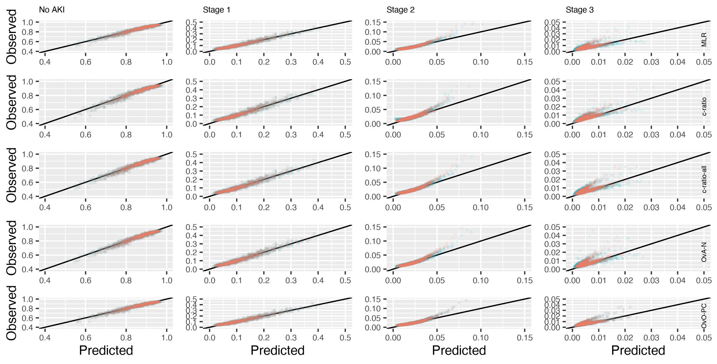
This plot was produced using the nominal calibration framework of van Hoorde et al.²

References
1. Pate A. GitHub repository. Manchester Predictive Healthcare Group. MRC-Multi-Outcome-Project-1.5-Polytomous-Outcomes-Part-1, https://github.com/manchester-predictive-healthcare-group/CHI-MRC-multi-outcome/tree/main/Project 1.5 Polytomous Outcomes Part 1 (2022).
2. Hoorde K Van, Vergouwe Y, Timmerman D, et al. Assessing calibration of multinomial risk prediction models. Stat Med 2014; 33: 2585–2596.

