Supplementary material

Assessing Coastal Erosion and Sediment Removal in the sand bar of the Isla Salamanca: Implications for the Barranquilla-Ciénaga Highway and Boca de Ceniza mouth – Colombia.

Study area
The study area presents accentuated erosion processes of the coastline, mainly at kilometer 19 (Figure S1) and kilometer 29 (Figure S2). These changes result in affectation and possible future damage to the Barranquilla-Pueblo Viejo highway, making the possible negative economic, material, social and environmental impacts more evident.

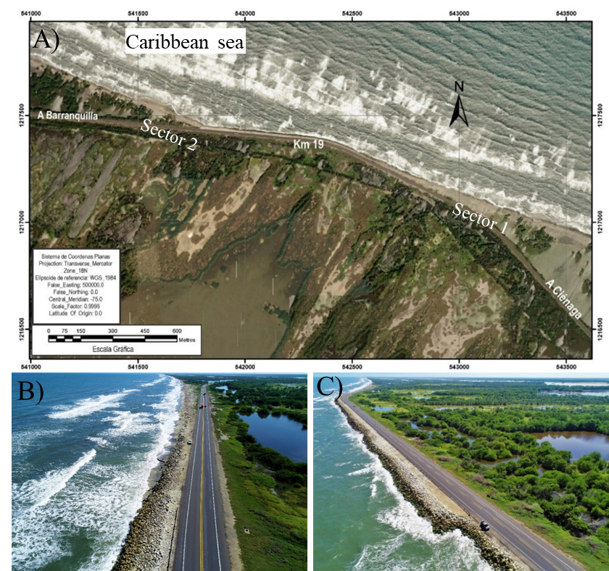
Figure S1. A) study area at Km 19. B) and C) Oblique image taken in December 2020 at Km 19 (Sector 1) and Km 19 (Sector 2). Note: link where you can view the 360° image taken at the beginning of the investigation:
https://www.google.com/maps/@11.0118702,-4.6107282,3a,75y,240.87h,43.02t/data=!3m7!1e1!3m5!1sAF1QipMH5pnjAogo7fVA98duB4svil4LhPWiYwnYwhg6!2e10!3e12!7i4096!8i2048

https://www.google.com/maps/@11.0129786,-74.6174404,3a,75y,232.33h,4.74t/data=!3m7!1e1!3m5!1sAF1QipM7l4OaVRYZLxFFAeJOjQiSAamfWzJkLGZRyVwa!2e10!3e12!7i4096!8i2048

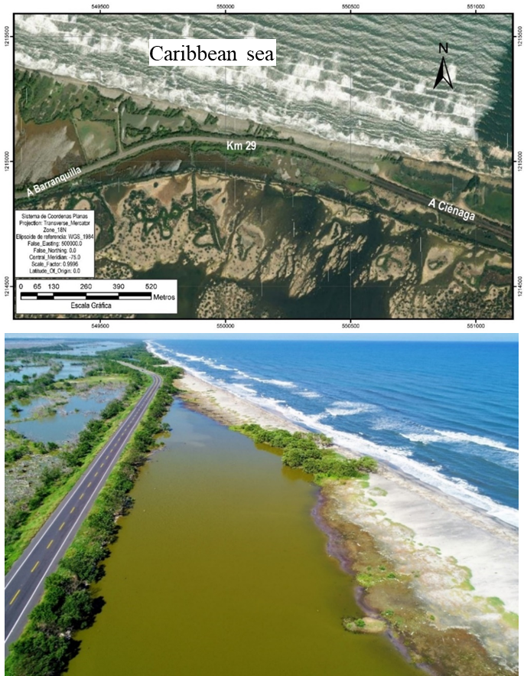
Figure S2. Oblique image taken in December 2020 at Km 29 (Sector 3). Note: link to the 360° image taken at the beginning of the investigation:
https://www.google.com/maps/@10.9892612,-74.5347365,3a,75y,279.42h,46.76t/data=!3m7!1e1!3m5!1sAF1QipMB-1pYP1bDBbeyRtaCllxRVfULCULw3uzMZKco!2e10!3e12!7i4096!8i2048

Research Methods and Techniques

The coastal morphological study was carried out by collecting historical and current information to define the migration trend of the coastline. The historical analysis was carried out through the collection of multi-temporal satellite information from 2004 to 2021 (17 years). The images were obtained through Google Earth Pro and SASPlanet applications, these georeferenced with control points obtained with the help of GNSS (Global Navigation Satellite System) equipment.
The analysis of current data (winter/summer 2020/09-2021/07) was obtained in two sections of the study area (kilometer 19 and kilometer 29) that present important erosion processes and was carried out with the support of advanced technology systems such as Drones and GNSS equipment for the positioning of the terrestrial control points. In addition, photogrammetric techniques were used with updated data collection (topography with indirect methods), which allow the capture of aerial images in real-time and later post-processing to obtain the digital terrain model and the ortho mosaic (Table S1).

Table S1. Dates of the images used in the study at spatial resolution.

Type of image | Source of images | Date (Month/Day/Year) | Spatial Resolution (cm/pixel)
Satellite image | Google Earth Pro | 13/03/2004 | 50
Satellite image | Google Earth Pro | 06/04/2010 | 50
Satellite image | Google Earth Pro | 01/26/2013 | 50
Satellite image | Google Earth Pro | 01/17/2015 | 50
Satellite image | Google Earth Pro | 03/01/2019 | 50
Satellite image | Google Earth Pro | 06/01/2021 | 50
Drone image | Own Orthomosaic | 12/10/2020 | 2.2
Drone image | Own Orthomosaic | 03/07/2021 | 2.2

Drone imaging

The data acquisition with current images was performed with photogrammetric techniques from a multirotor drone - Mavic 2 Pro DJI. The field procedure consisted of programming the aerial photography, with the flight height corresponding to the level of precision in GSD (distance on the ground for each pixel), the longitudinal and transverse overlap, establishing the take-off point, preferably central in the study area, calibrating the equipment to establish the take-off point, and finally executing the flight with capture software such as Pix4DCapture. The parameters considered for the flight to capture the images of the area under study are the following:
- Maximum allowable flight height of 400 feet, which in the case study is 230 feet (70 m).
- Longitudinal and transverse overlaps: 75%/80%.
- Travel speed: 9 m/s
- GSD (sampling distance): 2.2 cm/pixel
- Maximum wind speed: 8 m/s (30 km/hour)
- Maximum Kp (geomagnetic storm index): 4

Data processing

Once the aerial photos have been taken, they are processed in the Pix4D software, which is responsible for processing the photos in three steps, the first is the alignment of the images in which the similarity points are found (in this step the correction is made with control points), the second step is the dense cloud, and the final step is to obtain the ortho mosaic and the digital surface model (DSM).
Subsequently, the satellite images are digitized in the Global Mapper© V21.1 software of the multitemporal images to georeferenced them and perform the vectorization in each period of the coastlines. Likewise, the overlay, analysis, and vectorized classification of the historical coastline will be performed, and then export this information in shapefile format for the ArcMap© V10.8.1 software with the DSAS V5.0 extension (Digital Shoreline Analysis System-USGS) to calculate geostatistical the rates of change that are presented from the coastlines and the baseline.
Additionally, a topographic mooring with ground control points (GCP) was performed with the aerial photographs for greater relative accuracy in the correction of the orthoimages, which in the study areas are distributed 3 photo control points for each sector analyzed georeferenced in WGS84 geographic coordinates, in UTM-Zone18N planar coordinates.
The control points are located along the RN90 highway at kilometer 19 and kilometer 29, and will be located with semi-static points of ATLAS systems (95% accuracy in 4 cm), with a STONEX S900A GNSS equipment, which is equipped with a high-performance GNSS board of 800 channels and is capable of supporting multiple satellite constellations: GPS, GLONASS, BEIDOU, GALILEO, QZSS and IRNSS, with accuracy between 2 and 5 centimeters which is considered a high accuracy, taking into account that the GSD of the ortho images processed in x, y is 2. 2 centimeters per pixel, therefore the final accuracy will be between 2 to 3 times the GSD.
ATLAS is a worldwide GNSS differential correction service, offering the most innovative free-base corrections via L-Band satellites with accuracies ranging from meter level to a few centimeters. The Arrow Gold GNSS, with its L-Band option provides worldwide decimeter positioning to your smartphone, tablet, or laptop. With approximately 200 reference stations worldwide and L-Band satellites distributing coverage from 75°N to 75°S, of the entire landmass.

Shoreline variation analysis

The analysis of shoreline change was performed in ArcMap V10.8.1 software with the DSAS V5.0 (Digital Shoreline Analysis System) application developed by the United States Geological Survey (USGS), in which the statistics of the rates of change presented from the vectorization of shorelines and baseline were calculated, considering the multitemporal images of the respective years.
At kilometer 19 and kilometer 29, 8 ortho-rectified multitemporal images were evaluated in the periods 2004, 2010, 2013, 2015, 2015, 2019, 2020, 2021 as shown in Table S1. The images of each year are registered in UTM coordinates and WGS 1984 reference system, north zone 18.
For this study, the definition of shoreline developed by Crowell et al (1991) was used. They describe the shoreline as the location of the inland limit of a sandy coastal strip, marked by the limit reached during high tide. This boundary is determined by the change in shade of the beach sand. Shorelines are manually vectorized from images acquired in the previous stages (historical and current), the formats required for generating transects and obtaining statistical results of shoreline changes being the following: shoreline (OBJECTID, SHAPE, SHAPE_Length, DATE_, UNICERTAINITY) and baseline (OBJECTID, SHAPE, SHAPE_Length, ID).
The calculations are based on the statistical rate of change that a shoreline can undergo, such as EPR (End Poin Rate) - end point rate which indicates the rates calculated based on the changes in position between the oldest and most recent shoreline of the collected data, and the NSM (Net Shoreline Movement) value which allows us to know how much the shoreline has changed over the period of the 2004-2021 study, either with a positive sign indicating accretion or a negative sign indicating erosion.

Calculation of sediment volumetric change

To calculate the volume of material removed during the 10 months of the study period (September 2020 to July 2021) the difference between the two DSMs obtained by processing the aerial photographs with drones was used. We established profiles every 20 m in length, in which we calculated the area of the erosion zones (berm) and of the accumulation zones (backshore), performing an estimated calculation using the adapted prism formula, taking the average of the two areas, and multiplying by the distance (Equation S1).
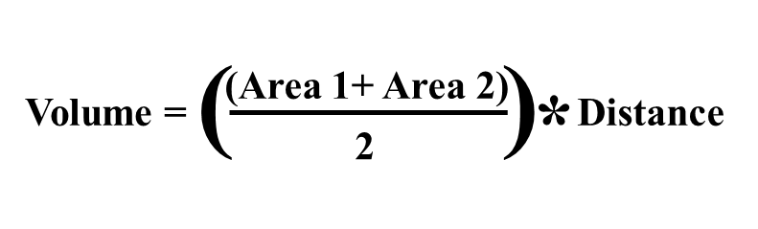

Equation S1

Tables S2, S3 and S4 show the values of erosion and accumulation areas used for volume calculations in the sectors of km 19-1, km 19-2 and km 29, respectively. Figures S3, S4 and S5 show examples of profiles obtained in Global Mapper© V21.1 software with the areas of erosion in red and the areas with sediment accumulation in orange, in the sectors of km 19-1, km 19-2 and km 29, respectively.

Table S2. Table with the volume calculations for the km 19 - 1 sector.
Section | High | Base area (m²) |  | Volume (m³)
Section | High | Erosion | Accumulation | Erosion | Accumulation
1 | 0 | 47.1 | 0.0
2 | 20 | 45.8 | 0.0 | 928.8 | 0.0
3 | 40 | 39.3 | 0.0 | 851.6 | 0.0
4 | 60 | 44.9 | 0.0 | 842.3 | 0.0
5 | 80 | 33.3 | 0.0 | 782.2 | 0.0
6 | 100 | 37.6 | 0.0 | 709.4 | 0.0
7 | 120 | 46.5 | 6.5 | 841.4 | 65.4
8 | 140 | 53.9 | 2.6 | 1004.5 | 91.3
9 | 160 | 33.6 | 4.6 | 875.5 | 71.5
10 | 180 | 25.7 | 0.0 | 592.8 | 45.6
11 | 200 | 44.8 | 0.0 | 704.5 | 0.0
12 | 220 | 31.8 | 0.0 | 766.0 | 0.0
13 | 240 | 26.7 | 0.0 | 585.5 | 0.0
14 | 260 | 19.8 | 4.8 | 465.4 | 47.6
15 | 280 | 15.2 | 7.1 | 350.4 | 118.9
16 | 300 | 23.9 | 15.3 | 391.0 | 224.6
17 | 320 | 20.6 | 13.4 | 444.5 | 286.9
18 | 340 | 24.5 | 15.5 | 451.1 | 288.7
19 | 360 | 21.1 | 18.4 | 456.2 | 339.3
20 | 380 | 35.8 | 0.0 | 568.7 | 184.2
21 | 400 | 29.9 | 14.6 | 656.7 | 146.3
22 | 420 | 47.8 | 0.0 | 777.3 | 146.3
23 | 440 | 34.2 | 0.0 | 820.1 | 0.0
24 | 460 | 60.2 | 0.0 | 943.9 | 0.0
25 | 480 | 26.9 | 0.0 | 871.2 | 0.0
26 | 500 | 39.5 | 0.0 | 664.3 | 0.0
27 | 520 | 19.7 | 0.0 | 591.9 | 0.0
28 | 540 | 30.7 | 0.0 | 503.4 | 0.0
29 | 560 | 23.5 | 0.0 | 541.9 | 0.0
Total volume (m³) |  |  |  | -18982.5 | +2056.6
Sediment balance (m³) |  |  |  | -16925.9

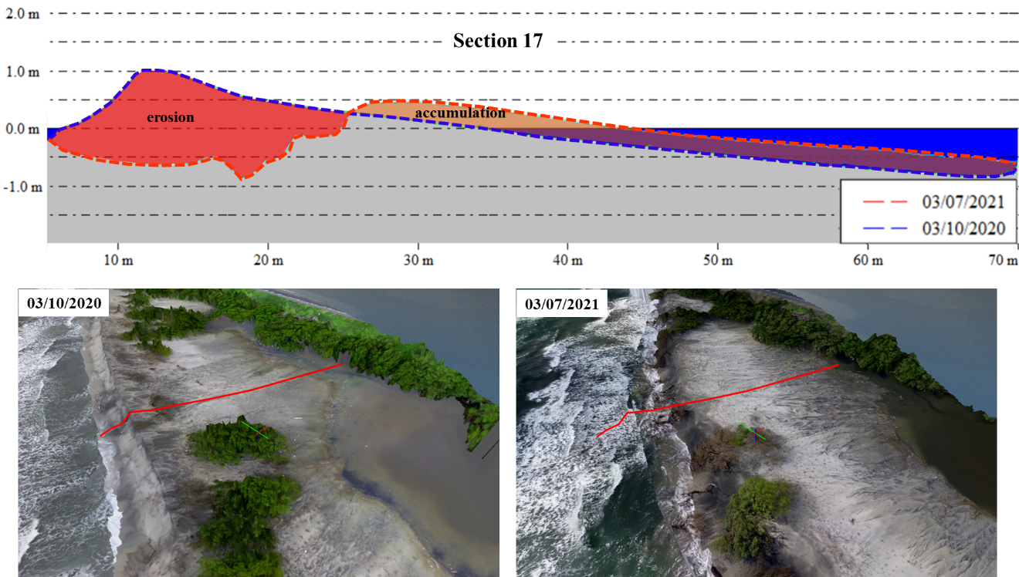
Figure S3. Example of the profile (section 17) used to obtain the areas with erosion and sediment accumulation in the sector of Km 19-1, with the oblique images of the ortomosaicos obtained in October 2020 and July 2021.

Table S3. Table with the volume calculations for the km 19 - 2 sector.
Section | High | Base area (m²) |  | Volume (m³)
Section | High | Erosion | Accumulation | Erosion | Accumulation
1 | 0 | 10.2 | 0.0
2 | 20 | 11.5 | 0.0 | 217.1 | 0.0
3 | 40 | 15.1 | 0.0 | 266.2 | 0.0
4 | 60 | 13.6 | 0.0 | 286.8 | 0.0
5 | 80 | 18.2 | 0.0 | 317.9 | 0.0
6 | 100 | 17.8 | 0.0 | 359.9 | 0.0
7 | 120 | 15.8 | 0.0 | 335.2 | 0.0
8 | 140 | 16.9 | 0.0 | 326.4 | 0.0
9 | 160 | 13.7 | 0.0 | 305.3 | 0.0
10 | 180 | 10.4 | 0.0 | 240.4 | 0.0
11 | 200 | 19.7 | 0.0 | 300.5 | 0.0
12 | 220 | 9.7 | 0.0 | 294.1 | 0.0
13 | 240 | 11.7 | 0.0 | 213.9 | 0.0
14 | 260 | 10.3 | 0.0 | 219.4 | 0.0
15 | 280 | 11.5 | 0.0 | 217.8 | 0.0
16 | 300 | 11.8 | 0.0 | 232.6 | 0.0
17 | 320 | 14.2 | 0.0 | 259.5 | 0.0
18 | 340 | 14.0 | 0.0 | 281.5 | 0.0
19 | 360 | 13.6 | 0.0 | 275.8 | 0.0
20 | 380 | 14.0 | 0.0 | 276.0 | 0.0
21 | 400 | 12.1 | 0.0 | 260.6 | 0.0
22 | 420 | 10.2 | 0.0 | 222.8 | 0.0
23 | 440 | 11.1 | 0.0 | 213.5 | 0.0
24 | 460 | 9.7 | 0.0 | 208.8 | 0.0
25 | 480 | 8.9 | 0.0 | 186.4 | 0.0
26 | 500 | 9.7 | 0.0 | 185.5 | 0.0
27 | 520 | 9.8 | 0.0 | 194.1 | 0.0
28 | 540 | 10.5 | 0.0 | 202.4 | 0.0
29 | 560 | 11.7 | 0.0 | 221.6 | 0.0
30 | 580 | 11.5 | 0.0 | 231.7 | 0.0
31 | 600 | 11.7 | 0.0 | 231.5 | 0.0
Total volume (m³) |  |  |  | -7585.2 | +0.0
Sediment balance (m³) |  |  |  | -7585.2

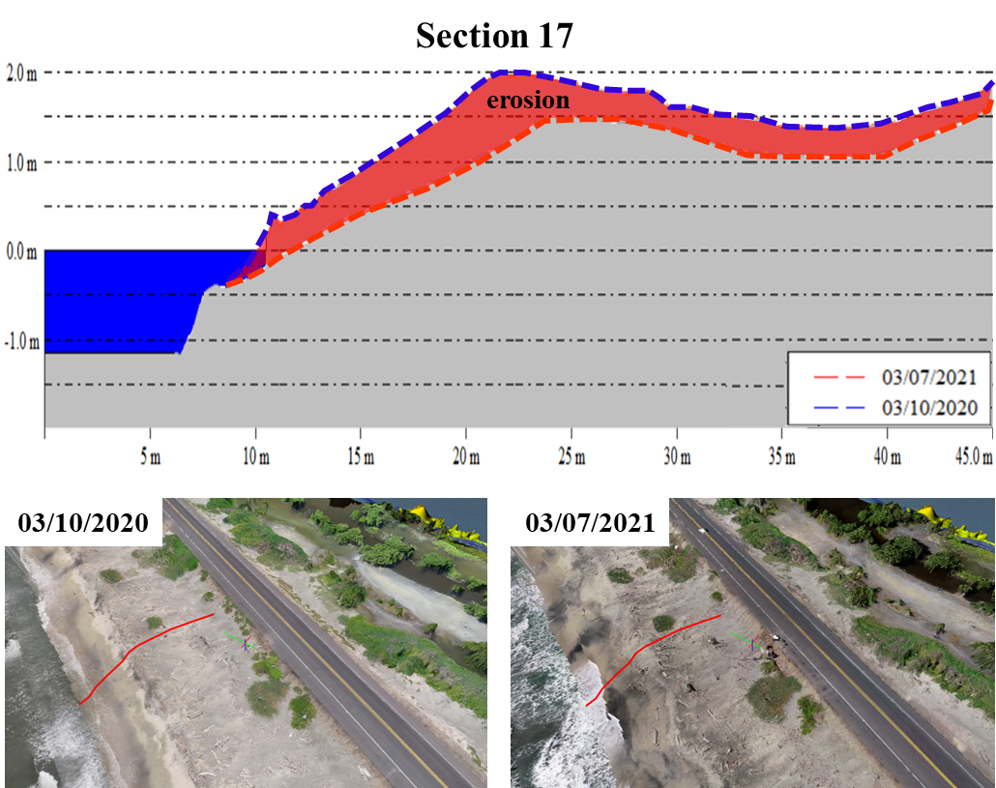
Figure S4. Example of the profile (section 17) used to obtain the areas with erosion and sediment accumulation in the sector of Km 19-2, with the oblique images of the ortomosaicos obtained in October 2020 and July 2021.

Table S3. Table with the volume calculations for the km 29 sector.
Section | High | Base area (m²) |  | Volume (m³)
Section | High | Erosion | Accumulation | Erosion | Accumulation
1 | 0 | 4.5 | 12.1 | 0.0 | 0.0
2 | 20 | 8.9 | 17.5 | 133.3 | 295.8
3 | 40 | 10.8 | 17.0 | 196.8 | 344.6
4 | 60 | 6.7 | 5.1 | 175.0 | 220.2
5 | 80 | 7.0 | 5.8 | 136.4 | 108.6
6 | 100 | 2.8 | 11.5 | 98.0 | 172.8
7 | 120 | 1.6 | 11.8 | 44.1 | 233.2
8 | 140 | 1.2 | 5.3 | 27.7 | 171.7
9 | 160 | 2.8 | 3.3 | 40.3 | 86.4
10 | 180 | 0.7 | 3.1 | 35.0 | 63.7
11 | 200 | 2.8 | 11.9 | 34.9 | 150.1
12 | 220 | 4.8 | 10.1 | 76.7 | 220.5
13 | 240 | 5.3 | 11.3 | 101.3 | 214.3
14 | 260 | 3.7 | 13.0 | 89.4 | 242.8
15 | 280 | 5.2 | 12.7 | 88.1 | 256.3
16 | 300 | 4.8 | 0.0 | 99.2 | 126.7
17 | 320 | 9.4 | 0.0 | 141.5 | 0.0
18 | 340 | 11.3 | 12.4 | 206.7 | 123.9
19 | 360 | 15.6 | 11.3 | 268.7 | 236.8
20 | 380 | 9.9 | 8.8 | 254.8 | 200.9
21 | 400 | 8.7 | 9.9 | 185.4 | 187.3
22 | 420 | 5.6 | 10.7 | 142.8 | 206.0
23 | 440 | 5.7 | 10.0 | 112.9 | 206.8
24 | 460 | 7.1 | 4.9 | 127.5 | 149.0
25 | 480 | 8.9 | 0.0 | 160.3 | 48.9
26 | 500 | 4.2 | 0.0 | 131.1 | 0.0
27 | 520 | 3.4 | 1.7 | 75.2 | 17.0
28 | 540 | 0.0 | 3.7 | 33.5 | 53.5
29 | 560 | 0.0 | 7.6 | 0.0 | 112.1
30 | 580 | 0.0 | 5.7 | 0.0 | 132.8
31 | 600 | 0.0 | 3.5 | 0.0 | 91.8
32 | 620 | 1.9 | 1.7 | 18.6 | 51.3
33 | 640 | 3.6 | 0.8 | 54.6 | 24.4
34 | 660 | 2.2 | 2.6 | 58.1 | 33.8
35 | 680 | 1.6 | 3.0 | 38.5 | 55.7
36 | 700 | 4.2 | 0.0 | 58.4 | 29.6
37 | 720 | 7.5 | 0.0 | 116.5 | 0.0
38 | 740 | 10.8 | 0.0 | 182.3 | 0.0
39 | 760 | 13.1 | 0.0 | 238.5 | 0.0
40 | 780 | 19.3 | 0.0 | 323.8 | 0.0
41 | 800 | 22.1 | 0.0 | 414.0 | 0.0
42 | 820 | 12.5 | 0.0 | 345.5 | 0.0
43 | 840 | 10.8 | 0.0 | 232.9 | 0.0
44 | 860 | 14.3 | 0.0 | 251.3 | 0.0
45 | 880 | 13.2 | 0.0 | 274.8 | 0.0
46 | 900 | 9.1 | 0.0 | 223.0 | 0.0
47 | 920 | 9.8 | 0.0 | 188.7 | 0.0
48 | 940 | 7.3 | 0.0 | 170.1 | 0.0
49 | 960 | 6.1 | 0.0 | 133.9 | 0.0
50 | 980 | 4.3 | 0.0 | 103.8 | 0.0
51 | 1000 | 10.6 | 0.0 | 148.2 | 0.0
Total volume (m³) |  |  |  | -6792.1 | 4869.3
Sediment balance (m³) |  |  |  | -1922.8
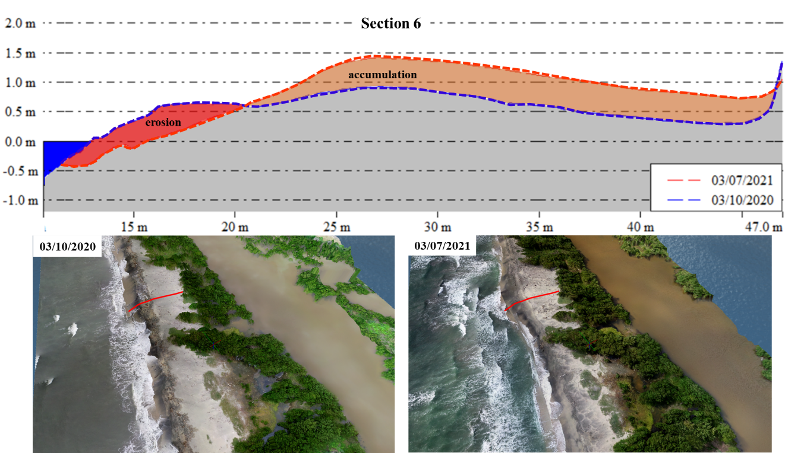
Figure S5. Example of the profile (section 6) used to obtain the areas with erosion and sediment accumulation in the sector of Km 29, with the oblique images of the ortomosaicos obtained in October 2020 and July 2021.

