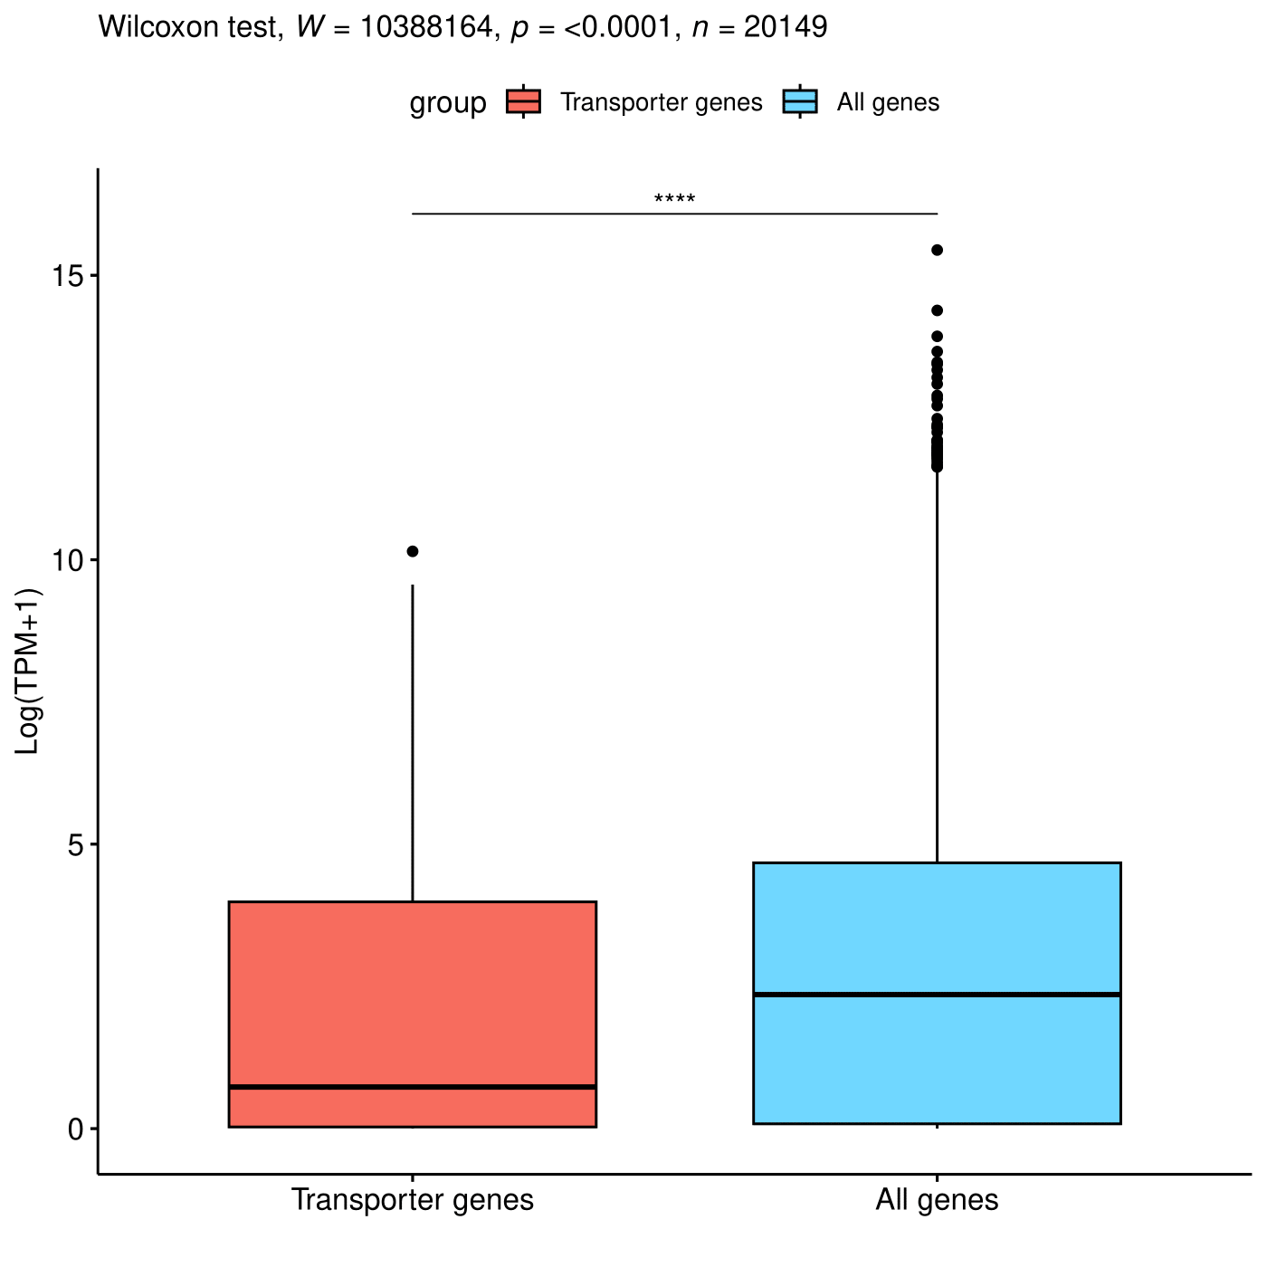

Supplementary Fig.1: Gene expression of transporter genes compared to all genes. The y axis represents the logarithm of TPM normalized expression level of genes plus 1. The p-value was calculated using Wilcoxon signed-rank test. n = 979 (only transporter) or 19,193 (all) genes. K562 RNA-seq data were downloaded from Dependency Map Portal.
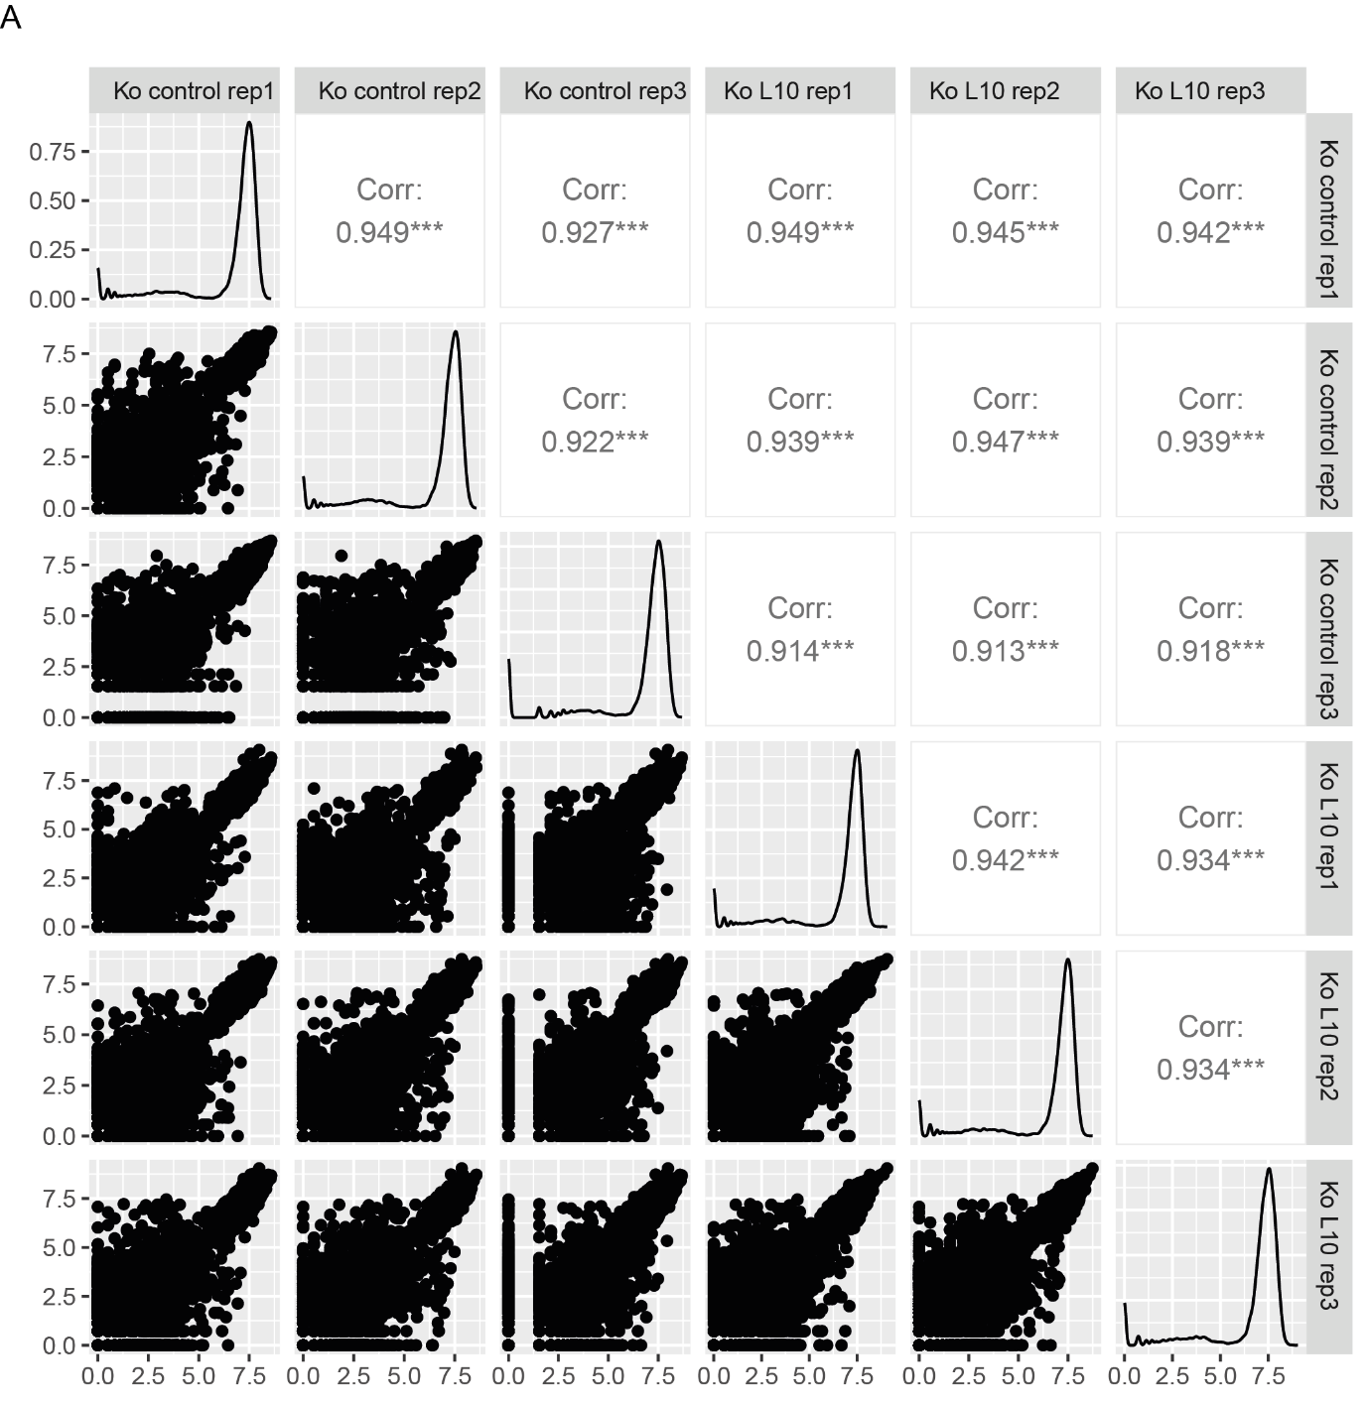
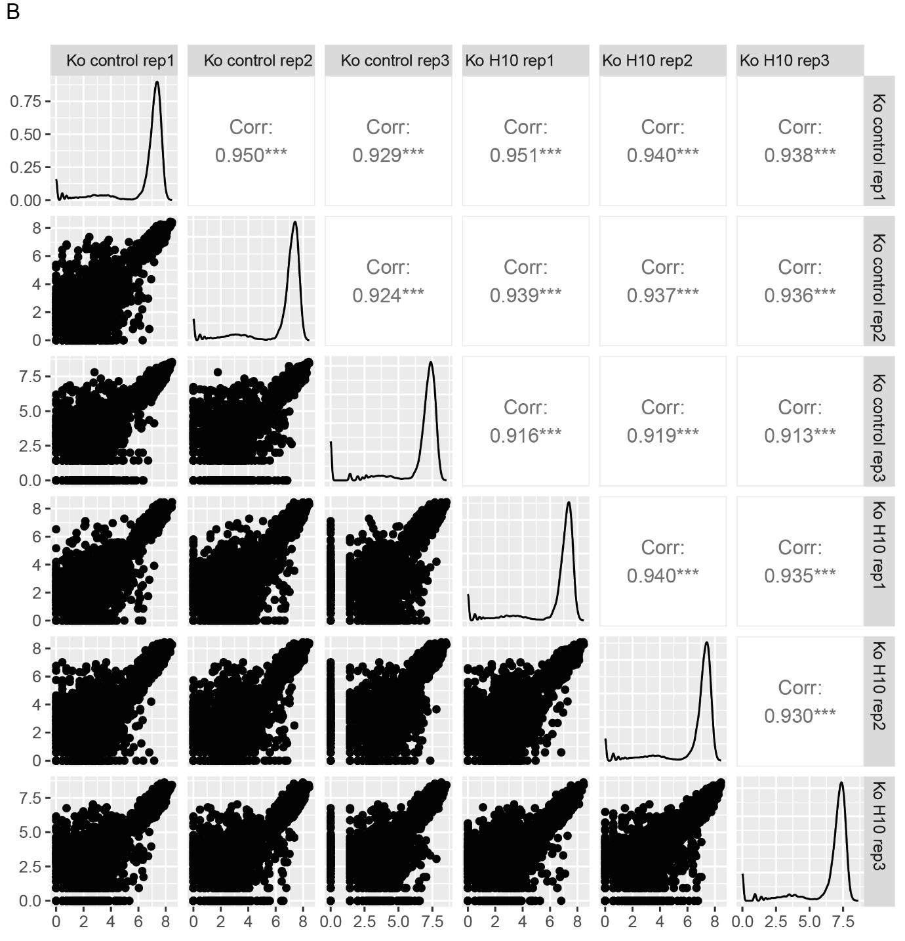
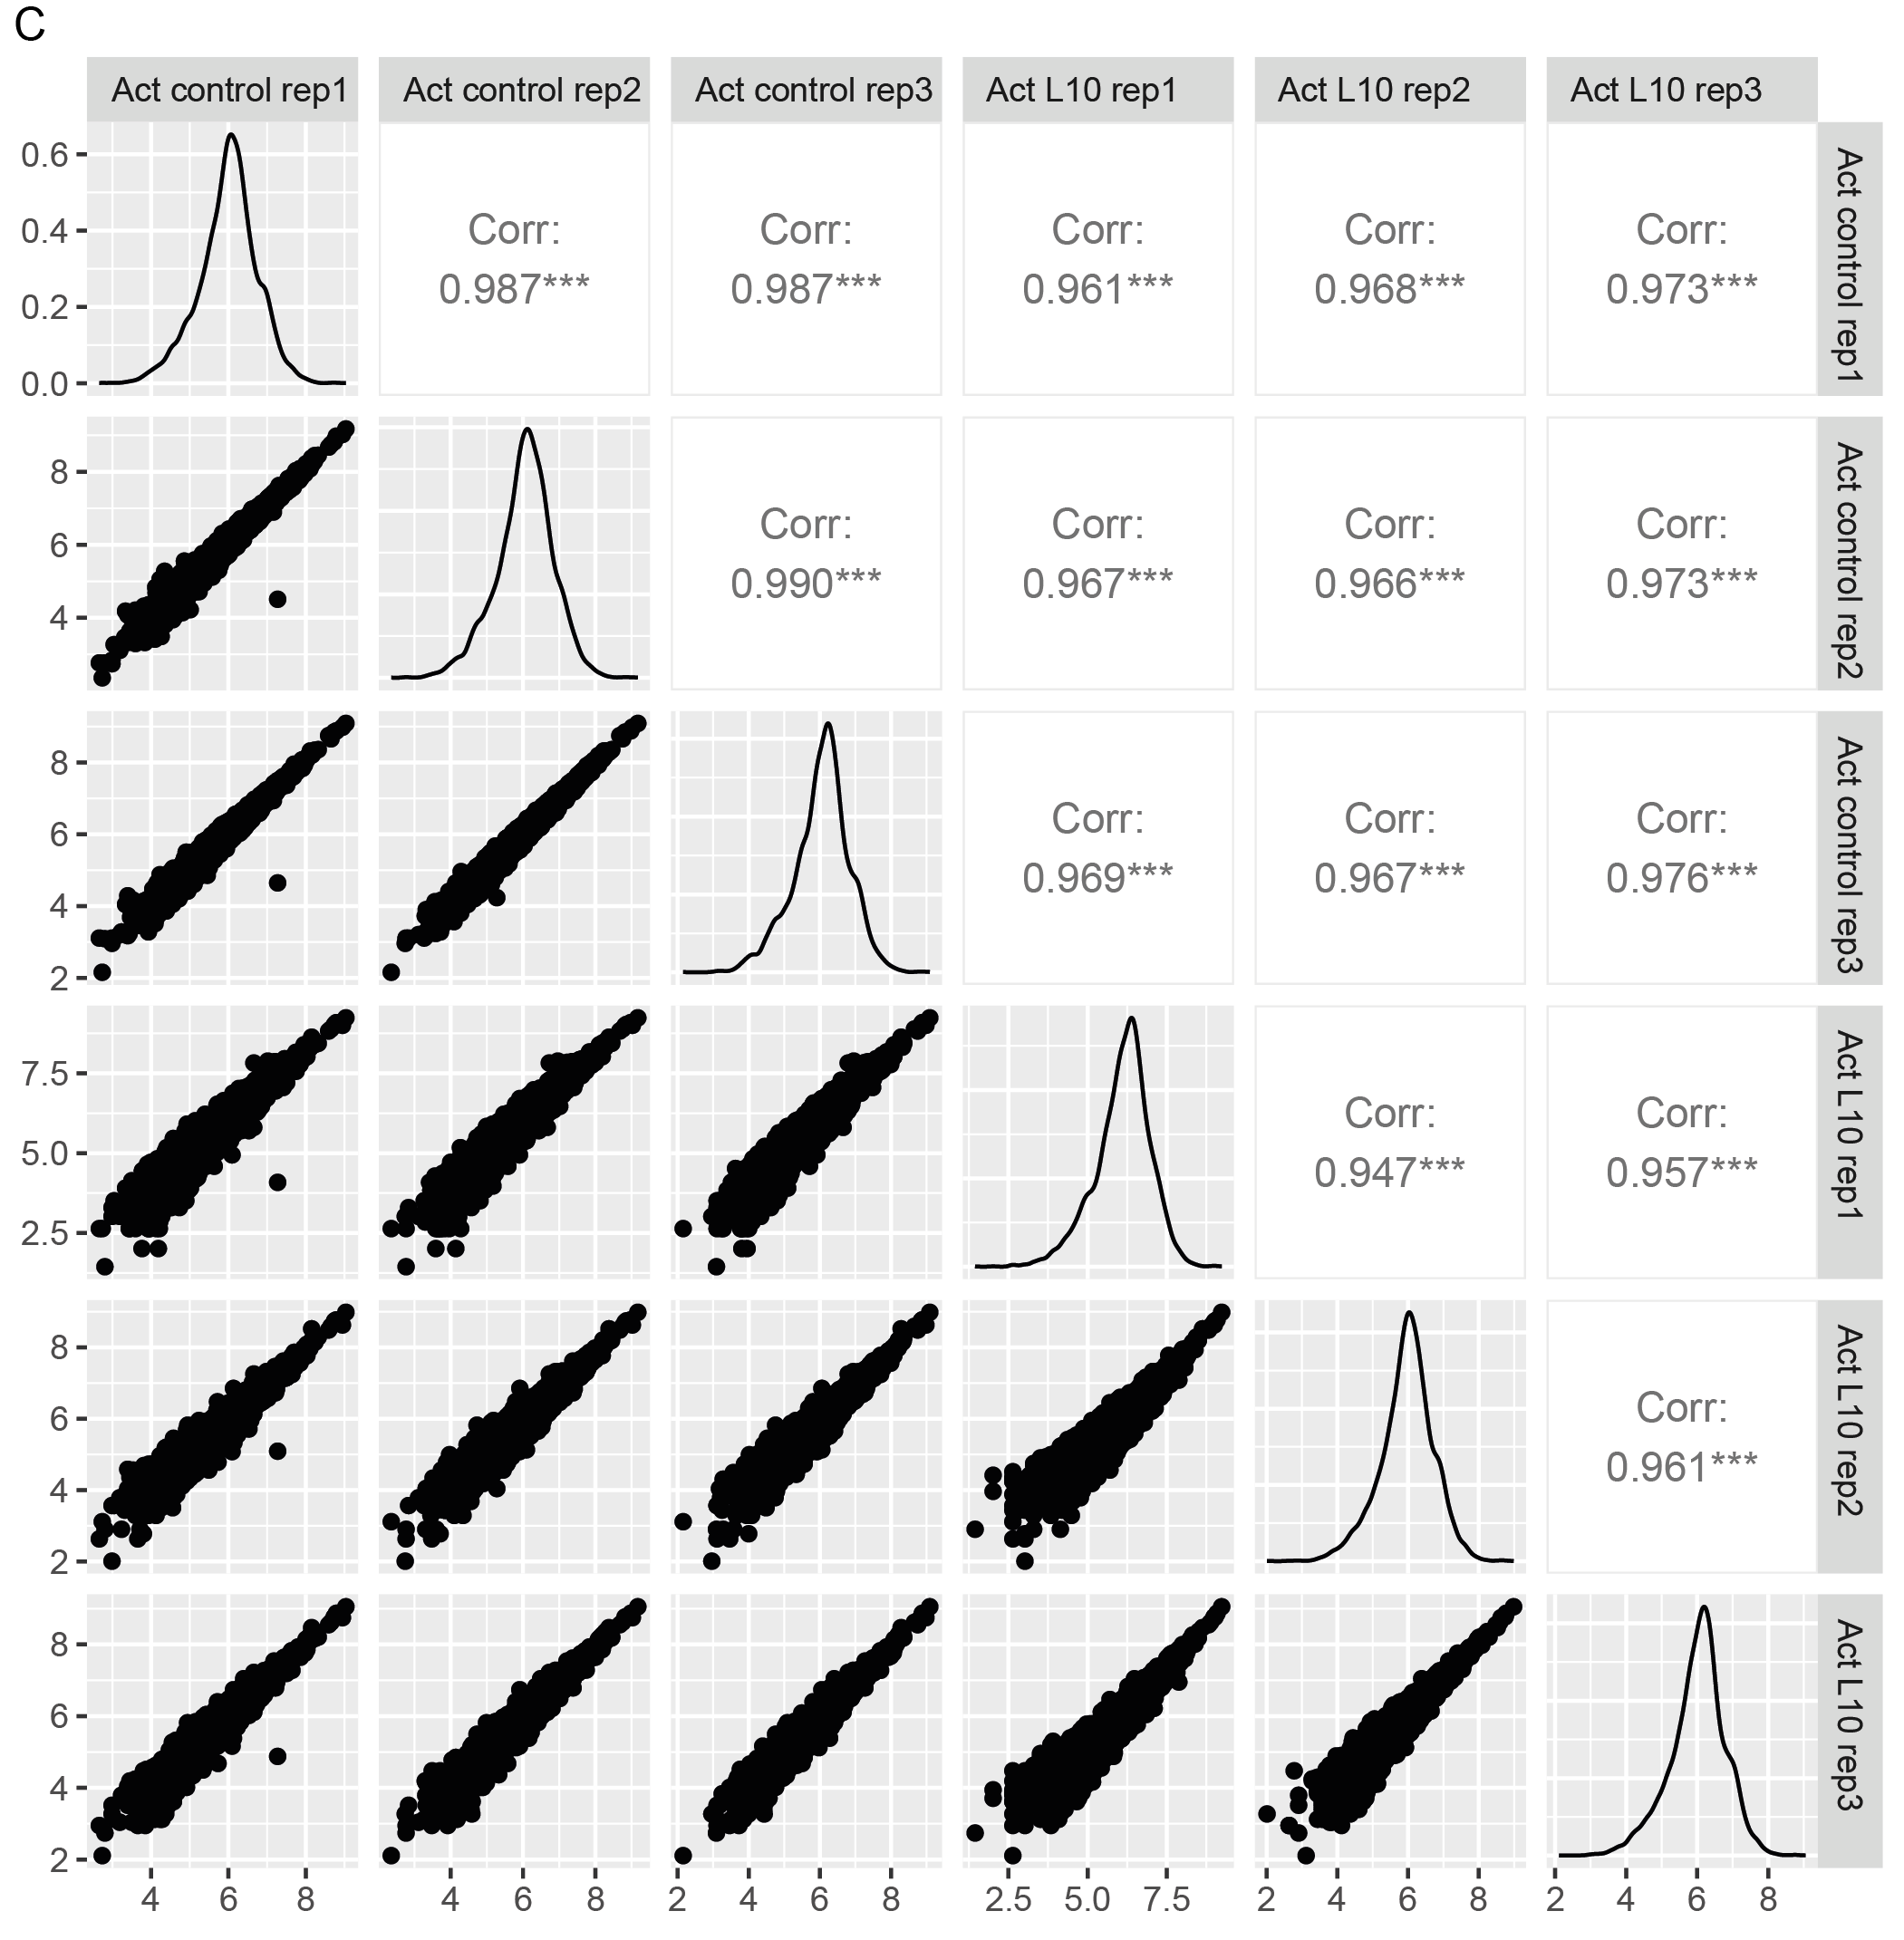
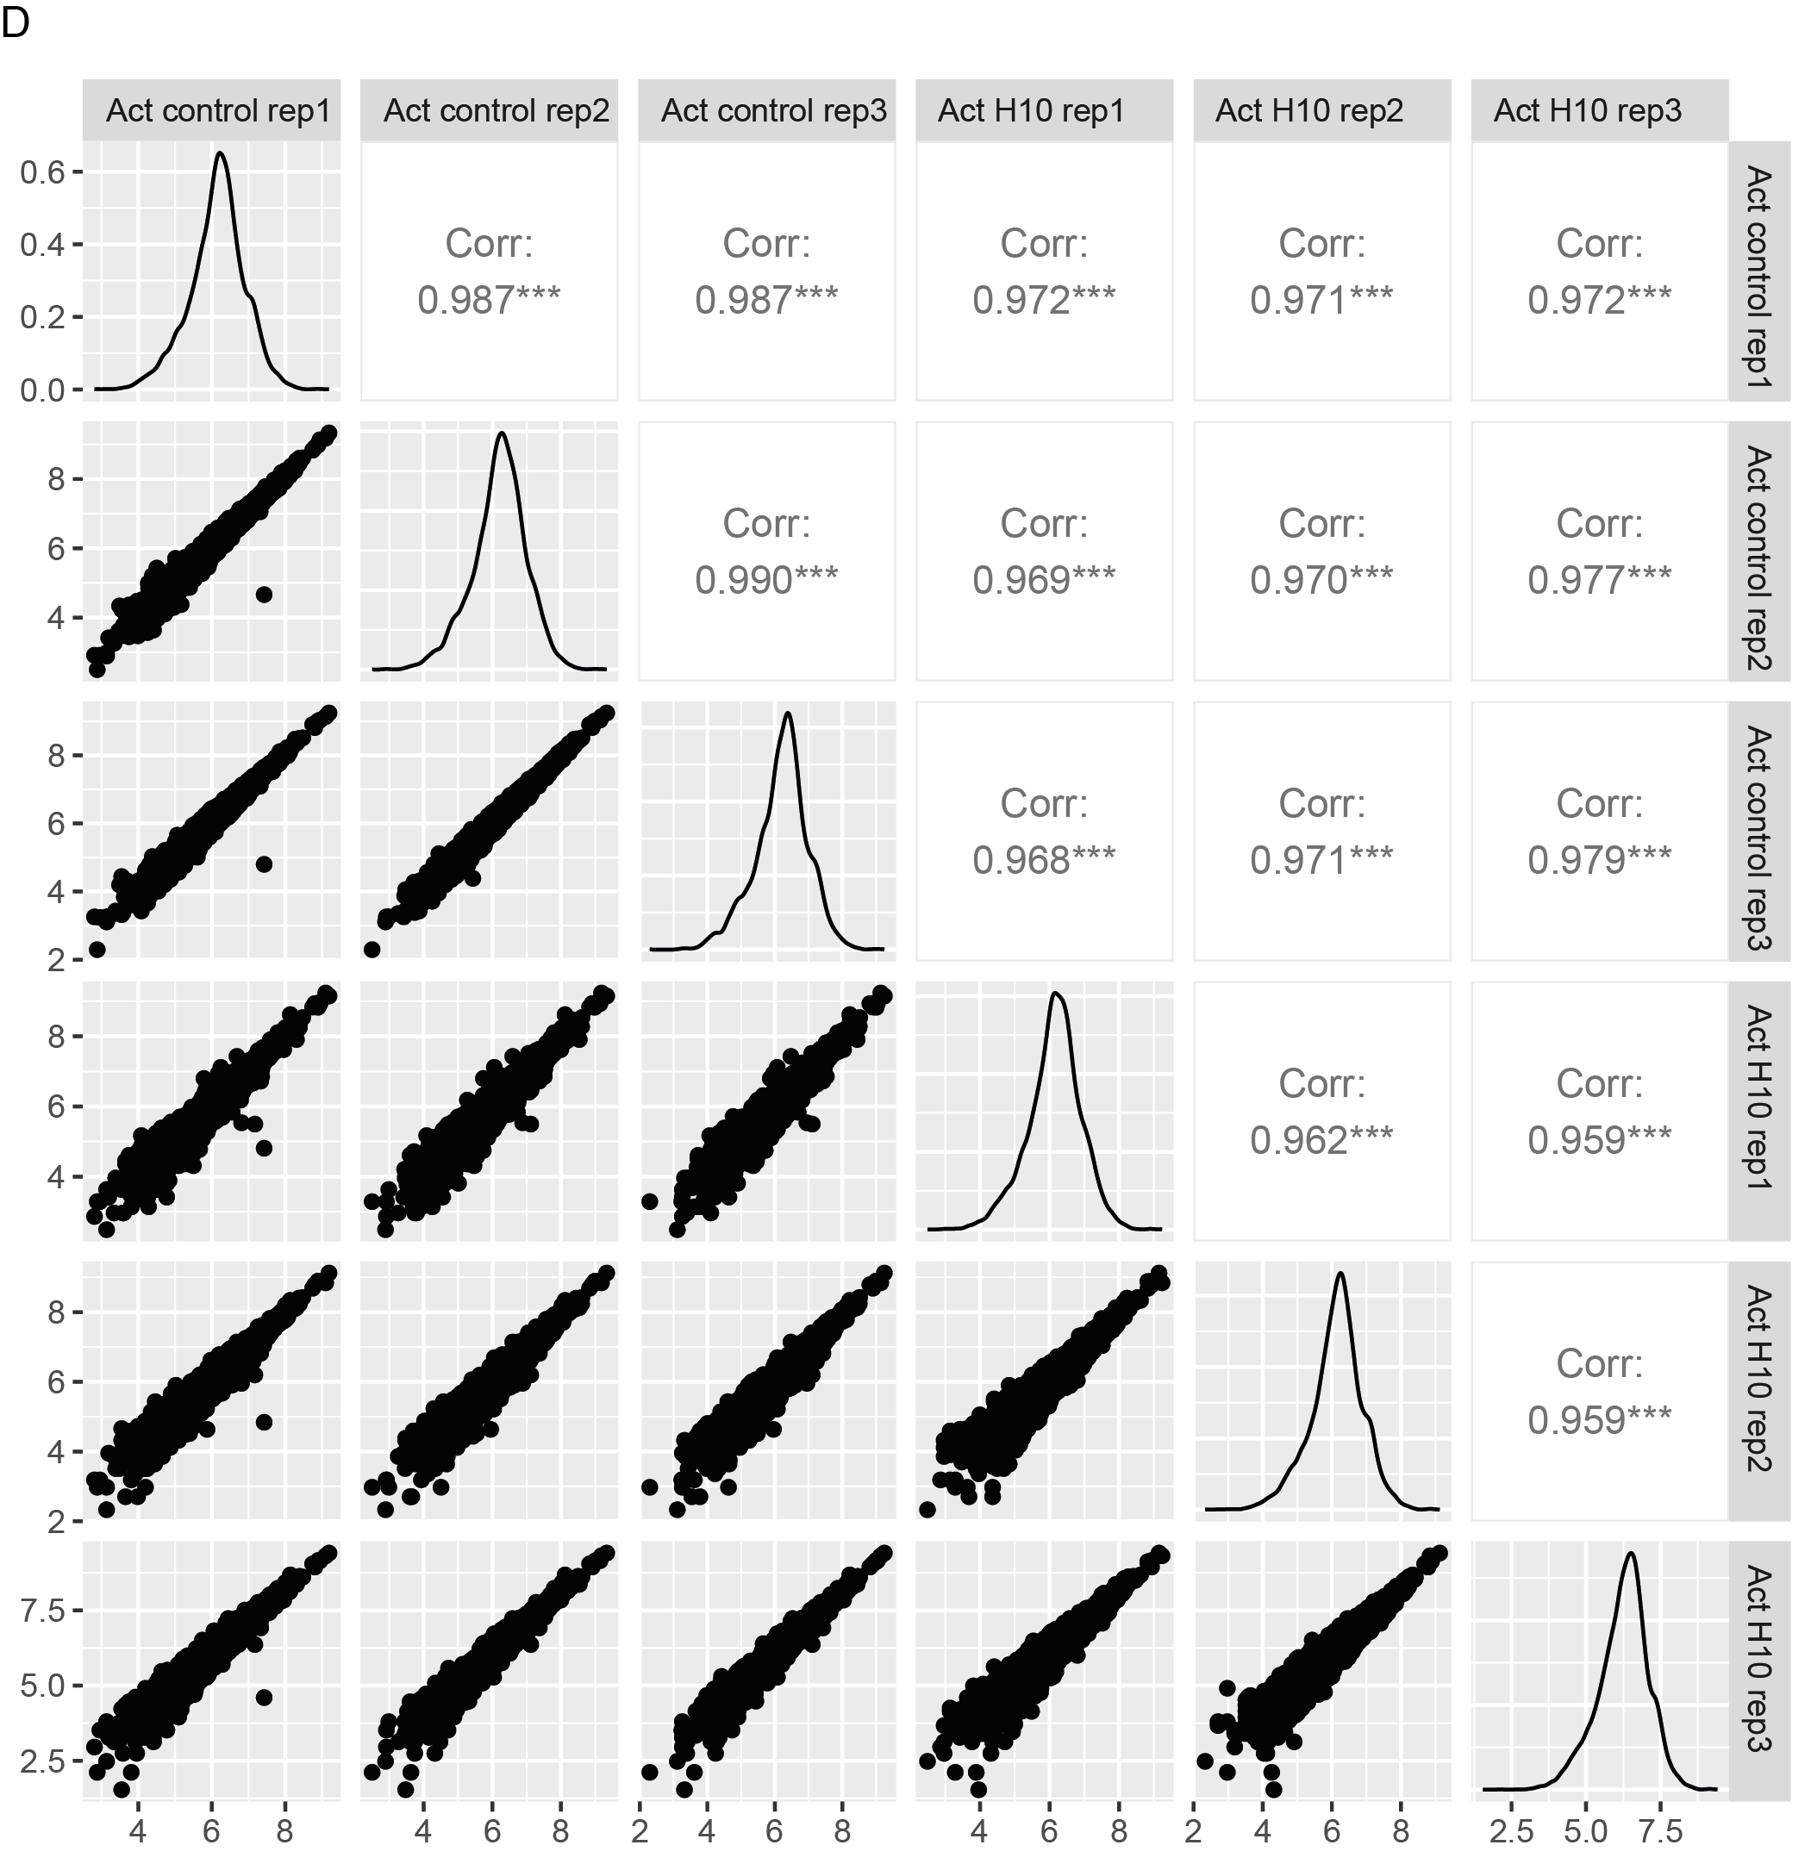
Supplementary Fig.2: Pairwise correlation of CRISPRko and CRISPRa screen replicates. A. Pairwise correlation of L10 population from the CRISPRko screening with the control group. B. Pairwise correlation of H10 population from the CRISPRko screening with the control group. C. Pairwise correlation of L10 population from the CRISPRa screening with the control group. D. Pairwise correlation of H10 population from the CRISPRa screening with the control group. The logarithm of read count plus 1 of each replicates pair was plotted. Pearson correlation coefficient was calculated to measure the correlation between each replicate pair.

Supplementary Fig.3: Doxorubicin uptake was enhanced in 293T cells with elevated SLC2A3 expression. A. qPCR was used to quantify the expression of SLC2A3 in 293T SLC2A3-CRISPRa bulk cells. B. FACS was used to quantify the uptake of doxorubicin in 293T SLC2A3-CRISPRa bulk cells. For each cell line, cells were treated with doxorubicin at the final concentration of 2 μM for 2 h. The fluorescence intensity of the drugs was quantified by FACS. Bars show mean value ± s.e.m. and significance was calculated using Student’s t-test (n = 2 or 3). *p < 0.05, **p < 0.005, and ***p < 0.0001 (versus the 293T-WT cells).

