Table 1. Substrate scope of benzylic electrophiles and organoboron nucleophiles.
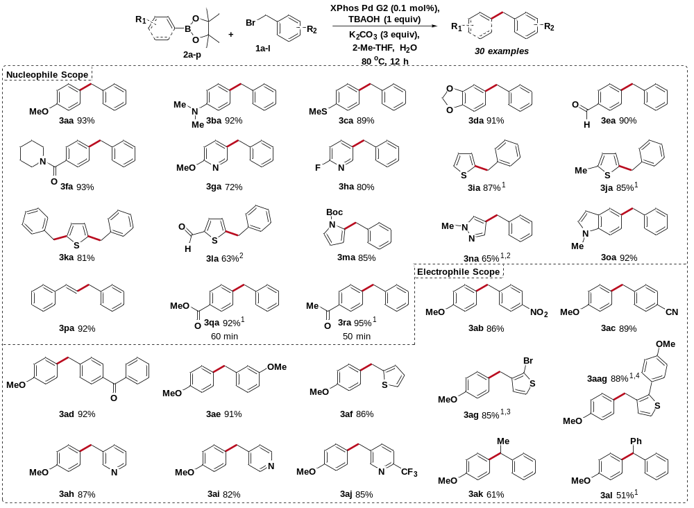
ªReactions were run on a 0.75 mmol scale; isolated yields reported. Conditions: 1a (1.0 equiv), 2a-n (1.3 equiv), K₂CO₃ (3.0 equiv), TBAOH (1.0 equiv), 2-MeTHF, H₂O, 80 ºC, 16 h; ¹ TBAB instead of TBAOH; ² 1.0 mol% Xphos Pd G2. ³ 1g (1.3 equiv) and 2a (1.0 equiv). ⁴ 1g (1.0 equiv) and 2a (2.7 equiv).

