Supplementary Materials
SM1. Picking duration
By far most of the time spent for a root sampling campaign is devoted to manually separating the roots from the soil, i.e. the root picking. For this study, a subset of 10 soil samples were processed for root biomass and necromass determination following an earlier methodological study (Berhongaray et al. 2013) for an optimized time investment in root biomass determination.
Soil samples were thawed and roots were manually picked for 1, 2, 5, 20, 40 and 60 min. The time intervals were shorter at the beginning in order to capture the increments of root biomass at early phases of the root picking. At each time, roots were sorted into dead, very fine (<1 mm), fine (1-2 mm) and coarse (>2 mm) roots, washed and put in paper bags for dry mass determination. The increases in the mass of roots collected over time were normalized by the maximum value, and calibration curves were fitted with picking duration study to transform the 20min biomass into the total biomass at 60 min.
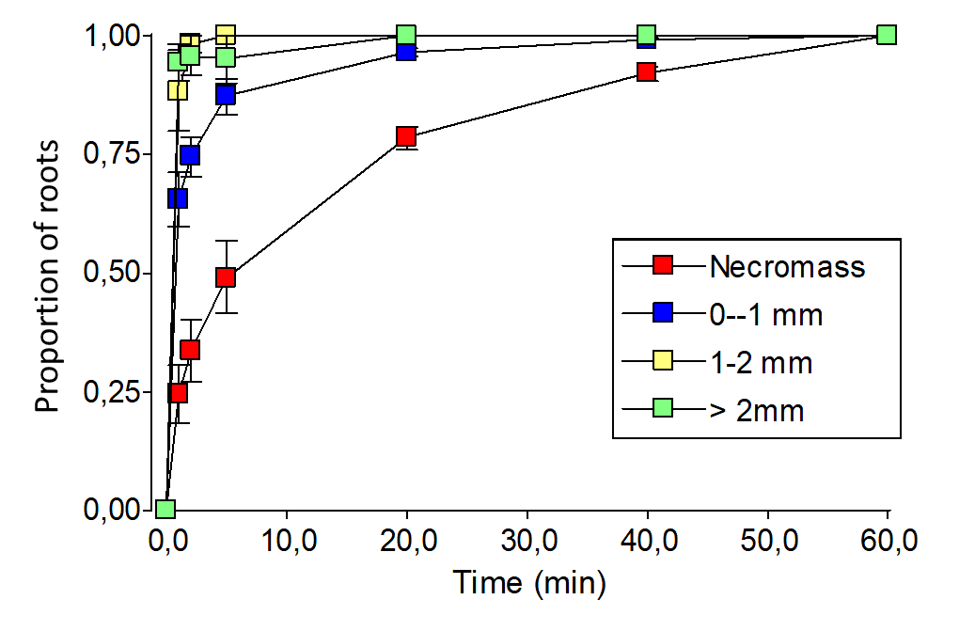
Figure SM1.1. Increments in the proportion of root biomass picked as a function of the duration of root picking. Proportions are relative to the maximum root biomass picked after 60 min.
SM2. Root biomass production
The decision matrix by Fairley and Alexander (1985) for calculating production (P) and mortality (M) of fine roots and decomposition (D) of dead fine roots during a measurement interval. ΔB and ΔN represent change during a measurement interval in the pools of live fine root mass and dead fine root mass, respectively. Inequalities in the top two rows and those in the first column from the left indicate conditions on the values of ΔB and ΔN. Suggested equations for calculation of g, m, and d are given in the Table for specific combination of the values of ΔB and ΔN. The equations in parentheses are assumptions under specific conditions.
Table SM2.1. The decision matrix method (Fairley and Alexander 1985) calculates productivity, mortality and disappearance of fine roots between consecutive sampling dates using data of fine root biomass and necromass.
 | ΔB ≥0 | ΔB<0
 |  | ΔN > |ΔB| | |ΔB| > ΔN
ΔN ≥0 | P = ΔB + ΔN | P = ΔB + ΔN | (P = 0)
 | M = ΔN | M = ΔN | M = −ΔB
 | (D = 0) | (D = 0) | D = −ΔB − ΔN
ΔN<0 | P = ΔB | (P = 0) | (P = 0)
 | (M = 0) | M = −ΔB | M = −ΔB
 | D = −ΔN | D = −ΔB − ΔN | D = −ΔB − ΔN
SM3. Variability of fine root biomass and production with soil depth
The coefficient of variation was calculated for root biomass and production at each depth. It was observed that as the sampling depth increases, the variability also increases. This may be due to two factors: on the one hand, the greater natural variability due to the few roots in depth; and on the other hand, a methodological error that, due to the lower biomass, affects the ability to find the roots during the picking. In both cases, this high variability obstructs the possibility of finding differences between treatments in the deep layers.

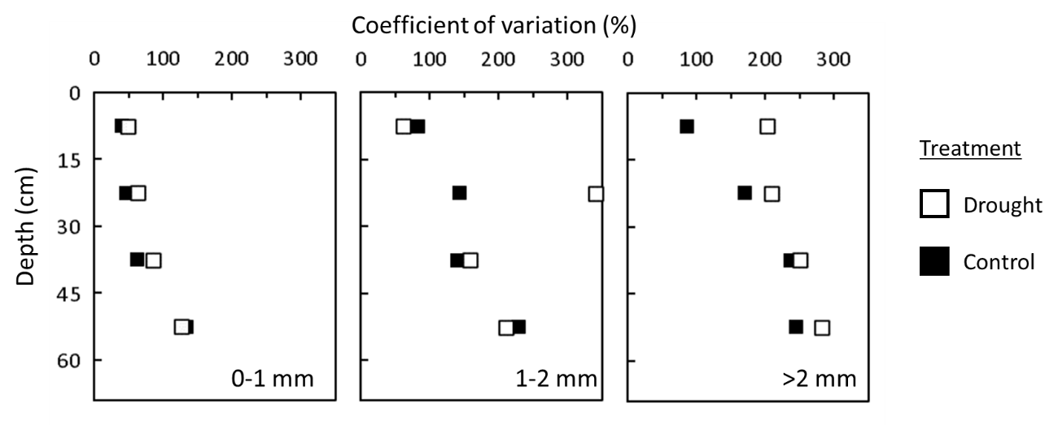
Figure SM3.1. Coefficient of variation (%) of fine root biomass measured in February 2014 at each sampling depth for the Control and Drought plots.

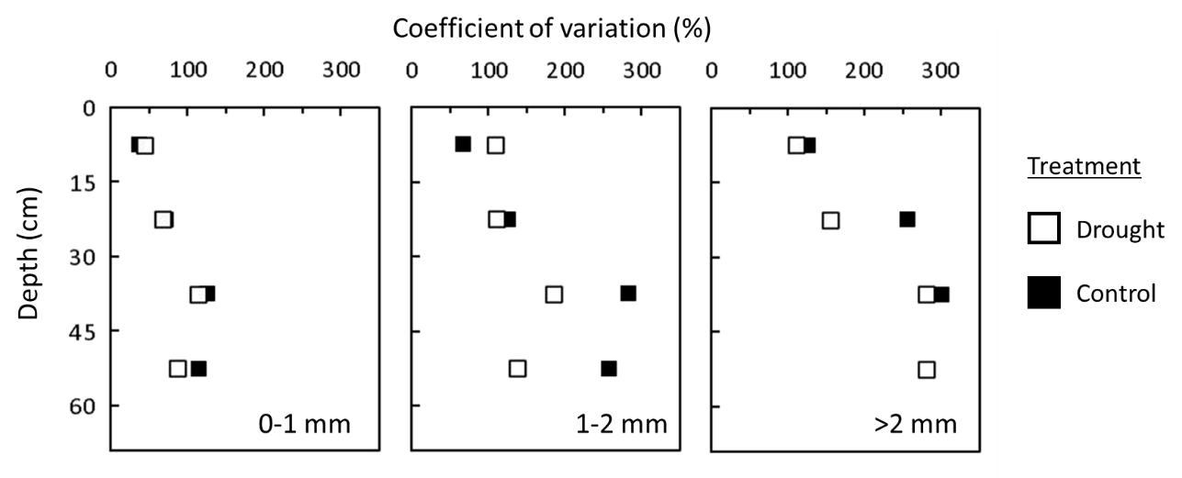
Figure SM3.1. Coefficient of variation (%) of fine root production from February till November 2014 at each sampling depth for the Control and Drought plots.

SM4. Effects of blocks to the results
There was a large variability between blocks (Figure SM4.1). Block A presented the lower above and belowground biomass production and almost no difference in biomass and soil moisture levels. Block B responded well to the treatments, with higher biomass under Control as compared with Drought treatment, while the opposite was observed in Block C. These observed differences are not statistical differences, since statistical comparisons between treatments in the same block are not possible due to lack of replicates.
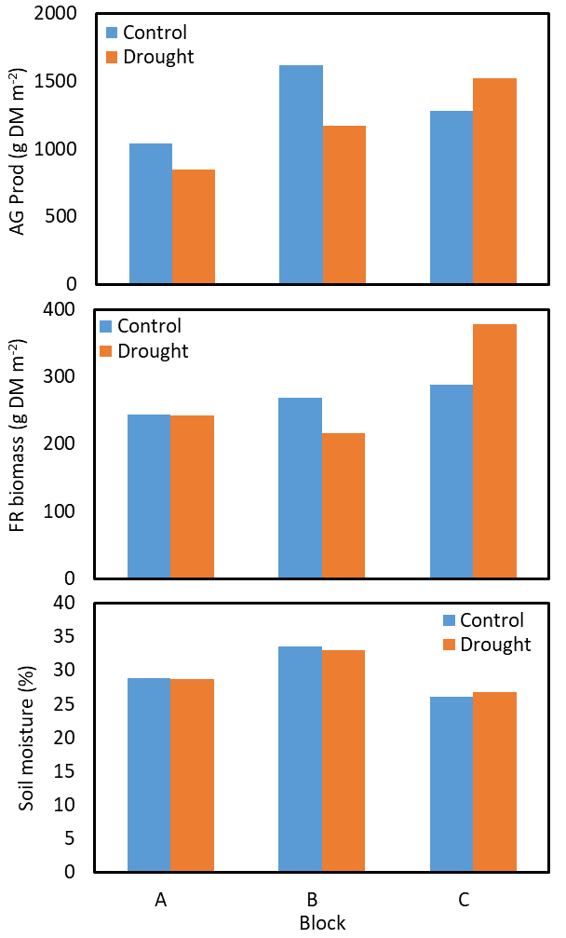
Figure SM4.1 Average values of Aboveground production (AG Prod; g DM m-2) during 2013, fine root (FR) biomass (d DM m-2) in February 2014 and average soil moisture during main growing season in 2013 (April to August)

SM5. Correlation analysis
A correlation analysis was carried out to associate root distribution coefficients β and D₅₀ with soil moisture during the growing season. The β parameter of the asymptotic equation (Jackson et al., 1996) and D₅₀ parameters of the logistic dose–response curve model (Schenk and Jackson, 2002) fitted to the vertical distribution of the fine root biomass and fine root production.
The month of May was the one that was most often significant, also on average it had the lowest p-value (Table SM4.2), which is why it was chosen as the month to study the vertical distribution of roots.

Table SM5.1. Table of partial correlations between the parameters (D50 and Beta) for root biomass (FRB) and root production (FRP) distribution and aboveground biomass produced (AG Prod) and soil moisture according to the months in 2013 for FRP and 2014 in FRP.
Variable(1) | Variable(2) | n | Pearson | p-value
D50_FRB | AG Prod (2013) | 36 | 0.19 | 0.260
D50_FRB | March | 12 | -0.33 | 0.287
D50_FRB | April | 36 | -0.38 | 0.022 | *
D50_FRB | May | 36 | -0.38 | 0.023 | *
D50_FRB | June | 36 | -0.36 | 0.033 | *
D50_FRB | July | 36 | -0.3 | 0.072
D50_FRB | August | 36 | -0.47 | 0.004 | **
D50_FRP | AG Prod (2014) | 18 | -0.32 | 0.194
D50_FRP | March |  | -0.52 | 0.026 | *
D50_FRP | April |  | -0.16 | 0.534
D50_FRP | May | 18 | -0.55 | 0.018 | *
D50_FRP | June | 18 | -0.46 | 0.053
D50_FRP | July | 18 | -0.31 | 0.207
D50_FRP | August |  | -0.49 | 0.041 | *
Beta_FRB | AG Prod (2013) | 36 | 0.09 | 0.619
Beta_FRB | March | 12 | -0.26 | 0.416
Beta_FRB | April | 36 | -0.39 | 0.019 | *
Beta_FRB | May | 36 | -0.4 | 0.016 | *
Beta_FRB | June | 36 | -0.4 | 0.017 | *
Beta_FRB | July | 36 | -0.38 | 0.023 | *
Beta_FRB | August |  | -0.48 | 0.003 | **
Beta_FRP | AG Prod (2014) | 18 | -0.25 | 0.320
Beta_FRP | March | 18 | -0.44 | 0.064
Beta_FRP | April | 18 | -0.01 | 0.950
Beta_FRP | May | 18 | -0.49 | 0.039 | *
Beta_FRP | June | 18 | -0.45 | 0.063
Beta_FRP | July | 18 | -0.16 | 0.534
Beta_FRP | August | 18 | -0.41 | 0.093

Table SM5.2. Number of cases with significant effect of the soil moisture and the parameters from Table SM4.1 and mean p-value
Month | Times significant | Mean p value
March | 1 | 0.199
April | 2 | 0.381
May | 4 | 0.024
June | 2 | 0.042
July | 1 | 0.209
August | 3 | 0.035

