Additional Fig 1. Hierarchical clustering dendrogram and distortion.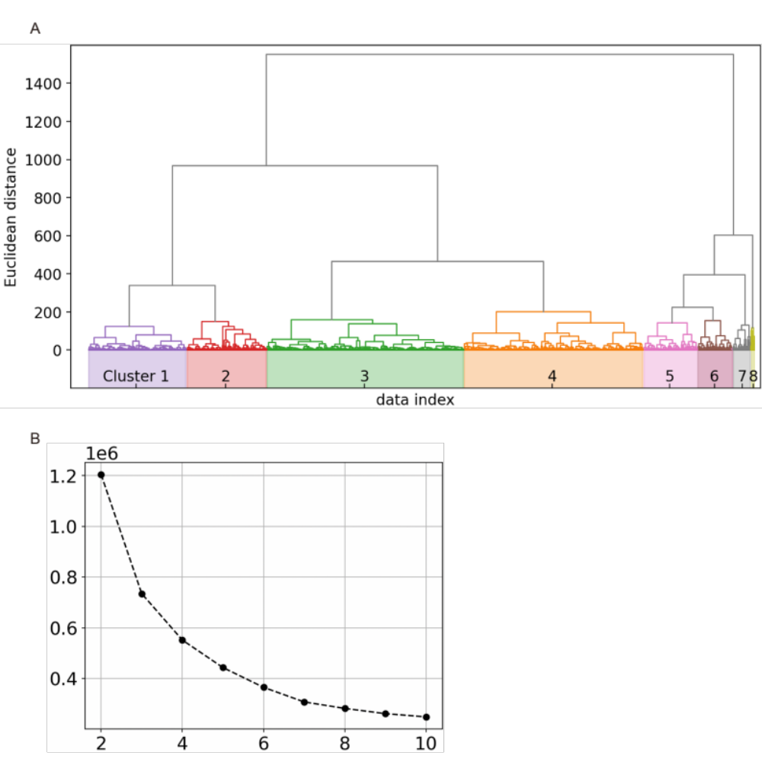
A. Hierarchical clustering dendrogram.

B. Distortion for the elbow method.

Additional Fig 2. Patient flowchart.
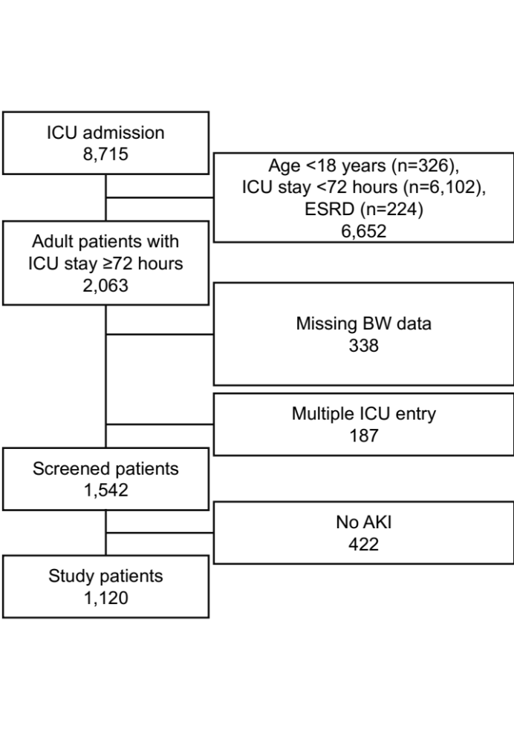
AKI, acute kidney injury; BW, body weight; ESRD, end-stage renal disease; ICU, intensive care unit

