Extended Data
Extended Table 1. Characteristics of Patients that were Evaluable for Survival
 | All  N = 57 | Tcm (Arms 1-4)  N = 37 | Tn/mem (Arm 5)  N = 20
Age (years) median (min, max) | 49 (16*, 71) | 56 (16,71) | 48 (24,64)
Gender No. (%)
Female | 21 | 11 | 10
Male | 36 | 26 | 10
Histology (at surgery) No. (%)
Gr 4 GBM IDH wildtype | 41 (72) | 27 (73) | 14 (70)
Gr 4 Diffuse midline glioma, H3 K27-altered | 2 (4) | 2 (5) | 0 (0)
Gr 4 Astrocytoma, IDH mutated | 6 (11) | 4 (11) | 2 (10)
Gr 4 Diffuse astrocytoma NOS | 1 (2) | 1(3) | 0 (0)
Gr 3 Glioma^ | 7 (12) | 3 (8) | 4 (20)
Astrocytoma, IDH mutated | 2 | 1 | 1
Ependymoma | 2 | 1 | 1
Oligodendroglioma | 3 | 1 | 2
MGMTMGMT No. (%)
Methylated | 21 (37) | 12 (32) | 9 (45)
Unmethylated | 30 (53) | 20 (54) | 10 (50)
Unknown or not tested | 6 (11) | 5 (14) | 1 (5)
IL13Rα2 H-Score median (min, max)
At screening | 150 (50, 230) | 160 (50, 230) | 132.5 (80, 210)
At surgery** | 90 (10, 270) | 100 (10, 230) | 55 (10, 270)
CD3 (at surgery) median (min, max) | 2 (1, 4) | 2 (1, 4) | 2 (1, 4)
Multifocal No. (%) | 17 (30) | 11 (30) | 6 (30)
Resection No. (%) | 49 (86) | 32 (86) | 17 (85)
Tumor Volume mm³ mean (S.D.)
Pre-Surgery | 23352 (20964) | 28400 (23558) | 14013 (10117)
Pre-CAR T cells | 15385 (15244) | 17830 (16156) | 10863 (12537)
Prior Bevacizumab No. (%) | 18 (32) | 15 (41) | 3 (15)
KPS (pre-CAR T cells) median (min, max) | 80 (60, 100) | 80 (60, 100) | 90 (80, 100)
EROTC QLQ-C30 Score (pre-surgery) median (min, max) | 80 (45, 100) | 80 (54, 100) | 79 (45, 96)
Recurrence No. (%)
1st | 14 (25) | 9 (24) | 5 (25)
2nd | 23 (40) | 14 (38) | 9 (45)
3rd or more | 20 (35) | 14 (38) | 6 (30)
* only one participant, 16 year old UPN228, was < 18 years of age.
^ For grade 3 disease, UPN181 and UPN277 had ependymoma, UPN180, UPN265 and UPN210 had oligodenroglioma, and UPN223 and UPN226 had astrocytoma, IDH mutated.
** The only exception being UPN156: IL13Rα2 H-Score at enrollment (100) was used since that at surgery was not available.

Extended Table 2. Breakdown of Variables by CD3 Level
Variable | 1,2 (n = 43) | 3,4 (n = 14)
Median Age (min, max) | 49.1 (16.4,70.7) | 51.3 (32.4, 64.7)
Gender - F:M | 16:27 | 5:9
Grade - 3:4 | 6:37 | 1:13
IDH Mutant - Y:N:ND | 8:32:3 | 3:11:0
Methylated MGMT - Y:N:ND | 16:21:6 | 5:9:0
Median IL13Rα2 H-Score (min, max) | 90 (10, 270) | 105 (20, 230)
Median KPS (min, max) | 90 (60, 100) | 90 (70, 90)
Median Survival (min, max) | 6.5 (2.2, 44.7) | 11.2 (6.0, 43.2)
Dead:Alive | 38:5 | 13:1
Product – Tcm:Tn/mem | 32:11 | 5:9

Extended Fig. 1. Effect of ICV delivered CAR T cells on large intraparenchymal tumor, survival of evaluable patients with rHGG and grade 4 rHGG, and change in EROTC QLQ-C30 summary scores over time. a, MRI images of UPN 145 under Arm 3 before (PRE, left panels) and after (POST, right panels) three ICV infusions of CAR T cells at DS1 show that while the leptomenigeal lesions resolved (yellow arrows, bottom panels) the parenchymal tumor progressed (yellow circles, top panels). b, c, Overall survival of all evaluable patients with rHGG (b) or grade 4 HGG (c) from date of surgery. Thin lines denote 95% confidence intervals. d, e, Survival comparison of all evaluable patients with rHGG (c) or grade 4 HGG (d) that were infused with either Tcm- or Tn/mem-derived cell products. Red dots indicate censored participants (i.e., lost to follow-up but hadn’t passed away). P-values for survival comparisons were determined using the Log-rank test. f, EROTC QLQ-C30 Summary scores are on a scale of 0-100 (the higher the score the better) and based on a patient-reported multidimensional health related QOL questionnaire, composed of 13 items - five functional scales (physical, role, emotional, cognitive, and social), three symptom scales (Fatigue, nausea and vomiting, pain) and five additional single items (dyspnea, insomnia, appetite loss, constipation, diarrhea). Slopes (change in scores per day) from pre-surgery to ~ day 38 (encompassing the three infusions and DLT period) for all evaluable participants (left) or evaluable participants with rGBM (right) are shown as box and whisker plots. The median and interquartile range with whiskers extending to the last point within 1.5 times the interquartile range are depicted for Arms 1-4 vs. Arm 5. The means are indicated as blue filled circles. Note the pre-cycle 1 score was used as baseline for four participants who did not have pre-surgery scores, and for 3 participants, 1 question for the timepoint was imputed with cycle 1 results. P-values were calculated using the two-sample t-test.
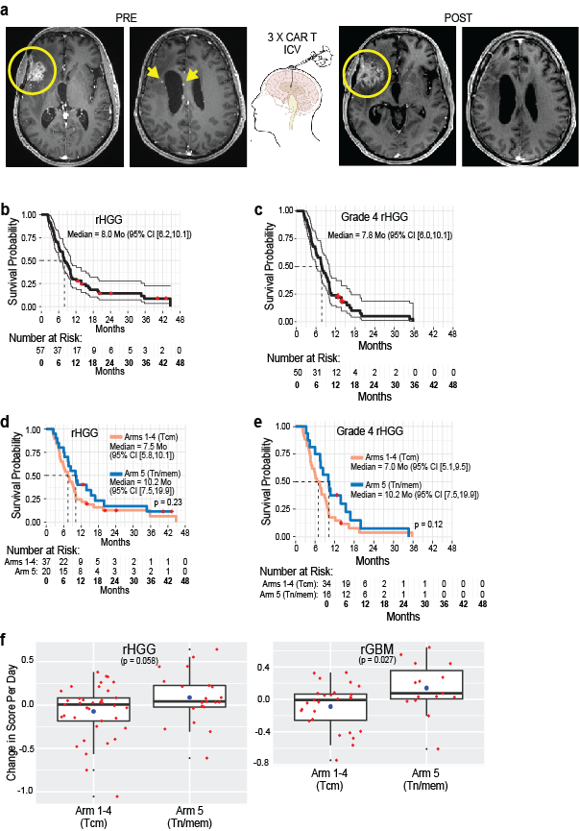

Extended Fig. 2. Further phenotype of Tcm- and Tn/mem-derived CAR T cell products. Expression of CD57, LAG-3, PD-1 and co-expression of LAG-3 and PD-1 on Tcm- and Tn/mem-derived final CAR T cell products as determined by flow cytometry, with means (±S.E.) indicated by black bars. ****, P < 0.0001; ***, P ≤ 0.0003 using an unpaired Student’s t-test. Due to limited cell product availability, only 46 products (32 Tcm, 14 Tn/mem) were assayed.

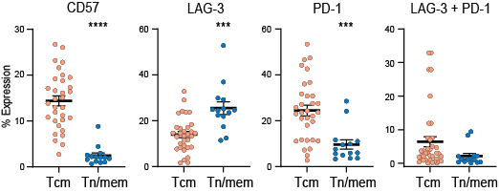

Extended Fig. 3. Preclinical evaluation of Tcm- vs. Tn/mem-derived CAR T cells. a, Schema of manufacturing processes. b, Flow cytometric phenotype of healthy donor Tcm- and Tn/mem-derived CAR T cell products. c, NSG mice were engrafted with Raji tumor cells (0.5x10⁶), treated with intravenous (IV) delivery of 1 million (M) CD19-targeting CAR+ T cells 3 days later, and then followed for survival. P = 0.0002 when comparing those treated with Tcm- vs. Tn/mem-derived CAR T cells using the log rank (Mantel-Cox) test. d, NSG mice were intracranially (IC) engrafted with human primary brain tumor (PBT) cells (0.1x10⁶), treated with intratumoral (ICT) delivery of 0.1 M mock-transduced (Mock) or IL13Rα2-targeting CAR+ T cells, and then followed for survival. P = 0.15 when comparing those treated with Tcm- vs. Tn/mem-derived CAR T cells using the log rank (Mantel-Cox) test.
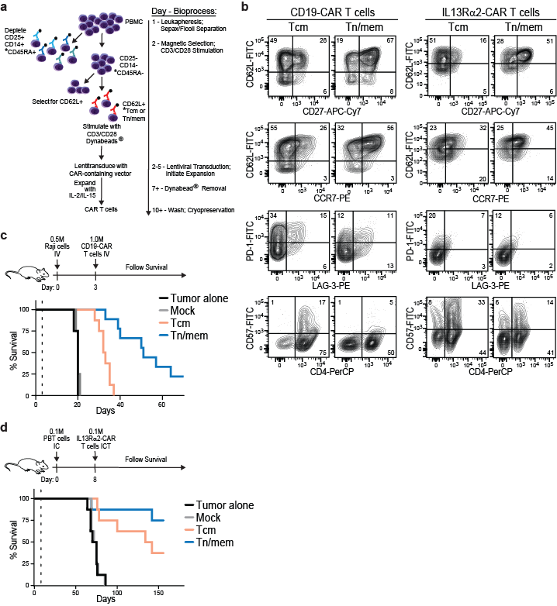
Extended Fig. 4. scRNA sequencing analyses. a, Heat map and unsupervised clustering of gene expression in the infusion products of 62 enrolled patients. Log2-normalized, scaled and quantile-normalized expression of 247 RNA features (rows) – including 89 canonical T cell markers, markers that maximally separate the 12 clusters, and markers differentiating Tn/mem- and Tcm-derived CAR T cell products – across a random subset of 30,000 CAR T product cells (columns). Cluster, batch, patient outcome, cell cycle phase, the percentage of reads mapping to mitochondrial (MT) genes, as well as memory-like and dysfunctional gene signature scores are indicated at the top. 42 canonical T cell markers included in the gene signature analysis are labeled at right. Rows are clustered at left based on Euclidean distances with k=10. b, Percentage proportions of Tcm- vs. Tn/mem-derived CAR T cells in each of the 12 clusters identified by scRNA sequencing. Wilcox-test p-values when comparing Tcm- and Tn/mem-derived products in each cluster (C0-C11) are indicated.
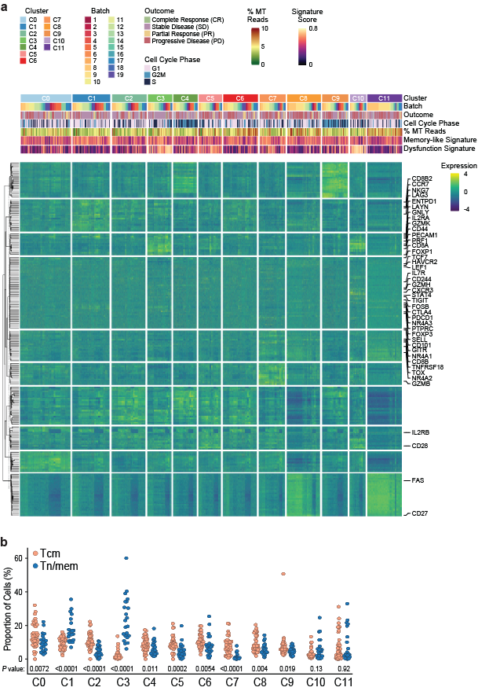
Extended Fig. 5. Summary of samples available for analyses and comparison of detected CAR T cell levels in patients vs. product phenotype. a, Graphs depicting cerebrospinal fluid (CSF; middle), tumor fluid (TF; bottom) and serum (SER; top) samples available for evaluation and broken down by infusion cycle and patient on each treatment arm. Blocks are shaded dark if both pre-treatment (day 0) and post-treatment (day 1 or 2) samples were available at any given cycle. Blocks were shaded lighter if there is either a pre-treatment or post-treatment sample (not both). For some patients, the TF catheter communicated with the CSF, which enabled TF to be collected during later treatment cycles. b, c, Percentages of the indicated surface marker expression of each CAR T cell product were plotted relative to levels of detected CAR T cells in either a, the CSF (area under the curve measurements over cycles 1-3, reference Fig. 3 b,c), or b, the blood (maximum copy numbers of WPRE per µg of DNA observed over the first six cycles, reference Fig. 3 d,e). Tcm- and Tn/mem-derived CAR T cell products are depicted as peach and blue dots, respectively. Regression lines for all products, with significant p-values for each regression (via t-test), are also depicted in each plot.
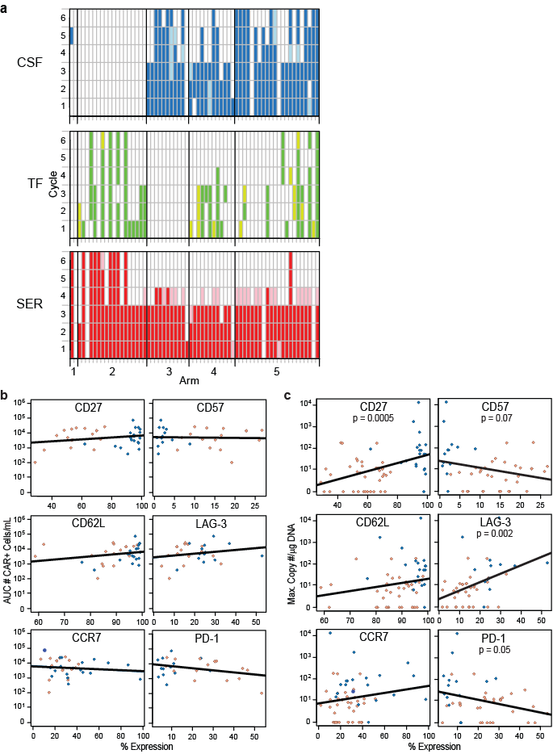

Extended Fig. 6. Cytokine profiles after IL13Rα2-CAR T cell therapy. a, CXCL10 levels depicted as density plots prior to CAR T cell infusion (C1D0) and one, two- or seven-days post-infusion (D1, D2, D7) of cycles 1-6 in either the CSF (left), TF (middle) or Serum (right). b, The same plot as in Fig. 4a has been colored to highlight where different dose schedules (DS) fall in the 2-dimensional projection generated by random forests and MDS plots. c, Box and whisker plots depicting the fold changes from patients’ baseline to the corresponding CxD1 in each of the indicated individual IFNg pathway cytokines within the CSF for patients treated on either arm 3, 4 or 5, for each of the first three cycles. By ANOVA: ***, p ≤ 0.00002; **, p ≤ 0.0003; and *, p ≤ 0.03 compared to each of the other arms in that graph; and ^^, p ≤ 0.0002; and ^, p ≤ 0.02 compared to each of the other cycles in that graph. d, Box and whisker plots depicting CSF IFNγ pathway score at C1D1 (Log10(IFNγ) + Log10(CXCL9) + Log10(CXCL10)) in all evaluable (left) or grade 4 (right) patients who exhibited either PD, SD, PR or CR upon CAR T cell treatment. P values determined by t-test. e, CSF IFNγ pathway score in all evaluable (left) or grade 4 (right) patients was plotted against time to progression in days, and the regression lines for all arms, with p-value (via t-test), is depicted in each plot. Arm 3 and 4 vs. Arm 5 patients are depicted as peach vs. blue dots, respectively, with dose schedule (DS) indicated by dot size (d,e).

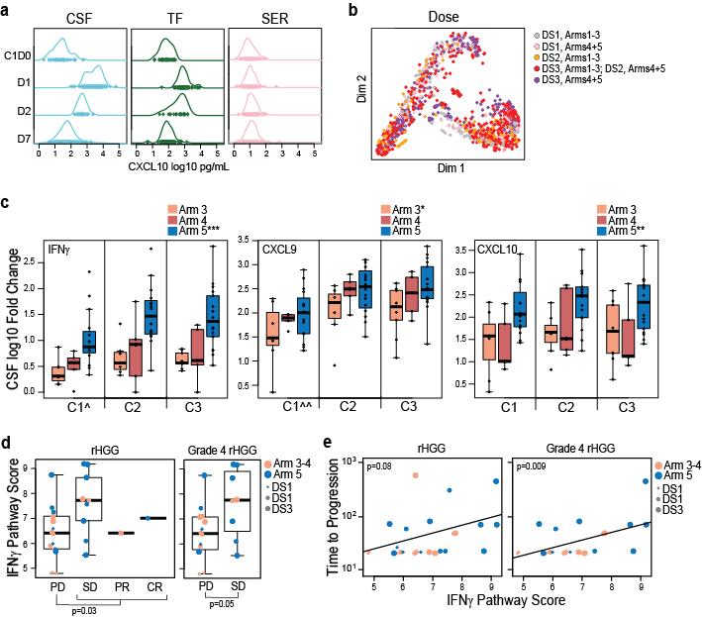

Extended Fig. 7. CD3 staining of patients’ tumors. Representative CD3 IHC staining patterns of tumors at time of surgery, from each patient that is evaluable for survival, and divided into those that were qualitatively scored as high (a), intermediate (b) or negative/low (c). UPN numbers are provided for each image, and bars in first image of each panel indicate 50 µm. Qualitative scoring for CD3 was as follows: tumors with few detectable T cells were given a CD3 IHC score of 1; those with scattered CD3+ cells throughout (e.g., UPN224), with possible occasional perivascular aggregates or hot spots (e.g., UPN181) were given a score of 2; those with many CD3+ cells throughout and dense hot spots were given a score of 3 (b); and those with many dense CD3+ cell infiltrates were given a score of 4 (a).
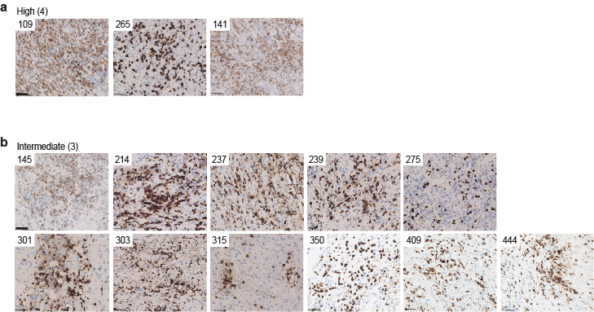
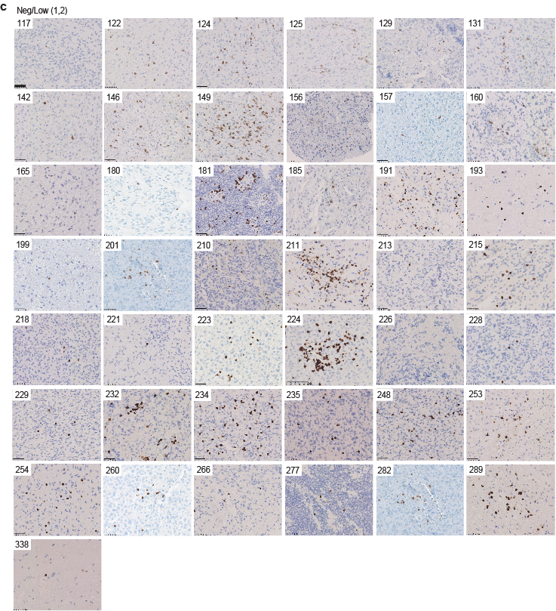

Extended Fig. 8. Further CD3 Staining of UPN109. Representative IHC staining patterns of UPN109 tumors at time of surgery (top; CD3 high) and at first recurrence after IL13Rα2-CAR T cell therapy (bottom; CD3 low). Red boxes indicate locations of images with 100 um reference bars; green circles indicate locations of images with 50 um reference bars. CD3 staining depicted in brown. 4-Plex staining shows CD4 staining in teal; CD8 staining in red/magenta; CD66b staining in purple (granulocytes); and CD68 staining in yellow (macrophages/monocytes/microglia).

