Appendix 1
Full model description of generalized linear model (GLM) with beta distribution and the results of the optimal model.
GLM with beta distribution:
$$Y_{ijk}\sim beta\left(μ_{ijk},ϕ\right)$$
$$logit\left(μ_{ijk}\right)=α_{0}+β_{0}×{Distance}_{ij}+{β_{l}×Pond_Combination}_{k}+{β_{m}×{Distance}_{ij}×Pond_Combination}_{k}+ε_{ijk}$$
where $ε_{ijk}\sim N(0,σ^{2})$
$$i=1,2, …,26$$
$$j=i+1, j<26$$
The term Y_{ijk} means the observation of community dissimilarities between pond i and pond j in in the pond scenario between ponds k. The pond combination contains three categories, i.e. “both fishless”, “one fishless and one with fish”, “both with fish”. The expectation of Y_{ijk} depends on π_{ijk}, while ϕ is the shape parameter. The term µ_{ijk} is modelled in terms of Euclidean distance between ponds (${Distance}_{ij}$) and the fish pond between ponds$({Pond_Combination}_{k}$). The terms α₀ is the intercept, while β₀ is the parameter of distance between ponds. The term β_{l} means the regression parameters for ${Pond_Combination}_{k}$, while the term β_{m} means the regression parameters for the interaction between ${Distance}_{ij}$ and ${Pond_Combination}_{k}$. The terms ε_{ijk} is the unexplainable variable assumed normally distributed with expectation 0 and variance σ².

The optimal model does not include the interaction between ${Distance}_{ij}$ and ${Pond_Combination}_{k}$. Here we show the results when the pond combination “both fishless” set as the reference level. SE means standard error.
 | Estimate | SE | Z-value | p-value
Intercept | 0.94 | 0.08 | 12.54 | <0.001
Distance | 0.24 | 0.05 | 4.66 | <0.001
Fishless + Fish | 0.48 | 0.10 | 4.81 | <0.001
Fish + Fish | 0.57 | 0.16 | 3.55 | <0.001

Appendix 2
Matrix of dytiscid species and ponds. The dark grey squares mean the species occurred in a pond at least 2 out of 3 sampling years, the light grey squares represent the species occurred in a pond only 1 out of 3 sampling years. The fish symbols represent ponds with fish.
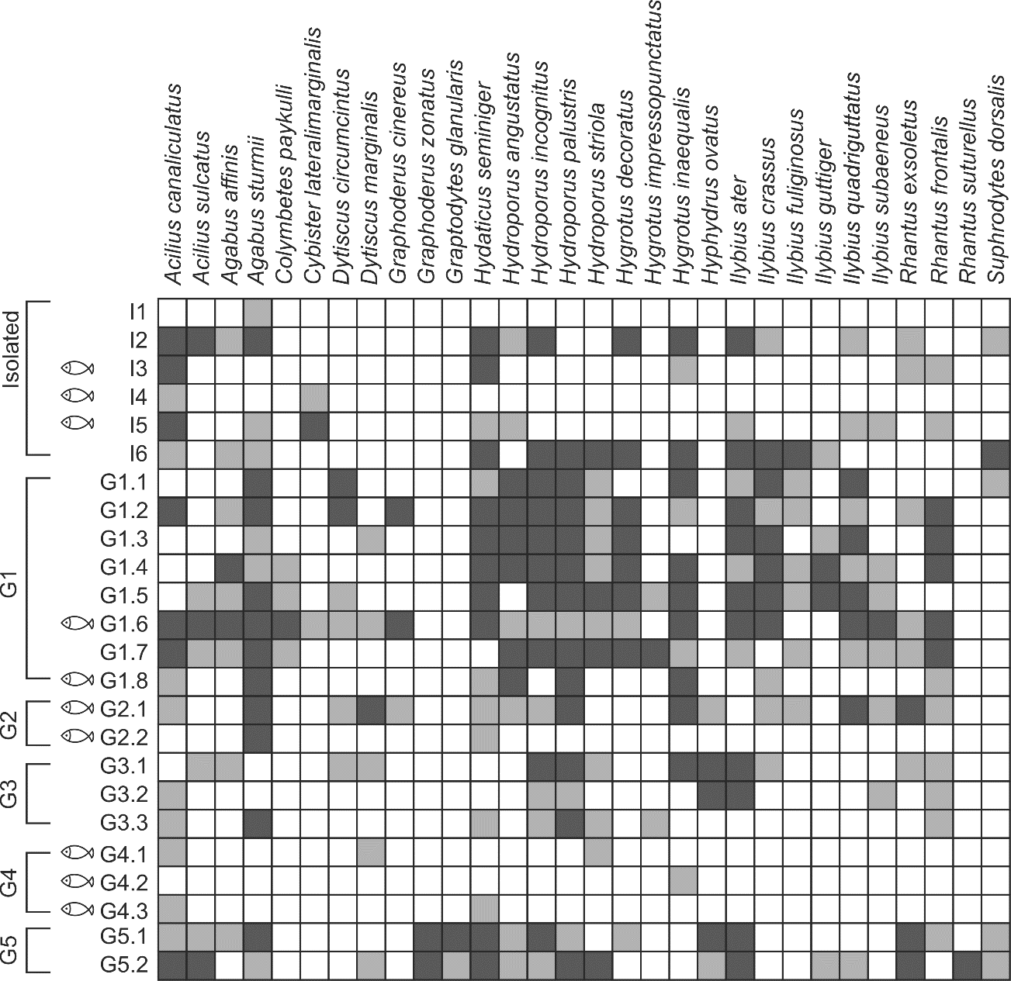

Appendix 3
Matrix of dytiscid species and ponds. The light grey squares represent the species occurred in a pond 1 out of 3 sampling years. The fish symbols represent ponds with fish.
