Supplementary Information
Erin Thorpe, MS¹; Taylor Williams, BS²; Chad Shaw, PhD^{2,3,4}; Evgenii Chekalin, PhD¹; Julia Ortega, PA, MHS^{1,5}; Keisha Robinson, MPM, MBA¹; Jason Button, MS¹; Marilyn C. Jones, MD^{6,7}; Miguel del Campo, MD^{6,7}; Donald Basel, MD⁸; Julie McCarrier, MS⁸; Laura Davis Keppen, MD⁹; Erin Royer, MS¹⁰; Romina Foster-Bonds, MPH¹¹; Milagros M. Duenas-Roque, MD¹²; Nora Urraca, MD, PhD¹³; Kerri Bosfield, MBBS¹³; Chester W. Brown, MD, PhD¹³; Holly Lydigsen, DNP, CPNP-PC¹³; Henry J. Mroczkowski, MD, PhD¹³; Jewell Ward, MD, PhD¹³; Fabio Sirchia, MD^{14,15}; Elisa Giorgio, PhD^{14,16}; Keith Vaux, MD¹⁷; Hildegard Peña Salguero, MD¹⁸; Aimé Lumaka Zola, MD^{19,20}; Gerrye Mubungu, MD¹⁹, PhD; Prince Makay, MD¹⁹ ; Mamy Ngole, MD¹⁹; Prosper Lukusa, MD, PhD¹⁹; Adeline Vanderver, MD^{21,22};Kayla Muirhead, MS²¹, Omar Sherbini, MPH²¹; Melissa D. Lah, MD²³; Katelynn Anderson, MS²³; Jeny Bazalar Montoya, MD²⁴; Richard S. Rodriguez, MD²⁴; Mario Cornejo Olivas, MD^{25,26}; Karina Milla-Neyra, BS²⁵; Marwan Shinawi, MD^{27,28}; Pilar Magoulas, MS²⁹; Duncan Henry, MD³⁰; Kate Gibson, MD³¹; Samuel Wiafe, MPhil³²; Parul Jayakar, MD³³; Daria Salyakina, PhD ³³; Diane Masser-Frye, MS ^{6,34}; Arturo Serize, MPH, PA-C³⁵; Jorge E. Perez, MD³⁵; Alan Taylor, MS³⁶; Shruti Shenbagam, MS³⁶; Ahmad Abou Tayoun, PhD^{36,37}; Alka Malhotra, PhD¹; Maren Bennett, MFS¹; Vani Rajan, MS; James Avecilla, BS¹; Andrew Warren, MD¹; Max Arseneault, MS¹; Tasha Kalista, MA¹, Ali Crawford, PhD¹; Subramanian S. Ajay, PhD¹; Denise. L. Perry, MS¹; John Belmont, MD²; Ryan J. Taft, PhD¹*

Affiliations
- Illumina Inc, San Diego, California
- Genetic and Genomic Services PBC, Houston, Texas
- Department of Molecular and Human Genetics, Baylor College of Medicine, Houston, Texas
- Department of Statistics, Rice University, Houston, Texas
- C2N Diagnostics, St. Louis, Missouri
- Rady Children’s Hospital, San Diego, California
- University of California San Diego, San Diego, California
- Children’s Wisconsin, Medical College of Wisconsin, Milwaukee, Wisconsin
- Sanford USD Medical Center, Sioux Falls, South Dakota
- Sanford Children’s Specialty Clinics at Sanford Health, USD Sanford School of Medicine, Sioux Falls, South Dakota
- Rare Genomics Institute, Los Angeles, California
- Instituto de Evaluación de Tecnologías en Salud e Investigación - IETSI, EsSalud, Lima, Peru
- University of Tennessee Health Science Center, Le Bonheur Children’s Hospital, Memphis, Tennessee
- Department of Molecular Medicine, University of Pavia, Pavia, Italy
- Medical Genetics Unit, IRCCS San Matteo Foundation, Pavia, Italy
- Medical Genetics Unit, IRCCS Mondino Foundation, Pavia, Italy
- Point Loma Pediatrics, San Diego, California
- Padrino Children's Foundation, Todos Santos, B.C.S., Mexico
- Centre de Genetique Humaine, Universite de Kinshasa, Democratic Republic of the Congo, Africa
- Center for Human Genetics, Centre Hospitalier Universitaire, Liège, Belgium
- Division of Neurology, Department of Pediatrics, Children's Hospital of Philadelphia, Philadelphia, Pennsylvania
- Department of Neurology, Perelman School of Medicine, University of Pennsylvania, Philadelphia, PA
- Indiana University School of Medicine, Indianapolis, Indiana
- Instituto Nacional de Salud del Niño-San Borja, Lima, Peru
- Neurogenetics Research Center, Instituto Nacional de Ciencias Neurologicas, Lima, Peru
- Carrera de Medicina Humana, Universidad Cientifica del Sur, Lima, Peru
- Washington University, St. Louis, Missouri
- St. Louis Children’s Hospital, St. Louis, Missouri
- Texas Children's Hospital, Houston, Texas
- UCSF Benioff Children’s Hospitals, San Francisco, California
- Canterbury District Health Board, Canterbury, New Zealand
- Rare Disease Ghana Initiative, Accra, Ghana
- Nicklaus Children's Health System, Miami, Florida
- San Diego-Imperial Counties Developmental Services, Inc.
- South Miami Hospital, South Miami, Florida
- Al Jalila Genomics Center of Excellence, Al Jalila Children’s Specialty Hospital, Dubai, United Arab Emirates
- Center for Genomic Discovery, Mohammed Bin Rashid University of Medicine and Health Sciences, Dubai, United Arab Emirates.

* To whom correspondence should be addressed rtaft@Illumina.com

Table of Contents
Supplemental Methods 4
Study Population 4
Clinical Genome Sequencing 4
Information content of HPO terms 7
HPO term de-duplication 7
Top-level terms 8
Ancestry Assessment 8
cGS Impact Survey 9
Outcomes 9
Diagnostic evaluation 9
Restricted definition of COM 10
Extended definition of COM 10
Statistical Analysis 10
Supplemental Figures 12
Supplementary Figure 1: iHope family member ancestry in relation to seven human superpopulations. 12
Supplementary Figure 2. iHope proband admixture analysis. 13
Supplementary Figure 3: Phenotypic information content 14
Supplementary Figure 4: Prior genetic testing 15
Supplementary Figure 5: Distribution of reported variant types. 16
Supplementary Figure 6: Distribution of reported Copy Number Variant (CNV) Sizes 17
Supplementary Figure 7: Directed acyclic graph representing the observational factors contributing to cGS diagnoses and associated impacts in HIC and LMIC. 18
Supplementary Figure 8: Genetic counseling and palliation management changes 19
Supplemental Tables 20
Supplementary Table 1: Cohort summary inclusive of diagnosis and cGS impact survey outcomes 20
Supplementary Table 2: cGS Impact Survey questions, versions and grouping 20
Supplementary Table 3: Relationship between test result category and diagnostic evaluation or change in management 21
Supplementary Table 4: Whole genome sequencing pipeline and test definitions 22
Supplementary Table 5: Pharmacogenomics screen description 23
Supplementary Information References 24

Supplemental Methods

Study Population
Participation in the iHope program was limited to individuals with signs or symptoms indicative of a monogenic disorder, consistent with current professional guidelines, and limited access to molecular testing.¹ In addition to site-mediated referrals, twenty-six individuals received cGS through individual clinician request and ordering. When families with multiple affected children were tested, siblings with identical test results were considered as a single patient for analyses so as not to artificially inflate diagnostic yield. For example, if a family-based analysis included two affected siblings and a shared, single diagnosis was identified, analyses considered this one diagnosis, not two. In 66 families, identical results were reported in affected siblings and therefore, these cases were considered as 66 results (not 132). Siblings with at least one unique reported variant between them were counted distinctly. For example, if a shared variant was reported in both siblings, but an additional variant(s) potentially associated with unique phenotype to one child was also reported only in one of those individuals, both siblings were included in the analysis as their results were not identical and they may have distinct or only partially shared disease etiologies. Parents were not considered in the diagnostic yield, DE or COM assessments.

Clinical Genome Sequencing
cGS was performed on DNA extracted from whole blood. A PCR-free library preparation protocol was utilized, and samples were sequenced with paired-end 150 base pair reads. The data were aligned according to build 37 of the Human Reference Genome (http://www. ncbi.nlm.nih.gov/projects/genome/assembly/grc/human) and sequenced to an average of ≥30- or ≥40-fold coverage depending on the sequencing instrument used for cGS testing. cGS pipelines used over time for variant calling are detailed in Supplementary Table 4.
Interpretation was performed for SNVs and indels that fall within 15 bp of a RefSeq exon boundary and size ranged from -7/+7 base pairs (bp) to -31/+35 bp depending on the time of testing. Copy number events greater than 10 kb were assessed, however sensitivity was only determined for events greater than 20 kb and was approximately 85%. CNV interpretation was limited to events that either overlapped an exon or had a boundary that was within 1 kb upstream or downstream of an exon. From July 2017 SNVs detected in the mitochondrial genome at an allele fraction greater than or equal to 3% were interpreted. From May 2018 forward, cases were assessed for the absence of the 'C' allele at GRCh37 Chr5:70247773 (NM_000344.3:c.840C>T) in the SMN1 gene. An absence of the c.840C allele is consistent with an absence of exon 7 of SMN1 and is reported as a positive result for Spinal Muscular Atrophy (SMA). Samples analyzed from November 2019 onward utilized Expansion Hunter (EH) to detect short tandem repeat (STR) expansions in the following genes: DMPK, CNBP, FXN, FMR1, HTT, JPH3, AR, ATXN1, ATXN2, ATXN3, CACNA1A, ATXN7, ATXN8OS, ATXN10, PPP2R2B, TBP, NOP56, ATN1, CSTB, TCF4, C9orf72. Only 'expanded' alleles were included on the clinical report - carrier status was not reported, and the specific repeat number was not reported. Orthogonal characterization of all clinically significant expanded STRs was facilitated through an external laboratory and results communicated in an addended report.
Variants of interest were identified using an in-house developed software system that considers population allele frequency, variant consequence, evolutionary conservation, occurrence in a gene with an established gene-disease relationship, occurrence in a gene whose disease association overlaps with the patient’s reported phenotype, and inheritance mode, as appropriate. A directed query of the Online Mendelian Inheritance In Man (OMIM) database was performed for each case using terms reflecting the proband’s phenotype as provided by the ordering clinician.² The resultant gene list was used to prioritize variants. Variant interpretation for SNVs and CNVs was performed according to the ACMG guidelines for variant classification.³
A clinical report was issued for the proband to include genomic findings of potential clinical significance related to the indication for testing. Clinical reporting practices were updated in September 2017 to include test result categories: “positive”, in which a likely pathogenic or pathogenic variant(s) is reported in a disease-associated gene(s) consistent with the clinical presentation and disease inheritance pattern; “see below”, referred in the manuscript text as “inconclusive”, in which variants of potential clinical significance are reported, inclusive of variants of unknown significance (VUS); and “negative”, in which no variants are reported for the individual. Reports issued prior to utilization of this framework were independently reviewed by three laboratory personnel (ET, AB, KB) and assigned a test result category for the purposes of data-analysis across the cohort. Coding discrepancies were reviewed and resolved by consensus.

Per laboratory policy, reanalysis was performed on cases with non-diagnostic test results when requested by the ordering clinician or when identified per routine laboratory practices (e.g. a variant reclassification occurred in another patient). Reanalysis was performed in 24 cases (HIC 16, LMIC 8) and the reanalyzed test result was utilized in the analysis. Reanalysis resulted in a change in the test result category in thirteen cases (9/16 HIC, 4/8 LMIC), while in eleven cases the test result category remained the same (7/16 HIC, 4/8 LMIC).
Ancillary reports for secondary findings and a pharmacogenomics screen were also provided for all individuals tested in a family, unless an individual opted-out of secondary findings. Results from the pharmacogenomics screen were not considered in this analysis. Results from the secondary findings report were not included in diagnostic yield assessment but were considered in DE and COM assessments due to the potential impact on clinical management.

Information content of HPO terms
The Human Phenotype Ontology directed acyclic graph (DAG) structure was obtained by download of the hp.obo file from the github repository: https//raw.githubusercontent.com/obophenotype/human-phenotype-ontology/master/hp.obo in November of 2022. To determine the information content of HPO terms, the gene-to-phenotype association data was obtained from the HPO website
(http://purl.obolibrary.org/obo/hp/hpoa/genes_to_phenotype.txt). The information content of each HPO term was determined by mapping each term to its ancestors using the ontologyIndex R-package. Gene-to-phenotype associations of descendant terms were propagated up the DAG to ancestor terms, and the total number of genes annotated at or below each DAG node was determined. In total, 2,364 genes were annotated to phenotypes in the genes-to-phenotype mapping file. The frequency of genes at or below each term was determined by dividing by this total number of genes. Then, -1 times the logarithm base 2 of this frequency was taken to be the information content of the term (IC). This logarithmic scaling assigns higher information content to rare terms whose phenotype is highly specific to individual genes, while assigning less information content to more ambiguous terms that are associated with many genes (i.e., intellectual disability or developmental delay).

HPO term de-duplication
After HPO terms were obtained for each case using PhenoTagger (please see main text) an algorithmic procedure was employed to remove terms whose ambiguated ancestors also appeared in the annotation of a case. This procedure reduced inflation of phenotypic content caused by errors in the natural language processing algorithm. The de-duplicated data retained the most specific terms for each case while removing more ambiguous terms in the DAG ancestry of these terms.

Top-level terms
The top-level HPO terms were taken to be all immediate descendants of the term Phenotypic Abnormality (HP:0000118). For each case, the unique top-level terms were identified where at least one descendant of each term was present in the low-level phenotypic assignments of each case. These top-level terms provide a simple summarization of the phenotypic character of each case.

Ancestry Assessment
Ancestry was assessed using variant call files (VCFs) generated by Strelka 2.7.1 or 2.9.2 or Starling 2.4.5 across all 2,786 genomes, inclusive of probands, parents and siblings.^{4,5} To ensure consistency of analysis, VCFs were parsed for quality, and naming conventions harmonized, using custom scripts and bcftools as described in Li et al. (2011), utilizing QUAL>40 and FMT/DP > 30 thresholds. Variants were annotated using dbsnp137 and merged by SNP ID.⁶ Quality control was performed using PLINK v1.90b6.26 using MAF>0.1, Hardy-Weinberg equilibrium equal to 0.01, genotyping rate 0.2, and LD window r² > 0.2, as described by Debortolili et al. (2021).^{7,8} This resulted in 131,431 SNPs with a genotyping rate of 1 across a reference set of 3,320 samples derived from the 1000 Genomes (27 populations), Human Genome Diversity (52 populations) and Simons Genome Diversity (15 populations) projects.^{9–11} SNP flips were removed, yielding 106,904 SNPs used for principal component analysis (PCA) and ancestry analysis using ADMIXTURE 1.3.0 with a supervised background of the 3,320 individuals from the reference cohort.¹² To simplify the presentation of the PCA analysis, populations across each project were grouped into 7 global superpopulations: African (n=744), American (n=398), East Asian (n=693). European (n=639), Middle East (153), Oceania (n=25) and Asian (n=668) ancestries.

cGS Impact Survey
Three survey versions were used over the course of the study. All versions included multiple choice questions and free-text responses. Harmonized coding of all survey responses was performed by a member of the study team (ET), and total responses available for analysis vary by question (Supplementary Table 2). Early survey versions were collected via paper survey and later data-entered into an electronic survey collection tool and are not included in the assessment of average survey response time. All statistical analyses utilized structured responses from multiple-choice questions. Free-text responses were used to provide additional details and identify patients with exceptional COM due to cGS intervention.

Outcomes

Diagnostic evaluation
Impact on diagnostic evaluation (DE) was defined as endorsement of any of the following response options to the cGS impact survey: confirmed a clinical diagnosis; confirmed a diagnosis within the differential diagnosis prior to testing; established/produced a new diagnosis that was not previously suspected; did not confirm or establish a diagnosis but did identify variants of potential interest in relation to the patient’s phenotype; produced an incidental diagnosis unrelated to the indication for testing; and/or ruled out a suspected diagnosis/diagnoses (Supplementary Table 2). The response options of confirmed a clinical diagnosis and confirmed a diagnosis within the differential diagnosis prior to testing were collapsed into a single response, confirmed a diagnosis, in Figure 3C of the primary text.

Restricted definition of COM
The restricted definition of COM included specialty referrals, imaging and testing, therapeutic interventions, and palliative care. Endorsement of the following cGS impact survey response options were considered referrals, imaging and testing: referral for specialty consultation; laboratory testing; imaging; and/or physiological testing. Endorsement of the following cGS impact survey response options were considered therapeutic COM: a medication, treatment or therapy specific to the diagnosis was recommended; nutritional or metabolic treatment; protein replacement therapy; disease specific medication; organ transplant; stem cell transplant; and/or gene therapy (Supplementary Table 2).

Extended definition of COM
The extended definition of COM also considered avoidance of additional testing and genetic counseling related topics, referred to here as genetic counseling although information was not necessarily conveyed by a certified genetic counselor. Endorsement of the following cGS impact survey response option was considered avoidance of additional testing: WGS eliminated the need for additional tests or evaluations. Endorsement of any of the following cGS impact survey response options were considered genetic counseling: counseling about patient prognosis; familial/recurrence risk estimates; counseling about reproductive screening and testing options; genetic screening or testing options for other family members; or clinical screening recommendations for other family members (Supplementary Table 2).

Statistical Analysis
To assess the impact of LMIC or HIC site designation on test result category a multinomial regression was performed. A negative test result served as the reference category, and a linear log-odds model was fit where LMIC or HIC site designation was included as a binary explanatory variable for the log-odds of positive and inconclusive test results, respectively. The multiplicative influence of LMIC compared to HIC on the odds ratio of positive and inconclusive test results was estimated by maximum likelihood. Confidence intervals (CI) were estimated by performing 10,000 bootstrap draws and computing the 0.025 and 0.975 quantile estimates. Permutation testing was employed to provide estimated p-values, and 10,000 samples were drawn where the LMIC or HIC site designation was randomly permuted with respect to test result category. Permutation samples determined a two-sided p-value by examining the quantile of the observed estimate from the true data compared to the permutation distribution. For the assessment of HIC or LMIC site designation on survey responses, a 95% central CI was calculated based on a 10,000-draw bootstrap analysis. To estimate p-values a permutation procedure was employed where the covariate status was randomized with respect to the outcome. The distribution of estimates under the permutation samples was used to determine the two-sided p-values. For the assessment of HIC or LMIC site designation on survey responses within each test result category, CIs were determined using a resampling procedure of 10,000 bootstrap samples to determine a 95% CI for each odds-ratio. A permutation procedure using 10,000 randomizations of the LMIC or HIC site designation of each survey outcome was used to generate the null distribution of the odds ratio and to estimate a two-sided p-value.

Supplemental Figures

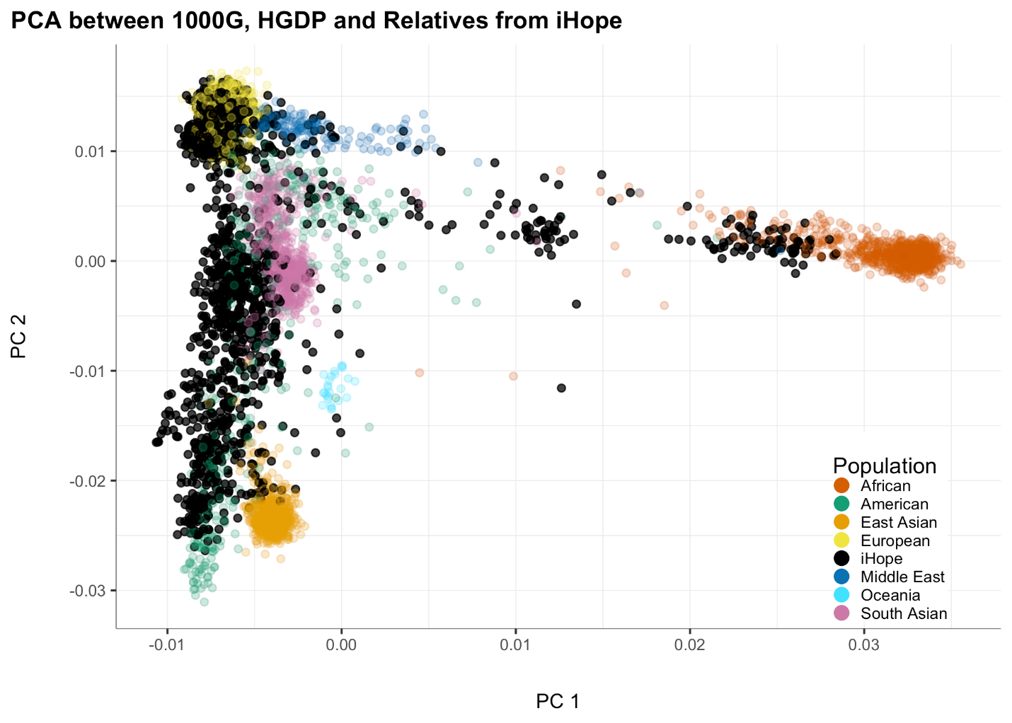

Supplementary Figure 1: iHope family member ancestry in relation to seven human superpopulations.
Principal component analysis of iHope family members (black) overlayed on seven human superpopulations derived from the 1000 Genomes, Human Genome Diversity and Simons Genome Diversity datasets. iHope families show representation across all seven superpopulations, including generally under-represented populations in genetic investigations including African and South Asian.

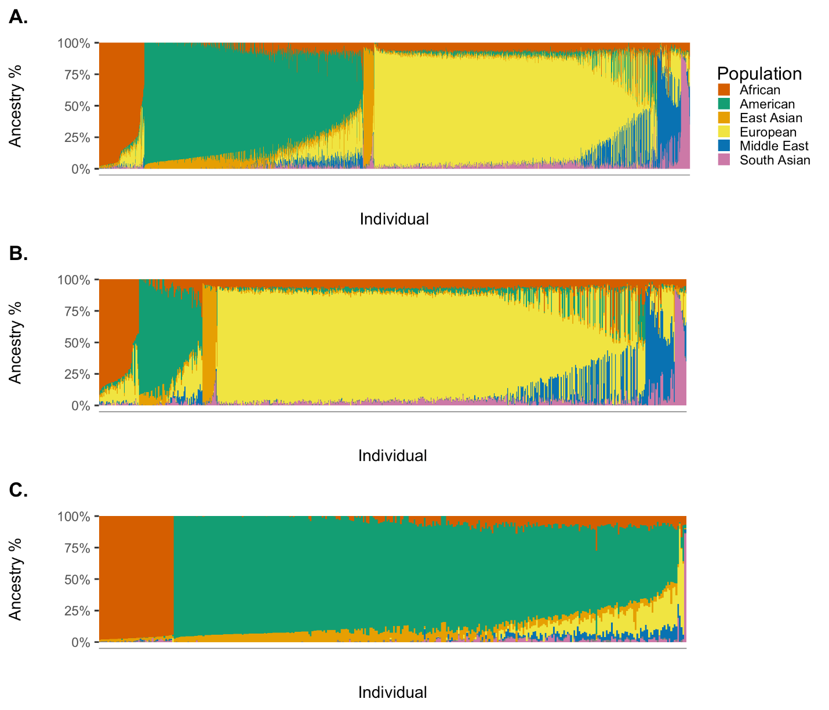

Supplementary Figure 2. iHope proband admixture analysis.
Admixture analysis of iHope cohort probands against a supervised background of 3,320 samples from the 1000 Genomes, Human Genome Diversity and Simons Genome Diversity datasets (see eMethods in the Supplement for additional details) grouped into seven superpopulations. (A) Admixture analysis of all iHope cohort probands, (B) HIC probands or (C) LMIC probands. Note a higher proportion of patients with computed American ancestry amongst LMIC patients, consistent with a high proportion of participation from two sites in northern Mexico and two sites in Peru.

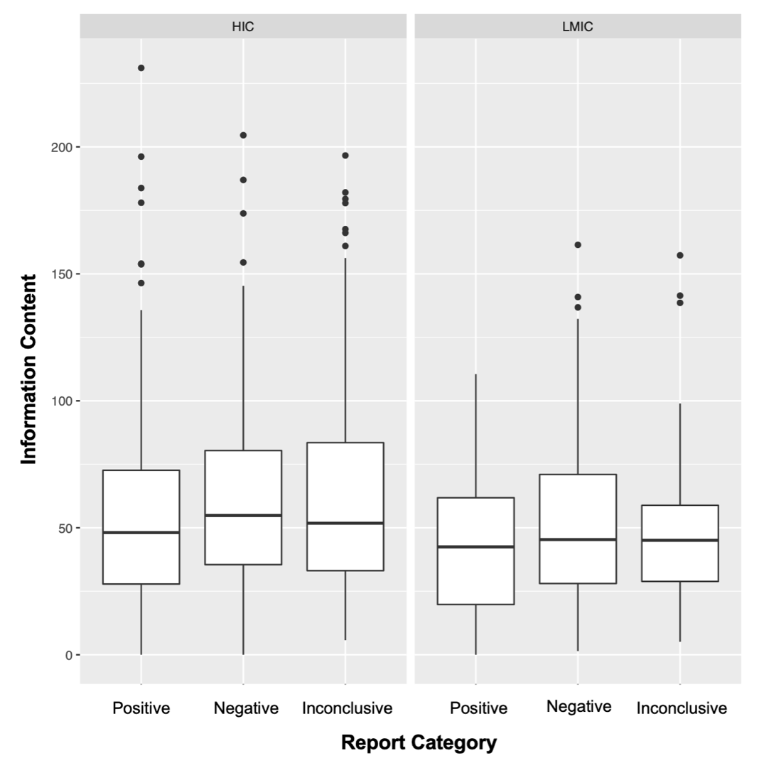

Supplementary Figure 3: Phenotypic information content
Boxplot of phenotypic information content (IC) for iHope cohort probands stratified by report category and HIC or LMIC site designation. There is no statistical difference in HPO IC between patients with negative, positive and inconclusive test results drawn from either LMIC or HIC sites; however, we observe slightly higher IC in patients from HIC sites overall. This increase in IC does not correlate with an increased likelihood of a positive test results.

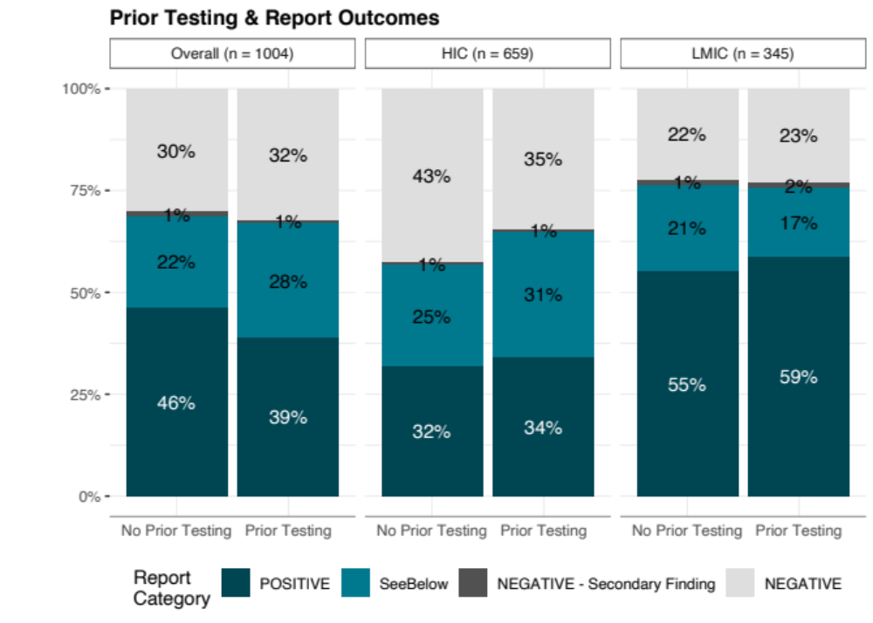

Supplementary Figure 4: Prior genetic testing
The proportion of iHope cohort probands with any form of genetic testing prior to cGS stratified by test result category and HIC or LMIC designation. There is no observed difference in the likelihood of a positive test result based on prior testing in either HIC or LMIC patients.

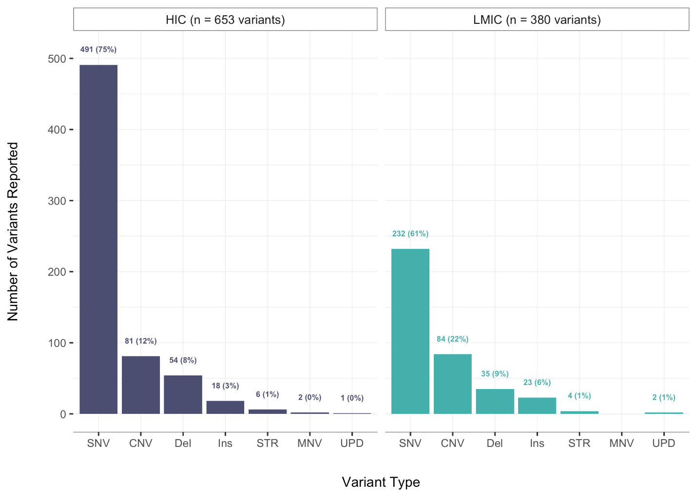

Supplementary Figure 5: Distribution of reported variant types.
Summary distribution of variant types reported across the iHope cohort and stratified by HIC or LMIC site designation. All classes of variants contributed to diagnoses, inclusive of STRs associated with repeat expansion disorders and cases of uniparental disomy associated with imprinting disorders. Note the higher proportion, and absolute number, of CNVs in the LMIC population, which may be reflective of the reduced availability microarray and karyotype testing and the use of cGS as a first-line test. SNV – single nucleotide variant; CNV – copy number variant; Del – deletion; Ins – insertion; STR – short tandem repeat variant; MNV – multi-nucleotide variant; UPD – uniparental disomy.

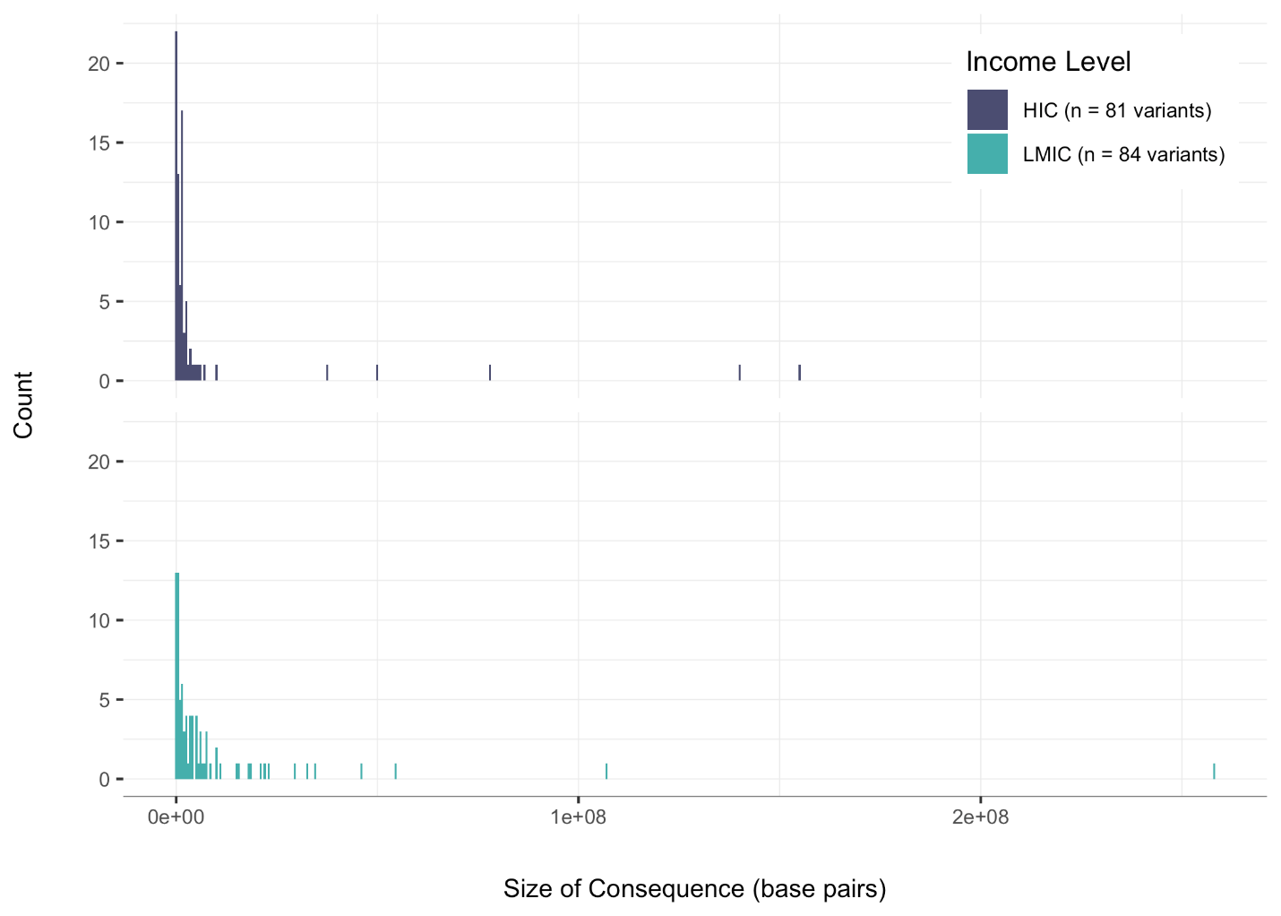

Supplementary Figure 6: Distribution of reported Copy Number Variant (CNV) Sizes
Distribution of reported CNV sizes in iHope cohort probands from high-income country (HIC) sites (top panel, dark blue) and low- and middle-income country (LMIC) sites (lower panel, light blue). Note the skewed right distribution in LMIC, suggestive of an increased number of patients with large CNVs and/or aneuploidies which may have been detected by microarray or karyotype testing if available.

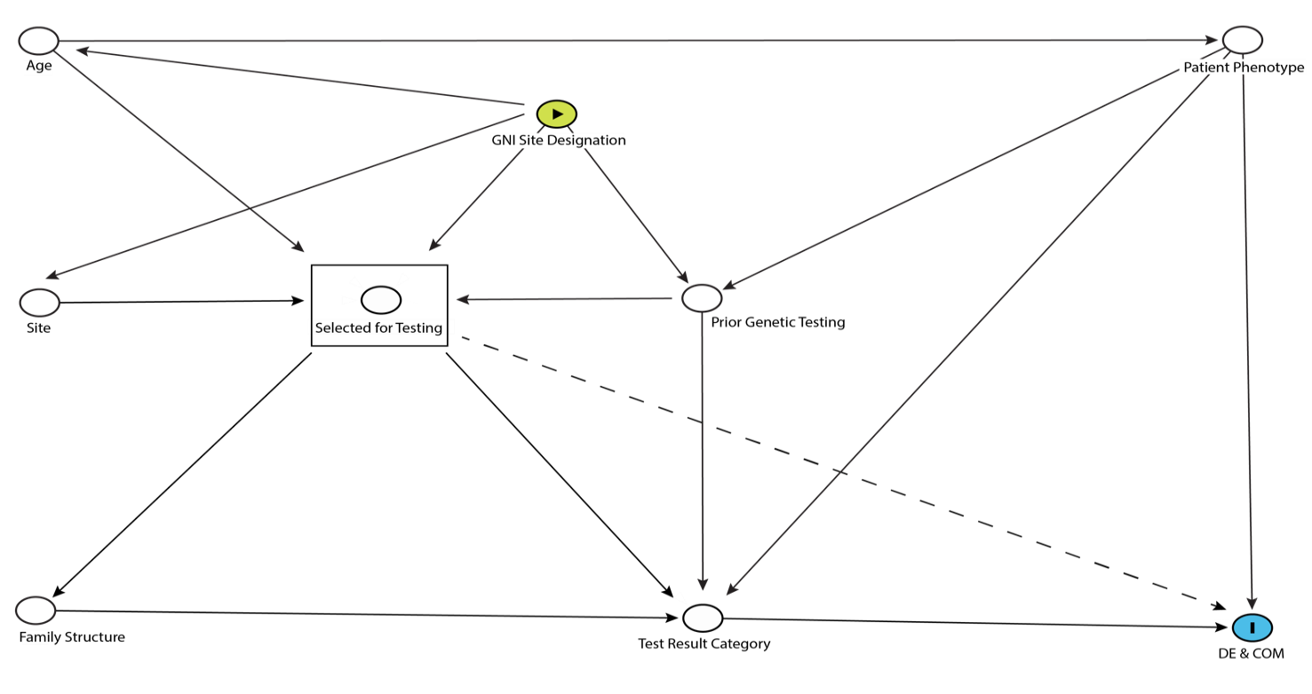

Supplementary Figure 7: Directed acyclic graph representing the observational factors contributing to cGS diagnoses and associated impacts in HIC and LMIC.
Observational factors linking cGS to diagnostic yield (test result category), diagnostic evaluation and change of management were modeled using the directed acyclic graph (DAG) are shown here. The DAG was constructed in a series of consensus development meetings between laboratory and clinical subject matter experts. The meetings were led by the biostatistician (CS) using both prepared and real-time modeling of the likely relationships between each of the factors. Multiple factors were considered with the resulting model, including patient age, their prior genetic testing, indications for testing (i.e. phenotype) and the availability of parental samples for testing (family structure). The dotted line indicates the influence of patient ascertainment on diagnostic evaluation (DE) and change of management (COM) given the observational design of the study, the impact of which was controlled for by stratifying LMIC and HIC comparisons by test result category as the DAG indicates that any potential influence of LMIC or HIC site designation on DE and COM is mediated by test result category (see Results and Discussion).

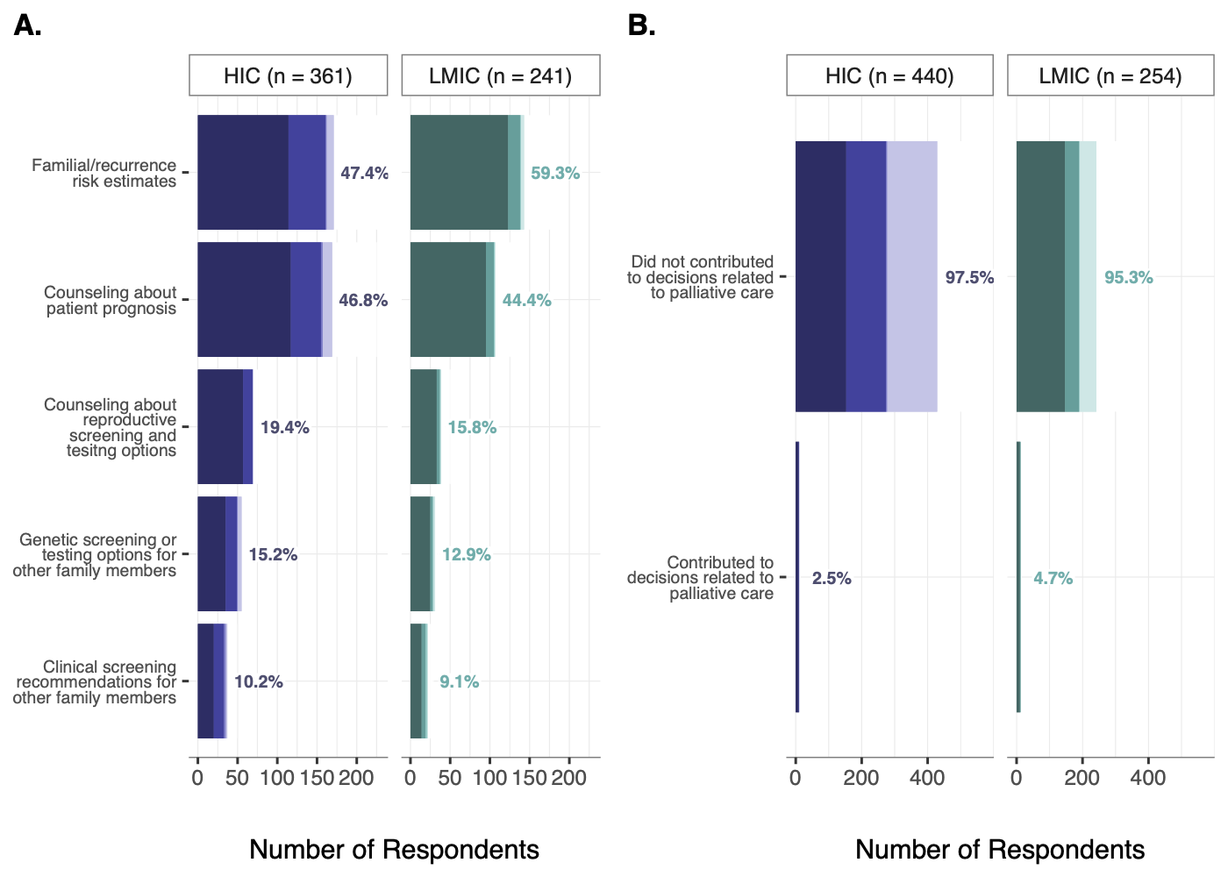

Supplementary Figure 8: Genetic counseling and palliation management changes
(A) Proportion of patients with available cGS impact survey data relevant to changes in management associated with genetic counseling (by any clinician) in HIC (left) and LMIC (right) sites. Patterns of COM are consistent between HIC and LMIC with familial/recurrence testing most common and screening recommendations for other family members least common. (B) Proportion of patients that have cGS findings that contributed to decisions about palliative care. Note a larger, but statistically insignificant, fraction of patients from LMIC sites with palliation COM as a result of cGS results.

Supplemental Tables

Supplementary Table 1: Cohort summary inclusive of diagnosis and cGS impact survey outcomes
(See attached supplementary Excel file)

Supplementary Table 2: cGS Impact Survey questions, versions and grouping
(See attached supplementary Excel file)

Supplementary Table 3: Relationship between test result category and diagnostic evaluation or change in management
 |  | Proportion HIC Patients |  |  | Proportion LMIC Patients |  | OR |  | CI lower bound |  | CI upper bound |  | P-value
Impact to diagnostic evaluation
 | All results |  | 0.706024 |  |  | 0.873518 |  | 2.17 |  | 1.347756 |  | 3.623608 |  | 1.00E-04
 | Positive test result |  | 0.962025 |  |  | 0.993631 |  | 6.129052 |  | 1.073064 |  |  |  | 5.33E-02
 | Inconclusive test result |  | 0.764706 |  |  | 0.954546 |  | 6.409289 |  | 2.12367 |  |  |  | 1.00E-03
 | Negative test result |  | 0.362319 |  |  | 0.442308 |  | 1.393326 |  | 0.714747 |  | 2.706633 |  | 3.22E-01
Change to clinical diagnosis
 | All results |  | 0.393 |  |  | 0.602 |  | 1.382219 |  | 0.896361 |  | 2.122612 |  | 6.10E-02
 | Positive test result |  | 0.802467 |  |  | 0.77706 |  | 0.857987 |  | 0.487123 |  | 1.482452 |  | 5.00E-01
 | Inconclusive test result |  | 0.311485 |  |  | 0.52272 |  | 2.420873 |  | 1.191119 |  | 5.025431 |  | 1.03E-02
 | Negative test result |  | 0.032051 |  |  | 0.150944 |  | 5.368973 |  | 1.583341 |  | 27.53524 |  | 1.90E-03
Change of Management
(RIT, therapeutics, palliation, testing avoided, counseling)
 | All results |  | 0.640909 |  |  | 0.779528 |  | 1.216864 |  | 0.791827 |  | 1.881867 |  | 3.36E-01
 | Positive test result |  | 0.91358 |  |  | 0.949045 |  | 1.758747 |  | 0.724022 |  | 5.263464 |  | 1.81E-01
 | Inconclusive test result |  | 0.672131 |  |  | 0.681818 |  | 1.045026 |  | 0.510267 |  | 2.35117 |  | 8.55E-01
 | Negative test result |  | 0.333333 |  |  | 0.358491 |  | 1.117043 |  | 0.558487 |  | 2.119661 |  | 7.48E-01
High-income country (HIC); low- or low-middle or middle-income country (LMIC); odds ratio (OR); confidence interval (CI); referrals, imaging and testing (RIT)

Supplementary Table 4: Whole genome sequencing pipeline and test definitions
Date | Variant Types | Instrument  (Read length) | Pipeline | Annotator
May 2016 | SNVs/Indels (-7bp/+7bp size)  CNVs | HiSeqX (2x150) | NorthStar 4/ v6.0.1c | Nirvana v1.5.1.0
Nov 2016 | SNVs/Indels (-12bp/+28bp size)  CNVs | HiSeqX (2x150) | NorthStar 4/ v6.1.0c | Nirvana v1.5.1.0
May 2017 | SNVs/Indels (-12bp/+28bp size)  CNVs  *ACMG Secondary Findings Gene List updated from 56 to 59 genes | HiSeqX (2x150) | NorthStar 4/ v6.1.0c | Nirvana v1.5.1.0
July 2017 | SNVs/Indels (-27bp/+31bp size)  CNVs, MT SNVs | HiSeqX (2x150) | NorthStar 5/ v7.0.0c | Nirvana v1.5.1.0
Jan 2018 | SNVs/Indels (-27bp/+31bp size)  CNV, MT SNVs | HiSeqX (2x150) | NorthStar 5/ v7.2.0c | Nirvana v1.5.2.0
May 2018 | SNVs/Indels (-27bp/+31bp size)  CNVs, MT SNVs, SMA | HiSeqX (2x150) | NorthStar 5/ v7.2.0c | Nirvana v1.5.2.0
July 2019 | SNVs/Indels (-31bp/+31bp size)  CNVs, MT SNVs, SMA | HiSeqX (2x150) | NorthStar 7 / WGS v8.1.0c | Nirvana v2.0.8
Nov 2019 | SNVs/Indels (-31bp/+31bp size)  CNVs, MT SNVs, SMA, STRs | HiSeqX (2x150) | NorthStar 7 / WGS v8.2.0c | Nirvana v2.0.8
Aug 2020 | SNVs/Indels (-31bp/+31bp size)  CNVs, MT SNV, SMA, STRs | HiSeqX (2x150) | NorthStar 7 / WGS v8.4.0c | Nirvana v3.9.0
Mar 2021 | SNVs/Indels (-28bp/+35bp size)  CNVs, MT SNVs, SMA, STRs | NovaSeq (2x150) | NorthStar 7 / WGS v8.6.1c | Nirvana v3.9.0
Single nucleotide variants (SNVs), insertion and deletions (Indels), copy number variants (CNVs), mitochondrial genome (MT), spinal muscular atrophy (SMA), short tandem repeated (STRs), base pairs (bp)

Supplementary Table 5: Pharmacogenomics screen description
Clinical interpretation is provided for well-characterized, high impact pharmacogenomics results which encompass 14 drugs, 10 genes, and 33 loci.

Gene | Drug | Allele Name | dbSNP ID
CYP2C19 | Antidepressants (Tricyclic Antidepressants and Selective Serotonin Reuptake Inhibitors); Clopidogrel; Voriconazole | *1/*17 | rs12248560 (C>T) rs28399504 (A>G) rs41291556 (T>C) rs72552267 (G>A) rs4986893 (G>A) rs4244285 (G>A) rs72558186 (T>A) rs56337013 (C>T)
CYP2C9 | Warfarin | *1/*3 | rs1799853 (C>T) rs1057910 (A>C)
VKORC1 | Warfarin | AA | rs9923231 (C>T)
IFNL3 | Pegylated interferon-alpha and ribavirin combination therapy | CC | rs12979860 (C>T)
CFTR | Ivacaftor | *1/*1 | rs75527207 (G>A) rs267606723 (G>A) rs193922525 (G>A) rs80282562 (G>A) rs121909013 (G>A) rs74503330 (G>A) rs121909041 (T>C) rs121908755 (G>A) rs121908757 (A>C) rs121909005 (T>G)
TPMT | Azathioprine, mercaptopurine, thioguanine | *1/*1 | rs1142345 (T>C) rs1800584 (C>T) rs1800460 (C>T) rs1800462 (C>G)
DPYD | Fluoropyrimidines (5-fluorouracil, capecitabine or tegafur) | *1/*1 | rs3918290 (C>T) rs55886062 (A>C) rs67376798 (T>A)
SLCO1B1 | Simvastatin | *1/*1 | rs4149056 (T>C)
HCP5 | Abacavir | *1/*1 | rs2395029 (T>G)
POLG | Valproic Ac | *1/*1 | rs113994095 (C>T) rs113994097 (C>G)
F5 | Eltrombopag | *1/*1 | rs6025 (C >T)  *Included in test definition from 2016 to August 2018.

Supplementary Information References

1. Manickam K, McClain MR, Demmer LA, et al. Exome and genome sequencing for pediatric patients with congenital anomalies or intellectual disability: an evidence-based clinical guideline of the American College of Medical Genetics and Genomics (ACMG). Genet Med. 2021;23(11):2029-2037. doi:10.1038/s41436-021-01242-6
2. Online Mendelian Inheritance in Man, OMIM®. World Wide Web URL: https://omim.org/
3. Richards S, Aziz N, Bale S, et al. Standards and guidelines for the interpretation of sequence variants: a joint consensus recommendation of the American College of Medical Genetics and Genomics and the Association for Molecular Pathology. Genet Med. 2015;17(5):405-424. doi:10.1038/gim.2015.30
4. Kim S, Scheffler K, Halpern AL, et al. Strelka2: fast and accurate calling of germline and somatic variants. Nat Methods. 2018;15(8):591-594. doi:10.1038/s41592-018-0051-x
5. Raczy C, Petrovski R, Saunders CT, et al. Isaac: ultra-fast whole-genome secondary analysis on Illumina sequencing platforms. Bioinformatics. 2013;29(16):2041-2043. doi:10.1093/bioinformatics/btt314
6. Li H. A statistical framework for SNP calling, mutation discovery, association mapping and population genetical parameter estimation from sequencing data. Bioinformatics. 2011;27(21):2987-2993. doi:10.1093/bioinformatics/btr509
7. Purcell S, Neale B, Todd-Brown K, et al. PLINK: A Tool Set for Whole-Genome Association and Population-Based Linkage Analyses. Am J Hum Genet. 2007;81(3):559-575. doi:10.1086/519795
8. Debortoli G, de Araujo GS, Fortes-Lima C, Parra EJ, Suarez-Kurtz G. Identification of ancestry proportions in admixed groups across the Americas using clinical pharmacogenomic SNP panels. Sci Rep. 2021;11(1):1007. doi:10.1038/s41598-020-80389-9
9. The 1000 Genomes Project Consortium, Corresponding authors, Auton A, et al. A global reference for human genetic variation. Nature. 2015;526(7571):68-74. doi:10.1038/nature15393
10. M’Charek A. The Human Genome Diversity Project: An Ethnography of Scientific Practice. 1st ed. Cambridge University Press; 2005. doi:10.1017/CBO9780511489167
11. Mallick S, Li H, Lipson M, et al. The Simons Genome Diversity Project: 300 genomes from 142 diverse populations. Nature. 2016;538(7624):201-206. doi:10.1038/nature18964
12. Alexander DH, Novembre J, Lange K. Fast model-based estimation of ancestry in unrelated individuals. Genome Res. 2009;19(9):1655-1664. doi:10.1101/gr.094052.109

