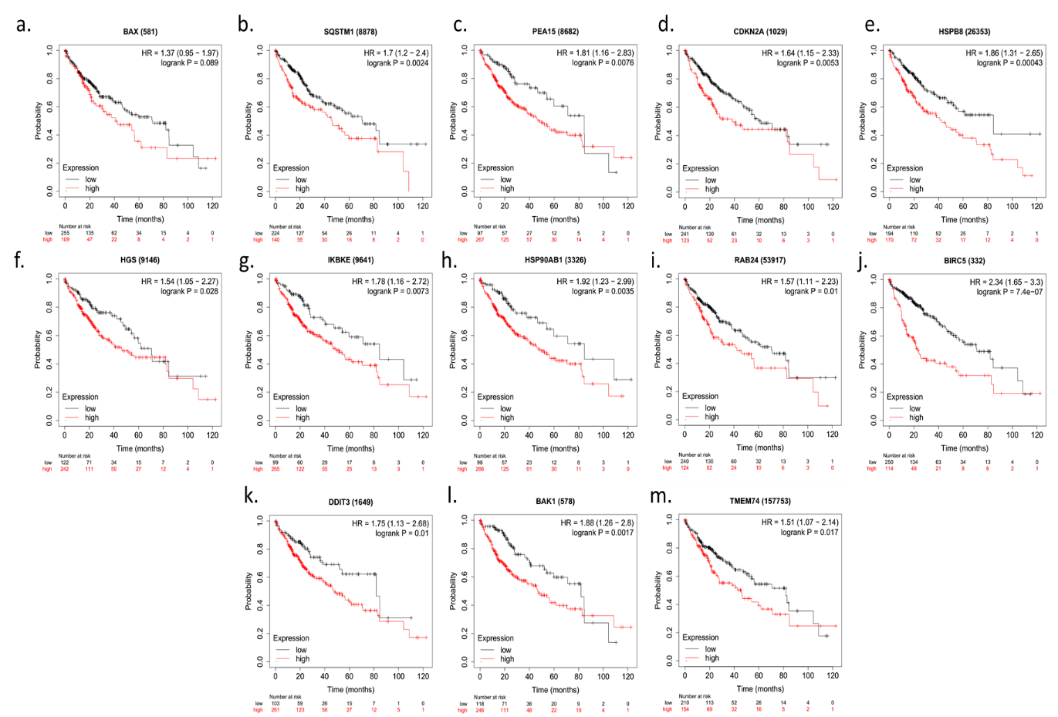
Figure. S1. Validation of prognostic role of 13 ARGs in Kaplan Meier-plotter website
The Kaplan Meier-plotter website (http://kmplot.com/analysis/index.php) was used to validate the prognostic role of 13 ARGs (BAX, SQSTM1, PEA15, CDKN2A, HSPB8, HGS, IKBKE, HSP90AB1, RAB24, BIRC5, DDIT3, BAK1, and TMEM74).

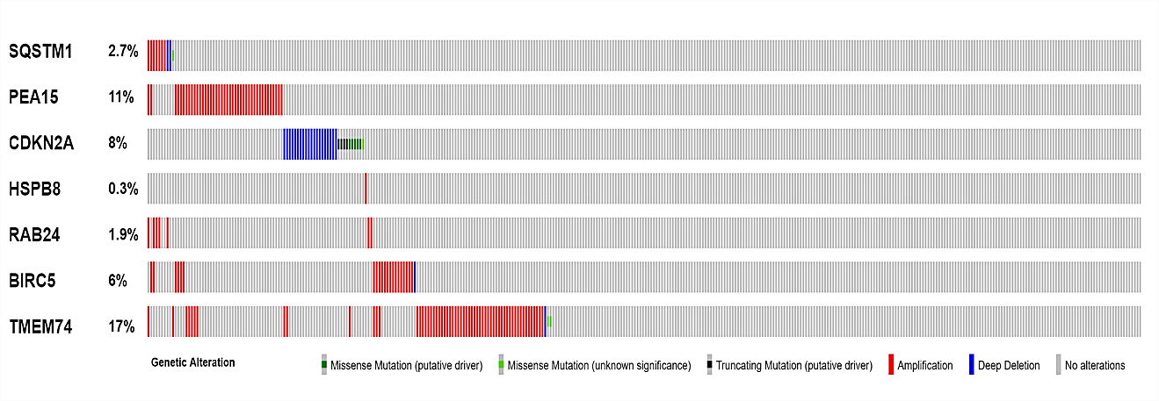
Figure. S2. Genetic alteration of 7 ARGs in the HCC cohort (TCGA, Firehose Legacy dataset).

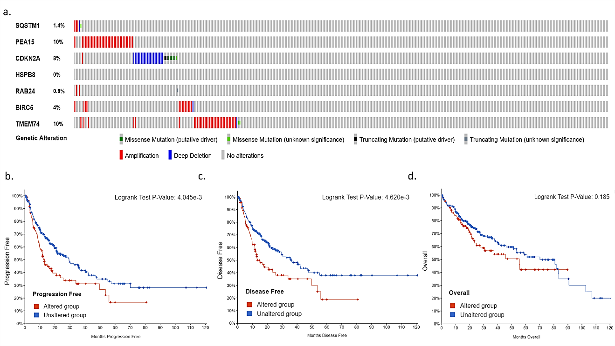
Figure. S3. Genetic alteration of 7 ARGs in the HCC cohort (TCGA, PanCancer Atlas dataset).
a. Genetic alteration of 7 ARGs in HCC patients. b. HCC patients in genes-altered group present poorer PFS (progression-free survival) than these in genes-unaltered group. c. HCC patients in genes-altered group have poorer DFS (disease-free survival) than these in genes-unaltered group. d. The OS curves present similar trend to PFS curves and DFS curves, but not statistically significant.

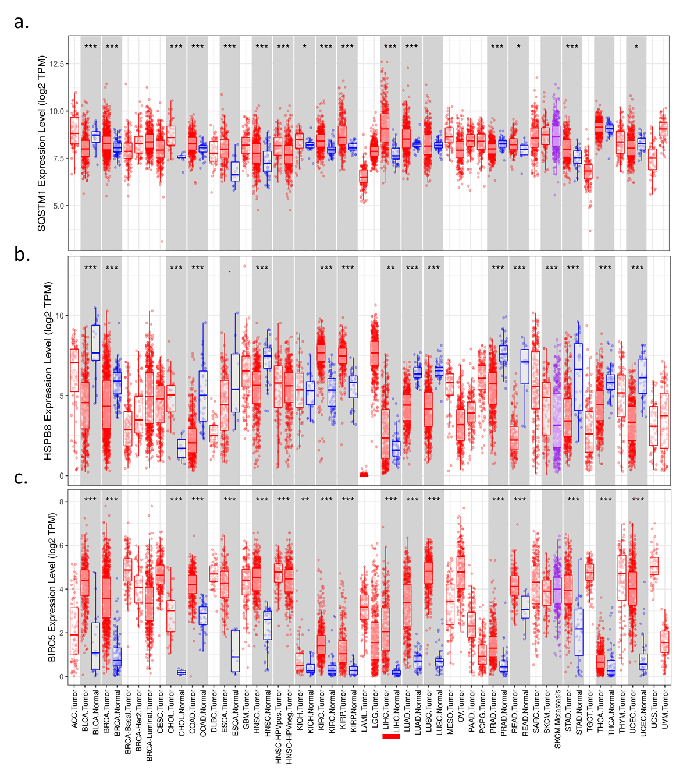
Figure. S4. Validation of the expression of ARGs at mRNA level
The TIMER database (https://cistrome.shinyapps.io/timer/) was used to validate the mRNA expression levels of SQSTM1(a), HSPB8 (b), and BIRC5(c) in HCC and normal tissues. **p<0.005; ***p<0.001

