SUPPLEMENTARY INFORMATION:
Microbially generated H₂S above 90 °C in the deep biosphere

Andrew W. Kingston¹, Gabrielle Scheffer², Omid H. Ardakani^{1,3}, Michael Nightingale³, Bernhard Mayer³, Casey Hubert²
¹Natural Resources Canada, Geological Survey of Canada, Calgary, Alberta, Canada
²Department of Biological Sciences, University of Calgary, Calgary, Alberta, Canada
³Department of Geoscience, University of Calgary, Calgary, Alberta, Canada

Component Type | Trade Name | Supplier | Purpose | Ingredient/Family Name | CAS # / HMIRC # | Concentration  in Component  (% by mass) | Concentration  in HFF  (% by mass)
CARRIER FLUID |  |  |  | Water | 7732-18-5 | 100.00% | 85.791303%
PROPPANT | 40/70 Premium | AG Sand |  | Crystalline silica, quartz | 14808-60-7 | 100.00% | 14.148211%
ADDITIVE | MC B-8510 | Mutli-Chem | Bactericide/Biocide | Inert Ingredient(s) | Not Available | 87.90% | 0.008117%
ADDITIVE | MC B-8510 | Mutli-Chem | Bactericide/Biocide | 2,2 Dibromo-3-nitrilopropionamide | 10222-01-2 | 30.00% | 0.002770%
ADDITIVE | MC B-8510 | Mutli-Chem | Bactericide/Biocide | 2-Monobromo-3-nitrilopropionamide | 1113-55-9 | 5.00% | 0.000461%
ADDITIVE | MC B-8510 | Mutli-Chem | Bactericide/Biocide | Dibromoacetonitrile | 3252-43-5 | 5.00% | 0.000461%
ADDITIVE | MC B-8510 | Mutli-Chem | Bactericide/Biocide | 2,2-Dibromomalonamide | 73003-80-2 | 1.00% | 0.000092%
ADDITIVE | OPTIFLO-III | HALLIBURTON | Breaker | Ammonium persulfate | 7727-54-0 | 100.00% | 0.011595%
ADDITIVE | OptiKleen WF | Halliburton | Breaker | Sodium perborate  tetrahydrate | 10486-00-7 | 100.00% | 0.004430%
ADDITIVE | OPTIFLO-III | HALLIBURTON | Breaker | Crystalline silica, quartz | 14808-60-7 | 30.00% | 0.003479%
ADDITIVE | OPTIFLO-III | HALLIBURTON | Breaker | Inert Ingredient(s) | Not Available | 30.00% | 0.003479%
ADDITIVE | OptiKleen WF | Halliburton | Breaker | Inert Ingredient(s) | Not Available | 20.00% | 0.000886%
ADDITIVE | MO-67 | Halliburton | Buffer | Inert Ingredient(s) | Not Available | 90.00% | 0.033729%
ADDITIVE | MO-67 | Halliburton | Buffer | Sodium hydroxide | 1310-73-2 | 30.00% | 0.011243%
ADDITIVE | CL-22 UC | Halliburton | Crosslinker | Inert Ingredient(s) | Not Available | 90.00% | 0.045906%
ADDITIVE | CL-31 | Halliburton | Crosslinker | Inert Ingredient(s) | Not Available | 69.00% | 0.000161%
ADDITIVE | CL-31 | Halliburton | Crosslinker | Potassium metaborate | 13709-94-9 | 60.00% | 0.000140%
ADDITIVE | CL-22 UC | Halliburton | Crosslinker | Potassium formate | 590-29-4 | 30.00% | 0.000153%
ADDITIVE | CL-31 | Halliburton | Crosslinker | Potassium metaborate | 1310-58-3 | 5.00% | 0.000012%
ADDITIVE | FightR-LXD | Halliburton | Friction Reducer | Inert Ingredient(s) | Not Available | 100.00% | 0.000419%
ADDITIVE | FightR EC-1 | Halliburton | Friction Reducer | Inert Ingredients(s) | Not Available | 100.00% | 0.000025%
ADDITIVE | Excelerate PS-2 | Halliburton | Friction Reducer | Inert Ingredient(s) | Not Available | 80.00% | 0.000033%
ADDITIVE | Excelerate PS-2 | Halliburton | Friction Reducer | Hydrotreated light petroleum  distillate | 64742-47-8 | 20.00% | 0.000008%
ADDITIVE | Excelerate PS-2 | Halliburton | Friction Reducer | Proprietary | Trade Secret | 20.00% | 0.000008%
ADDITIVE | WG-36 GELLING  AGENT | Halliburton | Gelling Agent | Guar gum | 9000-30-0 | 100.00% | 0.001353%

Table SI-1: Overview of hydraulic fracturing chemicals injected during this study. Data from Alberta Energy Regulator.

Genus | Total species within the genus (N) | Reported aerobes (N_{ar}) | Reported anaerobes (N_{an}) | Reported facultatives (N_{fac}) | R score | Classified as
Acinetobacter | 108 | 107 | - | 1 | -1.0 | Aerobe
Aliivibrio | 6 | 3 | - | 3 | -0.5 | Aerobe
Allorhizobium | 121 | 119 | - | 2 | -1.0 | Aerobe
Anaerobacillus | 7 | - | 6 | 1 | 0.9 | Anaerobe
Atopobium | 6 |  | 6 |  | 1.0 | Anaerobe
Aurantimonas | 9 | 7 | 1 | 1 | -0.7 | Aerobe
Caminicella | 1 | - | 1 |  | 1.0 | Anaerobe
Candidatus Obscuribacter | 2 | - | - | 2 | 0.0 | Facultative
Cloacibacterium | 4 | 2 | 1 | 1 | -0.3 | Aerobe
Corynebacterium | 142 | 93 | 10 | 39 | -0.6 | Aerobe
Cutibacterium | 6 | - | 6 | - | 1.0 | Anaerobe
Desulfosporosinus | 14 | - | 12 | 2 | 0.9 | Anaerobe
Glutamicibacter | 7 | 7 | - | - | -1.0 | Aerobe
Halanaerobium | 14 | - | 14 | - | 1.0 | Anaerobe
Halomonas | 62 | 53 | - | 9 | -0.9 | Aerobe
Lutibacter | 12 | 11 | - | 1 | -0.9 | Aerobe
Malaciobacter | 4 | 3 | - | 1 | -0.8 | Aerobe
Marinimicrobium | 5 | 5 | - | - | -1.0 | Aerobe
Marinobacter | 32 | 25 | 3 | 4 | -0.7 | Aerobe
Micrococcus | 38 | 38 | - | - | -1.0 | Aerobe
Nocardioides | 81 | 81 | - | - | -1.0 | Aerobe
Ornithinibacillus | 13 | 13 | - | - | -1.0 | Aerobe
Paraglaciecola | 11 | 11 | - | - | -1.0 | Aerobe
Pediococcus | 18 | 4 | 6 | 8 | 0.1 | Anaerobe
Planococcus | 14 | 14 | - | - | -1.0 | Aerobe
Pseudoalteromonas | 16 | 15 | - | 1 | -0.9 | Aerobe
Pseudomonas | 270 | 265 | 3 | 2 | -1.0 | Aerobe
Psychrobacter | 47 | 42 | 3 | 1 | -0.8 | Aerobe
Rhodobaculum | 1 | - | 1 | - | 1.0 | Anaerobe
Salinarimonas | 3 | - | - | 3 | 0.0 | Facultative
SEEP-SRB4 | 3 | - | 3 | - | 1.0 | Anaerobe
Sinobacterium | 2 | 1 | 1 | - | 0.0 | Facultative
Streptococcus | 209 | 45 | 65 | 35 | 0.1 | Anaerobe
Thalassotalea | 11 | 11 | - | - | -1.0 | Aerobe
Thiobacillus | 46 | 1 | - | 3 | 0.0 | Facultative
Vulcanibacillus | 1 | - | 1 | - | 1.0 | Anaerobe

Table SI-2: Classification of aerobic, anaerobic or facultative microorganisms
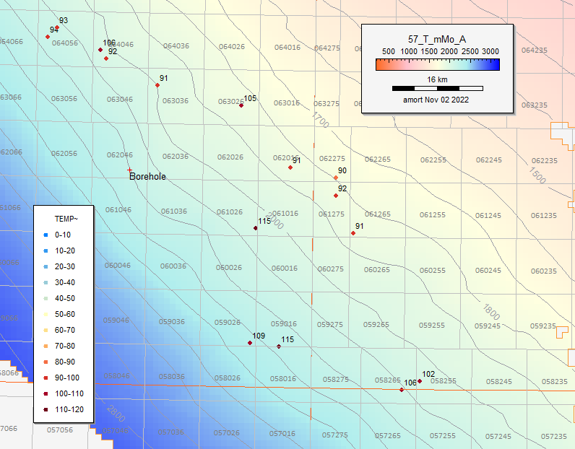
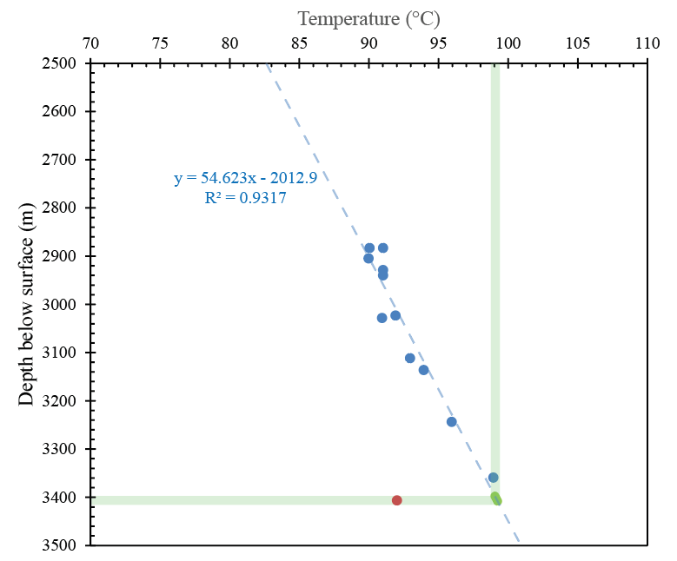
Figure SI-1: Localized geothermal gradient showing temperature vs. depth of local wells (blue) alongside the measured temperature and depth in the study well (red). The green line represents temperatures at the depths of the hydraulically fractured zone with light green regions denoting modeled temperatures for depths of the hydraulically fractured zone in this well. The inset shows the location of wells in the temperature-depth model using data from the Alberta Energy Regulator. Color scale shows depth to the base of the Montney Formation illustrating a southwestward dip.

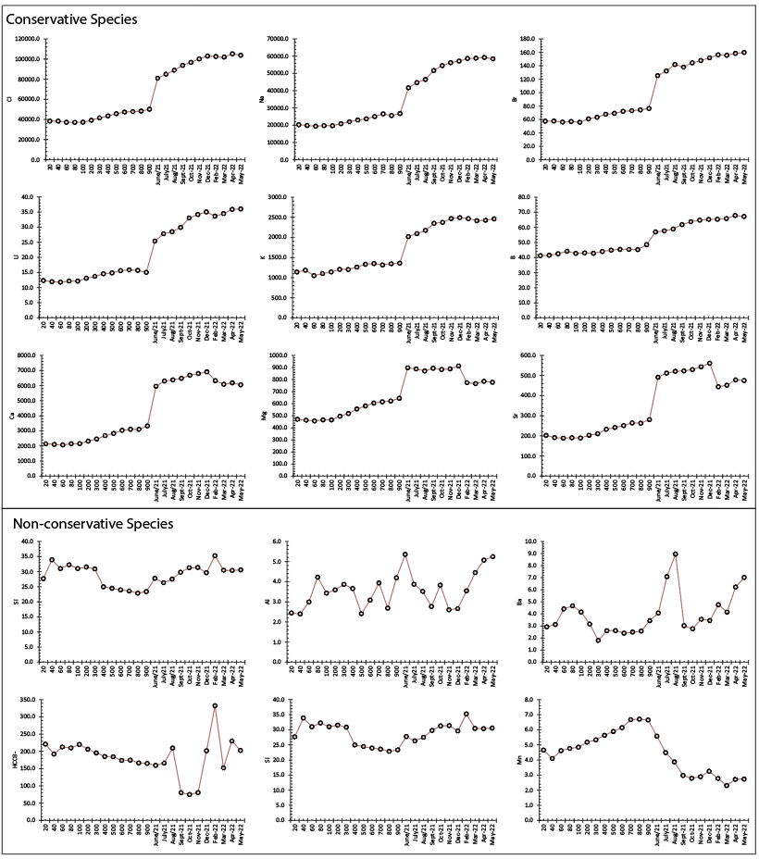
Figure SI-2: Time series of concentrations of dissolved cations, anions and minor and trace elements. Conservative species shown in top panel and non-conservative shown in bottom panel.

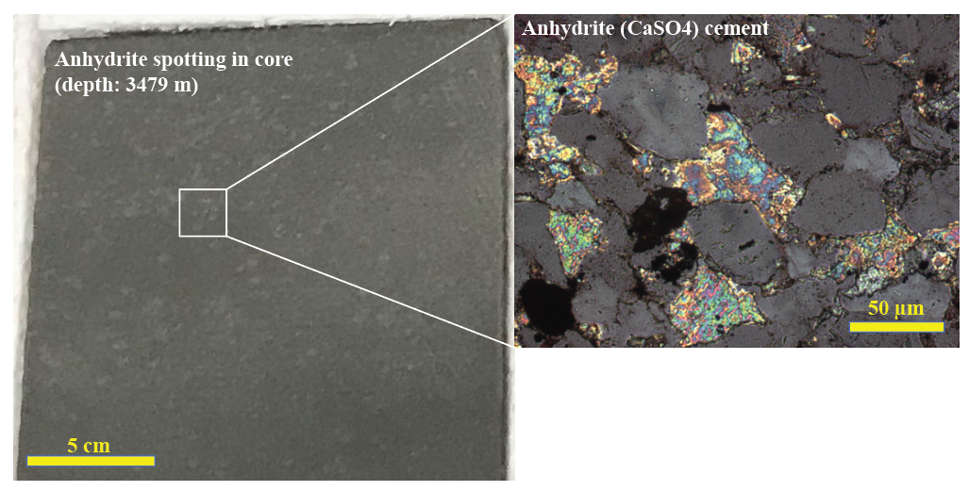
Figure SI-3: Core sample with abundant anhydrite “spotting” along with higher magnification photomicrograph of anhydrite cement (brightly colored).

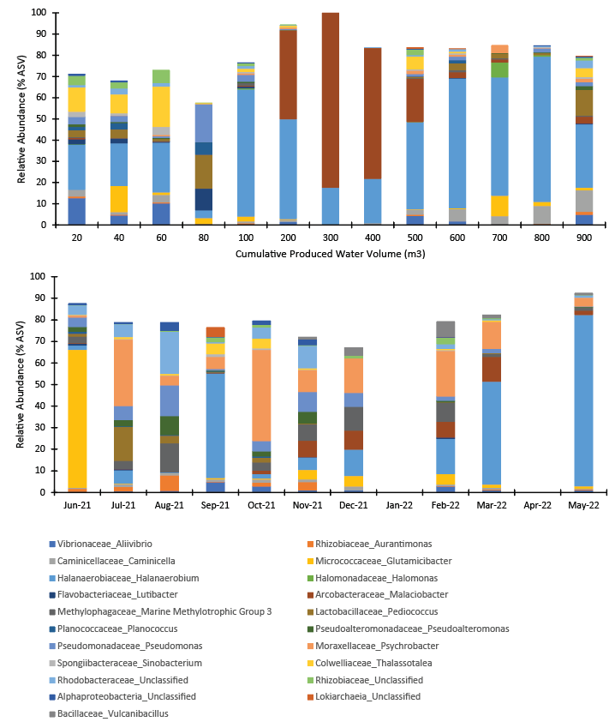
Figure SI-4: Microbial community composition of produced water samples during the initial production of the well (top panel), and subsequent monthly sampling (bottom panel). Only microbial variants that were recorded at higher than 3% relative abundance are presented. The closest taxonomy of each microorganism within each graph is presented as follow: Family_Genus.

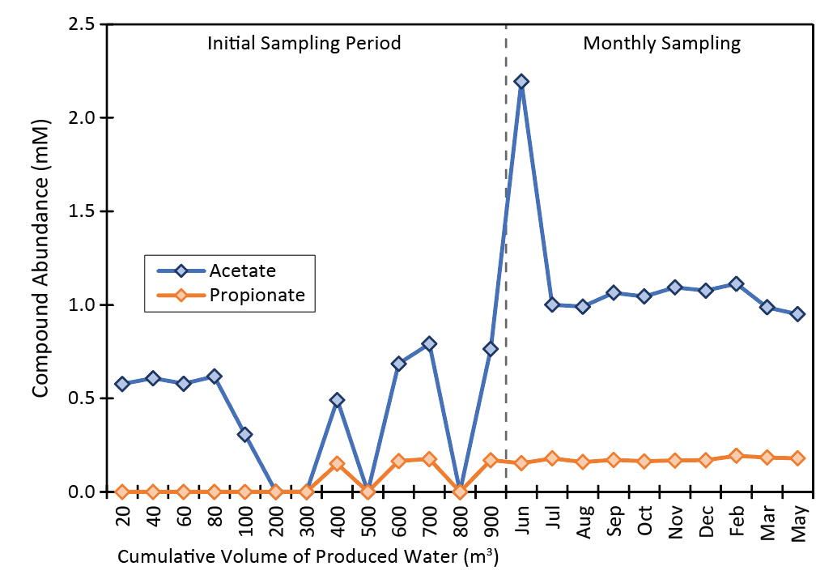
Figure SI-5: HPLC analysis of volatile fatty acid contents of produced fluids including acetate and propionate.

