SUPPLEMENTARY INFORMATION

Table S1. Transformation of all six targeted genes in the DHN-melanin biosynthetic pathway of Penicillium roqueforti. Success rates expressed as percentage of transformant colonies containing the correct integrating (replacement) selection cassette.

Batch | Protoplasts Produced | Protoplasts per Transformation | Target Genes | Vector Used per Transformation (µg) | Success Rate (%)
One | 4.0x10⁶ | 8.0x10⁵ | alb1, ayg1, arp1, abr1 | 1.0 - 1.5 | 11.5
Two | 3.6x10⁷ | 5.0x10⁶ | alb1, ayg1, arp1, arp2, abr1, abr2 | 1.1 - 2.2 | 5
Three | 1.3x10⁷ | 3.1x10⁶ | arp2 | 2.1 - 3.0 | 12.7
Four | 1.1x10⁷; 1.3x10⁷ | 2.8x10⁶; 3.2x10⁶ | abr2 | 3.4 - 5.3; 3.2 - 4.0 | 4.8

Table S2. UV induced mutations in Penicillium roqueforti. Wild type parental isolate 74-88 and ascospore strain B20 produced both phenotypic (colour) and genotypic (gene & mutation) alterations. * indicates stop codon. ‘None’ indicates no coding change found in any of the DHN-melanin biosynthetic pathway genes.
Strain | Colour | Gene | Mutation (nucleic acid) | Mutation (amino acid)
74-88-1 | Reddish-brown | arp2 | GTT to GAT | V to D
74-88-2 | Olive brown | abr1 | ATG to GAA | YF to *N
74-88-4 | Greyish-green | None | None | None
74-88-5 | Green | ayg1 | CTT to CCT | L to P
74-88-6 | White (albino) | None | None | None
74-88-10 | Intense blue | None | None | None
74-88-12 | Mustard Fawn | ayg1 | TGC to CGC | C to R
A22-26 | Powder blue | None | None | None
B20-1 | White (albino) | alb1 | TTG to TCG | L to S

Table S3. Production of volatile compounds by Penicillium roqueforti parental isolate 74-88 compared to various gene deletant strains in the melanin biosynthesis pathway (Δalb1, Δayg1, Δarp1, Δarp2 and Δabr2). Aroma profiles as determined by SPME-GCMS analysis. P-values derived from one-way ANOVA showing significant (p<0.05) or non-significant (ns) (p>0.05) differences between 74-88 and the respective gene deletant strain. There were significant changes in levels of between 8-15 of the 26 flavour compounds compared to strain 74-88.
 | 74-88 vs. Δalb1 | 74-88 vs. Δayg1 | 74-88 vs. Δarp2 | 74-88 vs. Δarp1 | 74-88 vs. Δabr1 | 74-88 vs. Δabr2
2-Propanone-1-methoxy | 0.0001 | 0.0001 | 0.0001 | 0.0001 | 0.0001 | 0.0001
Butanal-3-methyl | ns | ns | ns | ns | ns | ns
Butanal-2-methyl | ns | ns | ns | ns | ns | ns
2-Pentanone | ns | ns | ns | ns | ns | ns
2-Pentanol | 0.0014 | 0.0002 | 0.0086 | 0.0019 | 0.0037 | 0.003
1-Butanol-3-methyl | ns | 0.0016 | ns | ns | ns | ns
Butanoic acid | 0.0032 | 0.0379 | ns | ns | ns | ns
2-Hexanone | ns | ns | ns | ns | ns | ns
Butanoic acid ethyl ester | 0.0069 | 0.0088 | 0.0137 | 0.0074 | 0.0292 | 0.0111
Butanoic acid-3-methyl | ns | ns | ns | ns | ns | ns
2-Heptanone | ns | ns | ns | ns | ns | ns
2-Heptanol | 0.0016 | 0.0003 | 0.005 | 0.001 | ns | 0.0065
2-Heptanone-3-methyl | 0.0001 | 0.0194 | 0.0013 | 0.0014 | ns | 0.0197
Butanoic acid 2-methylpropyl ester | ns | ns | ns | ns | 0.0061 | ns
Hexanoic acid | 0.0002 | 0.0113 | 0.0021 | 0.0074 | 0.0012 | ns
3-Octanone | ns | 0.0409 | ns | ns | ns | ns
Hexanoic acid ethyl ester | 0.0003 | 0.0008 | 0.0006 | 0.0003 | 0.005 | 0.0006
Benzene 1-methoxy-4-methyl | ns | ns | ns | ns | ns | ns
Benzeneacetaldehyde | ns | ns | ns | ns | ns | ns
Butanoic acid 3-methylbutyl ester | ns | 0.0002 | ns | ns | ns | ns
8-Nonen-2-one | ns | ns | ns | ns | ns | ns
2-Nonanone | ns | ns | 0.0475 | ns | 0.0468 | ns
2-Nonanol | 0.002 | 0.0059 | 0.0012 | 0.0251 | 0.0024 | 0.0127
Phenylethyl Alcohol | ns | 0.0064 | ns | ns | ns | ns
Isopentyl hexanoate | ns | 0.0148 | ns | ns | ns | ns
2-Undecanone | 0.002 | 0.0069 | 0.0003 | ns | 0.0002 | 0.0062

Table S4. Master list of primers used in the present study, specifying particular applications.
Sequencing Primers
Primer Set | Oligo Name | Sequence 5' to 3' (include modification codes if applicable) | Comments
1 | MCayg1aF | CCTTACCCTCGTCATCTTGG | Starts at 37
1 | MCayg1aR | TTGATGATCTCGTGGGAGCG
2 | MCayg1bF | AAGCAGGTGTACCTGAAAGC | Starts at 837
2 | MCayg1bR | GGCTGCGACTCTTTAAAGCT | Starts at 1926
3 | arp2F | TCAACACGATTCCACACCCA
3 | arp2R | ﻿TCAGATGGTAATTGGCCCTGA
4 | MCarp1F | GAAATATGCTGGCCAGATCC | Starts at 10
4 | MCarp1R | GTTGTACCAGTTTCCCTTCG | Starts at 779
5 | MCarb1aF | AGCATGGCAGTGGAGTTATG | Starts at 6
5 | MCarb1aR | CTGCAGAACCTGGAATTGGT | Starts at 1090
6 | MCarb1bF | ATCGCTCTACACTGCCAACA | Starts at 916
6 | MCarb1bR | AGACTTGCGGGTATTATCGG | Starts at 2029
7 | MCalb1aF | CCTTAAGTTTTCGCCTGACC | Starts at 22
7 | MCalb1aR | CTTGCCTGTCTCACTTGACA | Starts at 1077
8 | alb1bF | ﻿GTTCCAATCCACGGCCCTTA
8 | alb1bR | ﻿AACCGACTGCATCTCCACTG
8/9 Gap | MCalb1b/cF | TAGTGTGGATACCGCTTGCT | Starts at 1848
8/9 Gap | MCalb1b/cR | CACATTCTCGTCATTGAGCG | Starts at 2667
9 | alb1cF | TCCAACAGCGACCCAAAAGA
9 | alb1cR | ﻿GCTGGGCGCATTGATACAAG
10 | alb1dF | ﻿ACACAATCTACCTTGCCGGG
10 | alb1dR | ﻿GATGAGGTAAGAGCTGCGCT
10/11 Gap | MCalb1d/eF | GCTGCGCCAGTTTCTGTTTT | Starts at 4066
10/11 Gap | MCalb1d/eR | ACGCTCGGATCGAACTTCTT | Starts at 4929
11 | MCalb1eF | GAAGAAGATCCTTGACCACG | Starts at 4495
11 | MCalb1eR | TGCTGTCATTTTGCTCCTGC | Starts at 5629
11/12 Gap | MCalb1e/fF | ﻿TTCCAAGCTCTGGCACGAAA | Starts at 5097
11/12 Gap | MCalb1e/fR | ﻿ACGCCGAATCTCAGCAATGT | Starts at 6155
12 | alb1fF | ﻿TCGAGTCCAAACAGCAGTGG
12 | alb1fR | ﻿ATACGTTTACGCCGAAGCCA
13 | arb2aF | ﻿AGGAAGGCGGTAAGAAAGGC
13 | arb2aR | ﻿GGGCAAATTGTTGGTCACGT
14 | MCarb2bF | GTCGAGAGGGAGATGATCTT | Starts at 926
14 | MCarb2bR | GCAGGTAGGATAGCAGGATA | Starts 2280
15 | arb2cF | ﻿GCGCTACTCTGCCATGATCA
15 | arb2cR | ﻿CGATGATGATGCCAGTCCCA
Mix | Alb1mixF | ﻿AAGGTGCTCAGTACACAGGC
Mix | Alb1mixR | ﻿CGCCCTTTCCAATTTCAGCC
Transformation Primers
Alb1
Primer Set | Oligo Name | Sequence 5' to 3' (include modification codes if applicable) | Comments
Upstream | Upstream_Alb1 Fwd | ACCTGCAGGCATGCAAGCTTCAGATGATGCCTGCAGATG | PUC19
Upstream | Upstream_Alb1 Rev | GCAGAGCTAATCTTCCTGGTAGCAGATTAATG | hph
hph | hph_Alb1 Fwd | AGGAAGATTAGCTCTGCAAAGGGCGTT | Upstream Alb1
hph | hph_Alb1 Rev | GCAATACGTCAGTGTGATGGAATTCGC | Downstream Alb1
Downstream | Downstream_Alb1 Fwd | TCACACTGACGTATTGCATTCGGGGAC | hph
Downstream | Downstream_Alb1 Rev | GACCATGATTACGCCAAGCTTACCGAAAACCGCCATTTG | PUC19
Ayg1
Primer Set | Oligo Name | Sequence 5' to 3' (include modification codes if applicable) | Comments
Upstream | Upstream_Ayg1 Fwd | AATTCGAGCTCGGTACCACTCGCTGCTTTGCTGCT | PUC19
Upstream | Upstream_Ayg1 Rev | GCAGAGCTTTTGAGCGGGATATAGACG | hph
hph | hph_Ayg1 Fwd | CGCTCAAAAGCTCTGCAAAGGGCGTT | Upstream Ayg1
hph | hph_Ayg1 Rev | GCACCCACCAGTGTGATGGAATTCGC | Downstream Ayg1
Downstream | Downstream_Ayg1 Fwd | TCACACTGGTGGGTGCTGTGTCAATATAG | hph
Downstream | Downstream_Ayg1 Rev | AGGATCCCCGGGTACCGAATTCAGGAAGCTGAAGATG | PUC19
Arp2
Primer Set | Oligo Name | Sequence 5' to 3' (include modification codes if applicable) | Comments
Upstream | Upstream_Arp2 Fwd | AATTCGAGCTCGGTACCATGAGAGTGACCACGAAGC | PUC19
Upstream | Upstream_Arp2 Rev | GCAGAGCTTTTGGCGGTTATTTTGATG | hph
hph | hph_Arp2 Fwd | CCGCCAAAAGCTCTGCAAAGGGCGTT | Upstream Arp2
hph | hph_Arp2 Rev | GACATCGACAGTGTGATGGAATTCGC | Downstream Arp2
Downstream | Downstream_Arp2 Fwd | TCACACTGTCGATGTCTCGTGGGGTTGCC | hph
Downstream | Downstream_Arp2 Rev | AGGATCCCCGGGTACCGGCGCGGTCGAGATGGCC | PUC19
Arp1
Primer Set | Oligo Name | Sequence 5' to 3' (include modification codes if applicable) | Comments
Upstream | Upstream_Arp1 Fwd | AATTCGAGCTCGGTACCTCTTGCTGCCCGCATAC | PUC19
Upstream | Upstream_Arp1 Rev | GCAGAGCTGGTTGTTCGGCAATCTTTG | hph
hph | hph_Arp1 Fwd | GAACAACCAGCTCTGCAAAGGGCGTT | Upstream Arp1
hph | hph_Arp1 Rev | CATTGACATCAGTGTGATGGAATTCGC | Downstream Arp1
Downstream | Downstream_Arp1 Fwd | TCACACTGATGTCAATGGGCTTTTGC | hph
Downstream | Downstream_Arp1 Rev | AGGATCCCCGGGTACCTTAAATTATCTGAAAGAAGTGTCG | PUC19
Abr1
Primer Set | Oligo Name | Sequence 5' to 3' (include modification codes if applicable) | Comments
Upstream | Upstream_Abr1 Fwd | AATTCGAGCTCGGTACCGACTATTCTTCTTCATCATG | PUC19
Upstream | Upstream_Abr1 Rev | GCAGAGCTATGTTCATCTTTTCCACCG | hph
hph | hph_Abr1 Fwd | GATGAACATAGCTCTGCAAAGGGCGTT | Upstream Abr1
hph | hph_Abr1 Rev | TGCTGGCACAGTGTGATGGAATTCGC | Downstream Abr1
Downstream | Downstream_Abr1 Fwd | TCACACTGTGCCAGCACCTGTGATATG | hph
Downstream | Downstream_Abr1 Rev | AGGATCCCCGGGTACCATCCCCACTCAGAGTCGTATC | PUC19
Abr2
Primer Set | Oligo Name | Sequence 5' to 3' (include modification codes if applicable) | Comments
Upstream | Upstream_Abr2 Fwd | AATTCGAGCTCGGTACCACTAGGGTGCAAATACTCATG | PUC19
Upstream | Upstream_Abr2 Rev | GCAGAGCTTTTGTGGAGTTGGTTGGAG | hph
hph | hph_Abr2 Fwd | CTCCACAAAAGCTCTGCAAAGGGCGTT | Upstream Abr2
hph | hph_Abr2 Rev | TAGAACACACAGTGTGATGGAATTCGC | Downstream Abr2
Downstream | Downstream_Abr2 Fwd | TCACACTGTGTGTTCTATGATTTTTCTATCC | hph
Downstream | Downstream_Abr2 Rev | AGGATCCCCGGGTACCATCAACGGGTATGCGATC | PUC19
Universal Hygromycin Primers
Primer Set | Oligo Name | Sequence 5' to 3' (include modification codes if applicable) | Comments
hph | Forward | AGCTCTGCAAAGGGCGTT
hph | Reverse | CAGTGTGATGGAATTCGCCCTT
Hygromycin Colony PCR Primers
Primer Set | Oligo Name | Sequence 5' to 3' (include modification codes if applicable) | Comments
hph | hph_for | CGATGTAGGAGGGCGTGGATA
hph | hph_rev | GCTTCTGCGGGCGATTTGTGT
Positional PCR Primers
Primer Set | Oligo Name | Sequence 5' to 3' (include modification codes if applicable) | Comments
Abr1 | Abr1-FF | TTCAGTCCCATCATCAGGAGCC
Abr1 | Abr1-FR | ATCTCCAGTCAATCTCCCGC
Abr2 | Abr2-Ff | ACCTCTACCATTGACCGCTC
Abr2 | Abr2-FR | ACTCGGTGCCTGGTTCATTG
Alb1 | Alb1-FF | CGGCAGATCTTATTCCGTCG
Alb1 | Alb1-FR | CCATGTAACTCGCCAAGAGC
Ayg1 | Ayg1-FF | CCATCAACAGCATTTATCGTCC
Ayg1 | Ayg1-FR | TTGTCCGAGACTACACTGGAGG
Arp1 | Arp1-FF | TTGGCTCCACCGTTACAAGG
Arp1 | Arp1-FR | TGTCCCGTTTTGCGTCCAAG
Arp2 | Arp2-FF | AGCCGCCTCACTATGGAAAC
Arp2 | Arp2-FR | GGCAGAGAAGAAGGTGTATCTATC
Hph1 | Hph1-FF | ACAATGCCTGAACTCACCGC
Hph1 | Hph1-FR | TCTACAAATGGTGGAGGCGG
Pos/hph | Hph2-FF | GCATTAATGCATTGGACCTCG
Pos/hph | Hph2-FR | GCTGAAGTCGATTTGAGTCC
Complementation Phleomycin Primers
Primer Set | Oligo Name | Sequence 5' to 3' (include modification codes if applicable) | Comments
Alb1 | PUC19 | CGACGTTGTAAAACGACGGCCAGTGAATTCAGATGATGCCTGCAGATG | 5_Flank
Alb1 | Alb1_gene | TGGGGCCCTCCATAATCTTCCTGGTAGCAGATTAATG | 5_Flank
Alb1 | 5_Flank | TACCAGGAAGATTATGGAGGGCCCCAGTCAT | Alb1_gene
Alb1 | Phle | TTGTGGTGAGCGGCCTTACGCCGAAGCCATAGAG | Alb1_gene
Alb1 | Alb1_gene | GGCTTCGGCGTAAGGCCGCTCACCACAAAAG | Phle
Alb1 | 3_Flank | GAATGCAATACGTGCGAGTGAGGGTTGAGTACG | Phle
Alb1 | Phle | AACCCTCACTCGCACGTATTGCATTCGGGGA | 3_Flank
Alb1 | PUC19 | AGAGGATCCCCGGGTACCGAGCTCGAATTCCTACAAAGGAAGGAAGAAGAG | 3_Flank
Abr2 | PUC19 | AGTGAATTCGAGCTCGGTACCCGGGGATCCACTAGGGTGCAAATACTCATG | 5_Flank
Abr2 | Abr2_gene | TCGTGTGTGTCATTTTGTGGAGTTGGTTGGAG | 5_Flank
Abr2 | 5_Flank | CCAACTCCACAAAATGACACACACGAAGTCC | Abr2_gene
Abr2 | Phle | TTGTGGTGAGCGGCCCTATAGGTAGTGAGGAGGAACTTC | Abr2_gene
Abr2 | Abr2_gene | TCACTACCTATAGGGCCGCTCACCACAAAAG | Phle
Abr2 | 3_Flank | ATCATAGAACACAGCGAGTGAGGGTTGAGTACG | Phle
Abr2 | Phle | AACCCTCACTCGCTGTGTTCTATGATTTTTCTATCC | 3_Flank
Abr2 | PUC19 | GCATGCCTGCAGGTCGACTCTAGAGGATCCGTATATACCTTTCTTACTTAATGGTTTC | 3_Flank
Heterologous Expression Primers
Primer Set | Oligo Name | Sequence 5' to 3' (include modification codes if applicable) | Comments
PksP | tagX_Proq_ PksP_fw | ATCACCATCACCATGGAATGGAGGGCCCCAGTCATTTG
PksP | Proq_PksP_ tag_rv | CTGCTGTTATCCATGGTTACGCCGAAGCCATAGAGTTAG
Ayg1 | IF_Ayg1_ TagSMx_f | GCATCATCATCACCATCACCATGGAGTGAATTGGATCCTCGGA
Ayg1 | IF_Ayg1_ TagSMx_rv | TTGAAATCACTGCTGTTATCCATGGTCAGTTCTTCACCTCCTTC

Alb1
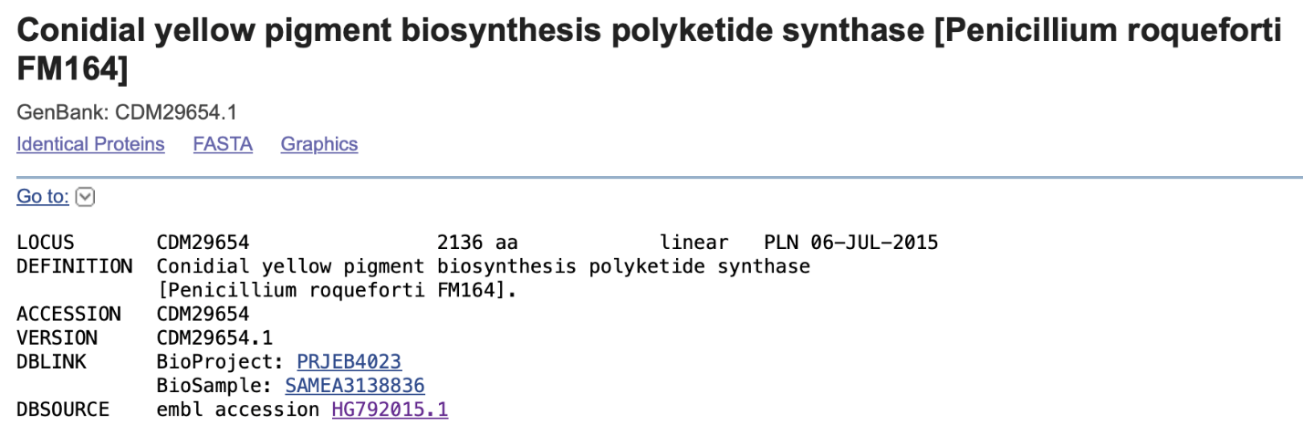
Ayg1
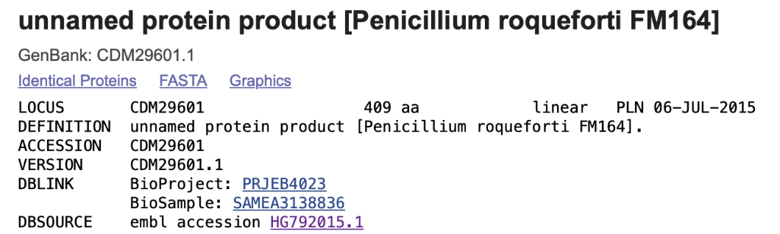
Arp1
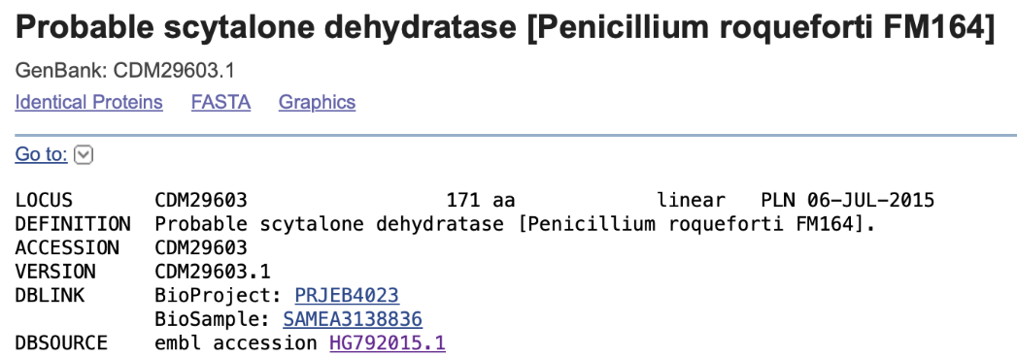
Arp2
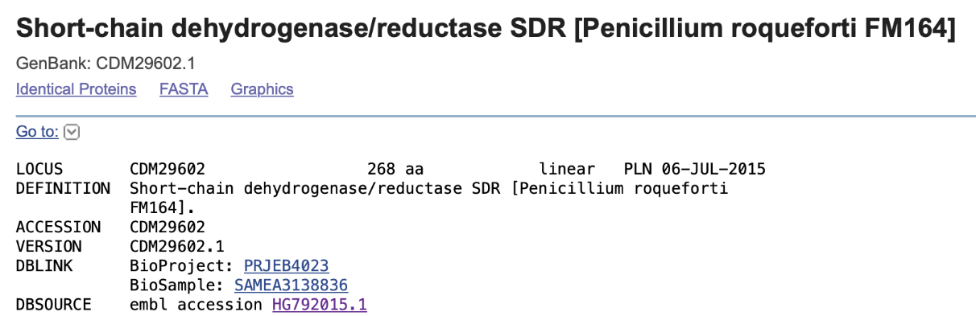

Abr1
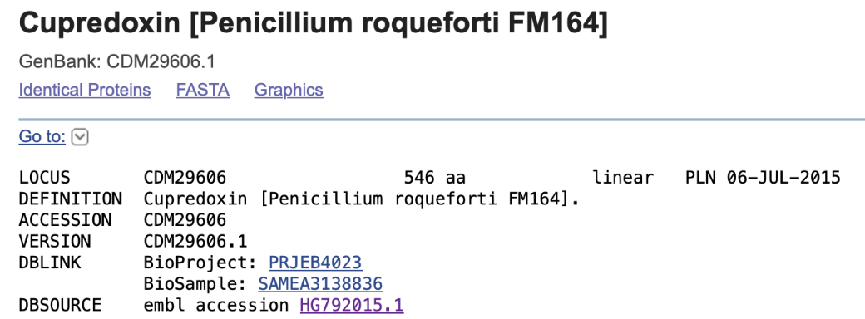
Abr2
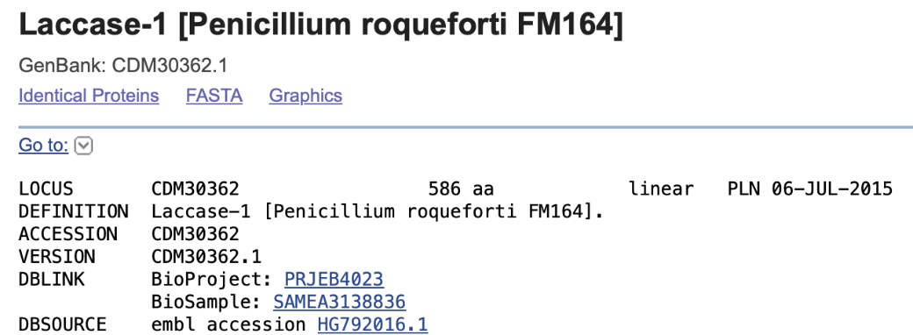

Fig. S1. Homologues of Aspergillus fumigatus DHN-melanin pathway genes identified in the Penicillium roqueforti FM164 genome through BLASTP searches.

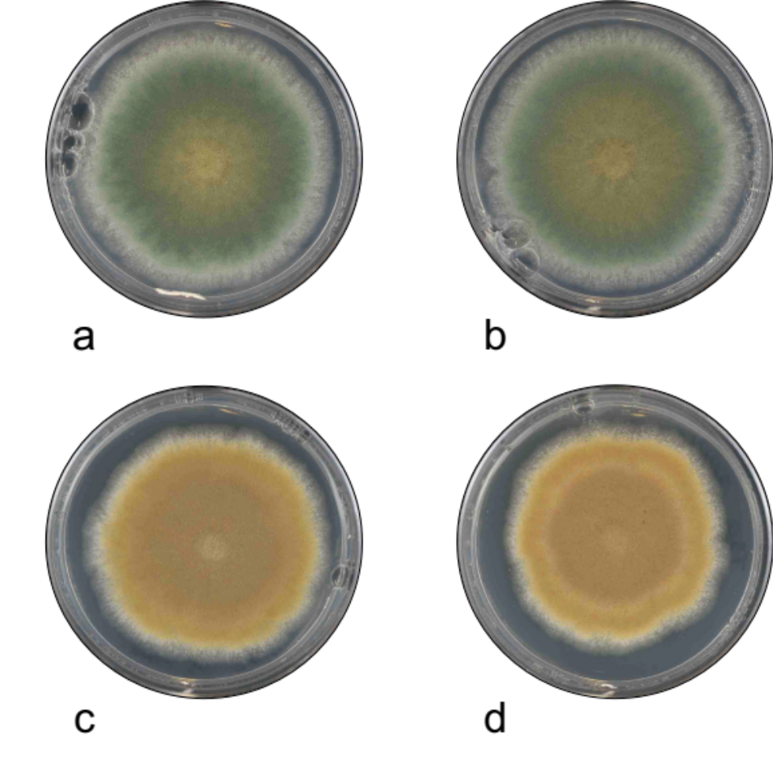

Fig. S2. Effect of enzyme inhibitors on colony colouration of Penicillium roqueforti isolate 74-88. a Non-supplemented medium, b Ethanol control, c Pyroquilon, d Tricyclazole. Compounds were added to the growth media at concentrations between 4-30 µg/mL.

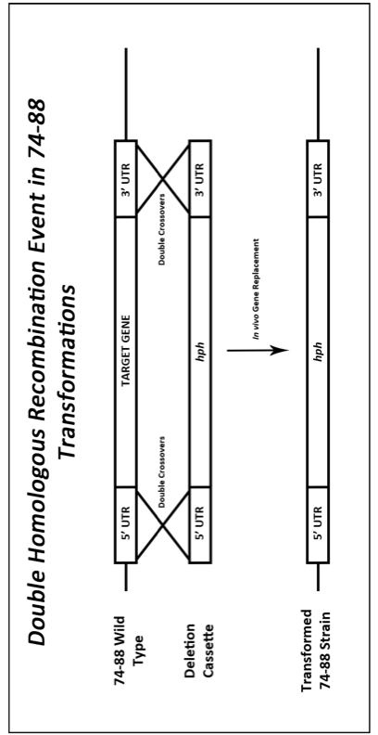

Fig. S3. Penicillium roqueforti transformation approach. Double homologous recombination events through 5’ and 3’ flanking regions replace the targeted pigment biosynthesis gene with a hygromycin resistance gene (hph) used for selection.

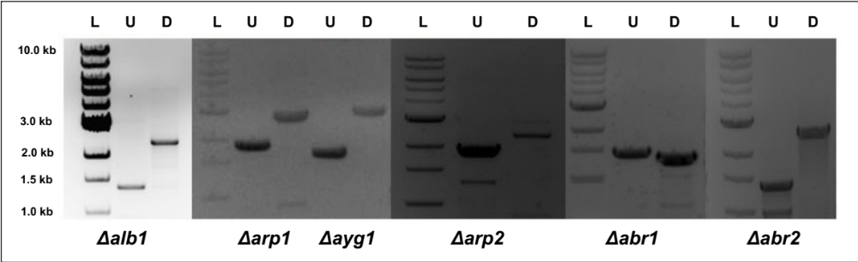

Fig. S4. Agarose gels used to resolve products from positional PCR of gene transformants to assess correct cassette integration and gene replacement. L = 1 kb ladder, U = upstream region, D = downstream region. Predicted sizes for correct integration: Δalb1U = 1427 bp, Δalb1D = 2500 bp; Δarp1U = 1883 bp, Δarp1D = 2679 bp; Δayg1U = 1749 bp, Δayg1D = 2761 bp; Δarp2U = 1784 bp, Δarp2D = 2548 bp; Δabr1U = 1480 bp Δabr1D = 1351 bp; Δabr2U = 1351 bp, Δabr2D = 2654 bp.

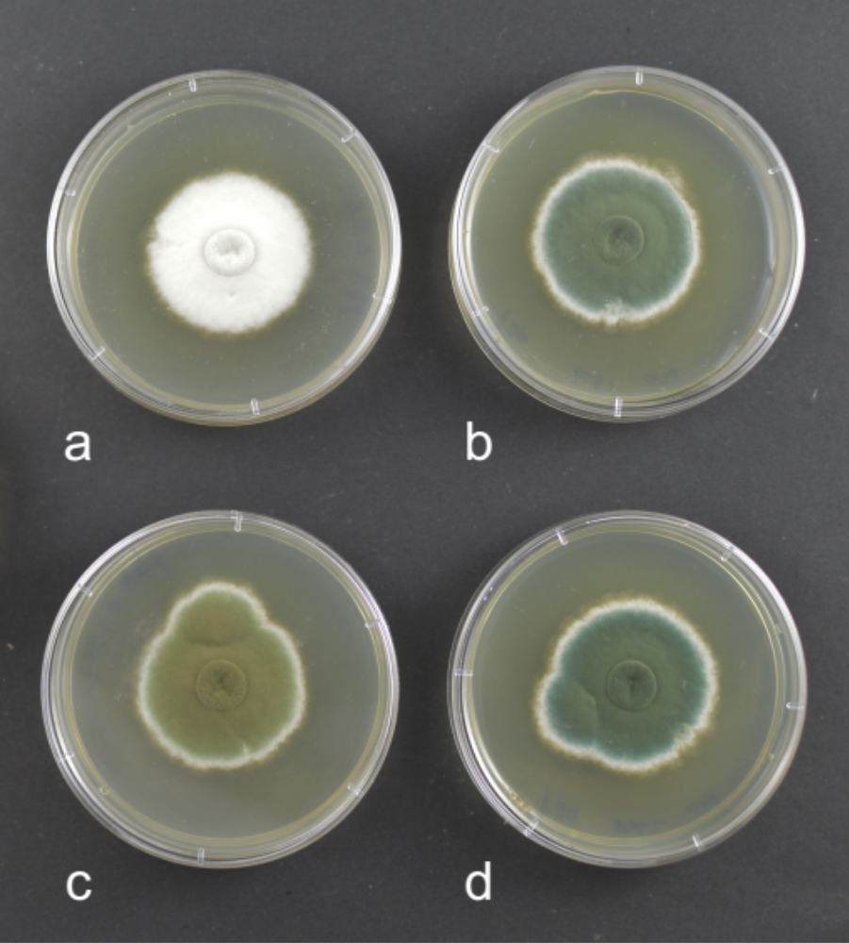

Fig. S5. Gene complementation. Experiments showing that transformation (re-integration) of the parental gene rescues and restores wild-type colour expression in colour mutants of Penicillium roqueforti isolate 74-88. Figure shows gene deletant strains a Δalb1 and c Δabr2, as compared to gene complementation strains b cΔalb1 and d cΔabr2.

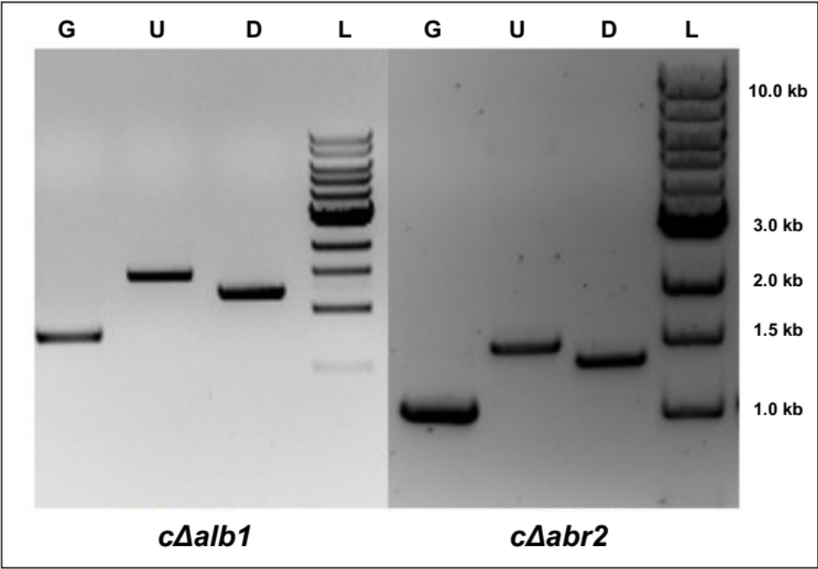

Fig. S6. Agarose gels used to resolve products from positional PCR of gene transformants to assess correct cassette integration in complementation gene strains. L = 1 kb ladder, U = upstream region, D = downstream region, G = Gene + Phleomycin nested PCR product. Predicted sizes for correct integration: Δalb1G = 787 bp, cΔalb1U = 1490 bp, cΔalb1D = 1166 bp; cΔabr2G = 1056 bp, cΔabr2U = 1635 bp, cΔabr2D = 1359 bp.

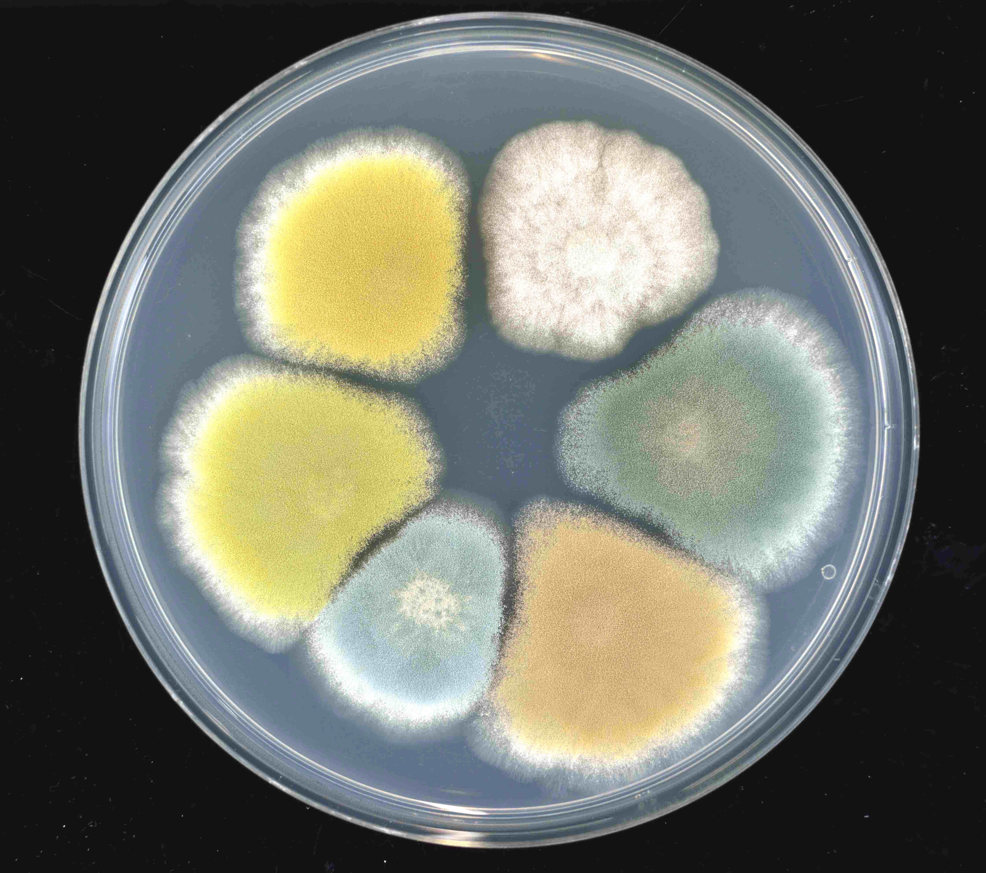

Fig. S7. Wild type and representative UV colour mutant strains of Pencillium roqueforti. Clockwise from top right strains are 74-88-6 (white), 74-88 (wild-type parent), 74-88-1 (reddish-brown), 74-88-10 (intense blue), 74-88-5 (green), and 74-88-12 (mustard fawn).

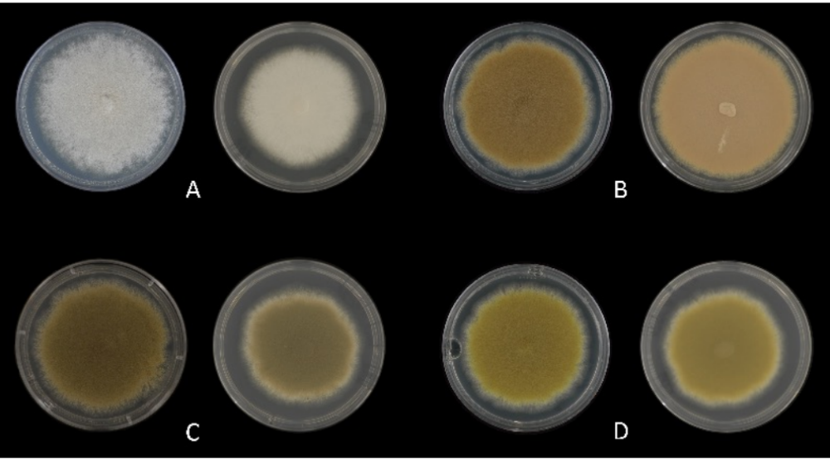

Fig. S8. Comparison of Penicillium roqueforti colony phenotypes between gene deletant transformation strains and UV mutants with the same effected gene. a B20-1 (alb1-L102S) [left] and 74-88 Δalb1 [right]; b 74-88-1 (arp2-T290A) [left] and 74-88 Δarp2 [right]; c 74-88-2 (abr1-Y42*;D43N) [left] and 74-88 Δabr1 [right]; d 74-88-12 (ayg1-C344R) [left] and 74-88 Δayg1 [right].

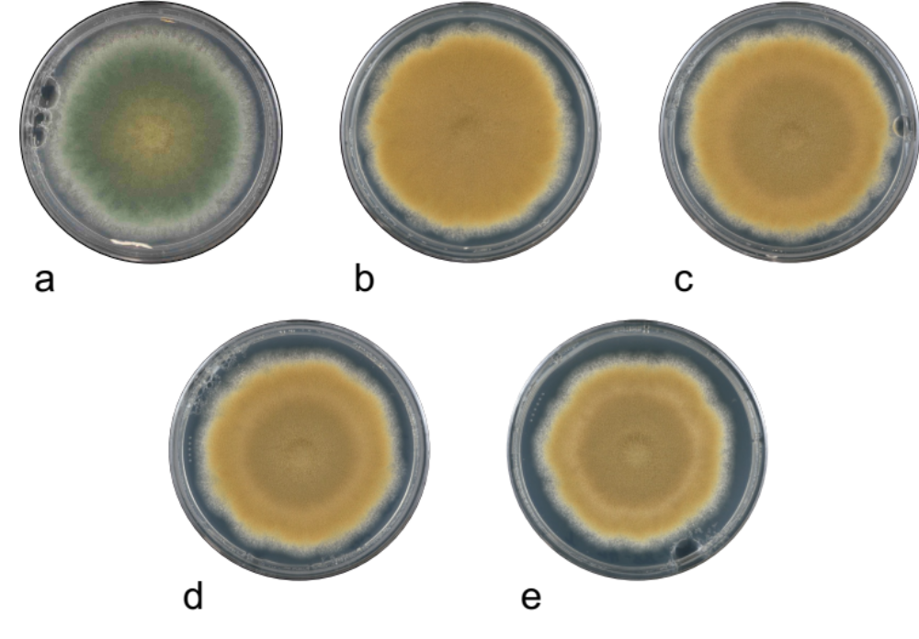

Fig. S9. Impact of enzyme inhibitors on colouration of colonies of Penicillium roqueforti UV colour mutant 74-88-1 (arp2-T290A). a 74-88 parent, b 74-88-1 on non-supplemented medium, c 74-88-1 on ethanol control medium, d 74-88-1 on Pyroquilon supplemented medium, e 74-88-1 on Tricyclazole supplemented medium. Compounds were added to the growth media to a final concentration of 30 µg/ml. Meanwhile, when colour mutants earlier in the putative DHN-melanin pathway were exposed to tricyclazole and pyroquilon, such as 74-88-12 (ayg1-C344R) that produced mustard fawn colonies, no change was seen in the colony colouration. This could be explained by the mutation in the ayg1 gene perturbing 1,3,6,8-THN production and causing any downstream enzyme inhibitors to have no effect (results not shown).

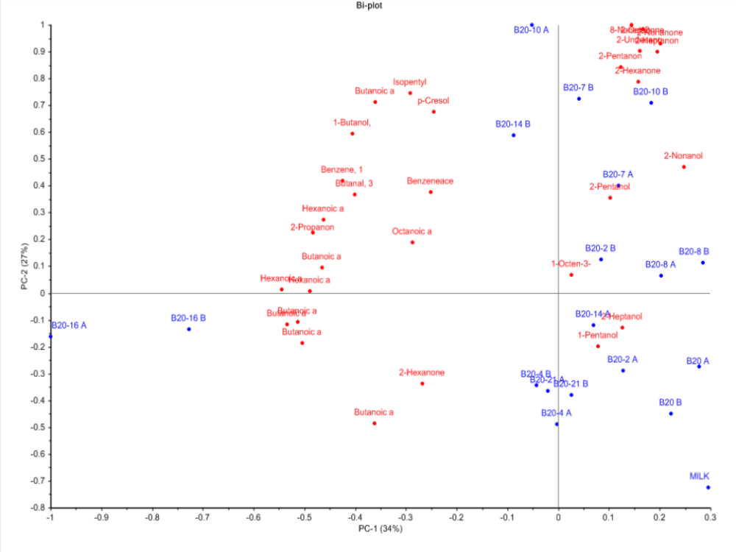

Fig. S10. PCA plot to show differences in profiles of production of volatile compounds (displayed in red) between the parental strain B20 and various UV-induced colour mutant strains. B20-2, B20-4, B20-7, B20-8, B20-10, B20-14, B20-16, and B20-21 displayed in blue. Note that suffixes (A) and (B) indicate replicate GC-MS trials.

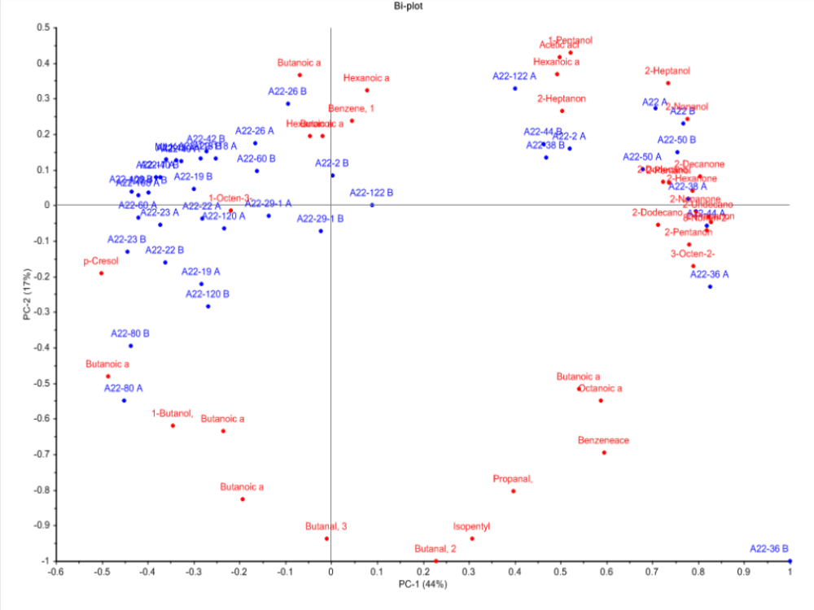

Fig. S11. PCA plot to show differences in profiles of production of volatile compounds (displayed in red) between the parental strain A22 and various UV-induced colour mutant strains. A22-2, A22-17, A22-19, A22-22, A22-23, A22-26, A22-29, A22-36, A22-38, A22-40, A22-42, A22-44, A22-50, A22-60, A22-80, A22-108, A22-118, A22-120, and A22-122 displayed in blue. Note that suffixes (A) and (B) indicate replicate GC-MS trials.

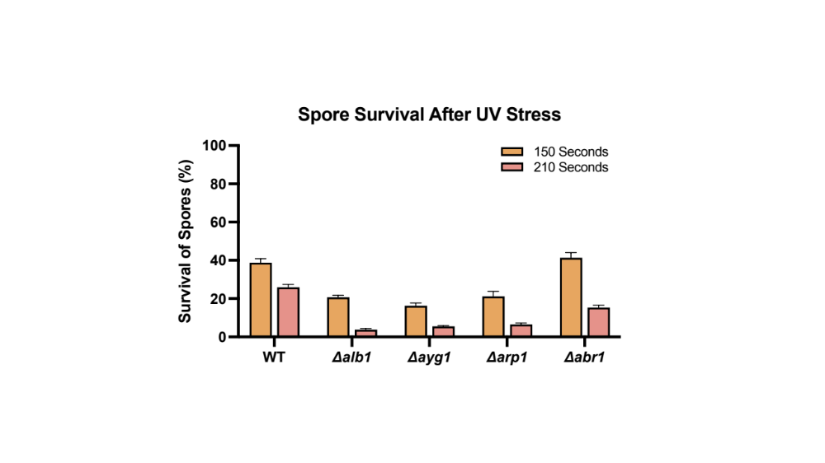

Fig. S12. Percentage survival of spores (relative to non-UV exposed controls) of either Penicillium roqueforti parental isolate 74-88 (WT) or various DHN-melanin biosynthesis gene deletion strains (Δalb1, Δayg1, Δarp1, and Δabr1) following exposure to UV stress for either 150 or 210 sec. For viability tests, 10 mL of a spore suspension of concentration 2,000/mL in 0.1% tween 20 was exposed in an open 5 cm diameter Petri dish to a Sylvania germicidal UV-C source emitting at a wavelength of 254 nm with an intensity of 100 μW cm⁻², whilst continuously stirring the spore suspension using a magnetic stirrer. There was a significant variation in spore survival between the various strains (two way ANOVA: F=48.4; DF=1,40; p<0.0001). Gene deletants showed up to an 8-fold decrease in percentage survival relative to 74-88 at the longest UV exposure time.

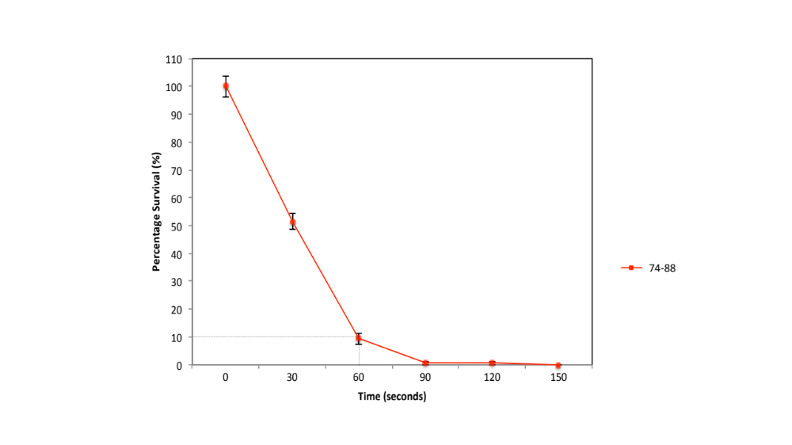

Fig. S13. UV dose response graph. Percentage survival of spores (relative to non-UV treated controls) dependent on time of exposure for conidia of Penicillium roqueforti isolate 74-88. Error bars indicate ±SEM. This involved exposure of 10 mL of a 200,000 spores/mL suspension in an open 5 cm diameter Petri dish for 60 sec to a Sylvania germicidal UV-C source emitting at a wavelength of 254 nm with an intensity of 100 μW cm⁻² (corresponding to 0.0001 Joule s⁻¹), whilst mixing using a sterilised magnetic stirrer. The intensity of UV exposure was determined using a J-225 Blak-Ray UV meter from Ultra-Violet Products (San Gabriel, California, USA).

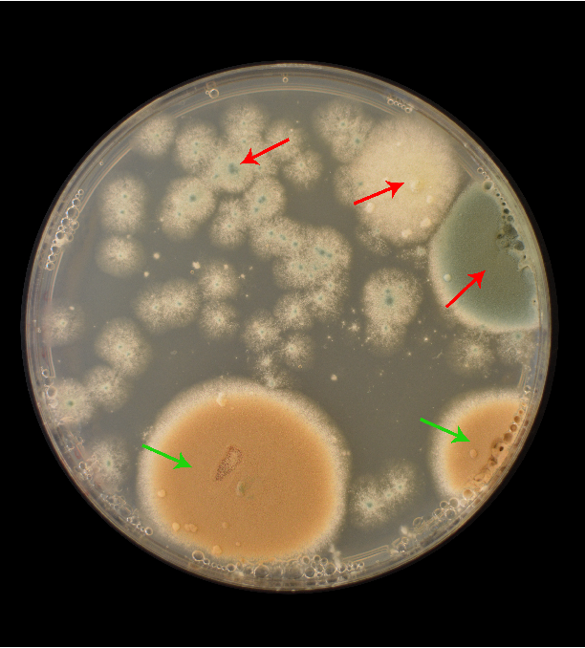

Fig. S14. Selection plate containing hygromycin-B for Penicillium roqueforti transformations. Image shows Δarp2 successful deletion (green arrows) along with false positive colonies (red arrows).

