Supplementary figure legends:
Figure S1: Sample clustering to detect outliers. (A) A549 dataset and (B) NHBE dataset. The color is proportional to the pathological stage (Red=infected samples and white=mock treated samples).
Figure S2: Selection of the soft-thresholding powers. (A) A549 dataset and (B) NHBE dataset. The left panel shows the scale-free fit index (y-axis) as a function of the soft-thresholding power (x-axis). The right panel displays the mean connectivity (degree, y-axis) as a function of the soft-thresholding power (x-axis). The power was set as 9 and 22 for A549 and NHBE datasets, respectively for the next analysis.
Figure S3: Cluster dendrogram and module assignment from WGCNA. The branches correspond to highly interconnected groups of genes. Colors in the horizontal bar represent the modules. A) A549 dataset and B) NHBE dataset.
Figure S4: Module-module associations. Eigengene dendrogram and Heatmap plot of the adjacencies in the eigengene network including the state represents the relationships among the modules and disease. A) A549 dataset and B) NHBE dataset.
Figure S5: Selection of Best Hubgenes for reconstruction of co-expression network in Turquoise (A) and Yellowgreen (B) modules. Hubgenes with GS and MM > 0.9915 and 0.94 respectively and fold changes |log₂FC| ≥ 2 were selected.

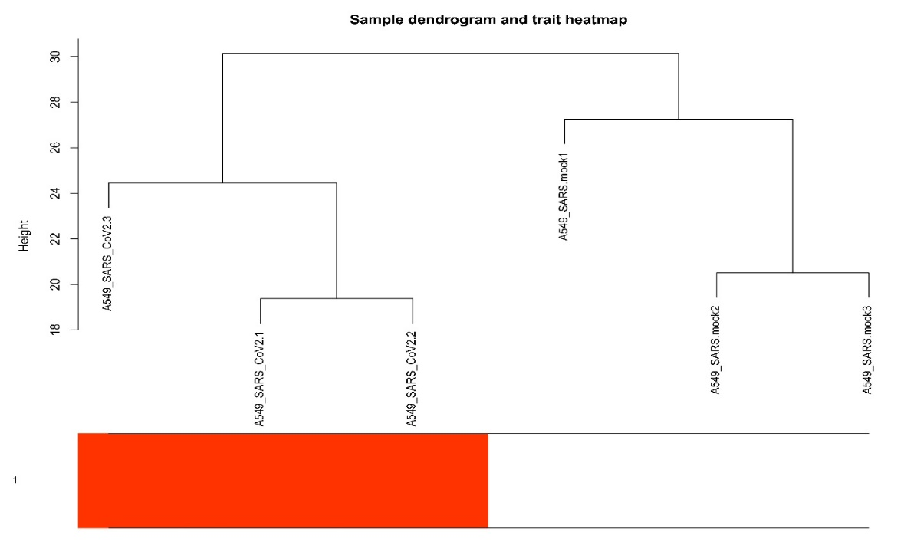
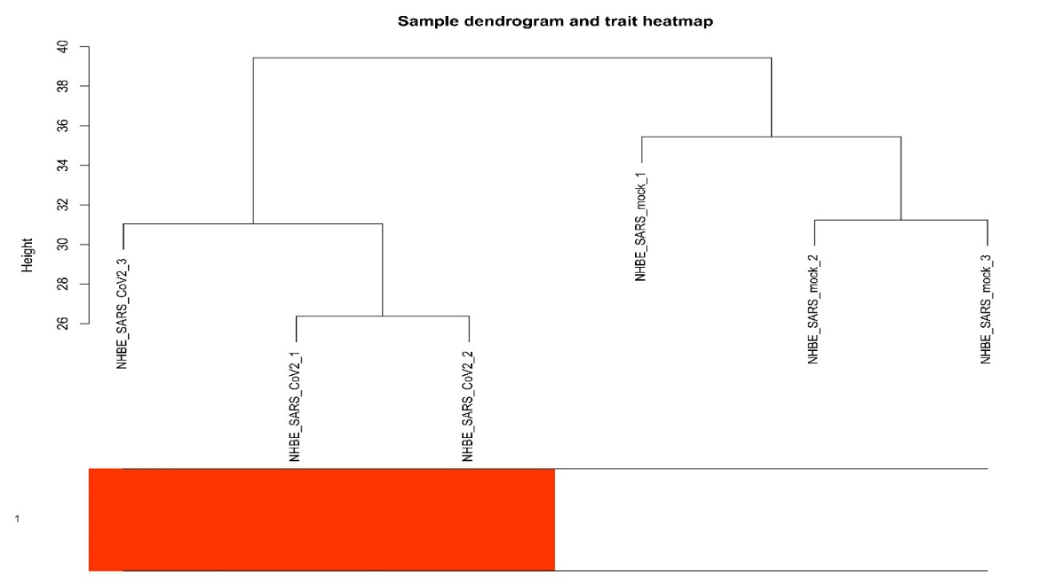
Figure S1:
A
B

Figure S2:

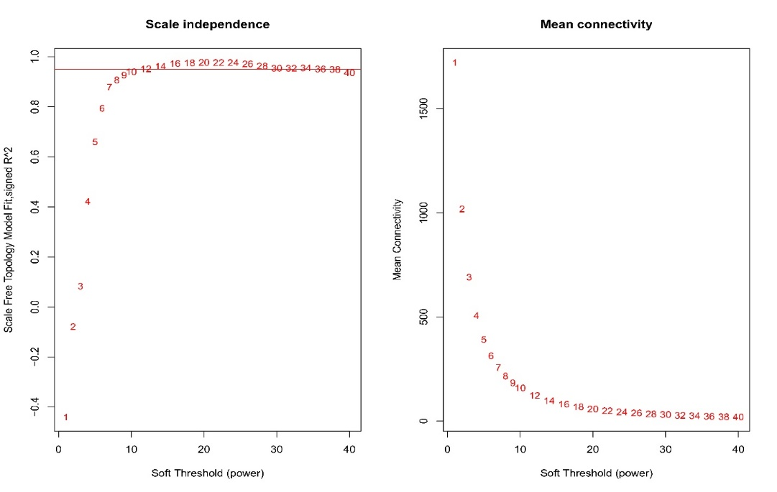
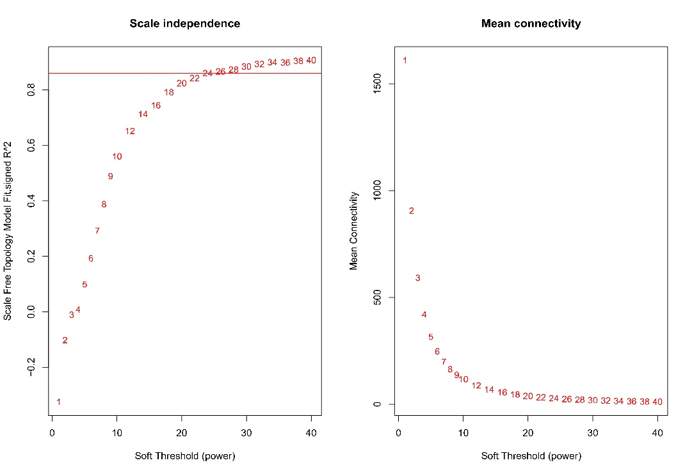
A
B

Figure S3:
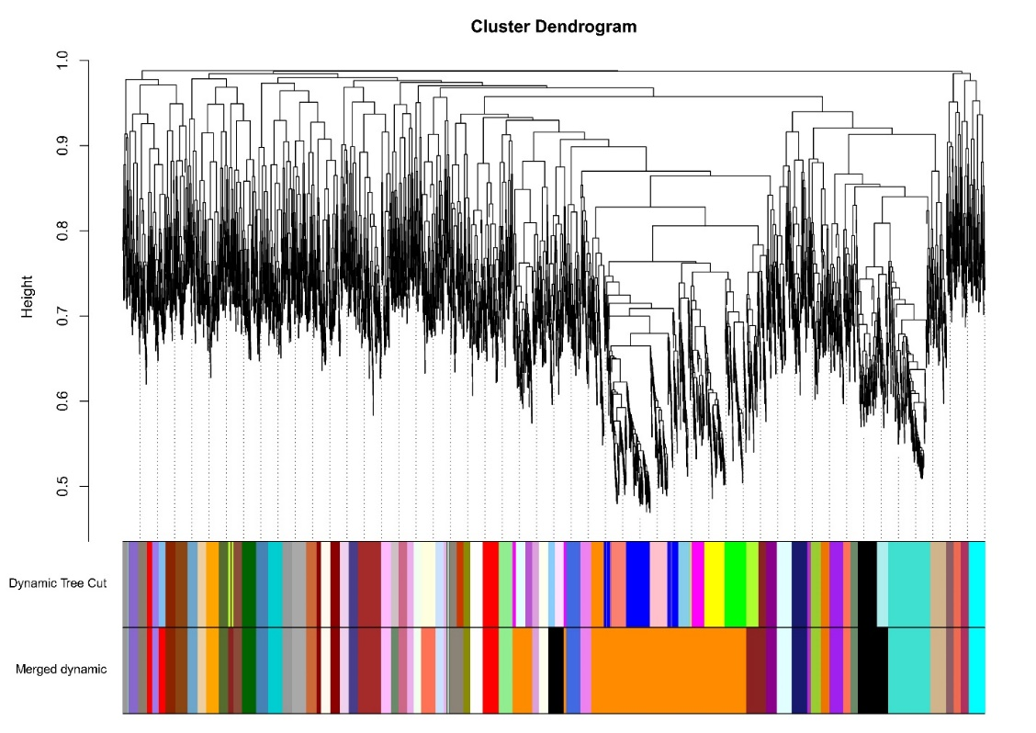
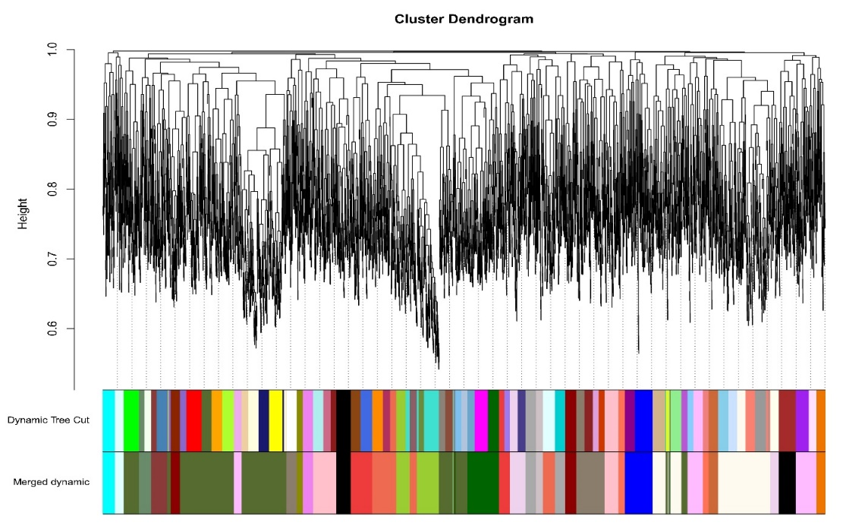
A
B

Figure S4:
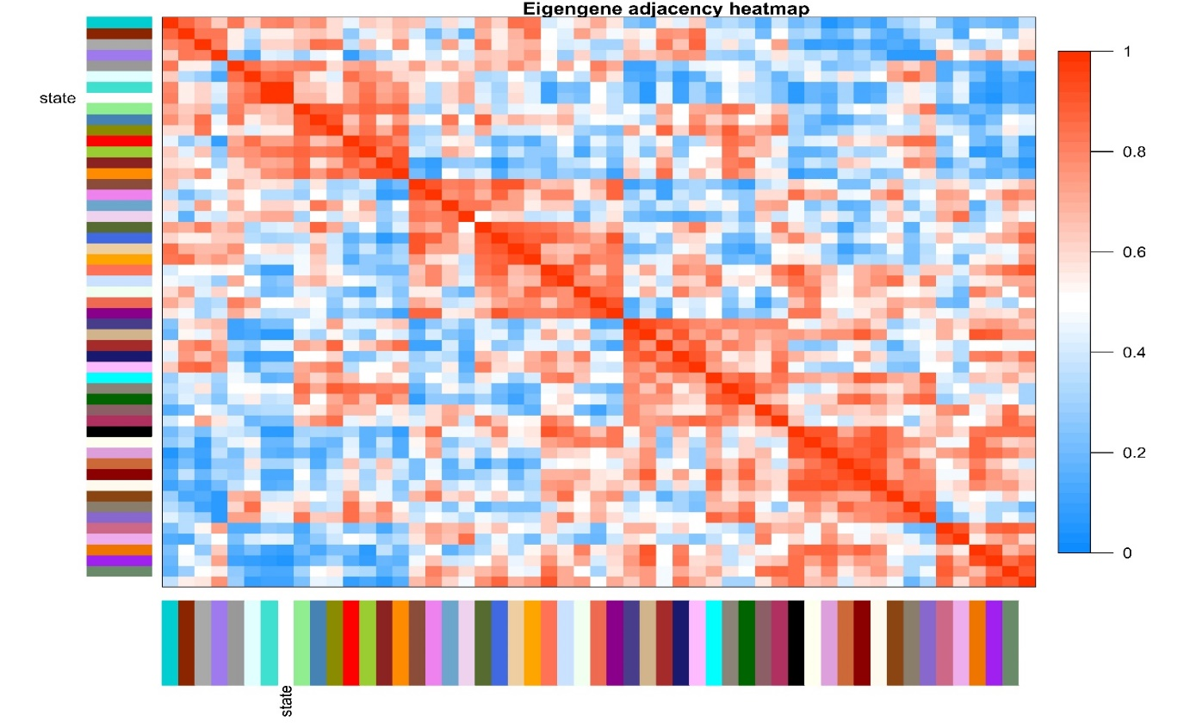
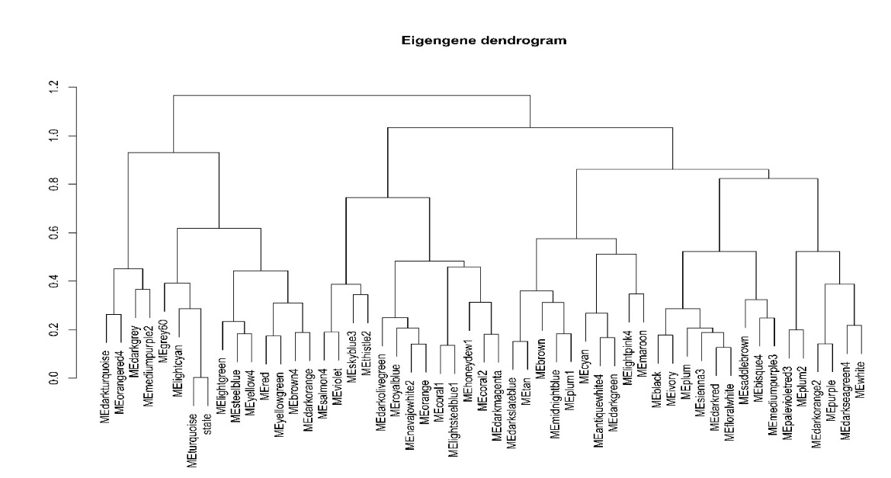
A
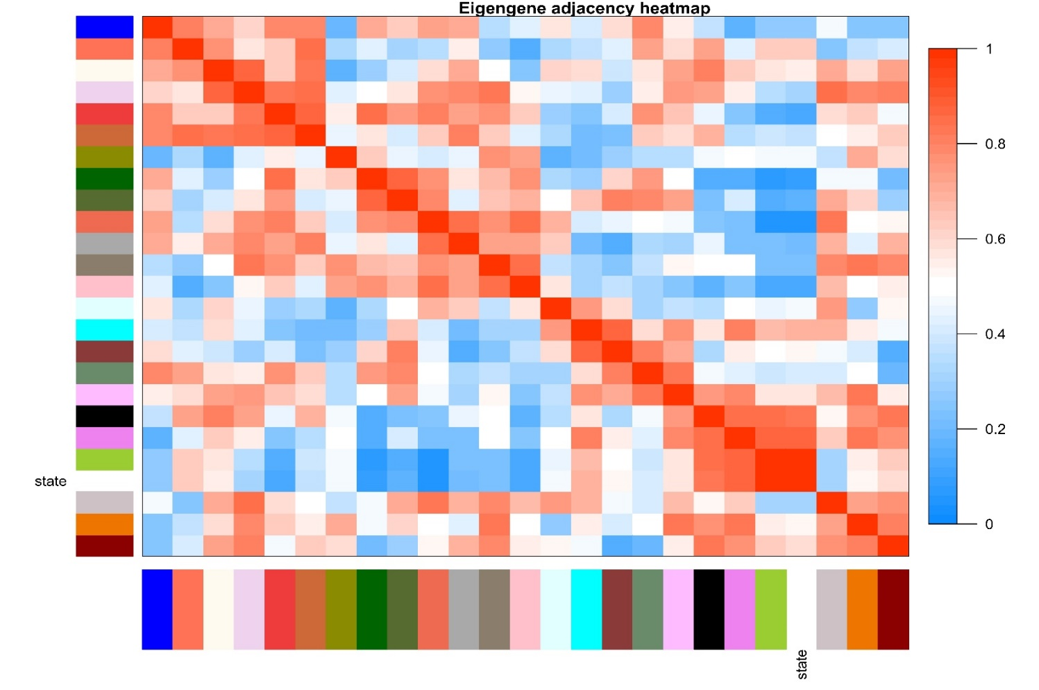
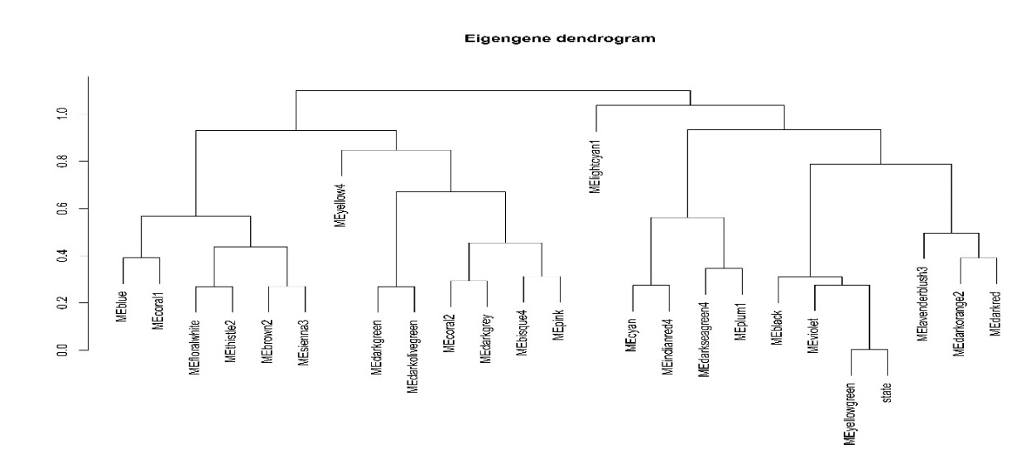
B
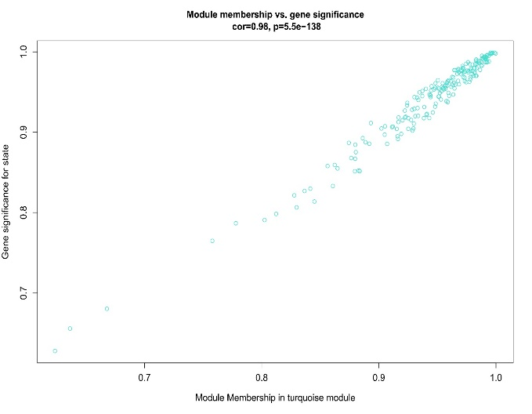
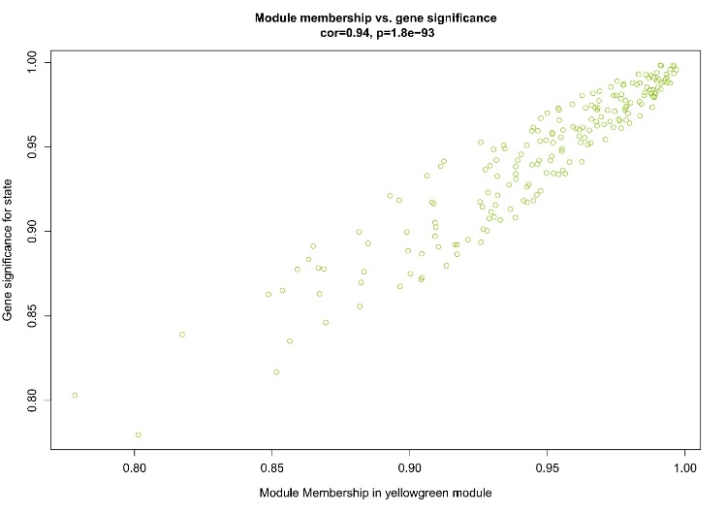
Figure S5:
A
B

