TABLE A.1. Patient and Tumor Characteristics.
 | Atypical Meningiomas (N=132) | Solitary Fibrosis Tumors (N=50) | P Value
Age (years) | 54.07±11.27 | 47.44±12.93 | 0.001
Gender |  |  | 0.01
Male | 46 | 28
Female | 86 | 22
Field Strength |  |  | 0.079
3.0T | 76 | 34
1.5T | 55 | 14
0.5T | 1 | 2
WHO Grade
WHO I |  | 25
WHO II | 132 | 9
WHO III |  | 16
Note: WHO = World Health Organization.

TABLE A.2. MRI Protocols of the Presented Study.
Strength Field | Machine Model, Manufacture | Sequence | TR/TE (ms) | FA (º) | FOV (mm) | Matrix | ST (mm)
1.5 Tesla | Signa Excite, GE Medical Systems | T1WI | 540-1840/20-22 | 90 | 240×180 | 288-320×192-224 | 6
1.5 Tesla | Signa Excite, GE Medical Systems | T2WI | 4000/108 | 90 | 240×180 | 384×288 | 6
1.5 Tesla | Prodiva CX, Philips Healthcare | T1WI | 334/4 | 90 | 220×200 | 276×183 | 5.5
1.5 Tesla | Prodiva CX, Philips Healthcare | T2WI | 3817/90 | 90 | 220×200 | 340×254 | 5.5
1.5 Tesla | Espree, Siemens Healthineers | T1WI | 190/4.76 | 75 | 220×200 | 320×216 | 5
1.5 Tesla | Espree, Siemens Healthineers | T2WI | 6000/108 | 150 | 220×200 | 320×216 | 5
3.0 Tesla | Verio/Skyra/Prisma, Siemens Healthineers | T1WI | 250/2.5 | 70 | 220×220 | 256-320×205-256 | 5
3.0 Tesla | Verio/Skyra/Prisma, Siemens Healthineers | T2WI | 6000/96-125 | 90-150 | 220×220 | 320-384×320-384 | 5
3.0 Tesla | Ingenia, Philips Healthcare | T1WI | 245/1.82 | 80 | 230×230 | 230×230 | 5
3.0 Tesla | Ingenia, Philips Healthcare | T2WI | 4000/102 | 90 | 230×230 | 340×322 | 5
Note: T2WI = T2-weighted imaging; T1WI = T1-weighted imaging; TR = repetition time; TE = echo time; FA = flip angle; FOV = field of view; ST = slice thickness; ms = millisecond; mm = millimeter.
TABLE A.3. Radiomics Features Extracted in This Study.
Feature category | Feature name
First-order statistics features (n = 18) | 10 Percentile, 90 Percentile, Energy, Entropy, Interquartile Range, Kurtosis, Maximum, Mean, Mean Absolute Deviation, Median, Minimum, Range, Robust Mean Absolute Deviation, Root Mean Squared, Skewness, Total Energy, Uniformity, Uniformity
Shape-based features (n = 14) | Elongation, Flatness, Least Axis Length, Major Axis Length, Maximum 2D Diameter Column, Maximum 2D Diameter Row, Maximum 2D Diameter Slice, Maximum 3D Diameter, Mesh Volume, Minor Axis Length, Sphericity, Surface Area, Surface Volume Ratio, Voxel Volume
Gray-level co-occurrence matrices (GLCM) features (n = 24) | Autocorrelation, Cluster Prominence, Cluster Shade, Cluster Tendency, Contrast, Correlation, Difference Average, Difference Entropy, Difference Variance, Id, Idm, Idmn, Idn, Imc1, Imc2, Inverse Variance, Joint Average, Joint Energy, Joint Entropy, MCC, Maximum Probability, Sum Average, Sum Entropy, Sum Squares
Gray-level run-length matrices (GLRLM) features (n = 16) | Gray Level Non-Uniformity, Gray Level Non-Uniformity Normalized, Gray Level Variance, High Gray Level Run Emphasis, Long Run Emphasis, Long Run High Gray Level Emphasis, Long Run Low Gray Level Emphasis, Low Gray Level Run Emphasis, Run Entropy, Run Length Non-Uniformity, Run Length Non-Uniformity Normalized, Run Percentage, Run Variance, Short Run Emphasis, Short Run High Gray Level Emphasis, Short Run Low Gray Level Emphasis
Gray-level size zone matrices (GLSZM) features (n = 16) | Gray Level Non-Uniformity, Gray Level Non-Uniformity Normalized, Gray Level Variance, High Gray Level Zone Emphasis, Large Area Emphasis, Large Area High Gray Level Emphasis, Large Area Low Gray Level Emphasis, Low Gray Level Zone Emphasis, Size Zone Non-Uniformity, Size Zone Non-Uniformity Normalized, Small Area Emphasis, Small Area High Gray Level Emphasis, Small Area Low Gray Level Emphasis, Zone Entropy, Zone Percentage, Zone Variance
Gray-level dependence matrices (GLDM) features (n = 14) | Dependence Entropy, Dependence Non-Uniformity, Dependence Non-Uniformity Normalized, Dependence Variance, Gray Level Non-Uniformity, Gray Level Variance, High Gray Level Emphasis, Large Dependence Emphasis, Large Dependence High Gray Level Emphasis, Large Dependence Low Gray Level Emphasis, Low Gray Level Emphasis, Small Dependence Emphasis, Small Dependence High Gray Level Emphasis, Small Dependence Low Gray Level Emphasis
Neighborhood gray-tone difference matrices (NGTDM) features (n = 5) | Busyness, Coarseness, Complexity, Contrast, Strength
Note: 2D = two dimension; Id = Inverse Difference; Idm = Inverse Difference Moment; Idmn = Inverse Difference Moment Normalized; Idn = Inverse Difference Normalized; Imc = Informal Measure of Correlation; MCC = Maximal Correlation Coefficient.

TABLE A.4. P Values of the Radiomics Models and the Radiologist’s Assessment by Delong Test.
 |  | T1WI-  Reader B | T2WI-  Reader B | rT1_{thalamus} | rT1_{centrum semiovale} | Radiomics  -T1WI | Radiomics  -T2WI | Radiomics  -T1&T2WI
Training | T1WI-  Reader B | - | - | - | - | - | - | -
Training | T2WI-  Reader B | 0.468 | - | - | - | - | - | -
Training | rT1  _{thalamus} | 0.216 | 0.896 | - | - | - | - | -
Training | rT1_{centrum semiovale} | 0.098 | 0.669 | 0.393 | - | - | - | -
Training | Radiomics -T1WI | 0.001 | 0.001 | 0.001 | 0.001 | - | - | -
Training | Radiomics  -T2WI | 0.003 | 0.001 | 0.001 | 0.001 | 0.941 | - | -
Training | Radiomics  -T1&T2WI | 0.001 | 0.001 | 0.001 | 0.001 | 0.001 | 0.006 | -
Testing | T1WI-  Reader B | - | - | - | - | - | - | -
Testing | T2WI-  Reader B | 0.260 | - | - | - | - | - | -
Testing | rT1  _{thalamus} | 0.364 | 0.560 | - | - | - | - | -
Testing | rT1_{centrum semiovale} | 0.617 | 0.378 | 0.112 | - | - | - | -
Testing | Radiomics  -T1WI | 0.485 | 0.409 | 0.159 | 0.906 | - | - | -
Testing | Radiomics  -T2WI | 0.740 | 0.313 | 0.106 | 0.904 | 0.760 | - | -
Testing | Radiomics  -T1&T2WI | 0.736 | 0.066 | 0.205 | 0.321 | 0.095 | 0.111 | -
Note: T2WI = T2-weighted imaging; T1WI = T1-weighted imaging.

TABLE A.5. Correlation between MR Imaging Parameters and Collagen Volume Fraction for 47 SFTs.
MR Imaging Parameters |  | r | P Value
Qualitative Parameters | T1WI-Reader B | -0.374 | 0.010
Qualitative Parameters | T2WI-Reader B | -0.449 | 0.002
Quantitative Parameters | rT1_{thalamus} | -0.380 | 0.008
Quantitative Parameters | rT1_{centrum semiovale} | -0.352 | 0.015
Quantitative Parameters | rT2_{thalamus} | -0.237 | 0.109
Quantitative Parameters | rT2_{centrum semiovale} | -0.232 | 0.117
Radiomics  Features | T1_original_glcm_JointEntropy | -0.136 | 0.361
Radiomics  Features | T1_original_glcm_SumEntropy | -0.100 | 0.504
Radiomics  Features | T1_original_shape_Elongation | -0.265 | 0.072
Radiomics  Features | T1_original_shape_Sphericity | -0.035 | 0.815
Radiomics  Features | T1_original_shape_SurfaceVolumeRatio | 0.033 | 0.825
Radiomics  Features | T1_wavelet-HHH_firstorder_Kurtosis | 0.081 | 0.587
Radiomics  Features | T1_wavelet-HHL_gldm_DependenceVariance | -0.066 | 0.661
Radiomics  Features | T1_wavelet-HLH_glrlm_LongRunEmphasis | -0.056 | 0.709
Radiomics  Features | T1_wavelet-LHH_glcm_ClusterShade | 0.165 | 0.267
Radiomics  Features | T1_wavelet-LHL_glrlm_LongRunEmphasis | -0.013 | 0.930
Radiomics  Features | T1_wavelet-LHL_glszm_SizeZoneNonUniformityNormalized | 0.083 | 0.580
Radiomics  Features | T1_wavelet-LHL_glszm_ZoneEntropy | -0.204 | 0.169
Radiomics  Features | T1_wavelet-LLH_firstorder_Mean | -0.040 | 0.789
Radiomics  Features | T1_wavelet-LLH_glrlm_GrayLevelVariance | -0.187 | 0.208
Radiomics  Features | T1_wavelet-LLH_glszm_GrayLevelVariance | -0.138 | 0.356
Radiomics  Features | T2_original_firstorder_10Percentile | -0.241 | 0.103
Radiomics  Features | T2_original_shape_Elongation | -0.265 | 0.072
Radiomics  Features | T2_original_shape_Sphericity | -0.035 | 0.815
Radiomics  Features | T2_original_shape_SurfaceVolumeRatio | 0.033 | 0.825
Radiomics  Features | T2_wavelet-HHL_glszm_LowGrayLevelZoneEmphasis | -0.190 | 0.200
Radiomics  Features | T2_wavelet-HHL_glszm_SmallAreaEmphasis | -0.101 | 0.500
Radiomics  Features | T2_wavelet-HLH_glcm_DifferenceAverage | 0.028 | 0.852
Radiomics  Features | T2_wavelet-HLH_glszm_SmallAreaLowGrayLevelEmphasis | -0.059 | 0.693
Radiomics  Features | T2_wavelet-HLL_firstorder_Kurtosis | 0.107 | 0.472
Radiomics  Features | T2_wavelet-LHL_glcm_InverseVariance | -0.087 | 0.559
Radiomics  Features | T2_wavelet-LHL_gldm_DependenceEntropy | 0.08 | 0.593
Radiomics  Features | T2_wavelet-LLH_glszm_SizeZoneNonUniformityNormalized | -0.018 | 0.906
Note: T2WI = T2-weighted imaging; T1WI = T1-weighted imaging.

FIGURE A.1: Flow chart depicting the patient selection process. ATMs, atypical meningioms; SFTs, solitary fibrous tumors.
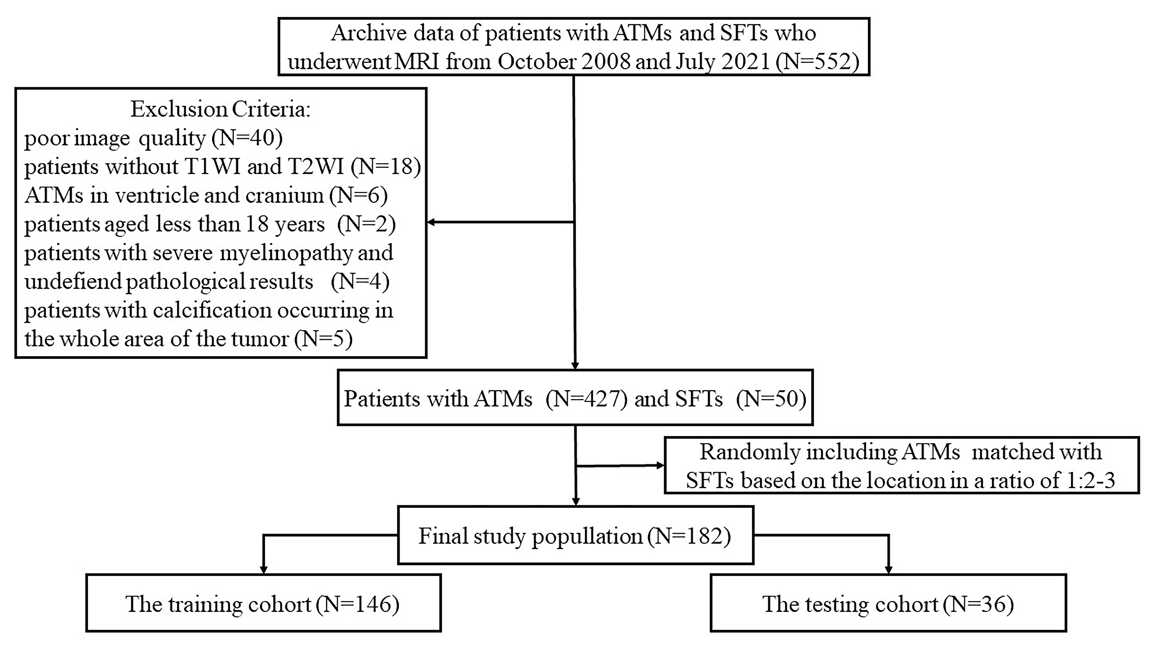

FIGURE A.2: Radiomics workflow. REF, Recursive Feature Elimination; LR, logistic regression; ROC, receiver-operating characteristic.
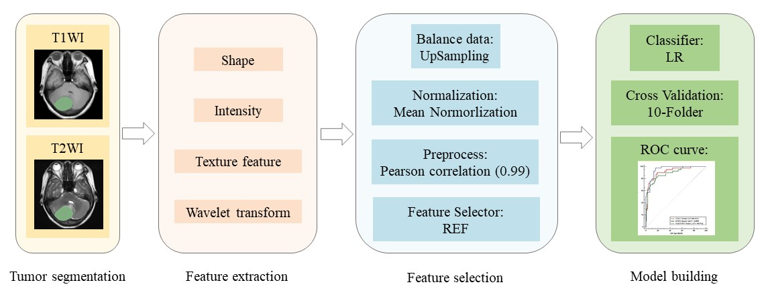

FIGURE A.3: Heat map of correlations between imaging features and collagen volume fraction among 47 patients of solitary fibrous tumors.

