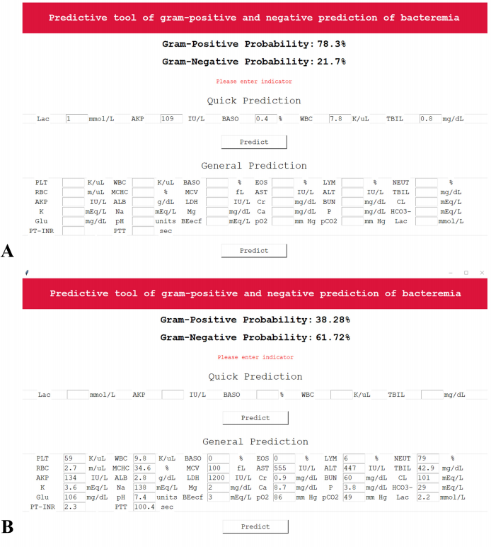
Figure S1 Interface of the prediction system based on the RF and DT models. A: Prediction interface based on Quick Prediction (for the DT model); B: prediction interface based on General Prediction (for the RF model).

