The recombinant L-Lysine α-oxidase from the fungus Trichoderma harzianum promotes apoptosis and necrosis of leukemia CD34+ hematopoietic cells
Mariana do Nascimento Costa¹, Thiago Aparecido Silva², Dimitrius Santiago Passos Simões Fróes Guimarães³, Rafael Ricci-Azevedo² Felipe Roberti Teixeira⁴, Leonardo Reis Silveira³, Marcelo Damário Gomes¹, Vítor Marcel Faça¹, Eduardo Brandt de Oliveira¹, Rodrigo T. Calado⁵, and Roberto N. Silva^{1*}

SUPPLEMENTARY MATERIAL
- Cloning of LO
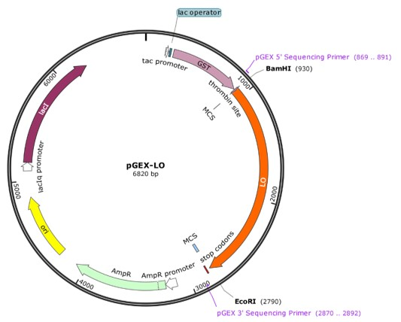

Figure S1. pGEX-4T1-LO vector map. The pGEX-4T1 bacterial vector is used to express GST-fused proteins. The vector has a multiple cloning region that contains several restriction sites. In orange: LO gene was added between BamHI and EcoRI restriction sites. Between the GST domain and the cloning sites there is a thrombin recognition site that allows GST removal. It also has a lac promoter for induction with IPTG and a gene that attributes resistance to ampicillin.

- Purification of native LO
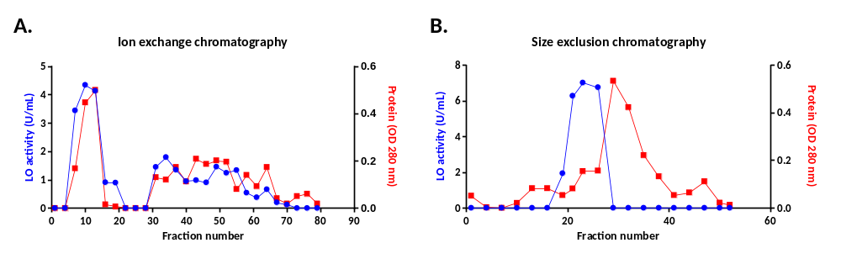
Figure S2. Purification of native rLO. (A) Step 1: Ion exchange chromatography. The native LO protein was purified based on its isoelectric point by DEAE Sephadex column forcation exchange chromatography. The graph shows the enzyme activity (o) and protein profile () of the fractions collected through the salt gradient. (B) Stel 2: Size exclusion chromatography. The LO protein was selected from it molecular size in a Sephacryl S-200 HR column. The graph shows the enzyme activity profile and the protein content of the fractions collected. The blue line shows the LO activity and the red line shows the absorbance at 280 nm.
Table 1. Purification yield of native LO.
 | LO activity (U/mL) | Yield (%) | Protein concentration (mg/mL) | LO specific activity (U/mg)
Crude extract | 13.37 | 100 | 0.655 | 20.41
Ion exchange chromatography | 7.178 | 53.7 | 0.307 | 23.38
Size exchange chromatography | 5.14 | 38.4 | 0.198 | 26.11

- Purification of recombinant LO
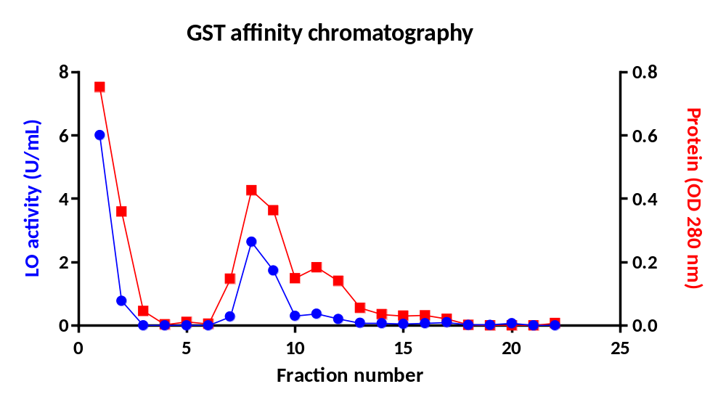
Figure S3. Purification of rLO. (A) Chromatographic profile of rLO purification by affinity chromatography. In blue: enzymatic activity of the fractions collected. In red: Absorbance of the samples at 280 nm.The firsts fractions The first fractions correspond to the crude extract. After washing the column, the enzyme activity falls and rises again when the elution of rLO begins

- Enzymatic characterization of rLO

Table 2. Substrate specificity data of rLO for different L-amino acids.
Amino acid* | Activity (U/mL) | Relative Activity (%)
L-lysine | 5.237 | 100
L-arginine | 1.591 | 30.4
L-phenylalanine | 1.162 | 22.2
*rLO was ineffective with others L-amino acids
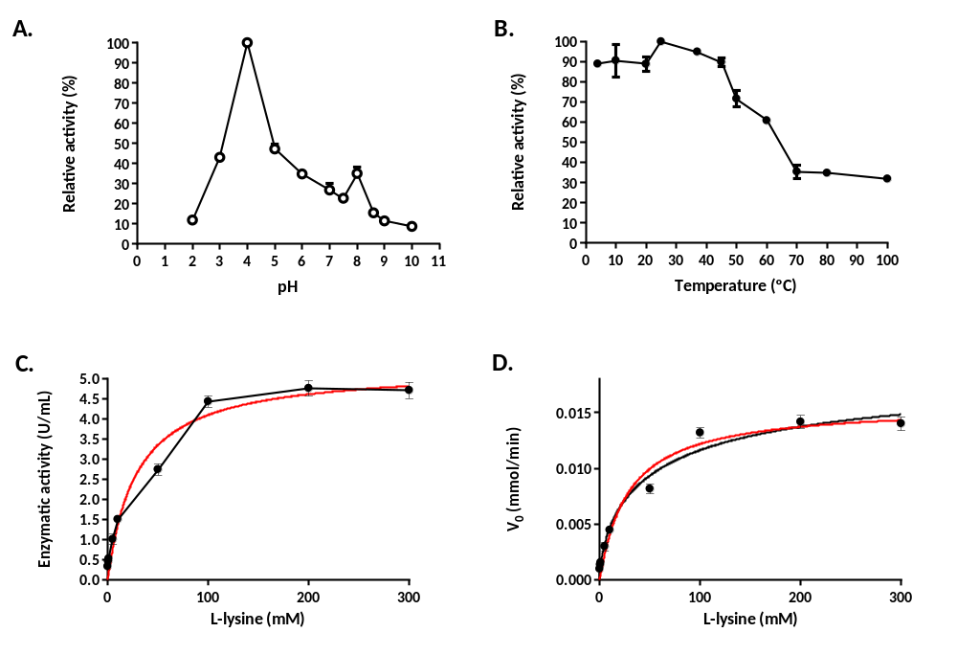
Figure S4. Enzymatic characterization of rLO. (A) Effect of pH on rLO in percentage of relative activity. The tested pHs were: 2, 3, 4, 5, 6, 7, 7.5, 8, 8.6, 9 and 10 with different buffers. (B) Effect of temperature on rLO activity. The incubation temperatures tested were 4, 10, 20, 25, 37, 50, 60, 70, 80 and 100 ºC. (C) Effect of substrate concentration on rLO activity. The concentrations used were: 0.1, 0.5, 1, 5, 10, 50, 100, 200, and 300 mM of L-lysine. (D) Graph of substrate concentration versus initial velocity (V0) to determine the Michaelis-Menten constant (K_{M}/ K_{0.5}) and Maximum velocity (V_{máx}).

Table 3. Kinetic parameters calculated for rLO with L-lysine as substrate.
Parameter | rLO
K_{M} (mM) | 28.84
Vmáx (µmol/min) | 0.01569
n_{H} | 0.933
- Influence of GST on rLO cytotoxicity
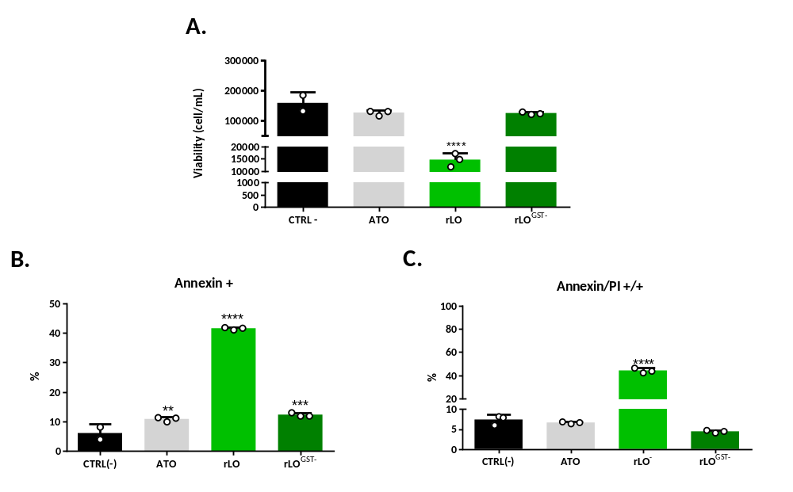
Figure S5. Comparison of the effect of rLO and rLO^{GST-}. The L-lysine oxidase enzyme was produced in E. coli by transforming the cloned vector pGEX-4T1-LO. The protein was expressed fused to Gluthatione-S-transferase protein (GST). GST can be separated from rLO through a reaction with the enzyme Thrombin, since there is a restriction site for this enzyme located between LO and GST. A comparative analysis of the two enzymes (with and without GST) was carried out regarding the toxicity of both in Jurkat cells. A) Viability of Jurkat cell treated with rLO and rLO^{GST-}. B) Percentage of positive cell for Annexin (cells in apoptosis). B) Percentage of positive cells in late apoptosis (double marker for Annexin and PI). rLO: with GST. rLO^{GST-}: whithout GST.
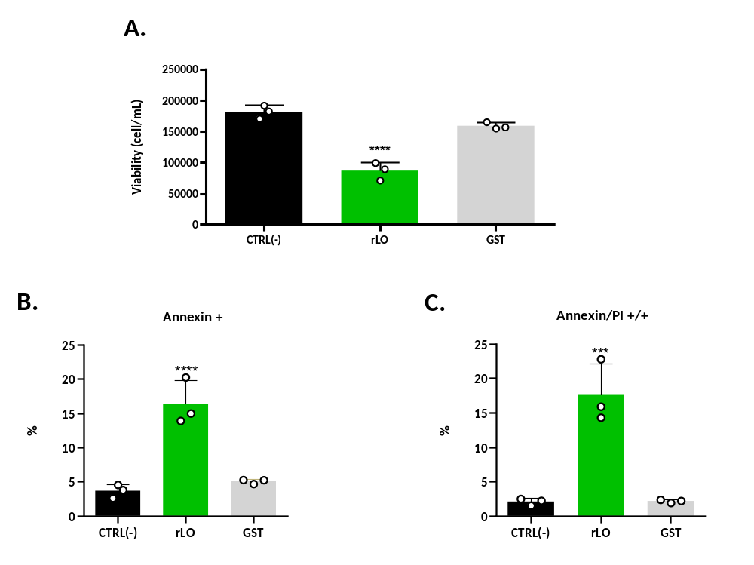
Figure S6. Influence of GST in rLO cytotoxicity. The effect of the protein Glutathione S-transferase in Jurkat cells was evaluated in comparison with rLO. GST was produced in E. coli by transforming the empty vector pGEX-4T1 (without LO gene). A) Viability of Jurkat cell treated with rLO and rLO^{GST-}. B) Percentage of positive cell for Annexin (cells in apoptosis). B) Percentage of positive cells in late apoptosis (double marker for Annexin and PI).

- Evaluation of gene expression of autophagy, JNK and p8 pathways

Table 4. List of signaling pathways, genes and primers whose expression were evaluated by qPCR
Pathway | Gene | Sense | Sequence
Autophagy | MAP1LC3A | F | AACATGAGCGAGTTGGTCAAG
Autophagy | MAP1LC3A | R | GCTCGTAGATGTCCGCGAT
JNK | TP53 | F | CCTCAGCATCTTATCCGAGTGG
JNK | TP53 | R | TGGATGGTGGTACAGTCAGAGC
Autophagy | ATG7 | F | CGTTGCCCACAGCATCATCTTC
Autophagy | ATG7 | R | CACTGAGGTTCACCATCCTTGG
JNK | Cyclin E | F | TGTGTCCTGGATGTTGACTGCC
JNK | Cyclin E | R | CTCTATGTCGCACCACTGATACC
JNK | Rbp | F | CTCTCGTCAGGCTTGAGTTTG
JNK | Rbp | R | GACATCTCATCTAGGTCAACTGC
p38 | p21 | F | AGGTGGACCTGGAGACTCTCAG
p38 | p21 | R | TCCTCTTGGAGAAGATCAGCCG
p38 | Elk1 | F | GCTGCCTCCTAGCATTCACTTC
p38 | Elk1 | R | CCACGCTGATAGAAGGGATGTG
p38 | ATF2 | F | GGTAGCGGATTGGTTAGGACTC
p38 | ATF2 | R | TGCTCTTCTCCGACGACCACTT
p38 | cJUN | F | CCTTGAAAGCTCAGAACTCGGAG
p38 | cJUN | R | TGCTGCGTTAGCATGAGTTGGC

