Supplementary methods: Description of the five different indicators used to calculate the functional diversity.

Physical distance indicator (PDI). The geometric centroids of all geographical areas employed in the study were calculated using the GIS software ArcMap (https://desktop.arcgis.com/en/arcmap/). Then, the PDI was obtained by calculating the Euclidian distance from the centroid of each area to the centroid of all other areas.
Climate indicator (CI). To account for different climates across cities in the United States, the Palmer Drought Severity Index (PDSI) was used¹. The monthly PDSI was obtained from the National Oceanic and Atmospheric Administration for the years 1895–2015 at the climate division geographic level. An area-weighted average was performed to aggregate the PDSI data at the metropolitan level. The CI was obtained by calculating the monthly correlation between an area and all other areas.
Urban classification indicator (UCI). To identify the urbanization level of a geographical area, the urban-rural classification indicator from the National Center for Health Statistics was employed². The indicator classifies counties on a scale from 1 to 6, where a value of 1 indicates that the county is highly rural and a value of 6 means highly urban. The UCI was obtained at the metropolitan level using an area-weighted average of the county-level values.
Network modularity indicator (NMI). This indicator identifies areas or network nodes that belong to the same community. A community is a group of nodes whose strength interactions are stronger than those with the rest of the network. To identify the network communities, we aggregated the flows from the four food sectors (crops, live animals, feed, and meat) considered in this study into a single-layer network. The communities were then identified by maximizing the Newman modularity measure^{3,4} using the greedy optimization algorithm of Blondel et al.^{5,6}. Network nodes that lie in the same community were assigned an NMI of 1 and 0 otherwise.
Economic specialization indicator (ESI). Each area was assigned a score based on the dominant domestic exporting economic sector of the area. Areas that export mainly crop products were given an ESI of 1, livestock products an ESI of 2, animal feed products an ESI of 3, and meat products an ESI of 4. The dominant exporting sector of each area was determined using the food flow networks derived from the FAF4 database⁷.

Supplementary Figures

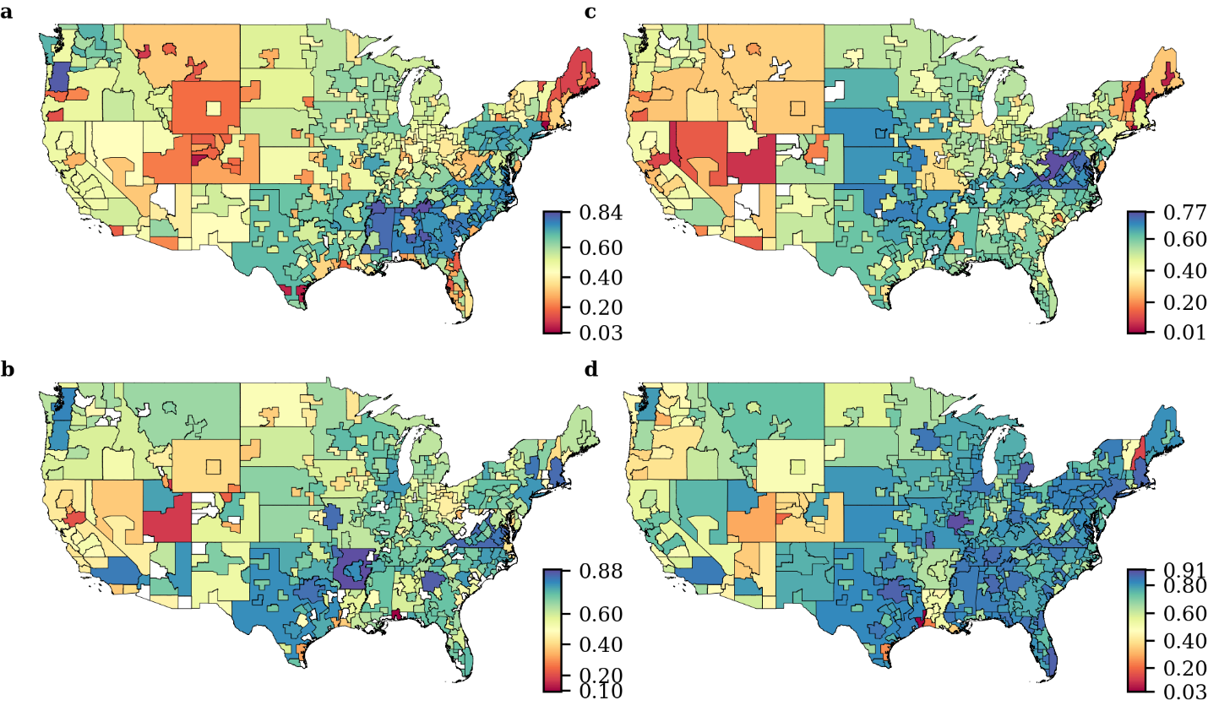
Supplementary Fig. 1: Average supply chain diversity.
a–d, Average supply chain diversity for the 2012–2015 period for the crop (a), feed (b), livestock (c), and meat (d) sectors.

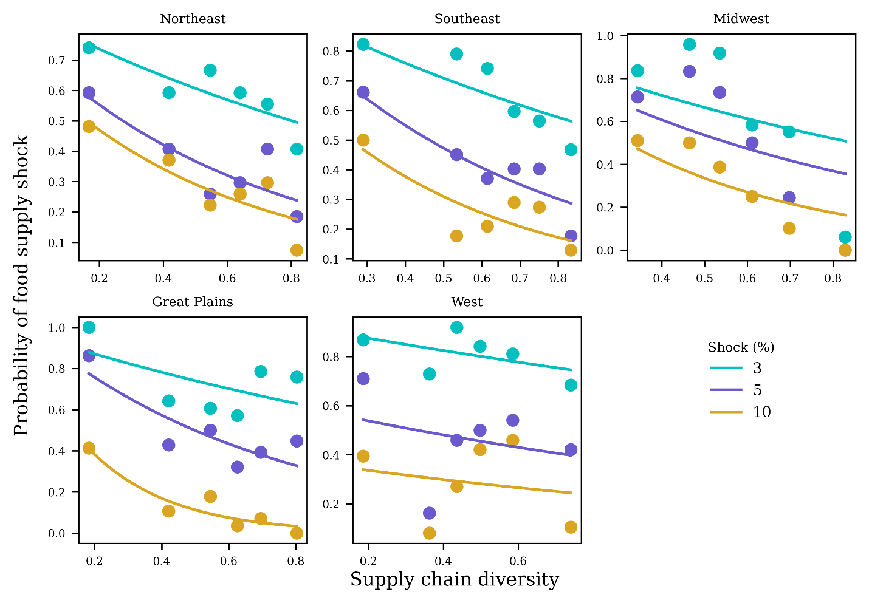
Supplementary Fig. 2: Relationship between supply chain diversity and the probability of food supply shock for different climate regions and shock intensities.
Food systems—each food system consists of the supply chain for one of the cities’ four food sectors—in each climate region were classified into 6 bins of supply chain diversity. The probability of food supply chain shock in each bin was calculated as the number of food systems with shocks larger than a shock intensity s divided by the total number of food systems in the bin⁸. The curves are exponential fits of the relationship of the form $y=exp(-kx+Do)$, where the parameters k and D_{o} were estimated using nonlinear least squares regression. The Northern and Southern Great Plains (Great Plains) and northwestern and southwestern (western) regions were combined to increase the sample size for the probability of shock calculations in each region. An inverse relationship between the probability of shock and supply chain diversity was observed for cities across all climate regions except for western cities, where the observed relationship was only weakly negative. Western cities have consistently low supply chain diversity and, on average, the lowest in the United States, which explains the observed weak negative relationship between supply chain diversity and the probability of food supply shock.

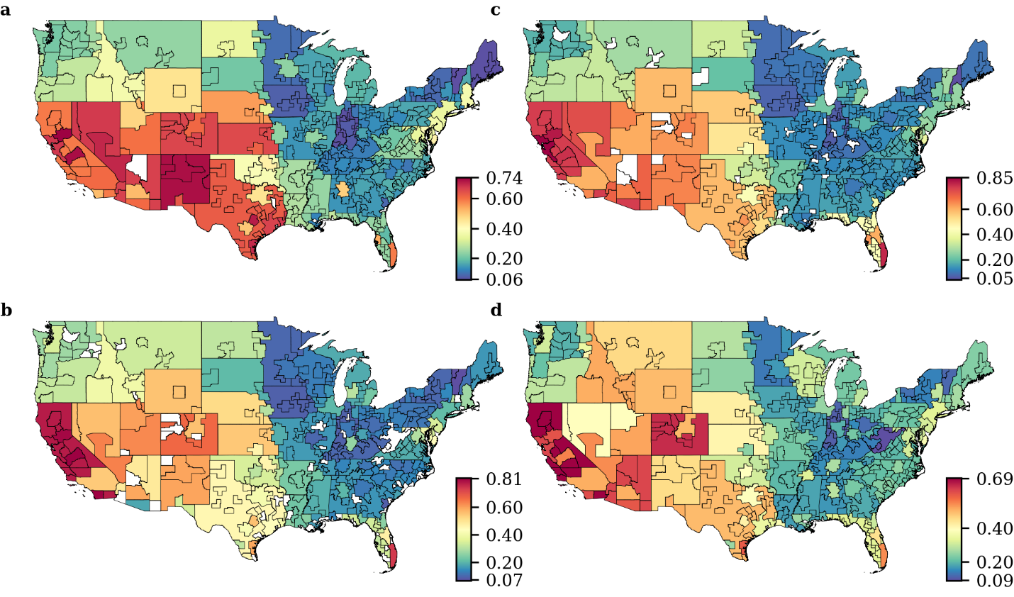
Supplementary Fig. 3: Supply chain exposure to water stress.
a–d, Average supply chain exposure to water stress for the 2012–2015 period for the crop (a), feed (b), live animal (c), and meat (d) sectors.

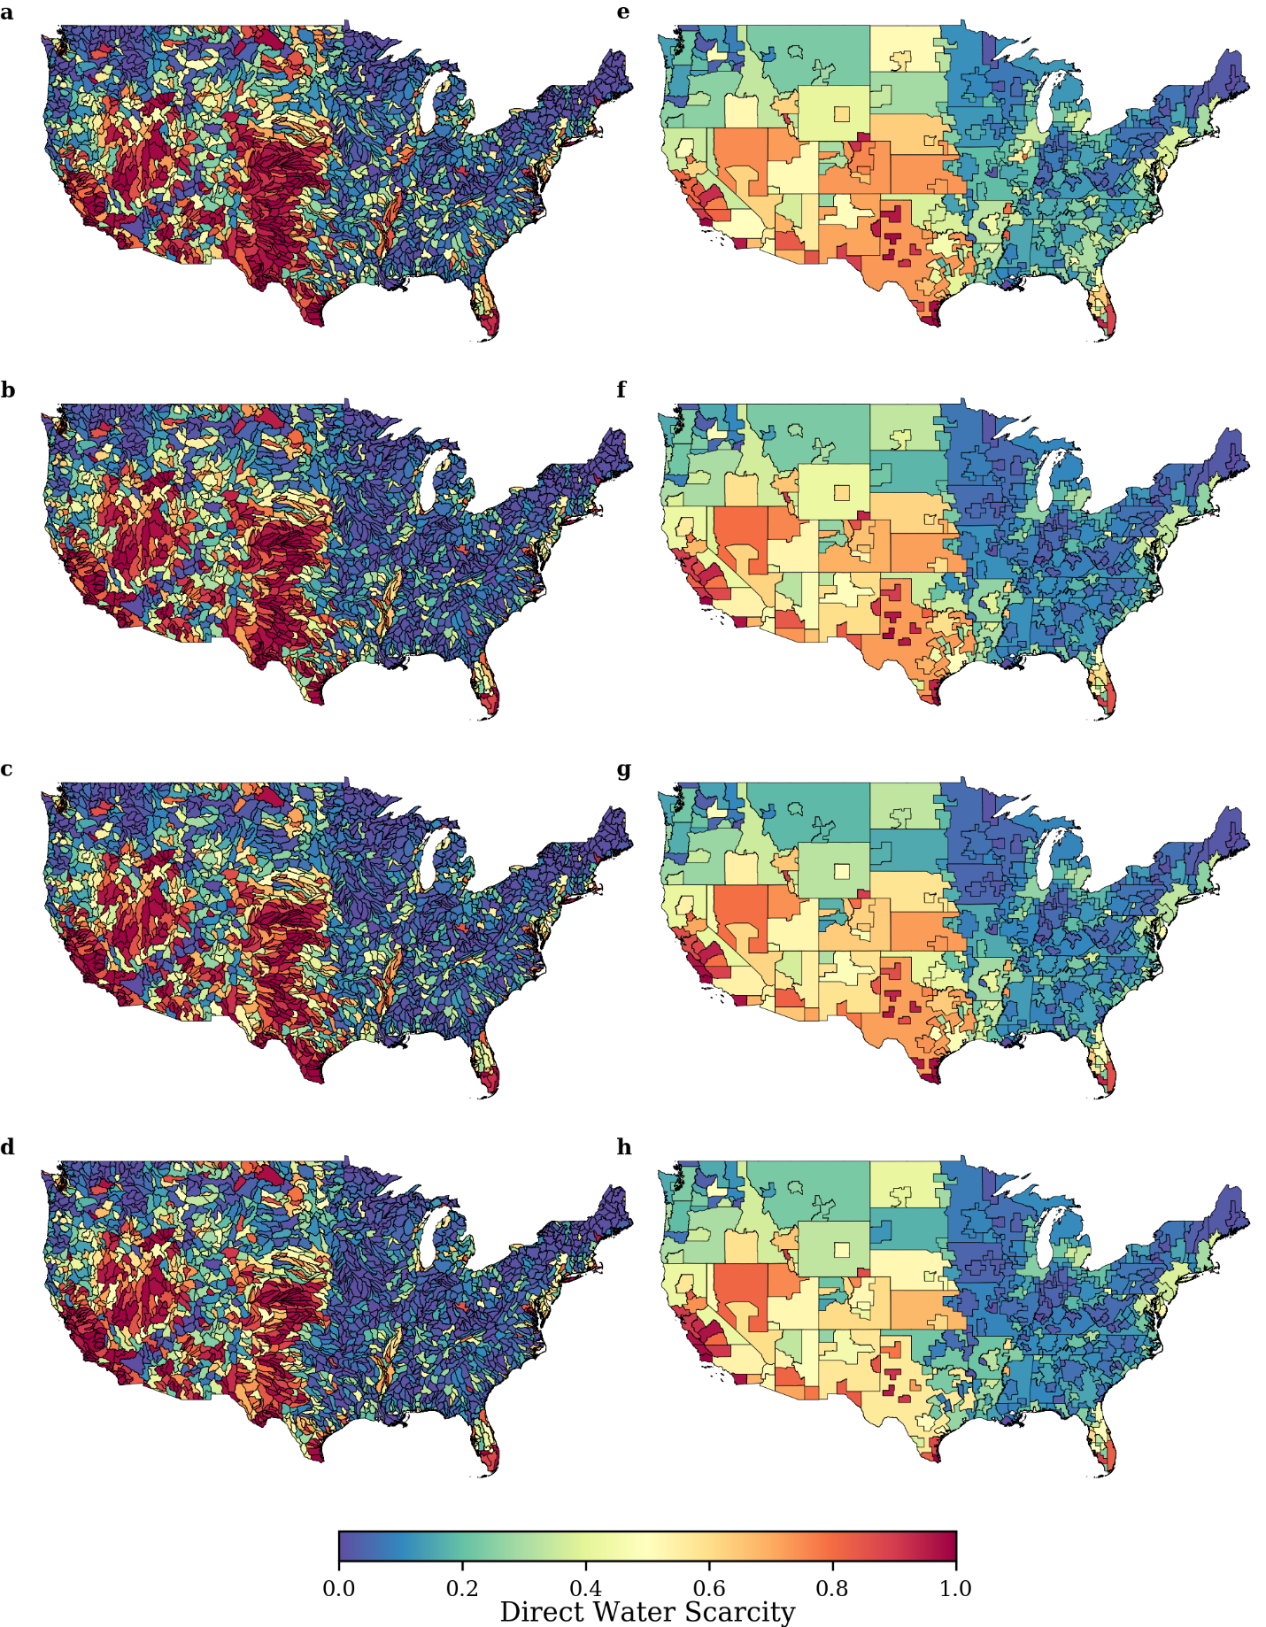
Supplementary Fig. 4: Direct water stress index.
a–j, Spatial distribution of the direct water stress index at the HUC8 level (a–d) and the metropolitan level (f–j) for the years 2012 (a,e), 2013 (b,f), 2014 (c,g), and 2015 (d,h).

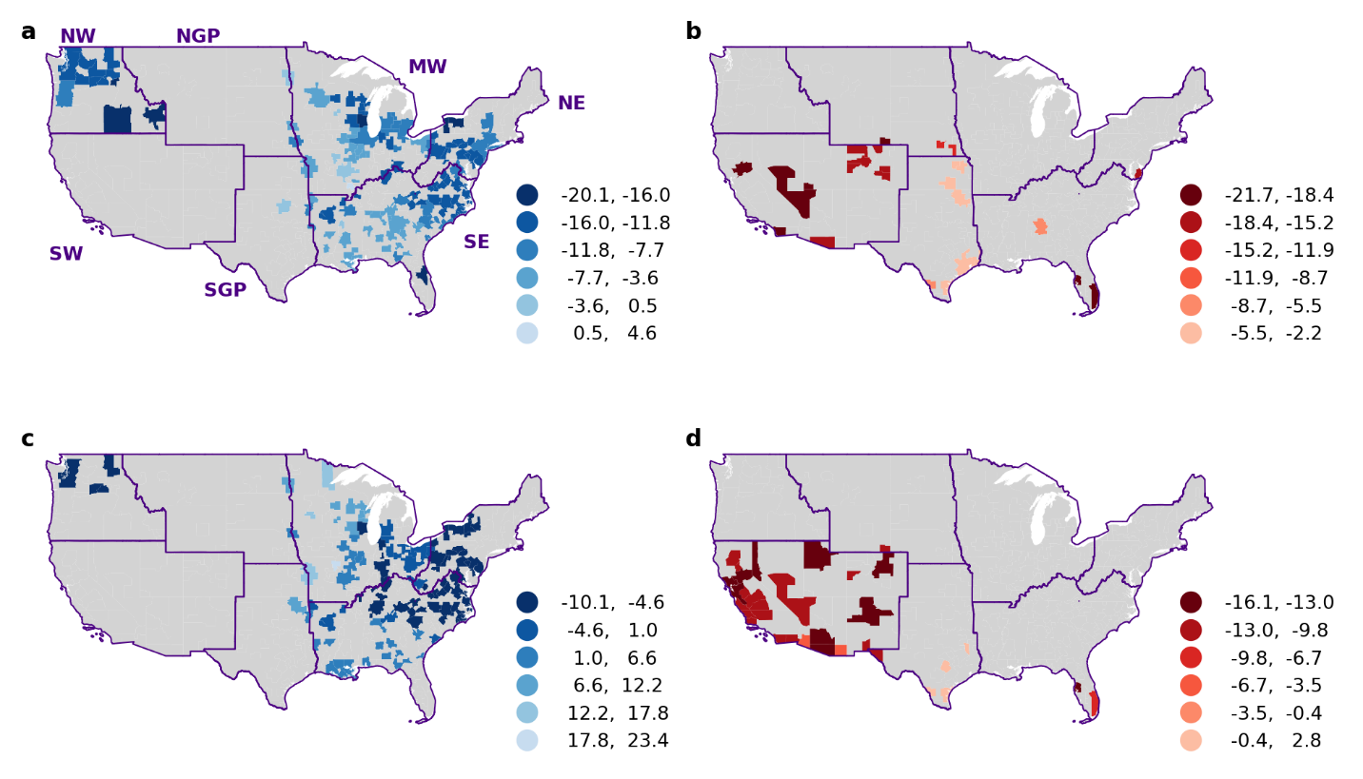
Supplementary Fig. 5: Annual food supply change.
a–d, Annual food supply change for cities in the high-SCD and low-SCE (a,c) and low-SCD and high-SCE (b,d) clusters for the crop (a,b) and live animal (c,d) sectors.

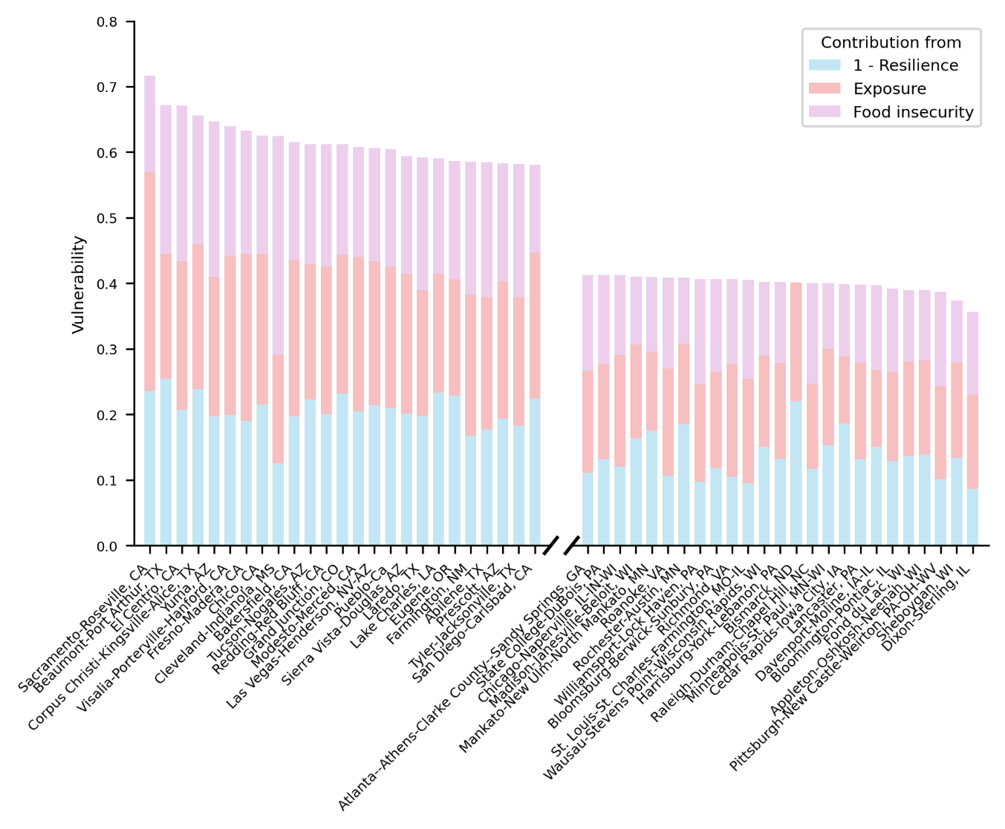
Supplementary Fig. 6: City vulnerability.
Top and bottom 25 cities in terms of vulnerability. The contribution from each indicator is indicated by the colors of the stacked bars.

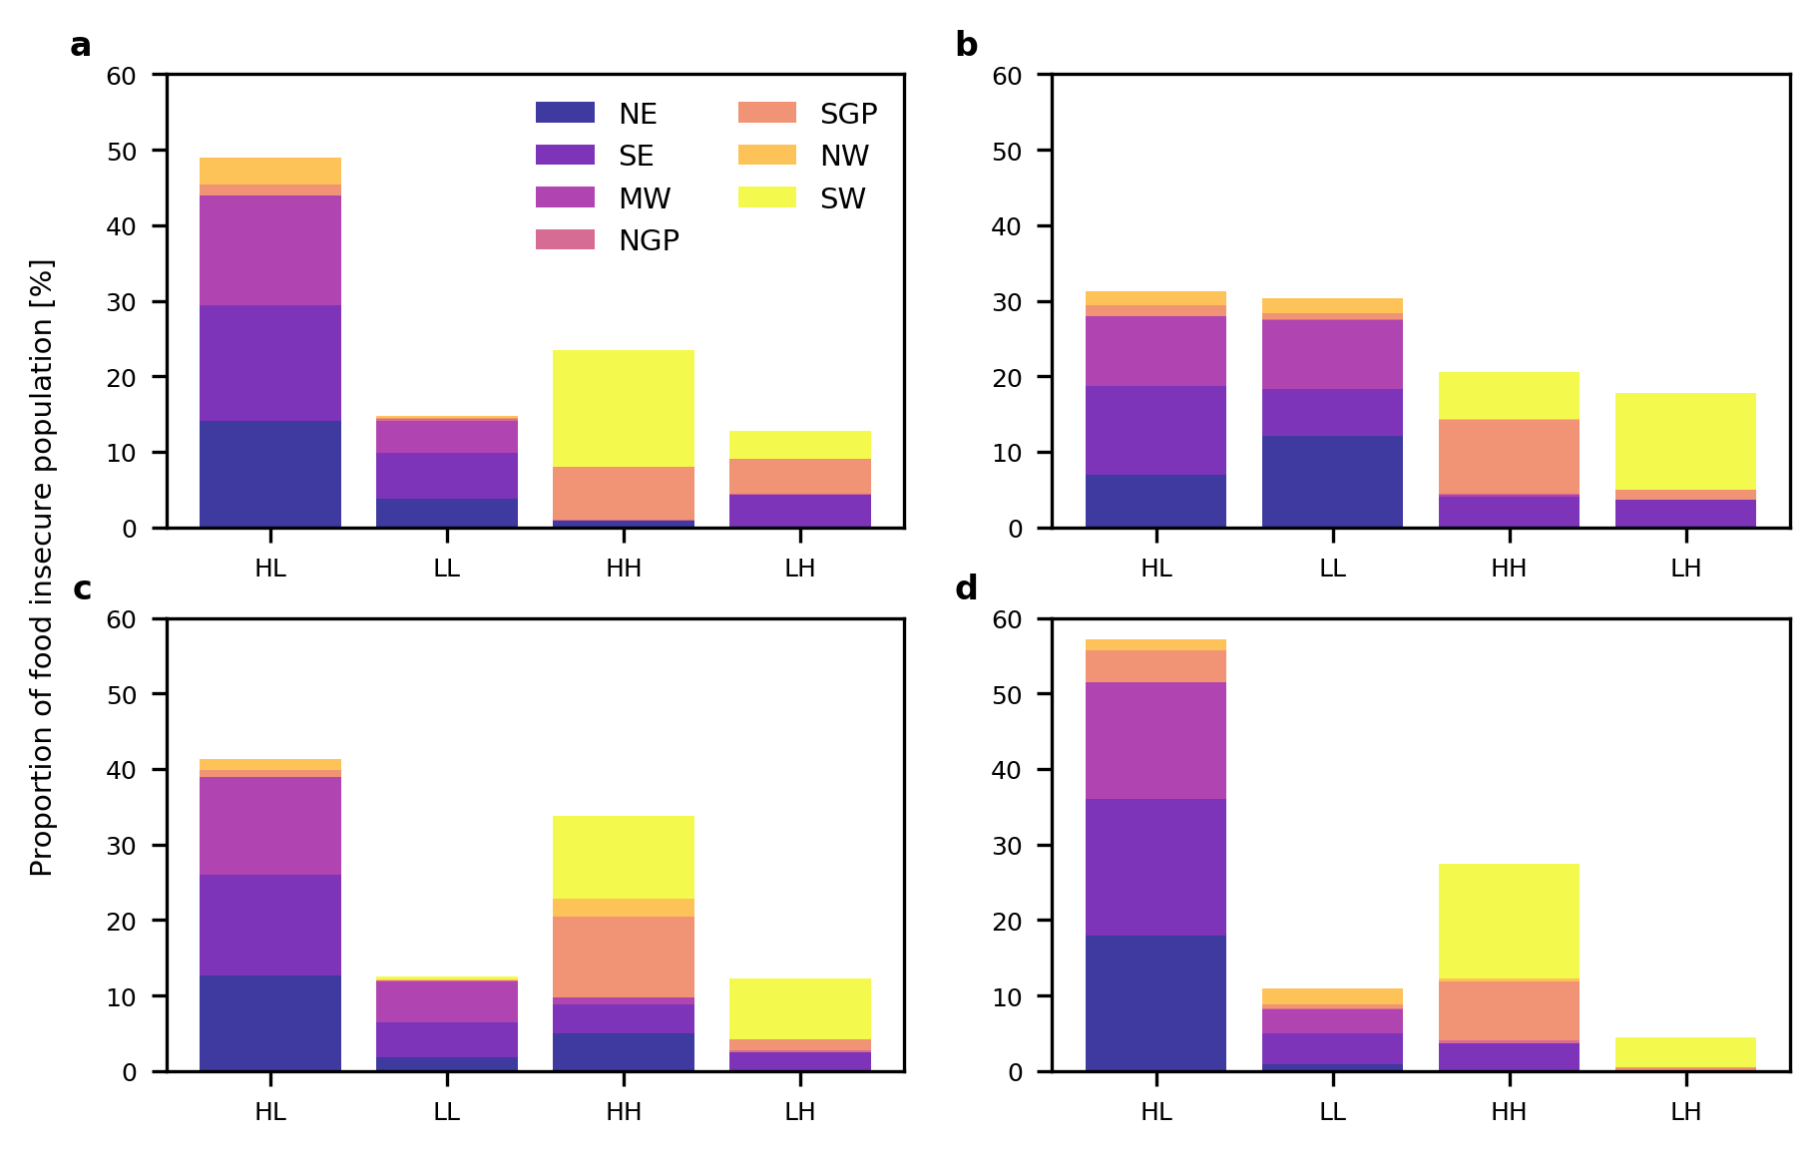
Supplementary Fig. 7: U.S. food insecurity.
a–d, Proportion of U.S. urban food-insecure population by resilience-exposure clusters for crops (a), live animal (b), feed (c), and meat (d).

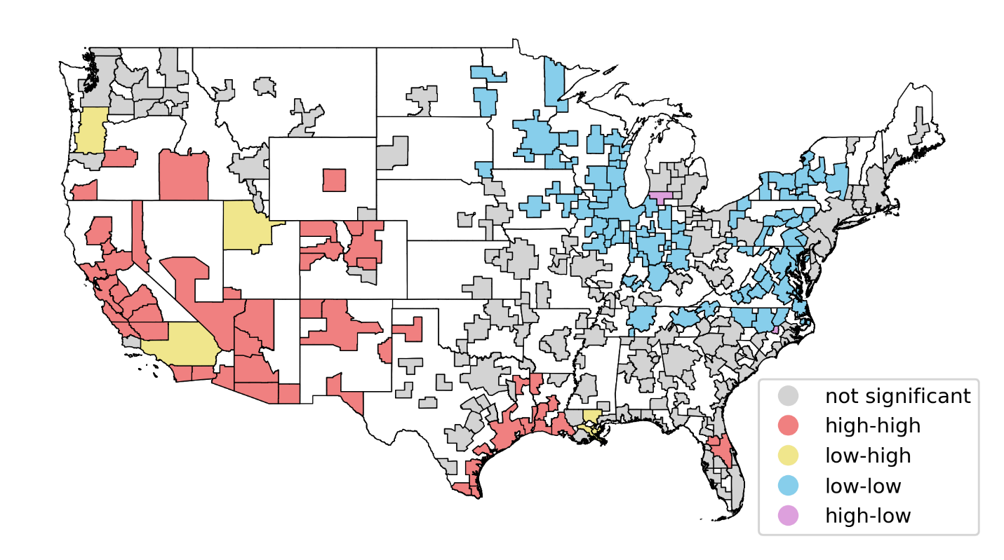
Supplementary Fig. 8: Local spatial autocorrelation of the vulnerability of U.S. cities to food shock.
The local spatial autocorrelation analysis was carried out in Python using the Exploratory Spatial Data Analysis library (esda)⁹, especifically the Moran_Local() function [esda.moran.Moran_Local()] with a 0.10 significance level. With this analysis, cities were divided into four clusters depending on their own vulnerability and the vulnerability of their neighbors. The high-high cluster (red) is composed of cities with high vulnerability surrounded by other areas with high vulnerability (hotspots of vulnerability). The low-low cluster (blue) groups cities with low vulnerability with neighbors with low vulnerability (cold spots). The low-high cluster (yellow) shows cities with low vulnerability with neighboring areas with high vulnerability. Cities with high vulnerability surrounded by areas with low vulnerability are grouped in the high-low cluster (pink). Cities with a local spatial autocorrelation that was not significant, at the 10% level, compared to random effects are shown in grey. For the spatial autocorrelation analysis, we included cities and remainders of state but only show the results for cities in this figure. Cities in the Northeast and Midwest are mostly cold spots of vulnerability, whereas cities in the Southwest, North Great Plains, and along the Gulf Coast are hotspots of vulnerability.

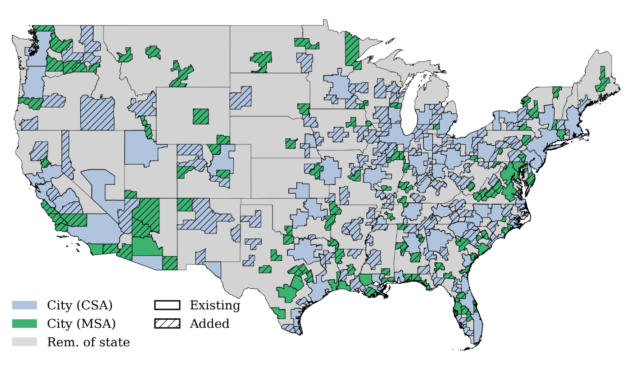
Supplementary Fig. 9: Map of the 329 geographical areas considered in this study.
Blue and green polygons represent combined statistical and metropolitan statistical areas, respectively; grey polygons represent remainders of state. Hatched polygons represent cities that were added using the disaggregation approach^{8,10}. In the legend, CSA stands for combined statistical area and MSA for metropolitan statistical area.

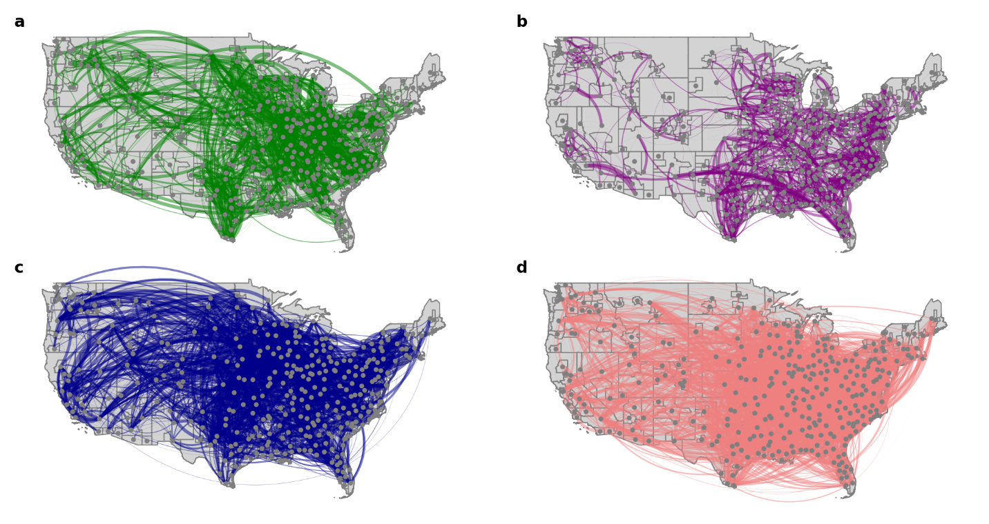
Supplementary Fig. 10: Food flow.
a–d, Food flow networks for crop (a), live animal (b), feed (c), and meat (d) sectors for the year 2012. The nodes in the networks represent both cities and remainders of state, and the weighted links represent the food flow between pairs of nodes. For illustration purposes, only the top 20% of food flows are shown. The total number of links for the crop, live animal, feed, and meat sectors was 18,258, 12,094, 27,615, and 28,146, respectively.

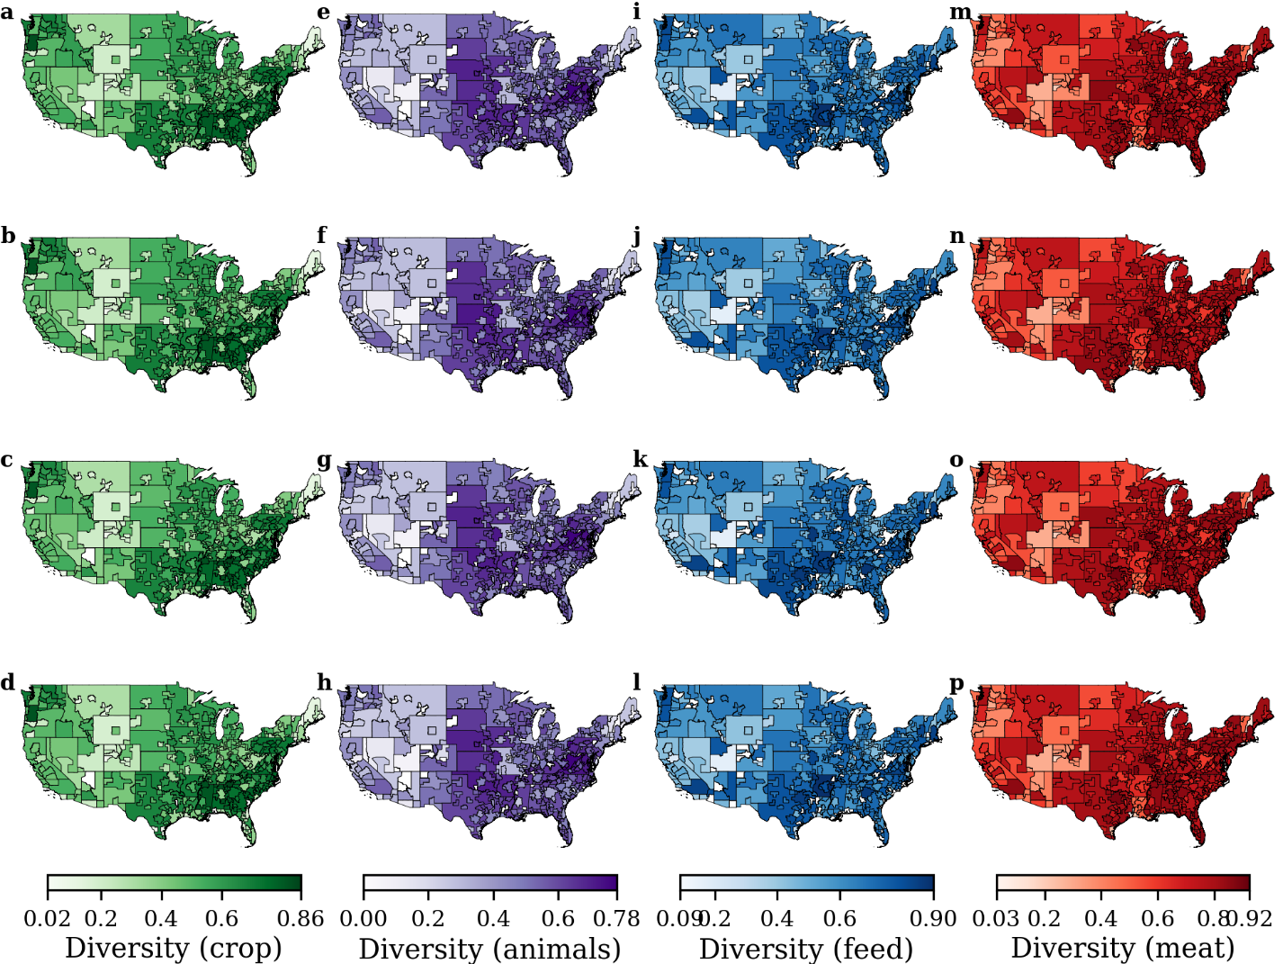
Supplementary Fig. 11: Distribution of supply chain diversity.
a–p, Spatial distribution of supply chain diversity for the crop (a–d), live animal (e–h), feed (i–l), and meat (m–p) sectors for the years 2012 (a,e,i,m), 2013 (b,f,j,n), 2014 (c,g,k,o), and 2015 (d,h,l,p).

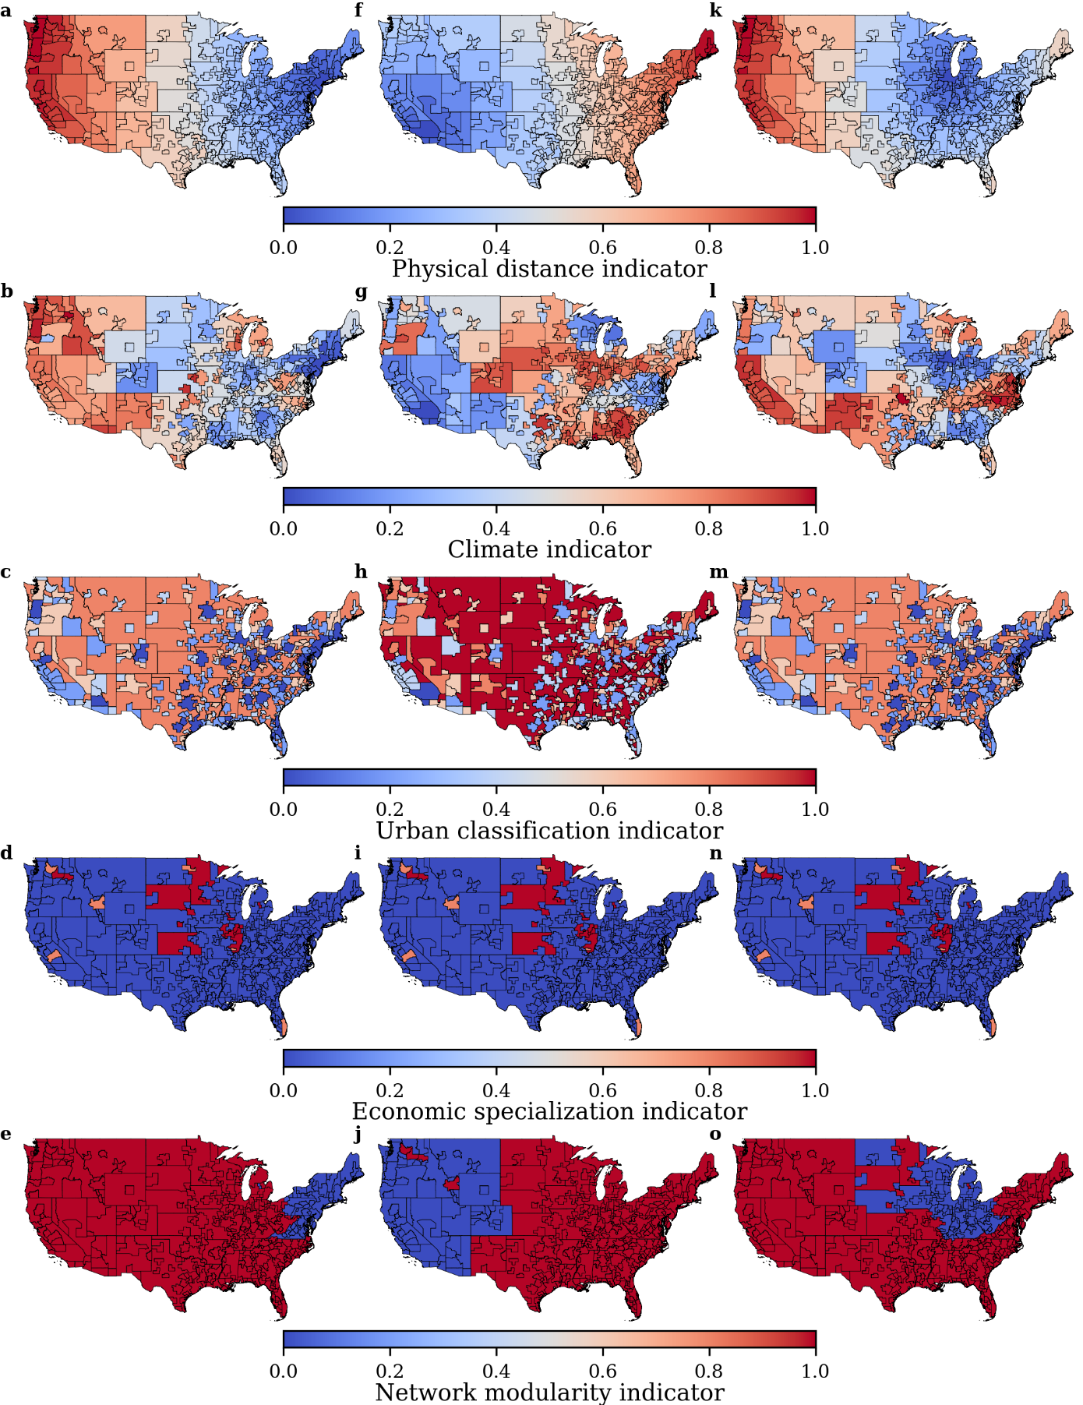
Supplementary Fig. 12: Five normalized indicators used in supply chain diversity calculations.
a–o, Maps show the three most populous cities in the United States: New York (a–e), Los Angeles (f–j), and Chicago (k–o). The five indicators measure physical distance (a,f,k), climate (b,g,l), urban classification (c,h,m), economic specialization (d,i,n), and network modularity (e,j,o).

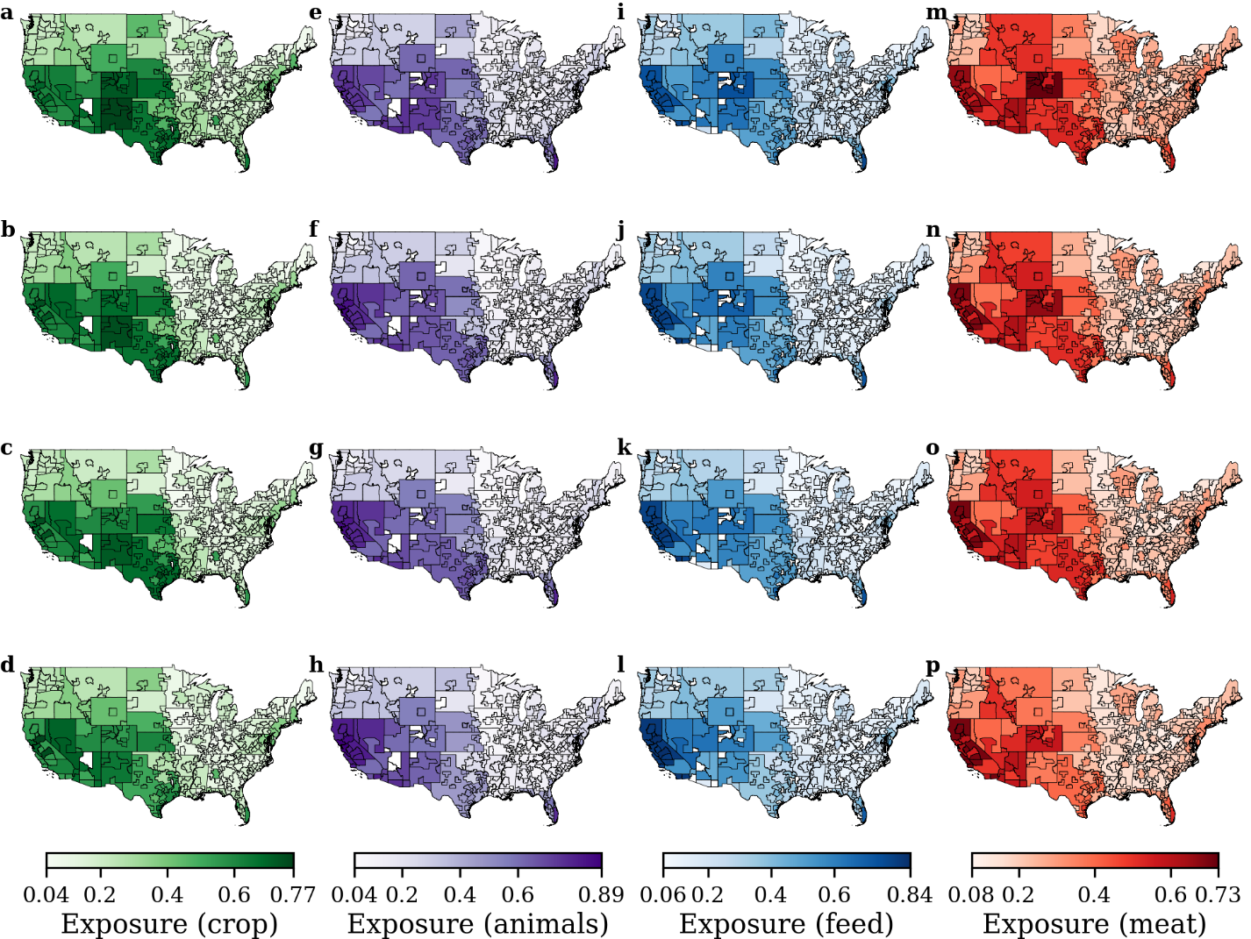
Supplementary Fig. 13. Supply chain exposure to water stress.
a–p, Spatial distribution of supply chain exposure to water stress for the crop (a–d), live animal (e–h), feed (i–l), and meat (m–p) sectors for the years 2012 (a,e,i,m), 2013 (b,f,j,n), 2014 (c,g,k,o), and 2015 (d,h,l,p).

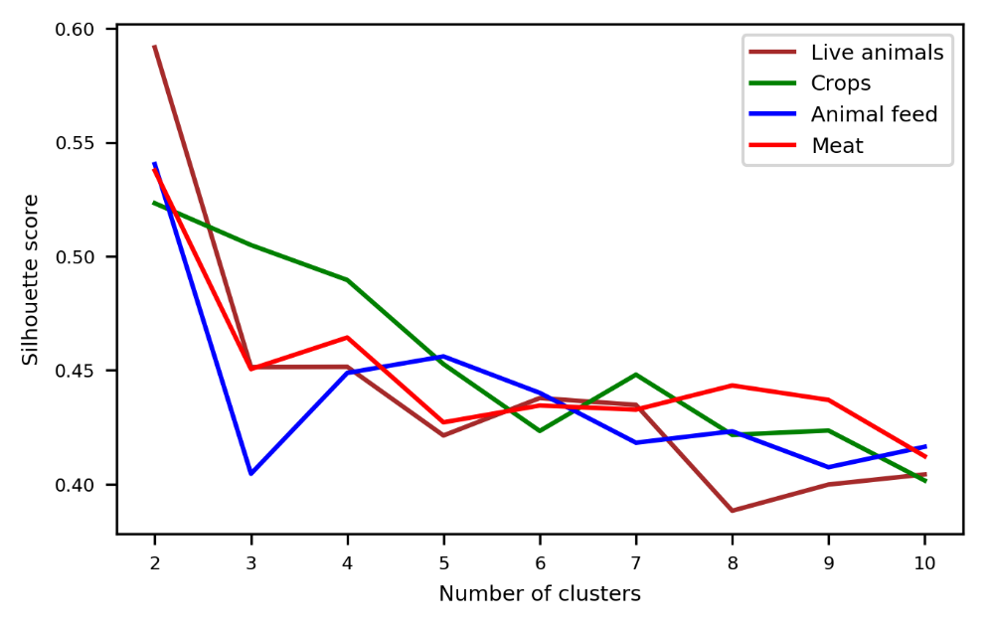
Supplementary Fig. 14: Selection of the optimal number of risk clusters in the resilience-exposure plane using the Silhouette score¹¹.

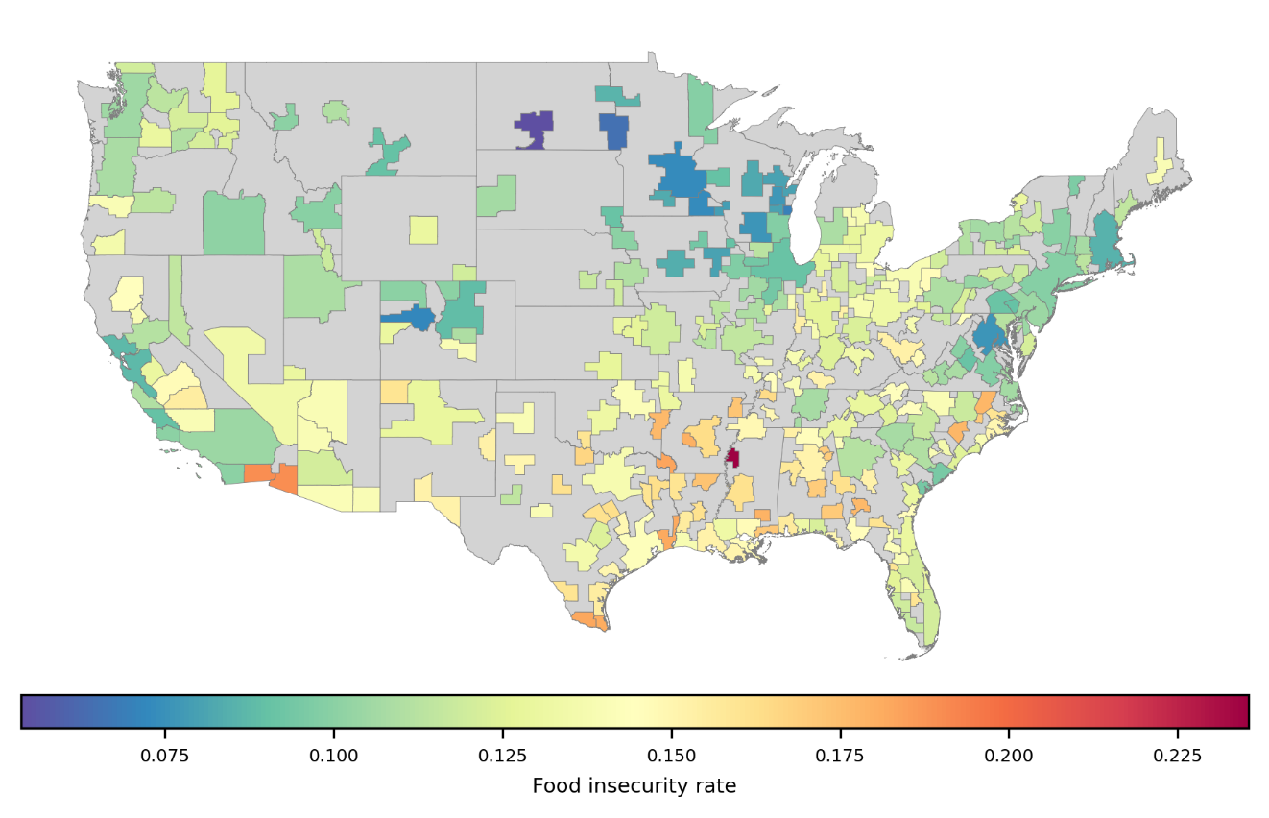
Supplementary Fig. 15: Food insecurity rates across U.S. cities derived from the Feeding America Map the Meal Gap dataset¹².

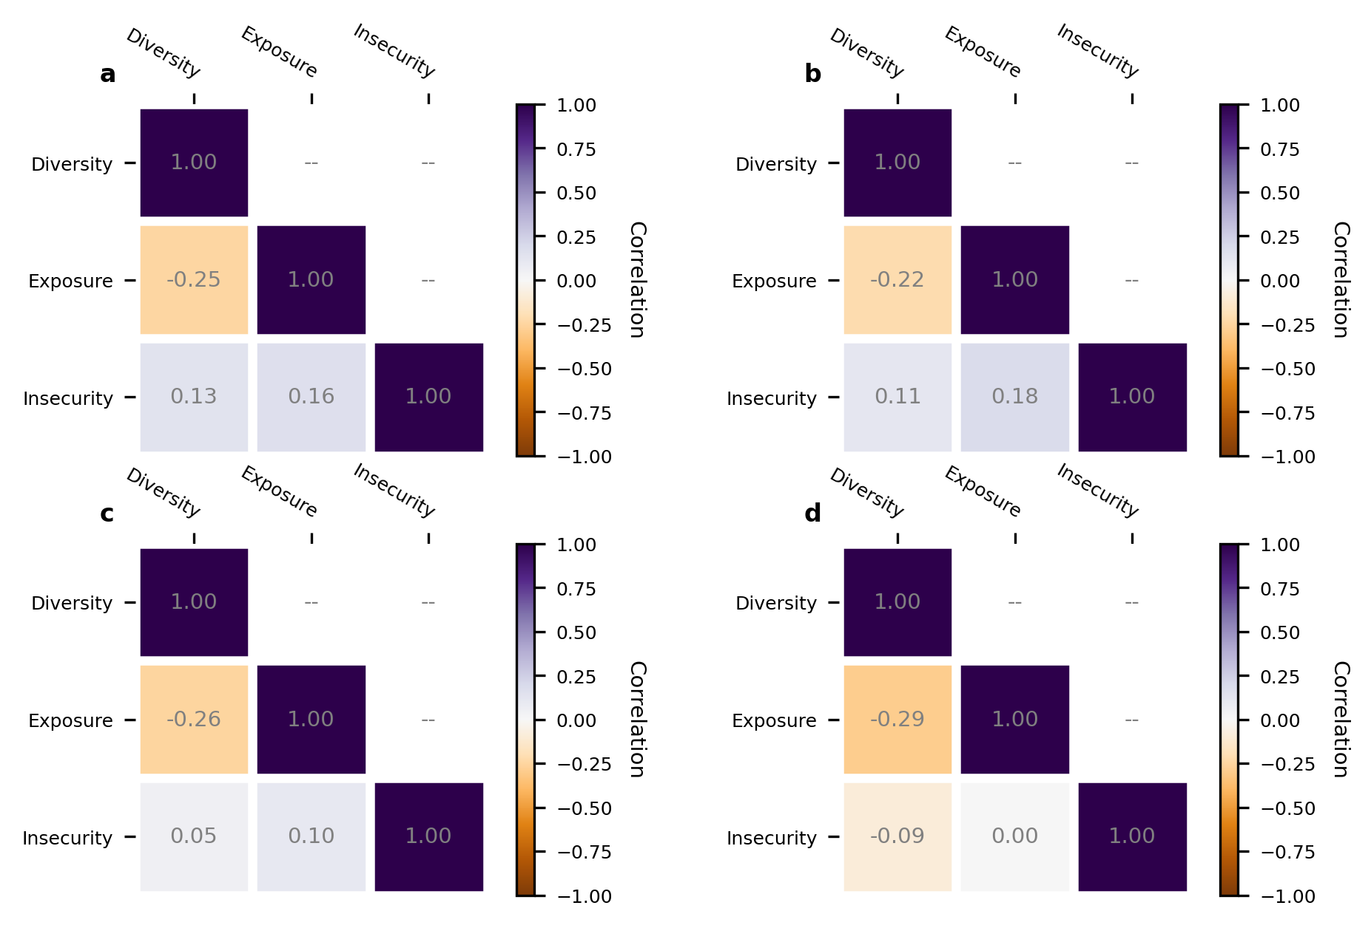
Supplementary Fig. 16: Pearson’s correlation matrices between diversity, exposure, and food insecurity metrics.
a–d, Matrices for the crop (a), live animal (b), feed (c), and meat (d) sectors. Person’s correlation coefficient shows that the 3 metrics are only marginally correlated across all food sectors.

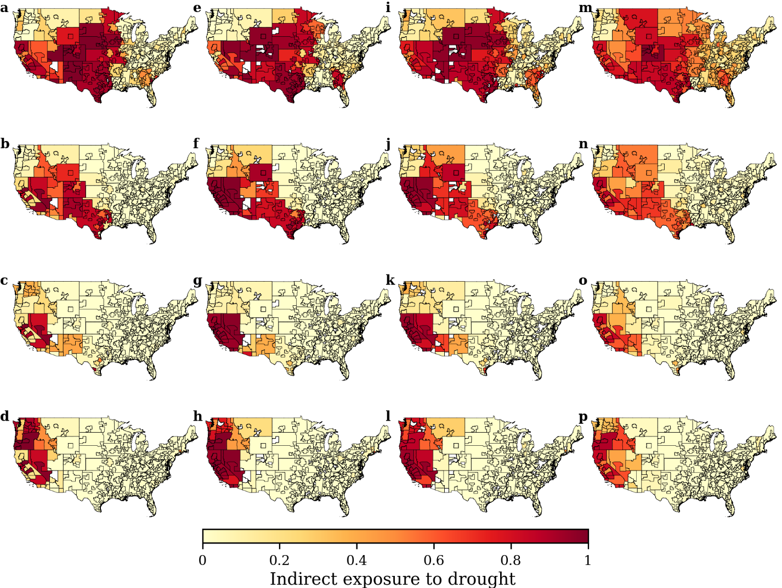
Supplementary Fig. 17: Indirect exposure to drought.
a–p, Spatial distribution of the indirect exposure to drought for the crop (a–d), live animal (e–h), feed (i–l), and meat (m–p) sectors for the years 2012 (a,e,i,m), 2013 (b,f,j,n), 2014 (c,g,k,o), and 2015 (d,h,l,p). The indirect exposure to drought was calculated as the proportion of the total food inflows to a node that originated from trading partners with a mean Palmer Drought Severity Index (PDSI)¹ value of less than −2 during the year 2012. An indirect exposure to drought of 1 indicates that all food inflows to a city originated from areas with a PDSI lower than −2 for a given food sector.

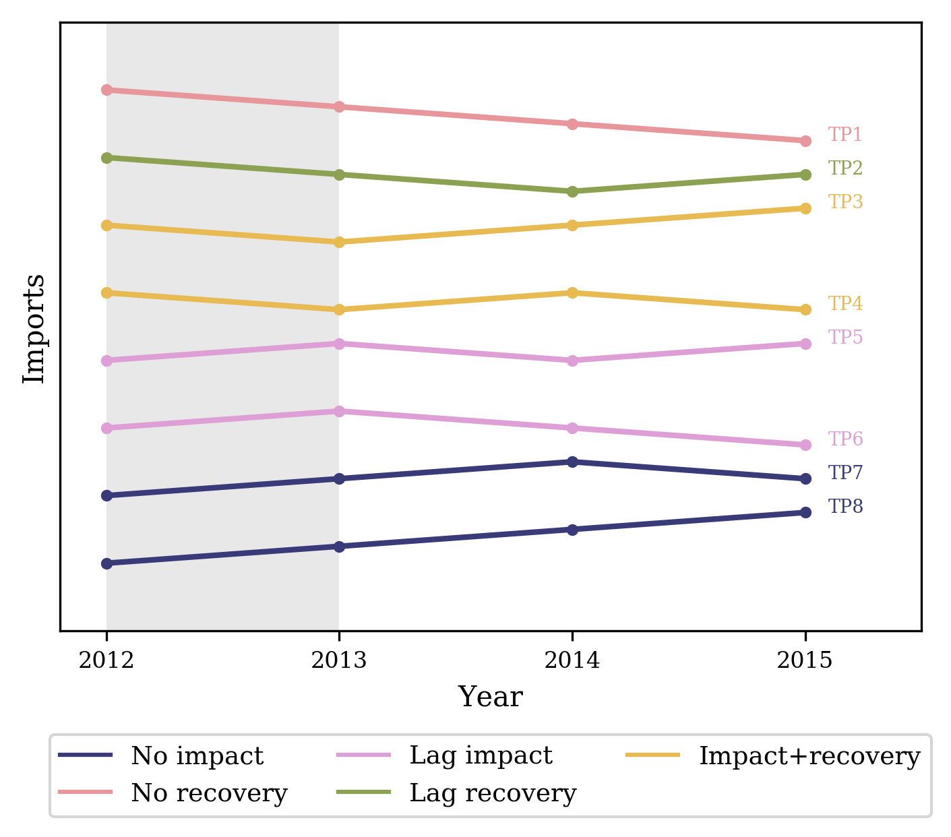
Supplementary Fig. 18: Schematic of temporal patterns of food inflows.
The temporal patterns were classified into 5 groups depending on their behavior during (gray shading) and after a selected pair of years, in this case 2012 and 2013.

Supplementary Tables
Supplementary Table 1: Average supply chain diversity and exposure and food insecurity rates across cities in the United States, grouped by sectors and regions
Region | Supply chain diversity |  |  |  | Supply chain exposure |  |  |  | Food insecurity rate
Region | Crop | Live animal | Animal feed | Meat | Crop | Live animal | Animal feed | Meat | Food insecurity rate
Northeast | 0.48 | 0.45 | 0.62 | 0.75 | 0.18 | 0.17 | 0.17 | 0.22 | 0.11
Southeast | 0.56 | 0.52 | 0.65 | 0.73 | 0.21 | 0.23 | 0.20 | 0.23 | 0.14
Midwest | 0.49 | 0.48 | 0.60 | 0.75 | 0.14 | 0.13 | 0.15 | 0.20 | 0.11
Northern Great Plains | 0.24 | 0.35 | 0.45 | 0.61 | 0.35 | 0.39 | 0.37 | 0.40 | 0.10
Southern Great Plains | 0.46 | 0.53 | 0.64 | 0.71 | 0.59 | 0.52 | 0.44 | 0.43 | 0.15
Northwest | 0.52 | 0.38 | 0.58 | 0.56 | 0.29 | 0.26 | 0.34 | 0.31 | 0.12
Southwest | 0.39 | 0.35 | 0.50 | 0.57 | 0.63 | 0.72 | 0.67 | 0.59 | 0.13
National | 0.49 | 0.47 | 0.60 | 0.70 | 0.29 | 0.29 | 0.27 | 0.30 | 0.13

Supplementary Table 2: Summary statistics of supply chain diversity: exposure clusters across food sectors
 | Cluster | No. of observation | Supply chain diversity |  |  |  |  |  | Exposure
 | Cluster | No. of observation | Min | Median | Mean | Max | Var | Std | Min | Median | Mean | Max | Var | Std
Crop | HL | 129 | 0.49 | 0.63 | 0.64 | 0.85 | 0.009 | 0.094 | 0.08 | 0.16 | 0.19 | 0.38 | 0.004 | 0.066
Crop | LL | 82 | 0.02 | 0.34 | 0.33 | 0.49 | 0.011 | 0.105 | 0.06 | 0.14 | 0.17 | 0.38 | 0.007 | 0.083
Crop | HH | 44 | 0.37 | 0.50 | 0.51 | 0.67 | 0.005 | 0.070 | 0.41 | 0.63 | 0.61 | 0.73 | 0.006 | 0.074
Crop | LH | 24 | 0.05 | 0.24 | 0.23 | 0.37 | 0.008 | 0.092 | 0.42 | 0.66 | 0.61 | 0.74 | 0.007 | 0.086
Live animal | HL | 110 | 0.45 | 0.55 | 0.56 | 0.76 | 0.005 | 0.070 | 0.07 | 0.14 | 0.15 | 0.30 | 0.002 | 0.046
Live animal | LL | 71 | 0.04 | 0.36 | 0.35 | 0.47 | 0.009 | 0.095 | 0.07 | 0.15 | 0.19 | 0.41 | 0.008 | 0.091
Live animal | HH | 40 | 0.39 | 0.57 | 0.55 | 0.66 | 0.004 | 0.067 | 0.34 | 0.58 | 0.53 | 0.66 | 0.007 | 0.084
Live animal | LH | 31 | 0.05 | 0.35 | 0.33 | 0.52 | 0.011 | 0.106 | 0.56 | 0.71 | 0.71 | 0.85 | 0.006 | 0.078
Feed | HL | 89 | 0.61 | 0.70 | 0.71 | 0.86 | 0.004 | 0.064 | 0.10 | 0.16 | 0.17 | 0.28 | 0.002 | 0.046
Feed | LL | 65 | 0.09 | 0.50 | 0.49 | 0.60 | 0.007 | 0.083 | 0.06 | 0.13 | 0.15 | 0.32 | 0.004 | 0.064
Feed | HH | 49 | 0.45 | 0.68 | 0.67 | 0.84 | 0.008 | 0.091 | 0.28 | 0.40 | 0.41 | 0.60 | 0.008 | 0.090
Feed | LH | 27 | 0.21 | 0.42 | 0.42 | 0.74 | 0.011 | 0.105 | 0.40 | 0.74 | 0.68 | 0.81 | 0.014 | 0.120
Meat | HL | 148 | 0.69 | 0.78 | 0.78 | 0.91 | 0.002 | 0.050 | 0.12 | 0.22 | 0.23 | 0.35 | 0.003 | 0.058
Meat | LL | 62 | 0.30 | 0.62 | 0.58 | 0.69 | 0.009 | 0.096 | 0.09 | 0.19 | 0.19 | 0.29 | 0.003 | 0.054
Meat | HH | 49 | 0.55 | 0.74 | 0.73 | 0.88 | 0.007 | 0.084 | 0.35 | 0.50 | 0.48 | 0.62 | 0.003 | 0.058
Meat | LH | 25 | 0.03 | 0.44 | 0.42 | 0.62 | 0.020 | 0.140 | 0.34 | 0.65 | 0.62 | 0.69 | 0.009 | 0.093

References
1. National Oceanic and Atmospheric Administration. Historical Palmer Drought Index. https://www.ncdc.noaa.gov/temp-and-precip/drought/historical-palmers/.
2. Ingram, D. & Franco, S. 2013 NCHS urban-rural classification scheme for counties. Vital Health Stat. 2, 1–65 (2014).
3. Girvan, M. & Newman, M. E. J. Community structure in social and biological networks. Proc. Natl. Acad. Sci. U. S. A. 99, 7821–7826 (2002).
4. Newman, M. E. J. Modularity and community structure in networks. Proc. Natl. Acad. Sci. U. S. A. 103, 8577–8582 (2006).
5. Blondel, V. D., Guillaume, J. L., Lambiotte, R. & Lefebvre, E. Fast unfolding of communities in large networks. J. Stat. Mech. P10008 (2008).
6. Garcia, S. & Mejia, A. Characterizing and modeling subnational virtual water networks of US agricultural and industrial commodity flows. Adv. Water Resour. 130, 314–324 (2019).
7. Hwang, H.-L. et al. The Freight Analysis Framework Version 4 (FAF4). ORNL/TM-20 (Oak Ridge National Laboratory, 2016).
8. Gomez, M., Mejia, A., Ruddell, B. L. & Rushforth, R. R. Supply chain diversity buffers cities against food shocks. Nature 595, 1–17 (2021).
9. Rey, S. J. & Anselin, L. PySAL: A Python library of spatial analytical methods. Rev. Reg. Stud. 37, 5–27 (2007).
10. Gomez, M., Mejia, A., Ruddell, B. L. & Rushforth, R. R. Metropolitan food flow network and supply chain diversity. Hydroshare (2021). https://doi.org/10.4211/hs.caebbbb68cce49f2bbf351f28d865794
11. Rousseeuw, P. J. Silhouettes: A graphical aid to the interpretation and validation of cluster analysis. J. Comput. Appl. Math. 20, 53–65 (1987).
12. Gundersen, C., Dewey, A., Engelhard, E., Strayer, M. & Lapinski, L. Map the Meal Gap (Feeding America, 2020).

