Mechanochemical Synthesis of Co(II) and Fe(III) Metal Complexes from Precursors in a Single Step without Isolating the Ligand

Getinet Tamiru Tigineh*, Atakilt Abebe
Department of Chemistry, Bahir Dar University, PO Box 79, Bahir Dar, Ethiopia
*Corresponding author: getsh2007@gmail.com; ORCID: 0000-0002-1819-7222

Supporting Information

Experimental Section

Instruments

A Retsch Mixer Mill MM400 was used for ball milling experiments. High-resolution mass spectra (HRMS) were obtained using a high-resolution quadrupole time-of-flight mass spectrometer (ion mode: FAB+). Infrared spectra were recorded on an ABB MB3000 Fourier-transform infrared (FT-IR) spectrometer equipped with an attenuated total reflectance module. The electronic spectra were recorded in the 200–800 nm regions using PerkinElmer UV WinLab 6.2.0.0741 / Lambda25 1.27 UV/Vis spectrophotometer. Cobalt(II) and Iron(III) content in each synthesized complex was determined using Perkin Elmer, Optima 7300 VHF Version ICP- OES spectrometer, after digesting each complex in a mixture of concentrated perchloric acid and nitric acid followed by diluting with distilled water. Elemental analyses were performed using a PERKIN ELMER 2400 CHN elemental analyzer. Powder XRD was recorded by using PHILIPS X’Pert PowderX-ray Diffractometer. The complexes' melting point temperatures were measured with Stuart SMP30, UK digital melting point apparatus. Chloride estimations were made thermosgravimetrically using the AgCl precipitate obtained from a mixture of the solution of each complex in distilled water with excess AgNO₃ solution.

Synthesis of complex 1 [CoL₁]
A 10 mL Teflon container was filled simultaneously with precursors 3-ethoxy-2-hydroxybenzaldehyde (2 mmol, 0.3324 g), benzene-1,2-diamine (1 mmol, 0.1082 g) and anhydrous CoCl₂ (1 mmol, 0.1298 g) respectively and one stainless-steel ball (10 mm diameter). After running the mixer mill at 30 Hz for 60 min. The crude product was collected directly from the container. The solid powdered substances were washed with diethyl ether and dried in a vacuum; the isolated yield was higher than 95%.

Synthesis of complex 2 [Fe(L₁)Cl]
A 10 mL Teflon container was filled simultaneously with precursors 3-ethoxy-2-hydroxybenzaldehyde (2 mmol, 0.3324 g), benzene-1,2-diamine (1 mmol, 0.1082 g) and anhydrous FeCl₃ (1 mmol, 0.1622 g) respectively and one stainless-steel ball (10 mm diameter). After running the mixer mill at 30 Hz for 60 min. The crude product was collected directly from the container. The solid powdered substances were washed with diethyl ether and dried in a vacuum; the isolated yield was higher than 97%.

Synthesis of complex 3 [CoL₂]
A 10 mL Teflon container was filled simultaneously with precursors 3-ethoxy-2-hydroxybenzaldehyde (2 mmol, 0.3324 g), ethane-1,2-diamine (1 mmol, 0.0668 mL) and anhydrous CoCl₂ (1 mmol, 0.1298 g) respectively and one stainless-steel ball (10 mm diameter). After running the mixer mill at 30 Hz for 60 min. The crude product was collected directly from the container. The solid powdered substances were washed with diethyl ether and dried in a vacuum; the isolated yield was higher than 96%.

Synthesis of complex 4 [Fe(L₂)Cl]
A 10 mL Teflon container was filled simultaneously with precursors 3-ethoxy-2-hydroxybenzaldehyde (2 mmol, 0.3324 g), ethane-1,2-diamine (1 mmol, 0.0668 mL) and anhydrous FeCl₃ (1 mmol, 0.1622 g) respectively and one stainless-steel ball (10 mm diameter). After running the mixer mill at 30 Hz for 60 min. The crude product was collected directly from the container. The solid powdered substances were washed with diethyl ether and dried in a vacuum; the isolated yield was higher than 98%.

- UV-Vis spectrum of Metal salt, Ligands and Complexes

- FT IR spectrum of Precursors, Ligands and Complexes

- Powder XRD pattern of Precursors, Ligand and Complexes

- HR Mass spectrum of Ligands

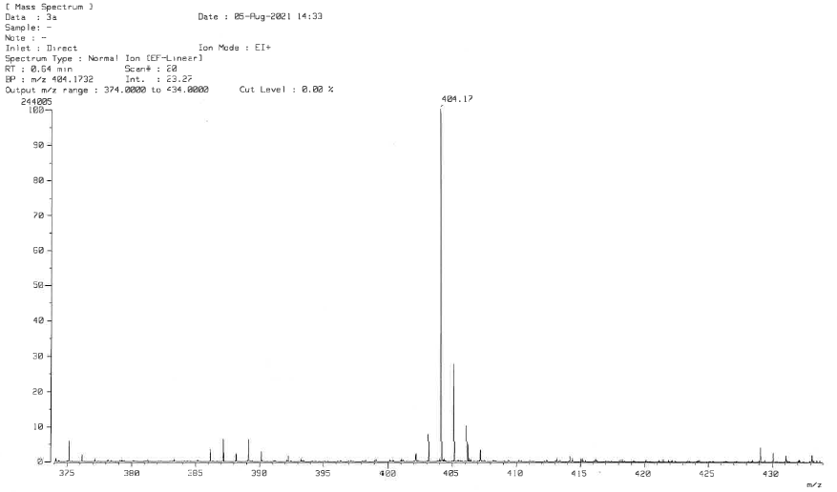
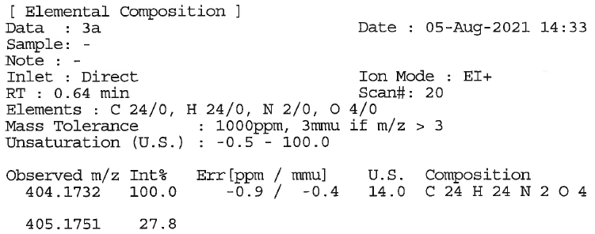
Figure. High-Resolution Mass data of Ligand/1, 2-phenylenediamine

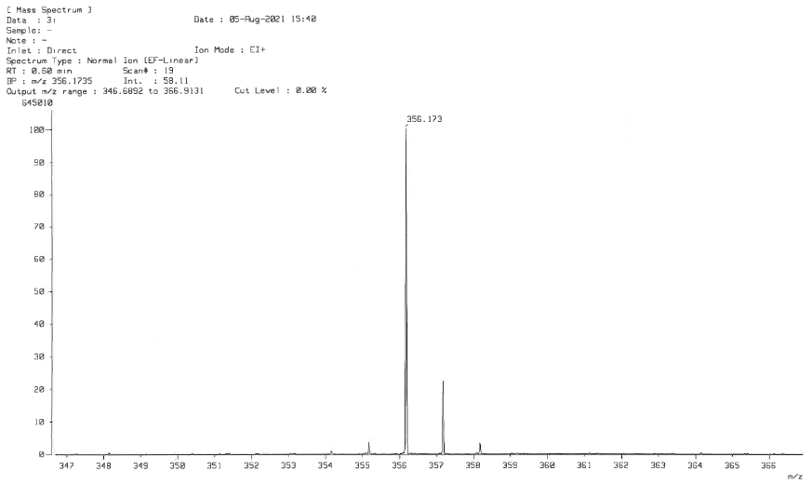
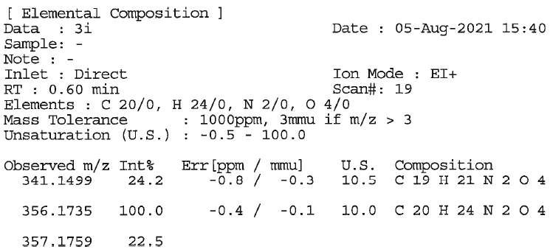
Figure. High-Resolution Mass data of Ligand/ethylenediamine

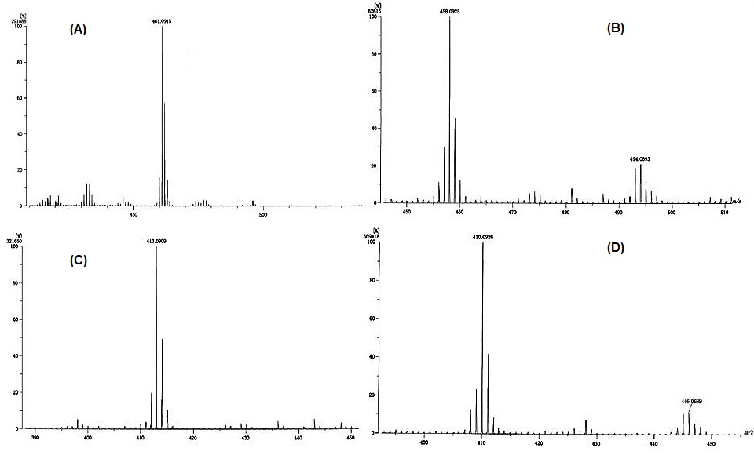

Figure. Mass spectra of (A) Complex 1, (B) Complex 2, (C) Complex 3, and (D) Complex 4

