Appendix
Supplementary Material 1: Table representing the evaluation using the Questionnaire Appraisal Scheme (Stage 2):
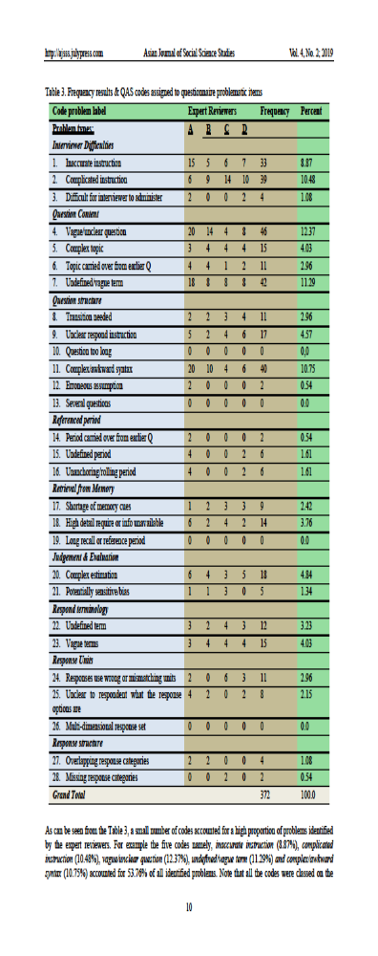 Referenced in the text of the Manuscript

Supplementary Material 2: Synthesis of the Elements after the Conduction of a Literature Review (Results of Stage 2):
Source | Survey Item
Geisler (1992) | 1. Was your physician empathetic and did he stand by your side ?
Geisler (1992) | 2. How did this affect your adherence to the PT exercises ?
Geisler (1992) | 3. Did your physician motivate you to take responsibility for your situation ?
Geisler (1992) | 4. How did this affect your adherence to the PT exercises ?
Geisler (1992) | 5. Did your physician give you specific recommendations for your early postoperative rehabilitation ?
Geisler (1992) | 6. How did this affect your adherence to the PT exercises ?
Geisler (1992) | 7. Did your doctor give you a realistic assessment regarding the early postoperative phase ?
Geisler (1992) | 8. How did this affect your adherence to the PT exercises ?
Mbada (1970) | 9. Did pain hinder you from completing your PT exercises ?
Mbada (1970) | 10. Were you confident that your prothesis would support the execution of the exercises ?
Mbada (1970) | 11. Was it unpleasant to do the exercises in front of a third party (other patients, medical staff …etc.) ?
Mbada (1970) | 12. Were you confident that your direct surroundings (chairs, bed, tables … etc.) would support you while performing the exercises ?
Groen (2012) | 13. Did your family support you (emotionally/ physically) while performing the exercises ?
References are included in the text of the manuscript.

Supplementary Material 3: Results of the Questionnaire Appraisal by the Experts:
Subject Matter Expert 1: Orthopaedic Surgeon
Item Number | QAS Number | Comment | Suggestions
1 | 0 | None | None
2 | find out | Not very specific | "to your prescribed PT exercises" instead of "the PT exercises"
3 | 0 | None | None
4 | 0 | None | None
5 | 7 and 15 | Some patients might not understand "early postoperative" | Instead use "in the first days after your operation"
6 | 0 | None | None
7 | 7 and 15 | Some patients might not understand "early postoperative" | Instead use "in the first days after your operation"
8 | 0 | None | None
9 | 4 | Patients receive specific programs from the physiotherapists | Use "your perscribed PT exercises instead of "your PT exercises"
10 | 7 | Prosthesis is too scientific | Use "your artificial joint" instead of "prothesis"
11 | 0 | None | None
12 | 7 | Some patients might read this rapidly and understand psychological instead of physical | Use "bodily" instead of "physically"

Subject Matter Expert 2: Physiotherapist
Item Number | QAS Number | Comment | Suggestions
1 | 5 | These are two questions | Eliminate one to avoid confusion (as they have the same meaning
2 | 0 | None | None
3 | 23 | What does responsibility mean? Is the arthrosis the patient´s fault? | Did your doctor motivate you you to take ownership in ameliorating your situation ?
4 | 0 | None | None
5 | 22 | Postoperative sometimes not really understood by the patients | "Early period of rehabilitation" instead of "early postoperative rehabilitation"
6 | 0 | None | None
7 | 20 | Outcomes or contents of the Physiotherapy ? | Use Outcomes
8 | 0 | None | None
9 | 0 | None | None
10 | 0 | None | None
11 | 0 | None | None
12 | 0 | None | None

Questionnaire Expert: Public Health Researcher
Item Number | QAS Number | Comment | Suggestion
1 | 0 | Grammatical Mistakes in German | Correction of Grammar
2 | 0 | Grammatical Mistakes in German | Correction of Grammar
3 | 0 | Grammatical Mistakes in German | Correction of Grammar
4 | 0 | Grammatical Mistakes in German | Correction of Grammar
5 | 0 | Grammatical Mistakes in German | Correction of Grammar
6 | 0 | Grammatical Mistakes in German | Correction of Grammar
7 | 0 | Grammatical Mistakes in German | Correction of Grammar
8 | 0 | Grammatical Mistakes in German | Correction of Grammar
9 | 0 | Grammatical Mistakes in German | Correction of Grammar
10 | 0 | Grammatical Mistakes in German | Correction of Grammar
11 | 0 | Grammatical Mistakes in German | Correction of Grammar
12 | 0

Supplementary Material 4: Patient´s Comments:
Patient 1: “These factors change from day to day. In the first day after the surgery I would have answered the questionnaire very differently.”
Patient 2: “Familial support is always nice. But having a competent doctor is more important than having an empathetic one”.

Supplementary Material 5: German Version of the Questionnaire:
War Ihr Arzt empathisch und stand er Ihnen zur Seite?
1.Nein 2.Eher nein 3.Neutral 4. Eher ja 5.Ja
Wie hat dies die Einhaltung der physiotherapeutischen Übungen beeinflusst?
1.Sehr Negativ 2.Negativ 3.Gar nicht 4.Positiv 5. Sehr Positiv
Hat Ihr Arzt Sie dazu motiviert Eigenverantwortung für Ihren Zustand zu übernehmen?
1.Nein 2.Eher nein 3.Neutral 4. Eher ja 5.Ja
Wie hat dies die Einhaltung der physiotherapeutischen Übungen beeinflusst?
1.Sehr negativ 2.Negativ 3.Gar nicht 4.Positiv 5. Sehr positiv
Hat Ihr Arzt Ihnen spezifische Anweisung für die frühe Rehabilitationsperiode gegeben?
1.Nein 2.Eher nein 3.Neutral 4. Eher ja 5.Ja
Wie hat dies die Einhaltung der physiotherapeutischen Übungen beeinflusst?
1.Sehr Negativ 2.Negativ 3.Gar nicht 4.Positiv 5. Sehr Positiv
Hat Ihr Arzt Ihnen eine realistische Einschätzung bezüglich der frühen postoperativen Rehabilitation gegeben?
1.Nein 2.Eher nein 3.Neutral 4. Eher ja 5.Ja
Wie hat dies die Einhaltung der physiotherapeutischen Übungen beeinflusst?
1.Sehr Negativ 2.Negativ 3.Gar nicht 4.Positiv 5. Sehr Positiv
Haben Ihre Schmerzen Sie daran gehindert, die Übung durchzuführen?
1.Nein 2.Eher Nicht 3.Neutral 4. Eher Schon 5.Ja
Waren Sie zuversichtlich, dass Ihre Prothese die Ausführung der Übungen funktionell unterstützt?
1.Nein 2.Eher nein 3.Neutral 4. Eher ja 5.Ja
War es Ihnen unangenehm die Übungen vor dritten (andere Patienten, medizinisches Personal…etc.) auszuführen?
1.Nein 2.Eher nein 3.Neutral 4. Eher ja 5.Ja
Waren Sie zuversichtlich das Ihre direkte Umgebung (Stühle, Bett, Wandlehnen) Ihnen bei der Ausführung der Übungen unterstützt?
1.Nein 2.Eher Nicht 3.Neutral 4. Eher Schon 5.Ja
Unterstützt Ihre Familie Sie (Emotional/Physisch) bei der Ausführung der Übungen?
1.Nein 2.Eher nein 3.Neutral 4. Eher ja 5.Ja

