SUPPLEMENTARY MATERIAL for
Effectiveness and Safety of Anti-PCSK9 Treatment in Patients with Hyperlipidemia: A Register-Based Cohort Study During a Mandated Switch
Michael Asger Andersen, Anne Helms Andresen2, Aleksander Søltoft-Jensen2 Lia Evi Bang3, Espen Jimenez Solem1, and Tonny Studsgaard Petersen
Content
Supplementary Methods 1
Supplementary Figures 4

Supplementary Methods
  - WebI
SAP Web Intelligence (WebI) is a tool that is integrated into the EPIC electronic medical record system. It allows users to create custom reports and analyses of data stored in the EPIC Clarity database. With WebI, users can build queries using a wide range of predefined variables and filters. WebI and can generate reports in a variety of formats including tables, graphs, and maps.
Mgcv
In the present study, we used generalized additive models (GAMs) as implemented in the mgcv package in R to analyze the data. GAMs are a flexible class of regression models that allow for the incorporation of non-linear relationships between the response variable and predictor variables. They are particularly useful for modeling complex, non-linear trends in data and can be seen as an extension of linear regression models. The mgcv package is a popular and widely used tool for fitting GAMs, and it provides a range of options for specifying and estimating model parameters. Overall, the use of GAMs and the mgcv package allowed us to accurately model and analyze the data, leading to insights and conclusions that would not have been possible with traditional linear regression models. To check the model fit of a GAM fitted with the mgcv package, the gam.check() function can be used. This function produces a plot that displays the residuals of the model, as well as a number of diagnostic plots that can be used to assess the model fit. The gam.check() function produces a plot that displays the residuals of the model on the left hand side, and a number of diagnostic plots on the right hand side. The residuals plot shows the residuals of the model as a function of the fitted values. Ideally, the residuals should be randomly distributed around zero, with no discernible pattern. If there is a pattern present in the residuals plot, it may indicate that the model is not adequately fitting the data. In mgcv, most smooths are required to satisfy a sum-to-zero identifiability constraint, which allows for the inclusion of an intercept in the model, especially when the model includes factor parametric terms. This constraint centers the smooth around 0 on the axis. The 0 line represents the average value of the response (or the reference levels for factor parametric terms) on the link scale. Negative values on the axis indicate that the effect of the covariate causes the response to be below average, while positive values indicate that the response is above average, all while taking into account the other estimated model terms.
Definitions
In this study, we used the International Classification of Diseases (ICD) Tenth Revision (ICD-10) codes, the Anatomical Therapeutic Chemical (ATC) codes, and the Nomenclature for Properties and Units (NPU) codes to categorize diagnoses, conditions, medications, and laboratory measurements, respectively. ICD-10 codes are standardized codes used for medical billing and record-keeping purposes. They are used to assign unique codes to every diagnosis, symptom, and procedure recorded in healthcare settings. ATC codes, on the other hand, are a classification system for medications, developed by the World Health Organization (WHO). They are used to classify drugs according to their therapeutic, pharmacological, and chemical characteristics. NPU codes, meanwhile, are used for assigning laboratory measurements. In this study, we used these codes to classify diagnoses and conditions, medications. The use of ICD-10, ATC, and NPU codes allowed us to accurately and consistently record and analyze the data from the laboratory, ensuring the reliability and validity of the results.
Atherosclerotic cardiovascular disease (ASCVD):
Disease | Diagnostic code: | Operation code:
Coronary heart disease (CHD) | I20, I21, I23, I24 and I25 | KFNA, KFNB, KFNC, KFND, KFNE, KFNH20, KFNF, KFNG00, KFNG02, KFNG05 and KFNG30
Atherosclerotic cerebrovascular disease | I630, I631, I632, I633, I634, I635, I638, I639, I66, I672, G458 and G459 | KAAL10 and KAAL11
Peripheral artery disease (PAD) | I65, I70, I713, I714, I715, I716, I739A, I739C, I741B, I742B, I743B, I744B, I745B, K550H and K551A | KPAF21, KPAK21, KPAF20, KPCE, KPCF, KPCH, KPCN, KPCP, KPDE, KPDF, KPDH, KPDN, KPDP, KPEE, KPEF, KPEH, KPEN, KPEP, KPFE, KPFF, KPFH and KPFN

Hypercholesterolemia criteria:
Disease: | Diagnostic code:
Hypercholesterolemia | E780A, E780C, E780D, E780E, E781, E782, E783, E784 and E785

Familial hypercholesterolemia (FH):
Disease | Diagnostic code:
FH (non-specific) | E780B
Homozygote FH | E780B2
Heterozygote FH | E780B1

Procedures prior to inclusion:
Procedure: | Procedure code: | Operation code:
Percutaneous coronary intervention (PCI) | None | KFNG and KZFFX01
Coronary artery bypass grafting (CABG) | None | KFNA, KFNB, KFNC, KFND, KFNE, KFNH20 and KFNF
Angioplasty and stent placement | None | KPAN, KPAP, KPBN, KPBP, KPCN, KPCP, KPDN, KPDP, KPEN, KPEP, KPFN and KPFP
Endarterectomy | None | KPEF, KPAF, KPBF, KPCF and KPDF
Thrombectomy | None | KAAL11, KFAB10, KPAE10, KPAE25, KPAE30, KPAE99, KPAU74, KPBE10, KPBE20, KPBE30, KPBE99, KPCE30, KPCE40, KPCE99, KPDE10, KPDE30, KPDU74, KPEE10, KPEE11, KPEE12, KPFE10, KPFE30, KPHE22, KPHE23, KPHE25, KPHE30, KPHE31 and KPHE99

Comorbidities prior to inclusion:
Cardiovascular comorbidities:
Disease: | Diagnostic code: | Operation code: | ATC-code:
Diabetes (DM) | E10, E11 and N083 | None | A10
Diabetes target organ damage | H360, E103, E113, G590, E104, E114, N083, E102 and E112 | None | None
Chronic kidney disease (CKD) | E102, E112, I120, N03, N04, N05, N06, N07, N08, N11, N12, N162, N163, N164, N182, N183, N184, N185, N26 and Q61 | None | None
Chronic obstructive pulmonary disease | J43 and J44 | None | None
Hypertension | I10, I11, I12, I13 and I15 | None | C07, C08, C09, C03A, C03B, C03C, C03EA, C03EB, C02L, C10BX, C03DA, C03DB, C03E, C02DB, C02DC, C02DD, C02DG, C02A, C02B and  C02C (excluding C02AC02)
Heart failure | I099A, I110, I130, I132, I420 and I50 | None | None
Cancer, ex. non-melanoma skin cancer | C00, C01, C02, C03, C04, C05, C06, C07, C08, C09, C10, C11, C12, C13, C14, C15, C16, C17, C18, C20, C21, C22, C23, C24, C25, C26, C30, C31, C32, C33, C34, C37, C38, C39, C40, C41, C43, C45, C46, C47, C48, C49, C50, C51, C52, C53, C54, C55, C56, C57, C58, C60, C61, C62, C63, C64, C65, C66, C67, C68, C69, C70, C71, C72, C73, C74, C75, C76, C77, C78, C79, C80, C81, C82, C83, C84, C85, C86, C88, C90, C91, C92, C93, C94, C95 and C96 | None | None
Liver disease | K70, K71, K72, K73, K74, K75, K76, K77, B15, B16, B17, B18, B19 and B581 | None | None
Rheumatoid arthritis | M05, M060, M069 and M080 | None | None

Laboratory values:
Biomarker: | Laboratory code:
Low-density lipoprotein cholesterol (LDL-C) | NPU01568, NPU10171, AAB00101, AAB00102 and DNK35308
High-density lipoprotein cholesterol (HDL-C) | NPU01567 and NPU10157
Total cholesterol (TC) | NPU18412 and NPU01566
Triglycerides (TGs) | NPU04094 and NPU03620
Lipoprotein a (Lp[a]) | NPU21687, NPU19840 and NPU58475
Apolipoprotein B (Apo-B) | NPU22299 and NPU19697

Cholesterol-lowering drug group classification:
Contains the ATC-codes used to define the cholesterol-lowering drug groups used in multiple endpoints.
Drug group: | ATC-code:
Statin | C10AA, C10BA01, C10BA02, C10BA03, C10BA04, C10BA05, C10BA06, C10BA07, C10BA08, C10BA09 and C10BX
PCSK9i | C10AX13 and C10AX14
Ezetimibe | C10AX09, C10BA02, C10BA05, C10BA06 and C10BA10
Bile acid sequestrants | C10AC01, C10AC02, C10AC03 and C10AC04
Fibrates | C10AB, C10BA03, C10BA04 and C10BA09

Supplementary Figures

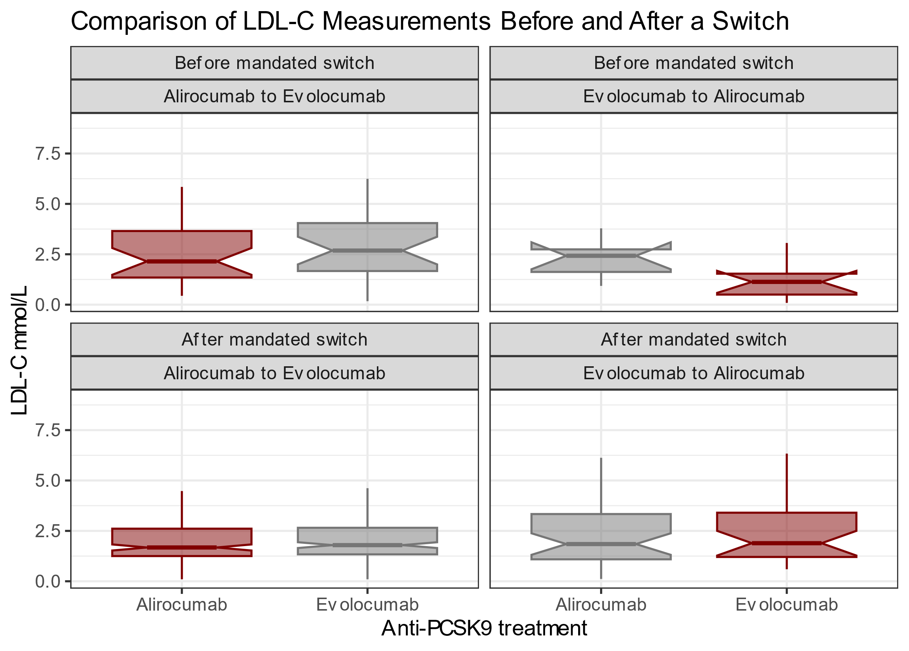

Figure 1 Figure shows four boxplots comparing LDL-C measurements before and after switching between alirocumab and evolocumab. Each boxplot is constructed using the interquartile range (IQR) of the data, with the lower and upper hinges corresponding to the first and third quartiles (25th and 75th percentiles). The line within the box represents the median and the whiskers show the spread of the data, with the upper whisker extending to the largest value within 1.5 * IQR of the hinge and the lower whisker extending to the smallest value within 1.5 * IQR of the hinge. The notches on the boxes extend to 1.58 * IQR / sqrt(n). The two upper boxplots represent LDL-C measurements before the date of the mandated switch from evolocumab to alirocumab and vice versa. The two lower boxplots represent LDL-C measurements after the date of the mandated switch.
PCSK9: proprotein convertase subtilisin/kexin type 9, HDL-C: low-density lipoprotein cholesterol, LDL-C: low-density lipoprotein cholesterol

