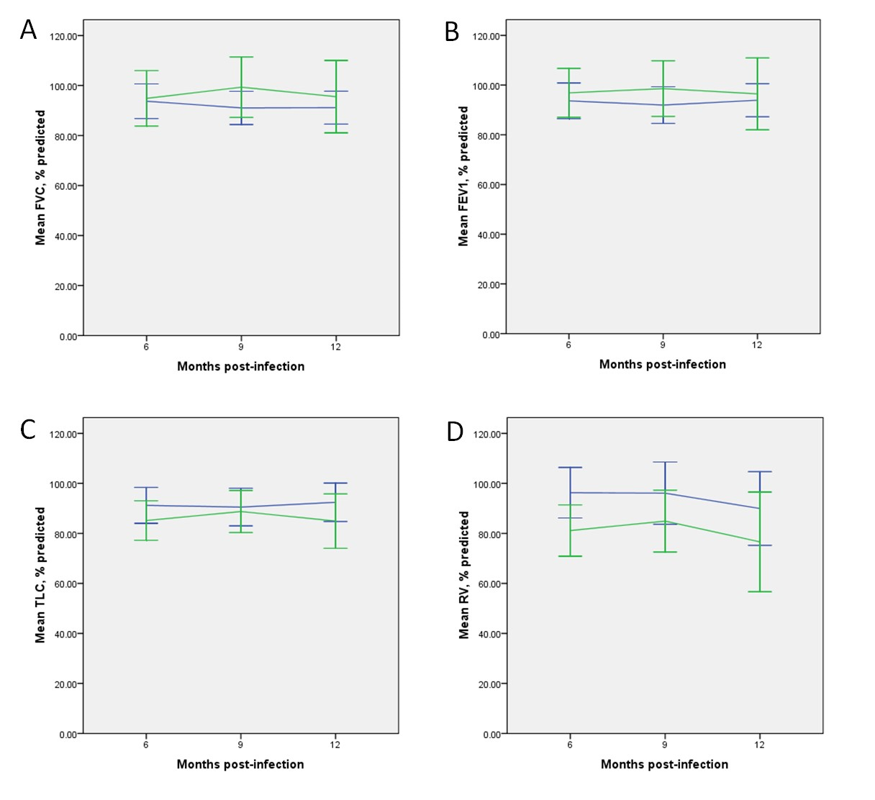
Supplemental figure 1. Plot of disease severity and time based on linear mixed model analysis. The spirometry measurements and lung volumes did not differ between the two disease severity groups. There were also no significant temporal variations in these aspects of lung function. Mild/moderate disease and severe/critical illness were represented by the blue and green lines respectively. Error bars indicated 95% confidence interval and statistical significance was represented by an asterisk. Abbreviations: FVC (forced vital capacity), FEV1 (forced expiratory volume in 1 sec), TLC (total lung capacity), RV (residual volume).

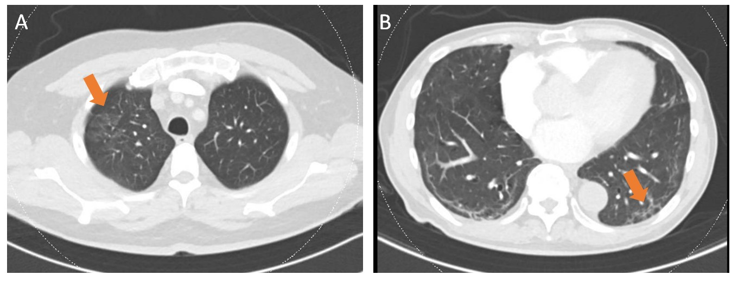

Supplemental figure 2. CT thorax of COVID-19 survivors showing mild (A) ground glass opacities and (B) subpleural reticulations
Supplemental table 1. Characteristics of the patients with DLCO defects
Patient | Disease severity |  | PFT at 18 months | Interval CT finding | Clinical diagnosis
COVID-001 | Critical illness, complicated by ARDS requiring invasive mechanical ventilation |  | Persistent DLCO defect | Non-fibrotic ILA (bilateral subpleural reticulations) | Severe COVID-19 pneumonia
COVID-002 | Mild disease |  | Normalised | Declined | Mild COVID-19 pneumonia
COVID-019 | Critical illness complicated by shock requiring inotropes |  | Declined | Declined | Severe COVID-19 pneumonia
COVID-022 | Critical illness, complicated by ARDS and shock requiring invasive mechanical ventilation and inotropes |  | Normalised | Non-fibrotic ILA (subpleural bands) | Severe COVID-19 pneumonia, morbid obesity
COVID-025 | Severe disease |  | Normalised | Non-fibrotic ILA (bilateral GGO, subpleural reticulations) | Severe COVID-19 pneumonia
COVID-033 | Mild disease |  | Persistent DLCO defect | Not ILA, mild subpleural bands | Mild COVID-19 pneumonia, morbid obesity
COVID-034 | Critical illness complicated by shock requiring inotropes |  | Normalised | Non-fibrotic ILA (bilateral upper lobe reticulations and subpleural blebs) | Severe COVID-19 pneumonia
COVID-040 | Mild disease |  | Declined | Declined | Mild COVID-19 pneumonia
COVID-041 | Severe disease |  | Persistent DLCO defect | Normal | Severe COVID-19 pneumonia, morbid obesity
COVID-042 | Critical illness, complicated by ARDS requiring invasive mechanical ventilation |  | Persistent DLCO defect | Normal | Severe COVID-19 pneumonia, morbid obesity  COPD
COVID-047 | Critical illness, complicated by ARDS requiring invasive mechanical ventilation |  | Declined | Non-fibrotic ILA (bilateral upper lobe subpleural reticulations) | Severe COVID-19 pneumonia
COVID-049 | Mild disease |  | Declined | Declined | Mild COVID-19 pneumonia
COVID-050 | Severe disease |  | Declined | Declined | Severe COVID-19 pneumonia
COVID-052 | Mild disease |  | Not needed due to non-COVID-19 diagnosis | Declined | Morbid obesity  Fluid overload
COVID-055 | Critical illness, complicated by ARDS requiring invasive mechanical ventilation |  | Declined | Non-fibrotic ILA (bilateral GGO and reticulations, subpleural cysts) | Severe COVID-19 pneumonia
Supplemental table 2. Characteristics of the patients with other PFT defects
Patient | Disease severity | PFT defect | Interval CT finding | Clinical diagnosis
COVID-022 | Critical illness, complicated by ARDS and shock requiring invasive mechanical ventilation and inotropes | Restrictive ventilatory defect, impaired DLCO | Non-fibrotic ILA (subpleural bands) | Severe COVID-19 pneumonia, morbid obesity
COVID-025 | Severe disease | Restrictive ventilatory defect, impaired DLCO | Non-fibrotic ILA (bilateral GGO, subpleural reticulations) | Severe COVID-19 pneumonia
COVID-026 | Mild disease | Restrictive ventilatory defect | Declined | Mild COVID-19 pneumonia, morbid obesity
COVID-033 | Mild disease | Restrictive ventilatory defect, impaired DLCO | Not ILA, mild subpleural bands | Mild COVID-19 pneumonia, morbid obesity
COVID-034 | Critical illness complicated by shock requiring inotropes | Restrictive ventilatory defect, impaired DLCO | Non-fibrotic ILA (bilateral upper lobe reticulations and subpleural blebs) | Severe COVID-19 pneumonia
COVID-037 | Mild disease | Restrictive ventilatory defect | Not needed due to non-COVID-19 diagnosis | Mild COVID-19 pneumonia, morbid obesity
COVID-040 | Mild disease | Restrictive ventilatory defect, impaired DLCO | Declined | Mild COVID-19 pneumonia
COVID-041 | Severe disease | Restrictive ventilatory defect, impaired DLCO | Normal | Severe COVID-19 pneumonia, morbid obesity
COVID-042 | Critical illness, complicated by ARDS requiring invasive mechanical ventilation | Restrictive ventilatory defect, impaired DLCO | Normal | Severe COVID-19 pneumonia, morbid obesity  COPD
COVID-047 | Critical illness, complicated by ARDS requiring invasive mechanical ventilation | Restrictive ventilatory defect, impaired DLCO | Non-fibrotic ILA (bilateral upper lobe subpleural reticulations) | Severe COVID-19 pneumonia
COVID-049 | Mild disease | Restrictive ventilatory defect, impaired DLCO | Declined | Mild COVID-19 pneumonia
COVID-052 | Mild disease | Restrictive ventilatory defect, impaired DLCO | Declined | Morbid obesity  Fluid overload
COVID-053 | Critical illness, complicated by ARDS | Restrictive ventilatory defect | Not needed due to non-COVID-19 diagnosis | Severe COVID-19 pneumonia, morbid obesity
COVID-004 | Mild disease | Obstructive ventilatory defect | Declined | Mild COVID-19 pneumonia
COVID-009 | Mild disease | Obstructive ventilatory defect | Not needed due to non-COVID-19 diagnosis | Asthma
COVID-013 | Mild disease | Obstructive ventilatory defect | Declined | Mild COVID-19 pneumonia

