SUPPLEMENTARY MATERIAL

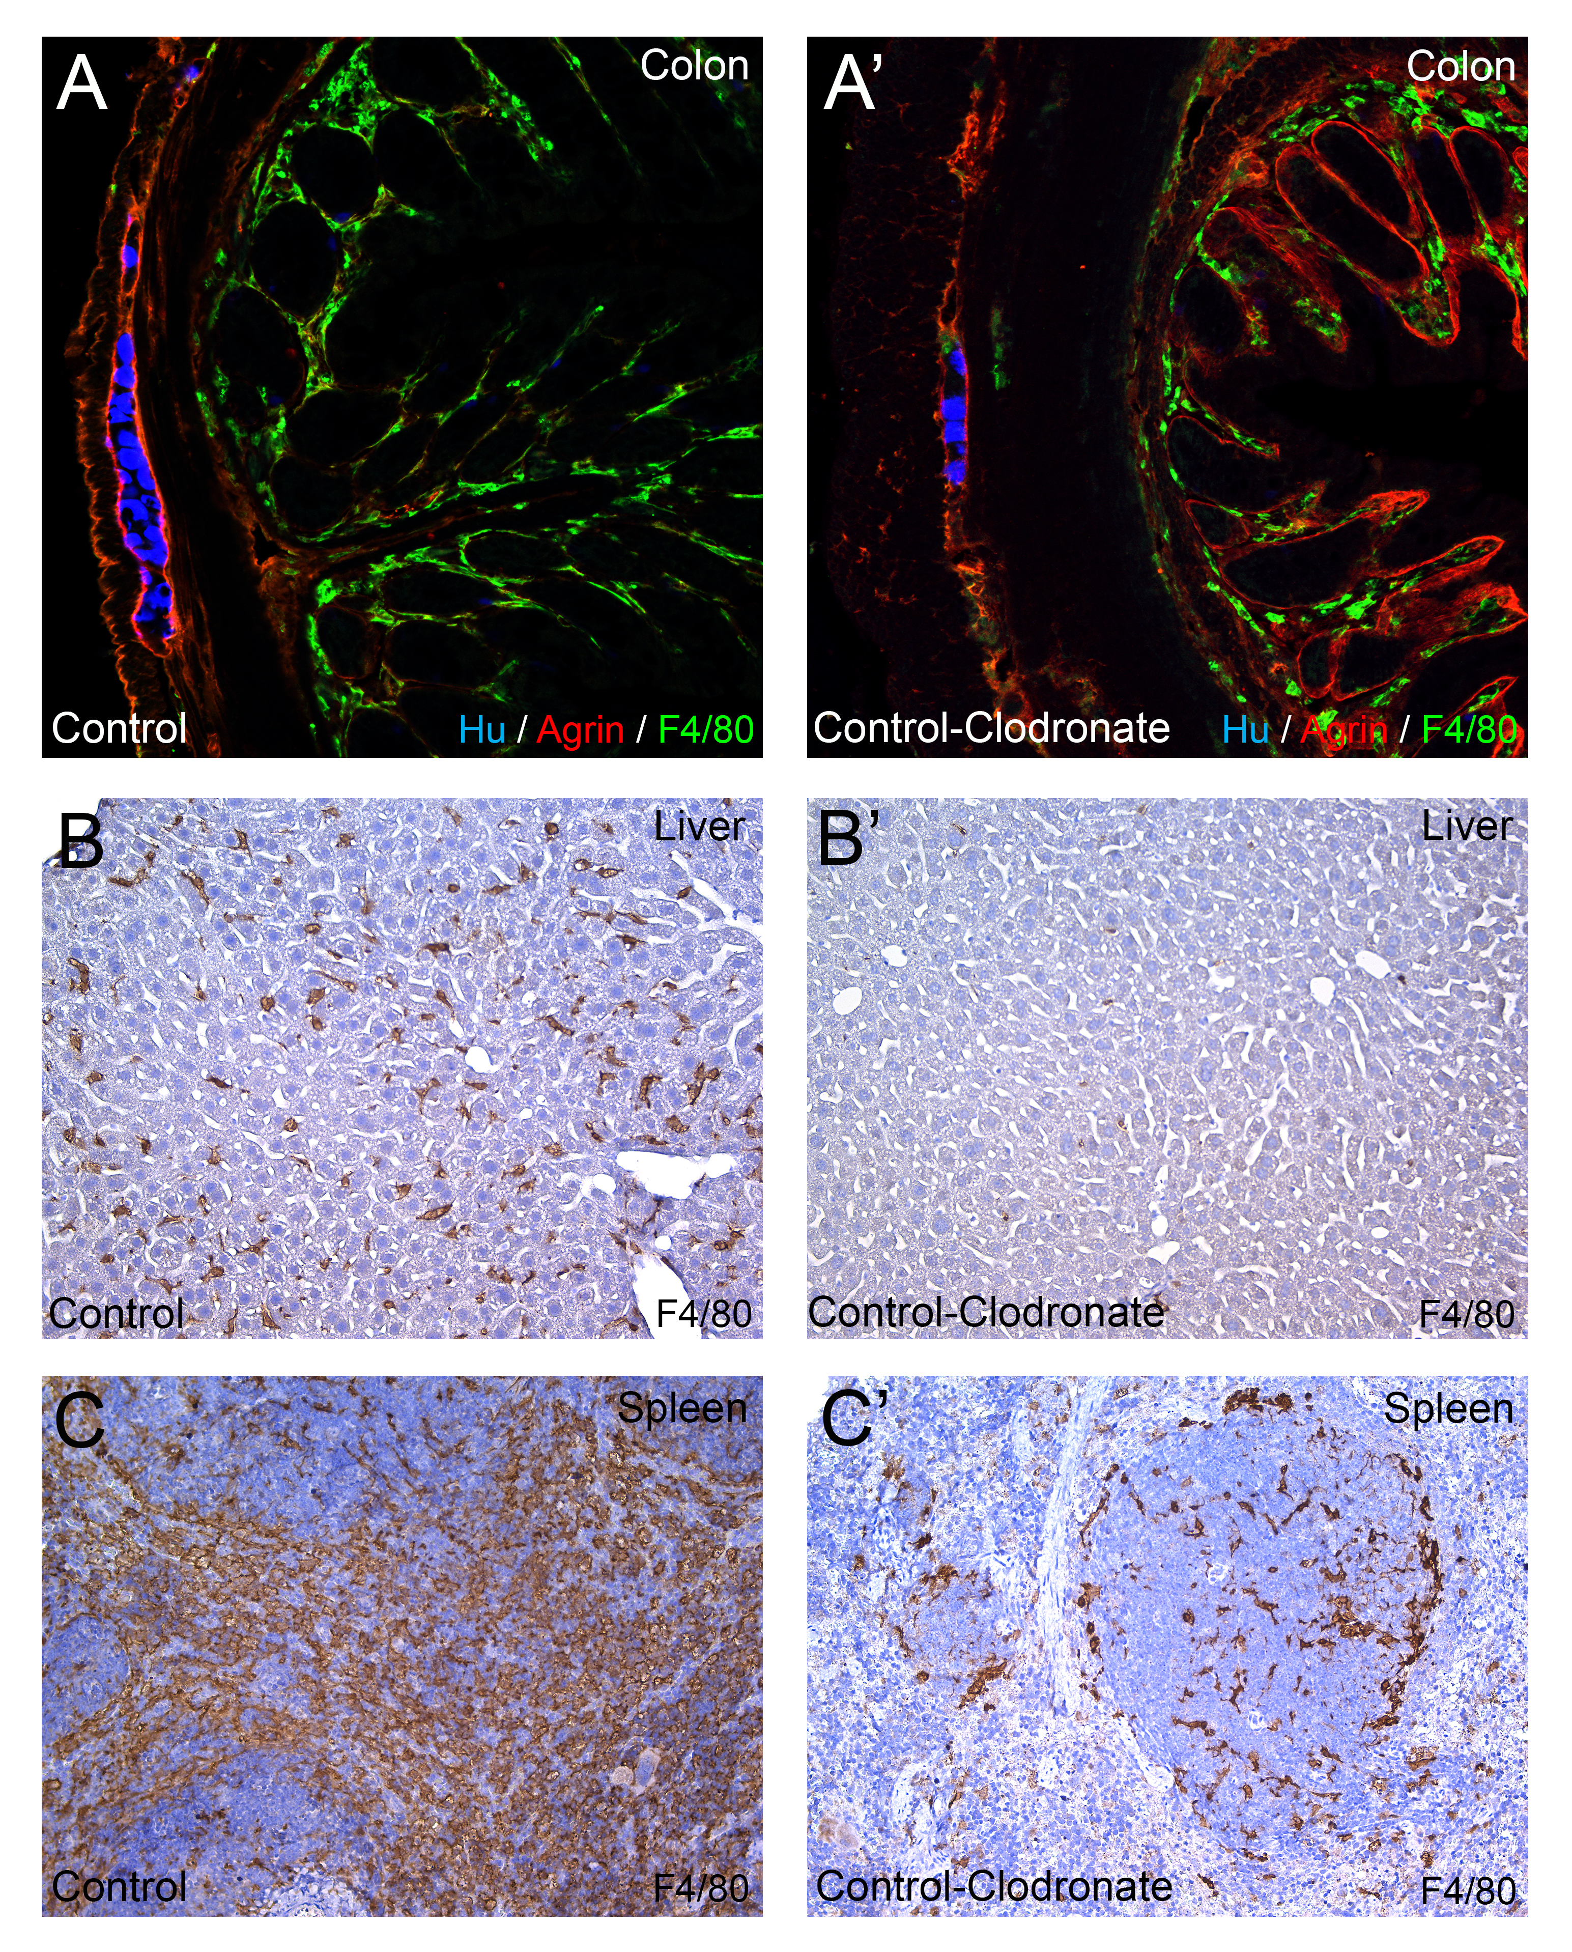
Supplementary Figure 1. Comparison of Control and Control-clodronate-treated organs. Immunofluorescence staining shows that no significant difference is present between the Control- and the Control-clodronate colon, concerning general morphology, integrity of the agrin-expressing myenteric plexus barrier, and F4/80+ macrophage infiltration in the mucosa or the muscularis (A-A’). Immunohistochemistry on liver and spleen tissues from the same animals demonstrate marked difference in the number of F4/80+ macrophages between Control- and Control-clodronate tissues, where the latter is present with notable reduction in the number of macrophages (B-C’).

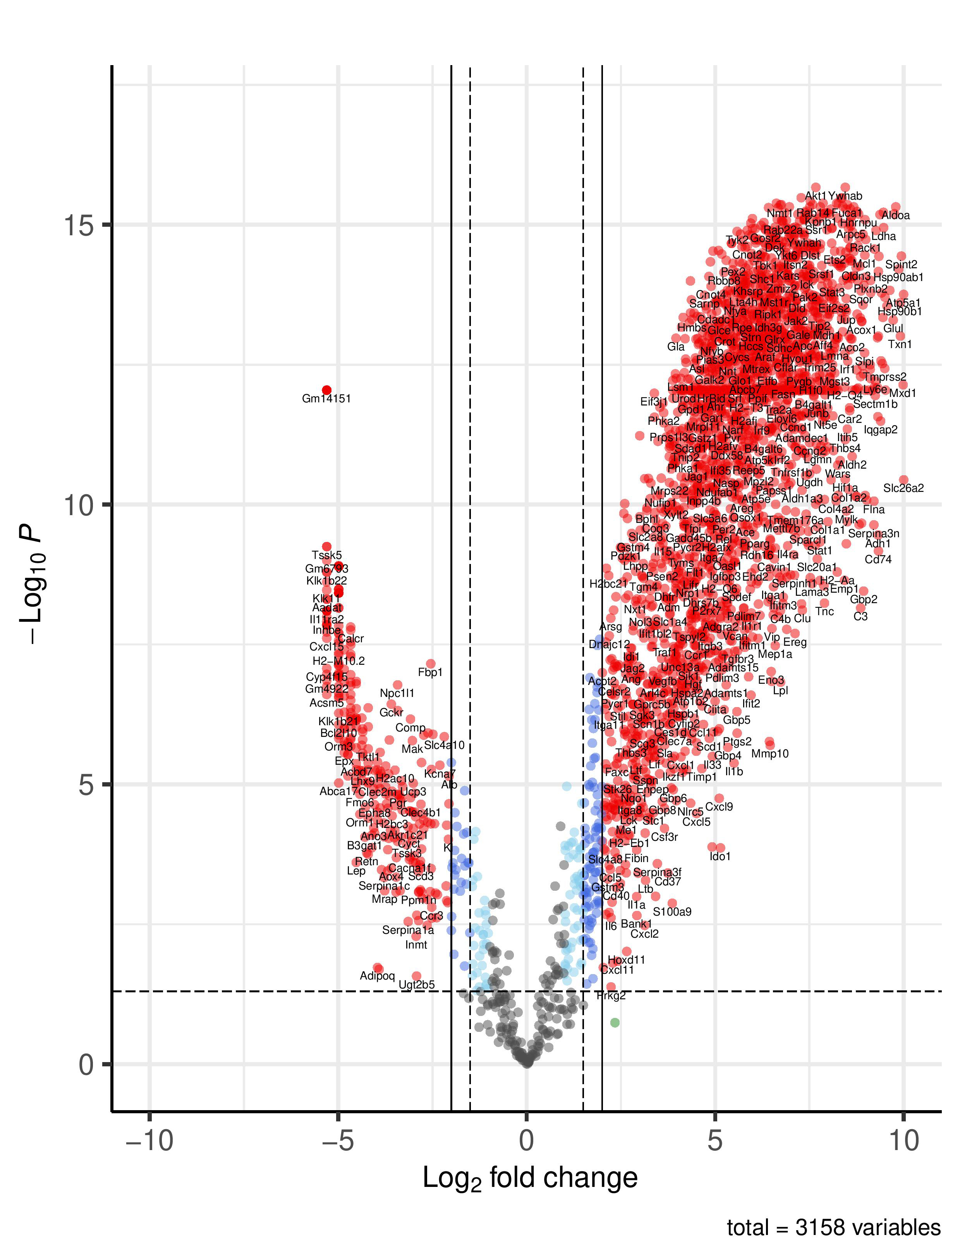
Supplementary Figure 2. Volcano plot of all detected genes (n=3158) according to bulk RNA-sequencing in DSS-treated vs. control mice colon. Each dot represents a gene; axis Y displays the log2-transformed adjusted p-values (Bonferroni correction). Axis X shows log2-transformed fold change (FC); Negative FC value reflects overexpression in control colon, positive FC value reflects increased expression in DSS-treated colon. Genes with Log2 FC value > [2] and a significant adjusted p-value (<0.05) are colored in red. Genes with significant adjusted p-value and Log2 FC value greater than [1.5], but lesser than [2] are colored in dark blue. Genes with significant adjusted p-value, but Log2 FC value < [1.5] are colored in light blue. Genes showing no significant difference between the two groups are colored in grey.
Supplementary Table 1. Primer sequences used in qRT PCR reactions.

gapdh f: TGACGTGCCGCCTGGAGAAA, r: AGTGTAGCCCAAGATGCCCTTCAG
atf4 f: GAATGGCCGGCTATGGATGA, r: TCTGTCCCGGAAAAGGCATC
nqo2 f: TATCACTGGTGCCCCCTCTA, r: GCACCCTATCCATCCAACCTT
casp8 f: CTCTCAGAAGAAGTGAGCGAGT, r: TGCCAGCATGGTCCTCTTCT
egr1 f: GCACCTGACCACAGAGTCCTTT, r: CGAGTCGTTTGGCTGGGATAA
hdac4 f: GCACAAATCCTCTCAACAGACA, r: GTCGCTATCCACCCCAACAC
bax f: GAACCATCATGGGCTGGACA, r: GGAGAGGAGGCCTTCCCAG
hif1a f: CGTGCTTGGTGCTGATTTGT, r: GAGCGGCCCAAAAGTTCTTC

