Supporting Information
Design, Synthesis, and Biological Evaluation of New Biaryl Derivatives of Cycloalkyl diacetamide Bearing Chalcone Moiety as type II c-MET Kinase Inhibitors
Somayeh Salarinejad ª; Soheila Seyfi ^{b}; Seiko Hayashi ^{c}; Setareh Moghimi ^{b}; Mahsa Toolabi ^{d}; Parham Taslimi ^{e}; Loghman Firoozpour ^{a,b}; Takeo Usui ^{c,} *; Alireza Foroumadi ^{a, b,} *
ª Department of Medicinal Chemistry, Faculty of Pharmacy, Tehran University of Medical Sciences, Tehran, Iran
^{b} Drug Design and Development Research Center, The Institute of Pharmaceutical Sciences (TIPS), Tehran University of Medical Sciences, Tehran, Iran
^{c} Institute of Life and Environmental Sciences, University of Tsukuba, Tennodai 1-1-1, Tsukuba, Ibaraki, 305-8572, Japan
^{d} Department of Medicinal Chemistry, School of Pharmacy, Ahvaz Jundishapur University of Medical Sciences, Ahvaz, Iran
^{e} Department of Biotechnology, Faculty of Science, Bartin University, 74100 Bartin, Turkey

Content:
Compound 14a  Compound 14b  Compound 14c  Compound 14d  Compound 14e  Compound 14f  Compound 14g  Compound 14h  Compound 14i  Compound 14j  Compound 14k  Compound 14l  Compound 14m  Compound 14n  Compound 14o  Compound 14p  Compound 14q | 2  6  10  14  19  24  28  32  36  40  44  49  53  57  61  65  70

Compound 14a: (E)-N-(4-ethynylphenyl)-N-(4-(3-(pyridin-2-yl)acryloyl)phenyl)cyclopropane-1,1-dicarboxamide: C₂₇H₂₁N₃O₃ .
¹H NMR (499 MHz, dmso) δ 10.45 (s, 1H, NH), 10.03 (s, 1H, NH), 8.68 (d, J = 4.7 Hz, 1H, Ar), 8.17 – 8.09 (m, 4H, Ar), 7.90 – 7.81 (m, 6H, Ar), 7.70 (d, J = 15.3 Hz, 1H, Ar), 7.62 (d, J = 8.2 Hz, 1H, Ar), 7.43 (dd, J = 9.7, 3.8 Hz, 1H, Ar), 7.31 (t, J = 7.9 Hz, 1H, Ar), 7.17 (d, J = 7.6 Hz, 1H, Ar), 4.15 (s, 1H, ), 1.48 (s, 4H, 2 CH₂, cyclopropane). ¹³C NMR (126 MHz, dmso) δ 188.25 (C=O , chalcone), 168.78 (C=O , amide), 168.64 (C=O , amide), 153.35, 150.47, 144.18, 142.94, 139.58, 137.66, 132.65, 130.11 (2C), 129.39, 127.24, 125.52, 125.35, 125.21, 123.92, 122.23, 121.51, 120.07 (2C), 83.83 (), 80.95 (), 32.70 (CH, cyclopropane), 15.98 (2 CH₂, cyclopropane); m/z [M + H]: 435.2

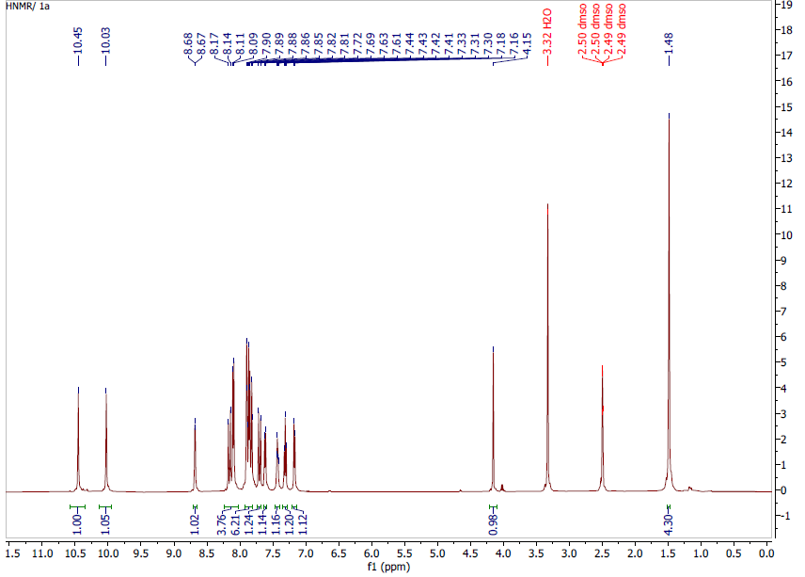
Figure 1. H-NMR. 14a
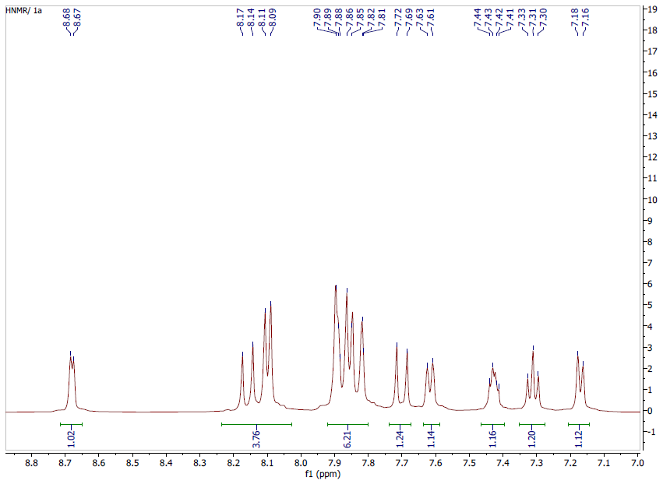
Figure 2. H-NMR. 14a

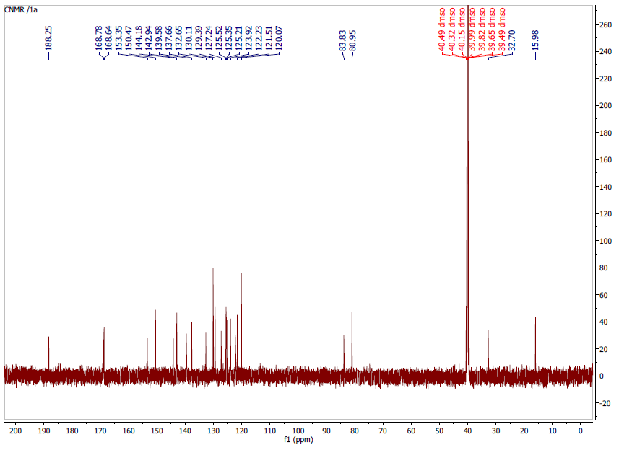
Figure 3. C-NMR. 14a
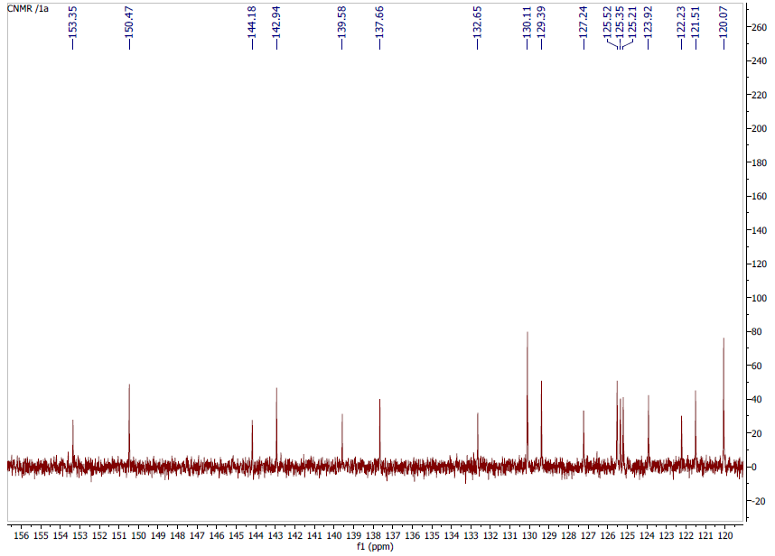
Figure 4. C-NMR. 14a

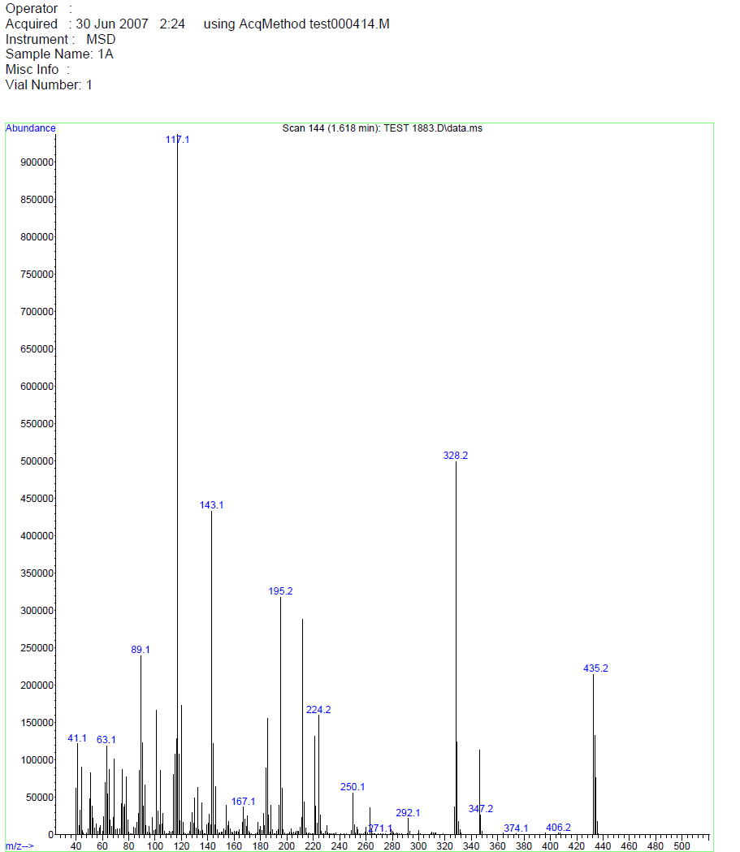
Figure 5. MASS spectrum. 14a

Compound 14b: (E)-N-(4-fluorophenyl)-N-(4-(3-(pyridin-2yl)acryloyl)phenyl)cyclopropane-1,1-dicarboxamide; C₂₅H₂₀FN₃O₃
¹H NMR (499 MHz, dmso) δ 10.52 (s, 1H, NH), 9.97 (s, 1H, NH), 8.67 (d, J = 4.6 Hz, 1H, Ar), 8.16 (d, J = 15.4 Hz, 1H, Ar), 8.10 (d, J = 8.4 Hz, 2H, Ar), 7.88-8.85 (m, 4H, Ar), 7.70 (d, J = 14.9 Hz, 1H, Ar), 7.64 – 7.62 (m, 2H, Ar), 7.41 (t, J = 5.2 Hz, 1H, Ar), 7.13 (t, J = 8.7 Hz, 2H, Ar), 1.49 (s, 4H, CH₂, cyclopropane). ¹³C NMR (126 MHz, dmso) δ 188.23, 168.91, 168.54, 158.77 (d, J = 239.6 Hz), 153.31, 150.40, 144.14, 142.86, 137.67, 135.62, 132.66, 130.11 (2C), 125.55, 125.35, 125.19, 122.98 (d, J = 7.6 Hz, 2C), 120.04 (2C), 115.45 (d, J = 22.3 Hz, 2C), 32.38, 16.03 (2C, cyclopropane); m/z [M + H]: 429.2

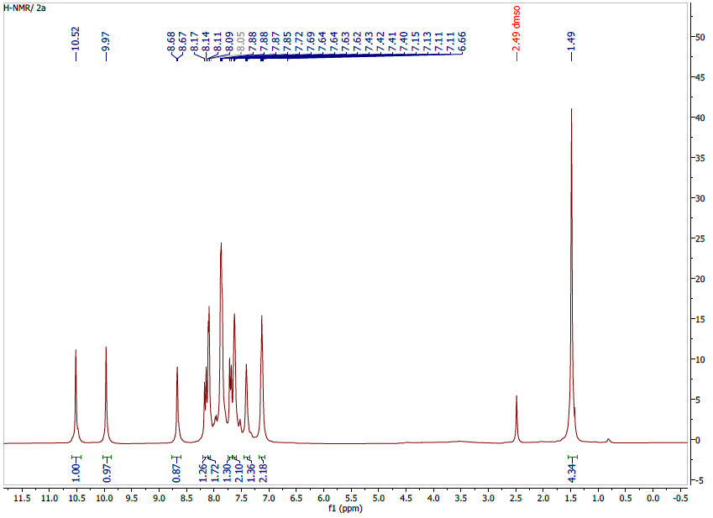
Figure 6. H-NMR. 14b
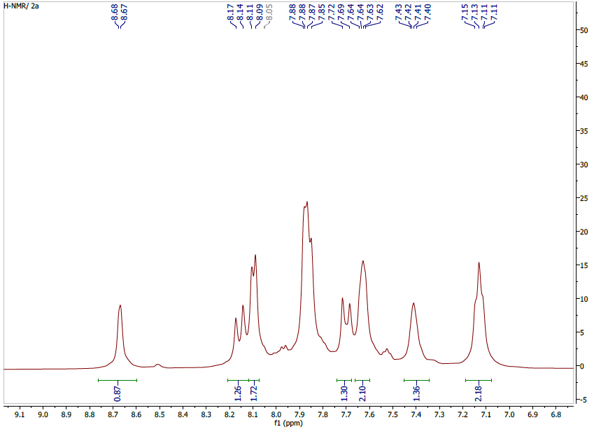
Figure 7. H-NMR. 14b

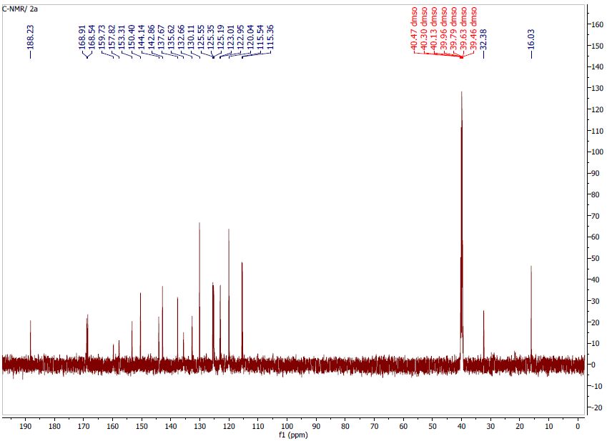
Figure 8. C-NMR. 14b

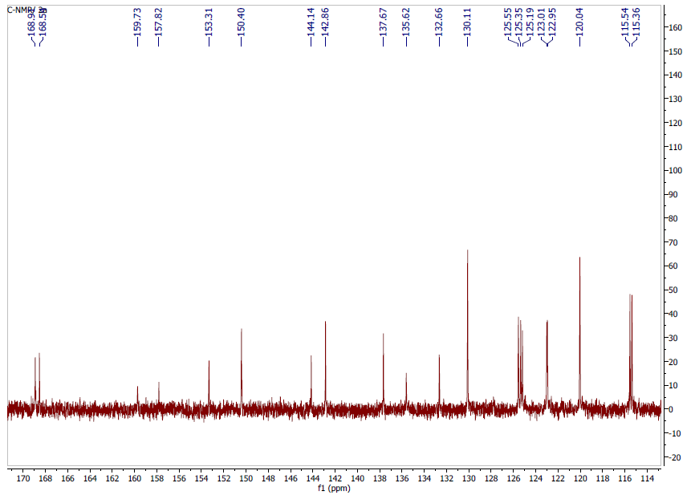
Figure 9. C-NMR. 14b

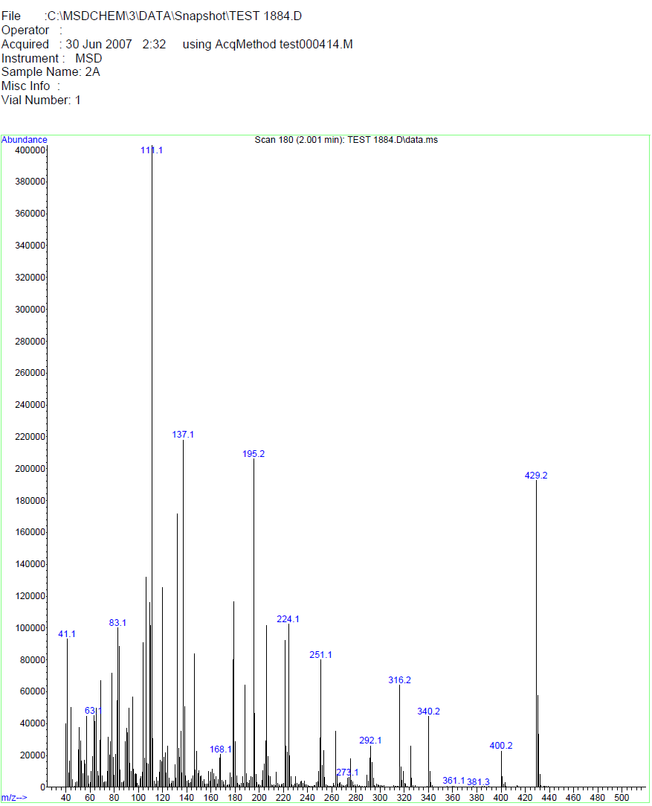
Figure 10. MASS spectrum. 14b

Compound 14c: (E)-N-(4-methyl-3-nitrophenyl)-N-(4-(3-(pyridin-2-yl)acryloyl)phenyl)cyclopropane-1,1-dicarboxamide; C₂₆H₂₂N₄O₅
¹H NMR (499 MHz, dmso) δ 10.47 (s, 1H, NH), 10.31 (s, 1H, NH), 8.67 (d, J = 4.7 Hz, 1H, Ar), 8.42 (s, 1H, Ar), 8.16-8.09 (m, 2H, Ar), 7.89-7.77 (m, 4H, Ar), 7.70 (d, J = 15.5 Hz, 2H), 7.44 – 7.41 (m, 3H, Ar), 2.46 (s, 3H, CH₃), 1.50 (s, 4H, 2CH₂, cyclopropane); ¹³C NMR (126 MHz, dmso) δ 188.25, 168.86, 168.56, 153.34, 150.46 (2C), 148.83, 144.20, 142.93, 138.39, 137.64, 133.27, 132.66, 130.40, 130.11 (2C), 127.94, 125.50, 125.35 (2C), 125.20, 120.03 (2C), 116.13, 32.84 (C, cyclopropane), 19.66 (CH₃), 15.98 (2CH₂, cyclopropane); m/z [M + H]: 470.2

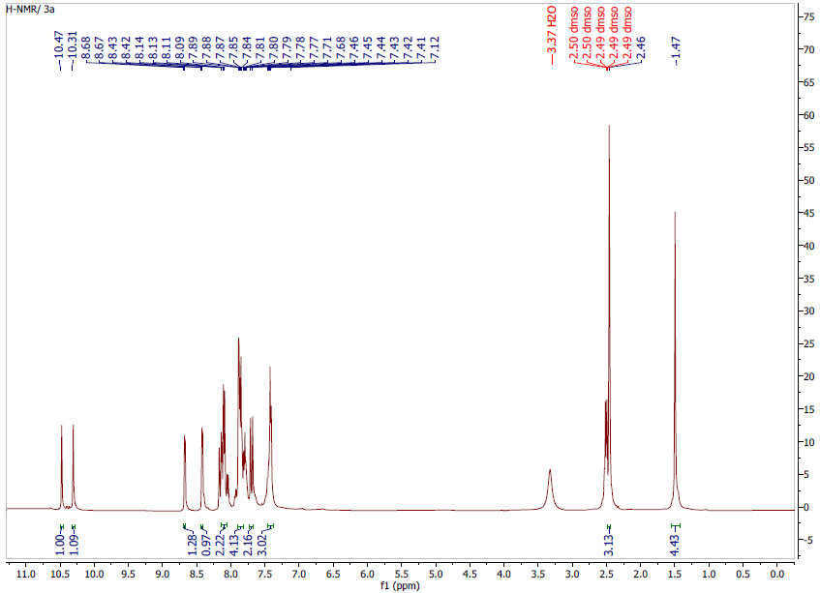
Figure 11. H-NMR. 14c

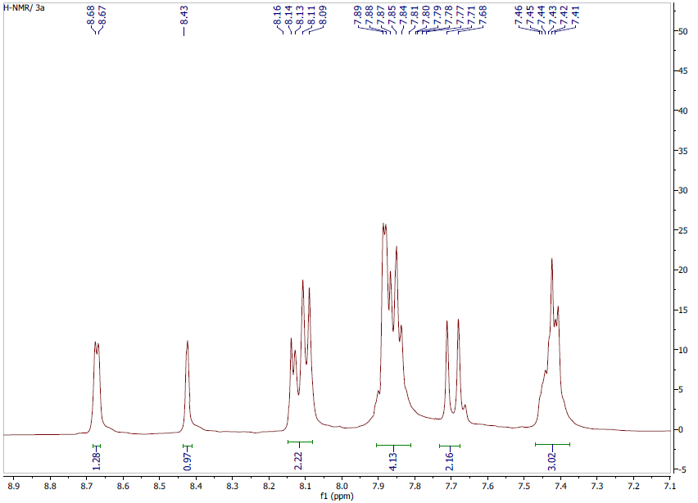
Figure 12. H-NMR. 14c

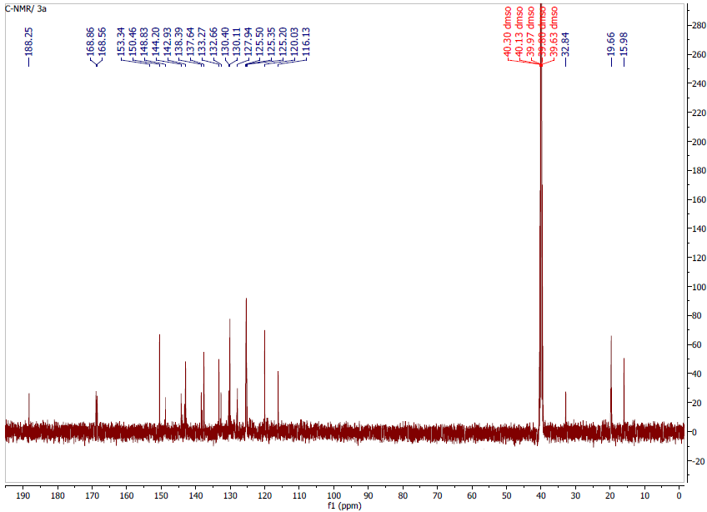
Figure 13. C-NMR. 14c
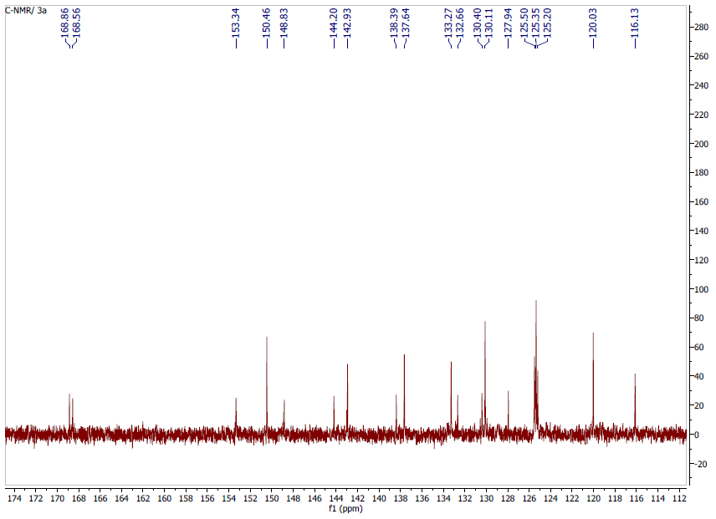
Figure 14. C-NMR. 14c

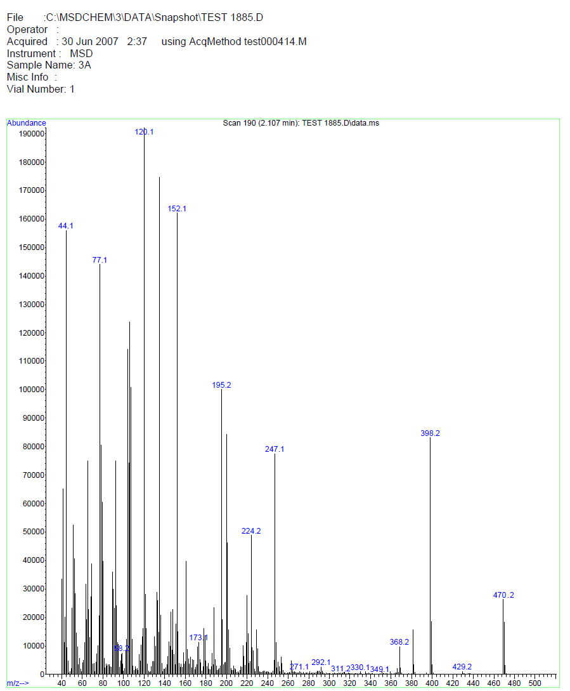
Figure 15. MASS spectrum. 14c

Compound 14d: (E)-N-(4-bromophenyl)-N-(4-(3-(pyridin-2-yl)acryloyl)phenyl)cyclopropane-1,1-dicarboxamide; C₂₅H₂₀BrN₃O_{5 .}
¹H NMR (499 MHz, dmso) δ 10.45 (s, 1H, NH), 10.07 (s, 1H, NH), 8.67 (d, J = 4.7 Hz, 1H, Ar), 8.16 (d, J = 15.3 Hz, 1H, Ar), 8.09 (d, J = 8.4 Hz, 2H, Ar), 7.88-7.84 (m, 4H, Ar), 7.70 (d, J = 15.5 Hz, 1H, Ar), 7.61 (d, J = 8.5 Hz, 2H, Ar), 7.47 (d, J = 8.6 Hz, 2H, Ar), 7.42 (t, J = 4.4 Hz, 1H, Ar), 1.48 (s, 4H, CH₂, cyclopropane); ¹³C NMR (126 MHz, dmso) δ 188.22, 168.83, 168.56, 153.31, 150.40, 144.16, 142.86, 138.76, 137.67, 132.66, 131.72 (2C), 130.10 (2C), 125.55, 125.35, 125.19, 122.86 (2C), 120.07 (2C), 115.72, 32.67 (C, cyclopropane), 16.02 (2CH₂, cyclopropane); m/z [M + H]: 491.1

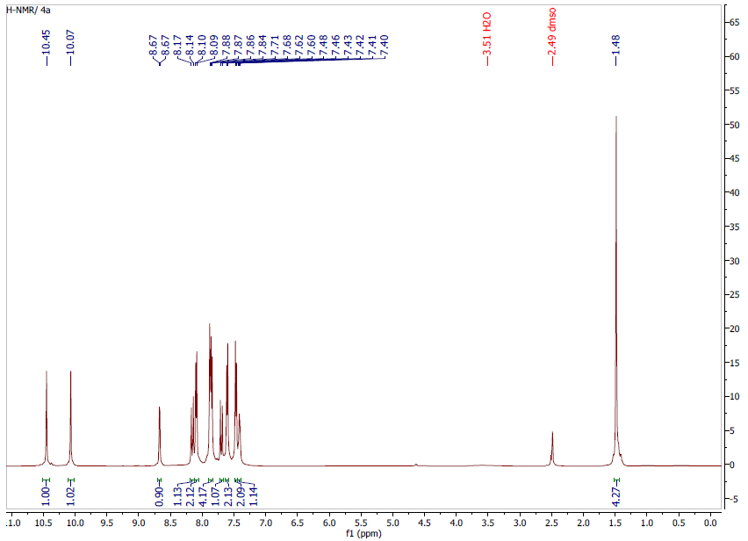
Figure 16. H-NMR. 14d
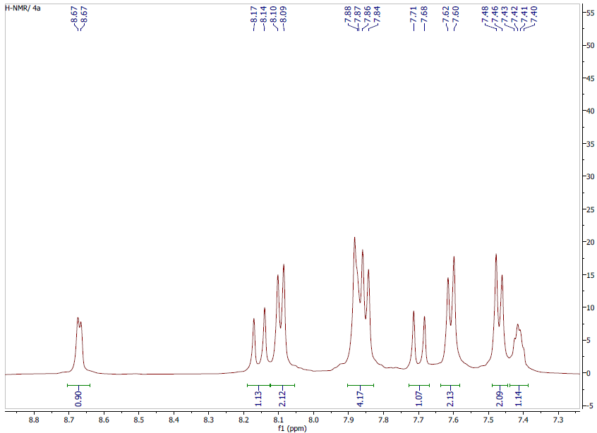
Figure 17. H-NMR. 14d

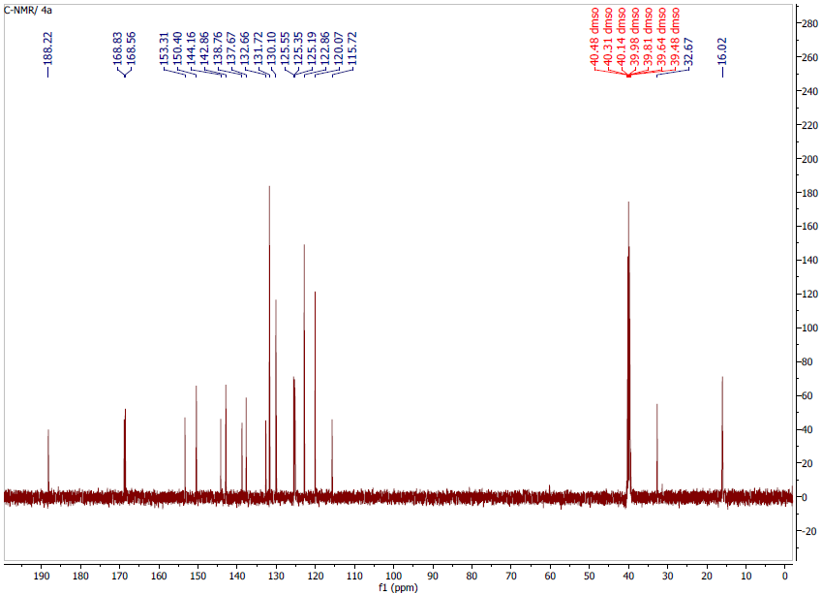
Figure 18. C-NMR. 14d

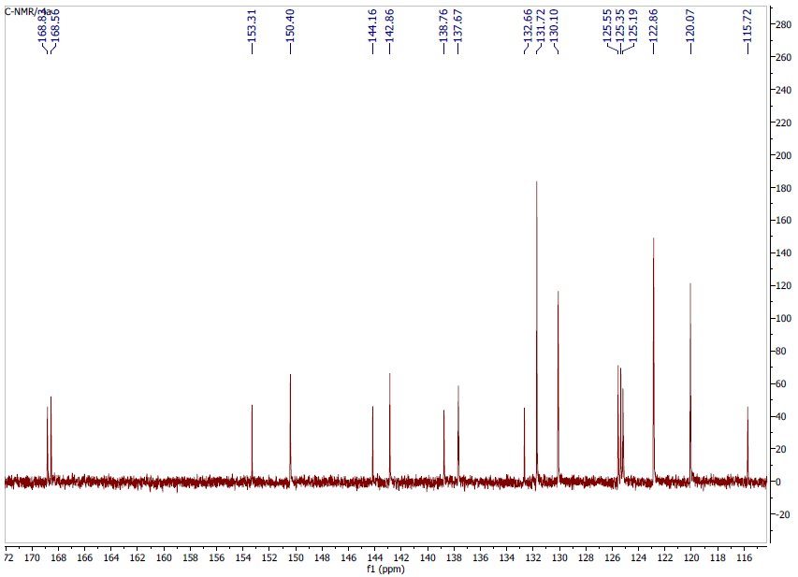
Figure 19. C-NMR. 14d

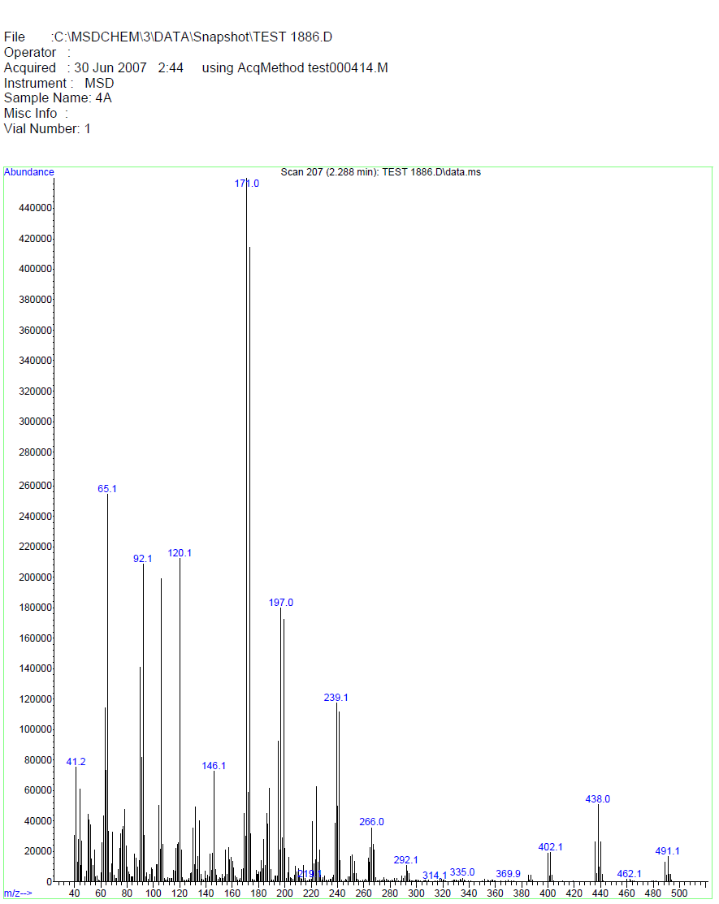
Figure 20. MASS spectrum. 14d

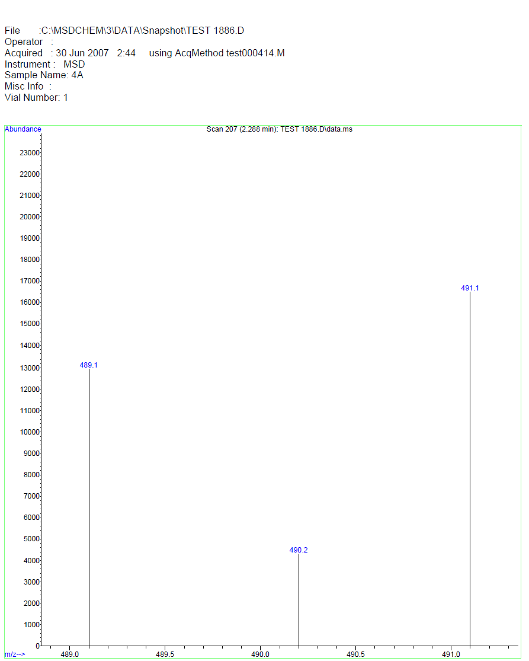
Figure 21. MASS spectrum. 14d

14e: (E)-N-(4-cyanophenyl)-N-(4-(3-(pyridin-4-yl)acryloyl)phenyl)cyclopropane-1,1-dicarboxamide; C₂₆H₂₀N₄O₃
¹H NMR (499 MHz, dmso) δ 10.42 (s, 1H, NH), 10.38 (s, 1H, NH), 8.67 (d, J = 5.0 Hz, 2H, Ar), 8.16 – 8.14 (m, 3H, Ar), 7.84 (m, 7H, Ar), 7.76 (d, J = 8.7 Hz, 3H, Ar), 7.66 (d, J = 15.6 Hz, 1H, Ar), 1.49 (s, 4H, CH₂, cyclopropane); ¹³C NMR (126 MHz, dmso) δ 187.89 (C=O, chalcone), 168.85 (C=O, amide), 168.62 (C=O, amide), 150.71 (2C), 144.35, 143.80, 142.38, 140.88, 133.45 (2C), 132.44, 130.33 (2C), 126.84 (2C), 123.00, 120.63 (2C), 120.00 (2C), 119.53 (CN), 105.6, 33.20 (CH, cyclopropane), 15.97 (2 CH₂, cyclopropane); m/z [M + H]: 436.2

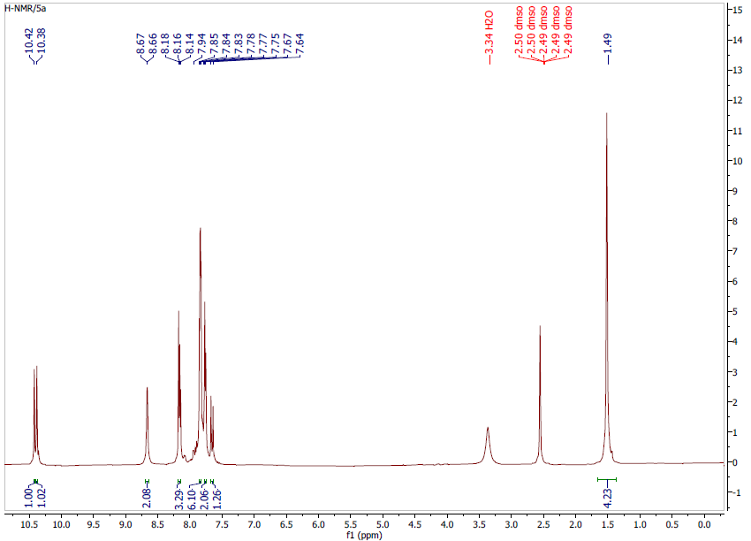
Figure 22. H-NMR. 14e

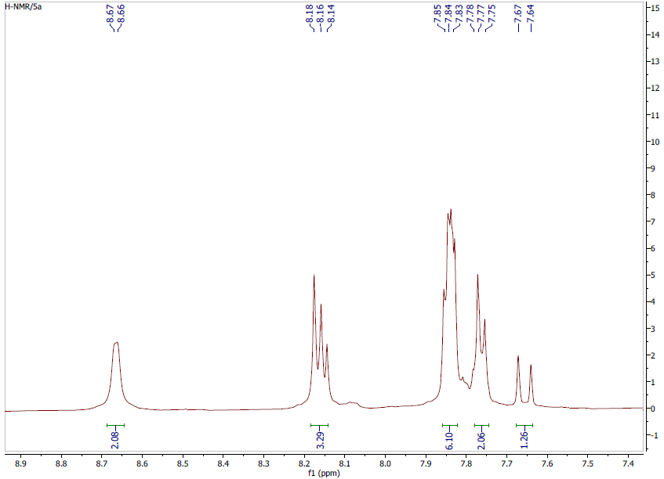
Figure 23. H-NMR. 14e

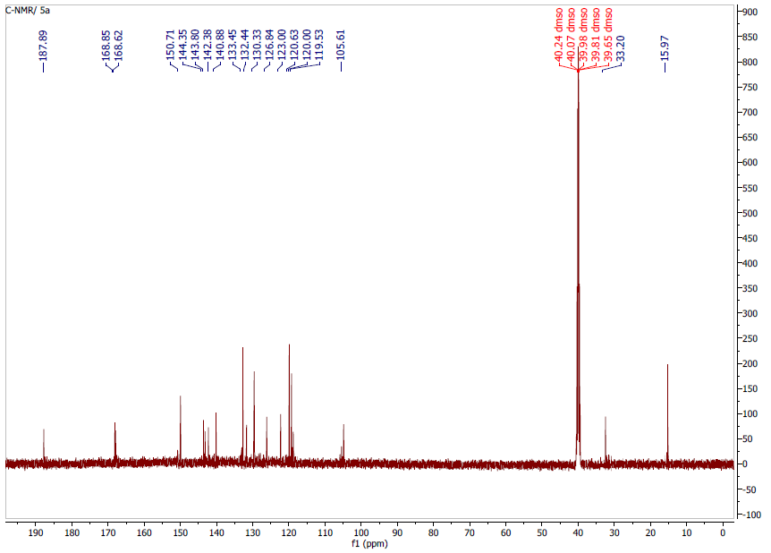
Figure 24. C-NMR. 14e

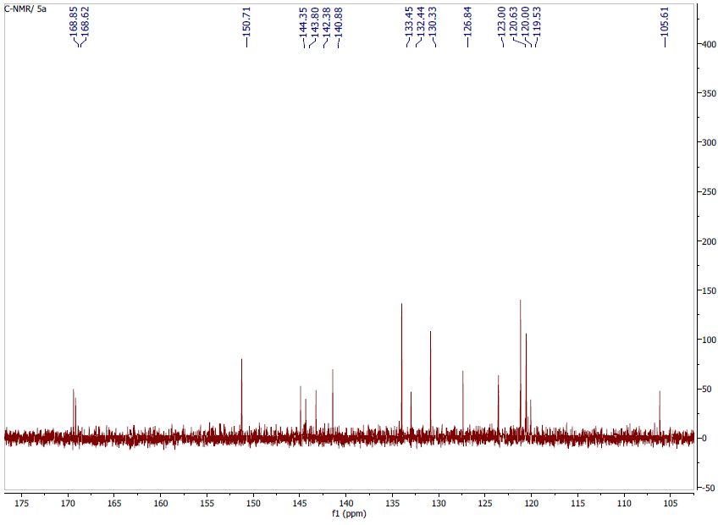
Figure 25. C-NMR. 14e

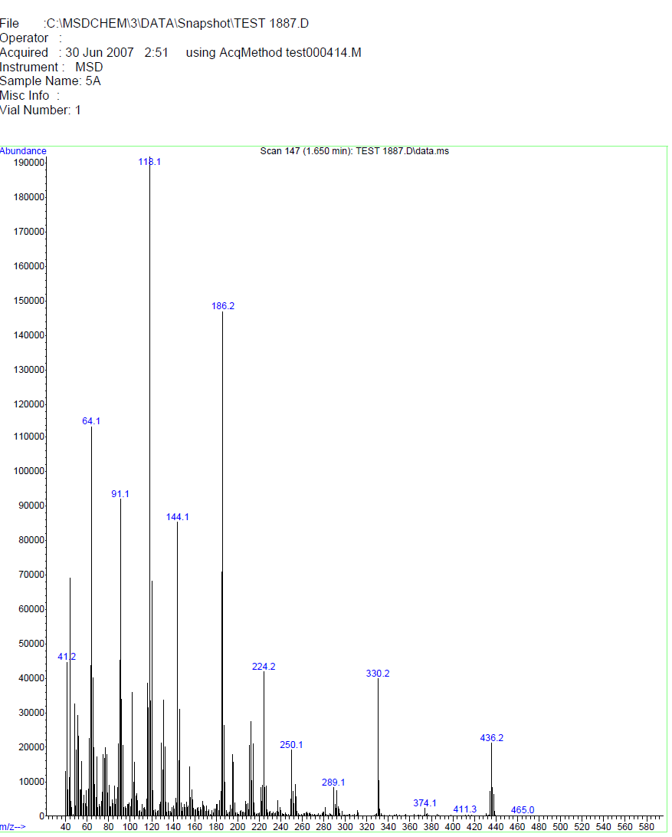
Figure 26. MASS spectrum. 14e

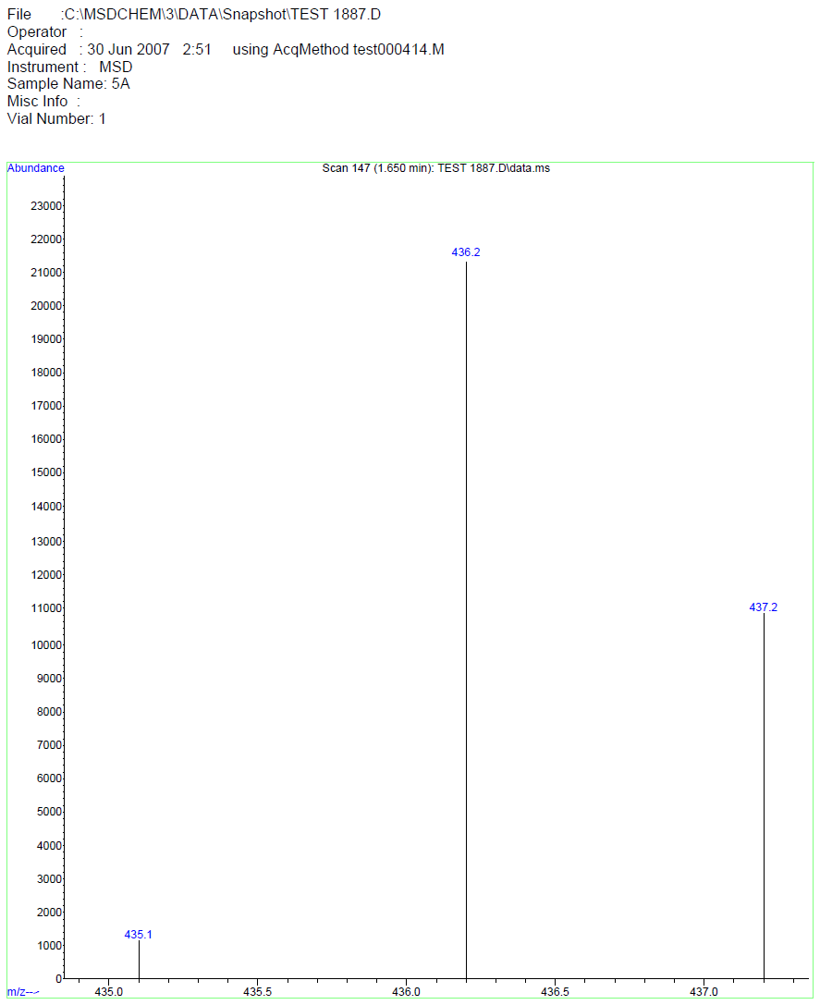
Figure 27. MASS spectrum. 14e

14f: (E)-N-(4-chlorophenyl)-N-(4-(3-(pyridin-2-yl)acryloyl)phenyl)cyclopropane-1,1-dicarboxamide; C₂₅H₂₀ClN₃O₃
¹H NMR (499 MHz, dmso) δ 10.46 (s, 1H, NH), 10.07 (s, 1H, NH), 8.67 (d, J = 4.6 Hz, 1H, Ar), 8.15 (d, J = 15.5 Hz, 1H, Ar), 8.09 (d, J = 8.6 Hz, 1H, Ar), 7.88 – 7.84 (m, 5H, Ar), 7.71-7.65 (m, 3H, Ar), 7.40 (t, J = 4.5 Hz, 1H, Ar), 7.34 (d, J = 8.6 Hz, 2H, Ar), 1.49 (s, 4H, 2CH₂, cyclopropane); ¹³C NMR (126 MHz, dmso) δ 188.24, 168.85, 168.57, 153.34, 150.44, 144.16, 142.91, 138.32, 137.63, 132.67, 130.10 (2C), 128.80, 127.68 (2C), 125.52, 125.35, 125.18, 122.51 (2C), 120.07 (2C), 32.63 (C, cyclopropane), 16.03, (2CH₂, cyclopropane); m/z [M + H]: 445.2 .

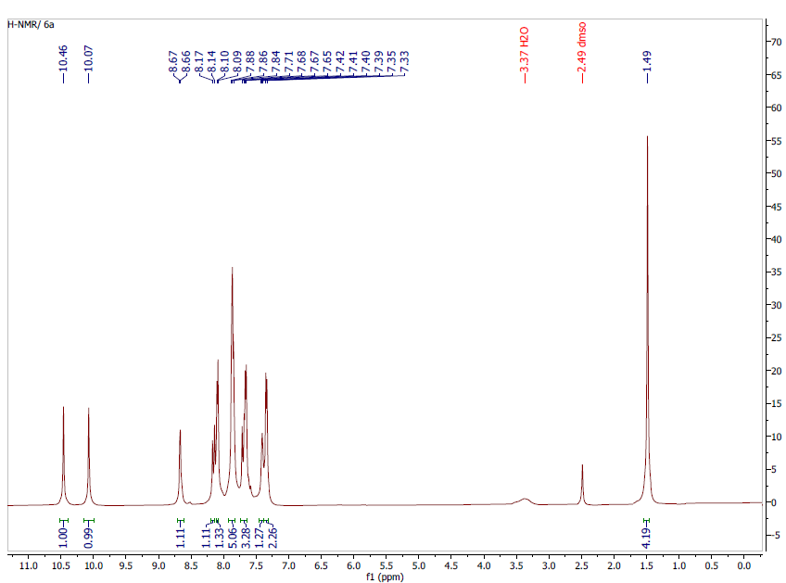
Figure 28. H-NMR. 14f

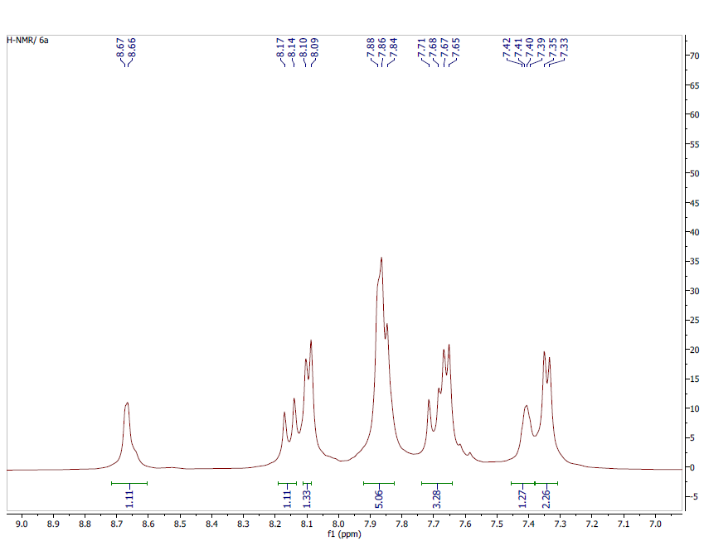
Figure 29. H-NMR. 14f
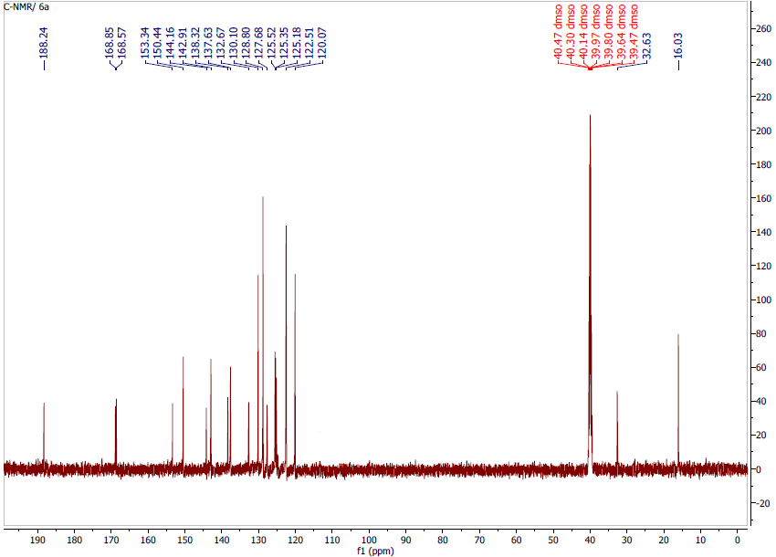
Figure 30. C-NMR. 14f

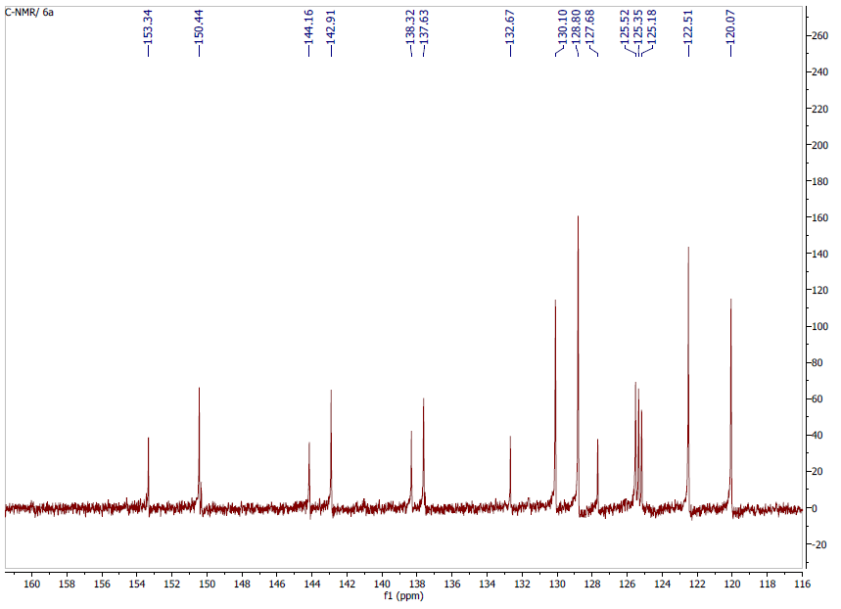
Figure 31. C-NMR. 14f

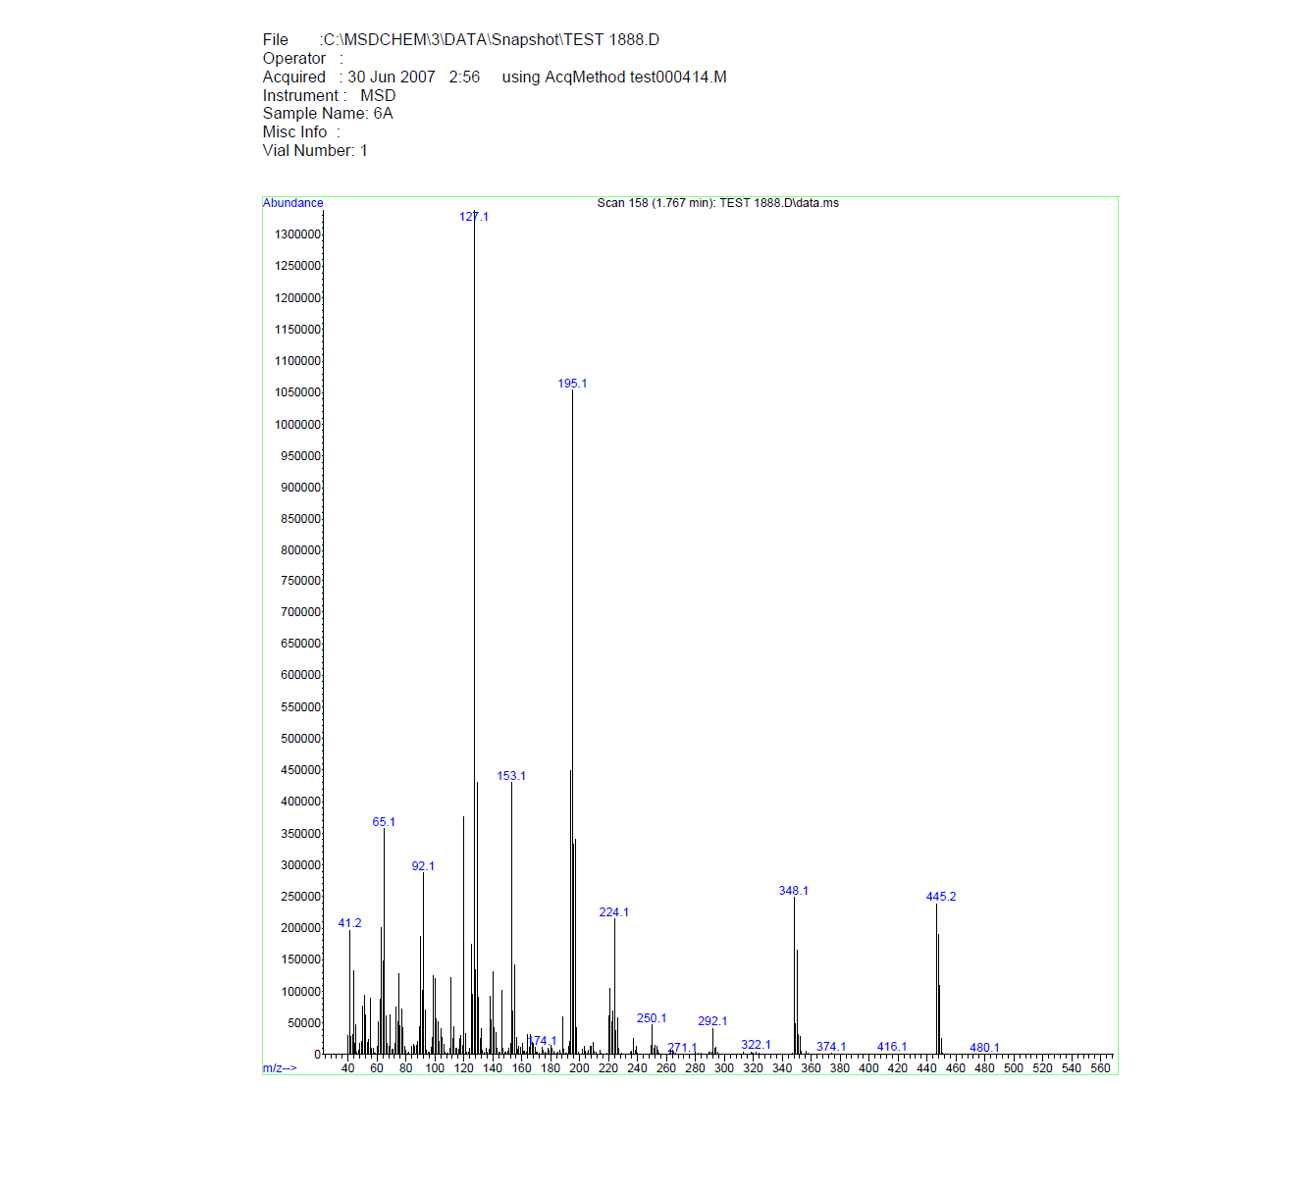
Figure 32. MASS spectrum. 14f

14g: (E)-N-(4-nitrophenyl)-N-(4-(3-(pyridin-4-yl)acryloyl)phenyl)cyclopropane-1,1-dicarboxamide; C₂₅H₂₀N₄O₅ .
¹H NMR (499 MHz, dmso) δ 10.62 (s, 1H, NH), 10.40 (s, 1H, NH), 8.69 (d, J = 4.6 Hz, 2H, Ar), 8.25 – 8.21 (m, 4H, Ar), 7.91-7.85 (m, 7H, Ar), 7.67 (d, J = 15.8 Hz, 1H, Ar), 1.52 (s, 4H, 2CH₂,cyclopropane); ¹³C NMR (126 MHz, dmso) δ 187.83, 169.00, 168.59, 149.71 (2C), 145.80, 144.40, 143.61, 142.76, 140.47, 132.40, 130.36 (2C), 127.48, 125.10 (2C), 123.35 (2C), 120.22 (2C), 120.01 (2C), 33.29, 16.07 (2CH₂, cyclopropane); m/z [M + H]: 456.2

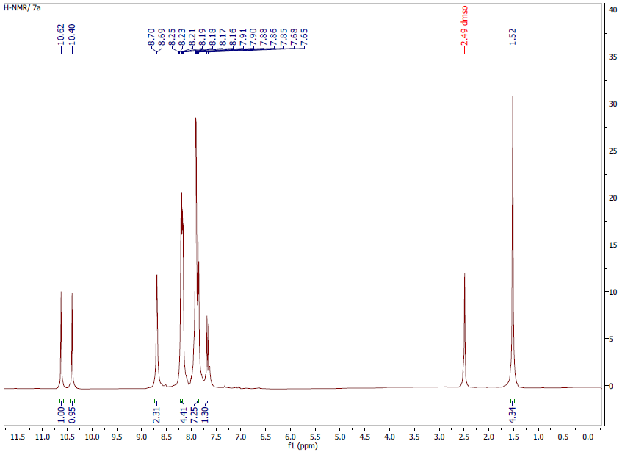
Figure 33. H-NMR. 14g

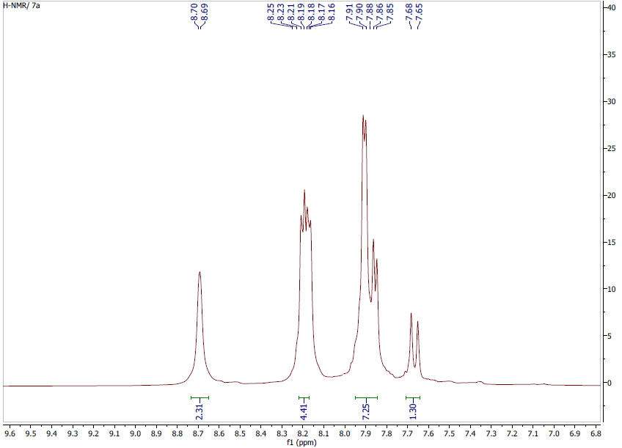
Figure 34. H-NMR. 14g

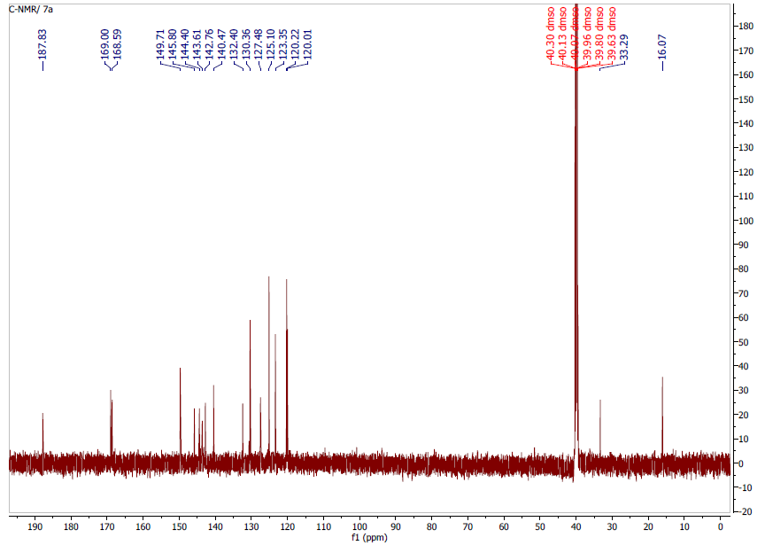
Figure 35. C-NMR. 14g

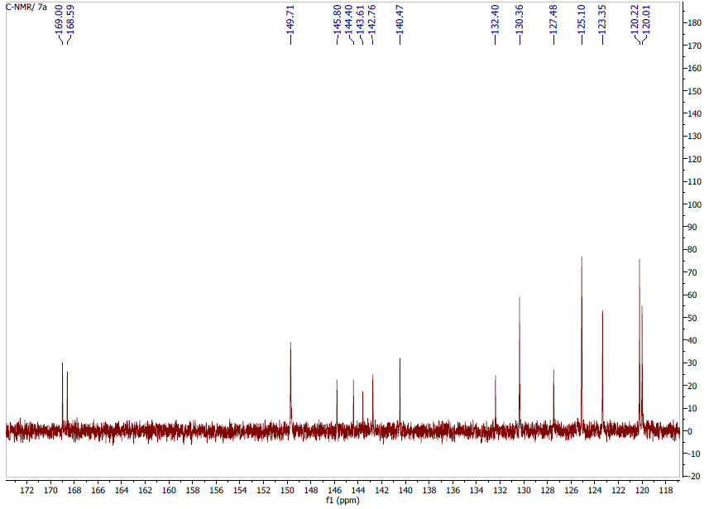
Figure 36. C-NMR. 14g

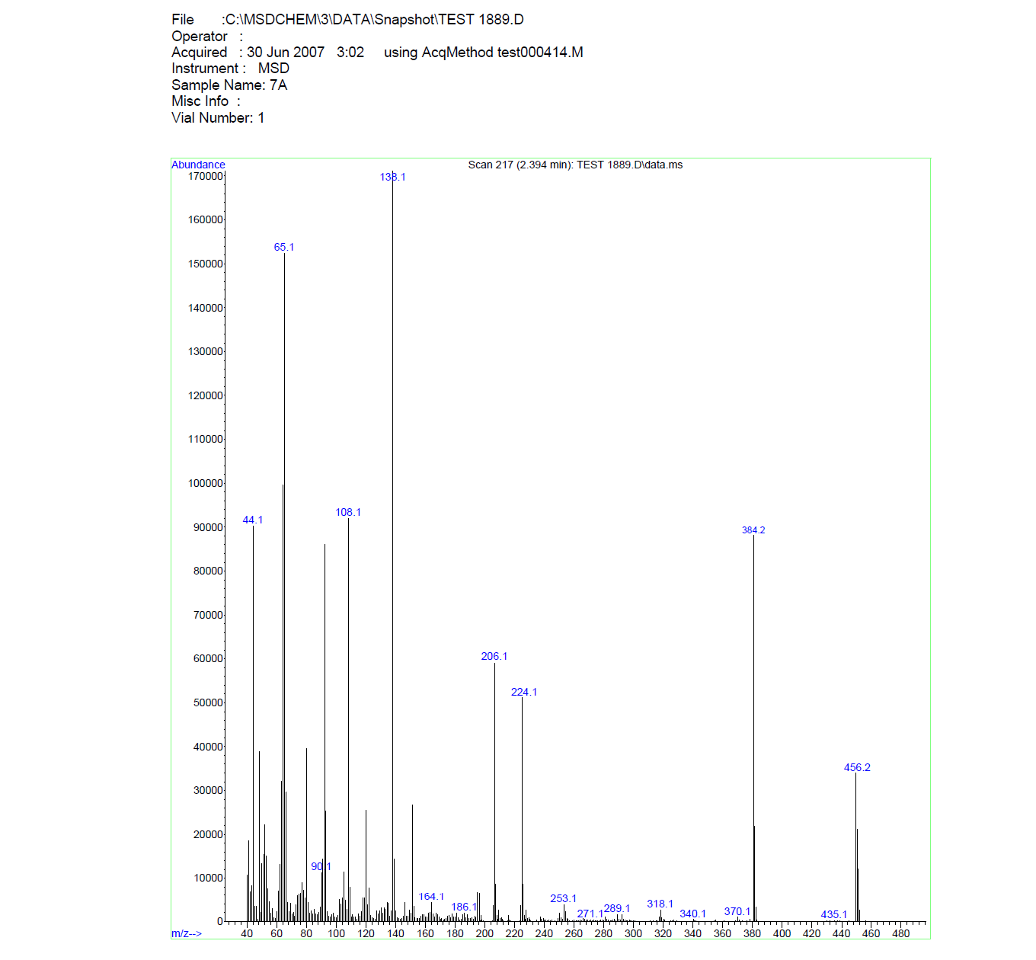
Figure 37. MASS spectrum. 14g

14h: (E)-N-(4-(3-(pyridin-4-yl)acryloyl)phenyl)-N-(4-(trifluoromethyl)phenyl)cyclopropane-1,1-dicarboxamide; C₂₆H₂₀f₃N₃O₃
¹H NMR (499 MHz, dmso) δ 10.76 (s, 1H, NH), 9.91 (s, 1H, NH), 8.66 (d, J = 5.1 Hz, 1H, Ar), 8.21 (d, J = 8.5 Hz, 1H, Ar), 8.17 (d, J = 15.8 Hz, 1H, Ar), 7.87-7.83 (m, 5H, Ar), 7.46 (m, 1H, Ar), 1.89 (s, 4H, 2CH₂, cyclopropane); ¹³C NMR (126 MHz, dmso) δ 187.98, 170.63, 170.48, 149.89, 145.03, 142.75, 139.68, 138.20, 132.82, 130.62 (2C), 126.81 (m), 125.55 (m, 2C), 124.80, 124.99 (2C), 122.75, 122.02, 120.55 (m, 2C), 118.67 (2C), 33.20, 15.12 (2CH₂, cyclopropane); m/z [M + H]: 479.1

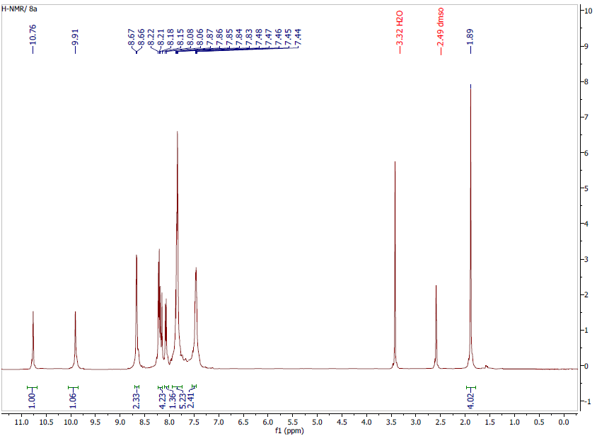
Figure 38. H-NMR. 14h
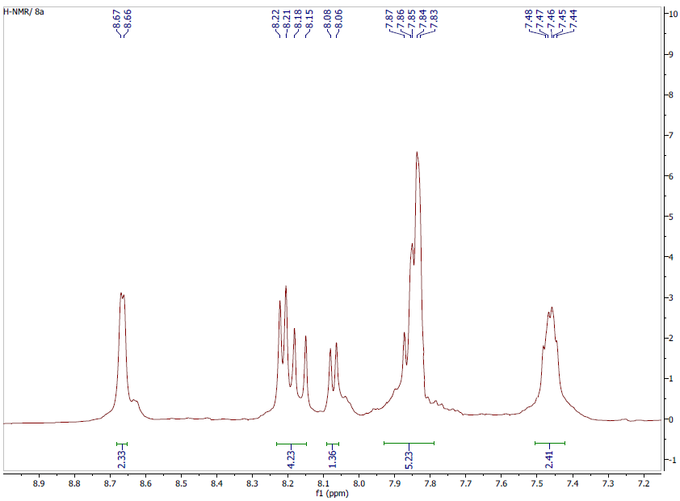
Figure 39. H-NMR. 14h

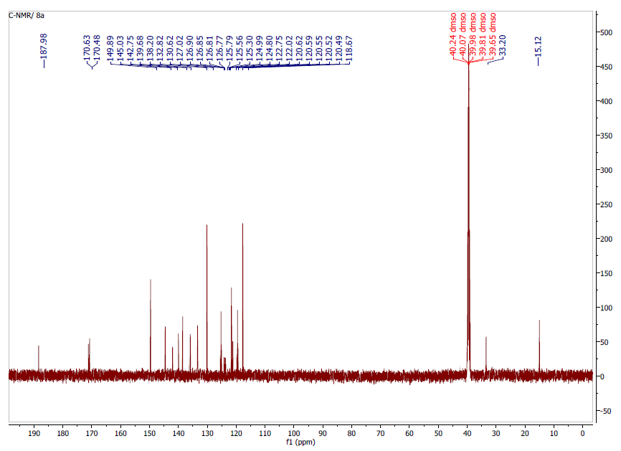
Figure 40. C-NMR. 14h
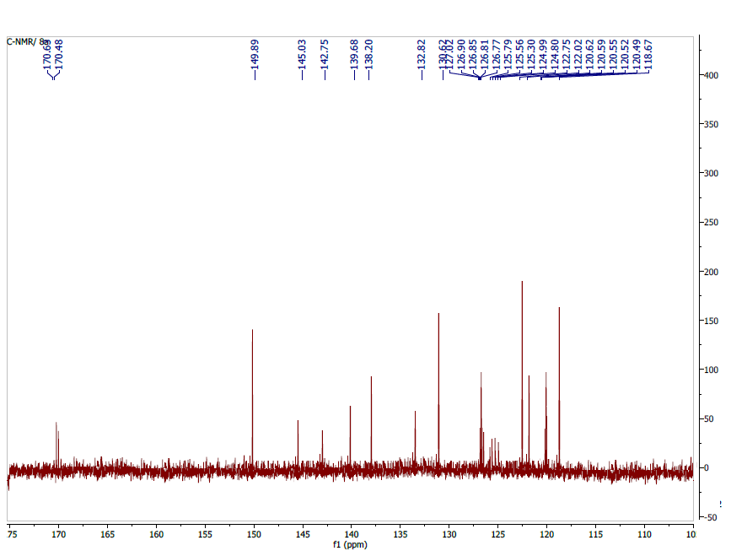
Figure 41. C-NMR. 14h

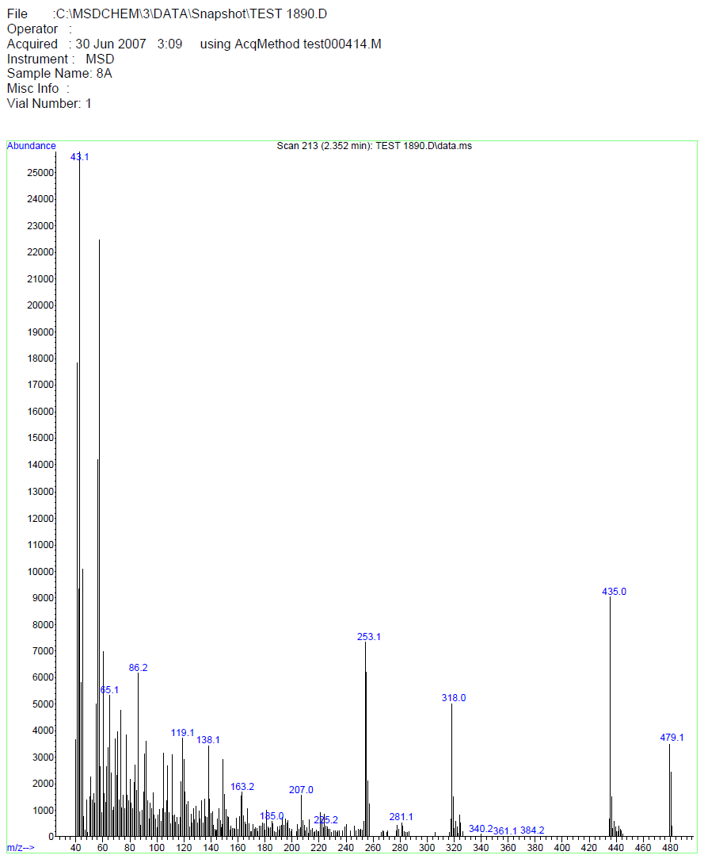
Figure 42. MASS spectrum. 14h

14i: (E)-N-(3-ethynylphenyl)-N-(4-(3-(pyridin-4-yl)acryloyl)phenyl)cyclopropane-1,1-dicarboxamide; C₂₇H₂₁N₃O₃ .
¹H NMR (499 MHz, dmso) δ 10.45 (s, 1H, NH), 10.02 (s, 1H, NH), 8.65 (d, J = 5.1 Hz, 2H, Ar), 8.17 – 8.14 (m, 3H, Ar), 7.86 – 7.81 (m, 5H, Ar), 7.66 – 7.60 (m, 2H, Ar), 7.30 (t, J = 7.9 Hz, 1H, Ar), 7.16 (d, J = 7.6 Hz, 1H, Ar), 4.14 (s, 1H, ), 1.48 (s, 4H, 2CH₂, cyclopropane); ¹³C NMR (126 MHz, dmso) δ 187.89, 168.81, 168.64, 150.79 (2C), 144.33, 140.90, 139.56, 132.41, 131.87, 130.33 (2C), 129.38, 127.24, 126.76, 123.92, 122.94, 122.76 (2C), 121.51, 119.96 (2C), 83.81 (), 80.93 (), 32.71 (C, cyclopropane), 15.97 (2CH₂, cyclopropane); m/z [M + H]: 435.2

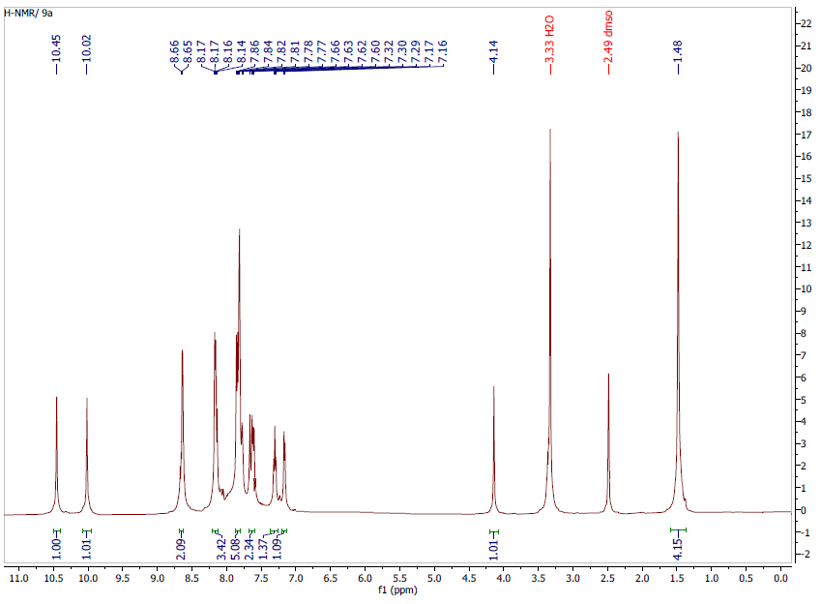
Figure 43. H-NMR. 14i

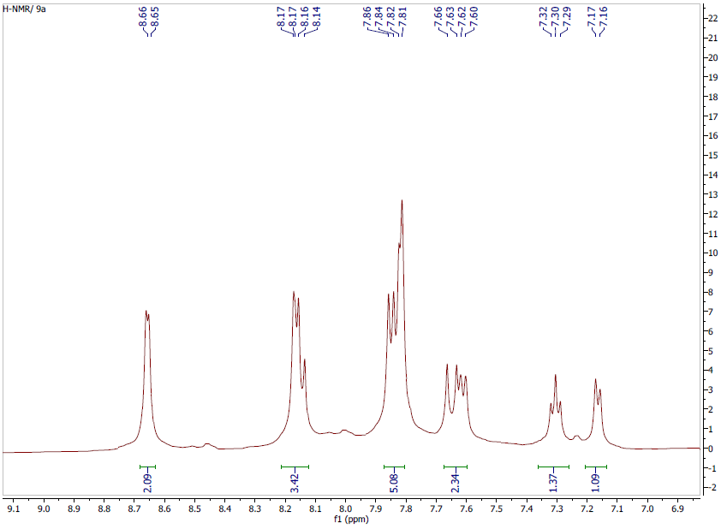
Figure 44. H-NMR. 14i
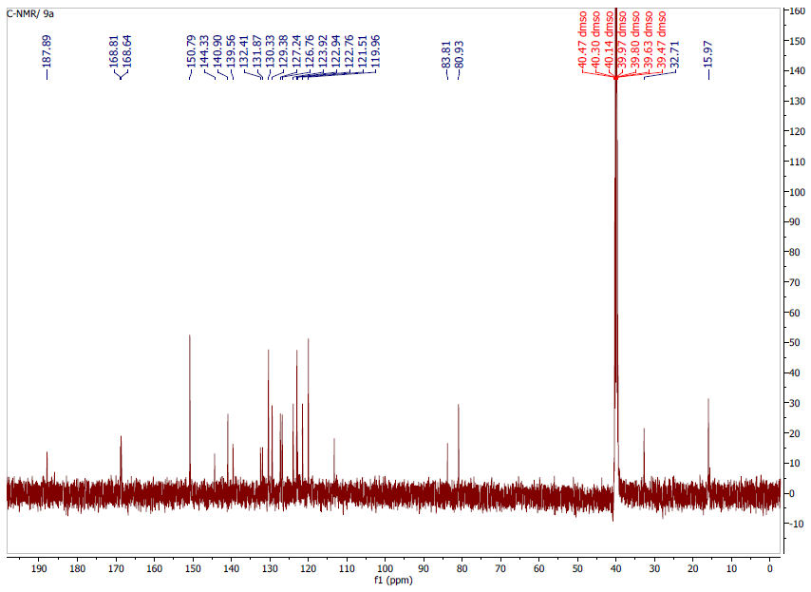
Figure 45. C-NMR. 14i

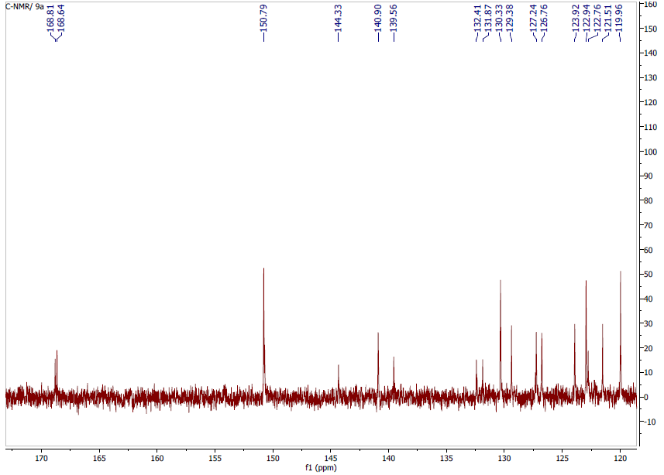
Figure 46. C-NMR. 14i

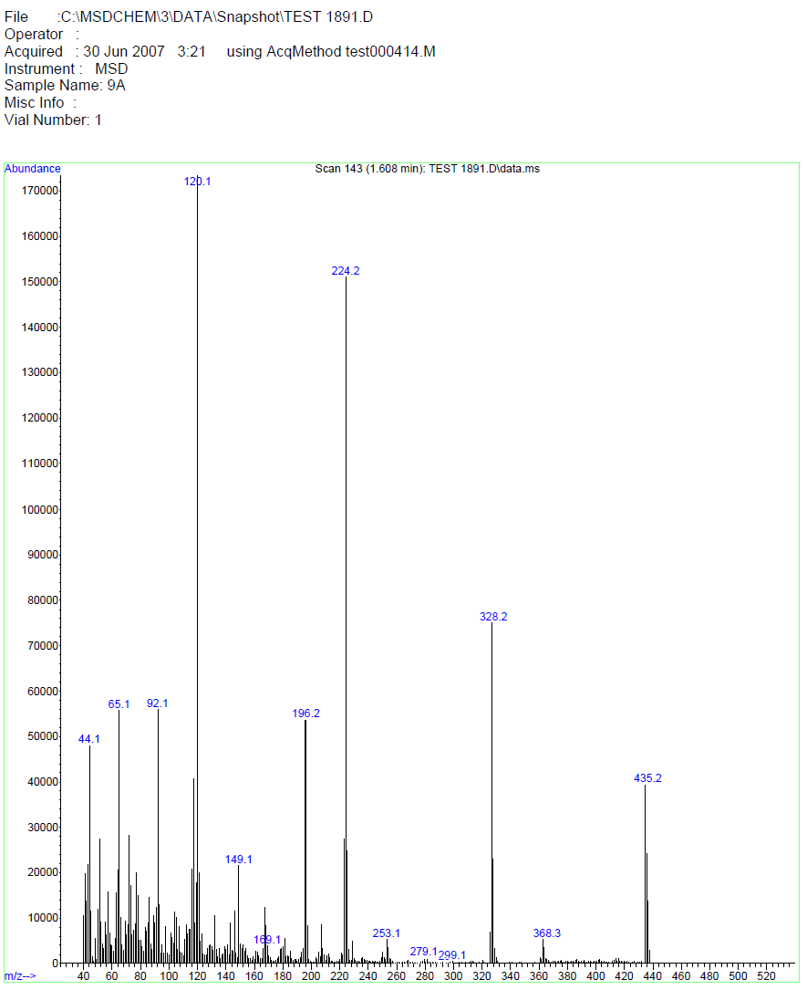
Figure 47. MASS spectrum. 14i

14j: (E)-N-(4-fluorophenyl)-N-(4-(3-(pyridin-4-yl)acryloyl)phenyl)cyclopropane-1,1-dicarboxamide, C₂₅H₂₀FN₃O₃ .
¹H NMR (499 MHz, dmso) δ 10.51 (s, 1H, NH), 9.96 (s, 1H, NH), 8.66 (d, J = 5.1 Hz, 2H, Ar), 8.18 – 8.13 (m, 3H, Ar), 7.86 – 7.82 (m, 4H, Ar), 7.67 – 7.61 (m, 3H, Ar), 7.14 (t, J _{F} = 8.7 Hz, 2H, Ar), 1.49 (s, 4H); ¹³C NMR (126 MHz, dmso) δ 187.89, 168.92, 168.50, 157.81, 159.73, 150.77 (2C), 143.36 (d, J_{C-F} = 241.3 Hz), 140.90, 135.61, 132.41, 130.36 (2C), 126.79 (2C), 122.96 (2C), 123.01, 119.93 (2C), 115.47 (d, J_{C-F} = 22.3 Hz, 2C), 32.46, 15.98 (2C); m/z [M + H]: 429.2

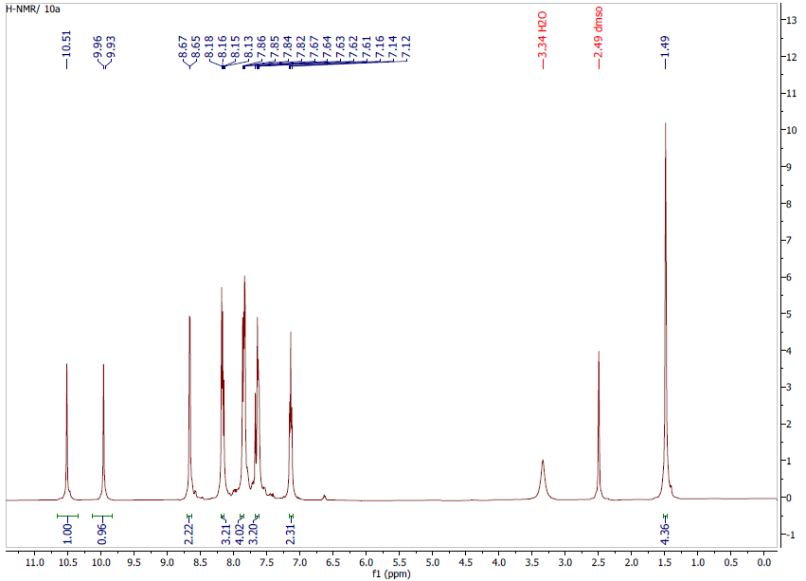
Figure 48. H-NMR. 14j

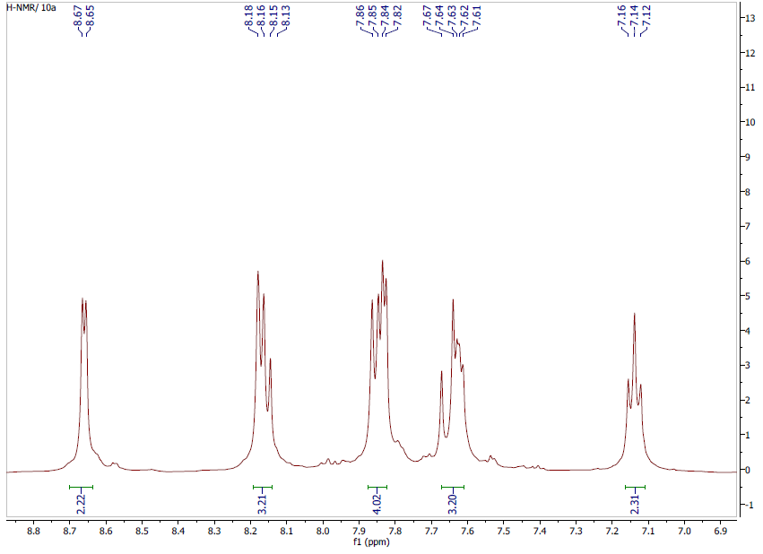
Figure 49. H-NMR. 14j

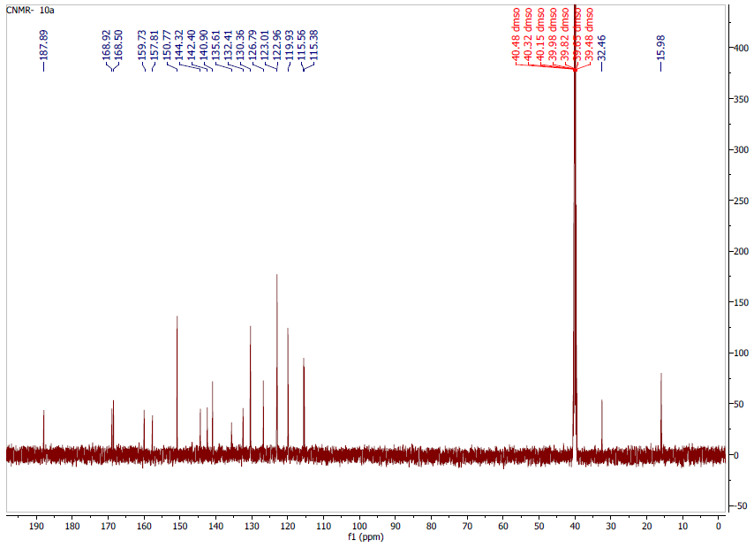
Figure 50. C-NMR. 14j

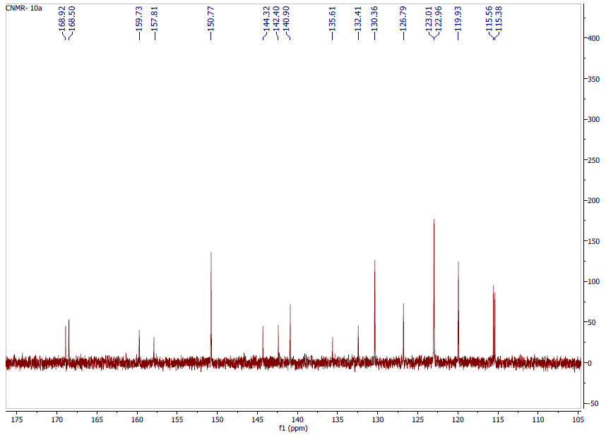
Figure 51. C-NMR. 14j
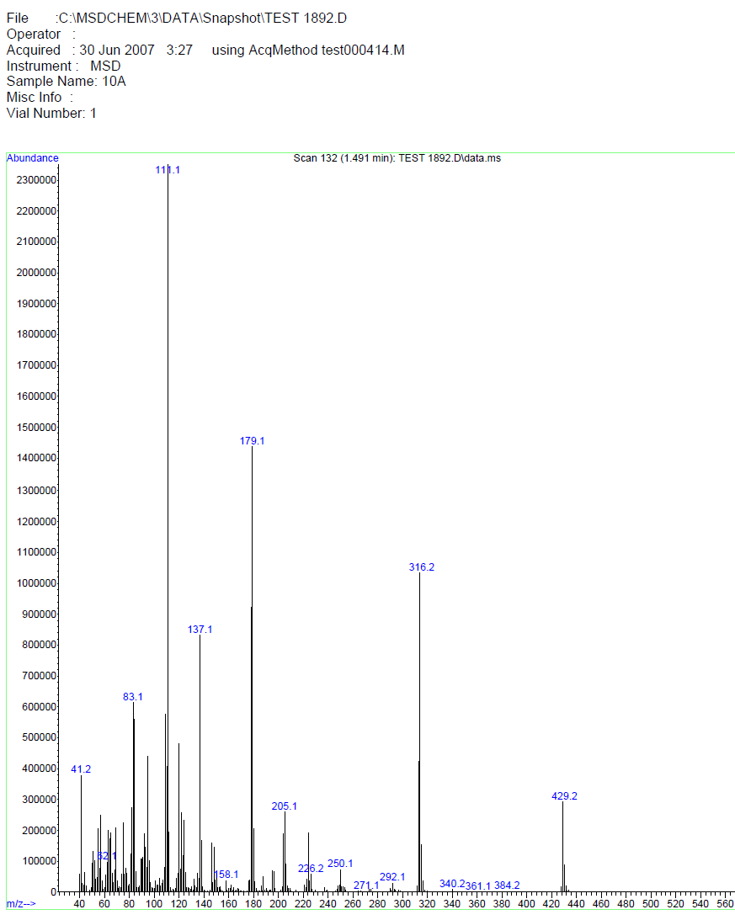
Figure 52. MASS spectrum. 14j

14k: (E)-N-(4-isopropylphenyl)-N-(4-(3-(pyridin-4-yl)acryloyl)phenyl)cyclopropane-1,1-dicarboxamide, : C₂₇₈H₂₇N₃O₃ .
¹H NMR (499 MHz, dmso) δ 10.63 (s, 1H, NH), 10.18 (s, 1H, NH), 8.66 (d, J = 4.7 Hz, 2H, Ar), 8.20 – 8.14 (m, 3H, Ar), 7.86 – 7.82 (m, 4H, Ar), 7.56-7.50 (m, 3H, Ar), 7.17 (d, J = 8.7 Hz, 2H, Ar), 2.82 (dt, J = 14.1, 7.2 Hz, 1H, CH, isopropyl), 1.49 (s, 4H, 2 CH₂, cyclopropane), 1.16 (s, 6H, 2CH₃); ¹³C NMR (126 MHz, dmso) δ 187.90 (C=O, chalcone), 167.98 (C=O, amide), 166.76 (C=O, amide), 150.80 (2C), 150.71, 144.28, 143.23, 141.00 (2C), 138.95, 132.73 131.88 (2C), 130.65, 126.95 (2C), 126.61 (2C), 122.95, 122.77, 119.97 (2C), 33.33 (C, cyclopropane), 27.93 (C, isopropyl), 24.41 (CH₃), 24.38 (CH₃), 16.06 (CH₂, cyclopropane); m/z [M + H]: 453.3

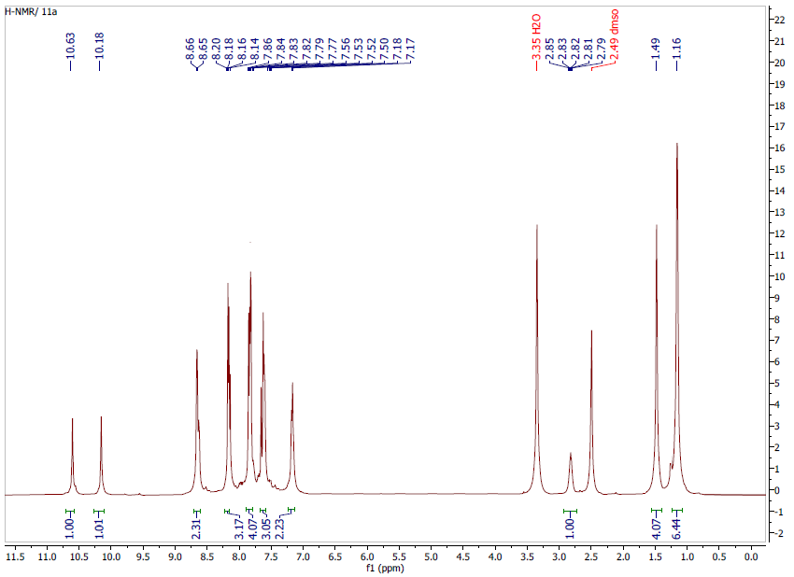
Figure 53. H-NMR. 14k

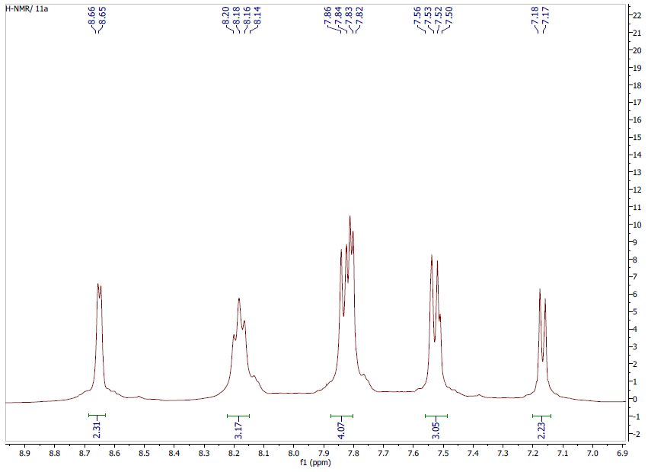
Figure 54. H-NMR. 14k
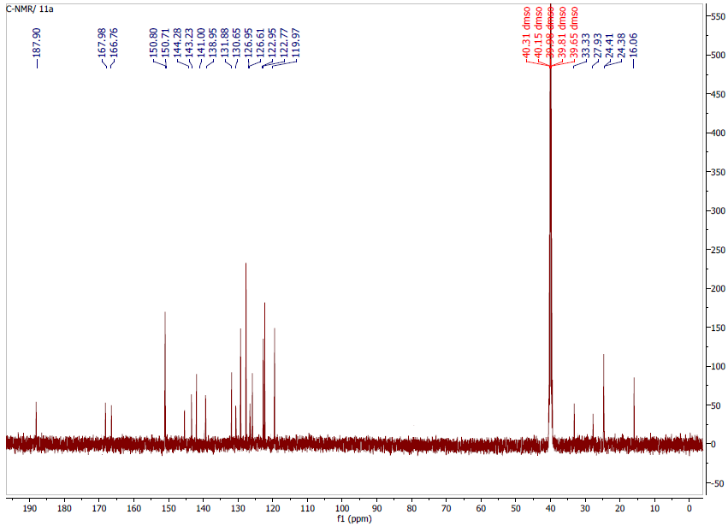
Figure 55. C-NMR. 14k

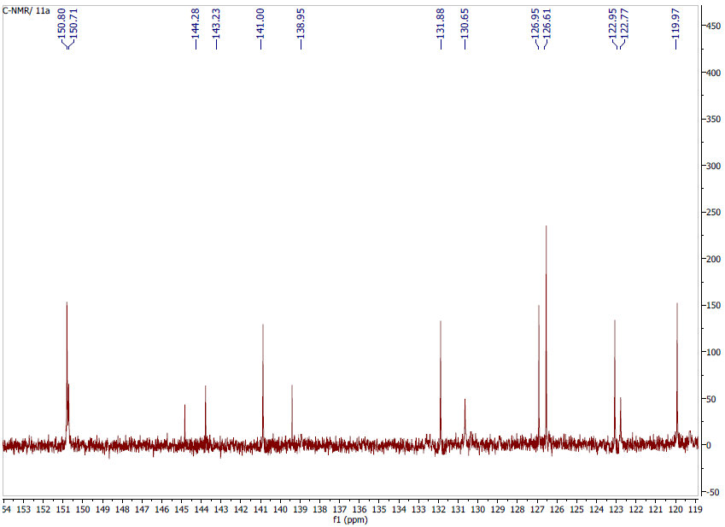
Figure 56. C-NMR. 14k

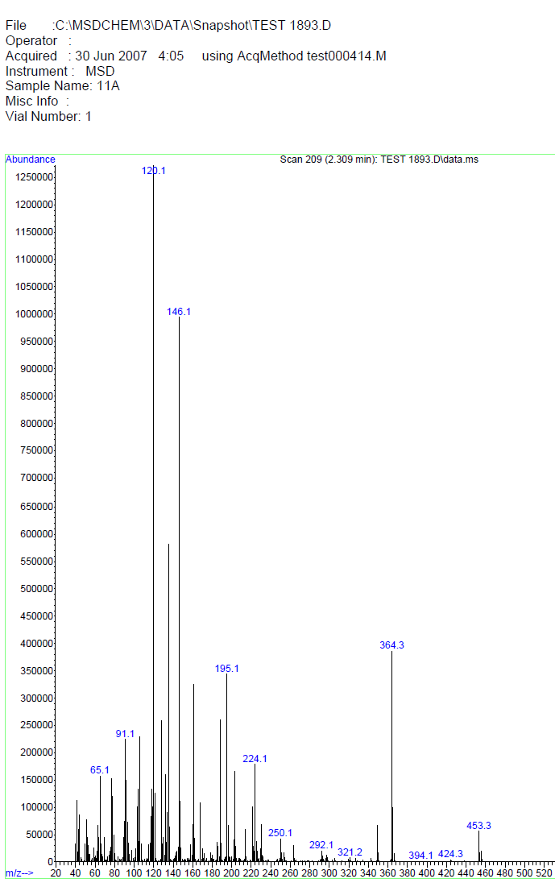
Figure 57. MASS spectrum. 14k

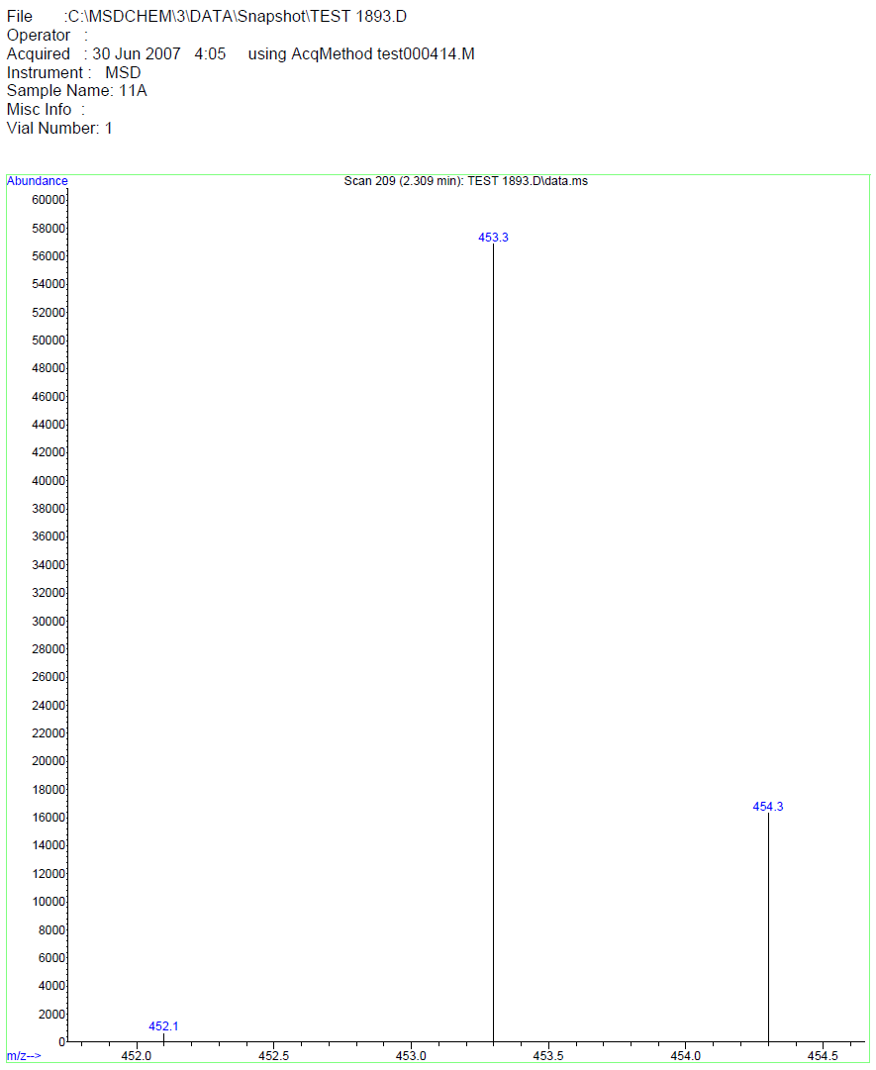
Figure 58. MASS spectrum. 14k

12l: (E)-N-(4-chlorophenyl)-N-(4-(3-(pyridin-4-yl)acryloyl)phenyl)cyclopropane-1,1-dicarboxamide; C₂₅H₂₀ClN₃O₃ .
¹H NMR (499 MHz, dmso) δ 10.46 (s, 1H, NH), 10.07 (s, 1H, NH), 8.66 (d, J = 5.1 Hz, 2H, Ar), 8.18 – 8.134 (m, 3H, Ar), 7.86-8.82 (m, 4H, Ar), 7.67 – 7.64 (m, 3H, Ar), 7.35 (d, J = 8.7 Hz, 2H, Ar), 1.48 (s, 4H, 2 CH₂, cyclopropane); ¹³C NMR (126 MHz, dmso) δ 187.89 (C=O, chalcone), 168.85 (C=O, amide), 168.53 (C=O, amide), 150.79 (2C), 150.71, 144.34, 142.37, 140.91, 138.34, 132.42, 131.88, 130.34, 128.82 (2C), 127.67, 126.77, 122.95, 122.50 (2C), 119.96, 113.23, 32.71 (CH, cyclopropane), 15.97 (2 CH₂, cyclopropane); m/z [M + H]: 445.1

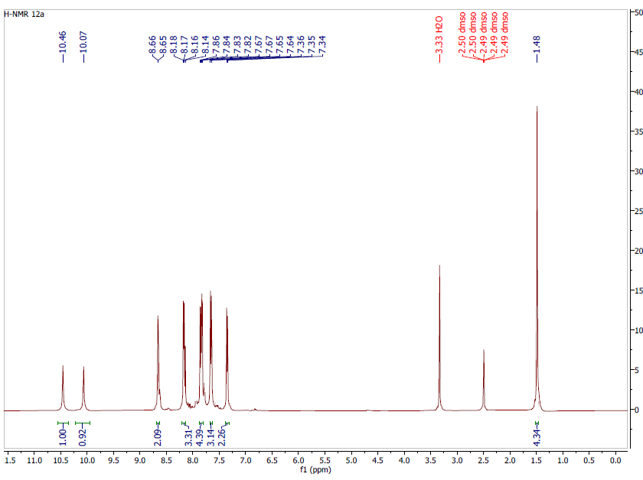
Figure 59. H-NMR. 14l

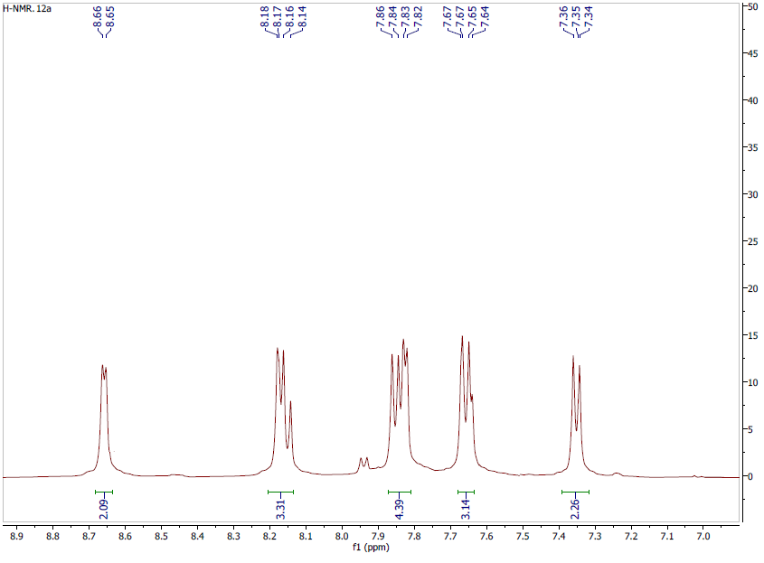
Figure 60. H-NMR. 14l

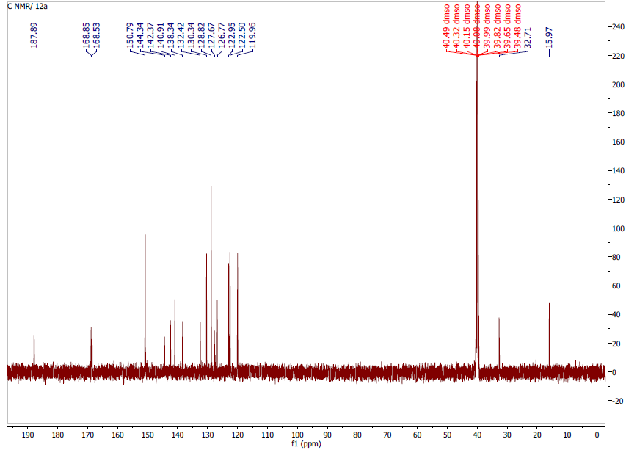
Figure 61. C-NMR. 14l

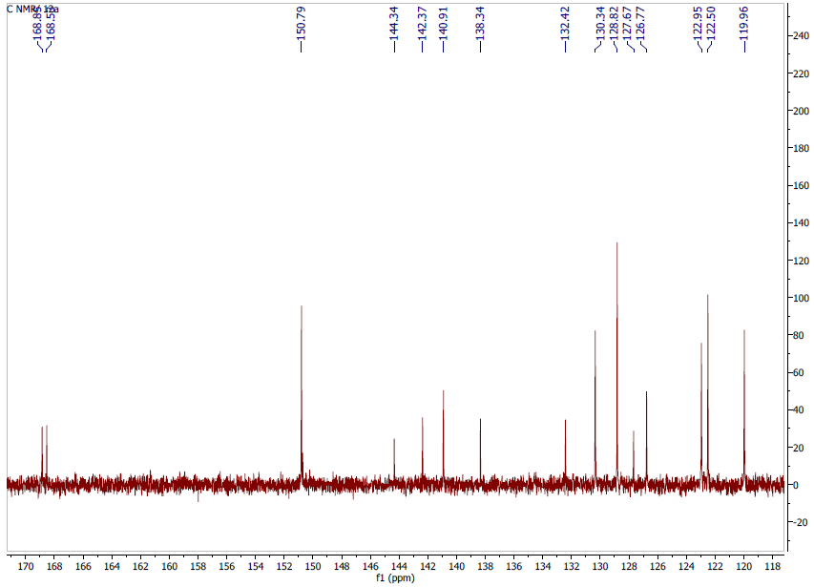
Figure 62. C-NMR. 14l

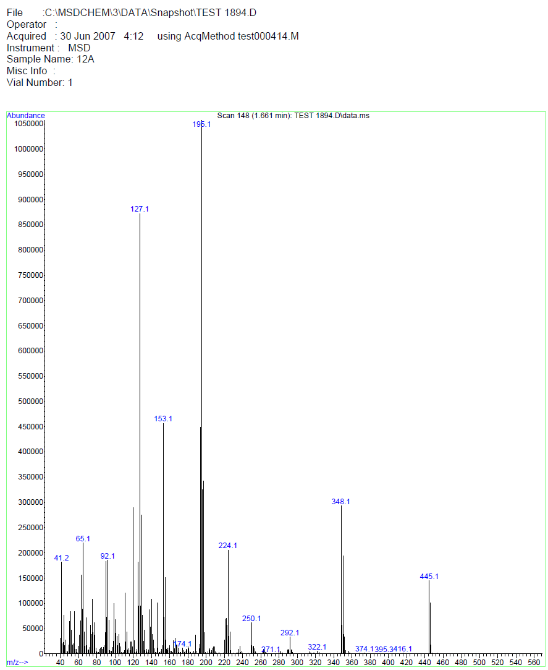
Figure 63. MASS spectrum. 14l

14m: (E)-N-phenyl-N-(4-(3-(pyridin-4-yl)acryloyl)phenyl)cyclopropane-1,1-dicarboxamide; C₂₅H₂₁N₃O₃ .
¹H NMR (499 MHz, dmso) δ 10.50 (s, 1H, NH), 9.94 (s, 1H, NH), 8.65 (d, J = 5.2 Hz, 2H, Ar), 8.18 – 8.14 (m, 3H, Ar), 7.87-7.81 (m, 4H, Ar), 7.66 – 7.61 (m, 3H, Ar), 7.29 (t, J = 7.8 Hz, 2H, Ar), 7.05 (t, J = 7.4 Hz, 1H, Ar), 1.49 (s, 4H, 2CH₂, cyclopropane); ¹³C NMR (126 MHz, dmso) δ 187.89, 169.10, 168.51, 150.78 (2C), 144.30, 142.37, 140.89, 139.26, 132.42, 130.34 (2C), 128.91 (2C), 126.77, 124.10, 122.94 (2C), 121.07 (2C), 119.98 (2C), 32.49 (C, cyclopropane), 16.03 (2CH₂, cyclopropane); m/z [M + H]: 411.2

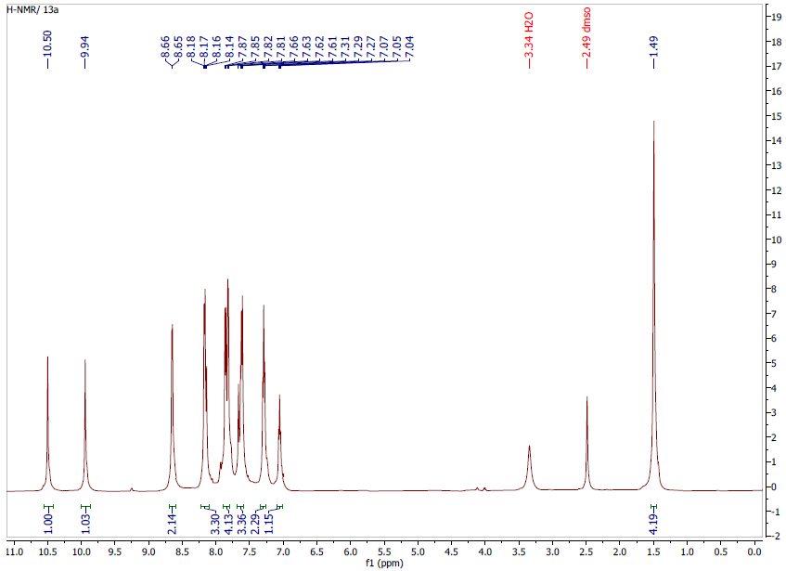
Figure 64. H-NMR. 14m

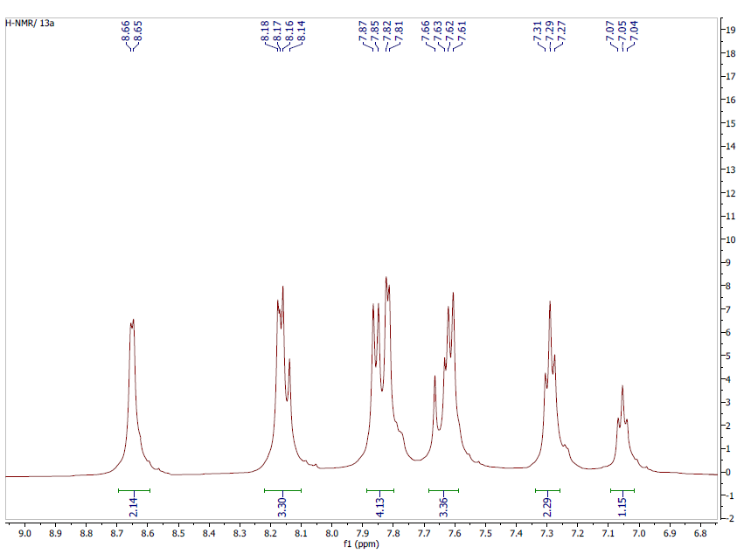
Figure 65. H-NMR. 14m
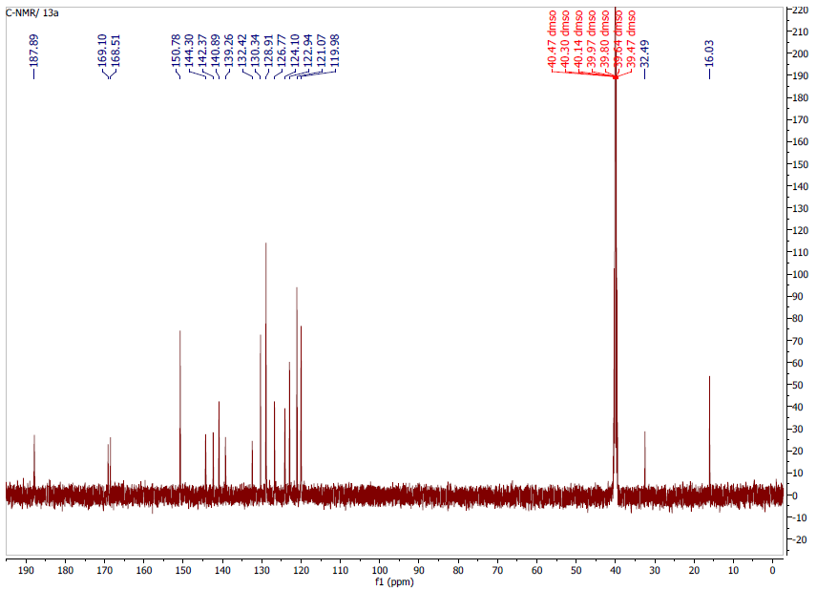
Figure 66. C-NMR. 14m
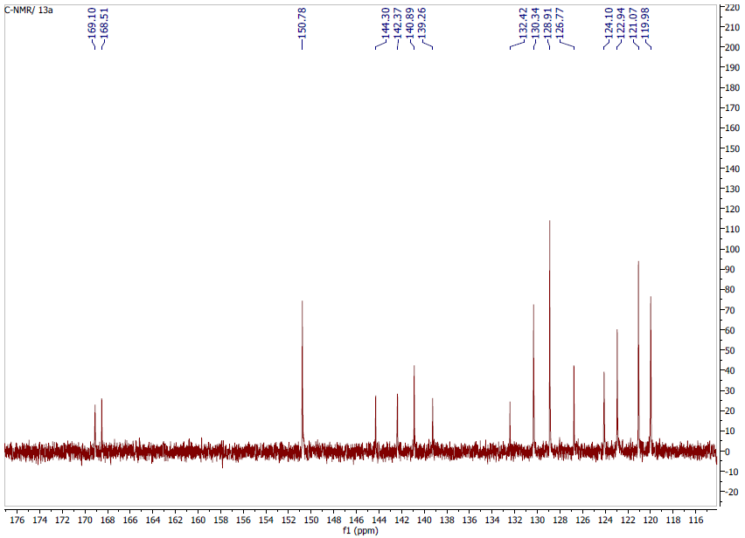
Figure 67. C-NMR. 14m

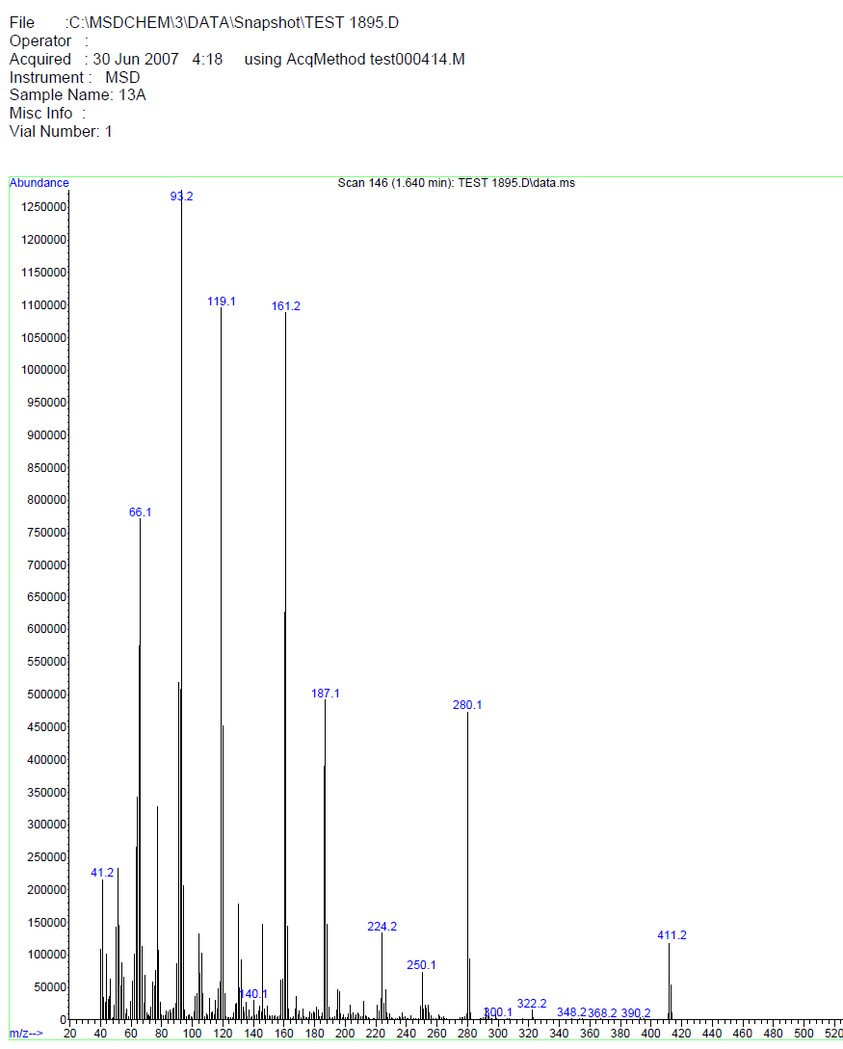
Figure 68. MASS spectrum. 14m

14n: (E)-N-(4-fluorophenyl)-N-(4-(3-(pyridin-4-yl)acryloyl)phenyl)cyclobutane-1,1-dicarboxamide; C₂₆H₂₂FN₃O₃ .
¹H NMR (499 MHz, dmso) δ 10.15 (s, 1H, NH), 9.85 (s, 1H, NH), 8.77 (d, J = 5.1 Hz, 2H, Ar), 8.25 (d, J = 15.7 Hz, 1H, Ar), 8.18 (d, J = 8.4 Hz, 2H, Ar), 8.07 (d, J = 5.4 Hz, 2H, Ar), 7.94 (d, J = 8.5 Hz, 2H, Ar), 7.72 – 7.66 (m, 3H, Ar), 7.12 (t, J = 8.7 Hz, 2H, Ar), 2.68 (t, J = 8.0 Hz, 4H, 2CH₂, cyclobutane), 1.83 (p, J = 8.1 Hz, 2H, CH₂, cyclobutane); ¹³C NMR (126 MHz, dmso) δ 187.75, 170.99, 170.09, 158.69 (d, J = 240.3 Hz), 147.78 (2C), 145.87, 144.58, 139.71, 135.77, 132.30, 130.48 (2C), 128.80, 124.09 (2C), 122.42 (d, J = 7.9 Hz, 2C), 119.76 (2C), 115.52 (d, J = 22.2 Hz, 2C), 57.05 (C, cyclobutane), 29.90 (CH₂, cyclobutane), 15.82 (2CH₂, cyclobutane); m/z [M + H]: 443.2

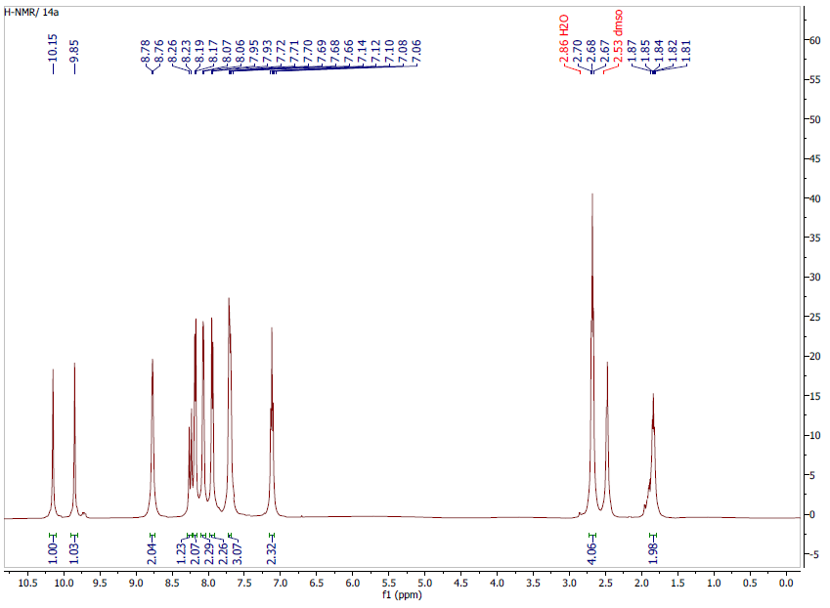
Figure 69. H-NMR. 14n
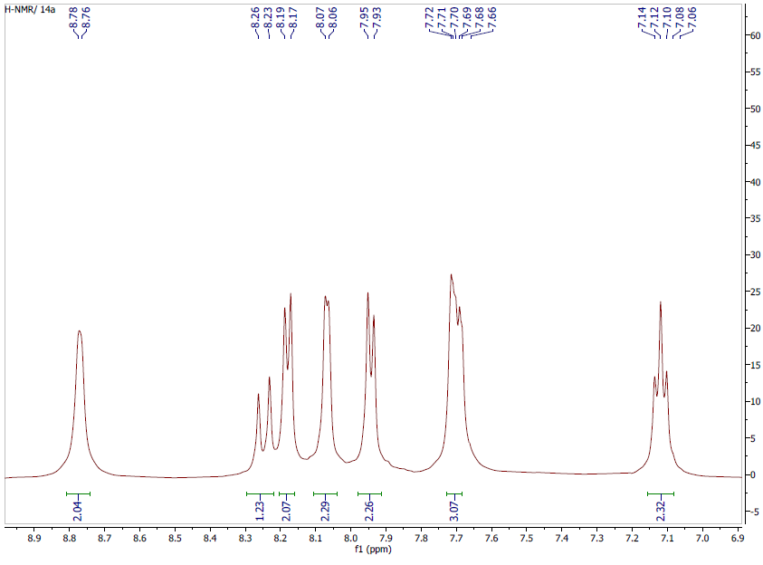
Figure 70. H-NMR. 14n

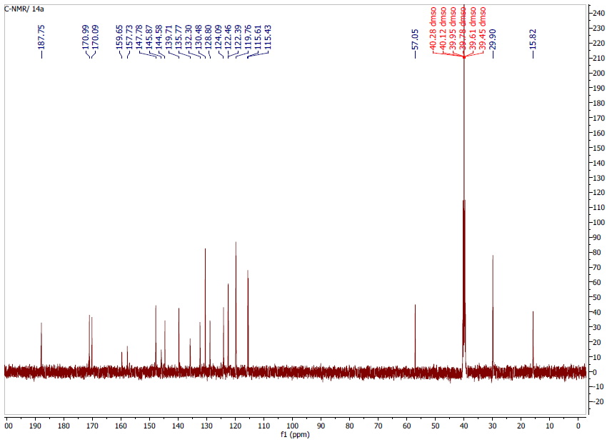
Figure 71. C-NMR. 14n
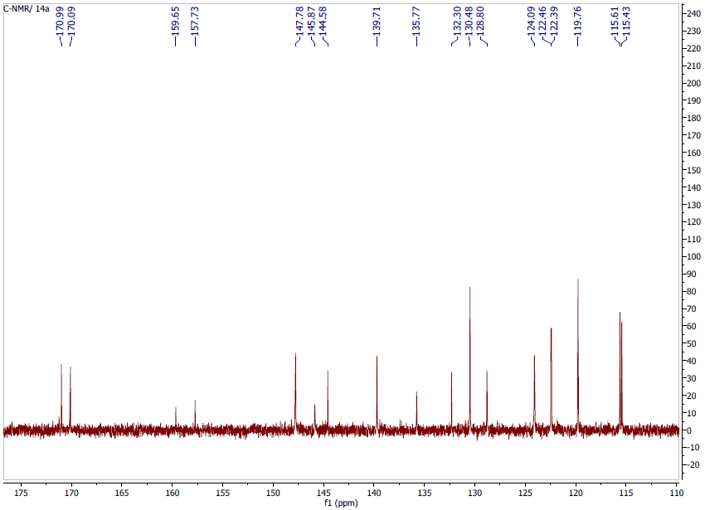
Figure 72. C-NMR. 14n

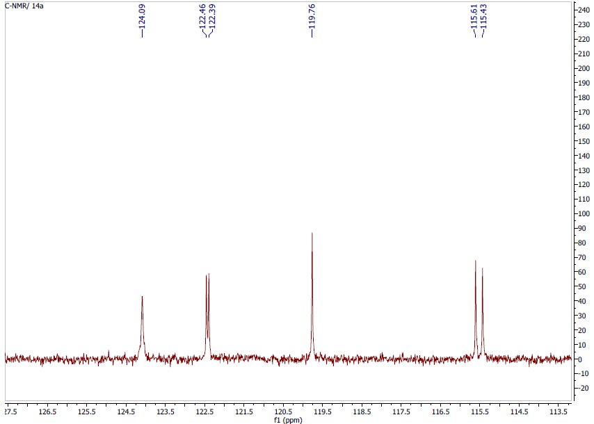
Figure 73. C-NMR. 14n
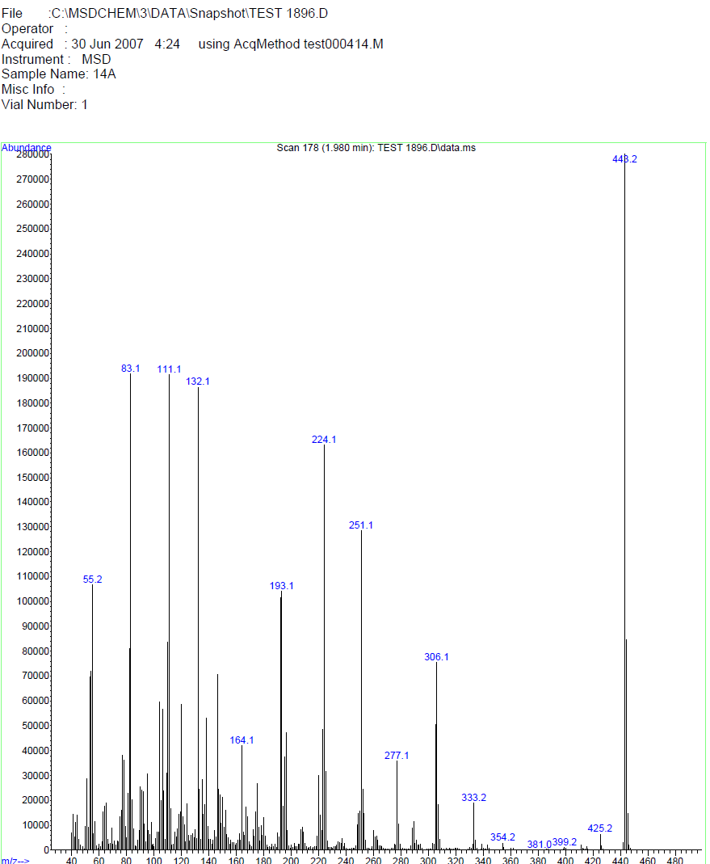
Figure 74. MASS spectrum. 14n

14o: (E)-N-(4-fluorophenyl)-N-(4-(3-(pyridin-2-yl)acryloyl)phenyl)cyclobutane-1,1-dicarboxamide; C₂₆H₂₀F₃N₃O₃ .
¹H NMR (499 MHz, dmso) δ 9.99 (s, 1H, NH), 9.69 (s, 1H, NH), 8.67 (d, J = 4.7 Hz, 1H, Ar), 8.15 (d, J = 15.4 Hz, 1H, Ar), 8.10 (d, J = 8.3 Hz, 2H, Ar), 7.91 – 7.867 (m, 3H, Ar), 7.71 – 7.67 (m, 3H, Ar), 7.42 (dd, J = 7.9, 3.0 Hz, 1H, Ar), 7.13 (t, J = 9.0 Hz, 2H, Ar), 2.68 (t, J = 7.9 Hz, 4H, 2CH₂, cyclobutane), 1.85 (p, J = 7.9 Hz, 2H, CH₂, cyclobutane); ¹³C NMR (126 MHz, dmso) δ 188.27, 170.95, 170.15, 158.71 (d, J_{C-F} = 240.6 Hz), 153.34, 150.46, 144.22, 142.97, 137.63, 135.74, 135.72, 132.72, 130.16 (2C), 125.52, 125.35, 125.19, 122.49 (2C, d, J_{C-F} = 7.8 Hz), 119.89 (2C), 115.55 (2C, d, J_{C-F} = 22.3 Hz), 56.94 (C, cyclobutene), 29.75 (2CH₂, cyclobutane), 15.83 (CH₂, cyclobutane); m/z [M + H]: 443.3

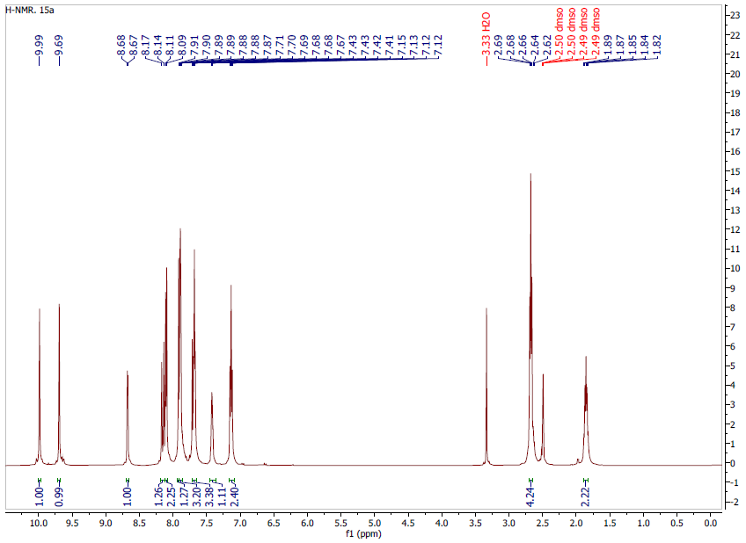
Figure 75. H-NMR. 14o
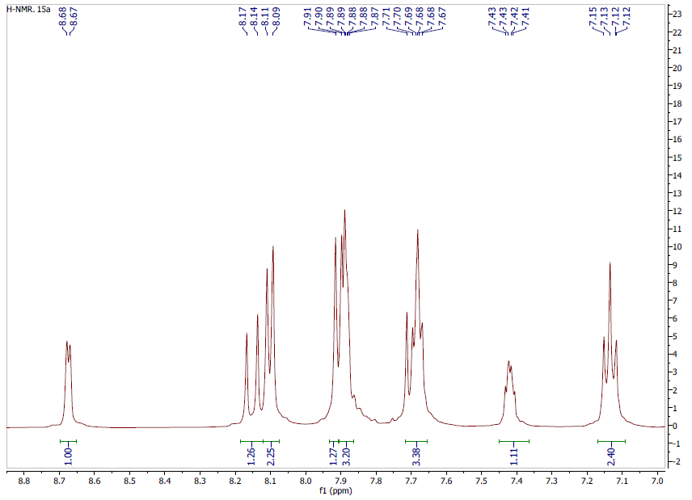
Figure 76. H-NMR. 14o

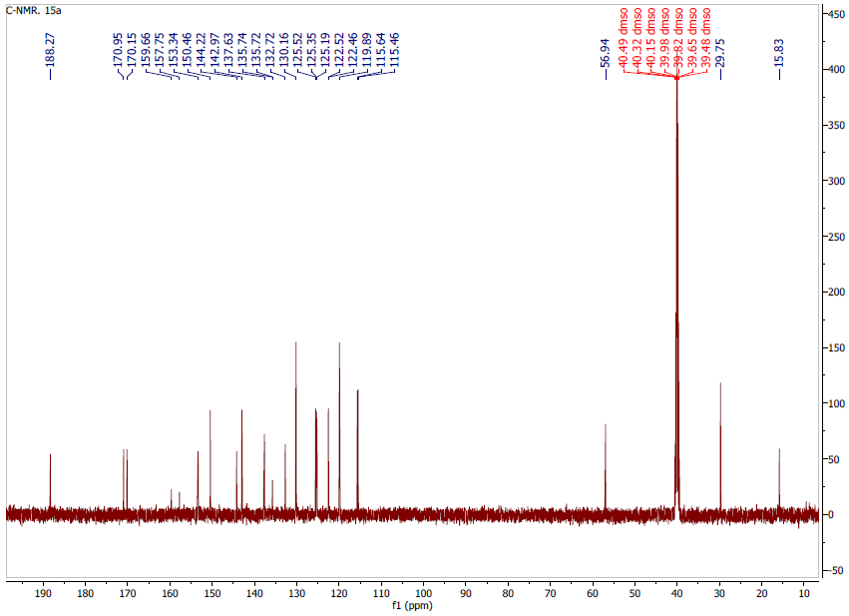
Figure 77. C-NMR. 14o

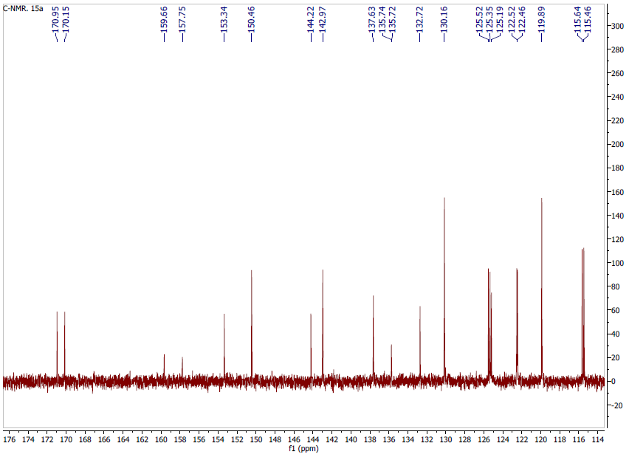
Figure 78. C-NMR. 14o
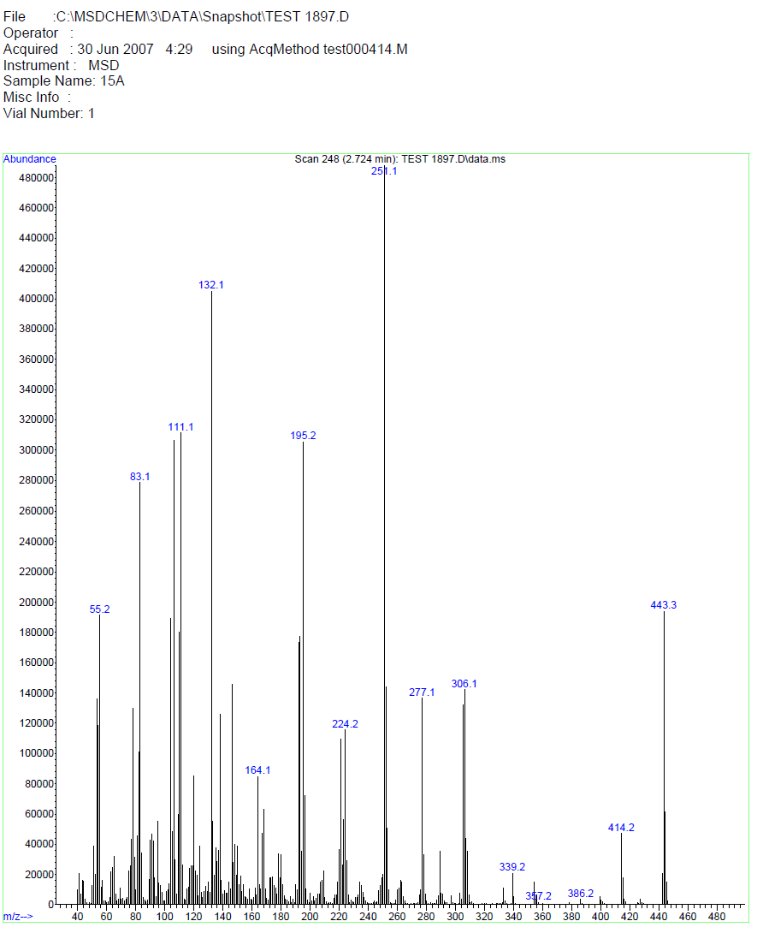
Figure 79. MASS spectrum. 14o

14p: (E)-N-(4-nitrophenyl)-N-(4-(3-(pyridin-4-yl)acryloyl)phenyl)cyclobutane-1,1-dicarboxamide; C₂₆H₂₂N₄O₅ .
¹H NMR (499 MHz, dmso) δ 10.28 (s, 2H, NH), 10.07 (s, 1H, NH), 8.68 (s, 2H, Ar), 8.26-8.15 (m, 5H, Ar), 7.97-7.90 (m, 5H, Ar), 7.87 (d, J = 5.0 Hz, 1H, Ar), 7.66 (d, J = 15.6 Hz, 1H, Ar), 2.71 (t, J = 6.3 Hz, 4H, 2CH₂, cyclobutane), 1.89 (p, J = 8.1 Hz, 2H, CH₂, cyclobutane); ¹³C NMR (126 MHz, dmso) δ 187.89, 171.03, 170.85, 170.58, 150.26, 145.72 (2C), 144.32, 142.91 (2C), 140.75, 132.55, 130.39 (2C), 127.10, 125.15 (2C), 120.19 (2C), 120.15, 119.90, 57.31 (C, cyclobutane), 29.57 (2CH₂, cyclobutane), 15.91 (CH₂, cyclobutane); m/z [M + H]: 470.3

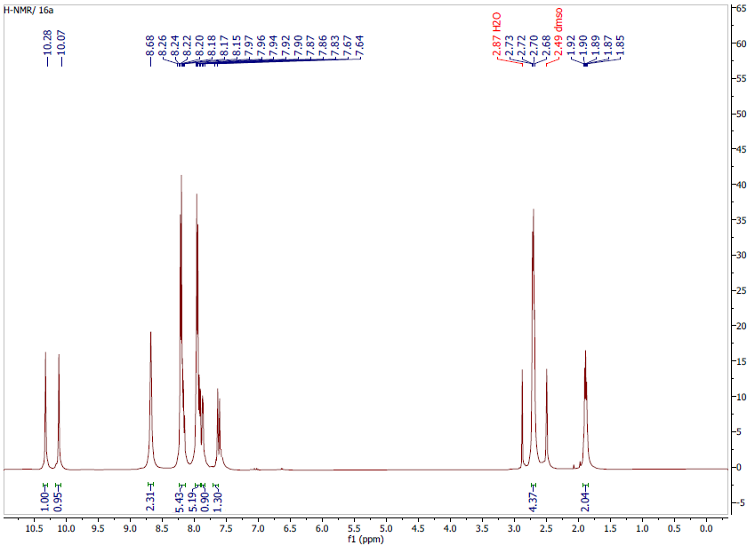
Figure 80. H-NMR. 14p

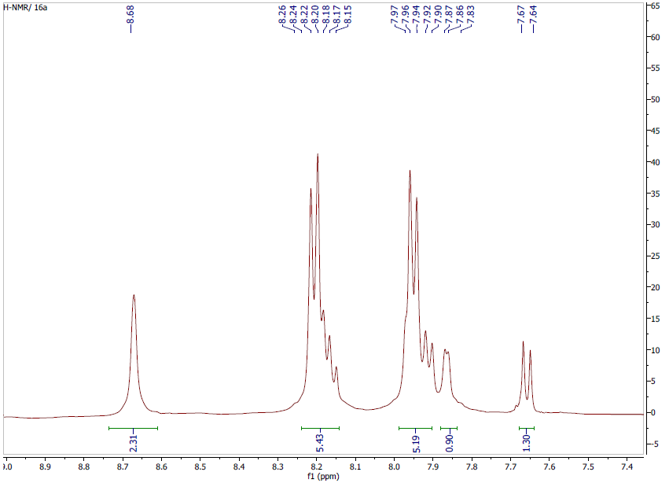
Figure 81. H-NMR. 14p

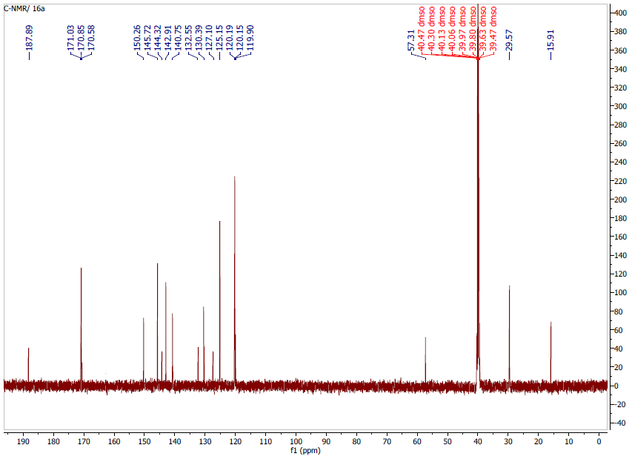
Figure 82. C-NMR. 14p
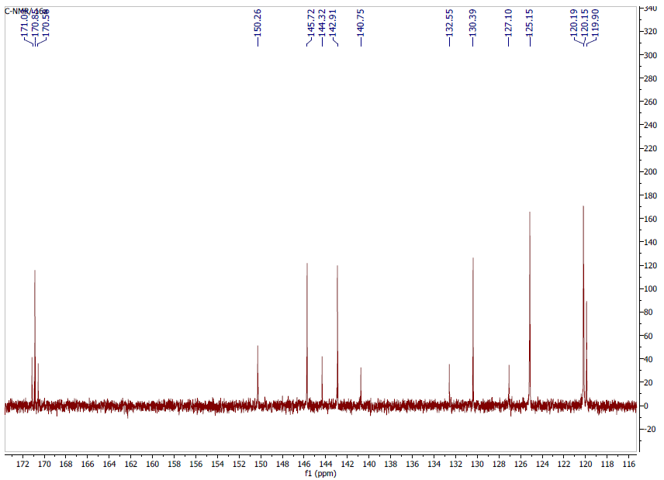
Figure 83. C-NMR. 14p

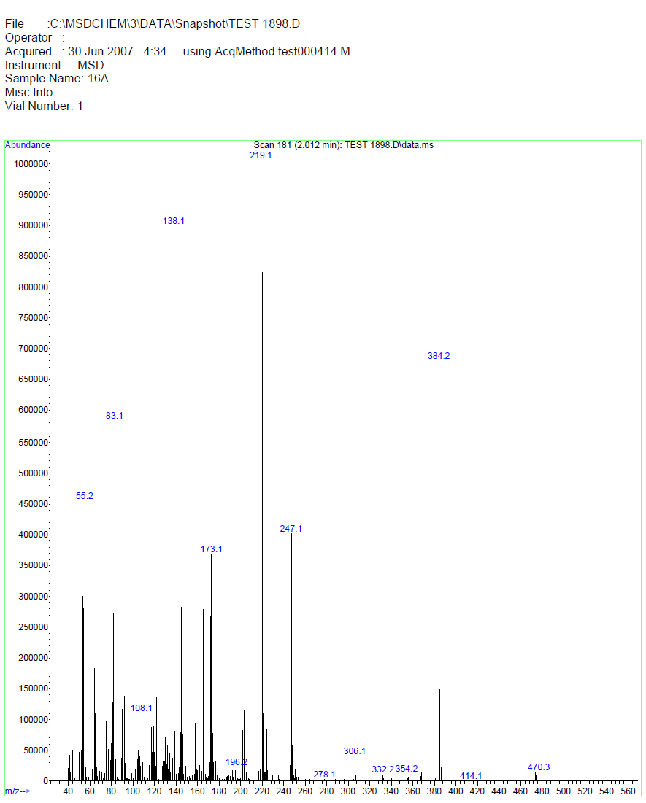
Figure 84. MASS spectrum. 14p

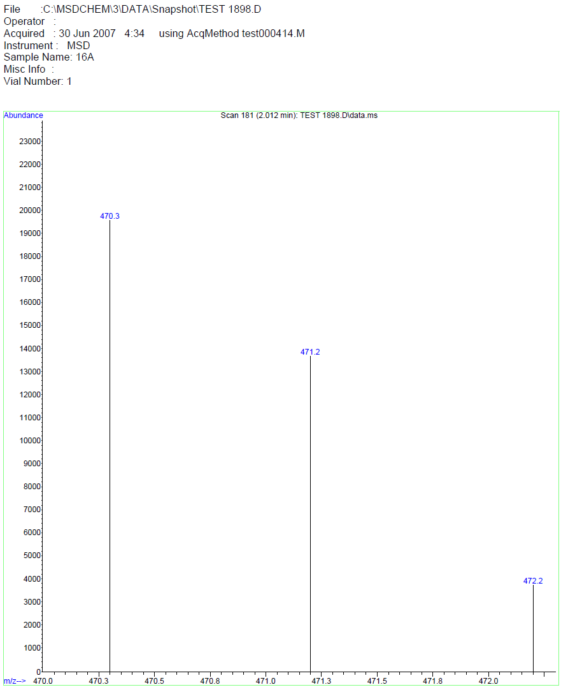
Figure 85. MASS spectrum. 14p

14q: (E)-N-(4-bromophenyl)-N-(4-(3-(pyridin-2-yl)acryloyl)phenyl)cyclobutane-1,1-dicarboxamide; C₂₆H₂₂BrN₃O₃ .
¹H NMR (499 MHz, dmso) δ 10.03 (s, 1H, NH), 9.80 (s, 1H, NH), 8.68 (d, J = 4.8 Hz, 1H, Ar), 8.17 – 8.09 (m, 3H, Ar), 7.91 – 7.88 (m, 5H, Ar), 7.71 – 7.65 (m, 4H, Ar), 7.48 (d, J = 8.7 Hz, 2H, Ar), 7.45-7.41 (m, 1H, Ar), 2.67 (t, J = 8.0 Hz, 4H, CH₂, cyclobutane), 1.85 (p, J = 8.2 Hz, 2H, 2CH₂, cyclobutane ); ¹³C NMR (126 MHz, dmso) δ 188.27 (C=O, chalcone), 170.83 (C=O, amide), 170.33 (C=O, amide), 153.34, 150.47, 144.20, 142.98, 138.81, 137.65, 132.73 (2C), 131.81, 130.15 (2C), 125.52, 125.35, 125.21, 122.54 (2C), 119.91 (2C), 115.75, 57.09 (C, cyclobutene) 29.75 (2 CH₂, cyclobutane), 15.84 (CH₂, cyclobutane); m/z [M + H]: 505.2

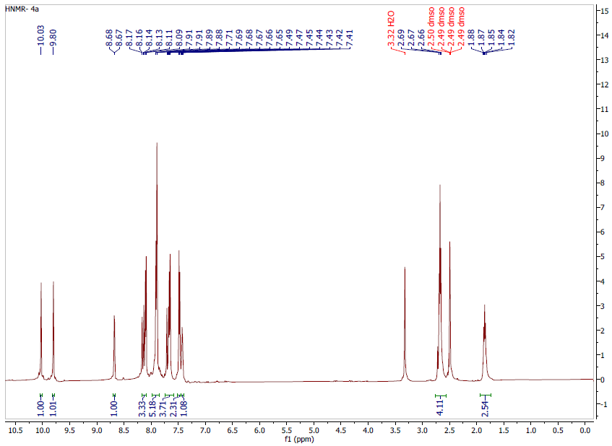
Figure 86. H-NMR. 14q
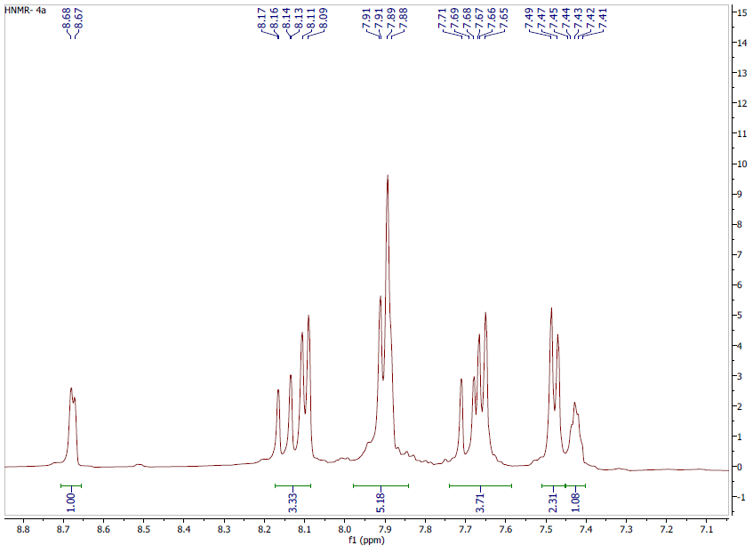
Figure 87. H-NMR. 14q

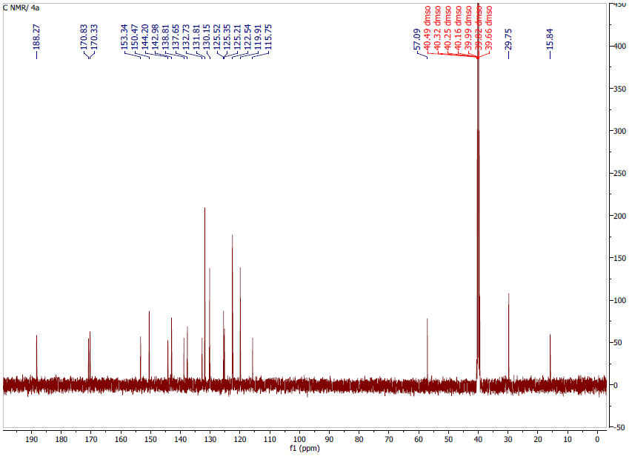
Figure 88. C-NMR. 14q
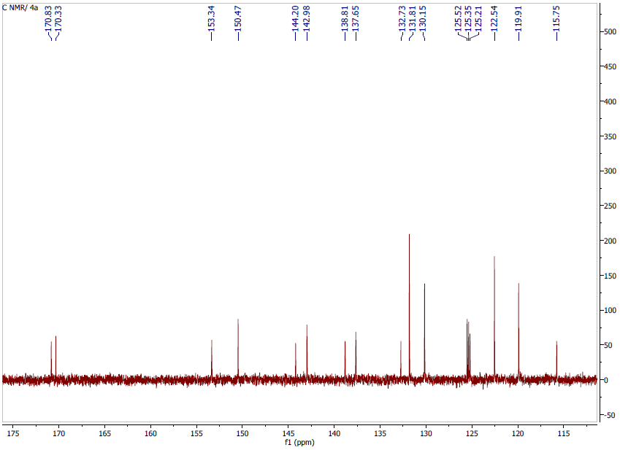
Figure 89. C-NMR. 14q

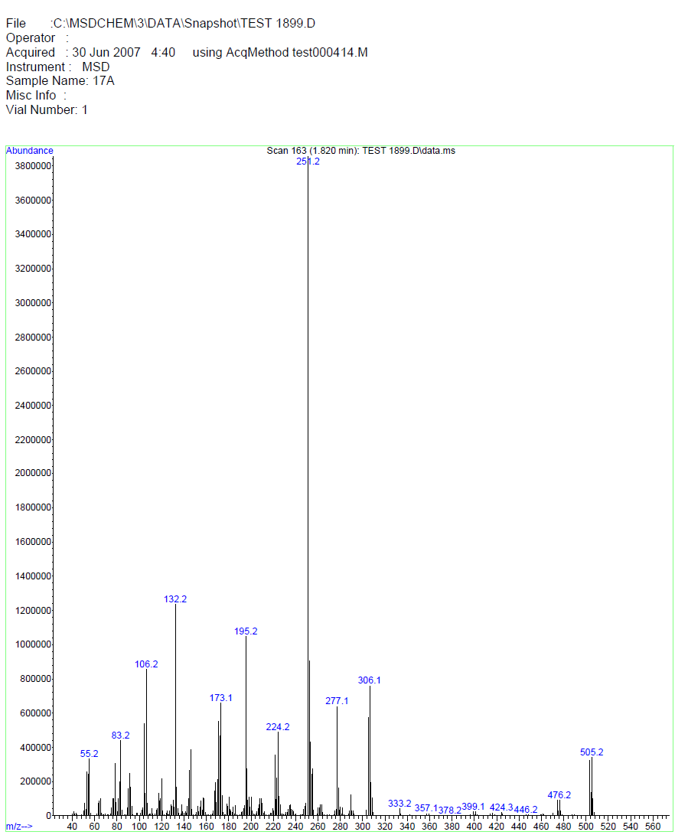
Figure 90. MASS spectrum. 14q
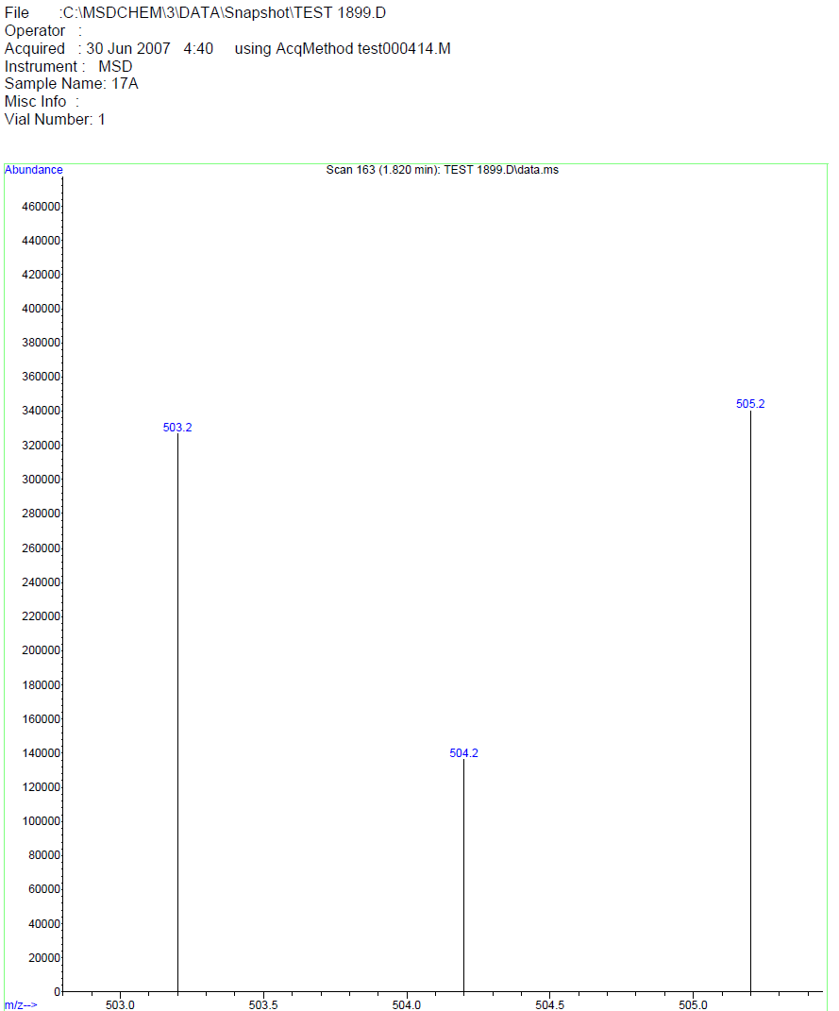
Figure 91. MASS spectrum. 14q

