Supporting information
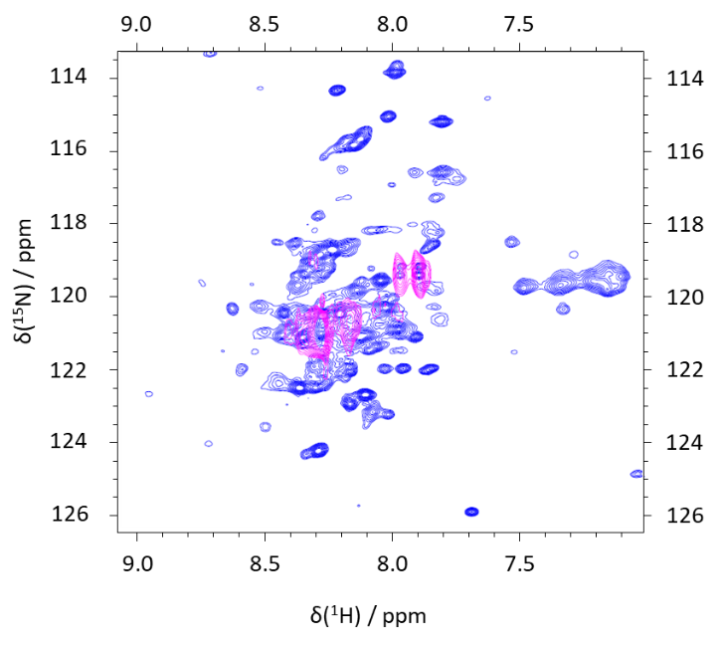

Figure SI 1. MYC spectra. Blue: ¹H-¹⁵N TROSY spectrum of a 0.1 mM slMYC sample, after mixing 1:1:1 with MAX:MAX and EBOX DNA; the experiment was recorded at 25° C, in MES buffer at pH 5.5. Pink: HNCO projection on the ¹H-¹⁵N plane, showing only the signals of the selectively labeled residues. Thus, the peaks of the HNCO could be identified by comparing them to the reference spectrum.

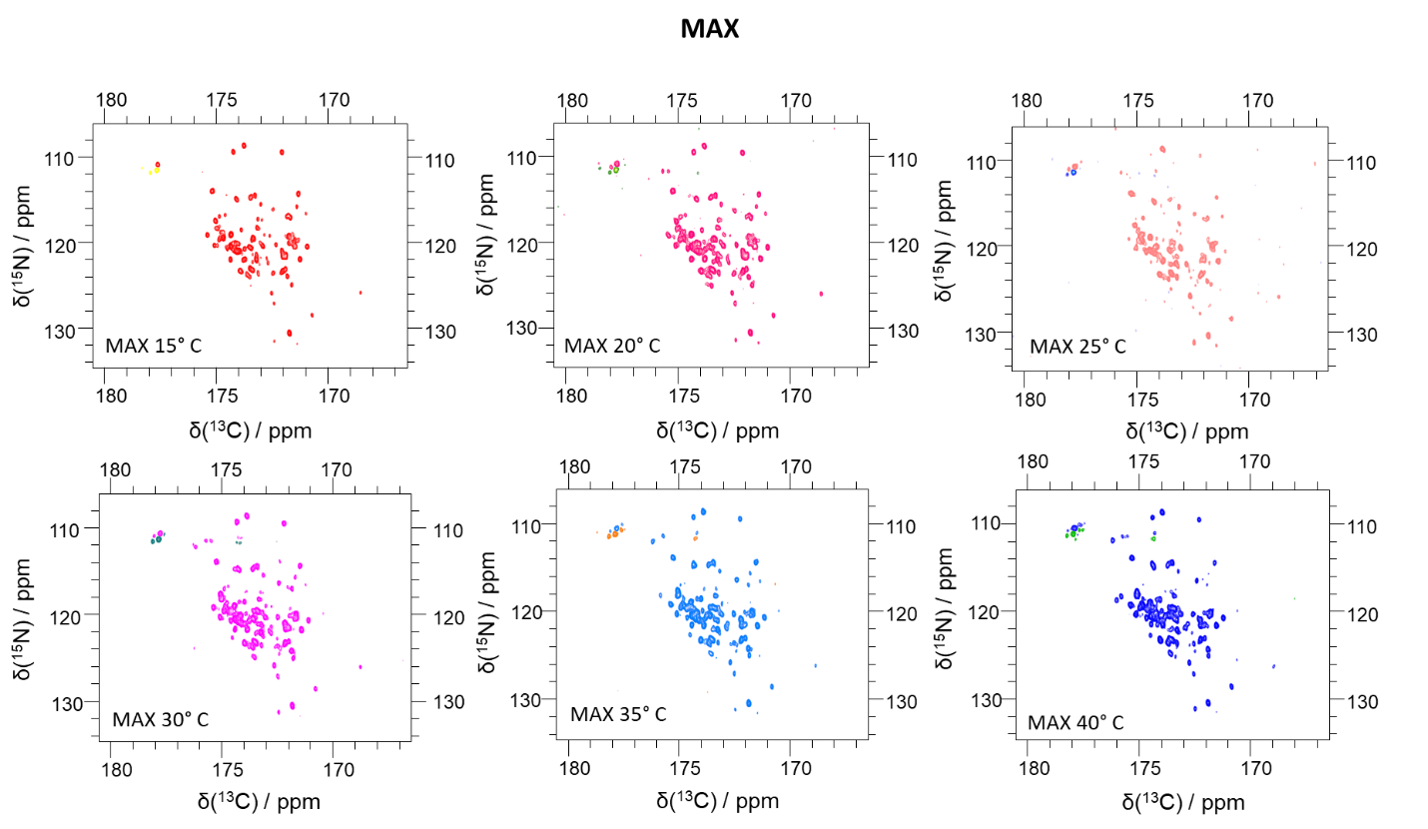

Figure SI 2. ¹³C-¹⁵N correlated NMR spectra of 0.1 mM ¹³C-¹⁵N labeled MAX in at pH 5.5 at temperatures ranging from 15 to 40° C.

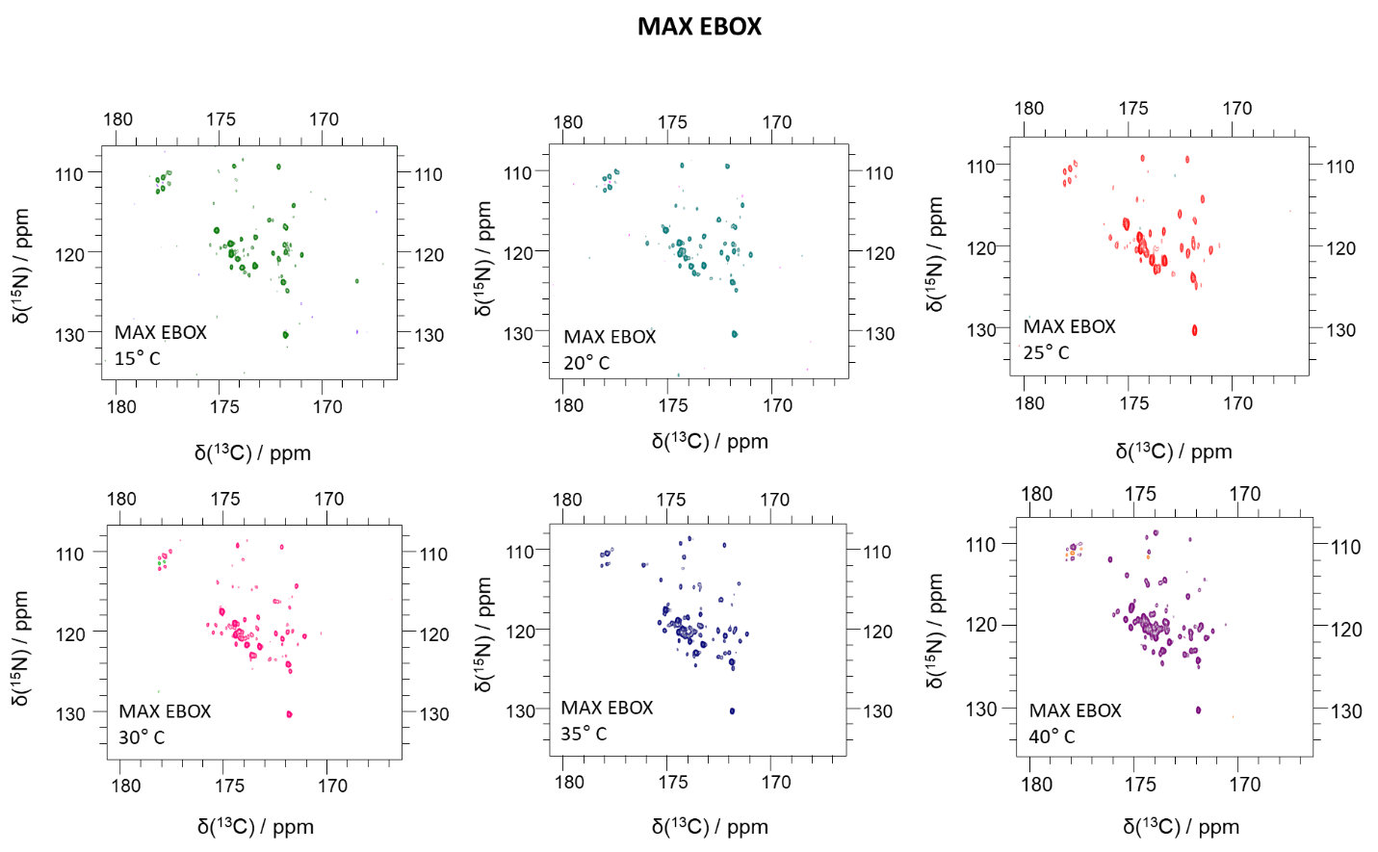

Figure SI 3. ¹³C-¹⁵N correlated NMR spectra of 0.1 mM ¹³C-¹⁵N labeled MAX in the presence of 1 eq. EBOX DNA at pH 5.5 at temperatures ranging from 15 to 40° C.
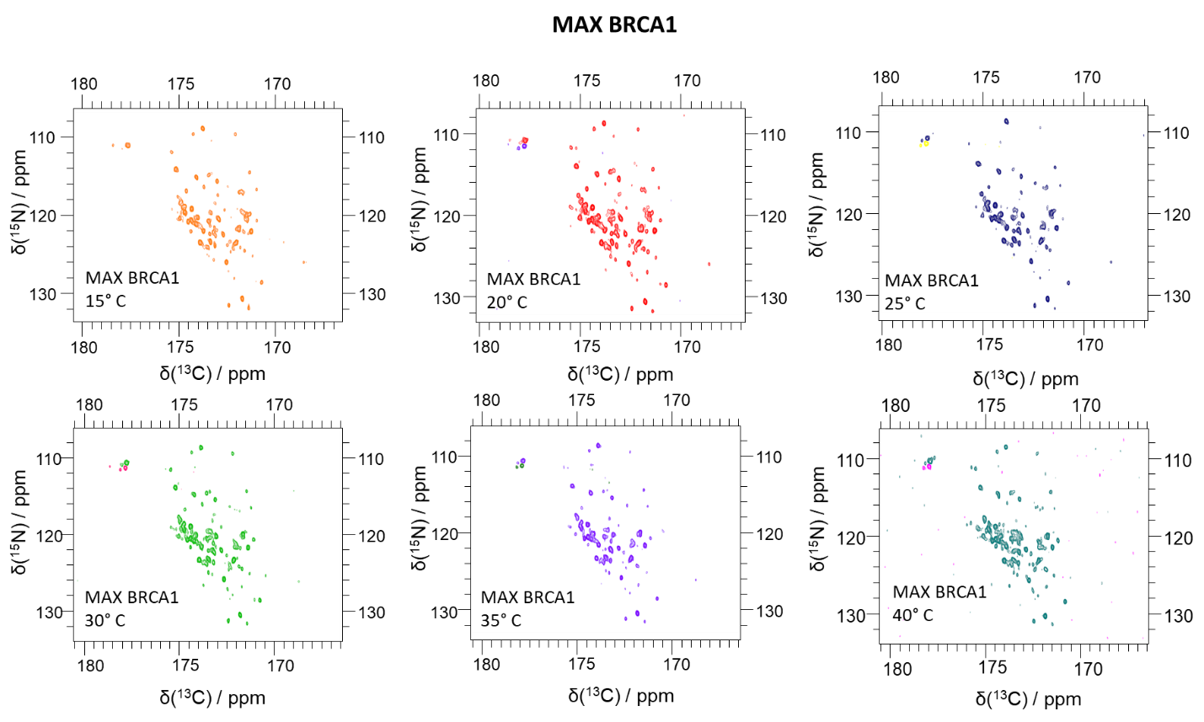

Figure SI 4. ¹³C-¹⁵N correlated NMR spectra of 0.1 mM ¹³C-¹⁵N labeled MAX in the presence of 1 eq. BRCA1 at pH 5.5 and temperatures between 15 and 40° C.

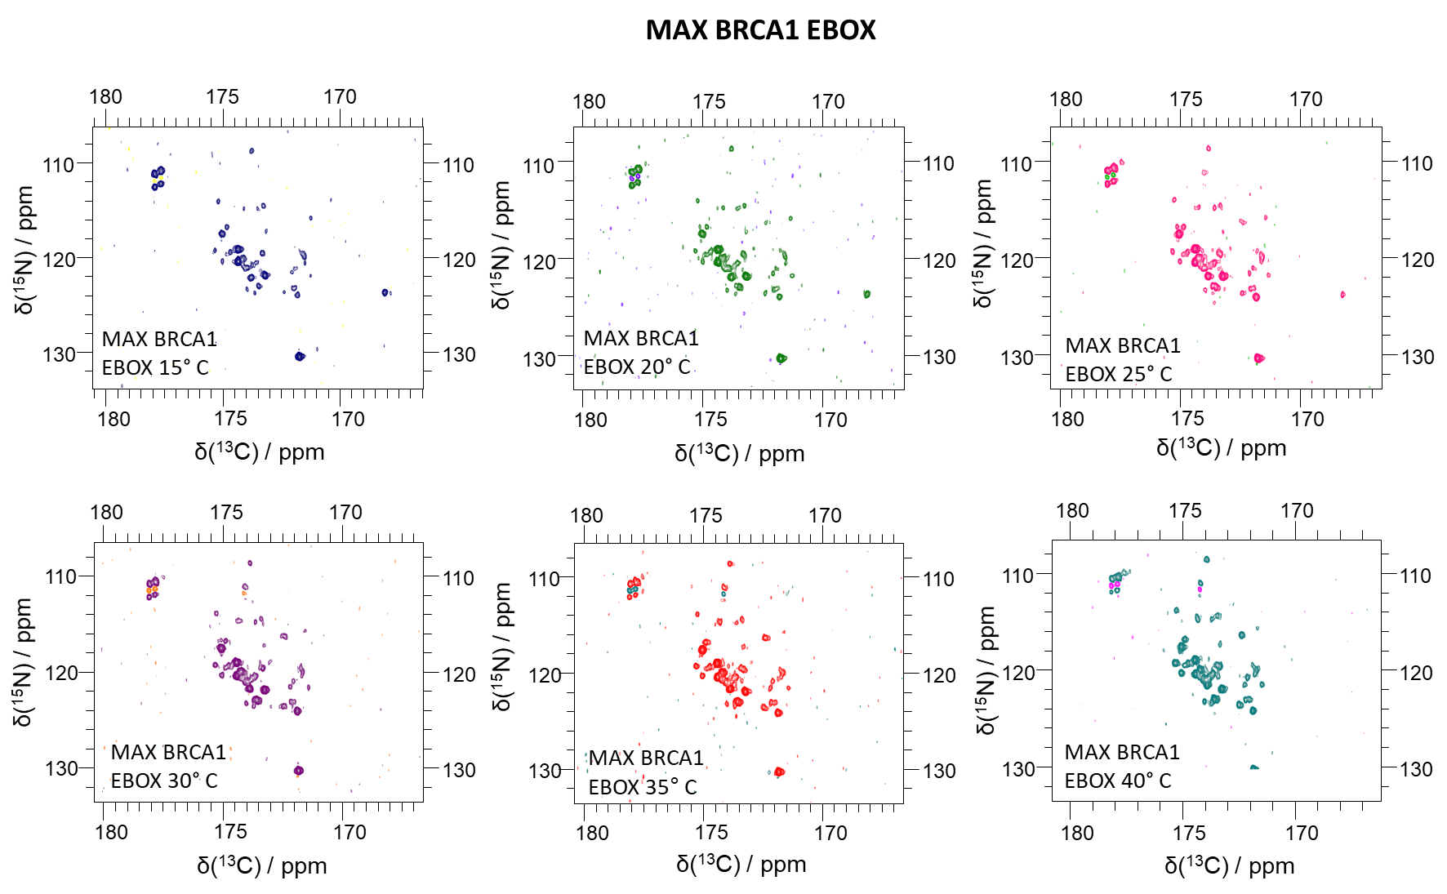

Figure SI 5. ¹³C-¹⁵N correlated NMR spectra of 0.1 mM ¹³C-¹⁵N labeled MAX in the presence of 1 eq. BRCA1 and EBOX DNA at pH 5.5 and temperatures between 15 and 40° C.

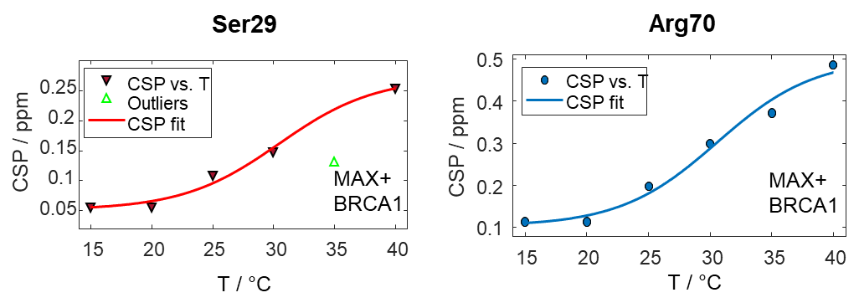

Figure SI 6. Effect of BRCA1 on the melting behavior of MAX for residues Ser29 (left) and Arg70 (right). The reverse triangles and the blue dots indicate the experimental CSPs data. The data were fitted with a sigmoidal function (red and blue lines).

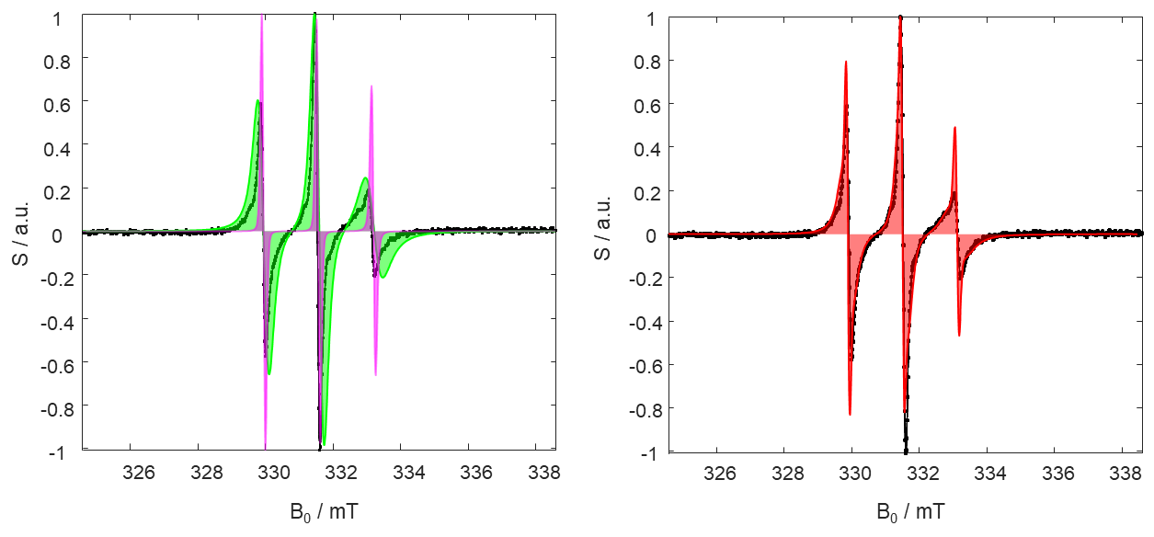

Figure SI 7. Schematic representation of a CW EPR spectrum (black) characterized by two main simulated contributions, one slow (in green) and one fast (in pink), shown on the left. The sum of the two contributions is depicted in red on the right spectrum.

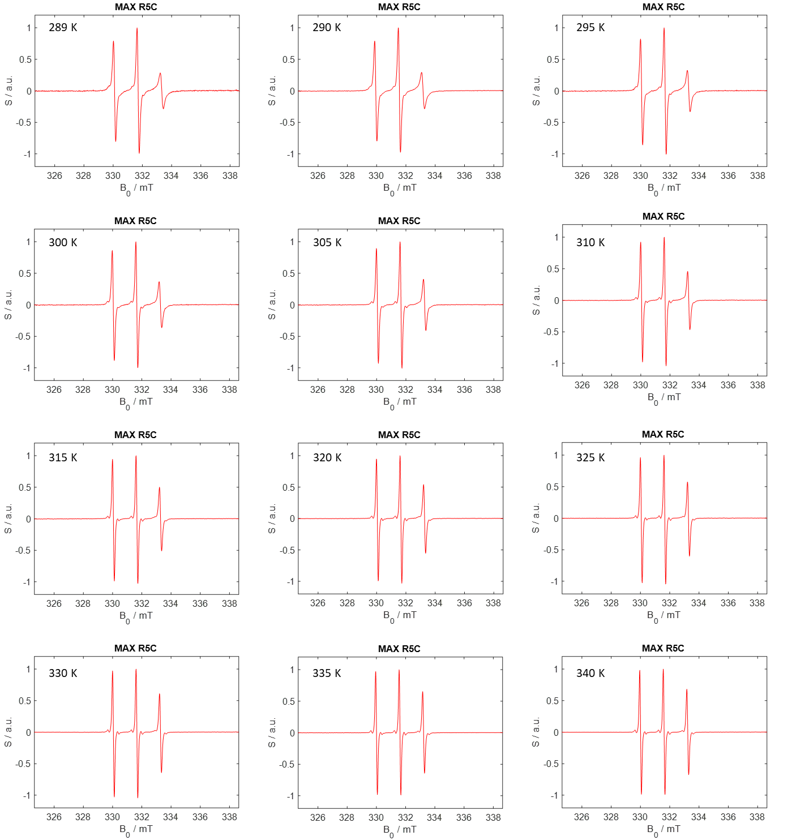

Figure SI 8. CW EPR spectra of MAX R5C. The experimental temperatures are indicated.

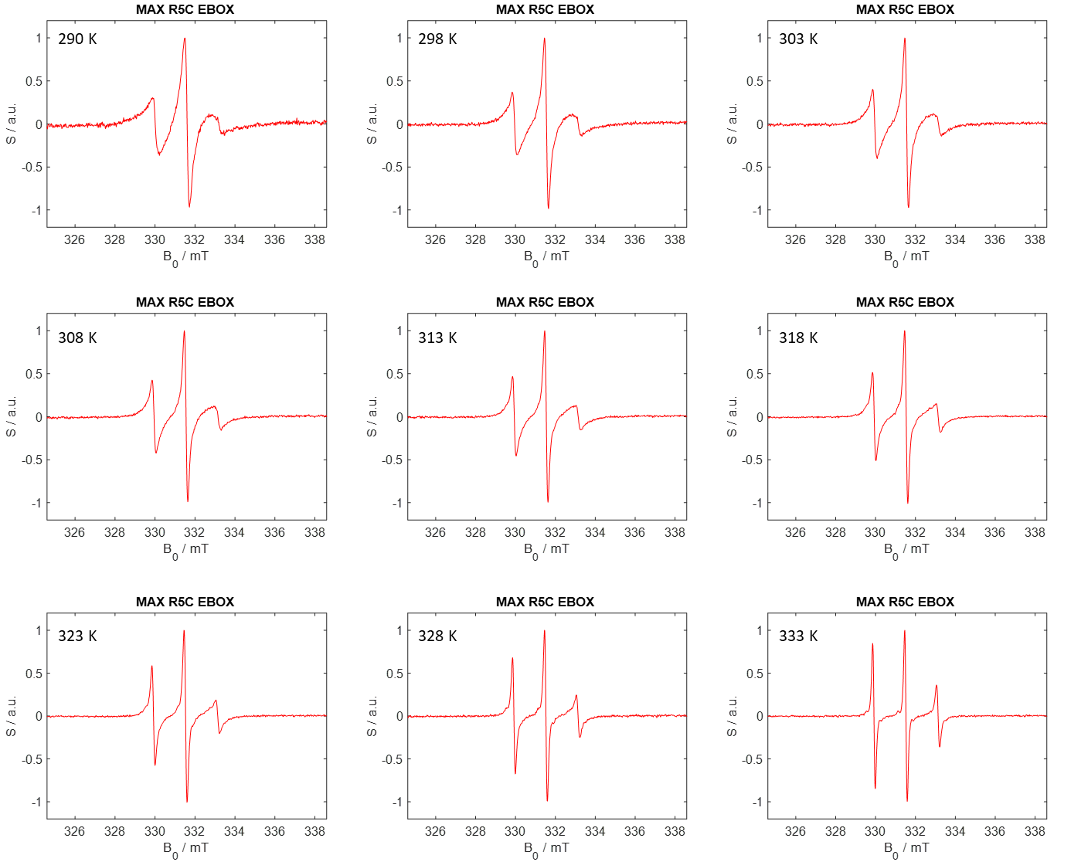
Figure SI 9. CW EPR spectra of MAX R5C + EBOX DNA. The experimental temperatures are indicated.

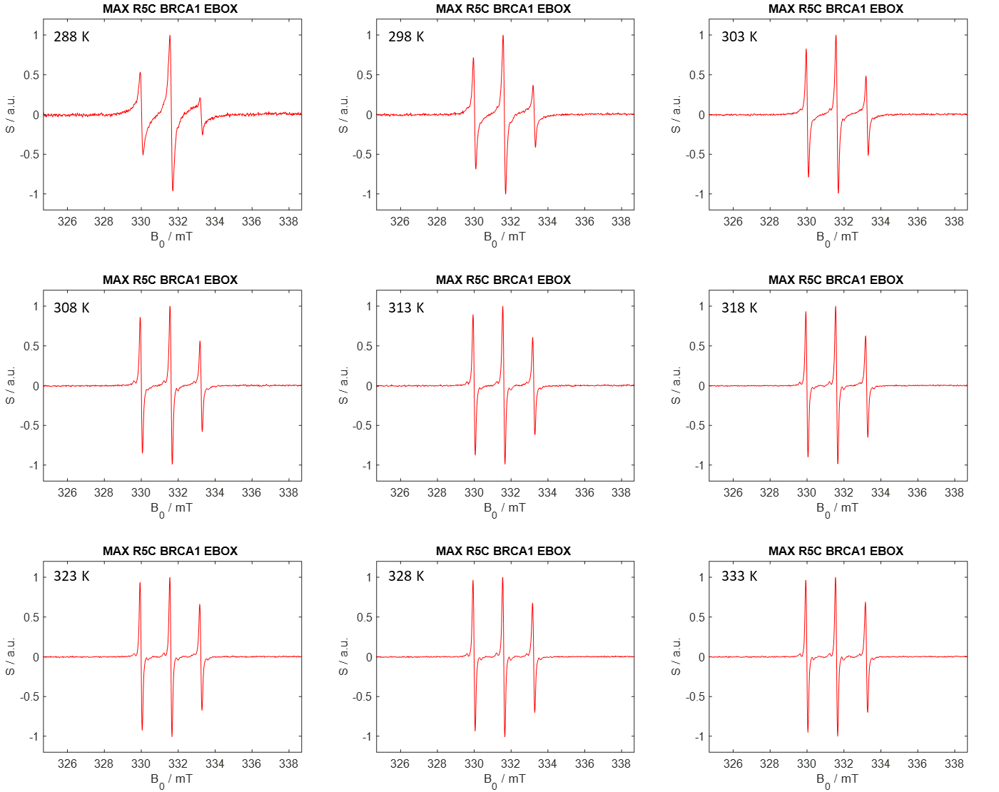

Figure SI 10. CW EPR spectra of MAX R5C + EBOX DNA + BRCA1. The experimental temperatures are indicated.

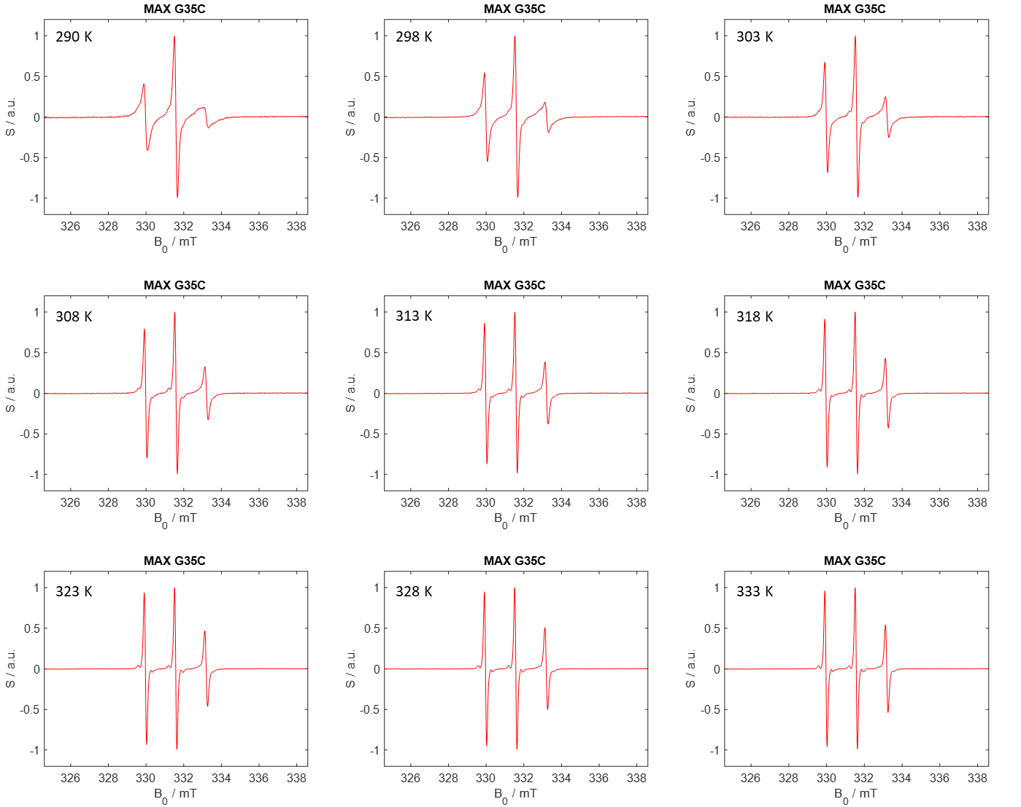

Figure SI 11. CW EPR spectra of MAX G35C. The experimental temperatures are indicated.

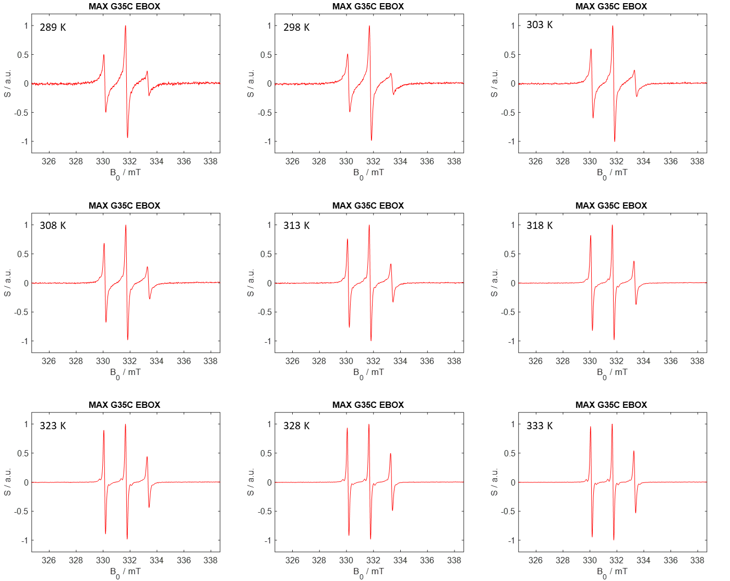

Figure SI 12. CW EPR spectra of MAX G35C + EBOX DNA. The experimental temperatures are indicated.

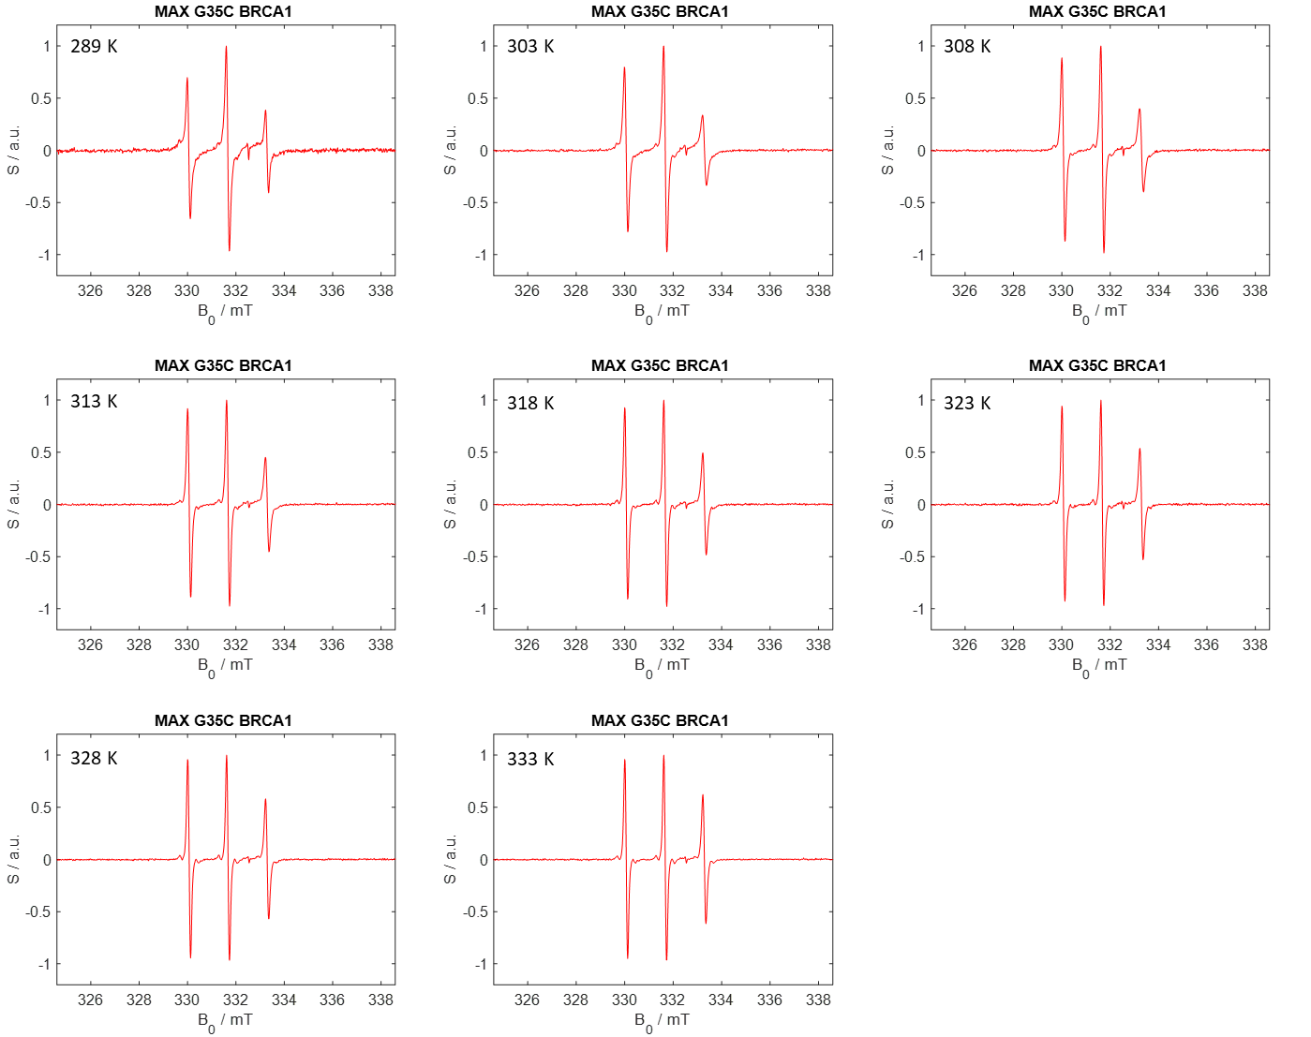

Figure SI 13. CW EPR spectra of MAX G35C + BRCA1. The experimental temperatures are indicated.

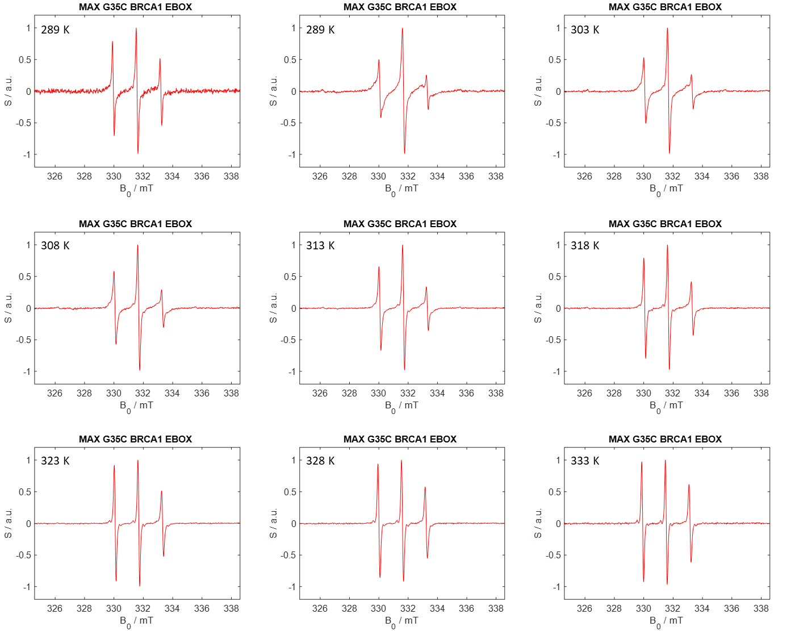

Figure SI 14. CW EPR spectra of MAX G35C + EBOX DNA + BRCA1. The experimental temperatures are indicated.

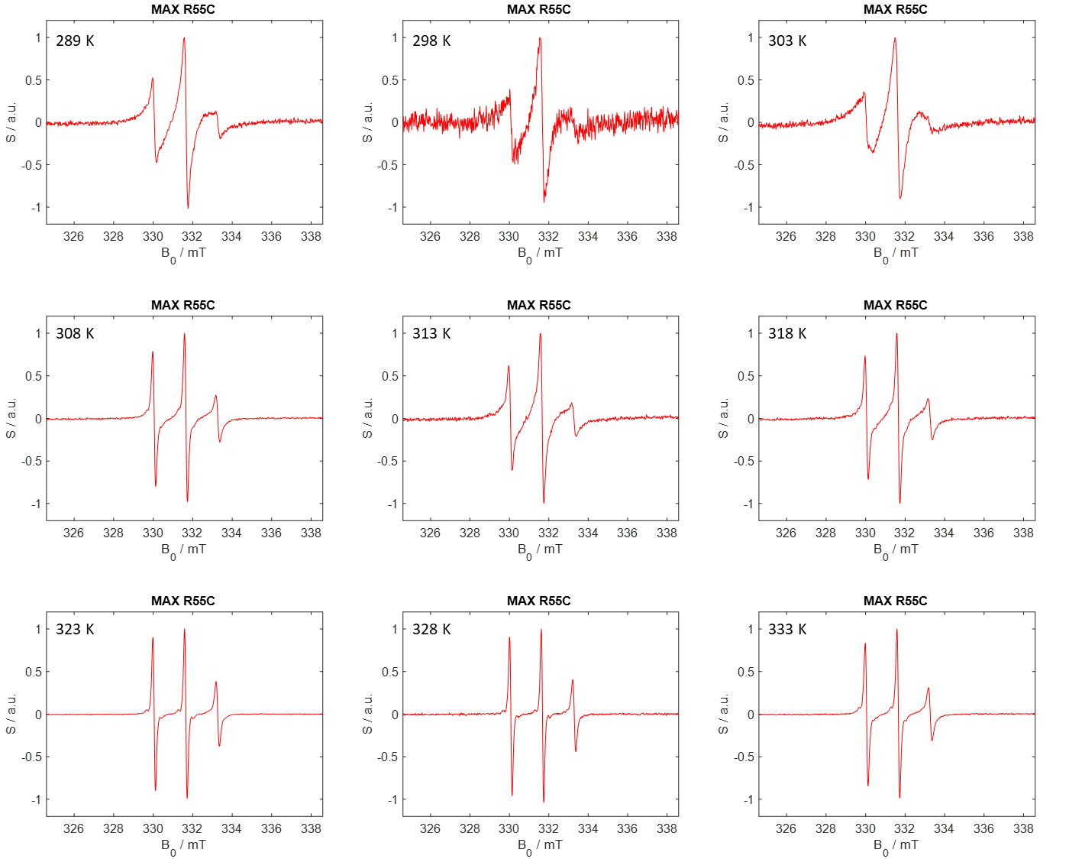

Figure SI 15. CW EPR spectra of MAX R55C. The experimental temperatures are indicated.

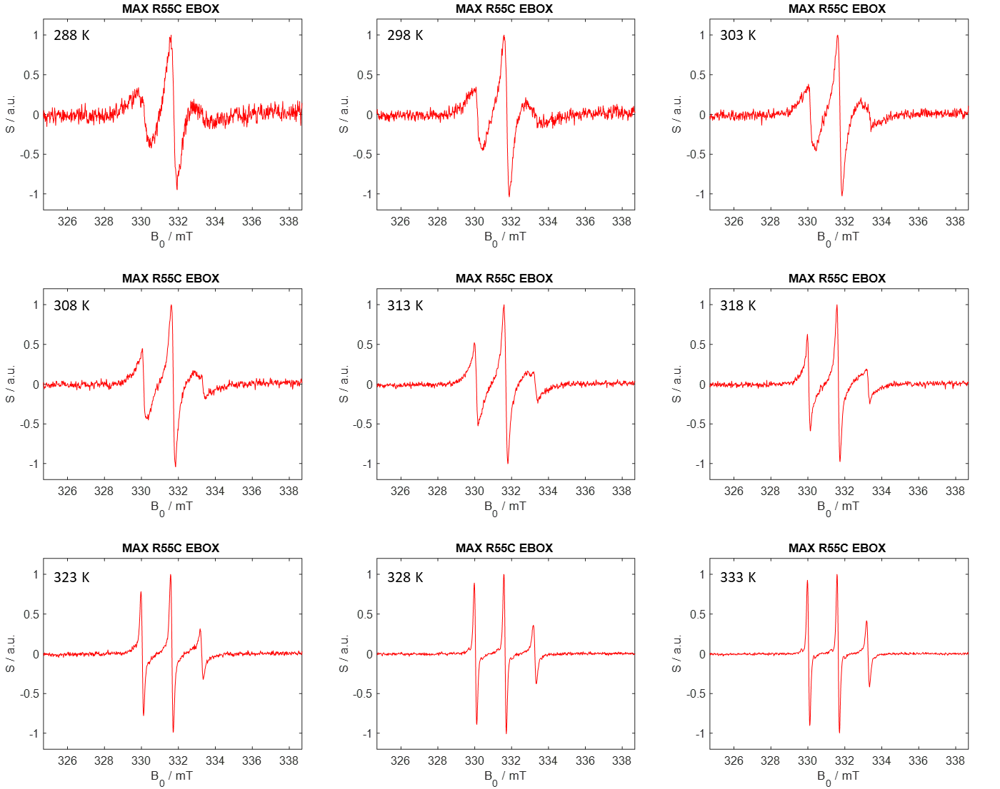

Figure SI 16. CW EPR spectra of MAX R55C + EBOX DNA. The experimental temperatures are indicated.

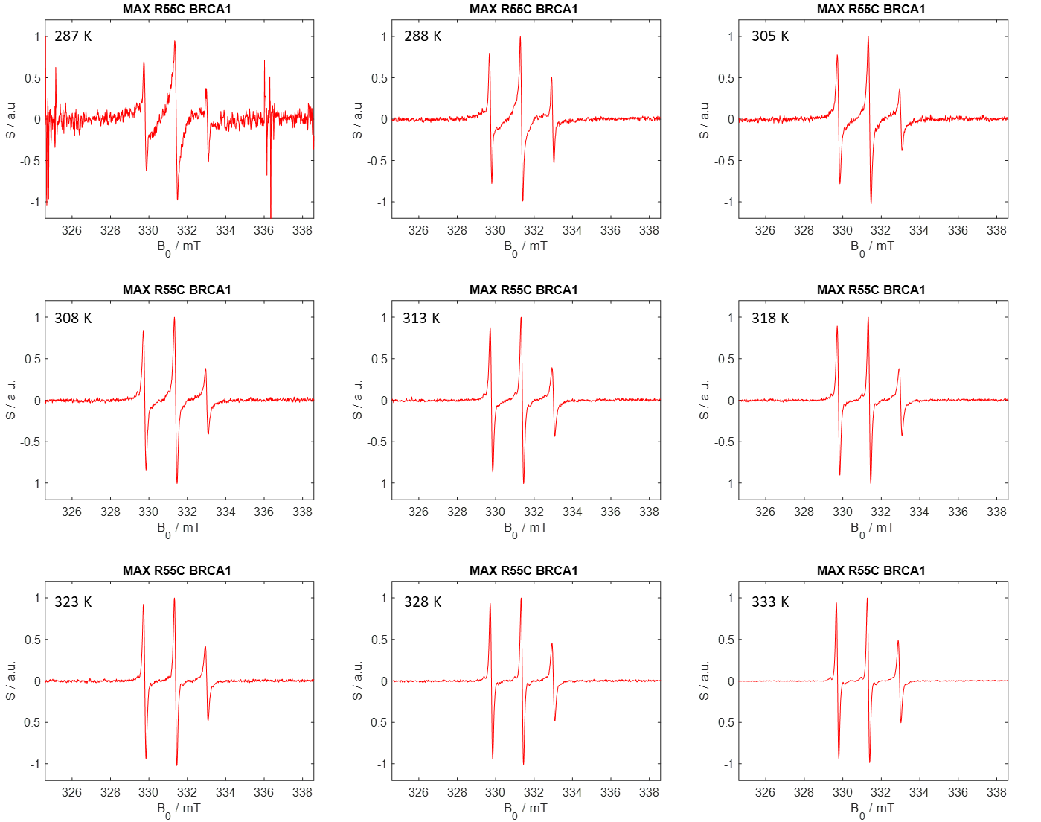

Figure SI 17. CW EPR spectra of MAX R55C + BRCA1. The experimental temperatures are indicated.

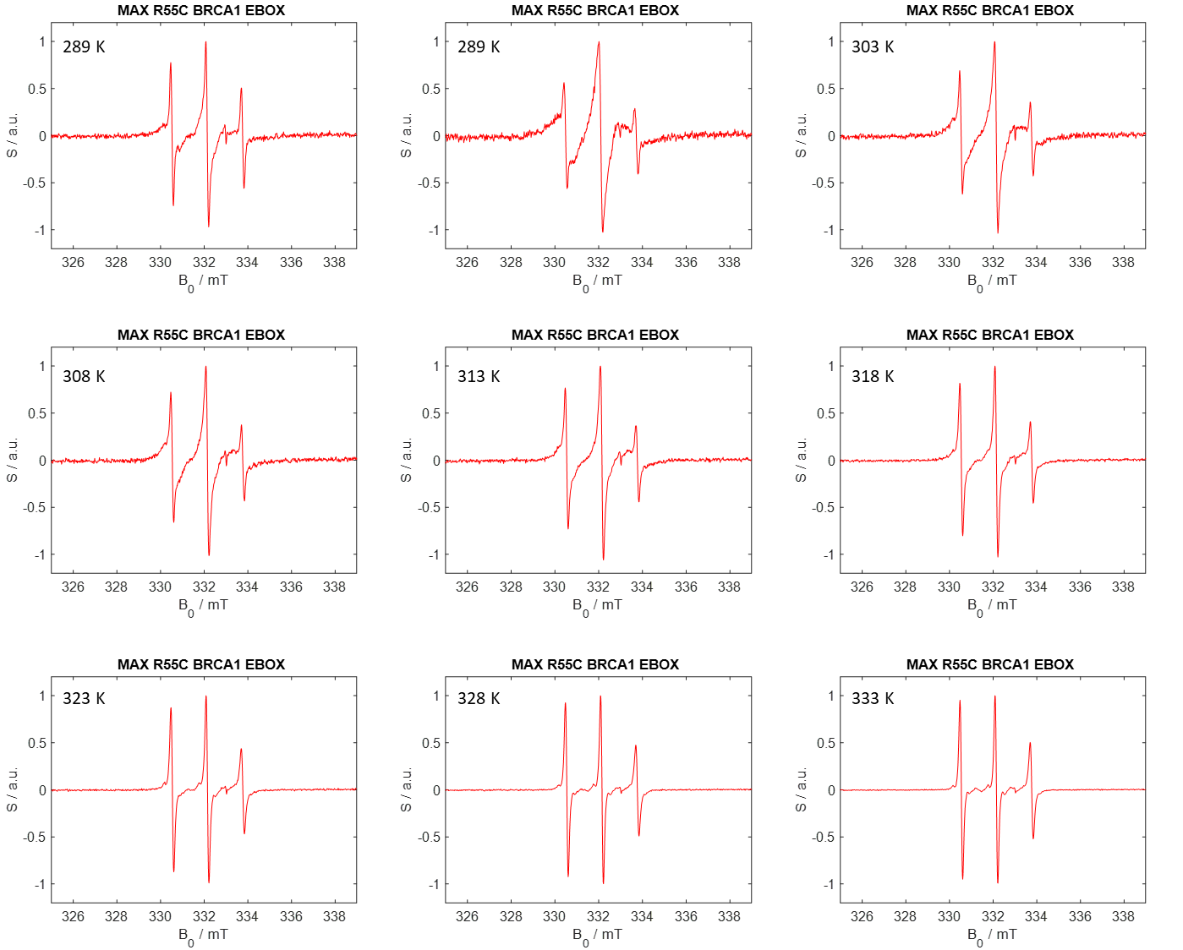

Figure SI 18. CW EPR spectra of MAX R55C + EBOX DNA + BRCA1. The experimental temperatures are indicated.

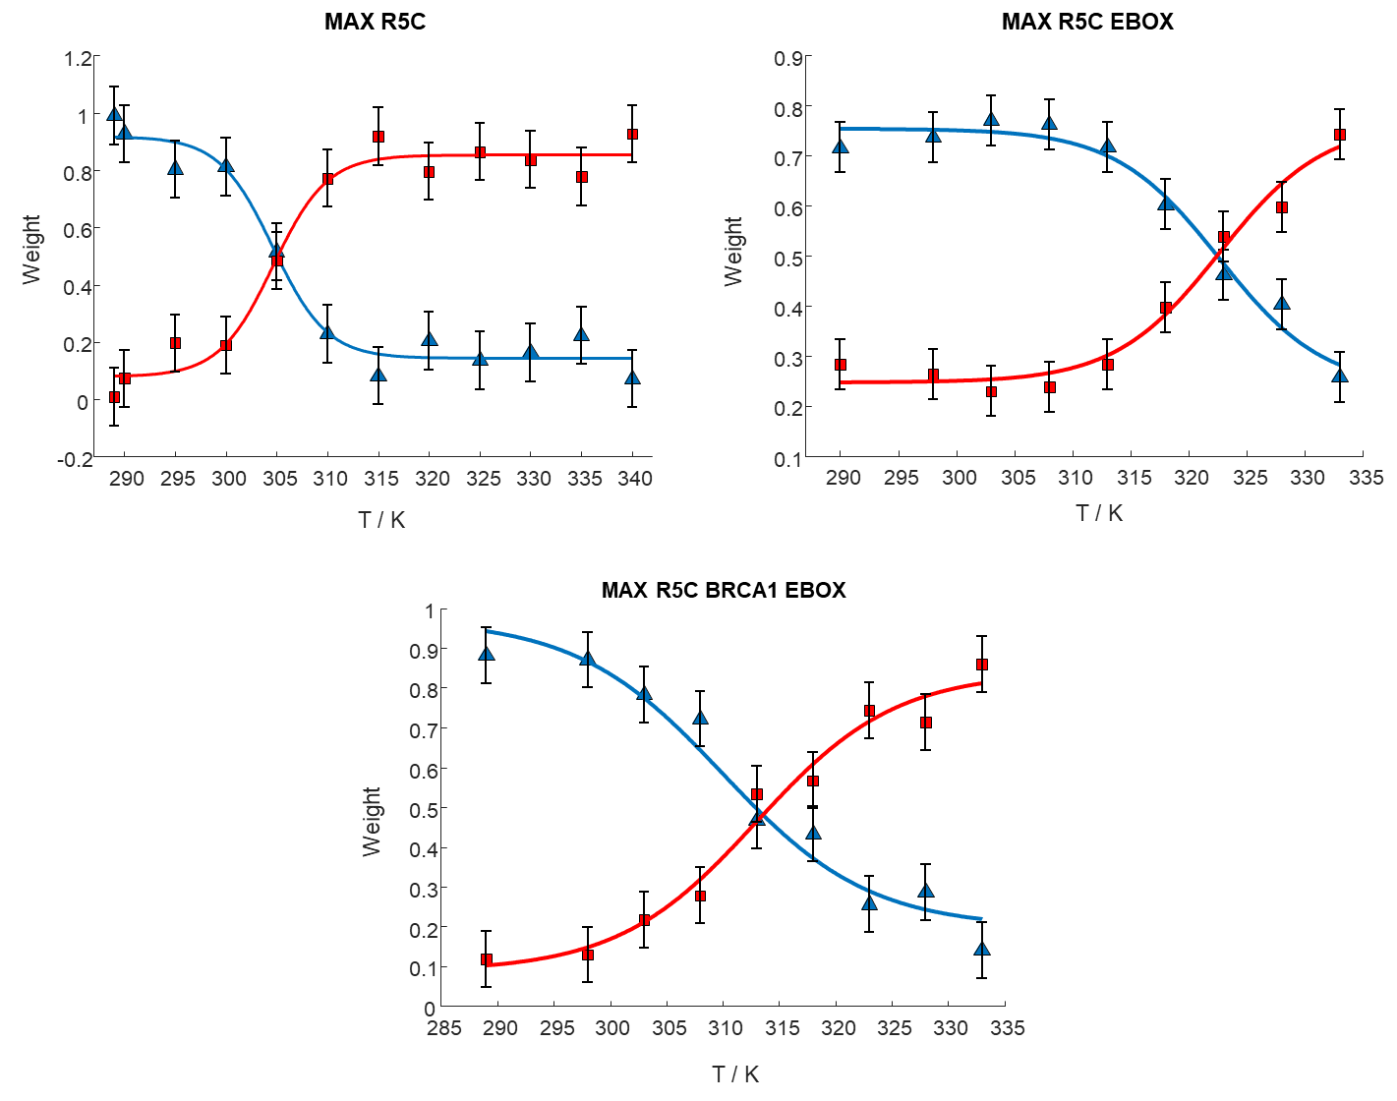

Figure SI 19. Weights of the slow contribution (blue triangles) and fast contribution (red squares) obtained from simulating the CW EPR spectra of MAX R5C at different temperatures. The experimental data were fitted with a sigmoidal function (blue and red lines, respectively). The melting temperature is identified as the crossing point between the fits. The experiments were performed in the absence or the presence of EBOX DNA and/or BRCA1.

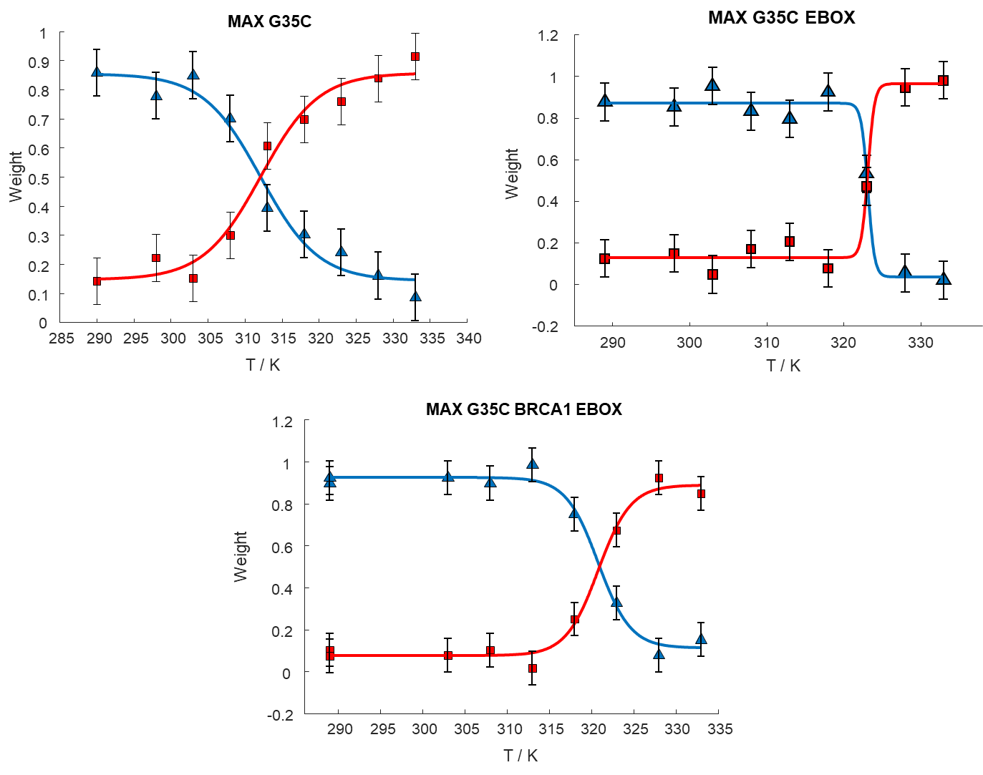

Figure SI 20. Weights of the slow contribution (blue triangles) and fast contribution (red squares) for MAX G35C at different temperatures. The experimental data were fitted with a sigmoidal function (blue and red lines, respectively). The melting temperature is identified as the crossing point between the fits. The experiments were performed in the absence or the presence of EBOX DNA and/or BRCA1.

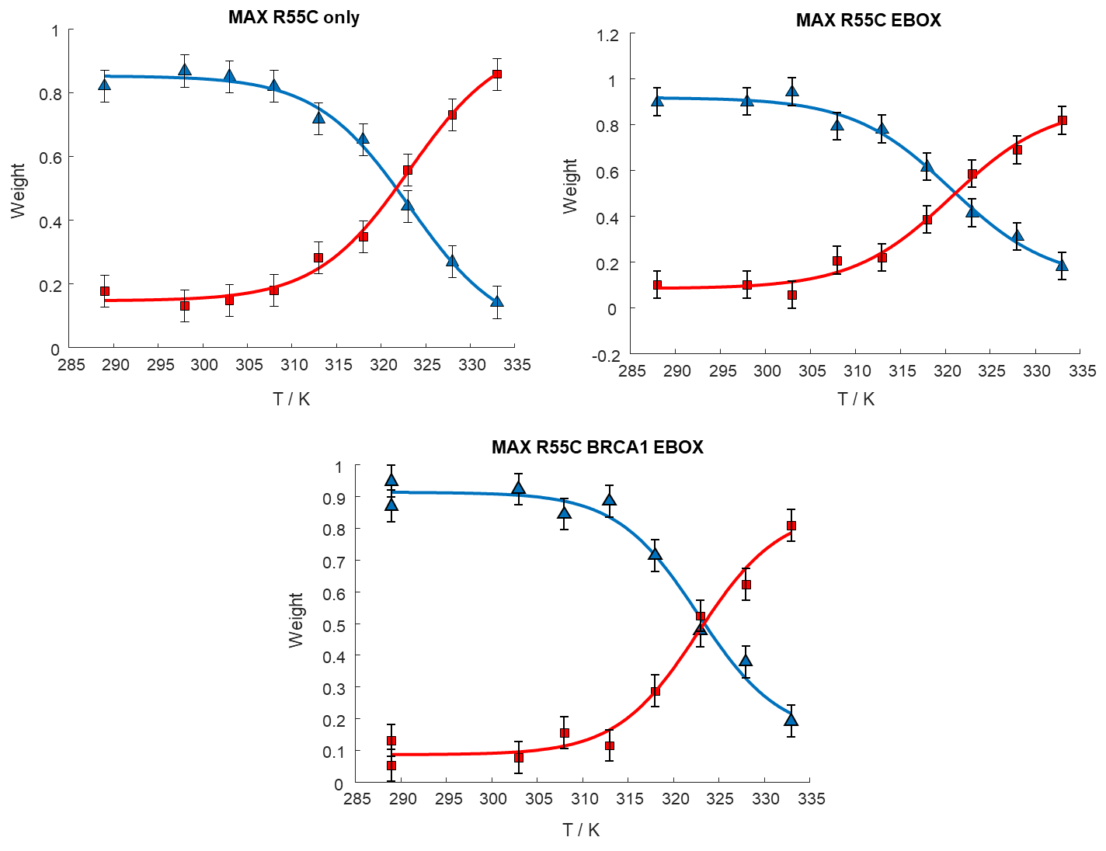

Figure SI 21. Weights of the slow contribution (blue triangles) and fast contribution (red squares) for MAX R55C at different temperatures. The experimental data were fitted with a sigmoidal function (blue and red lines, respectively). The melting temperature is identified as the crossing point between the fits. The experiments were performed in the absence or the presence of EBOX DNA and/or BRCA1.

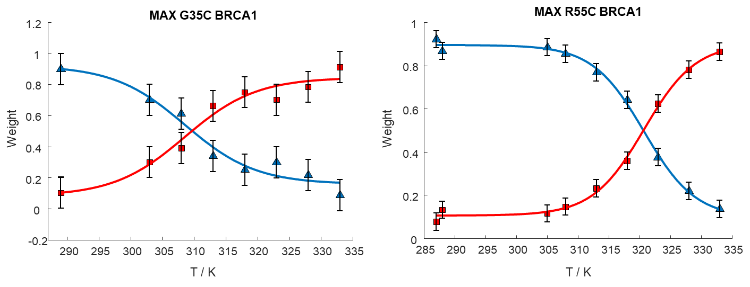

Figure SI 22. Weights of the slow contribution (blue triangles) and fast contribution (red squares) for MAX G35C and R55C at different temperatures. The experimental data were fitted with a sigmoidal function (blue and red lines, respectively). The melting temperature is identified as the crossing point between the fits. The experiments were performed in the presence of BRCA1.

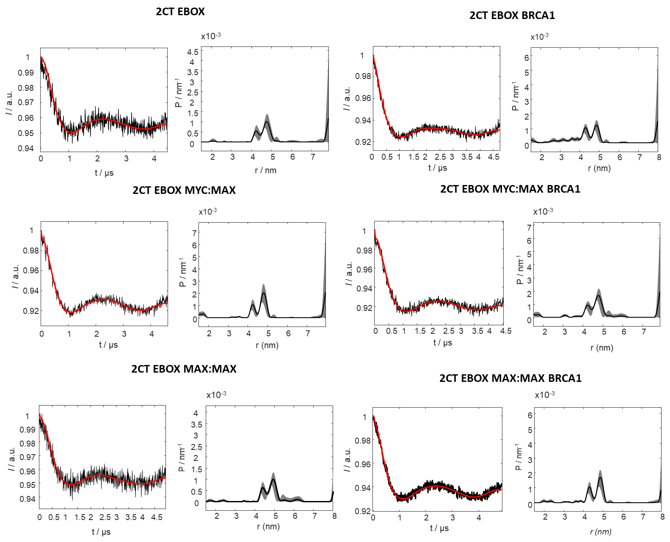

Figure SI 23. DEER form factors (black), fits (red) obtained by Thikonov-type regularization, and the corresponding distance distribution for the EBOX DNA labeled at the terminal cytosines.

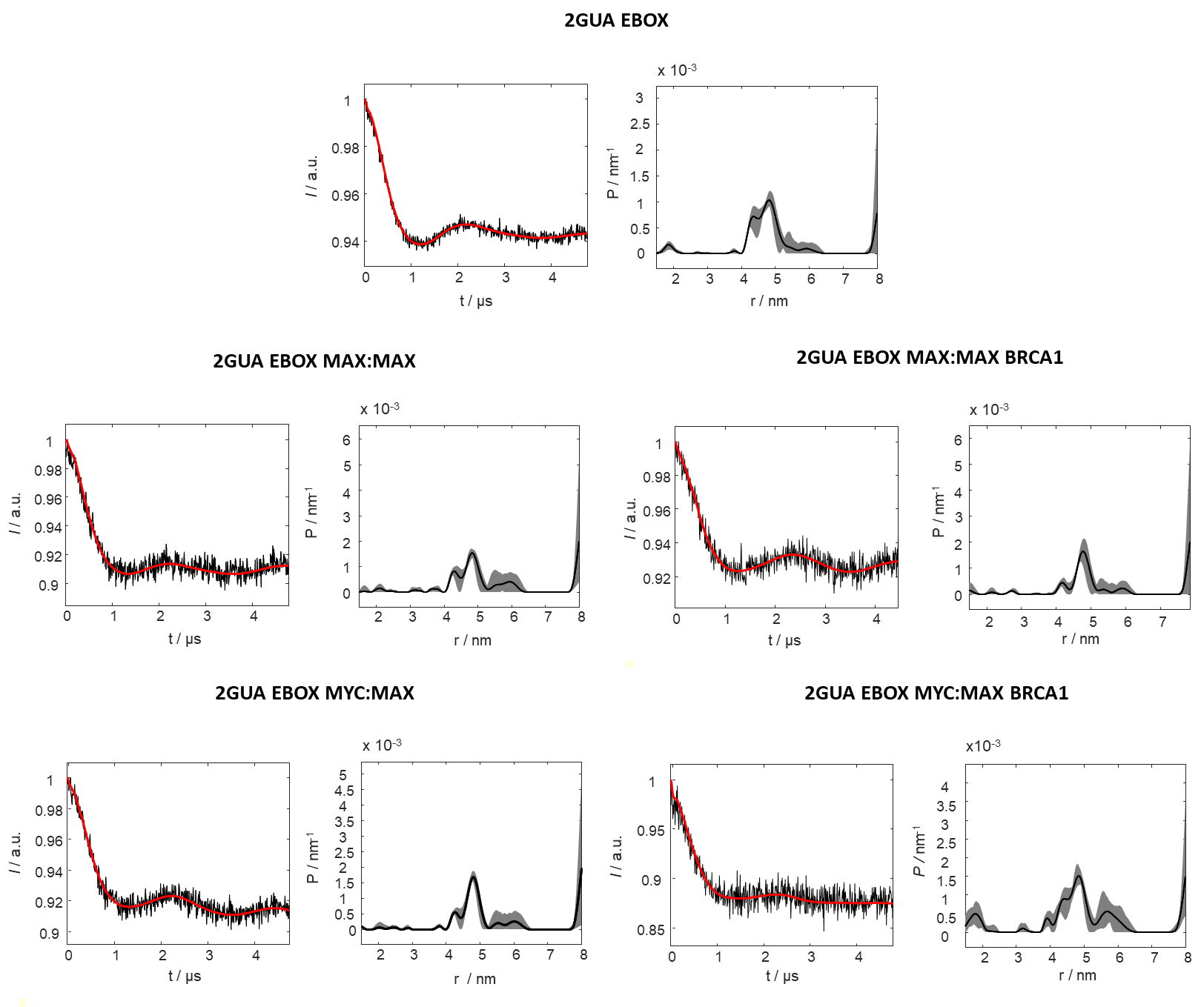
Figure SI 24. DEER form factors (black), fits (red) obtained by Thikonov-type regularization, and the corresponding distance distribution for the EBOX DNA labeled at the terminal guanosines. The results conform the distances found in Fig. SI 23.

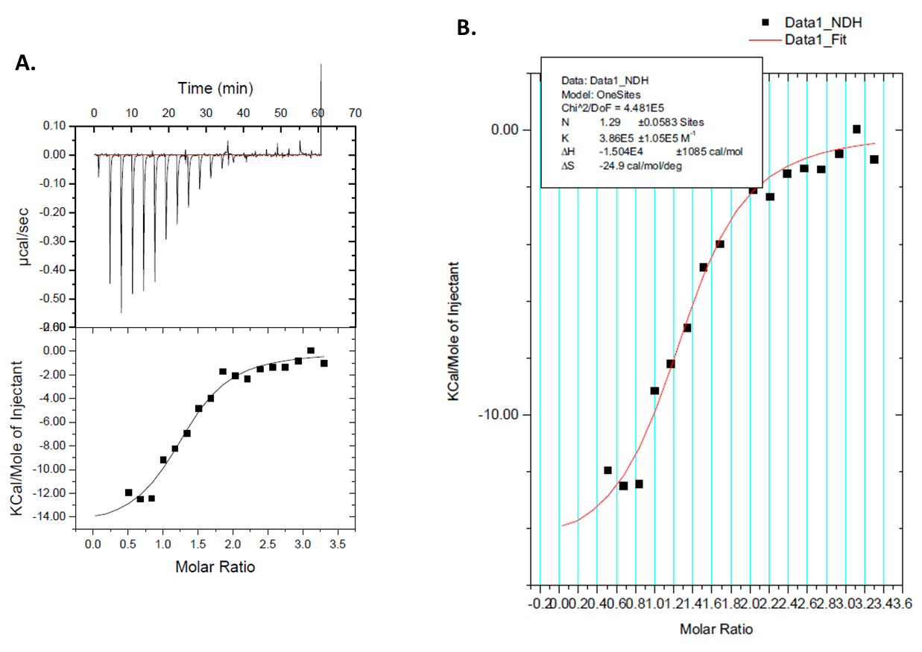

Figure SI 25. A.) ITC injection profiles and calculated heat of injectant (same as in the main text). B.) One-site model fit to the ITC titration profile. Enthalpy and entropy changes, the stoichiometry and dissociation constants are indicated in the legend.

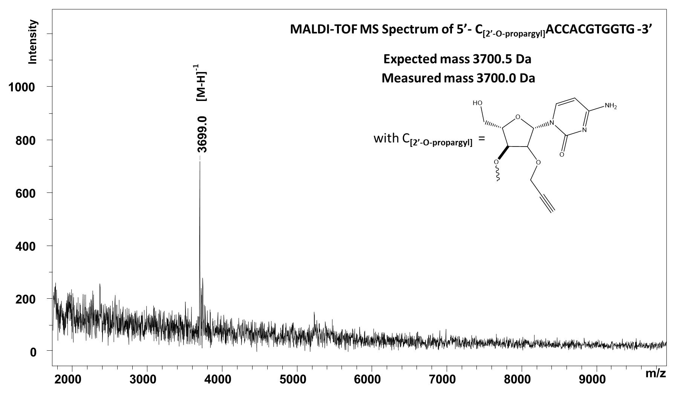
Figure SI 26. MALDI-TOF analysis: control experiment for oligonucleotide 5’-(C_{[2’-O-Propargyl]}ACCACGTGGTG)-3’.

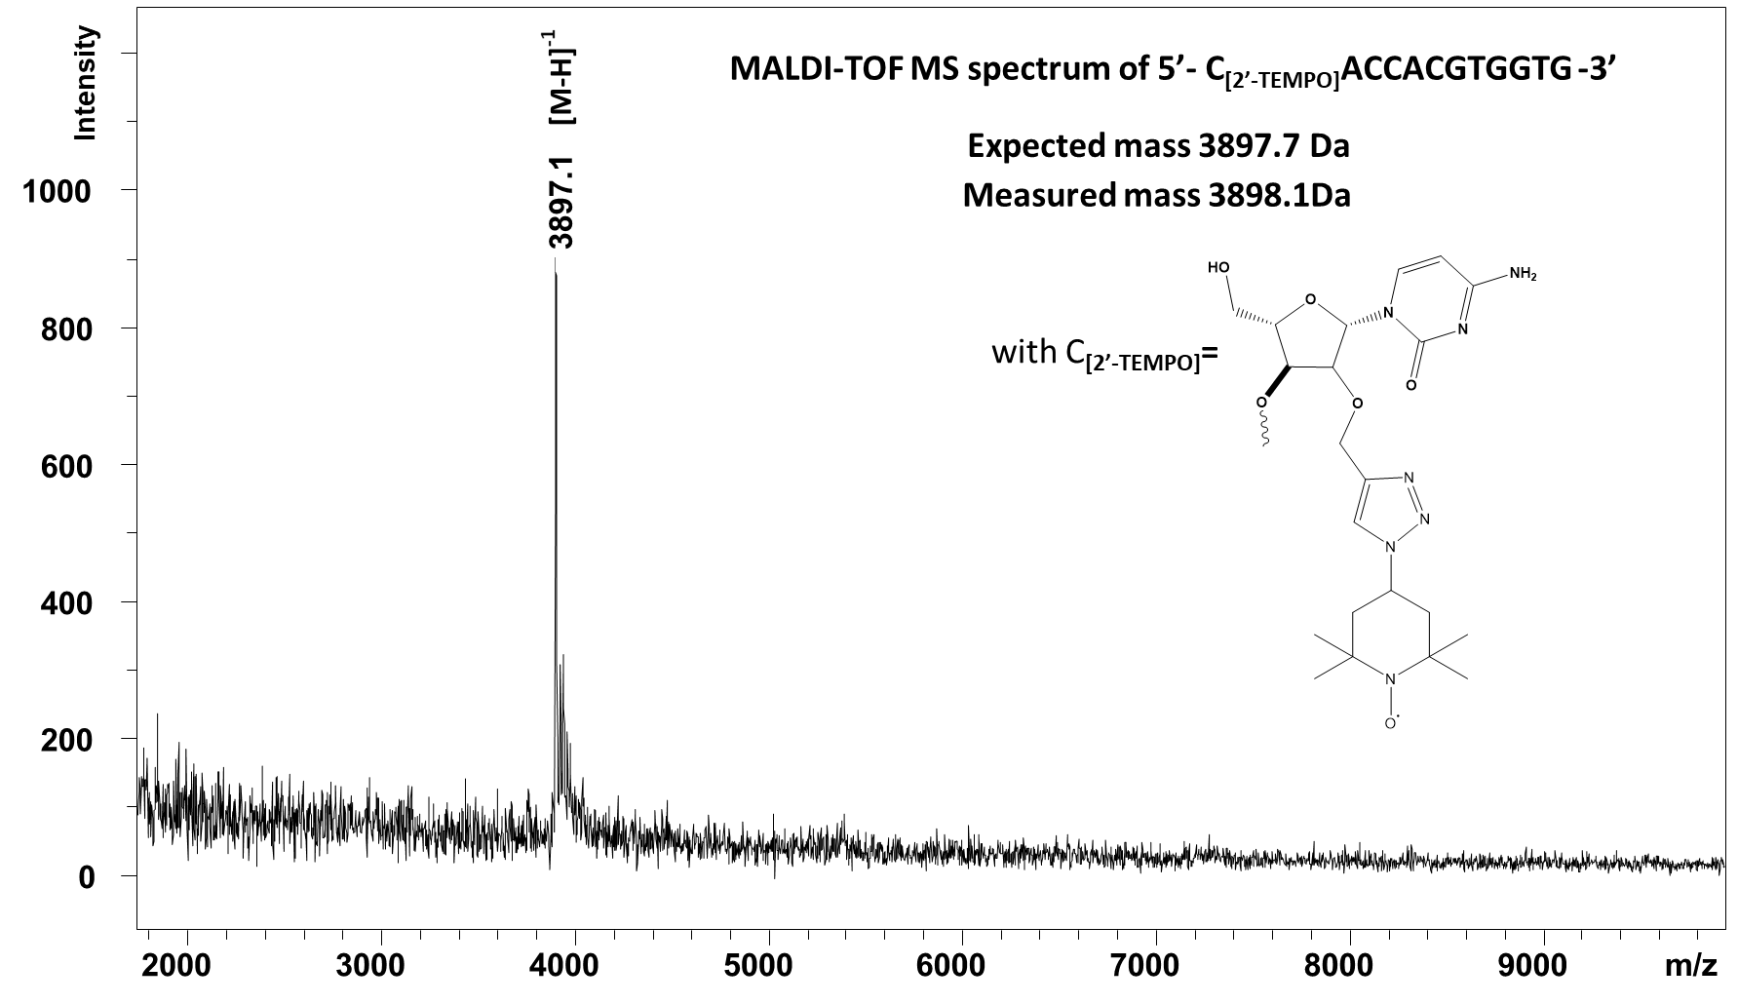

Figure SI 27. MALDI-TOF analysis: control experiment for oligonucleotide 5’-(C_{[2’-O-Propargyl]}ACCACGTGGTG)-3’ labeled with azido TEMPO through a “click chemistry approach”.

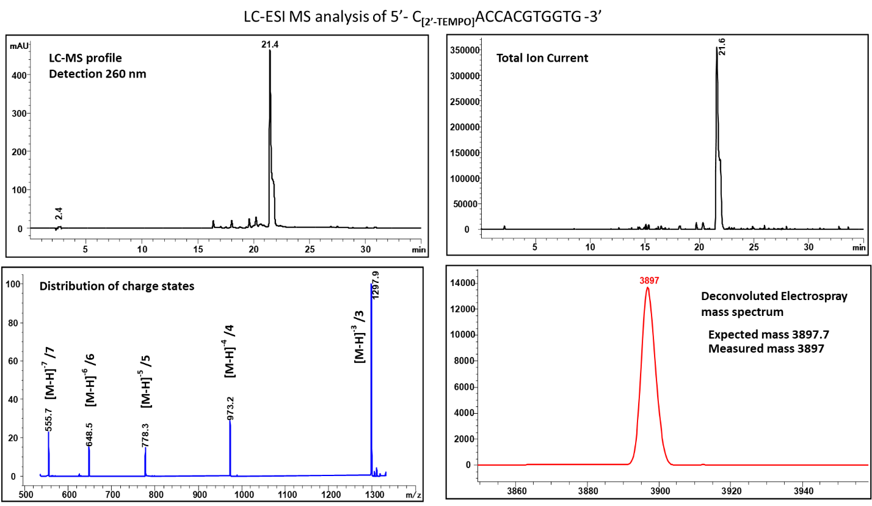

Figure SI 28. LC-ESI MS analysis: control experiment for oligonucleotide 5’-(C_{[2’-TEMPO]} ACCACGTGGTG)-3’.

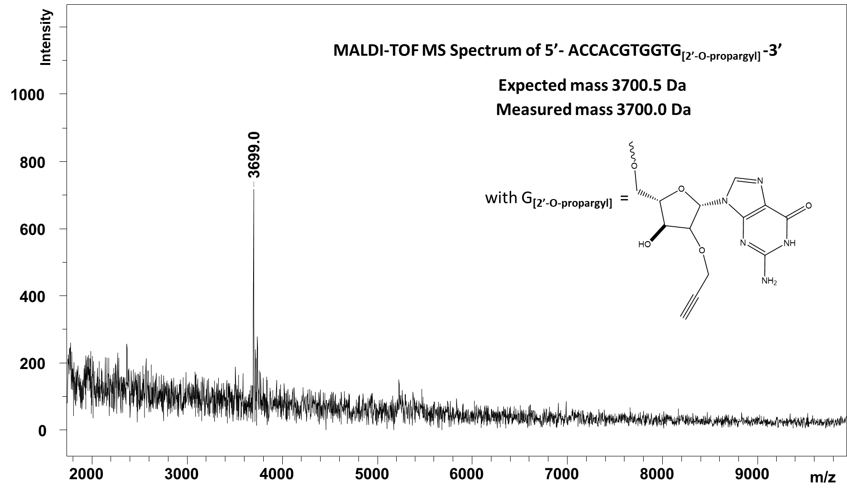

Figure SI 29. MALDI TOF analysis: control experiment for oligonucleotide 5’-(ACCACGTGGTG_{[2’-O-Propargyl]})- 3’.

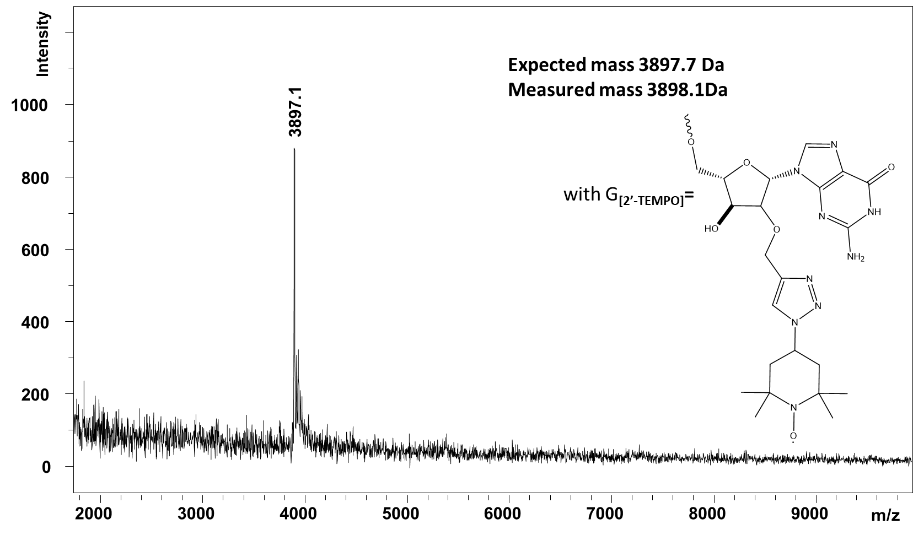

Figure SI 30. MALDI TOF analysis: control experiment for oligonucleotide 5’-(ACCACGTGGTG_{[2’-O-Propargyl]})- 3’ labeled with azido TEMPO through a “click chemistry approach”.

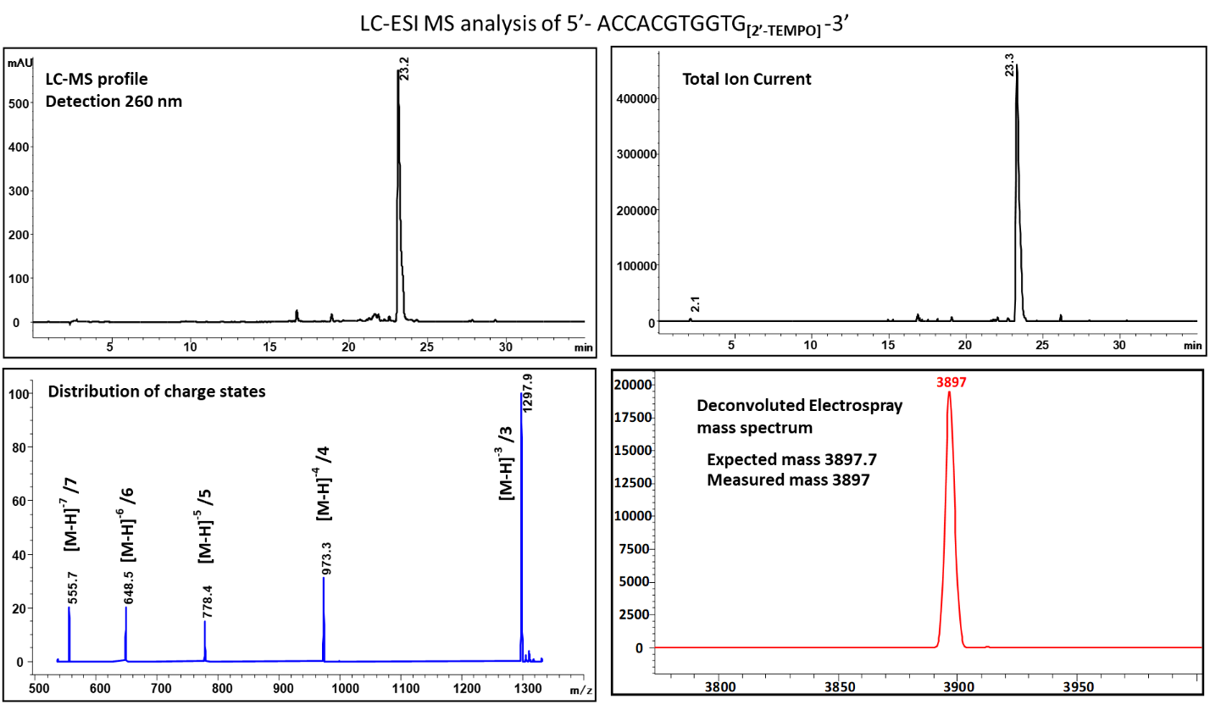

Figure SI 31. LC-ESI MS analysis: control experiment for oligonucleotide 5’-(ACCACGTGGTG_{[2’-TEMPO]})- 3’.

