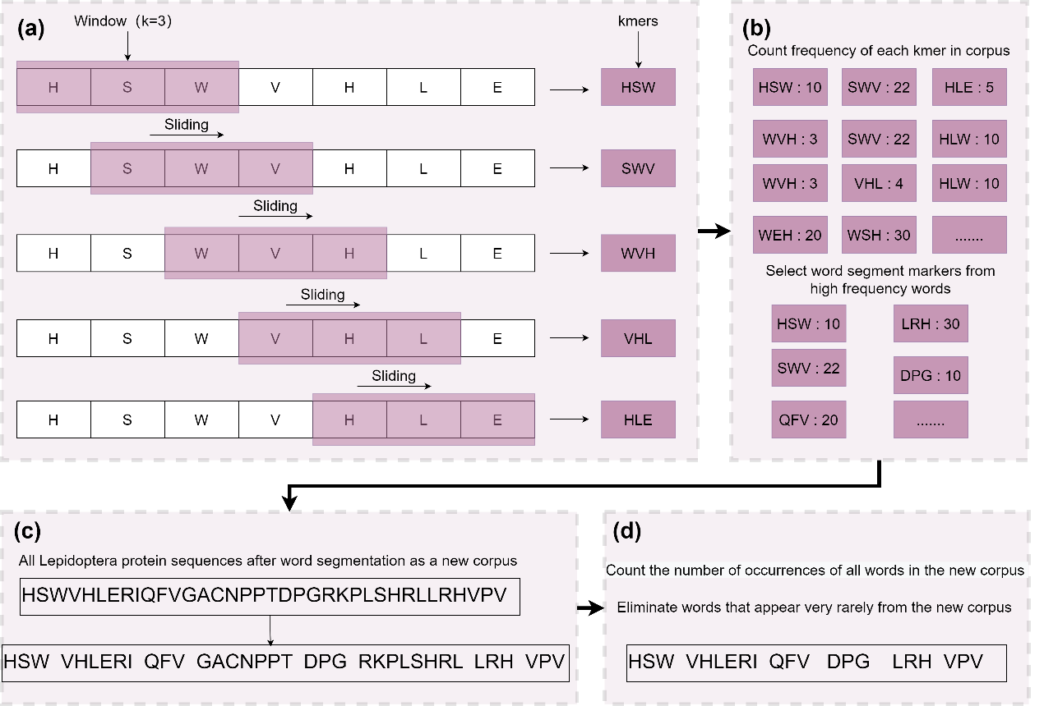
Figure S1. The generation process of variant kmer. (a) A sliding window of window size k (k=3) was used for all protein sequences to obtain multiple kmer. (b) The frequencies of all kmer occurrences in protein sequences(corpus) were counted, and the kmer with frequencies greater than the upper quartile were selected as the segment markers. (c) The corpus is segmented using these segmentation markers and all the short sequences of unequal length obtained after segmentation are used as words. (d) All words were counted for word frequency, and the very low frequency words were eliminated, and the retained words were used to characterize the corpus.

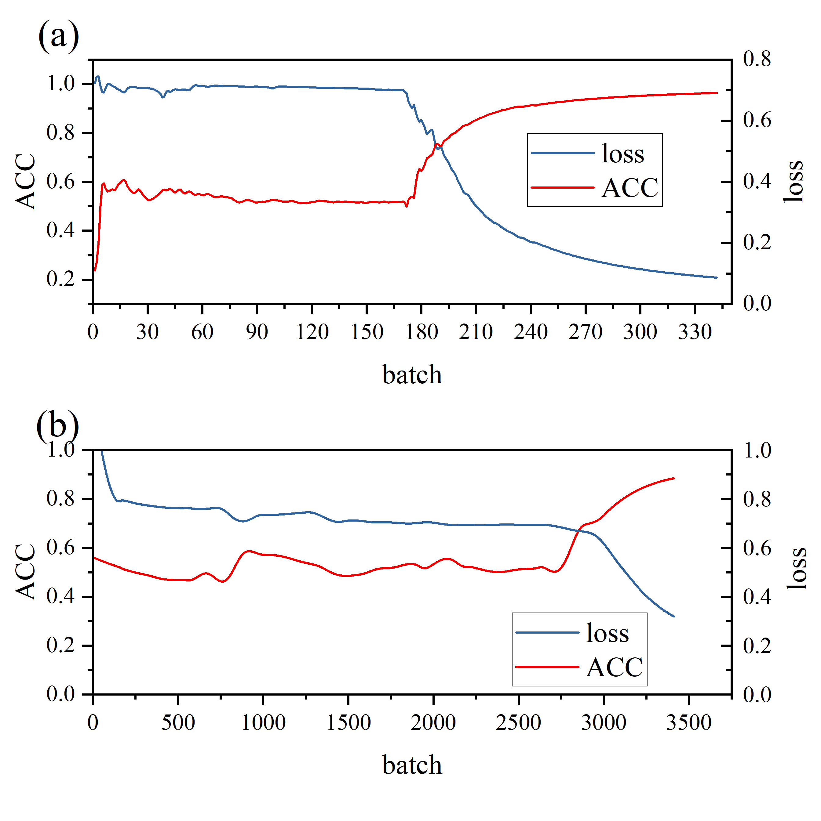
Figure S2. Variation in accuracy and loss during training using hierarchical attention classification networks. (a) represents the training process of constructing a dataset of word hierarchies using domain names(v=1). (b) represents the training process of constructing a dataset of word hierarchies using variant kmer (v=2).

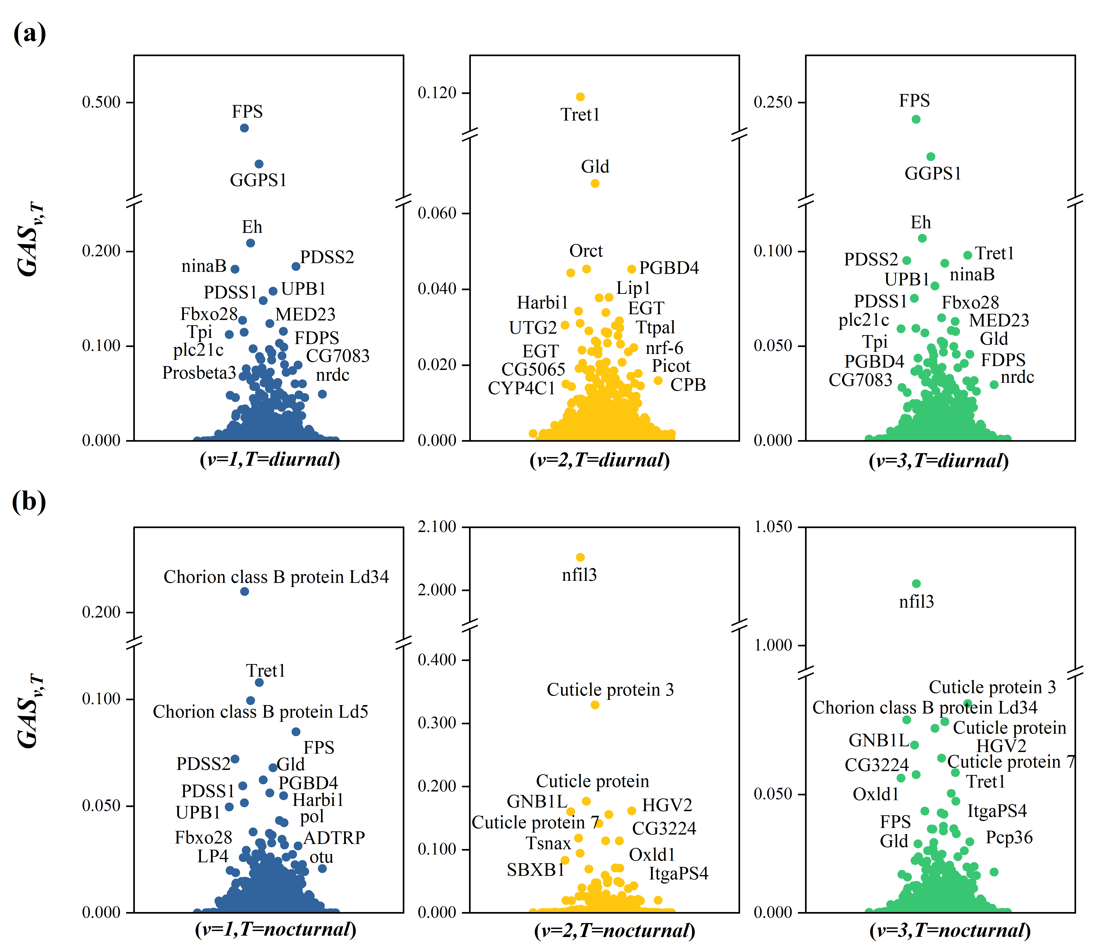
Figure S3. The distribution of ${GAS}_{v,T}$ values based on three types of attention mechanisms. When v=1, ${GAS}_{1,T}$ strands for domain attention; When v=2, ${GAS}_{2,T}$ strands for kmer attention; When v=3, ${GAS}_{3,T}$ strands for fused attention. (a) Distribution of ${GAS}_{v,T}$ of diurnal lepidopteran taxa ($T=diurnal$); (b) Distribution of ${GAS}_{v,T}$ of diurnal lepidopteran taxa ($T=nocturnal)$; In addition, the ${GAS}_{v,T}$ are normalized results.

