Supplemental materials
Supplemental figure
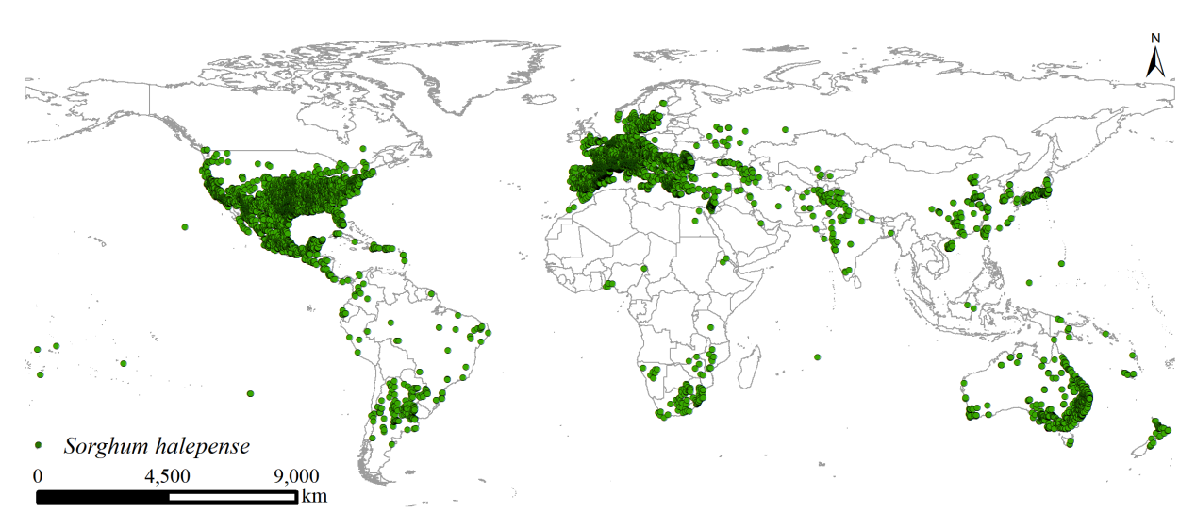
Fig. S1 Global distribution occurrences of Sorghum halepense

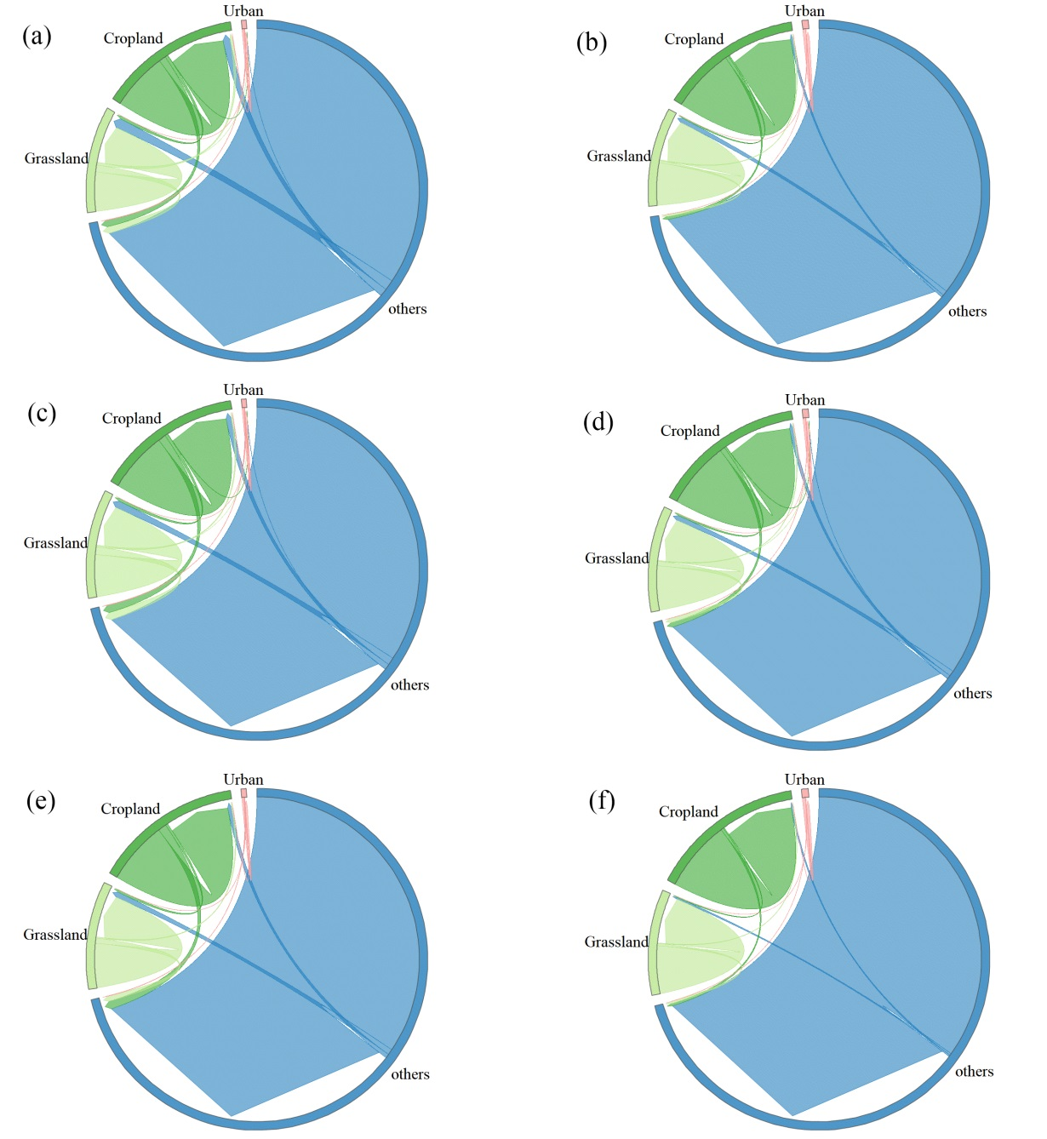
Fig. S2 Global land-use transitions by future scenarios. Each arrow represents from a specific land-use type to other land-use type. (a) the transitions from under SSP1-2.6 in the 2030s to the near current climate, (b) the transitions from under SSP1-2.6 in the 2050s to the SSP1-2.6 in the 2030s, (c) the transitions from under SSP2-4.5 in the 2030s to the near current climate, (d) the transitions from under SSP2-4.5 in the 2050s to the SSP2-4.5 in the 2030s, (e) the transitions from under SSP5-8.5 in the 2030s to the near current climate, (f) the transitions from under SSP5-8.5 in the 2050s to the SSP5-8.5 in the 2030s

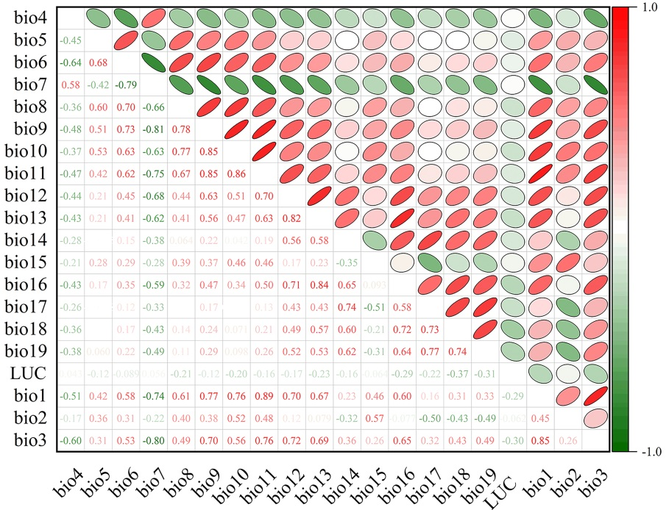
Fig S3 Correlation of twenty environmental variables via ENMTools

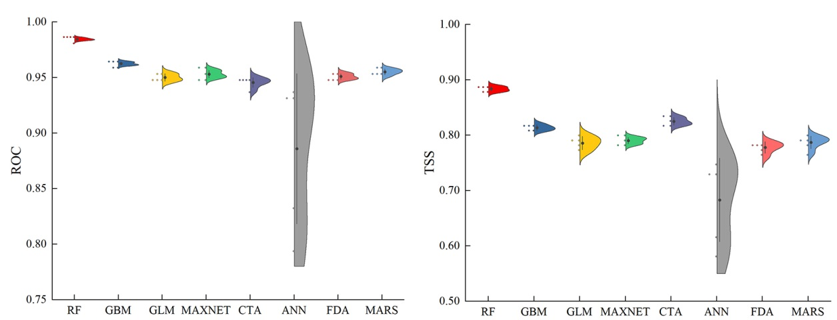
Fig. S4 Single model performance with ROC and TSS values

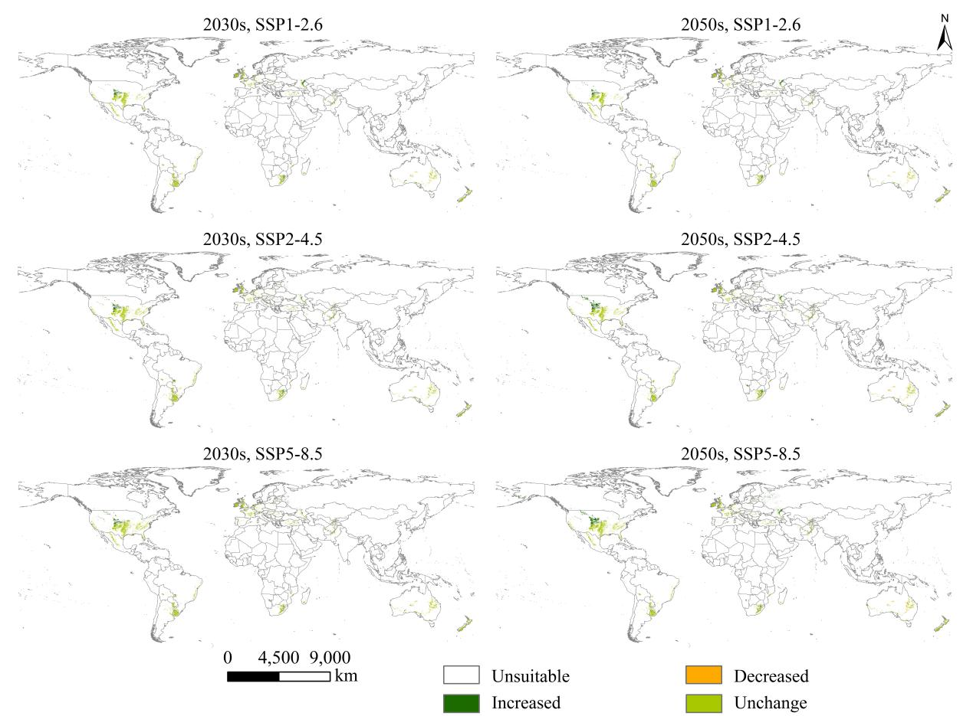
Fig. S5 Changes in suitable grassland area for Sorghum halepense from different future scenarios to the near current climate

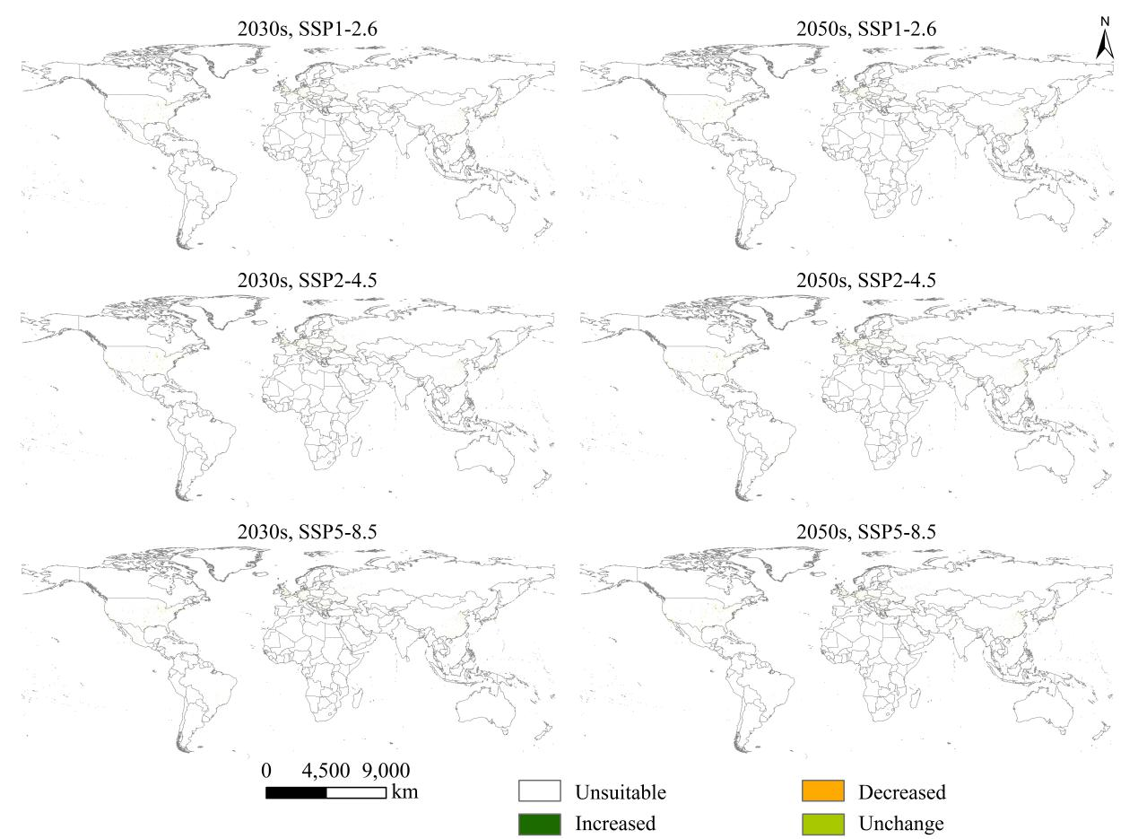
Fig. S6 Changes in suitable urban area for Sorghum halepense from different future scenarios to the near current climate

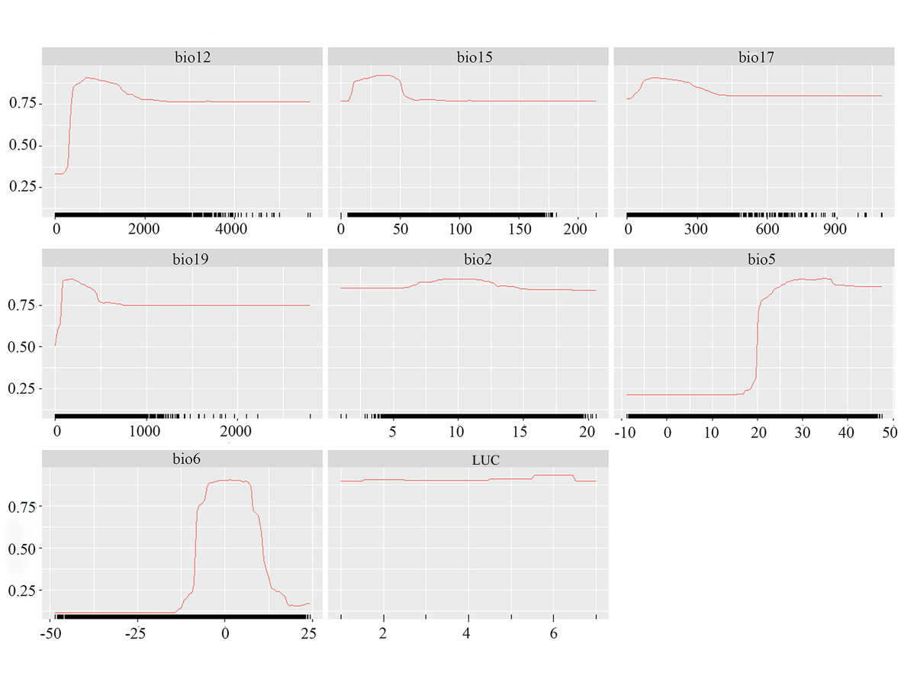
Fig. S7 Significant environmental variables to predict the potential global suitable habitats (PGSH) of Sorghum halepense

Supplemental table
Table S1 Environmental variables projected to predict the potential global suitable habitats (PGSH) of Sorghum halepense
Variable | Description | Unit
bio1 | Annual mean temperature | ℃
bio2 | Mean diurnal range (Mean of monthly (max temp-min temp) | ℃
bio3 | Isothermality (Bio2/Bio7)×100 | -
bio4 | Temperature seasonality (standard deviation×100) | ℃
bio5 | Max temperature of warmest month | ℃
bio6 | Min temperature of coldest month | ℃
bio7 | Temperature annual range (bio5-bio6) | ℃
bio8 | Mean temperature of wettest quarter | ℃
bio9 | Mean temperature of driest quarter | ℃
bio10 | Mean temperature of warmest quarter | ℃
bio11 | Mean temperature of coldest quarter | ℃
bio12 | Annual precipitation | mm
bio13 | Precipitation of wettest month | mm
bio14 | precipitation of driest month | mm
bio15 | Precipitation seasonality (coeffcient of variation) | -
bio16 | Precipitation of wettest quarter | mm
bio17 | Precipitation of driest quarter | mm
bio18 | Precipitation of warmest quarter | mm
bio19 | Precipitation of coldest quarter | mm
LUC | Land use change

Table S2 The mean ROC, TSS, and KAPPA values of eight single model and EM
model | mean ROC | mean TSS | mean KAPPA
ANN | 0.885 | 0.666 | 0.685
CTA | 0.943 | 0.818 | 0.810
FDA | 0.948 | 0.773 | 0.768
GBM | 0.960 | 0.809 | 0.808
GLM | 0.947 | 0.775 | 0.777
MARS | 0.952 | 0.778 | 0.782
MaxEnT | 0.951 | 0.785 | 0.778
RF | 0.983 | 0.880 | 0.880
EM | 0.984 | 0.851 | 0.856

