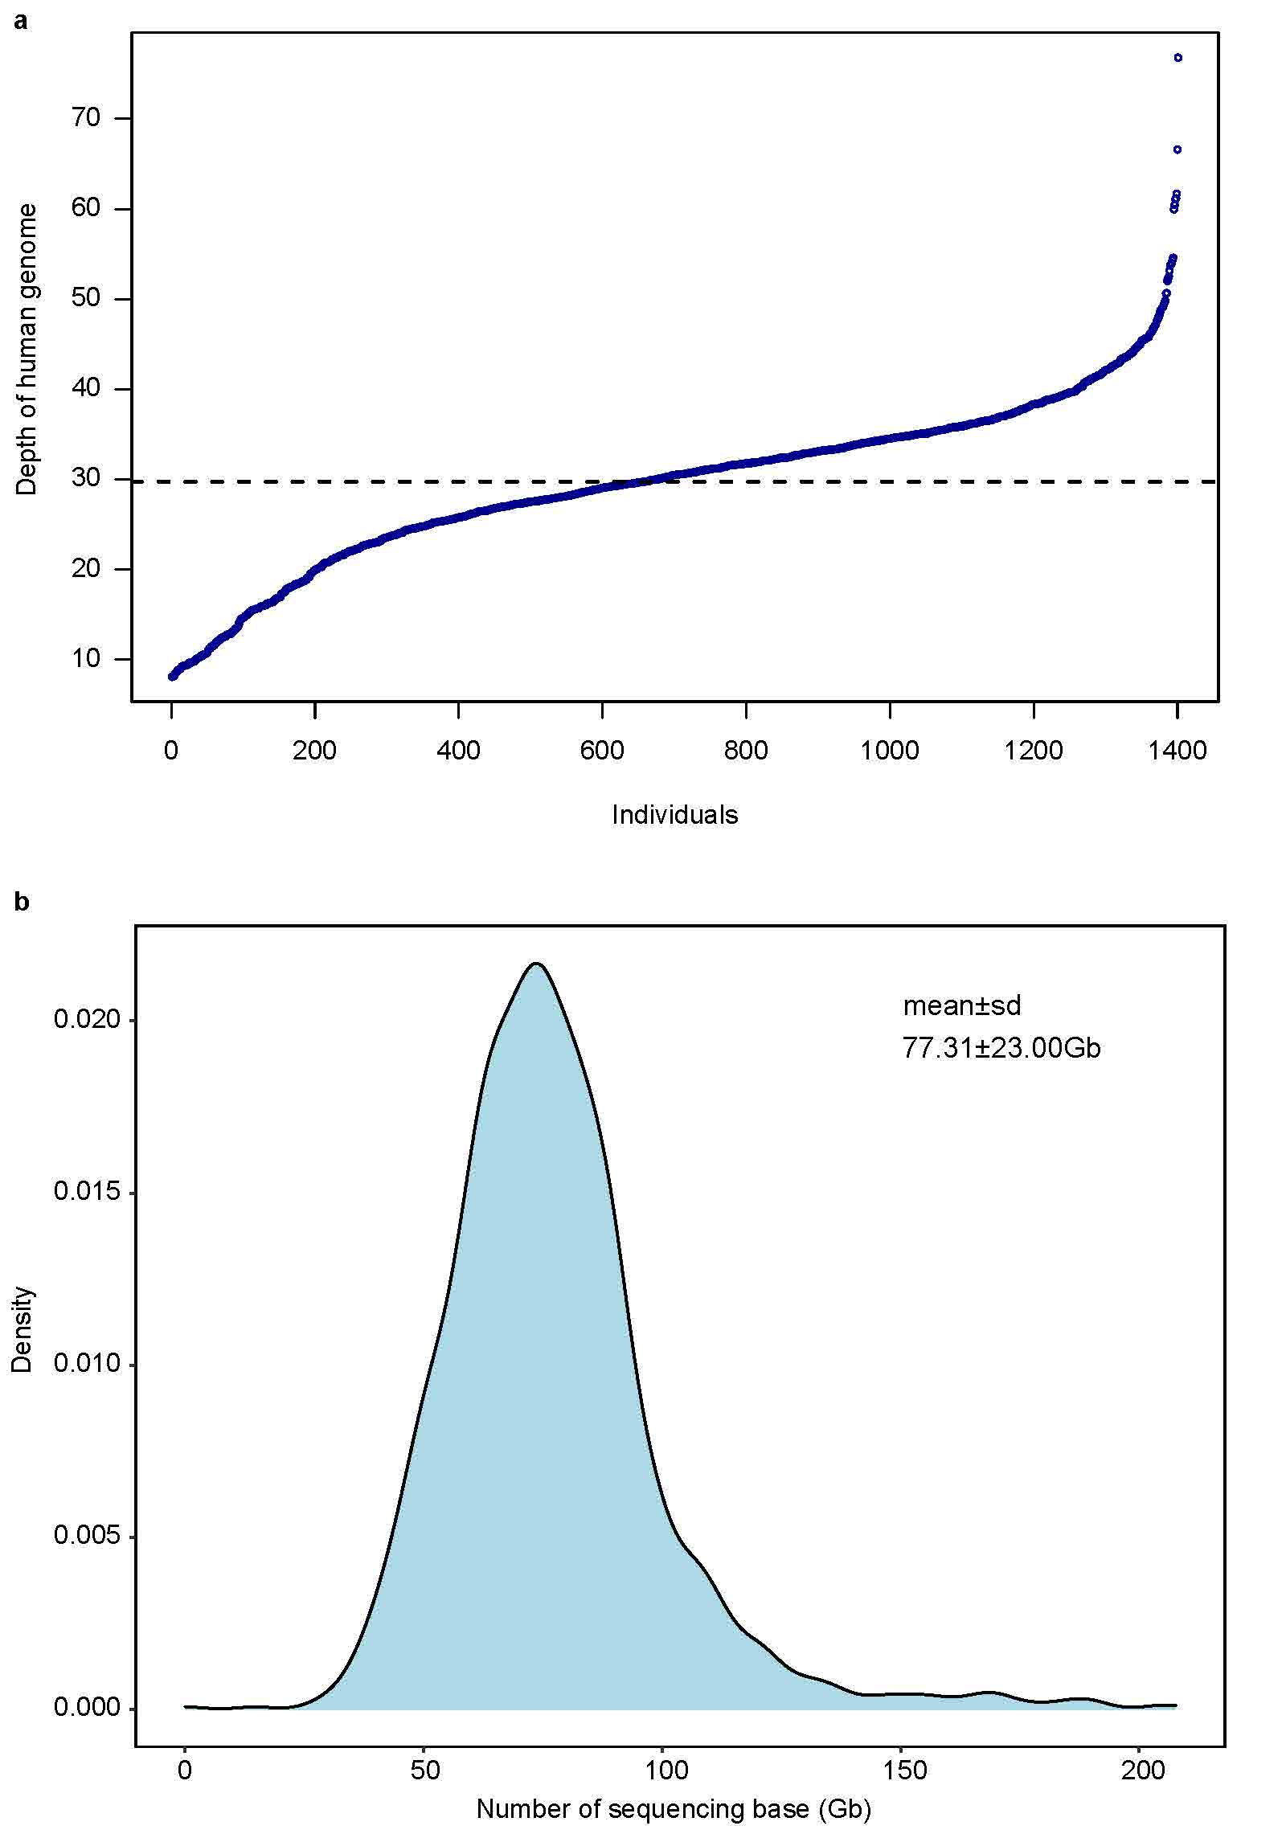
Supplementary Fig. 1. Host genome and metagenome sequencing data production. (a) Depth distribution of 1,401 host genomes by integrating host whole genome sequencing data from blood sample and human-derived reads data extracted from nasal sample. The mean depth is 30× (ranging from 8× to 78×). (b) Nasal metagenome sequencing at an average of 77.31 ± 23.00 Gb after trimming low quality reads.

Supplementary Fig. 2. Comparisons of the alpha-diversity of the nasal microbiome between the northern (N) and southern (S) individuals. Two alpha-diversity indicators, namely Shannon index (a) and simpson index (b), were plotted between N and S samples, respectively.

Supplementary Fig. 3. Manhattan plot of nasal microbial alpha-diversity (Shannon index). The red solid line indicates the genome-wide significance level at P = 5 × 10⁻⁸ and the blue solid line indicates the suggestive significance level at P = 10⁻⁵. The top associated signal of gene CACNB2 was marked in green.

Supplementary Fig. 4. Distribution of the lambda value (λ_{GC;} ranged from 0.979 to 1.054 with a median of 1.012). There are 293 independent M-GWAS tests performed on the nasal microbial features (86 taxa and 207 functions).
Supplementary Fig. 5. The correlation of species Gemella asaccharolytica with host traits in this cohort. The linear regression model was used with adjusting sex, age and the top four principal components (PC1, PC2, PC3 and PC4). Only correlations with p<0.05 were showed. Significant code: 0.05 * 0.01 ** 0.001.

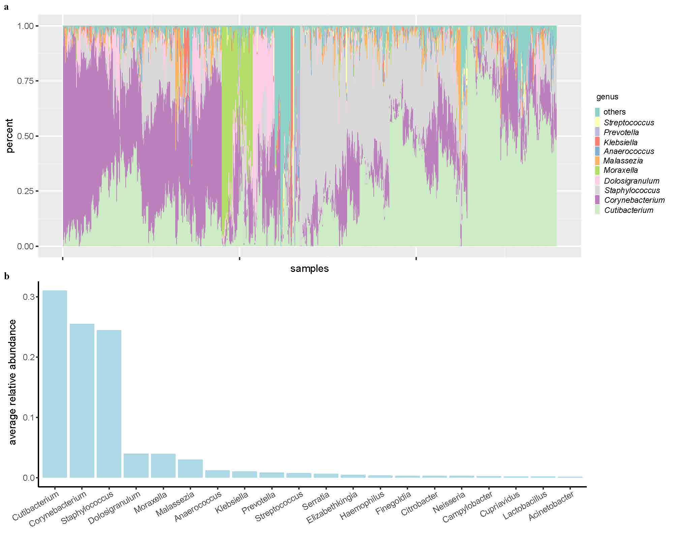

Supplementary Fig. 6. The top genus of the nasal microbiome in this Chinese cohort. a and b showed the top 10 and 20 genus with the highest relative abundances, respectively.
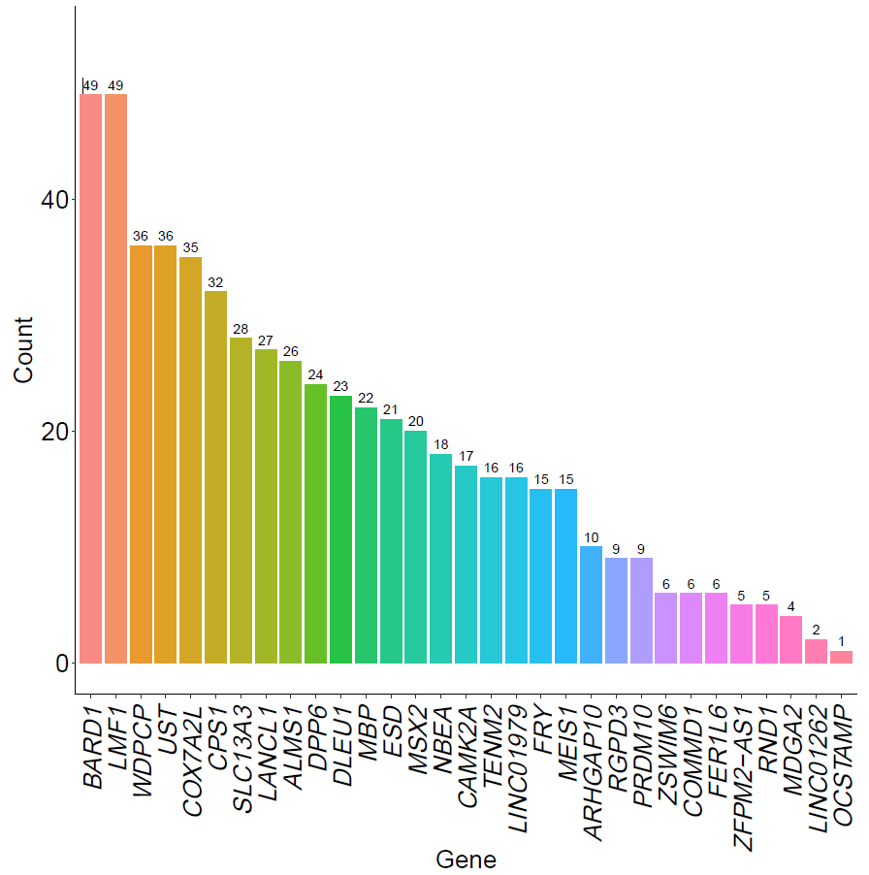
Supplementary Fig. 7. Top Genes among MAV Enriched Tissues.

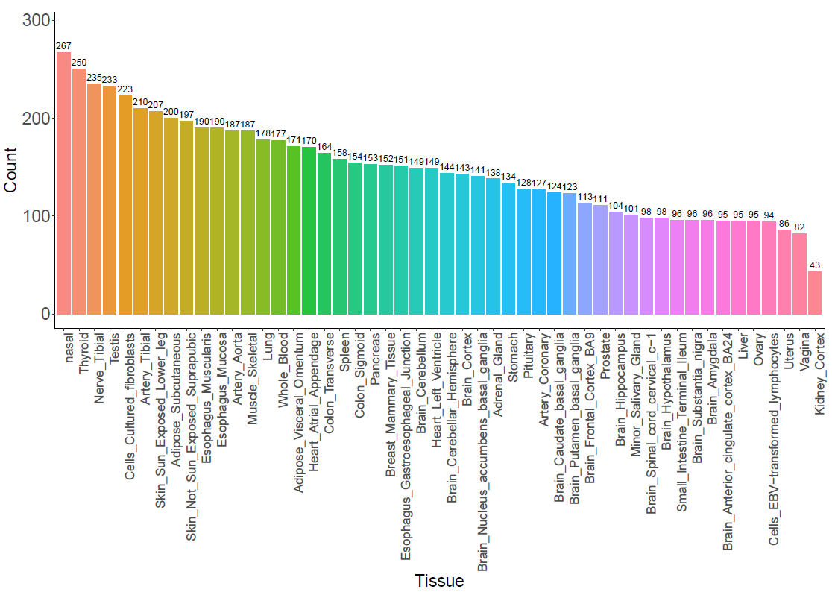

Supplementary Fig. 8. The 413 genes exhibiting suggestively significant nasal MAVs(p<1e-6) were enriched in the nasal airway epithelium and other relevant tissues. The nasal airway epithelium and other 49 tissue groups from the GTEx database were included for gene expression analysis.

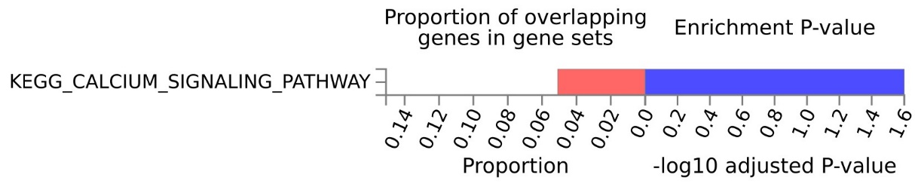
a

b

c
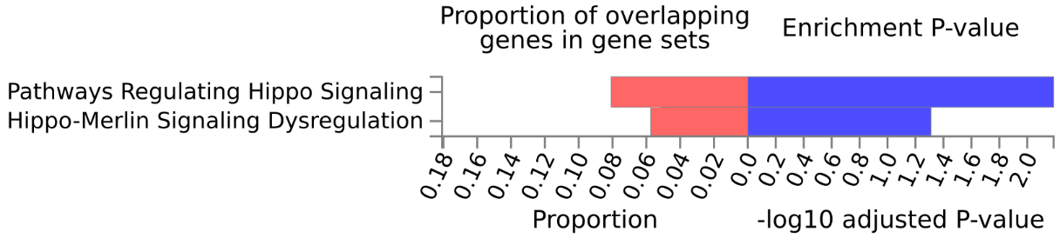
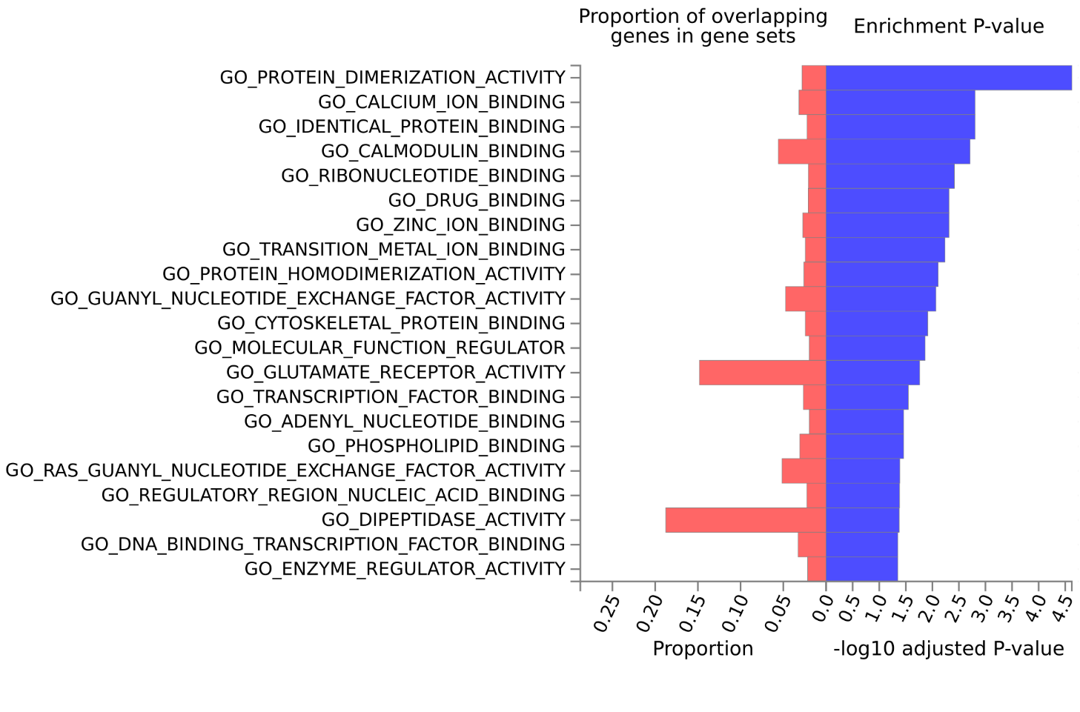 Supplementary Fig. 9. Gene functional mapping analysis identified enriched pathways using FUMA. a. KEGG (MsigDB c2) enrichment results. b. WikiPathways enrichment results. c. GO molecular functions (MsigDB c5) enrichment results.
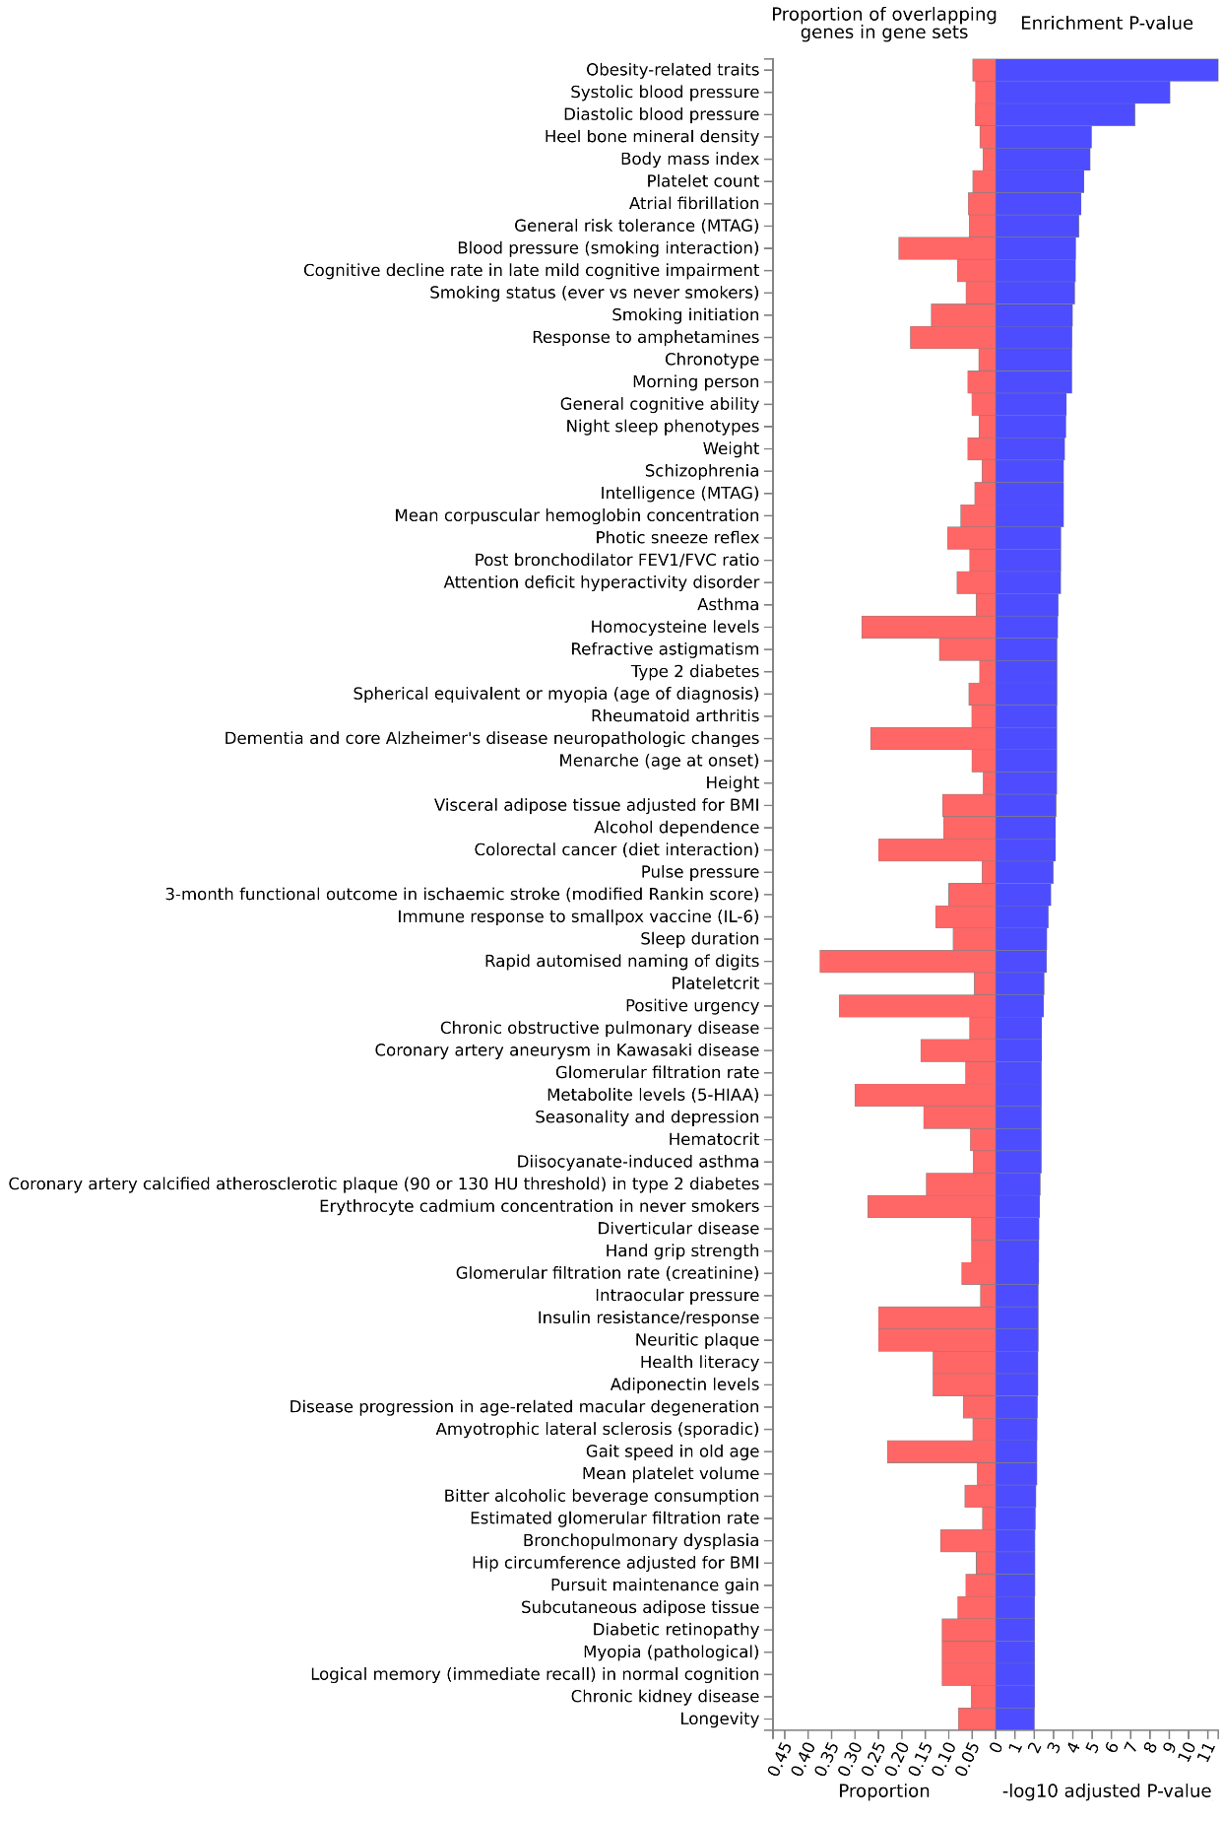
Supplementary Fig. 10. Significantly enriched traits (p_{adjusted} < 0.01) of top signals in the GWAS catalog from nasal M-GWAS analysis. The significant loci with p < 10⁻⁶ identified in nasal M-GWAS analysis were mapped to genes based on physical distance within a 5kb window. Mapped genes were further investigated using the GENE2FUNC procedure in FUMA (http://fuma.ctglab.nl/).

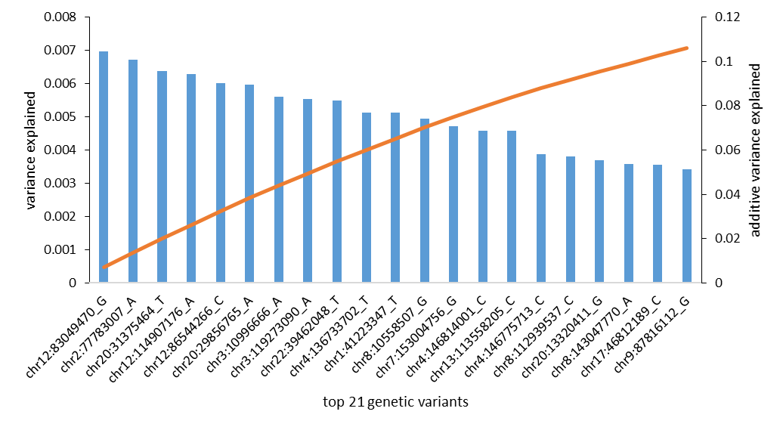
Supplementary Fig. 11. Variance explained by 21 top genetic variants associated with community compositions of nasal microbiome.

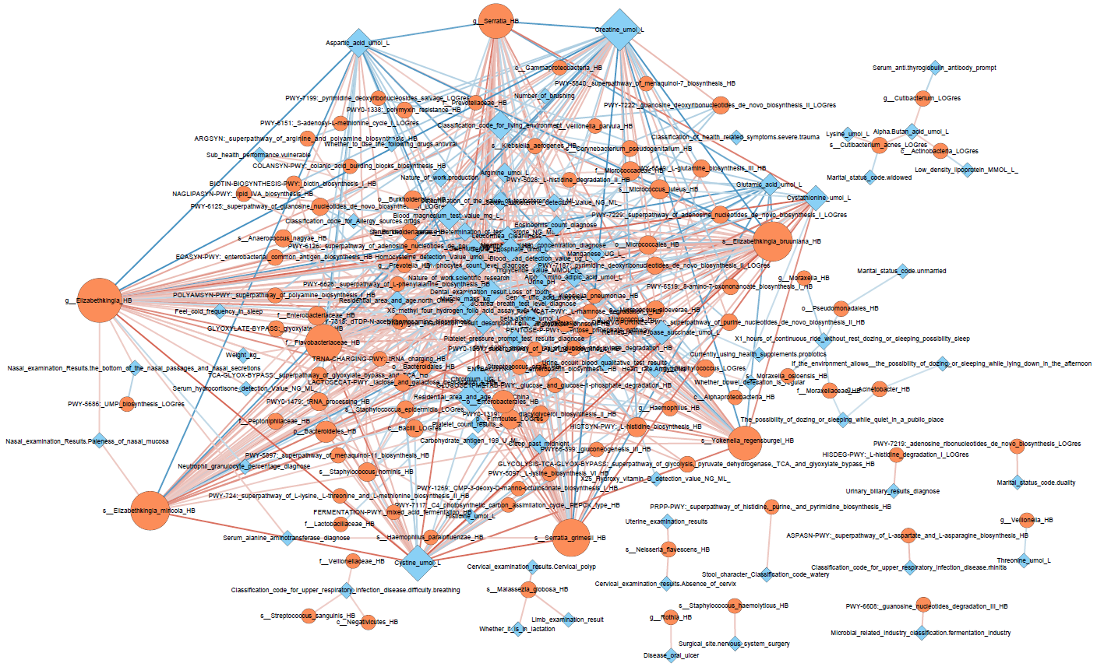

Supplementary Fig. 12. The interaction network represents 520 associations between microbiome features and host traits. The relationship between host traits (anthropometric traits and blood metabolites) and microbiome features were evaluated by linear regression analysis while adjusted for age and sex. Multiple test correction was performed using p.adjust() function in R (v3.2.5)) with the Benjamini–Hochberg procedure. The 520 significant associations with false discovery rate (FDR) adjusted P < 0.05 were showed. Each node represents either a host trait (blue diamonds, N= 81) or a microbiome feature (orange circles, N = 102). Each edge is an association between one host trait and one microbiome feature. Node size is directly proportional to the number of other nodes associated with it. Red edges correspond to positive correlations and blue edges to negative correlations.

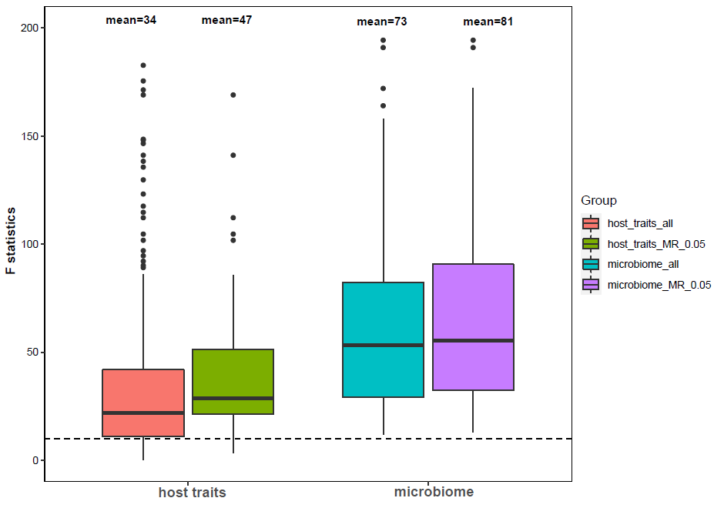
Supplementary Fig. 13. Distribution of the instrumental F statistics for the nasal microbiome and host traits (mainly metabolites) in this study.
For each nasal microbiota, we first selected genetic instruments using p < 1 × 10⁻⁶. Then, we tested the strengths of these instruments and the mean instrumental F statistics were all greater than 10 (the dotted line), indicating a strong instrumental strength.

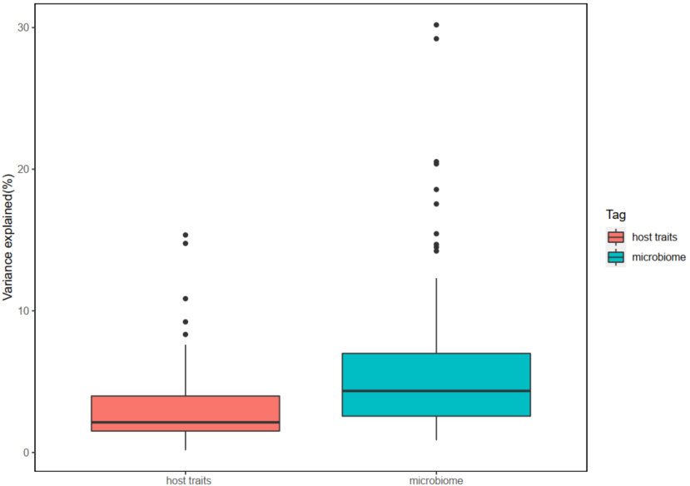
Supplementary Fig. 14. Distribution of variance explained for microbiome features in this study.
We showed the distribution of variance explained of microbiome features and host traits by genetic predictors selected in whole-genome wide association analysis at P-value threshold 1e-6 (boxplot).

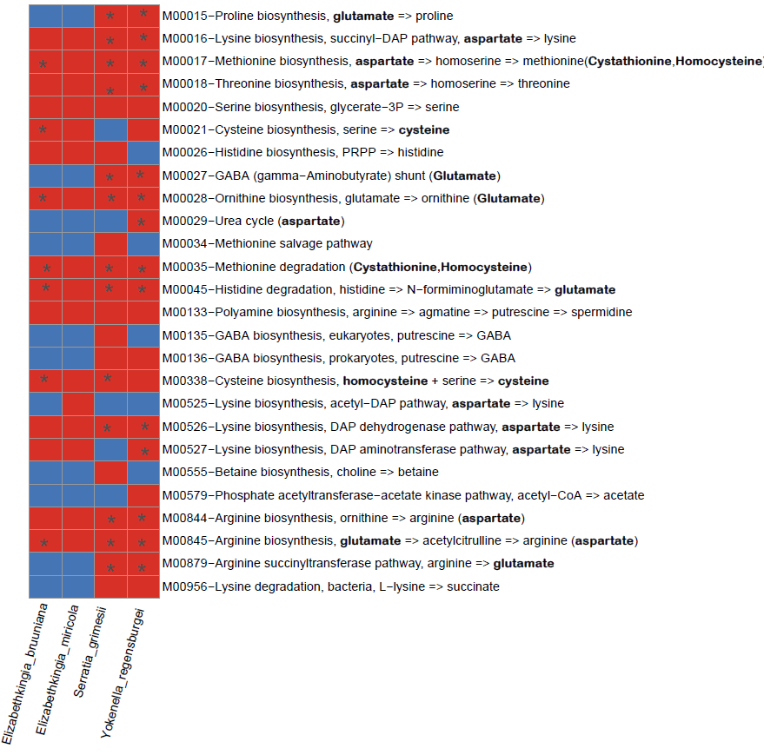
Supplementary Fig. 15. Functional modules of the four nasal bacteria identified by MR associated with serum amino acids. Genome-wide functional annotation was done by the eggNOG mapper (http://eggnog5.embl.de/). The red cell represented the genome of the microbiome contained this module or enzyme. The “*” indicated the nasal microbiome listed were also associated with the module or enzyme involving the corresponding serum amino acids in the MR analysis.

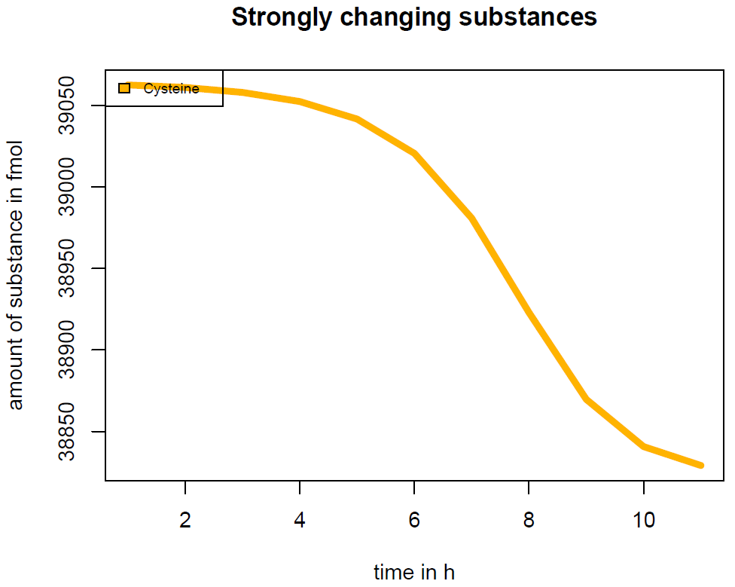
a

b
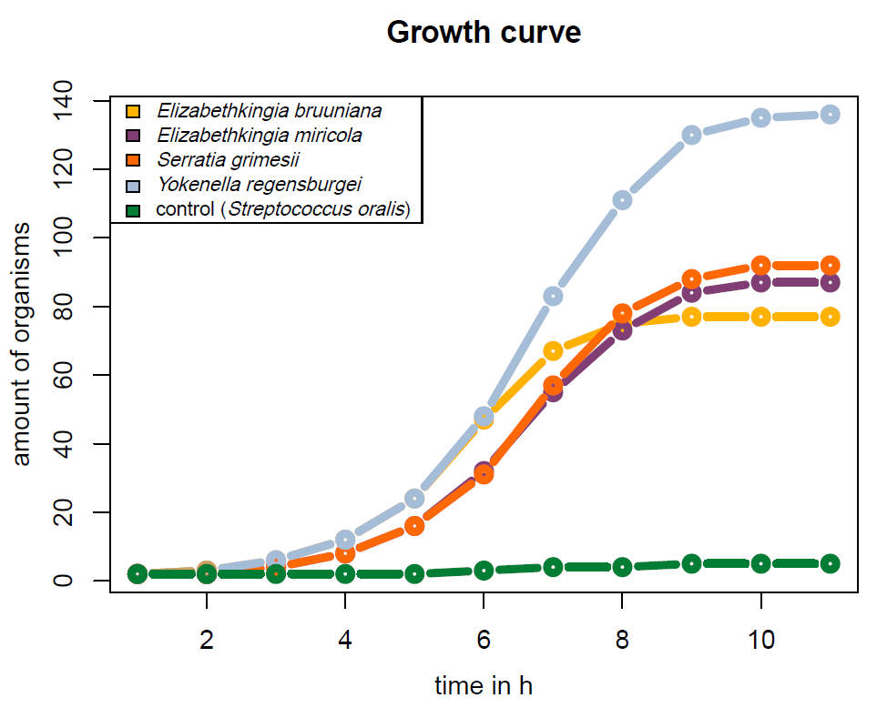
Supplementary Fig. 16. The cysteine consumption and microbial growth were predicted by the gapseq model. a. the cysteine metabolic consumption changed over time(h). b. the growth curve of several bacteria under the cysteine environment as predicted in the model.

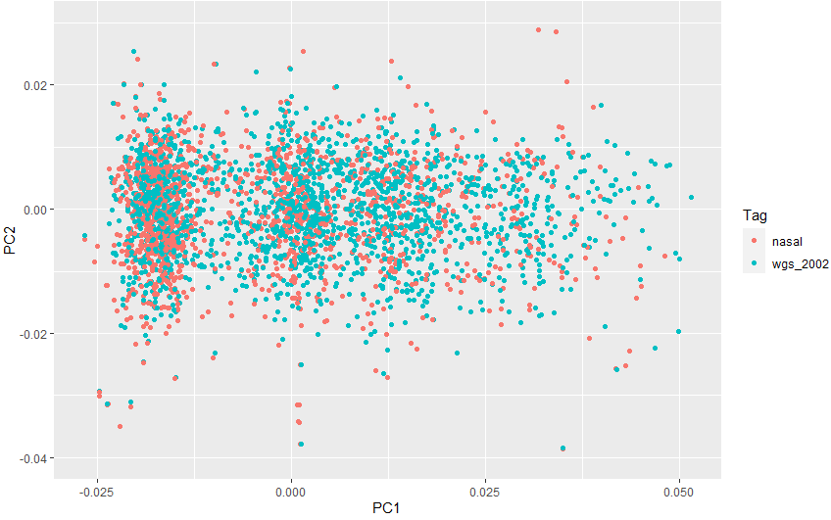

Supplementary Fig. 17. PCA analysis showed no population stratification between 1401 integrated WGS samples in this study and 2002 blood WGS samples as reported previously.

