Clinical Frailty Scale at Presentation to the Emergency Department: Interrater Reliability and Use of Electronic Decision Support
Authors List: Rainer Albrecht¹, Tanguy Espejo¹ (shared first author), Henk B. Riedel¹, Søren K. Nissen PhD^{2,3}, Jay Banerjee MD^{4,5}, Simon P. Conroy MD^{6,7}, Thomas Dreher-Hummel¹, Mikkel Brabrand MD², Roland Bingisser MD¹, and Christian H. Nickel MD¹
Affiliations:
¹ Emergency Department, University Hospital Basel, University of Basel, Basel, Switzerland
² Research Unit for Emergency Medicine, Odense University Hospital, Odense
³ Department of Geriatric Medicine, Odense University Hospital, Odense
⁴ University Hospitals of Leicester NHS Trust, Leicester, UK
⁵ Department of Population Health Sciences, University of Leicester, Leicester, UK
⁶ St Pancras Hospital, Central and North West London NHS Foundation Trust, London, UK
⁷ MRC Unit for Lifelong Health and Ageing, University College London, University College London Hospitals, London, UK
Corresponding Author
Christian H. Nickel, Emergency Department, University Hospital Basel, Petersgraben 2, CH-4031 Basel, Switzerland
Email: christian.nickel@usb.ch; Twitter: @replynickel
Phone: +41 61 265 58 30

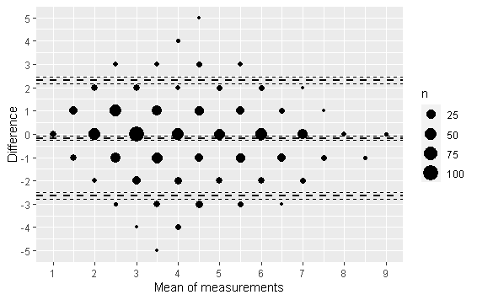
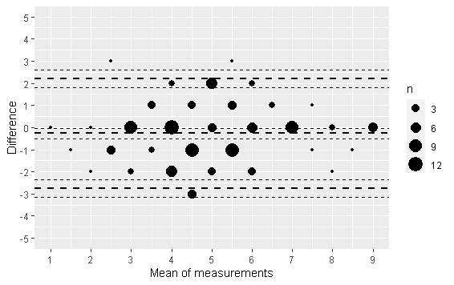
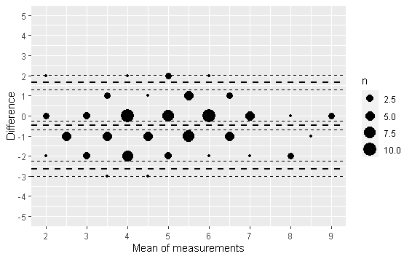
Legend: Bland Altman plot with differences between the CFS ratings on the Y-axis and the average of these CFS ratings on the X-axis. Mean bias and limits of agreements are displayed with their 95% CI

Abbreviations: geriED-TN, geriatric Emergency Department trained nurses; CI, confidence interval

Triage clinicians – geriED-TN
Triage clinicians – study team
Suplemental Fig. 1 Bland Altman plots

GeriED-TN – study team

Suplemental Table 1: Intraclass correlation coefficients (ICC)

 | ICC  between ordinal CFS (1-9) | 95% CI |  | n
 | ICC  between ordinal CFS (1-9) | Lower bound | Upper bound | n
TC – ST | 0.73 | 0.70 | 0.76 | 850
TC – geriED-TN | 0.78 | 0.70 | 0.85 | 105
ST – geriED-TN | 0.75 | 0.66 | 0.82 | 125
TC – ST – geriED-TN | 0.70 | 0.61 | 0.78 | 99
Legend: ICC (two-way mixed-effects model, single rater, absolute agreement) and 95% CI between the triage, the study team and the geriatric care team.
Abbreviations: ICC, intraclass correlation coefficients; CFS, clinical frailty scale; TC, triage clinicians; geriED-TN: geriatric Emergency Department trained nurses.

Supplemental Fig. 2 German version of Clinical Frailty Scale (CFS)
LegenThe Clinical Frailty Scale (CFS) translated in German with original pictograms
Abbreviations: CFS, clinical frailty scale.

