﻿Supplementary Information

PRMT5-mediated methylation of STAT3 is required for lung cancer stem cell maintenance and tumour growth

Takumi Sano, Yoshinori Abe, Naoki Otsuka, Masashi Ogawa, and Nobuyuki Tanaka
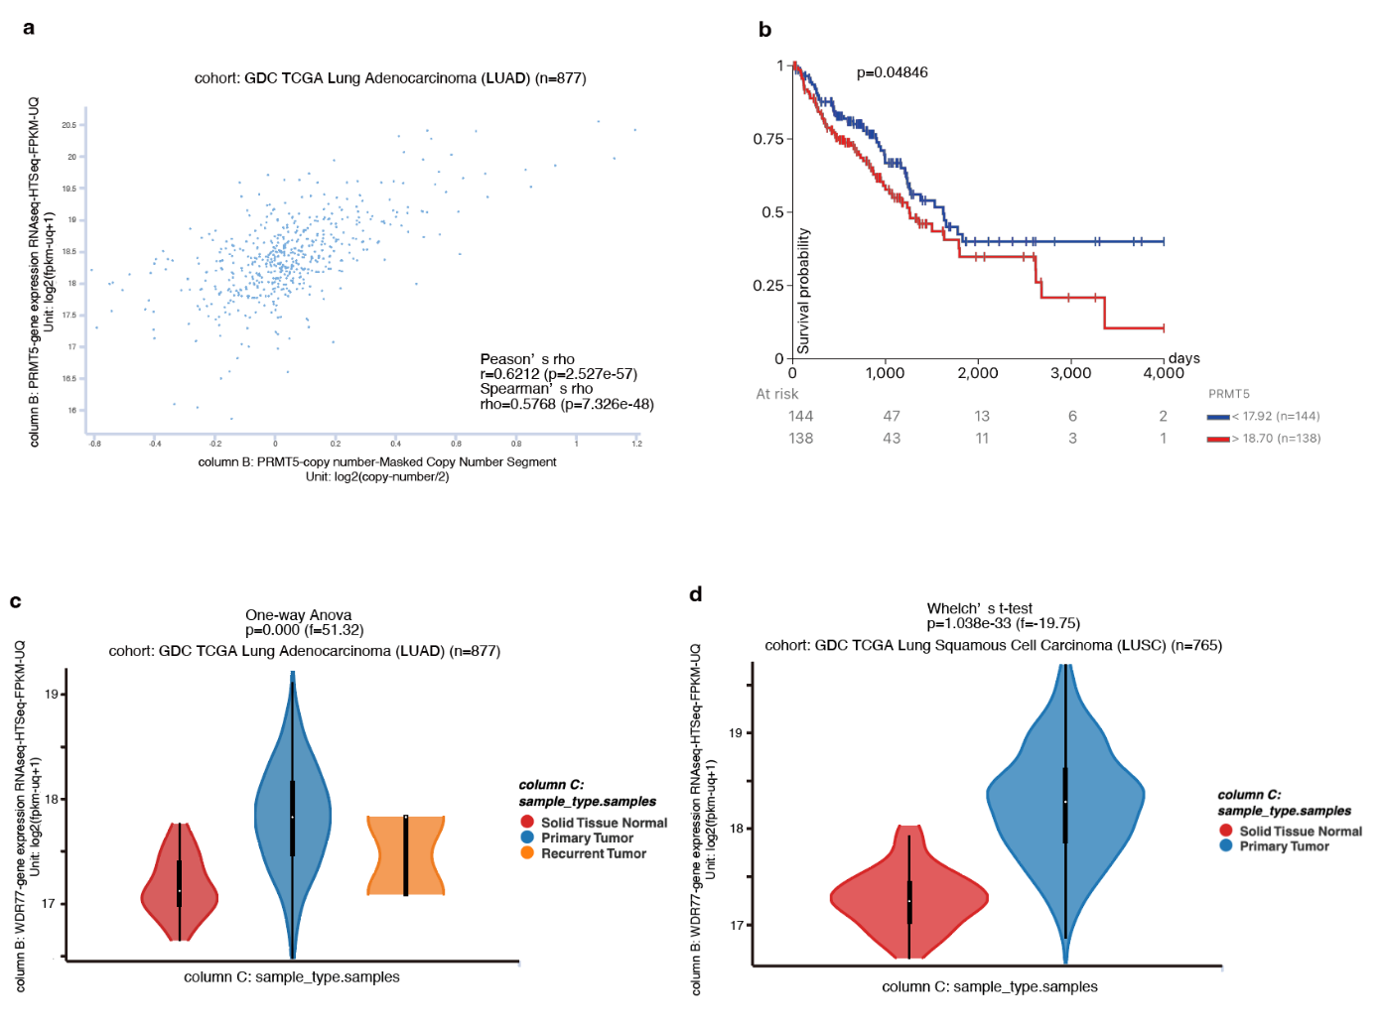
Supplementary Figure 1
a Correlation between PRMT5 copy number and PRMT5 expression levels in lung adenocarcinoma. b Higher PRMT5 expression levels correlate with worse overall survival. All dataset was obtained from The Cancer Genome Atlas (TCGA) and analysed using the UCSC Xena browser (https://xena.ucsc.edu). c, d MEP50 expression is enhanced in c) lung adenocarcinoma and d) lung squamous cell carcinoma. RNA-seq data from TCGA were analysed on the UCSC Xena browser.

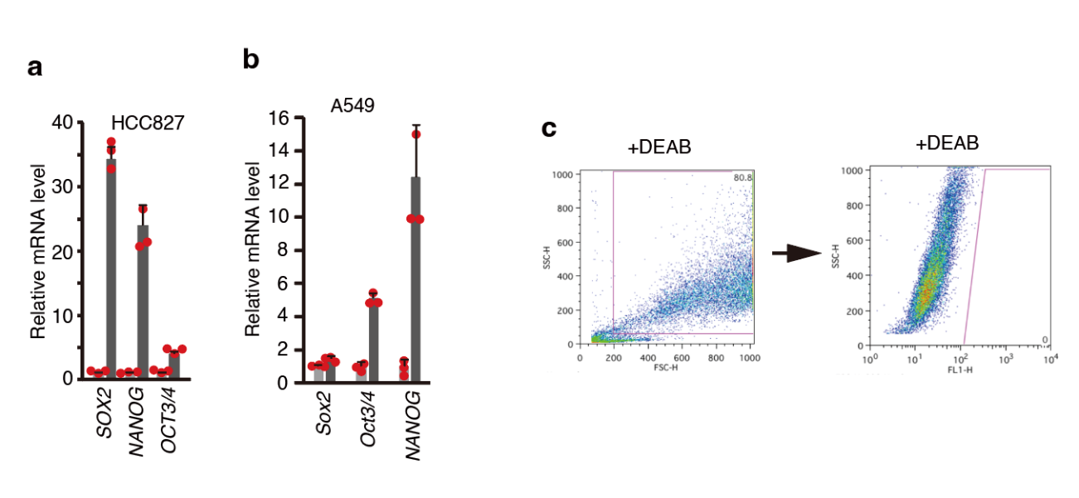
Supplementary Figure 2
a, b qPCR analysis of cancer stem cell marker genes in adherent cells and tumour spheres in a) HCC827 and b) A549 cells. Results are shown as the mean ± standard deviation (SD) from three experiments. c Gating strategy for flow cytometry using parental HCC827 cells. Debris and non-viable cells were ﻿excluded in Side Scatter (SSC) versus Forward Scatter (FSC) plot (left). The gating of cells having high aldehyde dehydrogenase (ALDH) activity was based on the SSC versus FL1 (FITC) plot of 4-diethylaminobenzaldehyde (DEAB)-treated cells (right). Source data are provided as Supplementary Data 3.

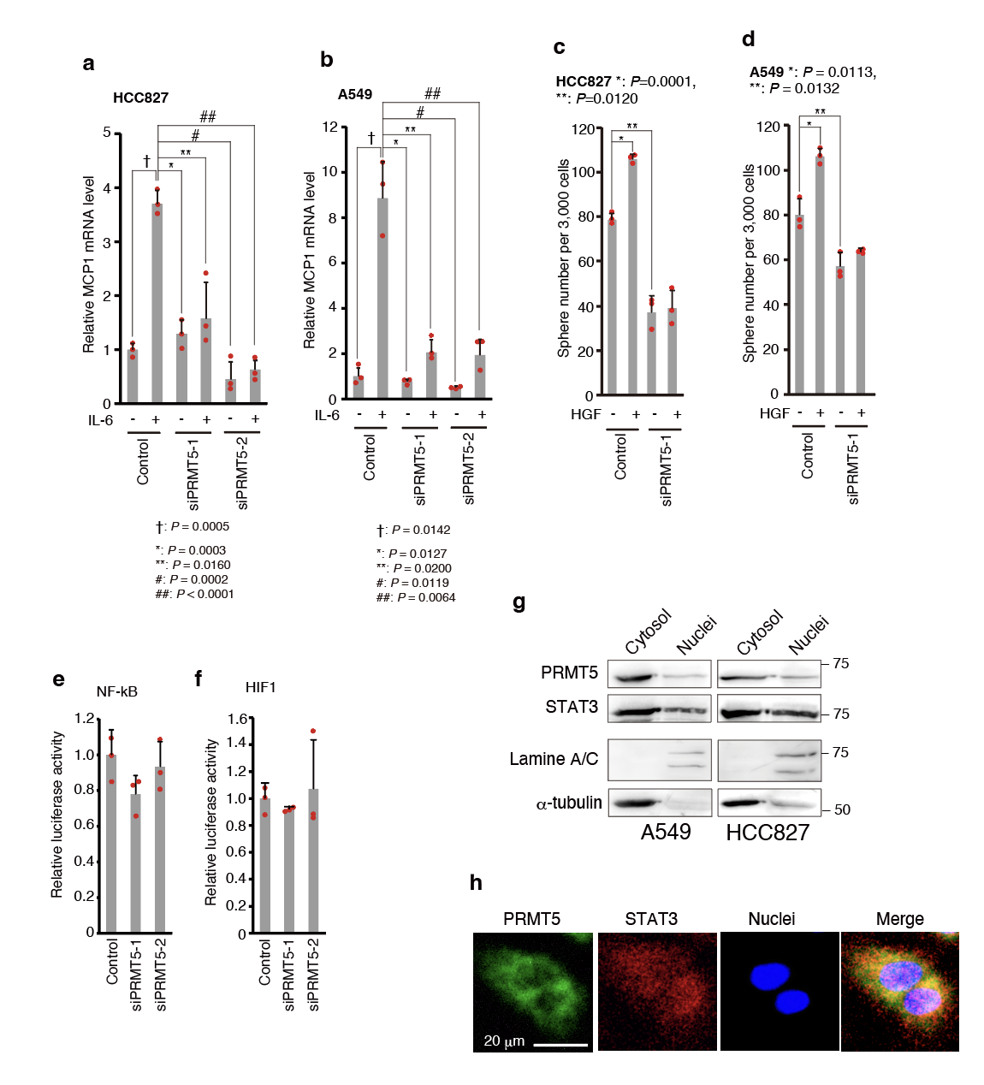
Supplementary Figure 3
a, b Knockdown of PRMT5 suppresses IL-6-STAT3 axis-mediated MCP1 expression in a) HCC827 and b) A549 cells. MCP1 expression levels were assessed by qPCR. c, d Sphere numbers with hepatocyte growth factor (HGF) treatment in siControl and siPRMT5-expressing c) HCC827 and d) A549 cells. Cells were treated with recombinant HGF for seven days, then sphere numbers were counted. The results are shown as the mean ± standard deviation (SD) from three experiments. e, f Knockdown of PRMT5 does not affect e) NF-κB or f) HIF1 transcriptional activity. NF-κB or HIF1 transcriptional activity was assessed by luciferase assays using an NF-κB or HIF1 reporter plasmid in A549 cells. Results are shown as the mean ± SD from three experiments. g PRMT5 is abundant in the cytoplasm. ﻿Cells were lysed and separated into cytosol and nucleus fractions. ﻿Nuclear or cytosolic PRMT5 and STAT3 were detected by immunoblots using antibodies against PRMT5 and STAT3. Lamin A/C is a nucleic marker and α-tubulin is a cytoplasmic marker. h Immunofluorescent images of PRMT5 and STAT3 localization in A549 cells. Nuclei were stained using Hoechst33342. Representative results in a–f were from two independent results. Bar, 20 μm. Source data are provided in Supplementary Data 3; Full immunoblot images are shown in Supplementary Data 4.

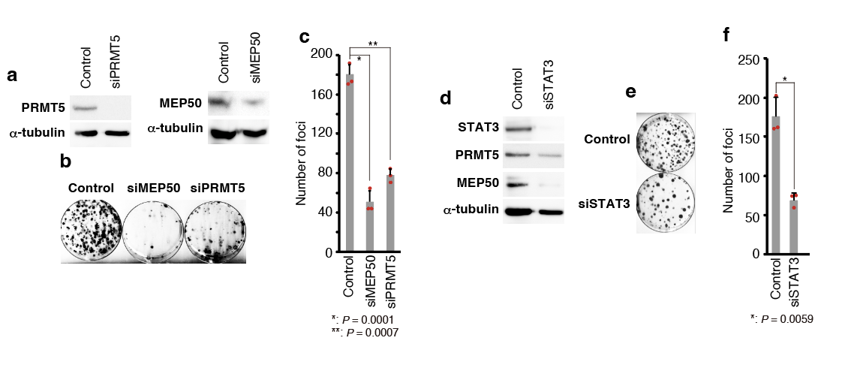
Supplementary Figure 4
a–f A quantitative focus formation assay was performed by plating v-src- and short hairpin RNA (shRNA) (siPRMT5 (a–c), siMEP50 (a–c), or siSTAT3 (d–f))-expressing p53 null mouse embryonic fibroblasts (MEFs) at a density of 1×10³ cells per 10 cm dish. After 14 days of culture, cells were fixed with methanol and stained with crystal violet. a, d Western blot analysis of endogenous protein levels (A: siPRMT5 and siMEP50, D: siSTAT3). siRNAs for PRMT5, MEP50, or STAT3 were stably expressed by recombinant retrovirus. b, e Representative plate image (B: siPRMT5 and siMEP50, E: siSTAT3). c, f Quantification of foci (c: siPRMT5 and siMEP50, f: siSTAT3). Representative results in c were from two independent experiments. Source data are provided in Supplementary Data 3; Full immunoblot images are shown in Supplementary Data 4.

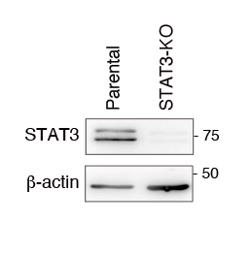
Supplementary Figure 5
STAT3 expression in STAT3 knockout BEAS2B cells. STAT3 knockout was performed using the CRISPR-Cas9 system. STAT3 protein levels were detected by western blot analysis. Full immunoblot images are shown in Supplementary Data 4.

Supplementary Table 1: Antibodies used in this study.
Antibody (clone) | Manufacturer (Catalog number) | Usage: Dilution
PRMT5 (EPR5772) | Abcam (ab109451) | IB: 1:2000  IP: 1 μl
PRMT5 (A-11) | SantaCruz (sc-376937) | IF: 1:1000
MEP50 (EPR10708(B)) | Abcam (ab154190) | IB: 1:1000
MEP50 (3F10) | Abnova (H00079084-M01) | IB: 1:1000
STAT3 (D3Z2G) | Cell Signaling Technology (12640) | IB: 1:1000  IF: 1:500
STAT3 (124H6) | Cell Signaling Technology (9139) | Ch: 1:300
Phospho-STAT3-Tyr705 (D3A7) | Cell Signaling Technology (9138) | IB: 1:1000
Symmetric di-methyl arginine (SYM11) | Merck Millipore (07-413) | IB: 1:700
LAMIN A/C (346) | SantaCruz (sc-7293) | IB: 1:1000
HA-tag (16B12) | Abcam (ab130275) | IB: 1:1000
Myc-tag (9E10) | Abcam (ab32) | IB: 1:1000
α-tubulin (DM1A) | Sigma-Aldrich (T6199) | IB: 1:2000
β-actin (AC-74) | Sigma-Aldrich (A2228) | IB: 1:2000
Mouse-IgG1 Isotype Control | Cell Signaling Technology (5415) | Ch: 1:300
Anti-Rabbit IgG, HRP-Linked  F (ab’) ₂ Fragment Donkey (secondary Ab) | Cytiva (NA9340) | IB: 1:5000
Anti-Mouse IgG, HRP-Linked  F (ab’) ₂ Fragment Sheep (secondary Ab) | Cytiva (NA9310) | IB: 1:5000
Alexa-488-conjugated  anti-Mouse IgG (secondary Ab) | ThermoFisher Scientific (A11017) | IF: 1:500
Alexa-568-conjugated  anti-Rabbit IgG (secondary Ab) | ThermoFisher Scientific (A11011) | IF: 1:500
IB: Immunoblot, IP: Immunoprecipitation, Ch: Chromatin Immunoprecipitation (ChIP) assay, IF: Immunofluorescence

Supplementary Table 2: Short hairpin RNA (shRNA) sequences used for RNA interference (RNAi) experiments.
siRNA | Sequence
Human siPRMT5-1 | GGAATCTCAGACATATGAAGTTTCAA  GAGAACTTCATATGTCTGAGATTCC
Human siPRMT5-2 | GCTATTGCACCTTGGAATTTCTTCAA  GAGAGAAATTCCAAGGTGCAATAGC
Mouse siPRMT5-1 | ﻿GACTCTAGTATCAAGGAATTCAA  GAGATTCCTTGATACTAGAGTCC
Human siMEP50-1 | GGACTCTGTGTTTCTTTCATTCAA  GAGATGAAAGAAACACAGAGTCC
Mouse siMEP50-1 | GCATGCATGGAACGTCAATTTCA  AGAGAATTGACGTTCCATGCATGC
Human siSTAT3-1 | GCCCGTCAACAAATTAAGAACTC  GAGTTCTTAATTTGTTGACGGG
Human siSTAT3-2 | GCCTCTCTGCAGAATTCAACTCGA  GTTGAATTCTGCAGAGAGGC
Human siSTAT3-3 | GGTACAACATGCTGACCAATTCAA  GAGATTGGTCAGCATGTTGTACC
Human siSTAT3-4 | GCTGAACAACATGTCATTTCTCGA  GAAATGACATGTTGTTCAGC
Mouse siSTAT3 | GCACAACCTTCGAAGAATCTTCAAGA  GAGATTCTTCGAAGGTTGTGCTTTTTA
Control siRNA | ﻿ATCTCGCTTGGGCGAGAGTAAGTTCAA  GAGACTTACTCTCGCCCAAGCGAGAT
Underlined sequences indicate the hairpin loop sequence.

Supplementary Table 3: Guide RNAs for CRISPR-Cas9-mediated gene knockout.
Gene | Sequence | Exon / Intron | Strand
STAT3 (#1) | TCCAGTTCACTACTAAAGTC | Exon | -
STAT3 (#2) | TCAAACACTTGGTATGTGGG | Intron | -
STAT3 (#1) was used for STAT3 knockout in BEAS2B cells and STAT3 (#2) was used for STAT3 knockout in HCC827 cells.

Supplementary Table 4: PCR primer list for generation of mutant STAT3.
STAT3 mutant | Primer
STAT3-R379K | Sense – CGTTGCAGCTCTCAAAGGATCCCGGAAAT  Antisense – ATTTCCGGGATCCTTTGAGAGCTGCAACG
STAT3-R423K | Sense – TGGGAATGGGGGCAAAGCCAATTGTGATG  Antisense – CATCACAATTGGCTTTGCCCCCATTCCCA
STAT3-R518K | Sense – CTCCACCACCAAGAAAGGACTGAGCATCG  Antisense – CGATGCTCAGTCCTTTCTTGGTGGTGGAG
STAT3-R609K | Sense – CACCTTCCTGCTAAAATTCAGTGAAAGCA  Antisense – TGCTTTCACTGAATTTTAGCAGGAAGGTG

Supplementary Table 5: TaqMan probes used in this study.
Gene Symbol | Assay ID
PRMT5 | Hs01047345_g1
MCP-1 | Hs00234140_m1
β-actin | Hs01060665_g1

Supplementary Table 6: PCR primer list for Chromatin Immunoprecipitation.
Region | Primer sequence
-1231 – -1224 | Forward: GCCTGCTACCACGTTTAGGA  Reverse: GAATGAAAGCCGGAAAAGCG
-1139 – -1130 | Forward: GGCTTTCATTCTTTTGGGGC  Reverse: GTTGGATGGAGGTCGCTAGA
-959 – -951 | Forward: TCTAGCGACCTCCATCCAAC  Reverse: CCTGAGAAAGCAAAGTAGGGG
-627 – -620 | Forward: CCTCCCTATGTCTTTCCTTGC  Reverse: AAACGCCTAAACACACACAC
-540 – -532  -500 – -492 | Forward: TGTGTGTGTGTTTAGGCGTTT  Reverse: AACTGGGTTAATGGCTGGTG
-375 – -366 | Forward: AGGGTAGTTACGGGAAAAGCT  Reverse: CCTTTCCTTTCGCAGCTTGA
-267 – -260 | Forward: TGCATAACCCAACCGACTCA  Reverse: GGGGTTCCTCGCAGCTTC

