SUPPORTING INFORMATION

Title: Synthesis of 6,6-Dimethyl-3-azabicyclo [3.1.0]hexane via Ru (II)-Catalyzed Intramolecular Cyclopropanation.
Author(s): Yu Li, Yujie Ma, Shihao Cheng, Chenhun Dong, Xueer Zhong, Jun Xu, Yu Zhao

TABLE OF CONTENTS
General Experimental 1
Experimental Section 2
NMR spectra and X-ray data 7

General Experimental
All solvents were reagent grade and, when necessary, were purified and dried by standard methods. The column chromatography was performed on silica gel (200–300 mesh). ¹H NMR and ¹³C NMR spectra were recorded with a Bruker Avance 400 and 100 MHz spectrometer, respectively, at 300 K, using tetramethylsilane as an internal standard. MS spectra were recorded on a Thermo Fisher Scientific LTQ FTICR-MS.
Experimental Section
- Synthesis of 3-methylbut-2-en-1-yl 2-bromoacetate （3）
860mg of 3-methyl-2-butenol (10mmmol) and 2520mg of NaHCO₃ (30mmol) were dissolved in 30ml of acetonitrile. Then, 3015mg (15mmol) of bromoacetyl bromide was added dropwise to the solution under ice bath conditions. After 30 minutes, the solution was quenched with water, and extracted three times by DCM. Combined with the organic phase, dried with anhydrous sodium sulfate, and concentrated under reduced pressure to obtain 2000 mg of colorless and transparent oily product 3 with a yield of 97%.
¹H NMR (400 MHz, ) δ 7.71 (dd, J = 5.5, 3.1 Hz, 2H), 5.35 – 5.19 (m, 1H), 4.38 – 4.13 (m, 2H), 1.84 (s, 3H), 1.72 (s, 3H).¹³C NMR (100 MHz, CDCl₃) δ 167.3, 140.5, 117.6, 63.2, 26.2, 25.8, 18.1.HRMS (ESI): m/z calcd for C₇H₁₂O₂Br: 207.0021; found: 207.0016 [M+ H]⁺.

- Synthesis of 3-methylbut-2-en-1-yl 2-diazoacetate （4）
205mg of 3-methylbutan-2-en-1-yl-2-bromoacetate (1mmol) and 340mg of N, N '- dimethylbenzenesulfonyl hydrazine (1mmol) were dissolved in 2ml of tetrahydrofuran. Place the solution in ice water, add 305mg of DBU (2mmol) dropwise to the solution, and reacted for 2 hours. After the reaction was completed, the solution turns yellow and appears cloudy. After standing, the solution turns yellow and transparent and directly concentrated under reduced pressure, and purified by flash column chromatography gradient elution (PE: EA=30:1) to obtained 115mg of yellow oily product 4 with a yield of 75%.
¹H NMR (400 MHz, Chloroform-d) δ 5.28 (t, J = 7.2 Hz, 1H), 4.68 (s, 1H), 4.59 (d, J = 7.2 Hz, 2H), 1.70 (s, 3H), 1.65 (s, 3H). ¹³C NMR (100 MHz, CDCl₃) δ 166.9, 139.3, 118.5, 61.7, 46.2, 25.8, 18.0.HRMS (ESI): m/z calcd for C₇H₁₀N₂O₂K: 193.0379; found: 193.0380 [M+ K]⁺.

- Synthesis of (1R,5S)-6,6-dimethyl-3-oxabicyclo[3.1.0]hexan-2-one （5）
6mg of Ru (II)-(S)-PHEOX (0.01mmol) was dissolved in DCM in an ice bath. Dissolve 155mg (1mmol) of 4 in 5ml of DCM and add it dropwise to the Ru (II)-(S)-PHEOX solution. The reaction is rapid, generating nitrogen bubbles. After 1 minute, the reaction ends. Filter the catalytic agent and concentrated under reduced pressure to obtain 106mg of colorless and transparent oily product 5 with a yield of 86%.
¹H NMR (400 MHz, Chloroform-d) δ 4.37 (dd, J = 9.9, 5.5 Hz, 1H), 4.16 (dt, J = 9.9, 1.1 Hz, 1H), 2.05 (td, J = 6.0, 5.5, 1.1 Hz, 1H), 1.96 (dd, J = 6.3, 1.1 Hz, 1H), 1.18 (d, J = 3.4 Hz, 6H). ¹³C NMR (100 MHz, DMSO) δ 170.3, 61.9, 25.8, 25.3, 20.5, 18.4, 9.7. HRMS (ESI): m/z calcd for C₇H₁₀O₂Na: 149.0578; found: 149.0577 [M+ Na]⁺.

- Synthesis of (1R,3S)-3-((1,3-dioxoisoindolin-2-yl)methyl)-2,2-dimethylcyclopropane-1-carboxylic acid （6）
Put 126 mg of 5 (1mmol) in a schlenk tube, and add 222 mg of potassium phthalate imide (1.2mmol), dissolved in 2ml of DMF and reacted under 150 ℃ overnight. After the reaction, reduce to room temperature. Add 20 ml of dichloromethane to the reaction, wash three times with water and once with brine water, dry it with anhydrous sodium sulfate, concentrated under reduced pressure and get 248 mg of white powder product 6 with a yield of 90%.
¹H NMR (400 MHz, Chloroform-d) δ 7.88 (dd, J = 5.5, 3.1 Hz, 2H), 7.74 (dd, J = 5.5, 3.1 Hz, 2H), 4.19 (dd, J = 14.7, 7.9 Hz, 1H), 4.02 (dd, J = 14.6, 4.8 Hz, 1H), 1.66 (d, J = 8.7 Hz, 1H), 1.59 (td, J = 8.2, 4.9 Hz, 1H), 1.42 (s, 3H), 1.20 (s, 3H). ¹³C NMR (100 MHz, CDCl₃) δ 177.6, 173.0, 139.6, 136.9, 128.2, 38.6, 34.8, 33.4, 33.2, 29.7, 19.5. HRMS (ESI): m/z calcd for C₁₅H₁₅NO₄Na: 296.0899; found: 296.0900 [M+ Na]⁺.

- Synthesis of ((1S,3R)-3-carboxy-2,2-dimethylcyclopropyl)methanaminium hydrochloride （7）
273 mg of compound 6 (1mmol) were placed in a Schlenk tube, and 5ml of 6N hydrochloric acid solution was added and reflux reaction overnight. After the reaction was completed, cooled to room temperature. 10 ml of distilled water was added. The aqueous phase was washed three times with ethyl acetate and concentrated under reduced pressure obtain 155mg of a light yellow solid product with a yield of 90%.
¹H NMR (400 MHz, DMSO-d₆) δ 12.29 (s, 1H), 8.19 (s, 3H), 3.11 (tp, J = 13.6, 6.8 Hz, 2H), 1.57 (d, J = 8.3 Hz, 1H), 1.33 (q, J = 7.4 Hz, 1H), 1.16 (s, 6H). ¹³C NMR (100 MHz, CDCl₃) δ 177.6, 39.7, 33.3, 33.2, 33.0, 29.7, 19.0. HRMS (ESI): m/z calcd for C₇H₁₅NO₂Cl: 180.0791; found: 180.0794 [M+ H]⁺.

- Synthesis of (1R,5S)-6,6-dimethyl-3-azabicyclo[3.1.0]hexan-2-one （8）
Dissolved 30 mg (0.17 mmol) of 7 in a round bottom flask with 5ml anhydrous methanol, cool to -10 ℃. Then add 40 mg SOCl₂ (0.34 mmol) dropwise, and react overnight. After the reaction was completed, concentrated under reduced pressure, add 10 ml of dichloromethane, neutralize with 2M NaOH solution, and stir overnight at room temperature. After the reaction is completed, separate the organic phase, dry with anhydrous sodium sulfate, concentrated under reduced pressure and purified by flash column chromatography gradient elution (PE: EA=3:1) to obtain 15 mg of a shallow yellow crystal product 8 with a yield of 70%.
¹H NMR (400 MHz, DMSO-d₆) δ 7.18 (s, 1H), 3.32 (dd, J = 11.0, 6.5 Hz, 1H), 3.00 (dq, J = 11.0, 1.3 Hz, 1H), 1.72 – 1.66 (m, 1H), 1.52 (dt, J = 6.5, 1.5 Hz, 1H), 1.05 (s, 3H), 1.00 (s, 3H). ¹³C NMR (100 MHz, DMSO) δ 174.9, 32.4, 26.9, 25.9, 20.3, 14.1. HRMS (ESI): m/z calcd for C₇H₁₁NONa: 148.0738; found: 148.0741 [M+ Na]⁺.

- Synthesis of 6,6-dimethyl-3-azabicyclo[3.1.0]hexane （9）
Add 15 mg of 8 (0.12mmol) to a sclenk tube, add 2ml of anhydrous tetrahydrofuran, and 24 mg (0.6mmol) of lithium aluminum hydride in an ice bath. Reflux the reaction overnight. After the reaction is completed, 10ml of water was added to the solution under ice bath to quench the reaction, and then drop 10ml of 10% NaOH solution slowly to filter out the resulting solid. The solid was washed several times with Et₂O, and then concentrated under reduced pressure to obtain 6mg of the oily product 9 with the yield of 80%.
¹H NMR (400 MHz, DMSO-d₆) δ 3.36 (ddd, J = 11.1, 3.7, 1.7 Hz, 1H), 3.19 (d, J = 11.1 Hz, 1H), 2.94 (ddd, J = 10.8, 3.2, 1.6 Hz, 1H), 2.76 (d, J = 10.7 Hz, 1H), 1.32 (dd, J = 3.5, 1.6 Hz, 1H), 1.22 (dd, J = 3.2, 1.5 Hz, 1H), 1.01 – 0.81 (m, 6H). ¹³C NMR (100 MHz, DMSO) δ 42.2, 25.9, 22.3, 14.3, 8.5. HRMS (ESI): m/z calcd for C₇H₁₄N: 112.1126; found: 112.1125 [M+ H]⁺

NMR spectrum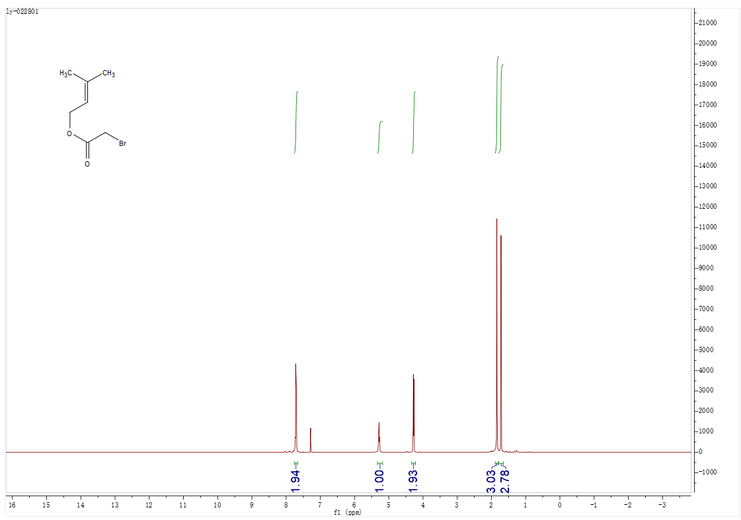
¹H NMR spectrum of 3 (400 MHz, CDCl₃)

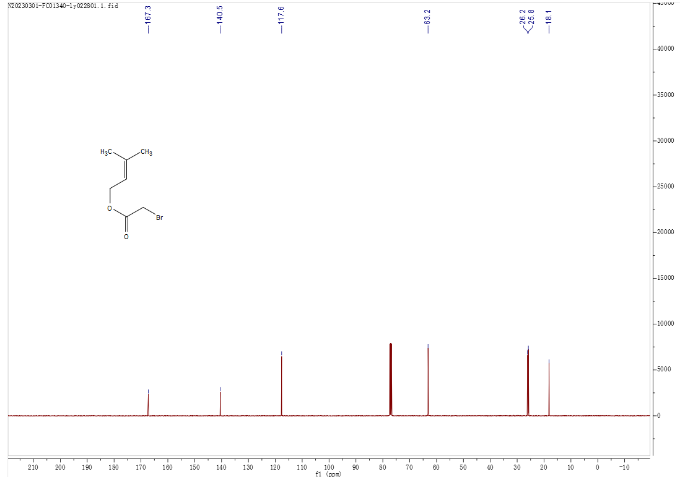¹³C NMR spectrum of 3 (100 MHz, CDCl₃)
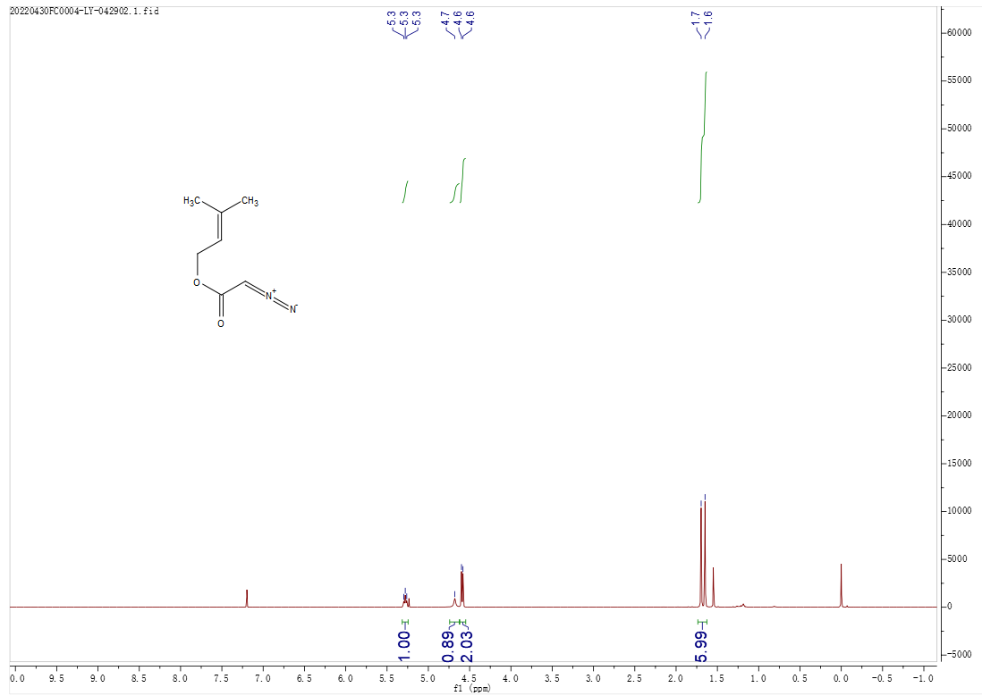
¹H NMR spectrum of 4 (400 MHz, CDCl₃)

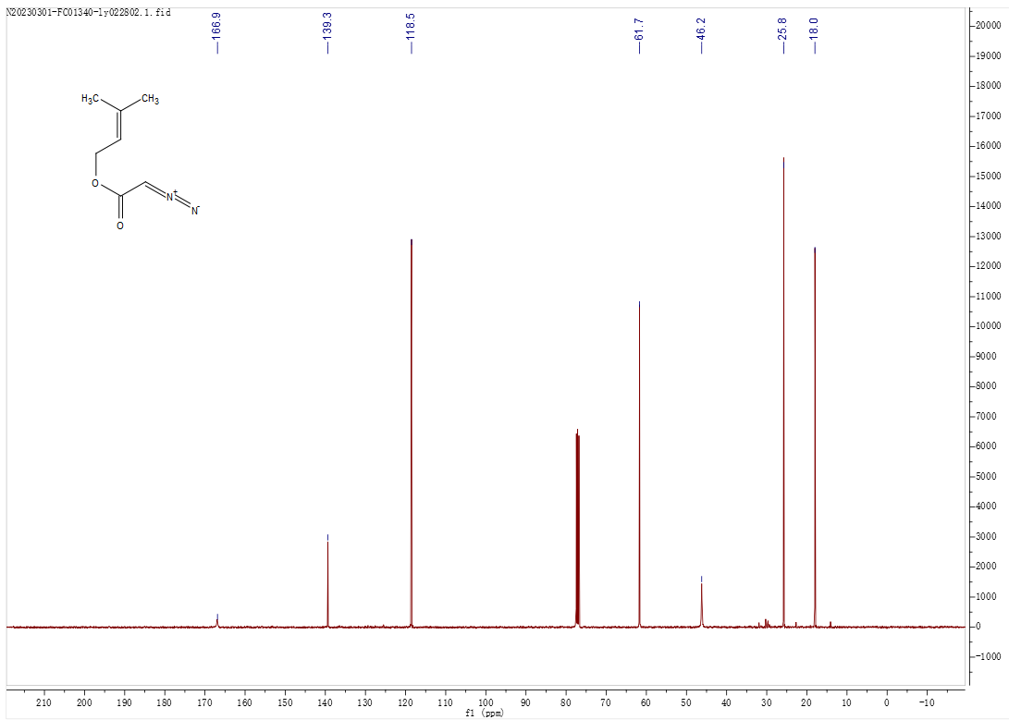
¹³C NMR spectrum of 4 (100 MHz, CDCl₃)
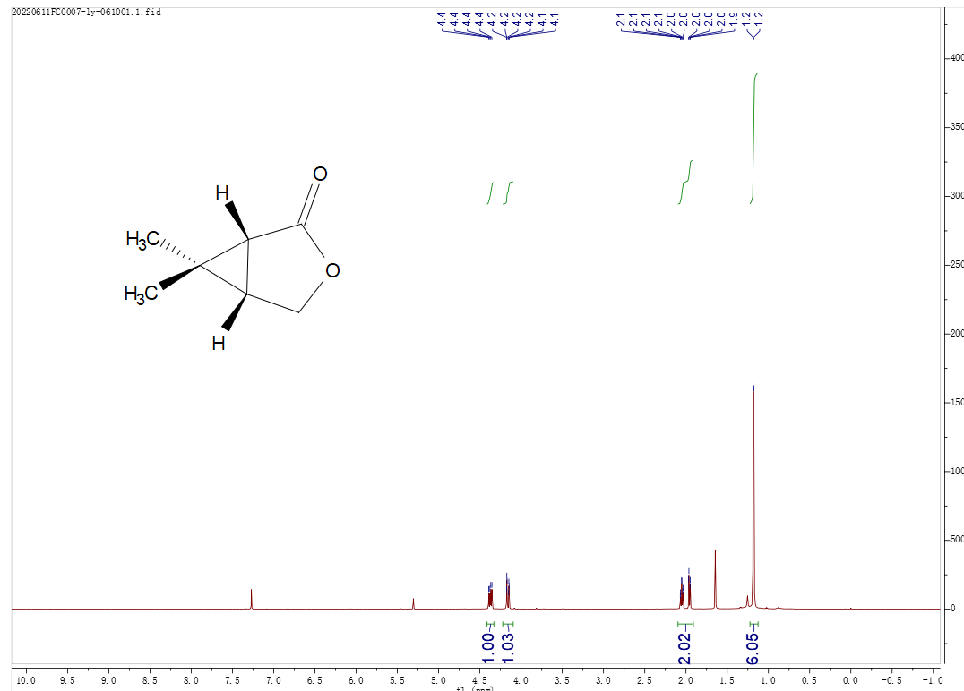
¹H NMR spectrum of 5 (400 MHz, CDCl₃)

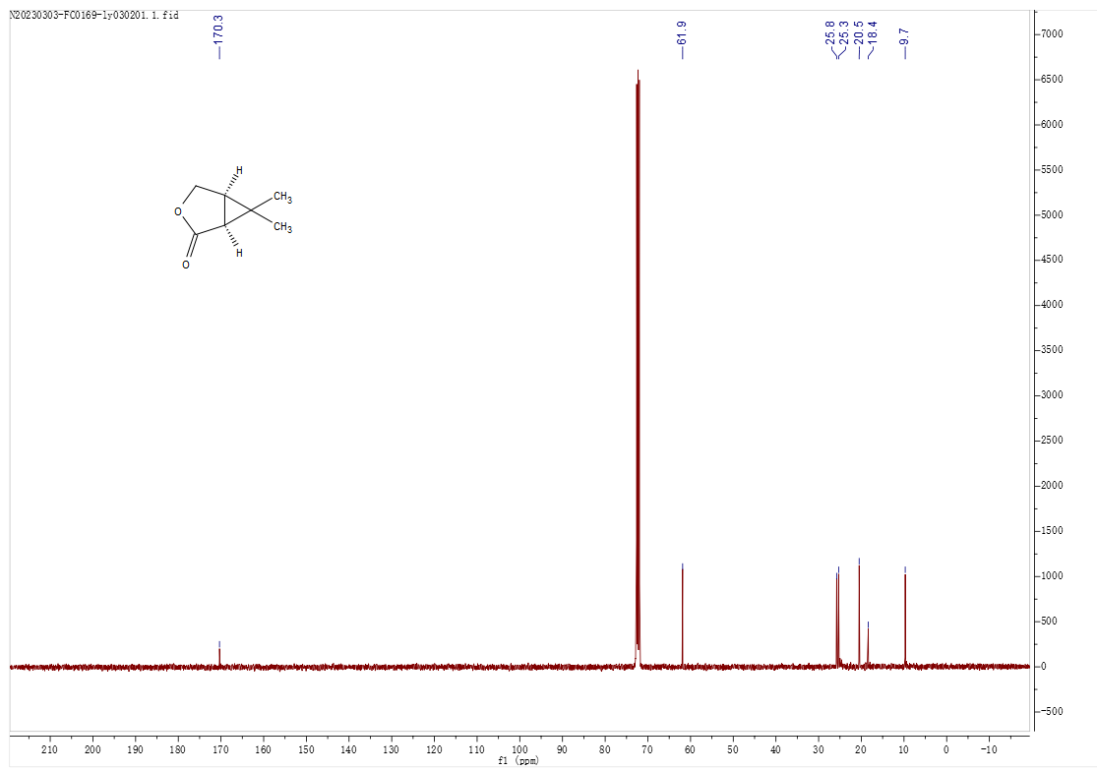
¹³C NMR spectrum of 5 (100 MHz, CDCl₃)
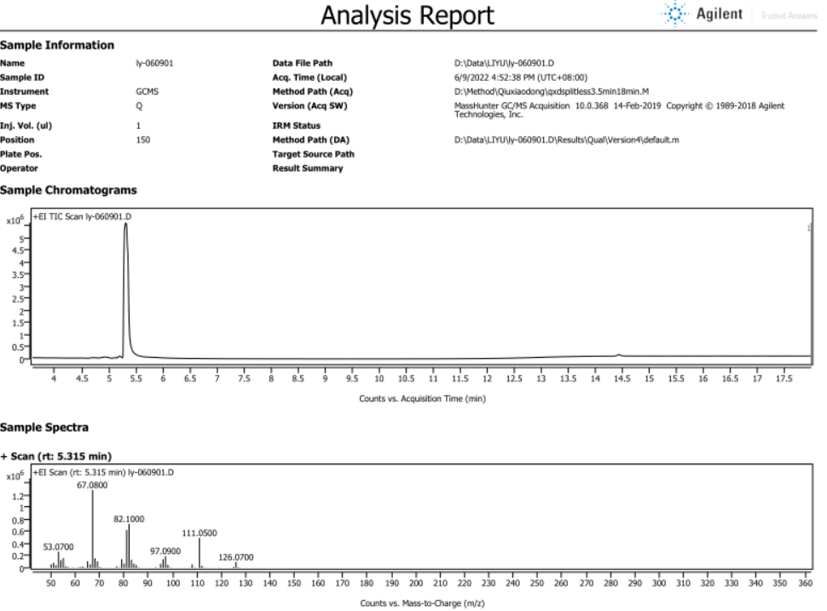
GC/MS Analysis Report of 5

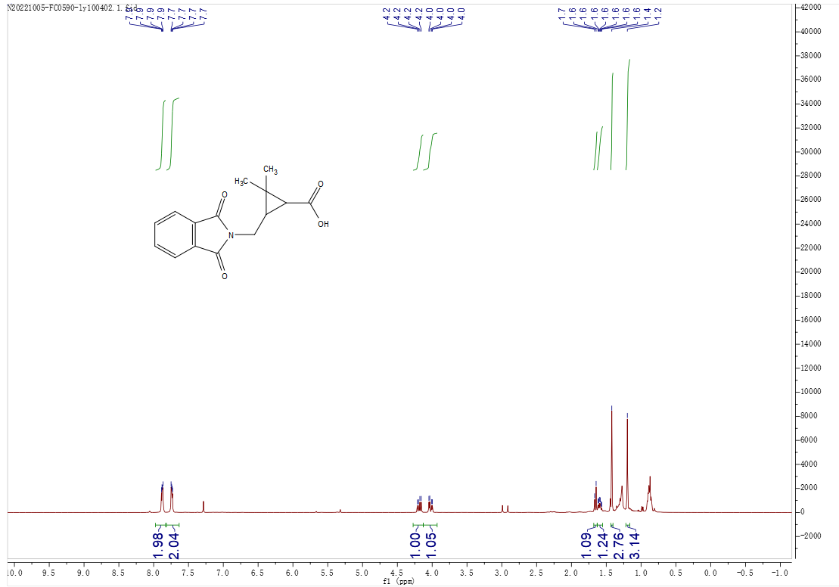
¹H NMR spectrum of 6 (400 MHz, CDCl₃)
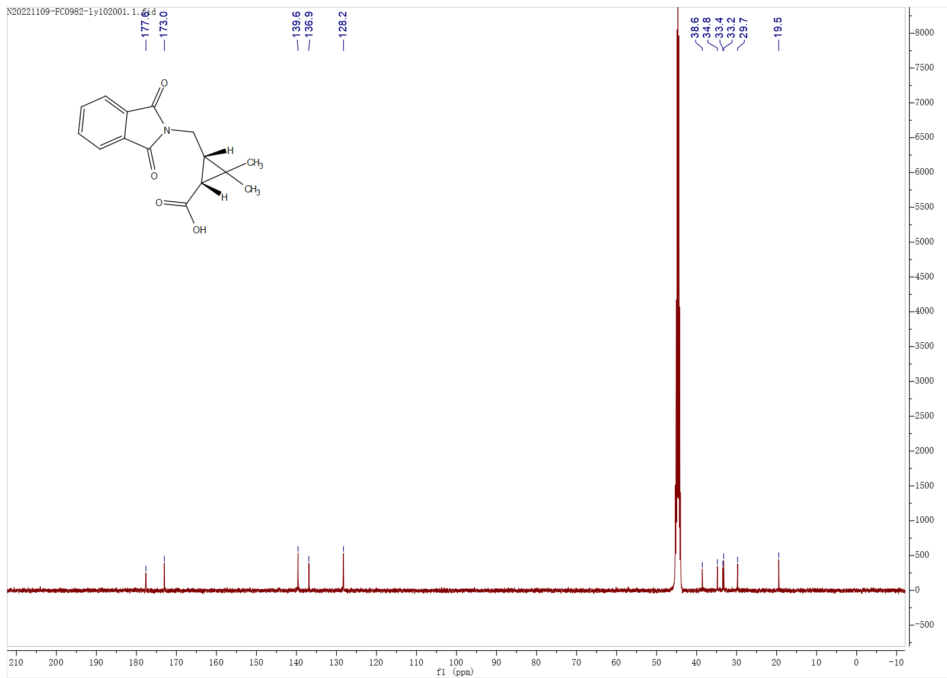
¹³C NMR spectrum of 6 (100 MHz, DMSO-d₆)

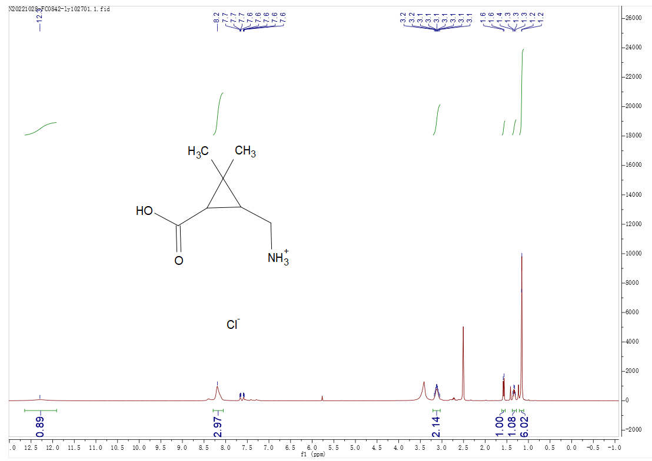
¹H NMR spectrum of 7 (400 MHz, DMSO-d₆)
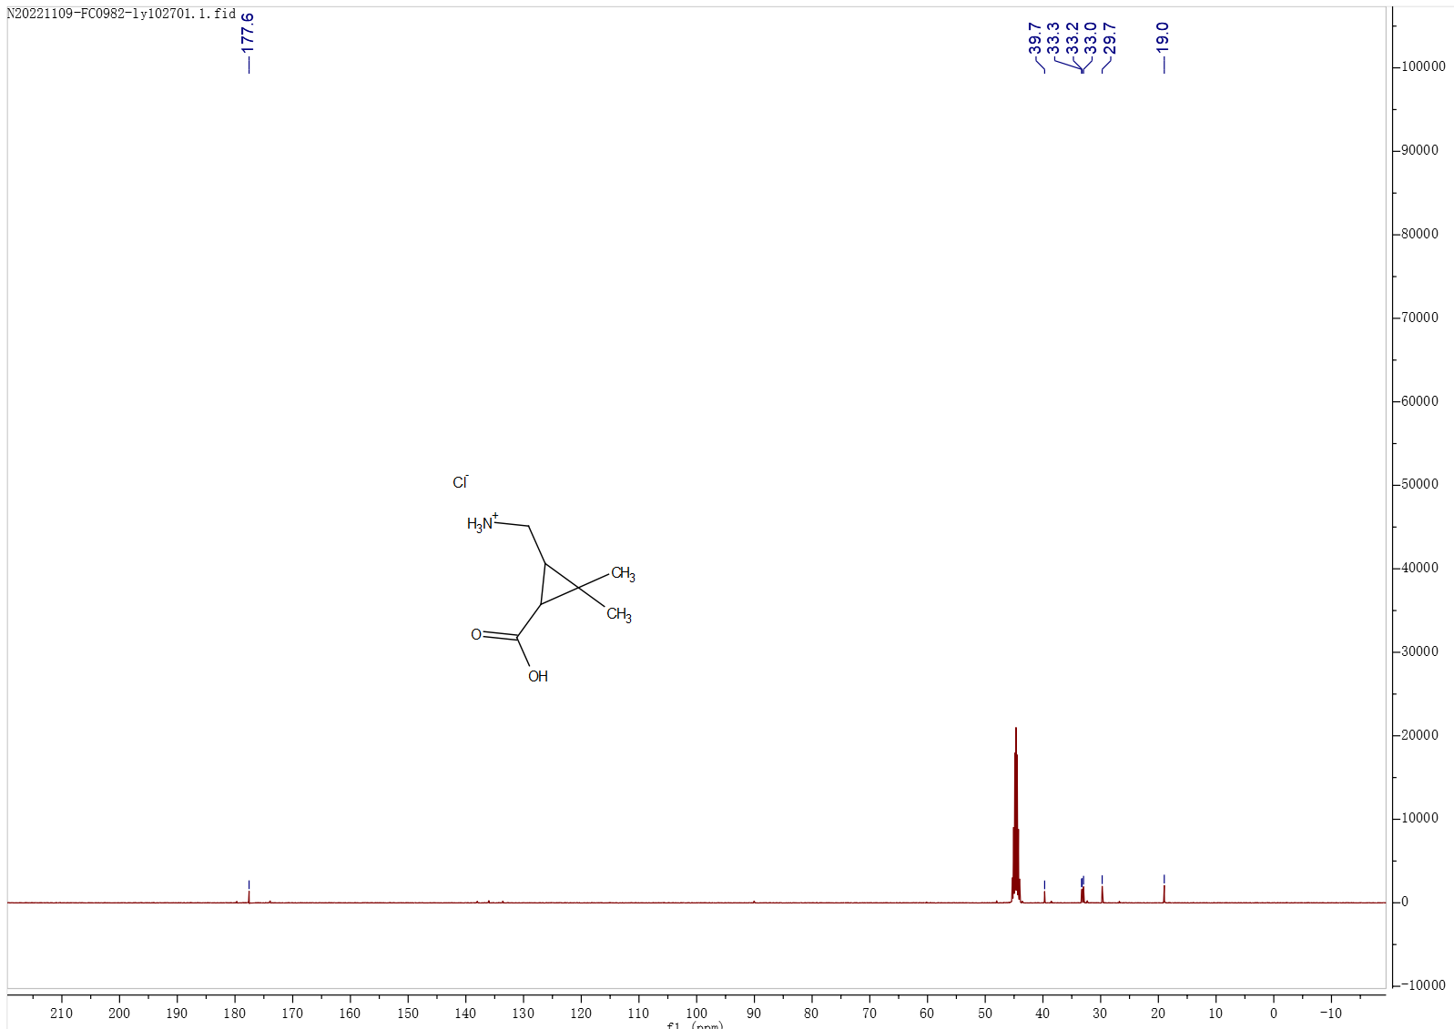
¹³C NMR spectrum of 7 (100 MHz, DMSO-d₆)

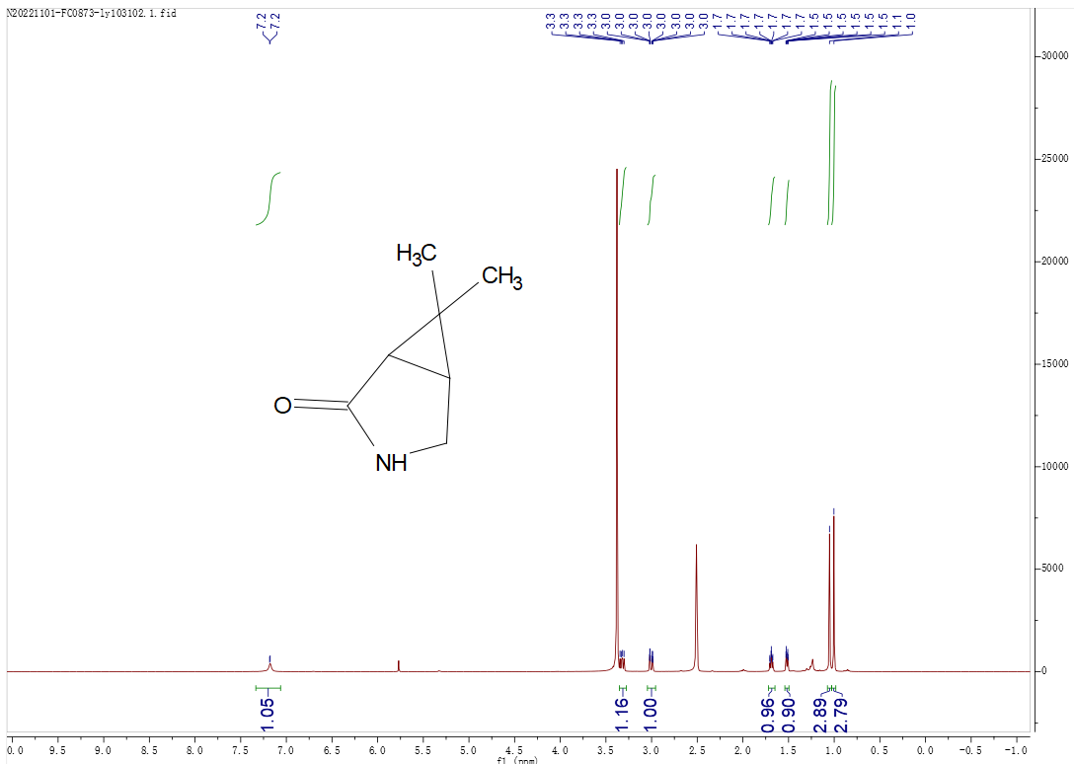
¹H NMR spectrum of 8 (400 MHz, DMSO-d₆)

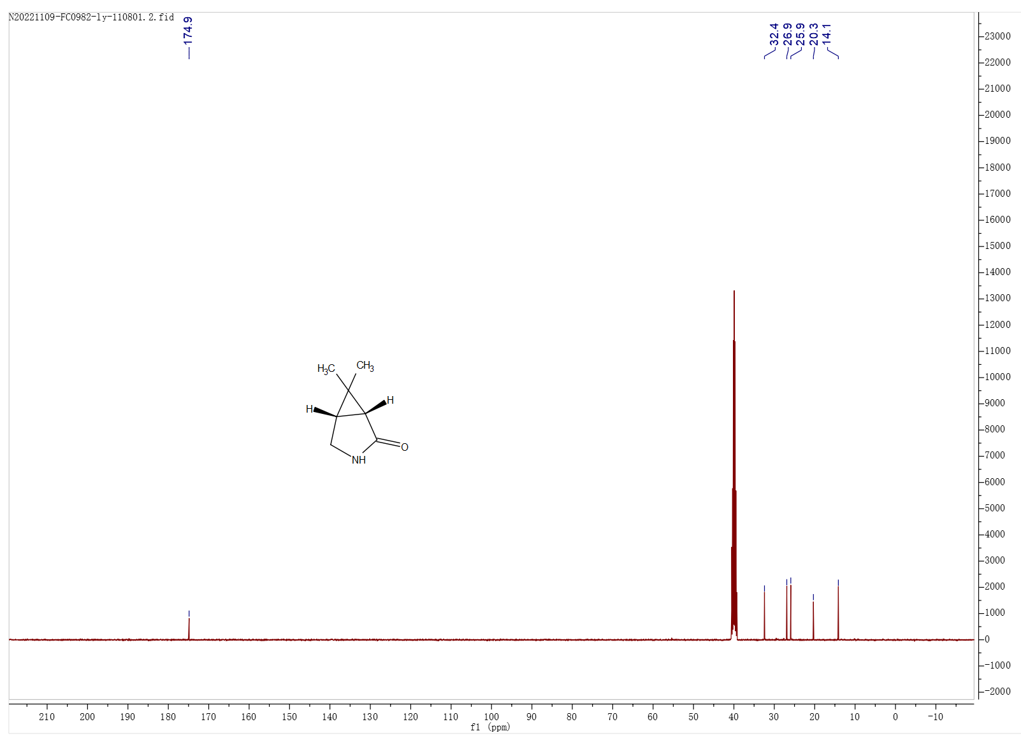
¹³C NMR spectrum of 8 (100 MHz, DMSO-d₆)

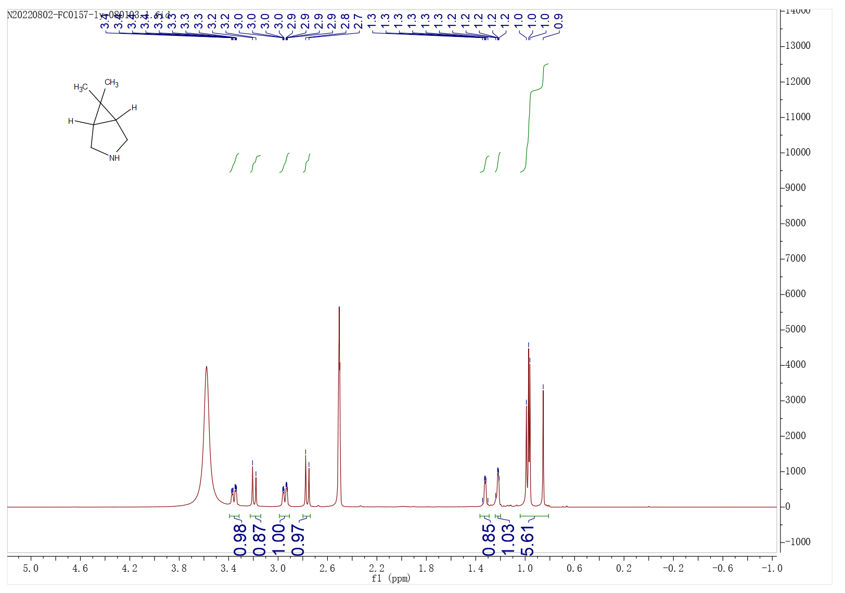
¹H NMR spectrum of 9 (400 MHz, DMSO-d₆)
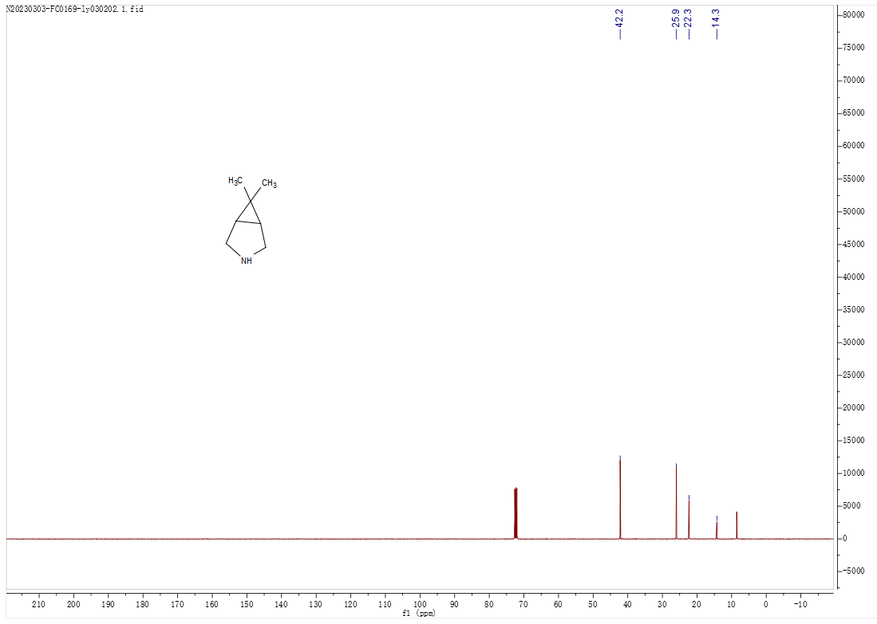
¹³C NMR spectrum of 9 (100 MHz, CDCl₃)

