Supplementary table 1
Name | Sequence | Application
APE1-F | 5′-FAM-gcccccFggggacgtacgatatcccgctcc-3′ | AP site cleavage assay
APE1-R | 5′-ggagcgggatatcgtacgtcccccgggggc-Quencher (DABCYL)-3′ | AP site cleavage assay
SP-BER | 5′-FAM-gcaggaaagcgagggtatccUacaaagtccagcgtaccata-3′ | SP-BER assay
SP-BER | 5′-tatggtacgctggactttgtgggataccctcgctttcctgc-3′ | SP-BER assay
LP-BER | 5′-FAM-gcaggaaagcgagggtatccFacaaagtccagcgtaccata-3′ | LP-BER assay
LP-BER | 5′-tatggtacgctggactttgtgggataccctcgctttcctgc-3′ | LP-BER assay
Pol β-primer | 5′-FAM-gcaggaaagcgagggtatcc-3′ | Pol β primer activity assay
Pol β-primer | 5′-tatggtacgctggactttgtgggataccctcgctttcctgc-3′ | Pol β primer activity assay
Pol β-gap filling | 5′-FAM-gcaggaaagcgagggtatcc-3′ | Pol β gap filling activity assay
Pol β-gap filling | 5′-acaaagtccagcgtaccata-3′ | Pol β gap filling activity assay
Pol β-gap filling | 5′-tatggtacgctggactttgtgggataccctcgctttcctgc-3′ | Pol β gap filling activity assay
FEN1-FEN | 5′-gcaggaaagcgagggtatcc-3′ | FEN1 FEN activity assay
FEN1-FEN | 5′-FAM-taggttgttacacaaagtccagcgtaccata-3′ | FEN1 FEN activity assay
FEN1-FEN | 5′-tatggtacgctggactttgtgggataccctcgctttcctgc-3′ | FEN1 FEN activity assay
FEN1-GEN | 5′-gcaggaaagcgagggtatcc-3′ | FEN1 GEN activity assay
FEN1-GEN | 5′-aagtccagcgtaccata-3′ | FEN1 GEN activity assay
FEN1-GEN | 5′-tatggtacgctggactttgtgggataccctcgctttcctgc-FAM-3′ | FEN1 GEN activity assay

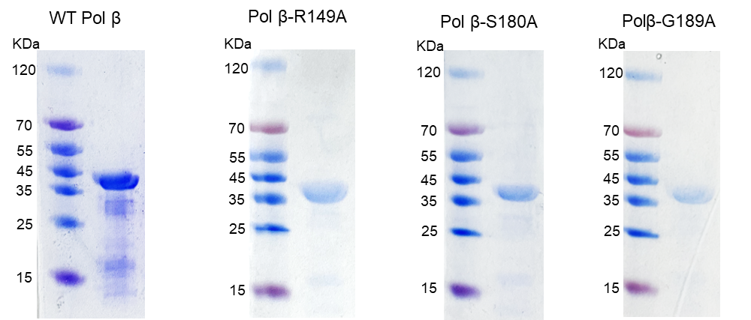

Fig. S1. Construction, expression and purification of WT, R149A, S180A and G189A mutant Pol β.

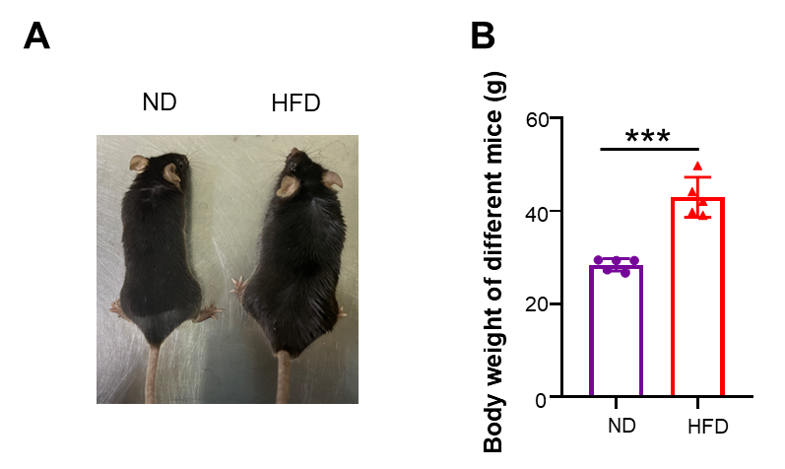
Fig. S2. Body weights of mice fed by normal diet or high fat diet. (A) Representative photos of the whole body of normal library diet and HFD fed mice. (B) Body weights of two groups of mice (n=5). ***P<0.001.

