Supplementary

Supplementary methods

Reverse Triplet Loss
The equation of the Reverse Triplet Loss is the same as the normal Triplet loss:
$$L_{revTriplet}\left(A,P,N\right)=\max\left(|\text{f}\left(A\right)-\text{f}\left(P\right)|_{2}-|\text{f}\left(A\right)-\text{f}\left(N\right)|_{2}+α,0\right)$$
Where A is the anchor input, P is any Positive input of the same batch as A, N is any negative sample of a different batch than A, α is the margin between positive and negative pairs and f is the embedding given by passing the inputs through the encoder of the autoencoder. Using this equation would result in samples from the same batch to cluster together and different batches to be far away from each other. The distance between the clusters is controlled by the hyperparameter α. The Reverse Triplet loss does the opposite by applying a GRL for each embedding in the equation, which encourages batch-free representations. The samples from different batches get closer, while samples from the same batch are pushed further apart. The later objective is used to prevent all samples from collapsing. If the samples from the same batch are not pushed apart, the loss would be optimal if all samples were transformed into the exact same value, which is not the desired outcome. The distance minimized in this case is the Euclidean distance, but any distance could be used.

Supplementary Figures

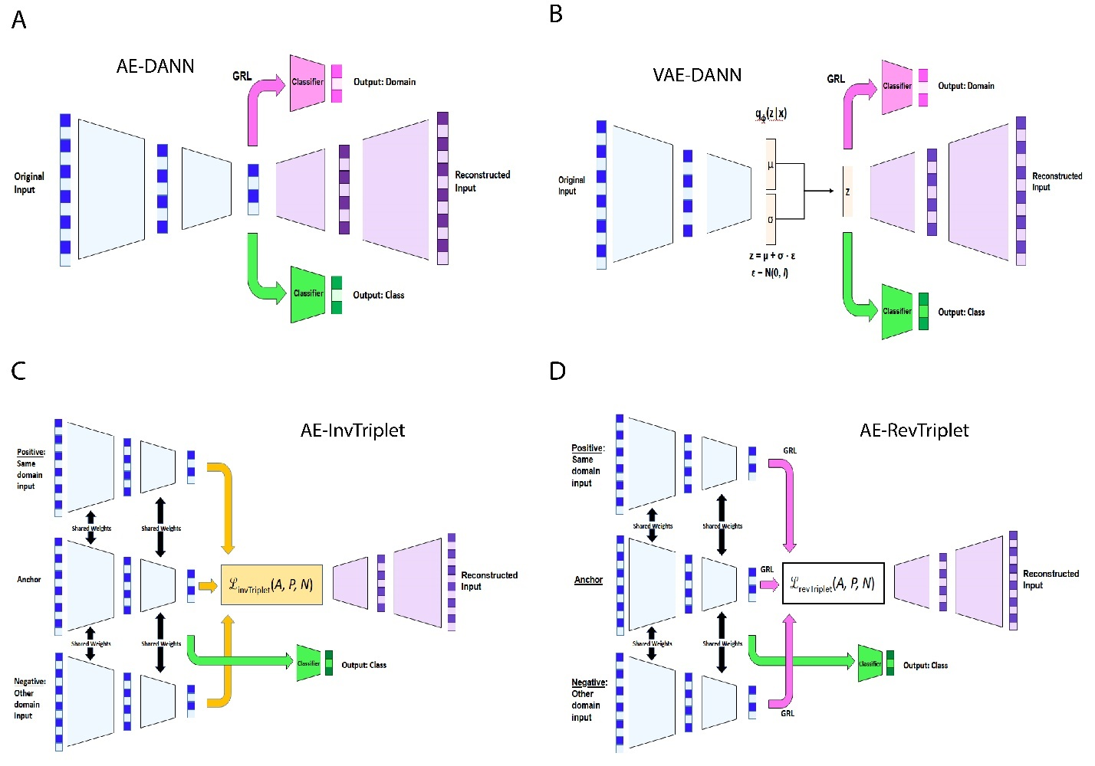
Figure S1: Complete models architectures.
A) AE-DANN is an autoencoder with a domain classifier trained with a gradient reversal layer (GRL). B) VAE-DANN is a variational autoencoder with a domain classifier trained with a gradient reversal layer (GRL). C) is an Autoencoder that uses the inverse triplet loss to make the new representation batch-free. The encoders for the positive, negative and anchor samples all share the same weights. D) is an Autoencoder that uses the reverse triplet loss to make the new representation batch-free. The encoders for the positive, negative and anchor samples all share the same weights. For all models, the autoencoder and methods to remove batch effects (DANN, invTriplet or revTriplet), if used, are trained during warmup. The label classifier is trained either with the rest of the model frozen (Alzheimer) or not (Adenocarcinoma and AgingMice). Not all models are depicted, but all models can be made from a combination of these models. AE is like A but without the domain classifier. VAE is like B but without the domain classifier. VAE-invTriplet is like C but the bottleneck encodes a gaussian distribution like in B. VAE-revTriplet is like D but the bottleneck encodes a gaussian distribution like in B. The models have many modules in common, which are depicted using different colors.
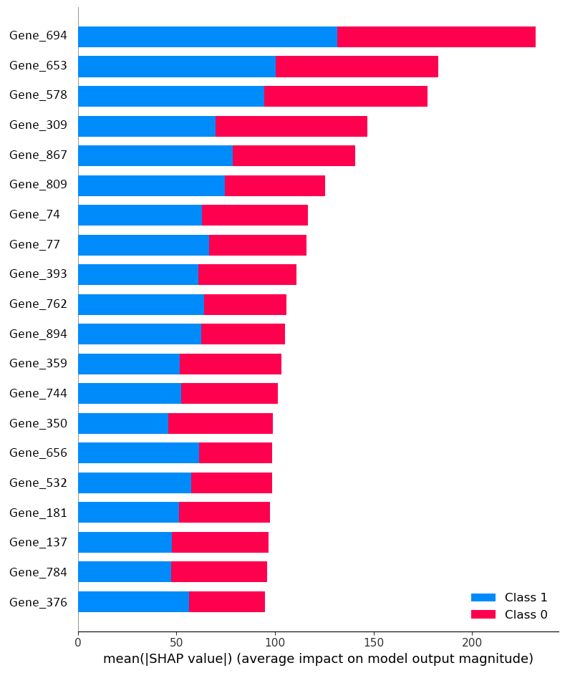
Figure S2: Deep Learning model interpretation using SHAP’s DeepExplainer.
Depicted here are the top 20 genes associated with the best classifier for the Alzheimer dataset, VAE-DANN. The higher mean absolute SHAP values, the higher its importance to explain the model’s decision. Class 0 is control and class 1 is Alzheimer’s disease with dementia (DEM-AD).

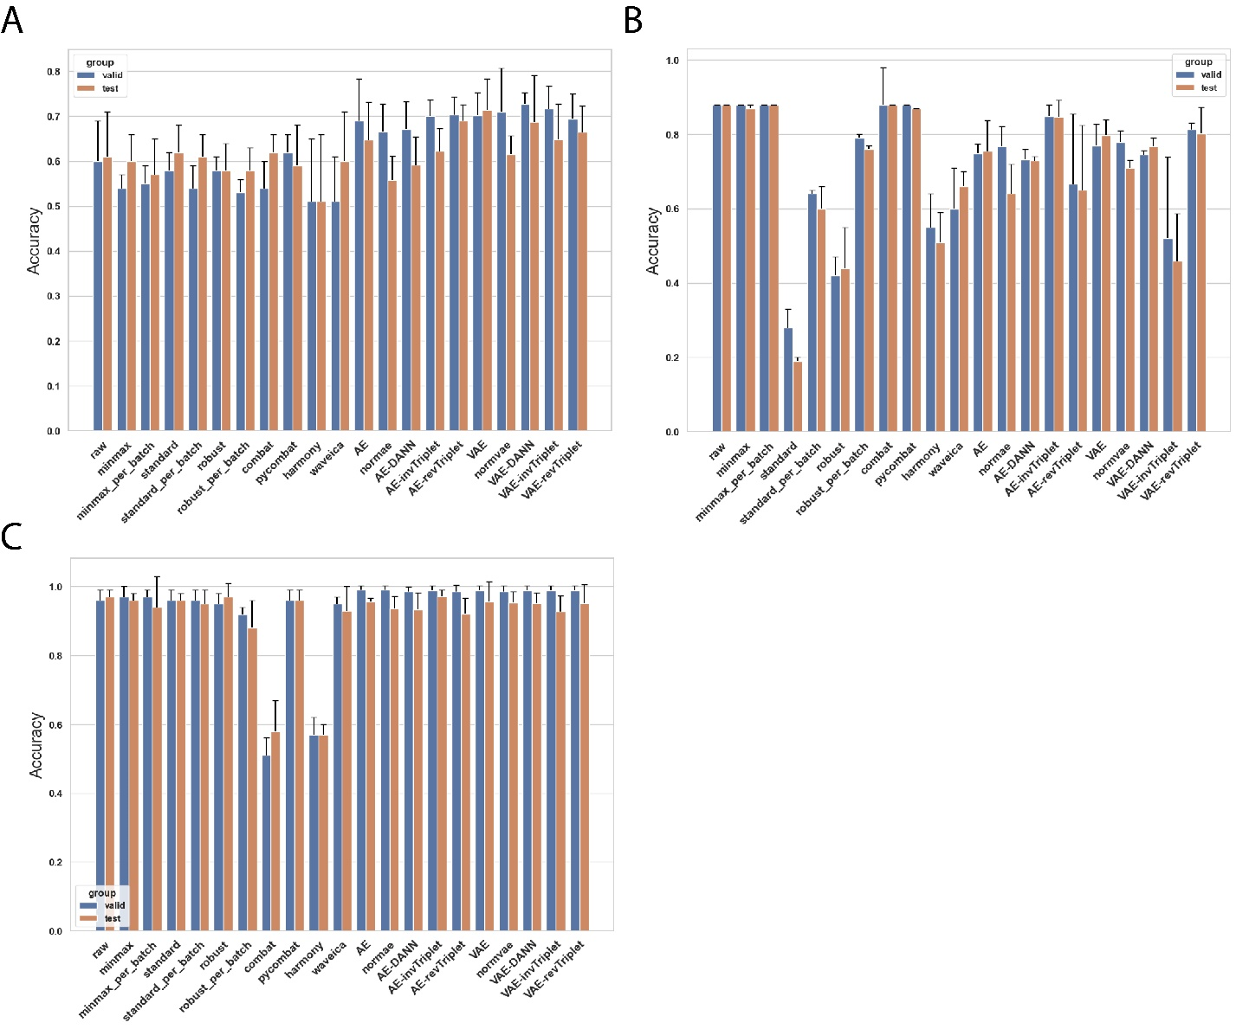
Figure S3: Accuracies of the three datasets studied.
A) Alzheimer’s disease dataset, B) Adenocarcinoma dataset and C) AgingMice dataset.

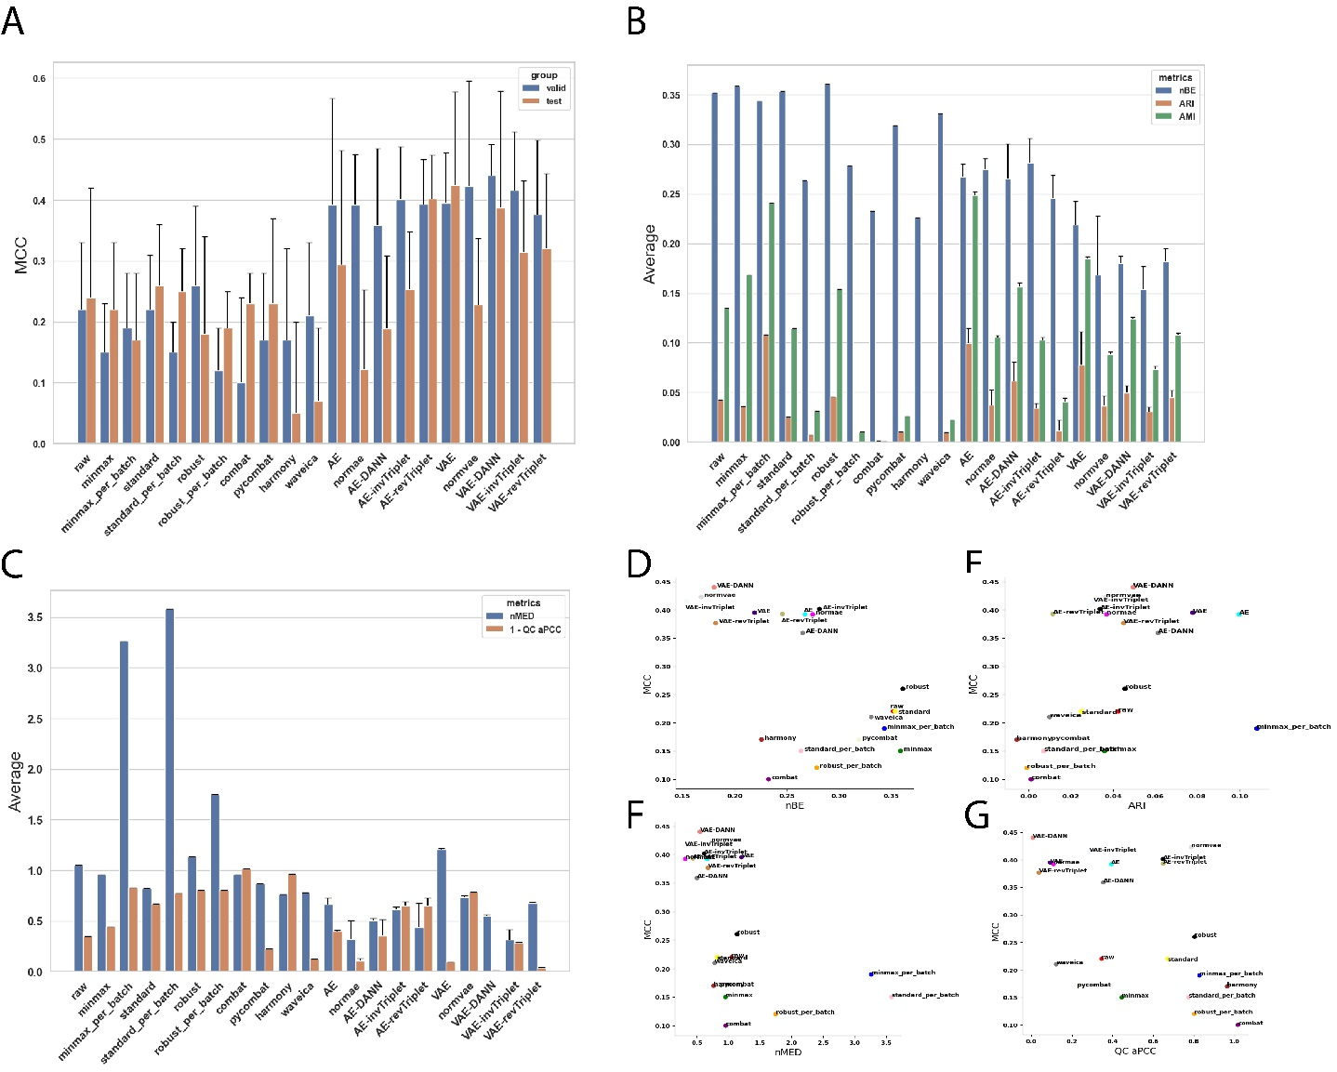
Figure S4: Complete metrics on the Alzheimer dataset.
A) Valid and test MCC scores for all methods benchmarked. Higher is better. B) Batch mixing metrics: Max Entropy – Batch Entropy (ME-BE), Adjusted Rand Index (ARI), Adjusted Mutual Information (AMI). The maximum entropy is ln(21). Smaller is better. C) QC metrics: Normalized Median Euclidean distance (nMED) and QC average Pearson Correlation Coefficient (qc_aPCC). Lower nMED and 1-qc_aPCC is better. (D-G) MCC is compared to D) ME-BE, E) ARI, F) QC nMED and G) QC aPCC.

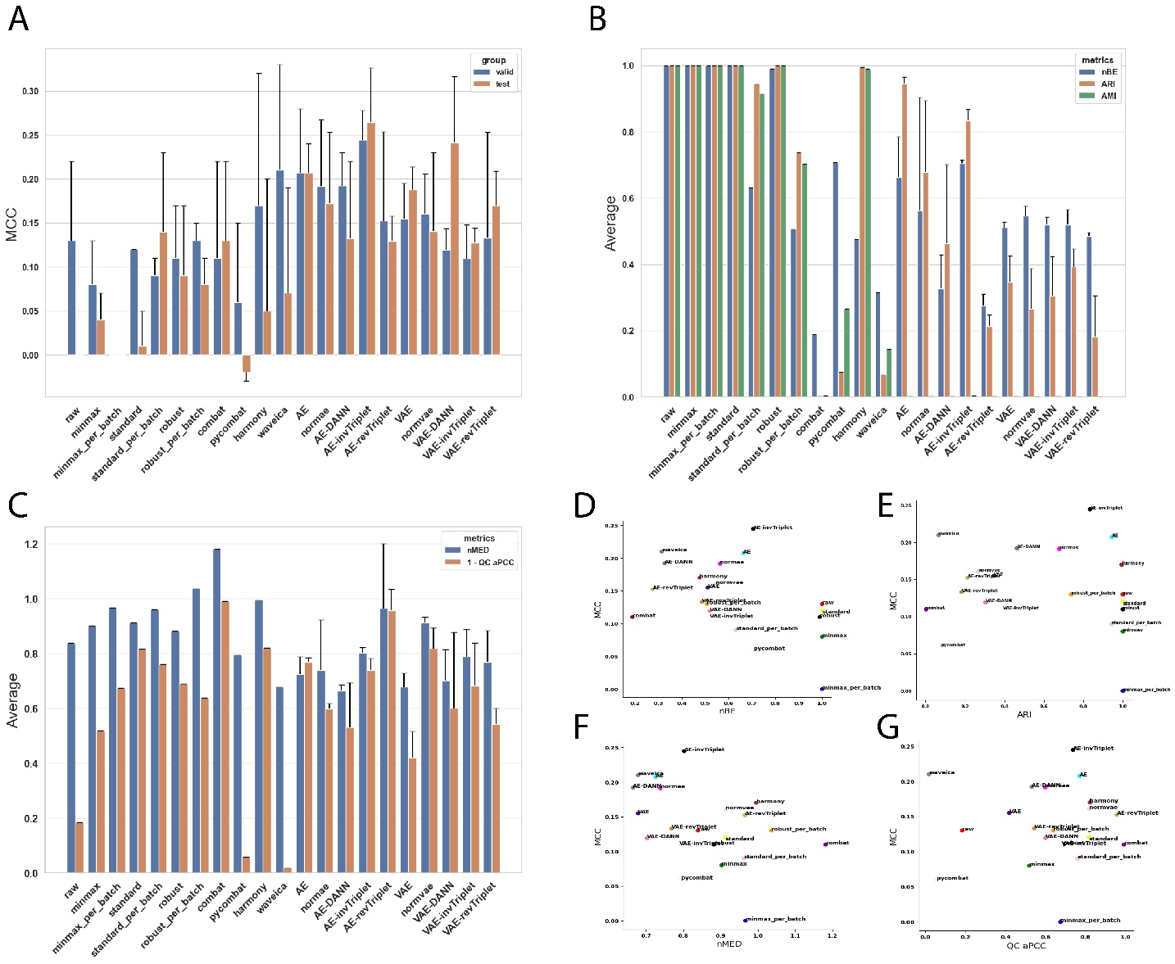
Figure S5: Complete metrics on the Adenocarcinoma dataset.
A) Valid and test MCC scores for all methods benchmarked. Higher is better. B) Batch mixing metrics: Max Entropy – Batch Entropy (ME-BE), Adjusted Rand Index (ARI), Adjusted Mutual Information (AMI). The maximum entropy is ln(3). Smaller is better. C) QC metrics: Normalized Median Euclidean distance (QC nMED) and QC average Pearson Correlation Coefficient (qc_aPCC). Lower nMED and 1-qc_aPCC is better. (D-G) MCC is compared to D) ME-BE, E) ARI, F) QC nMED and G) QC aPCC.

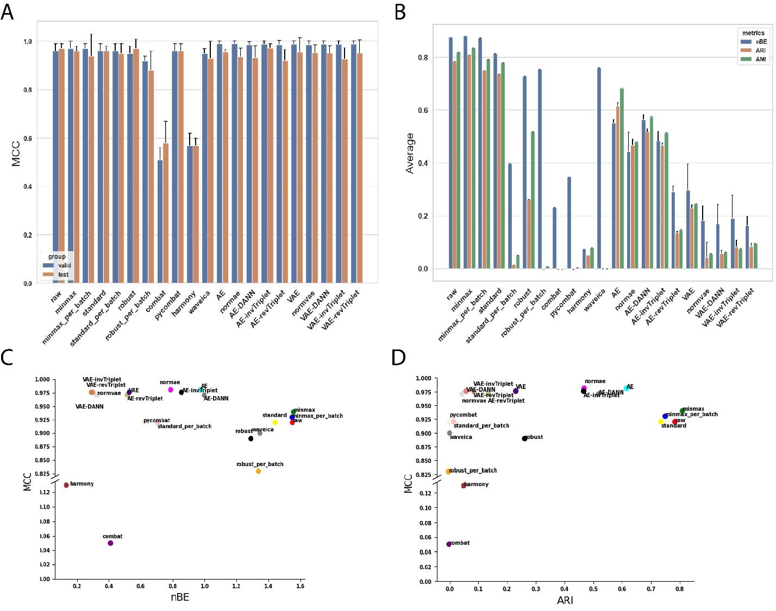
Figure S6: Complete metrics on the AgingMice dataset.
A) Valid and test MCC scores for all methods benchmarked. Higher is better. B) Batch mixing metrics: Max Entropy – Batch Entropy (ME-BE), Adjusted Rand Index (ARI), Adjusted Mutual Information (AMI). The maximum entropy is ln(7). Smaller is better. (C-D) MCC is compared to C) ME-BE and D) ARI.

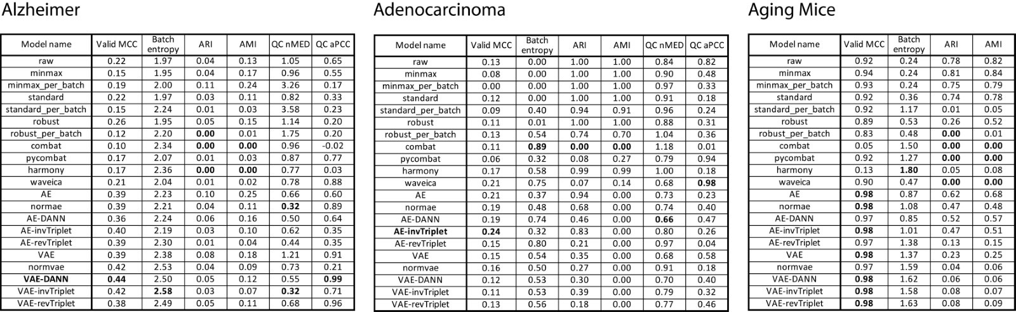
Figure S7 – Batch effect correction metrics summary tables

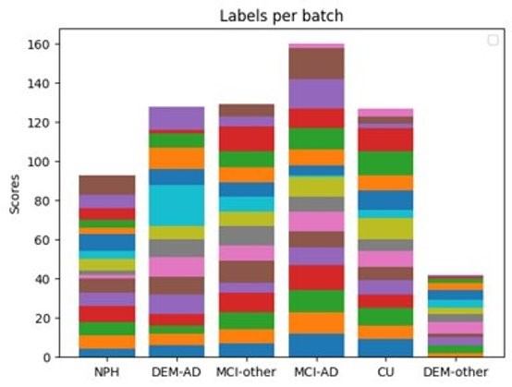
Figure S8: Number of labels per batch for all 6 categories composing complete dataset.
Samples from all categories are used to train the autoencoder and batch classifier, but the labels classifier only learn to distinguish DEM-AD and CU. NPH: Normal Pressure Hydranencephalies, DEM-AD: Dementia from Alzheimer’s Disease, MCI-other: Mild Cognitive Impairment from another disease than Alzheimer’s, MCI-AD: Mild Cognitive Impairment from Alzheimer’s Disease, CU: Cognitively Unimpaired, DEM-other: Dementia from another disease than Alzheimer’s.

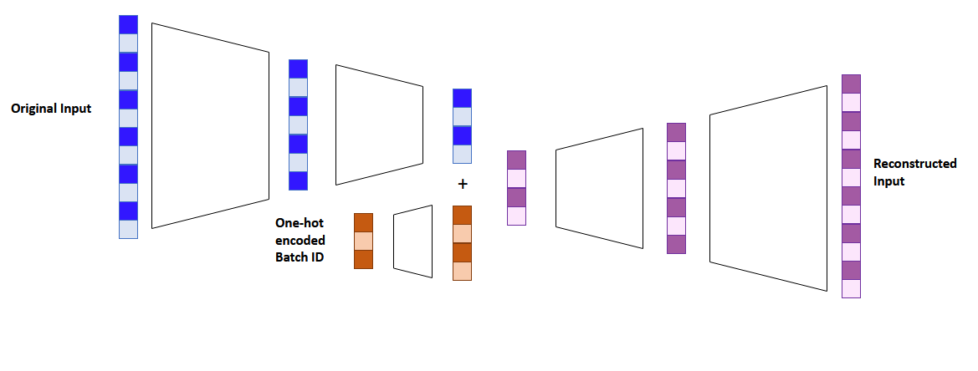
Figure S9: Autoencoder with batch mapping.
Batch information is encoded into a vector of the same size as the bottleneck representation of the autoencoder using a single-layer neural network. The two vectors of the same size are added together before being reconstructed. This allows the reconstruction to be more accurate, because it needs the batch information to do so, but the encoded representation is trained to be free of batch information.

Table S1 – List of known contaminant genes
Contaminants
ALB
DMKN
FLG
FLG2
HRNR
KRT1
KRT10
KRT12
KRT13
KRT14
KRT15
KRT16
KRT17
KRT19
KRT2
KRT20
KRT222
KRT23
KRT24
KRT25
KRT26
KRT27
KRT28
KRT3
KRT31
KRT32
KRT33A
KRT33B
KRT34
KRT35
KRT36
KRT37
KRT38
KRT39
KRT4
KRT40
KRT5
KRT6A
KRT6B
KRT6C
KRT7
KRT71
KRT72
KRT73
KRT74
KRT75
KRT76
KRT77
KRT78
KRT79
KRT8
KRT80
KRT81
KRT82
KRT83
KRT84
KRT85
KRT86
KRT9
KRTAP10-12
KRTAP19-5
KRTAP2-4
KRTAP3-1
KRTAP4-1
KRTAP4-3
KRTAP4-6
KRTAP4-9
PRSS1

